

Appliance Repair & Small-Engine Shops
Website workbook
A practical workshop for a 6-page website. Study the example, plan the content and draft your own version in Word or on paper.
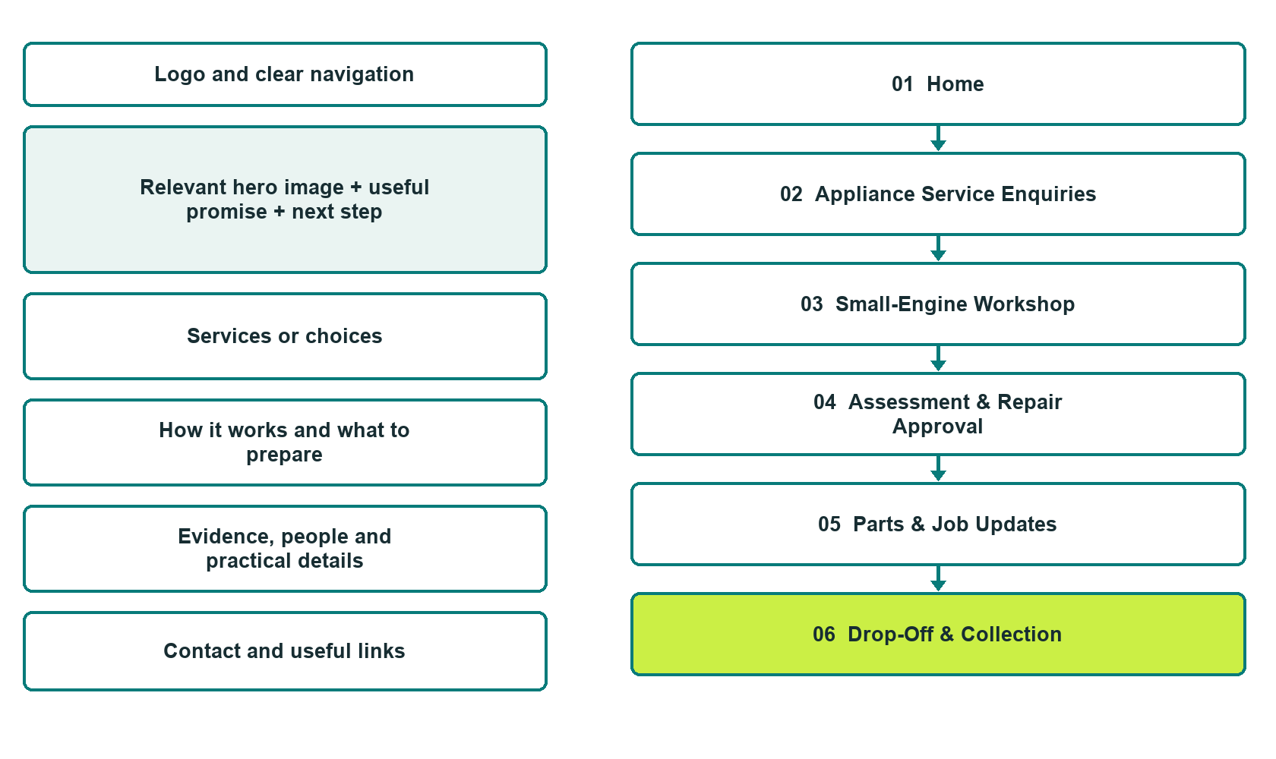

Plan → Draft → Build → Test
Captured demo edition. Study the unpublished six-page example, then draft your own verified content. Paired desktop and mobile previews, Editor Highlights, Themes and Paint appear in the industry gallery.
Explore Website Builder and compare plans

Before you build
Your business supplies the facts. Prairie Bench Repair is a fictional teaching example, not a live service.

□ Request an equipment acceptance check
□ Verified business identity, services and current contact information
□ A clear enquiry, review and confirmation process
□ Choose original photographs and confirm permission to use them.
□ Keep private customer records out of public website forms.

Your audience and the action you want them to take

Facts to verify and people who must approve them
Create your SaaSTech account

01 Home
Give this page one clear job in the customer journey.
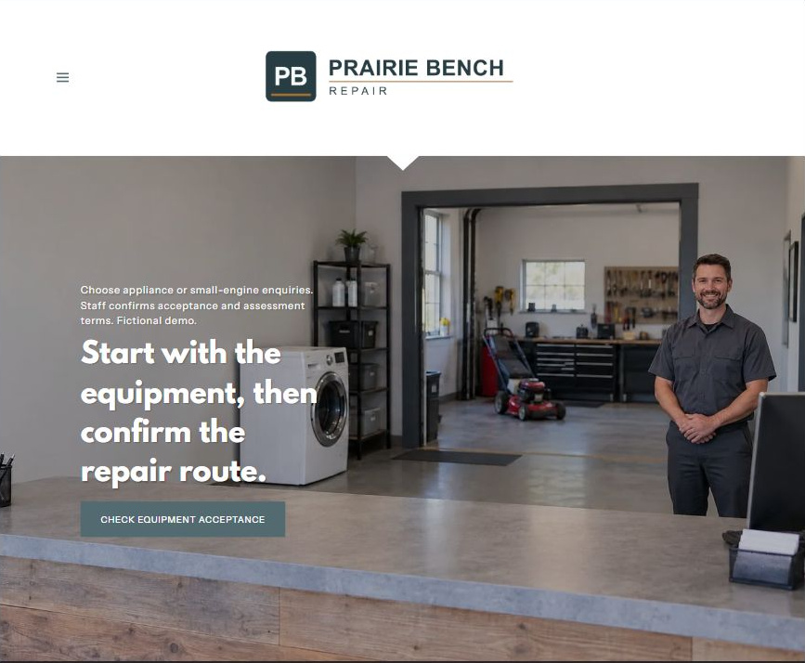
Actual desktop Website Builder preview. The paired mobile view appears in the industry gallery.

Sample wording — adapt and verify
Start with the equipment, then confirm the repair route.
Choose appliance or small-engine enquiries. Staff confirms acceptance and assessment terms. Fictional demo.
The Home button opens the equipment acceptance enquiry form. An enquiry is not a repair authorization.
Suggested next step: Check equipment acceptance on Home

Website advice
Present appliance and small-engine enquiries as separately verified services, with acceptance checks, assessment authorization and collection arrangements.

Your draft: Home
Write in the voice of your own business. Use facts you can verify, not promises copied from the example.

Headline and short introduction

Main content and details visitors need

Button wording and destination

Photo choice, permission and facts still to confirm
Partner check: can someone unfamiliar with the business find a useful next step?

02 Appliance Service Enquiries
Give this page one clear job in the customer journey.
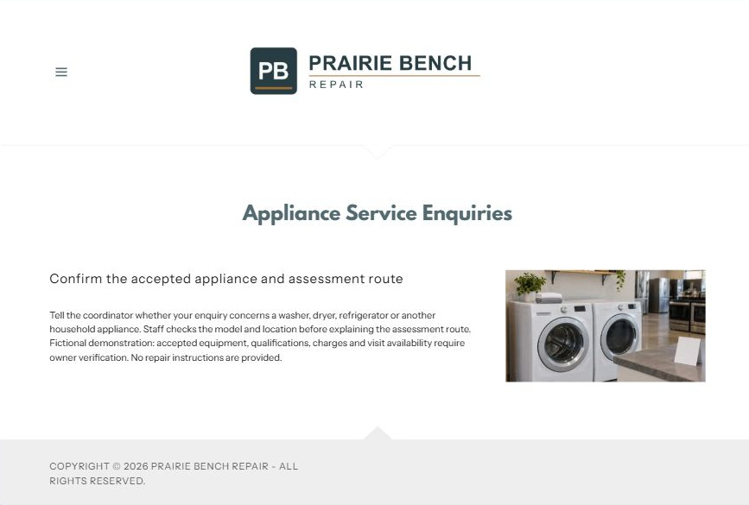
Actual desktop Website Builder preview. The paired mobile view appears in the industry gallery.

Sample wording — adapt and verify
Appliance Service Enquiries
Tell the coordinator whether your enquiry concerns a washer, dryer, refrigerator or another household appliance.
Staff checks the model and location before explaining the assessment route. Accepted equipment, charges and visit availability require owner verification.
Suggested next step: Check equipment acceptance on Home

Website advice
Separate household appliance categories and explain how staff checks the exact model and service arrangement.

Your draft: Appliance Service Enquiries
Write in the voice of your own business. Use facts you can verify, not promises copied from the example.

Headline and short introduction

Main content and details visitors need

Button wording and destination

Photo choice, permission and facts still to confirm
Partner check: can someone unfamiliar with the business find a useful next step?

03 Small-Engine Workshop
Give this page one clear job in the customer journey.
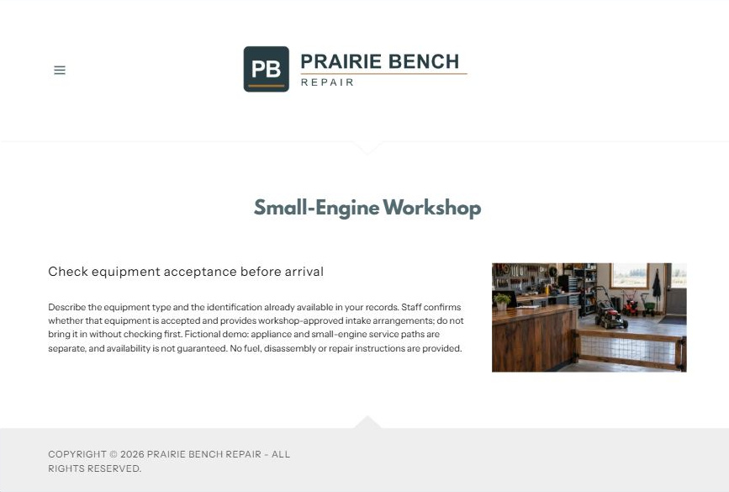
Actual desktop Website Builder preview. The paired mobile view appears in the industry gallery.

Sample wording — adapt and verify
Small-Engine Workshop
Describe the equipment type and the identification already available in your records.
Staff confirms whether that equipment is accepted and provides the workshop-approved intake arrangements; do not bring it in without checking first.
Suggested next step: Check equipment acceptance on Home

Website advice
Create a distinct route for accepted mower and other small-engine equipment without extending appliance capabilities by implication.

Your draft: Small-Engine Workshop
Write in the voice of your own business. Use facts you can verify, not promises copied from the example.

Headline and short introduction

Main content and details visitors need

Button wording and destination

Photo choice, permission and facts still to confirm
Partner check: can someone unfamiliar with the business find a useful next step?

04 Assessment & Repair Approval
Give this page one clear job in the customer journey.
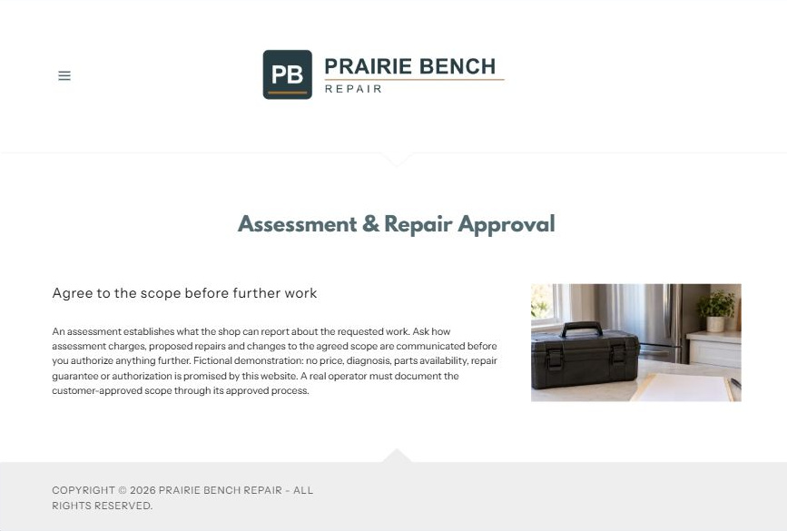
Actual desktop Website Builder preview. The paired mobile view appears in the industry gallery.

Sample wording — adapt and verify
Assessment & Repair Approval
An assessment establishes what the shop can report about the requested work.
Ask how assessment charges, proposed repairs and changes to the agreed scope are communicated before you authorize anything further.
Suggested next step: Check equipment acceptance on Home

Website advice
Explain the difference between receiving equipment, assessing it and receiving permission to repair.

Your draft: Assessment & Repair Approval
Write in the voice of your own business. Use facts you can verify, not promises copied from the example.

Headline and short introduction

Main content and details visitors need

Button wording and destination

Photo choice, permission and facts still to confirm
Partner check: can someone unfamiliar with the business find a useful next step?

05 Parts & Job Updates
Give this page one clear job in the customer journey.
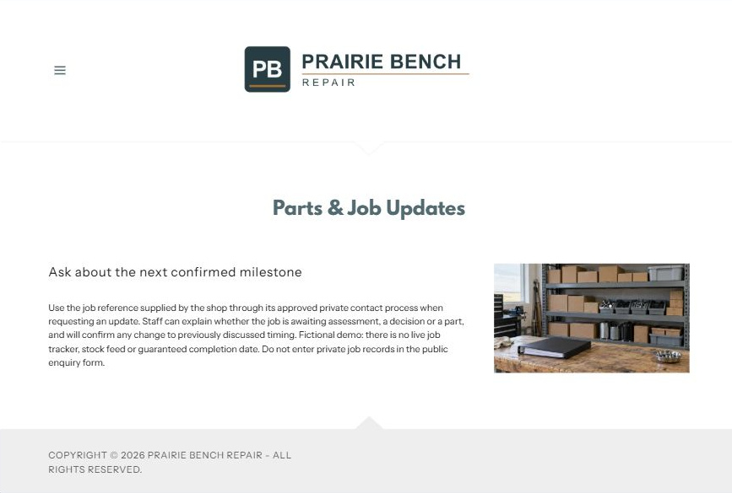
Actual desktop Website Builder preview. The paired mobile view appears in the industry gallery.

Sample wording — adapt and verify
Parts & Job Updates
Use the job reference supplied by the shop through its approved private contact process when requesting an update.
Staff can explain whether the job is awaiting assessment, a decision or a part, and will confirm any change to the previously discussed timing.
Suggested next step: Check equipment acceptance on Home

Website advice
Make parts availability and timing conditional and keep private job details out of public forms.

Your draft: Parts & Job Updates
Write in the voice of your own business. Use facts you can verify, not promises copied from the example.

Headline and short introduction

Main content and details visitors need

Button wording and destination

Photo choice, permission and facts still to confirm
Partner check: can someone unfamiliar with the business find a useful next step?

06 Drop-Off & Collection
Give this page one clear job in the customer journey.
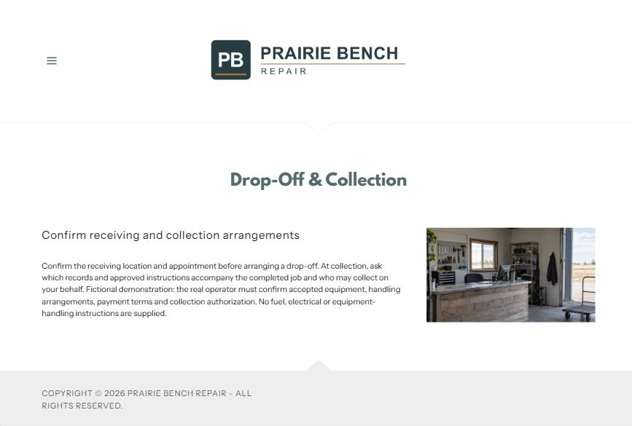
Actual desktop Website Builder preview. The paired mobile view appears in the industry gallery.

Sample wording — adapt and verify
Drop-Off & Collection
Confirm the receiving location and appointment before arranging a drop-off.
At collection, ask which records and approved instructions accompany the completed job and who may collect on your behalf.
Suggested next step: Check equipment acceptance on Home

Website advice
Cover verified receiving arrangements and collection authorization rather than equipment transport advice.

Your draft: Drop-Off & Collection
Write in the voice of your own business. Use facts you can verify, not promises copied from the example.

Headline and short introduction

Main content and details visitors need

Button wording and destination

Photo choice, permission and facts still to confirm
Partner check: can someone unfamiliar with the business find a useful next step?

Test before publishing
Review the captured desktop and phone journey. Home has Name, required Email, Phone and a brief equipment acceptance question. Recipient blank; attachments and messaging off. It was not submitted or delivery-tested. Configure approved delivery before launch.
□ Fictional repair-shop demonstration. Do not assume one operator services both categories. Verify accepted brands, equipment, qualifications and collection services; no electrical, fuel, disassembly or repair instructions are provided.
□ Verify every service description, contact route and operating detail.
□ Replace fictional identity and example information before a live launch.
□ Test enquiries, links and downloads on desktop and mobile.
□ Keep confidential records in approved private systems.
□ Obtain operator approval for public wording and images.
□ Check every link, form destination, download and confirmation message.
□ Check logo contrast, hero framing, text sizes and image loading.
□ Save a named backup and assign a content-review date.

Changes to finish and person responsible

Approval and next review date
Website Builder plans and signup

