

Agricultural Input & Crop Services
Website workbook
A practical workshop for a 5-page website. Study the example, plan the content and draft your own version in Word or on paper.
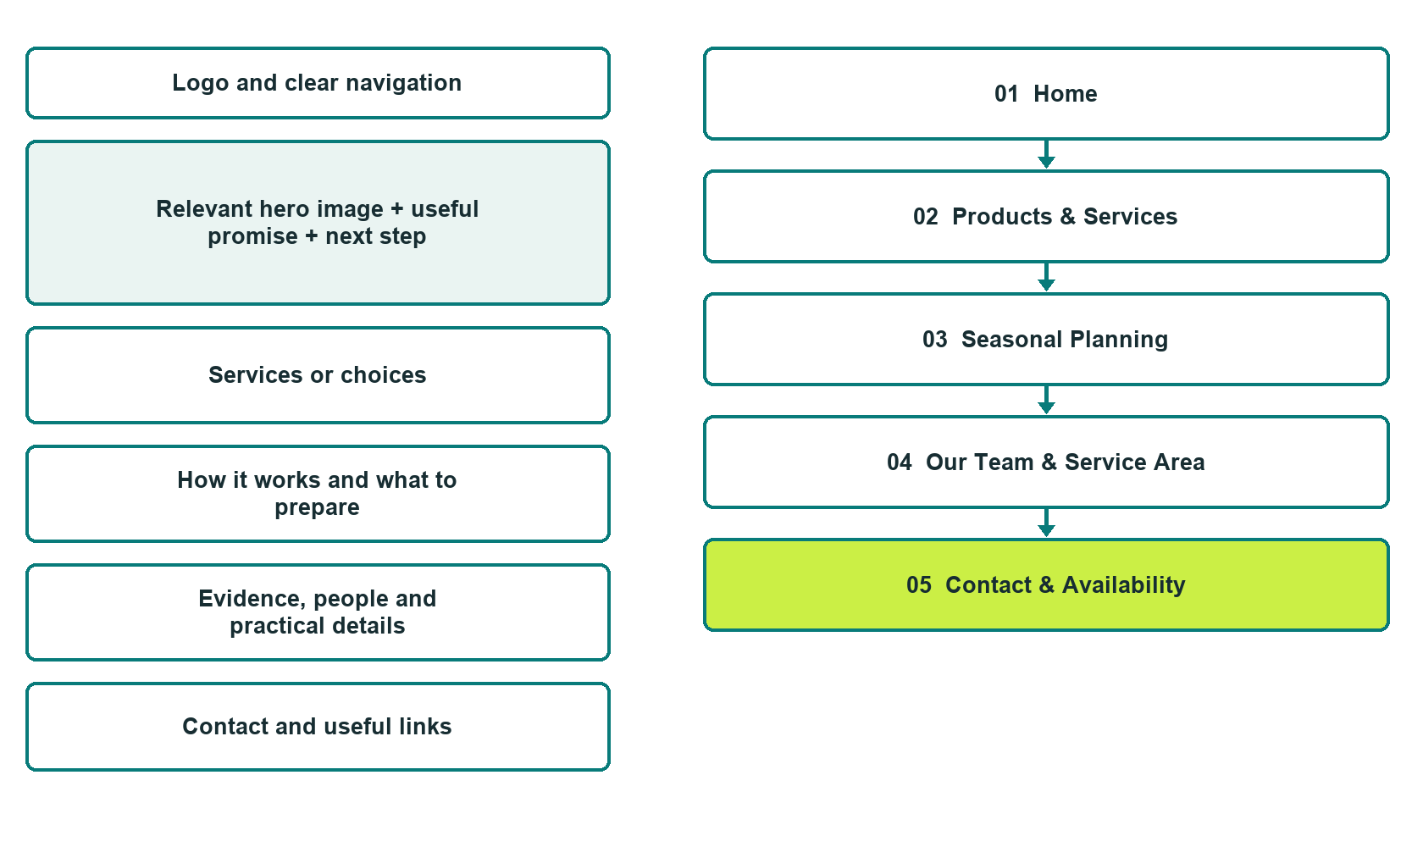

Plan → Draft → Build → Test
Captured demo edition. Study the unpublished five-page example. Paired desktop and mobile previews, Editor Highlights, Themes and Paint settings appear in the industry gallery.
Explore Website Builder and compare plans

Before you build
Your business supplies the facts. Prairie Acre Crop Services is a fictional teaching example, not a live service.

□ Ask about crop-service options
□ Verified identity, service scope and current contacts
□ Clear enquiry and confirmation steps
□ Choose original photographs and confirm permission to use them.
□ Keep private customer records out of public website forms.

Your audience and the action you want them to take

Facts to verify and people who must approve them
Create your SaaSTech account

01 Home
Give this page one clear job in the customer journey.
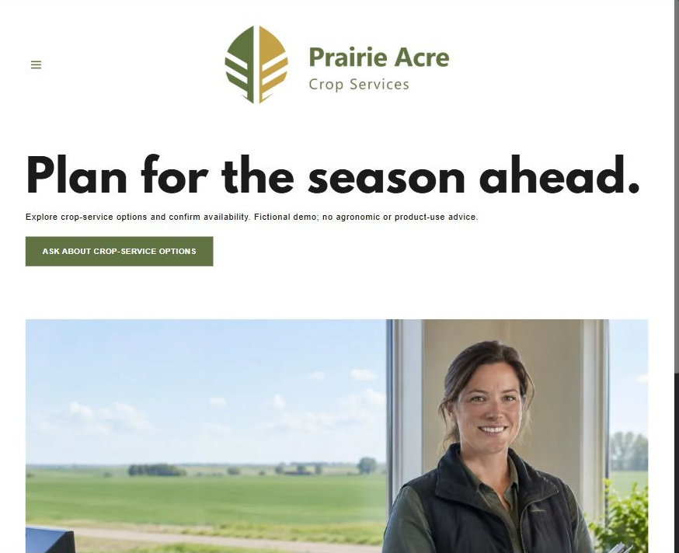
Actual desktop Website Builder preview. The paired mobile view appears in the industry gallery.

Sample wording — adapt and verify
Plan for the season ahead.
Explore crop-service options and confirm availability. Fictional demo; no agronomic or product-use advice.
The Home button opens Contact & Availability. The fictional enquiry form has no delivery recipient and does not confirm stock or service.
Suggested button: Ask about crop-service options

Website advice
Describe verified product and service categories, seasonal enquiries and staff review without agronomic prescriptions or yield promises.

Your draft: Home
Write in the voice of your own business. Use facts you can verify, not promises copied from the example.

Headline and short introduction

Main content and details visitors need

Button wording and destination

Photo choice, permission and facts still to confirm
Partner check: can someone unfamiliar with the business find a useful next step?

02 Products & Services
Give this page one clear job in the customer journey.

Actual desktop Website Builder preview. The paired mobile view appears in the industry gallery.

Sample wording — adapt and verify
Discuss options before ordering
Ask about the products and services currently available through the team. Availability and suitability need direct confirmation before an order or service is arranged.
Contact the team to discuss your questions and confirm the next step.
Suggested button: Contact the team

Website advice
Group verified categories and distinguish illustrated examples from current stock.

Your draft: Products & Services
Write in the voice of your own business. Use facts you can verify, not promises copied from the example.

Headline and short introduction

Main content and details visitors need

Button wording and destination

Photo choice, permission and facts still to confirm
Partner check: can someone unfamiliar with the business find a useful next step?

03 Seasonal Planning
Give this page one clear job in the customer journey.
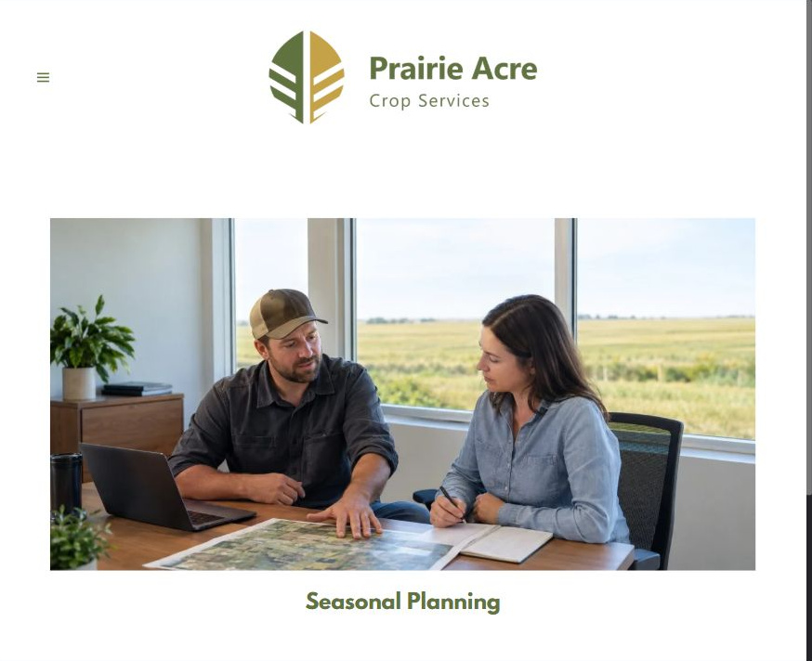
Actual desktop Website Builder preview. The paired mobile view appears in the industry gallery.

Sample wording — adapt and verify
Bring your seasonal questions
Bring your questions about timing, service coordination and options for review. The team explains what information to share and which decisions need qualified advice.
Contact the team to discuss your questions and confirm the next step.
Suggested button: Contact the team

Website advice
Explain enquiry timing and staff consultation; do not publish application guidance.

Your draft: Seasonal Planning
Write in the voice of your own business. Use facts you can verify, not promises copied from the example.

Headline and short introduction

Main content and details visitors need

Button wording and destination

Photo choice, permission and facts still to confirm
Partner check: can someone unfamiliar with the business find a useful next step?

04 Our Team & Service Area
Give this page one clear job in the customer journey.
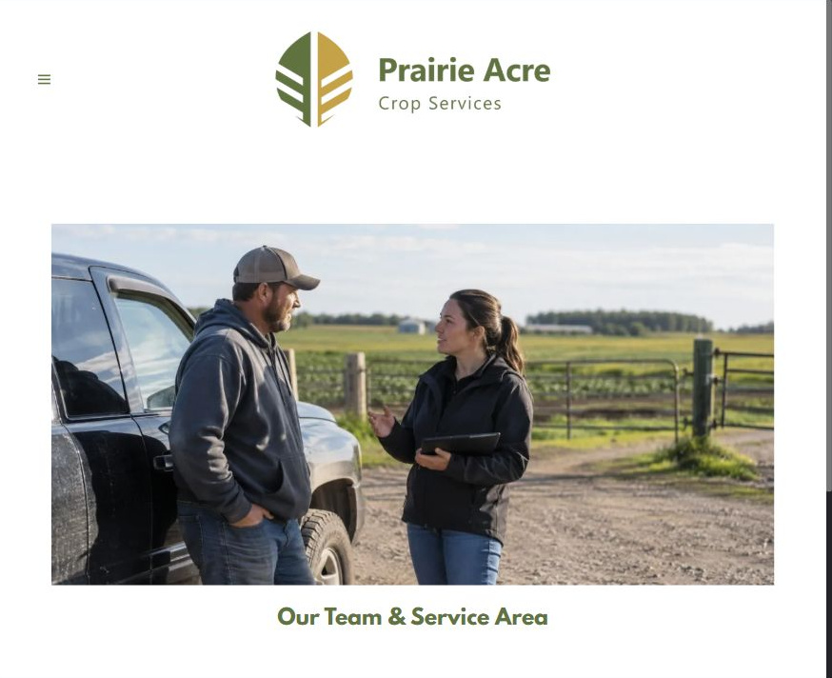
Actual desktop Website Builder preview. The paired mobile view appears in the industry gallery.

Sample wording — adapt and verify
People who coordinate your enquiry
Meet the people who respond to seasonal enquiries and coordinate follow-up. Ask whether your general location is within the current service area and who can address your questions.
Contact the team to discuss your questions and confirm the next step.
Suggested button: Contact the team

Website advice
Publish verified staff roles and service boundaries without invented qualifications.

Your draft: Our Team & Service Area
Write in the voice of your own business. Use facts you can verify, not promises copied from the example.

Headline and short introduction

Main content and details visitors need

Button wording and destination

Photo choice, permission and facts still to confirm
Partner check: can someone unfamiliar with the business find a useful next step?

05 Contact & Availability
Give this page one clear job in the customer journey.
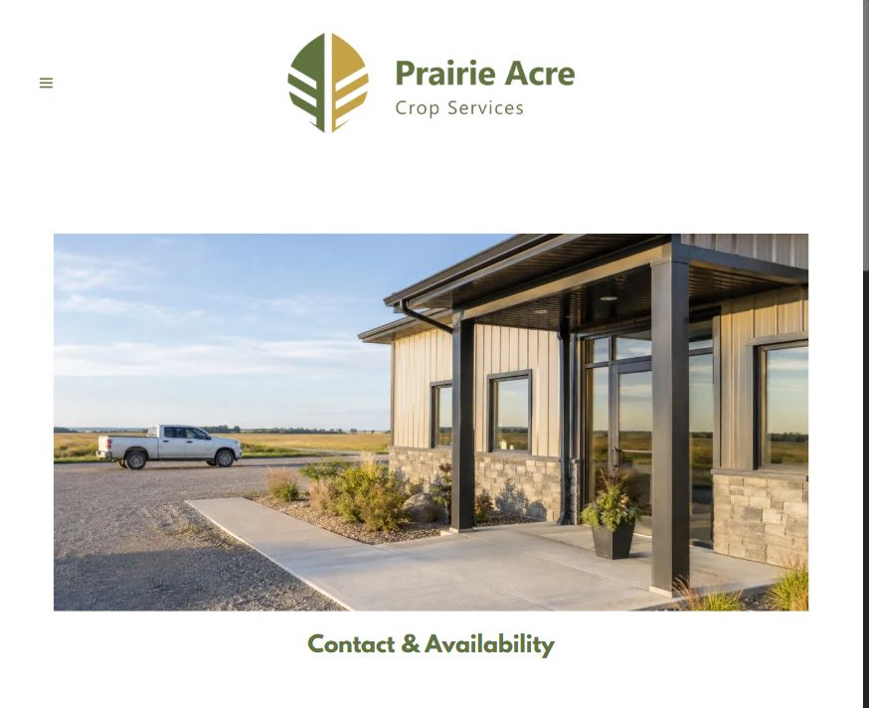
Actual desktop Website Builder preview. The paired mobile view appears in the industry gallery.

Sample wording — adapt and verify
Tell us what you want to discuss
Tell us the general product or service category and the timing you want to discuss. The team reviews the request before any stock, delivery or service appointment is confirmed.
Contact the team to discuss your questions and confirm the next step.
Suggested button: Contact the team

Website advice
Collect a general crop-service question and contact preference; confirm orders separately.

Your draft: Contact & Availability
Write in the voice of your own business. Use facts you can verify, not promises copied from the example.

Headline and short introduction

Main content and details visitors need

Button wording and destination

Photo choice, permission and facts still to confirm
Partner check: can someone unfamiliar with the business find a useful next step?

Test before publishing
Review the captured desktop and phone journey. The demo form asks for Name, required Email, Phone, general category, area, timing and a brief question. Recipient blank; attachments and messaging off. It was not submitted or delivery-tested. Configure approved delivery before launch.
□ Fictional business example. No agronomic, pesticide or fertilizer-use advice is provided. Qualified staff must approve all technical, regulatory, suitability and product wording.
□ Verify contact routes, location, hours, service scope and all commercial terms.
□ Replace fictional identities and AI illustrations or label them accurately.
□ Remove unverified testimonials, results, credentials and availability.
□ Check every link, form and download on desktop and mobile.
□ Keep sensitive documents, access information and payment details out of public forms.
□ Check every link, form destination, download and confirmation message.
□ Check logo contrast, hero framing, text sizes and image loading.
□ Save a named backup and assign a content-review date.

Changes to finish and person responsible

Approval and next review date
Website Builder plans and signup

