

Welding & Machine Shops website workbook
A print-ready workshop guide: study the example, plan each page and draft wording that reflects the shop’s real capabilities.
WORKSHOP NOTE
Prairie Forge Welding & Machine is a fictional learning example. Replace every sample detail with verified business information before use. Keep drawings, payment data and private customer records in approved systems.
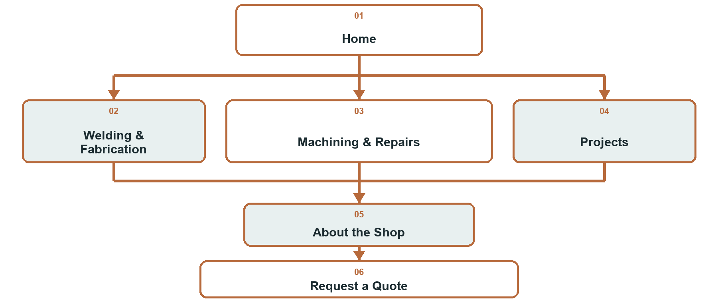

How to use this workbook
☐ Choose one audience and one main action for each page.
☐ Use project photos you have permission to publish.
☐ State capabilities precisely; publish certifications only when verified.
☐ Keep quote forms short and move drawings or sensitive details to a private follow-up.
☐ Test every page and primary action on desktop and mobile.
Explore Website Builder and compare plans
Open the Welding & Machine Shops guide

PAGE PLANNING

Home
Introduce the shop, its main work and its service area. Make Request a Quote the clearest next step.
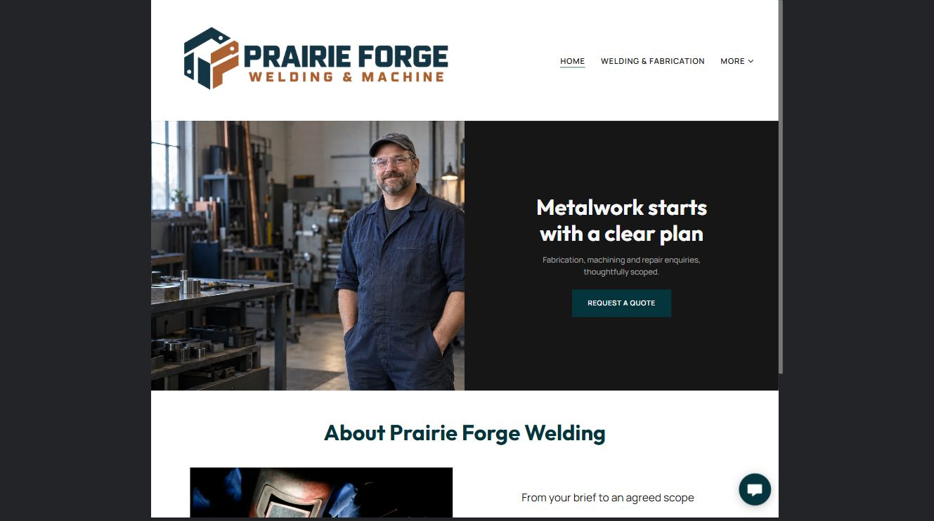

Clearly labelled sample wording
Prairie Forge Welding & Machine provides custom fabrication, machining and practical repair support for commercial, agricultural and community projects.

Write a short headline, proof point and primary action.

Photo, proof and link checklist

PAGE PLANNING

Welding & Fabrication
Explain materials, processes and project types. Help a customer decide whether the service fits before they enquire.
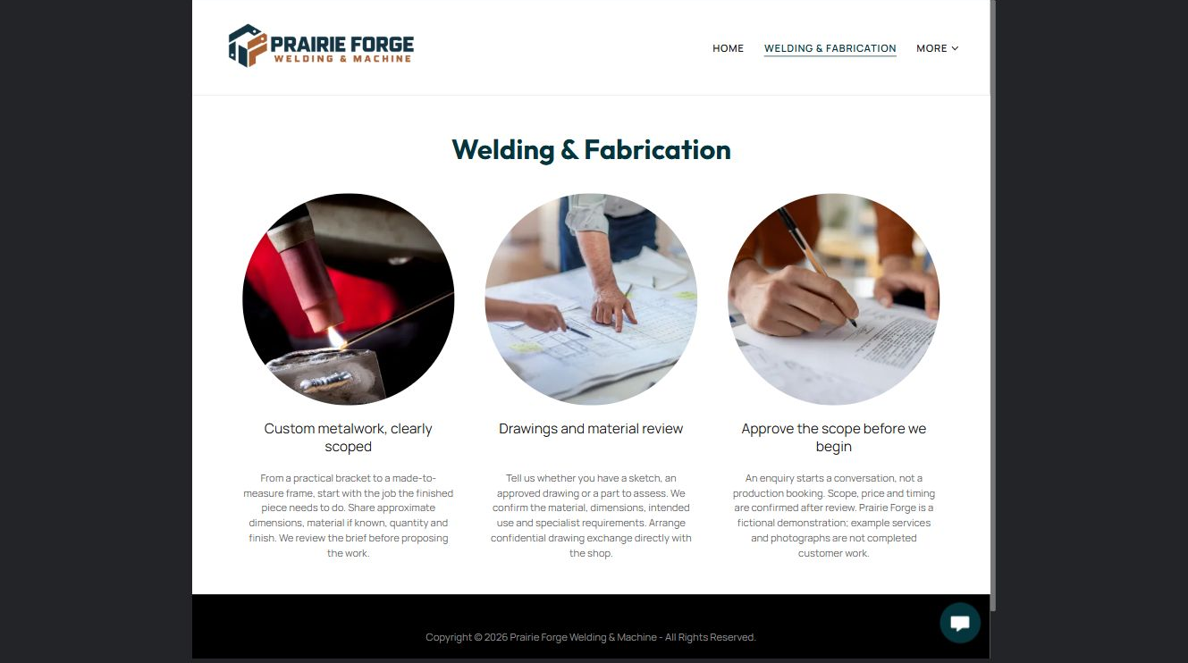

Clearly labelled sample wording
Share the intended use, approximate dimensions, material and finish. We will confirm what else is needed before preparing an estimate.

Draft your fabrication overview and the facts customers should provide.

Photo, proof and link checklist

PAGE PLANNING

Machining & Repairs
Separate machining, repair and inspection work. Explain the information needed to assess fit and timing.
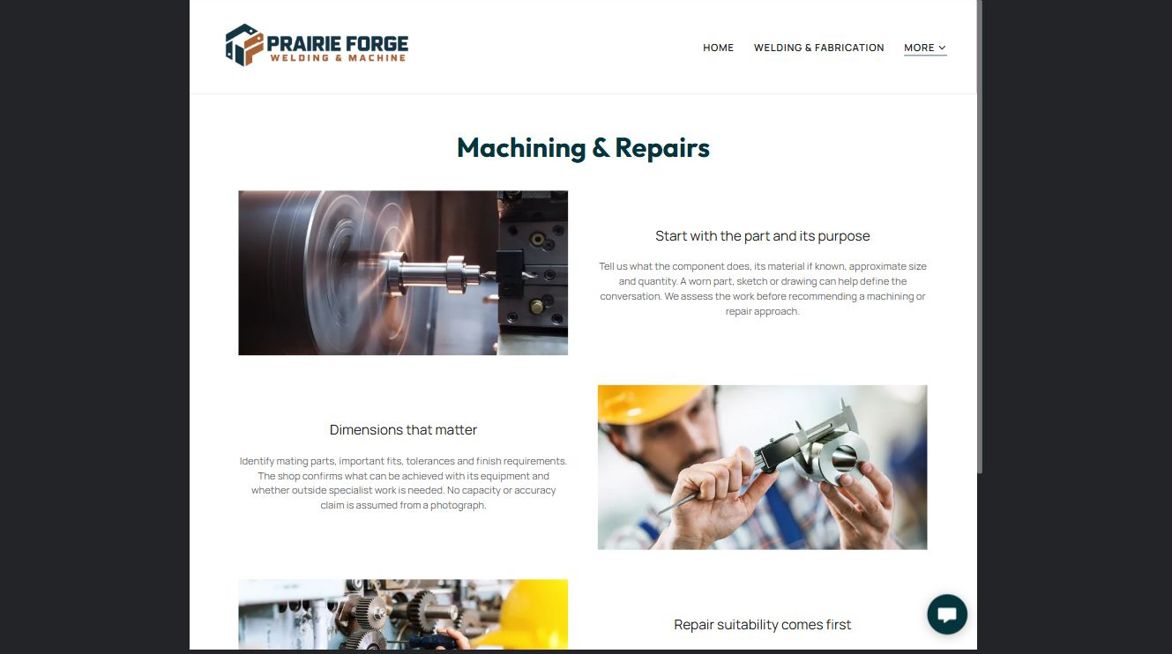

Clearly labelled sample wording
Bring the part, drawing or clear measurements when practical. We confirm scope, limitations and timing before work begins.

Describe the repair or machining journey in plain language.

Photo, proof and link checklist

PAGE PLANNING

Projects
Use varied, permission-cleared examples. Caption each project with the customer problem, process and result without exposing confidential details.
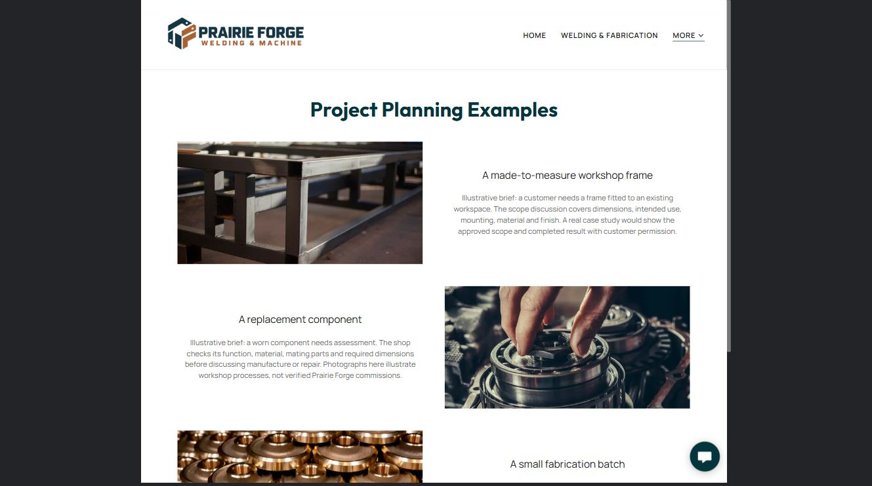

Clearly labelled sample wording
Representative example: a custom steel assembly planned around verified dimensions, material requirements and the customer’s intended use.

List three projects you can show and the proof each one provides.

Photo, proof and link checklist

PAGE PLANNING

About Shop
Introduce the people, experience, service area and working approach. Avoid unsupported certification or safety claims.
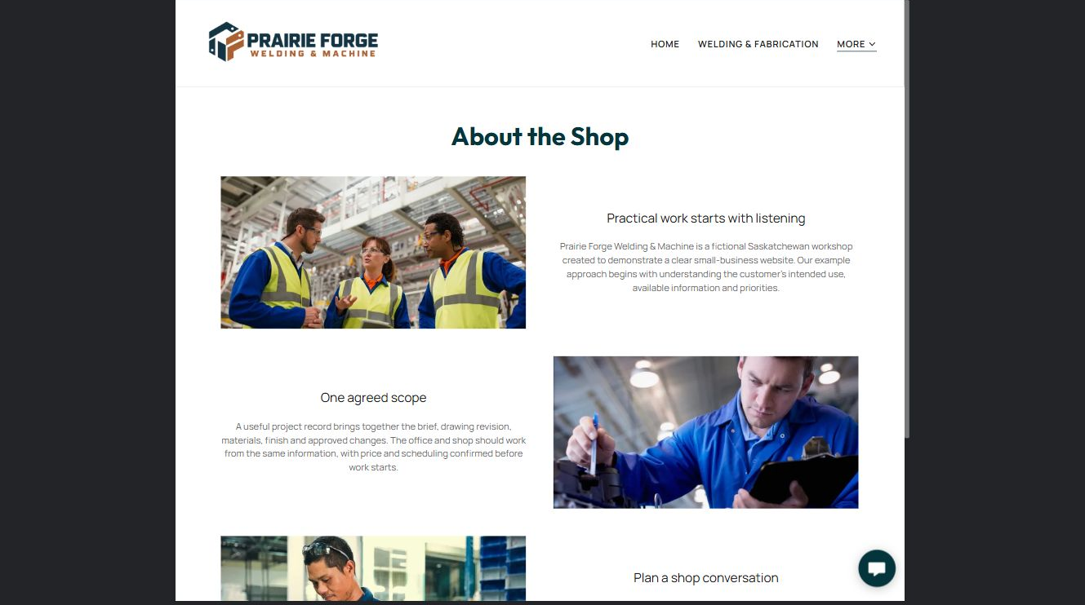

Clearly labelled sample wording
We start by understanding the job, confirming the information required and explaining the next step before committing to scope or timing.

Write the shop story and identify every fact that needs verification.

Photo, proof and link checklist

PAGE PLANNING

Request a Quote
Ask only for enough information to route the enquiry. Do not use a public form for controlled drawings, payment data or sensitive records.
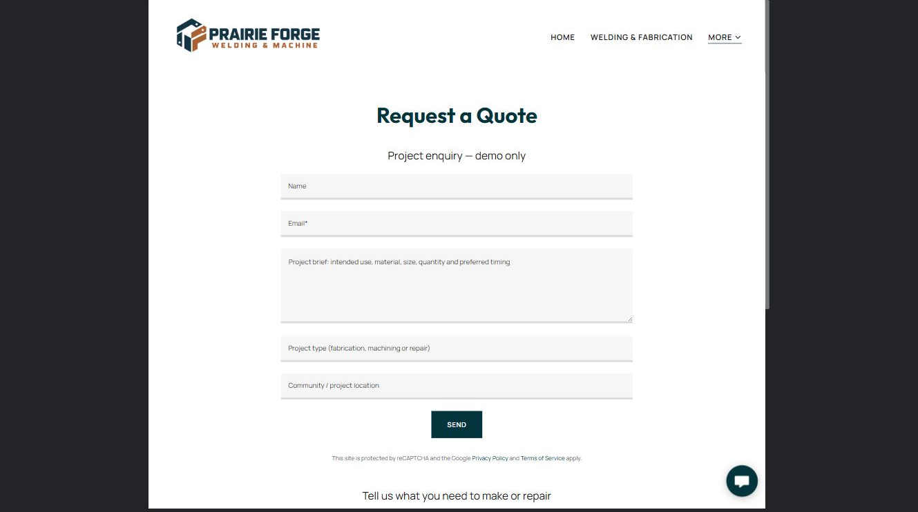

Clearly labelled sample wording
Tell us the project type, intended use, material, approximate size, quantity, location and preferred timing. We will follow up to confirm the details needed for an estimate.

Draft the form introduction, fields, privacy boundary and confirmation message.

Photo, proof and link checklist

FINAL REVIEW

Launch with the customer journey intact
Ask someone unfamiliar with the shop to complete the main journey on a phone and desktop before launch.
☐ Every page has one clear job and a useful next step.
☐ The logo is readable on light and dark backgrounds.
☐ Photos are distinct, relevant and permission-cleared.
☐ Capabilities, service area, hours and certifications are verified.
☐ Forms explain what happens next and avoid sensitive information.
☐ Desktop and mobile previews are checked.
☐ A clearly named final backup is saved.
☐ An owner and review date are assigned for future updates.

Changes found during review

Content owner and next review date

