
WEBSITE PLANNING WORKSHOP

Web Designers
Website workbook
Plan a clear website for web designers. Explore a worked example, shape your own message and prepare to build with SaaSTech Servers.
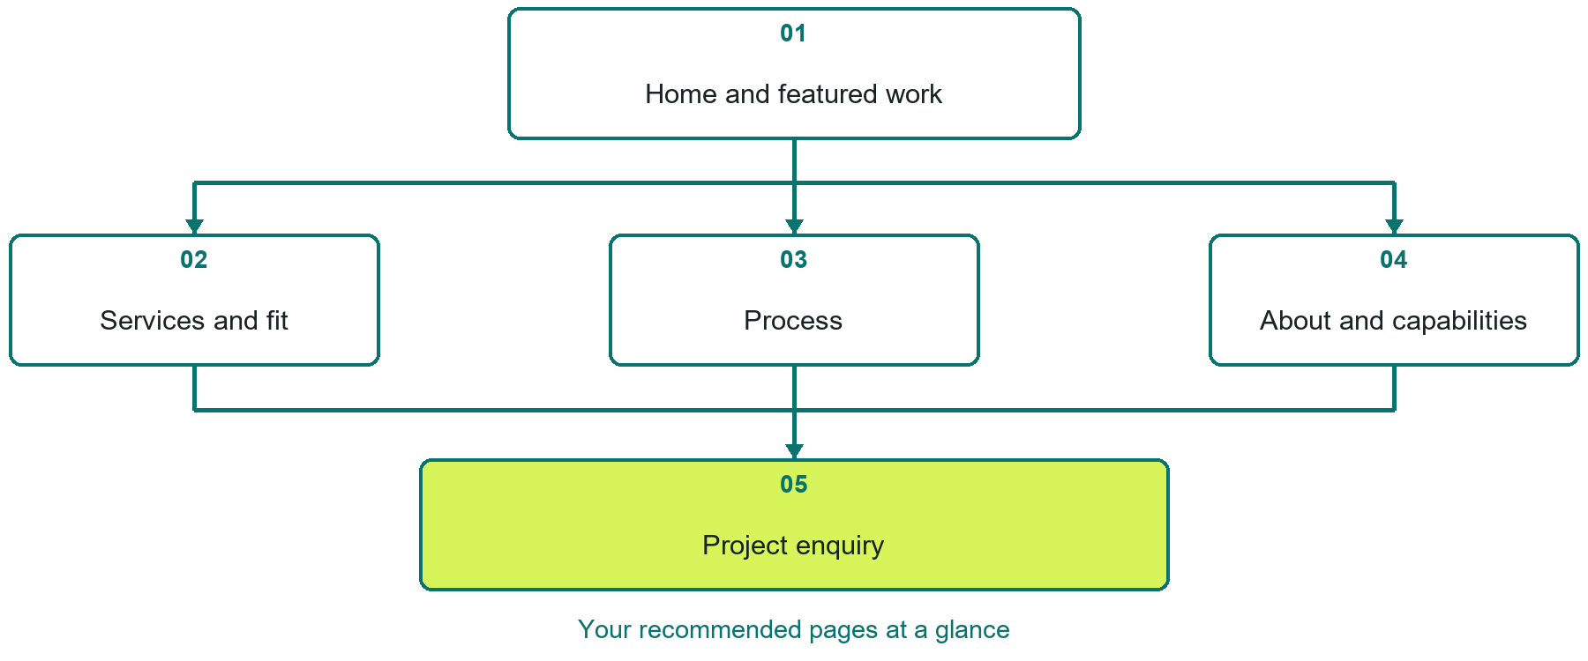

Inside this workbook
Five page examples • Practical writing exercises • A launch review
Use it in a workshop or at your own pace. Write by hand or complete the response fields in Word. The final page links to Website Builder, plans and account signup.
Example business Northline Web Studio

WEB DESIGNERS

Your website brief
A SaaSTech Servers workshop for web designers. Plan your website, learn from the Northline Web Studio example and draft content for your own business.
Each page has a reference sheet followed by a writing sheet. Demo excerpts are labelled separately from new sample wording, which may differ from the screenshot. Click a blank response line to type; longer answers may add pages. Replace fictional details and verify every claim before publishing.
Your business or organization and workshop date

Who should visit your site and what do they need

The main action you want a visitor to take

What you offer and where or how you provide it

Facts photos and permissions to gather before publishing

Workshop rhythm: review the example, write your draft and exchange feedback. Use the final review to choose your next changes. Website Builder and account links are on the last page.

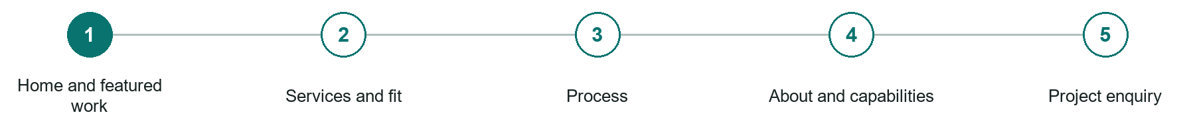
LOOK AND LEARN

Home and featured work

The job of this page
Introduce the studio, explain the strongest client fit, feature selected work with permission, and lead into a clear project conversation.
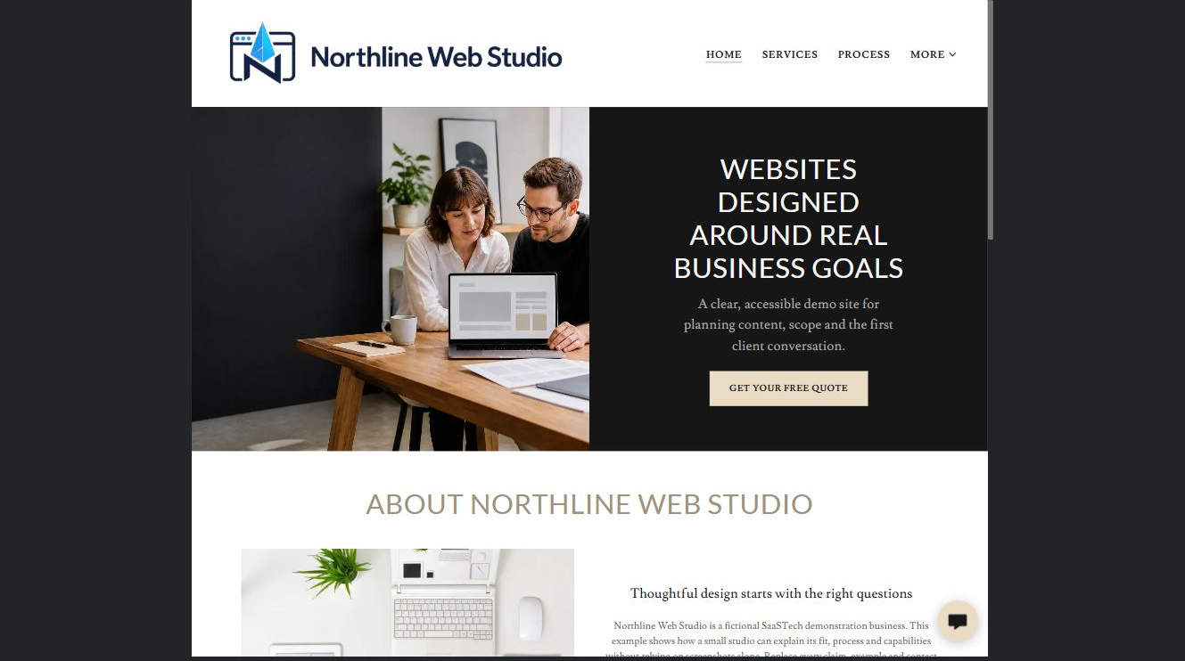
Northline Web Studio example | Explore SaaSTech Website Builder

Sample wording to adapt
A website planned around what visitors need
Explore the work and the kinds of projects we support. Start with your goals, audience and existing site. We will discuss scope before suggesting a project approach.

Pause and plan
Could a first-time visitor explain what you do and who it is for after one glance? Choose one main action and the strongest truthful detail that gives them confidence to continue.

WRITE YOUR PAGE

Home and featured work
Write for your visitor. Be specific about what they need to know and what happens next. You can revise the wording after the workshop.
Your page headline

Your opening paragraph

Your offer audience location and most useful supporting details

Button or link wording and where it should lead

Photo idea caption and permission or credit needed

Facts to verify or questions to resolve

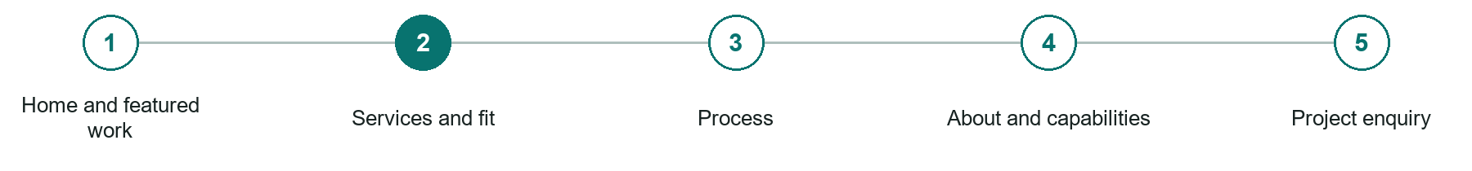
LOOK AND LEARN

Services and fit

The job of this page
Define strategy, design, development, content, ecommerce, maintenance, accessibility, and the projects accepted.
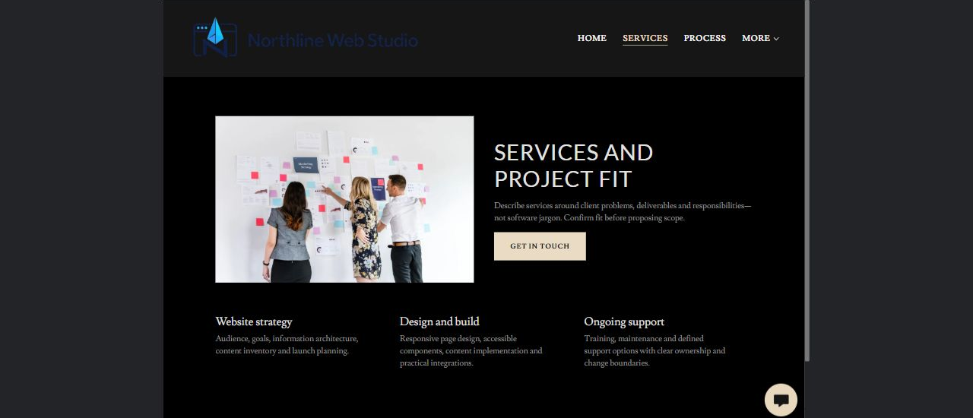
Northline Web Studio example | Explore SaaSTech Website Builder

Sample wording to adapt
Choose the support your website needs
Discuss a new site, a focused refresh or ongoing improvements. Agree the pages, content responsibilities and functionality before quoting. External services and ongoing fees should be identified separately.

Pause and plan
Who is each option for, what does it include and where are its limits? Describe the information needed to check fit. Make the next step clear without promising an outcome before assessment.

WRITE YOUR PAGE

Services and fit
Write for your visitor. Be specific about what they need to know and what happens next. You can revise the wording after the workshop.
Your page headline

Your opening paragraph

Service options who they suit and what each includes

Button or link wording and where it should lead

Photo idea caption and permission or credit needed

Facts to verify or questions to resolve

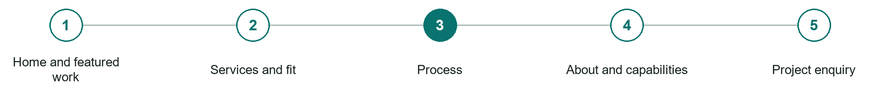
LOOK AND LEARN

Process

The job of this page
Explain discovery, content, approvals, design, build, testing, launch, training, ownership, and support.
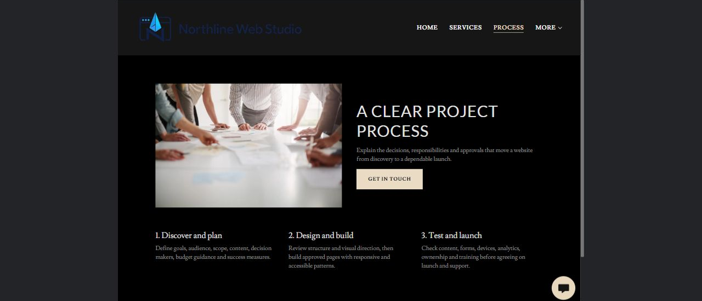
Northline Web Studio example | Explore SaaSTech Website Builder

Sample wording to adapt
From brief to launch
Clarify the goals, agree the structure and prepare the content. Review the build together, test the important tasks and confirm the handover. Changes outside the agreed scope are discussed before work proceeds.

Pause and plan
What question brings a visitor to this page? List the details they need, the evidence you can provide and the next useful action. Remove content that does not help them decide or proceed.

WRITE YOUR PAGE

Process
Write for your visitor. Be specific about what they need to know and what happens next. You can revise the wording after the workshop.
Your page headline

Your opening paragraph

Key sections visitor questions and supporting details

Button or link wording and where it should lead

Photo idea caption and permission or credit needed

Facts to verify or questions to resolve

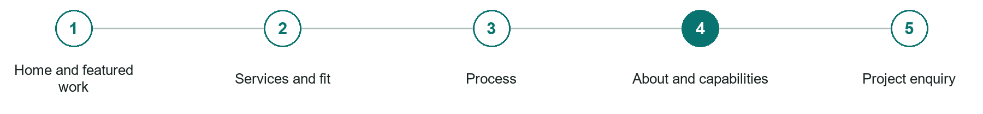
LOOK AND LEARN

About and capabilities

The job of this page
Connect relevant experience, collaborators, platforms, working style, and accessibility standards to client needs.
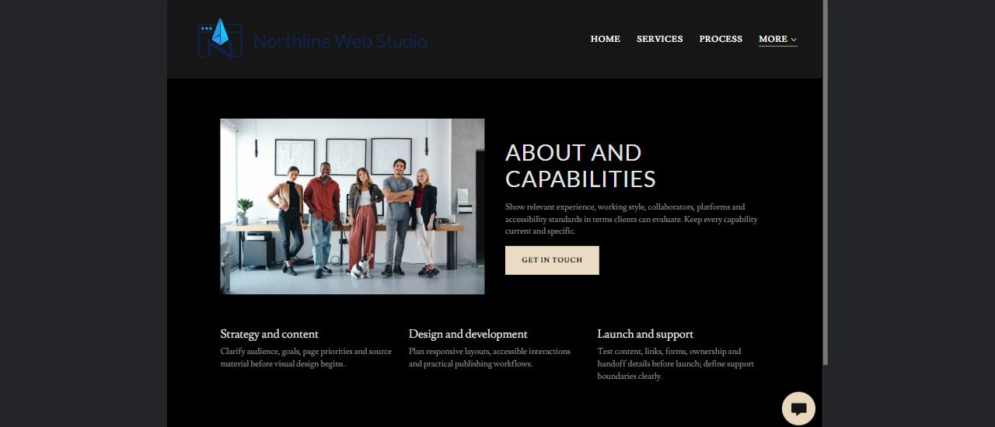
Northline Web Studio example | Explore SaaSTech Website Builder

Sample wording to adapt
Know who is building your site
Ask about the team's relevant work, technical approach and communication process. Confirm ownership, access and support arrangements. Case studies should identify the actual contribution made.

Pause and plan
Which names, roles and qualifications can you verify? What would help a visitor feel comfortable contacting you? Obtain permission for portraits and describe actual experience without unsupported claims.

WRITE YOUR PAGE

About and capabilities
Write for your visitor. Be specific about what they need to know and what happens next. You can revise the wording after the workshop.
Your page headline

Your opening paragraph

People roles approach and verified credentials to introduce

Button or link wording and where it should lead

Photo idea caption and permission or credit needed

Facts to verify or questions to resolve

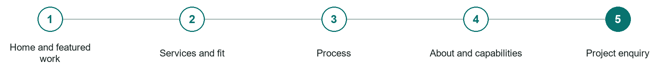
LOOK AND LEARN

Project enquiry

The job of this page
Ask for goals, audience, existing site, features, content readiness, timing, budget guidance, and decision process.
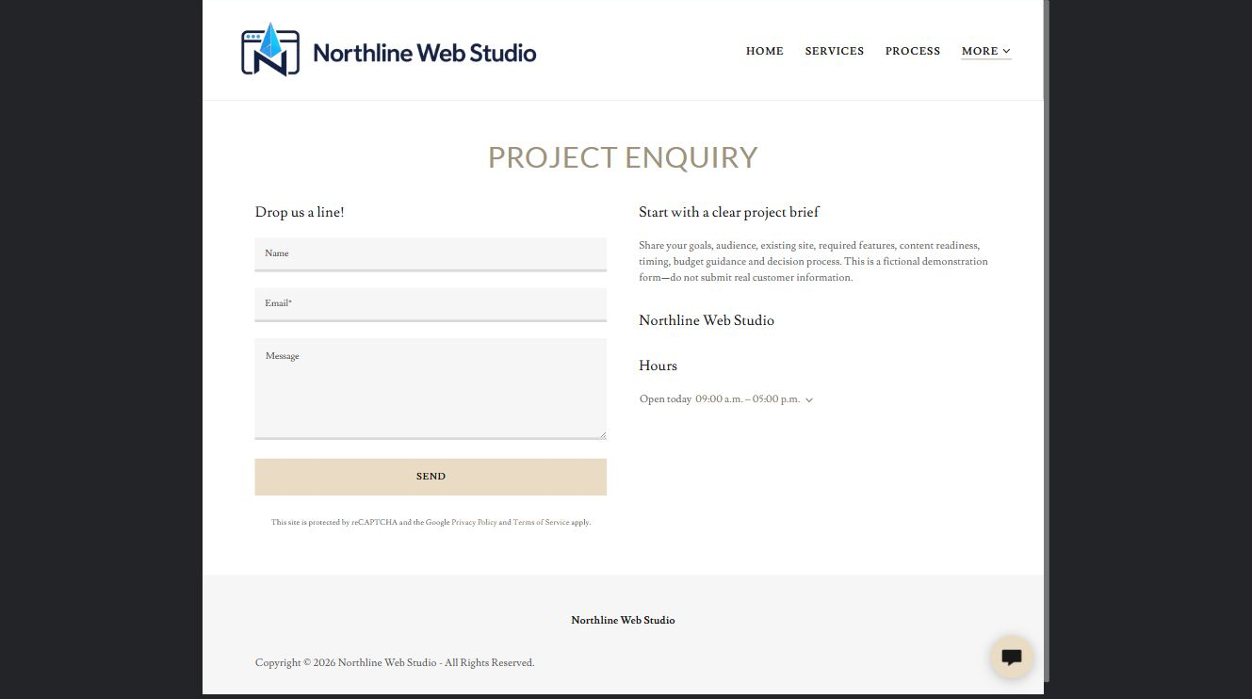
Northline Web Studio example | Explore SaaSTech Website Builder

Sample wording to adapt
Tell us what the site needs to do
Share your audience, goals, existing website and approximate timing. Mention required pages or functions. Do not send passwords through the form; access can be arranged securely later.

Pause and plan
What must someone provide, and what happens after they send it? Separate a request from a confirmed booking, order or place. Decide what information should stay out of a public form.

WRITE YOUR PAGE

Project enquiry
Write for your visitor. Be specific about what they need to know and what happens next. You can revise the wording after the workshop.
Your page headline

Your opening paragraph

Information to request and how you will reply or confirm

Button or link wording and where it should lead

Photo idea caption and permission or credit needed

Facts to verify or questions to resolve

WORKSHOP CLOSE

Review and next steps
Ask a partner to read your draft as a first-time visitor. Can they explain what you offer, who it is for and the next step without extra help?

Before you publish
[ ] Every page has a clear purpose and a useful next step.
[ ] Headlines are specific and the wording sounds like your business.
[ ] Names, service areas, prices, dates and policies have been checked.
[ ] Credentials, testimonials and results are genuine and permission-cleared.
[ ] Photos support the text, do not repeat needlessly and have appropriate permissions.
[ ] Forms ask only for necessary information and explain what happens next.
[ ] Links, downloads and the main visitor task work on a phone.
The most useful feedback from your workshop partner

First change to make and who will do it

Information or photographs still needed

Target review date and who will approve the final content

Keep sensitive customer, patient, employee and payment information out of this workbook. Completing it does not publish a website or connect to Website Builder.

BUILD WITH SAASTECH SERVERS

Put your draft into Website Builder
Use the content you have written to build your own site. Keep the web designers demo as a reference, and replace its company name, images and claims with your verified business information.

Explore the builder
See the editor, compare available plans and decide which features your business needs. Confirm current pricing and terms before purchasing.
Website Builder overview

Create your account
Set up your SaaSTech Servers customer account using your own details. Creating an account is separate from purchasing a Website Builder plan.
Create your SaaSTech account

Choose your plan
Open the secure shop to review the plan, subscription term and final total. Use the account connected to your purchase when you open your service.
View Website Builder plans

Build and check your pages
Add the pages from this workbook. Transfer your approved wording, upload permission-cleared photos and review each page on desktop and mobile before publishing.
Return to the Website Builder guide

Using a printed workbook
Type these short addresses into your browser. The account guide includes the Create My Account button.
www.saastech.net/products/website-builder
www.saastech.net/create-account
This workbook does not create an account, purchase a plan or publish your website. Keep passwords, payment details and confidential customer information out of your draft.

