
WEBSITE PLANNING WORKSHOP

Comedians, Magicians & Variety Entertainers
Website workbook
Plan a clear website for comedians, magicians & variety entertainers. Explore a worked example, shape your own message and prepare to build with SaaSTech Servers.
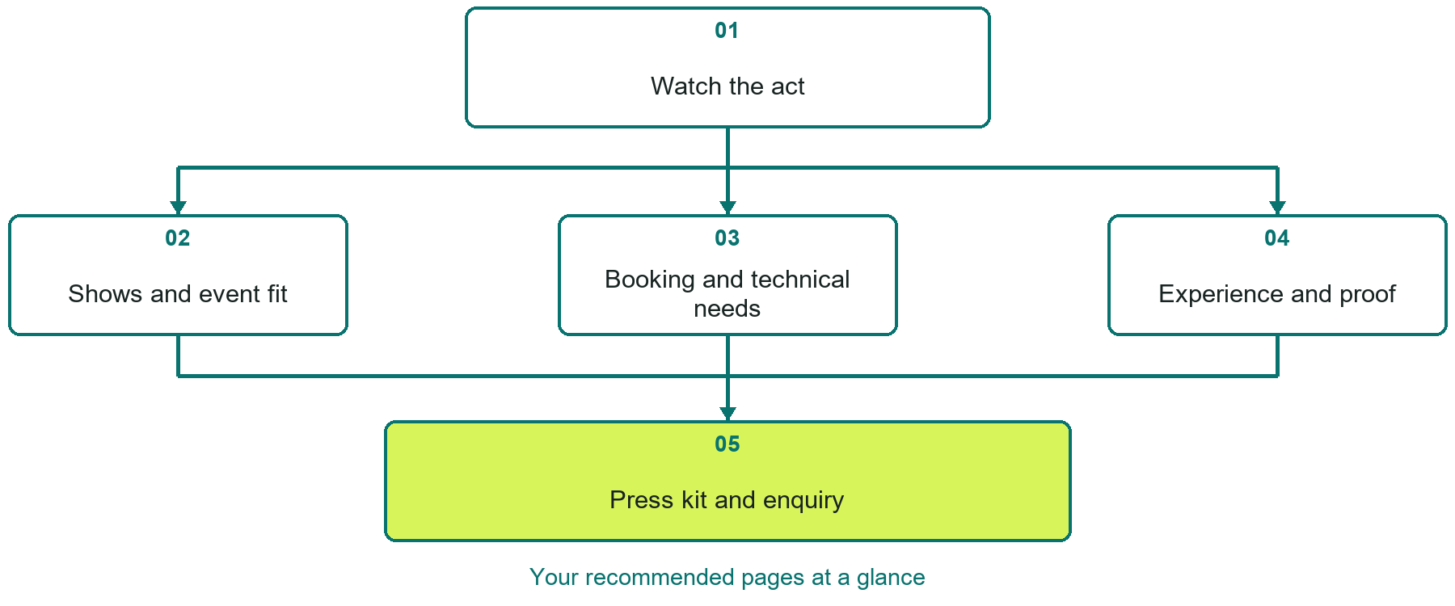

Inside this workbook
Five page examples • Practical writing exercises • A launch review
Use it in a workshop or at your own pace. Write by hand or complete the response fields in Word. The final page links to Website Builder, plans and account signup.
Example business Prairie Spotlight Live

COMEDIANS, MAGICIANS & VARIETY ENTERTAINERS

Your website brief
A SaaSTech Servers workshop for comedians, magicians & variety entertainers. Plan your website, learn from the Prairie Spotlight Live example and draft content for your own business.
Each page has a reference sheet followed by a writing sheet. Demo excerpts are labelled separately from new sample wording, which may differ from the screenshot. Click a blank response line to type; longer answers may add pages. Replace fictional details and verify every claim before publishing.
Your business or organization and workshop date

Who should visit your site and what do they need

The main action you want a visitor to take

What you offer and where or how you provide it

Facts photos and permissions to gather before publishing

Workshop rhythm: review the example, write your draft and exchange feedback. Use the final review to choose your next changes. Website Builder and account links are on the last page.

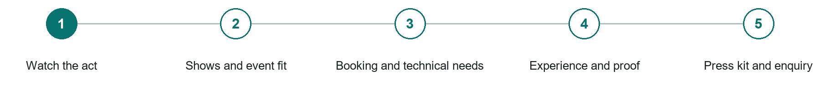
LOOK AND LEARN

Watch the act

The job of this page
Lead with short representative clips organized by show type, audience, or event setting, with captions and enough context to judge fit.

Prairie Spotlight Live example | Explore SaaSTech Website Builder

Sample wording to adapt
See whether the act fits your event
Watch the performance sample and read the audience and venue guidance. Ask about the format and availability before making plans. A video alone does not confirm suitability for every setting.

Pause and plan
What question brings a visitor to this page? List the details they need, the evidence you can provide and the next useful action. Remove content that does not help them decide or proceed.

WRITE YOUR PAGE

Watch the act
Write for your visitor. Be specific about what they need to know and what happens next. You can revise the wording after the workshop.
Your page headline

Your opening paragraph

Key sections visitor questions and supporting details

Button or link wording and where it should lead

Photo idea caption and permission or credit needed

Facts to verify or questions to resolve

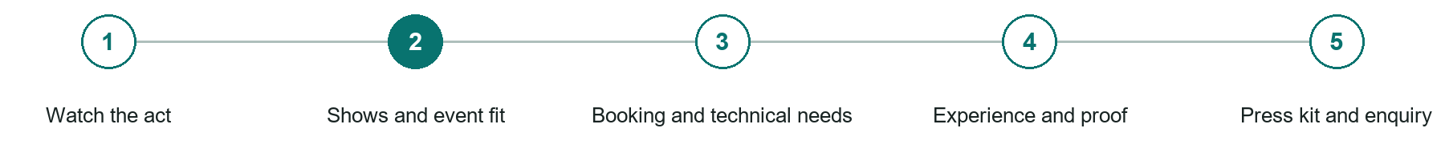
LOOK AND LEARN

Shows and event fit

The job of this page
Explain available formats, duration, audience age, language, tone, participation, venue size, virtual options, and events the act suits best.
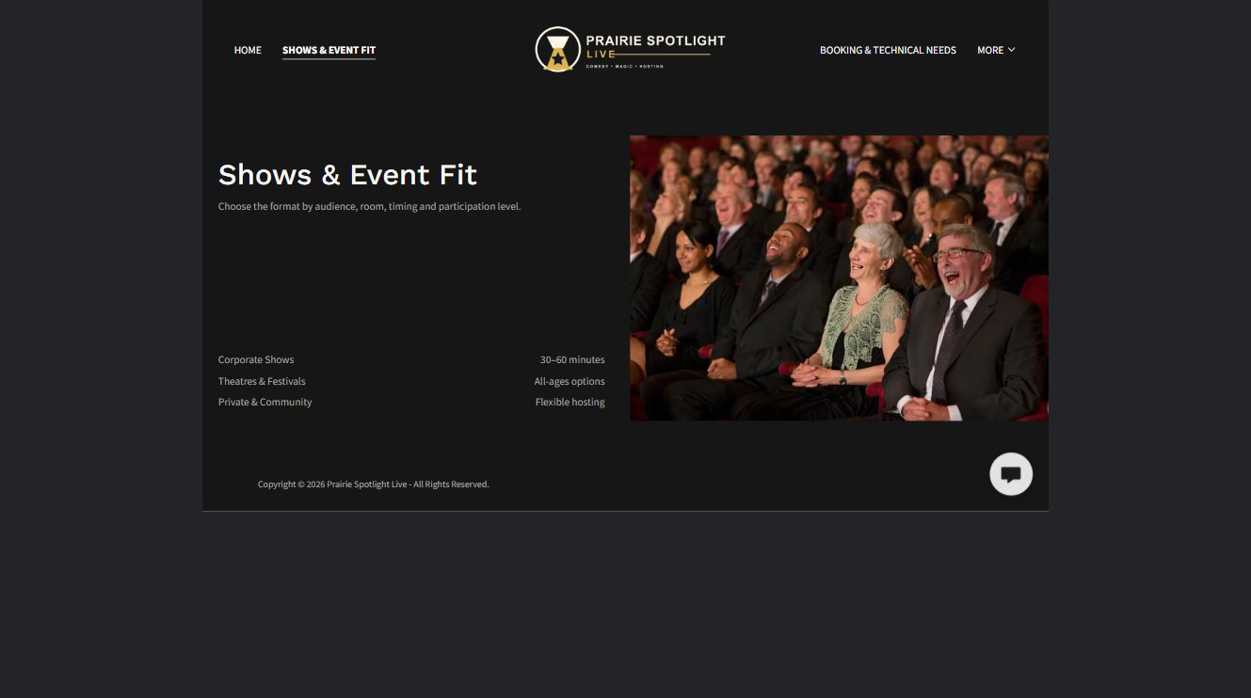
Prairie Spotlight Live example | Explore SaaSTech Website Builder

Sample wording to adapt
Choose the right show format
Tell us the audience, occasion and approximate guest count. Discuss performance length, participation and any venue restrictions. The performer will confirm the appropriate format before booking.

Pause and plan
Which dates and locations need to stay current? Decide who will update changes and where visitors should check before travelling. Separate archived information and illustrative schedules from current availability.

WRITE YOUR PAGE

Shows and event fit
Write for your visitor. Be specific about what they need to know and what happens next. You can revise the wording after the workshop.
Your page headline

Your opening paragraph

Dates locations update process and participation details

Button or link wording and where it should lead

Photo idea caption and permission or credit needed

Facts to verify or questions to resolve

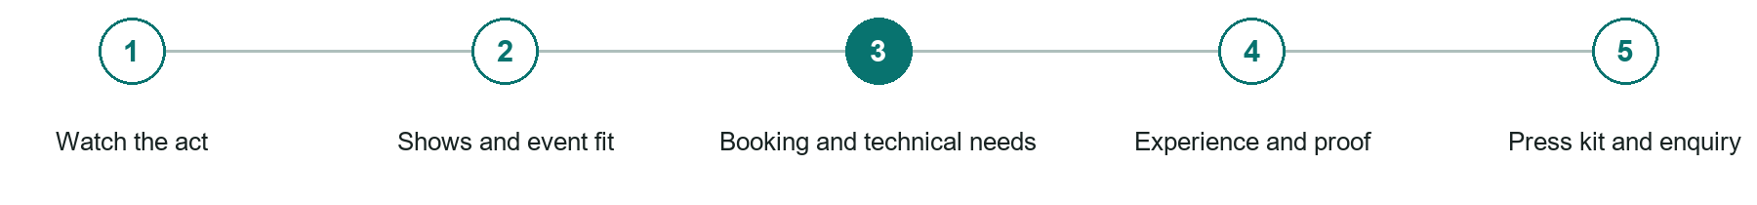
LOOK AND LEARN

Booking and technical needs

The job of this page
Publish service area, travel, availability process, fee or starting guidance, deposits, cancellation terms, stage, sound, lighting, setup, and accessibility needs.
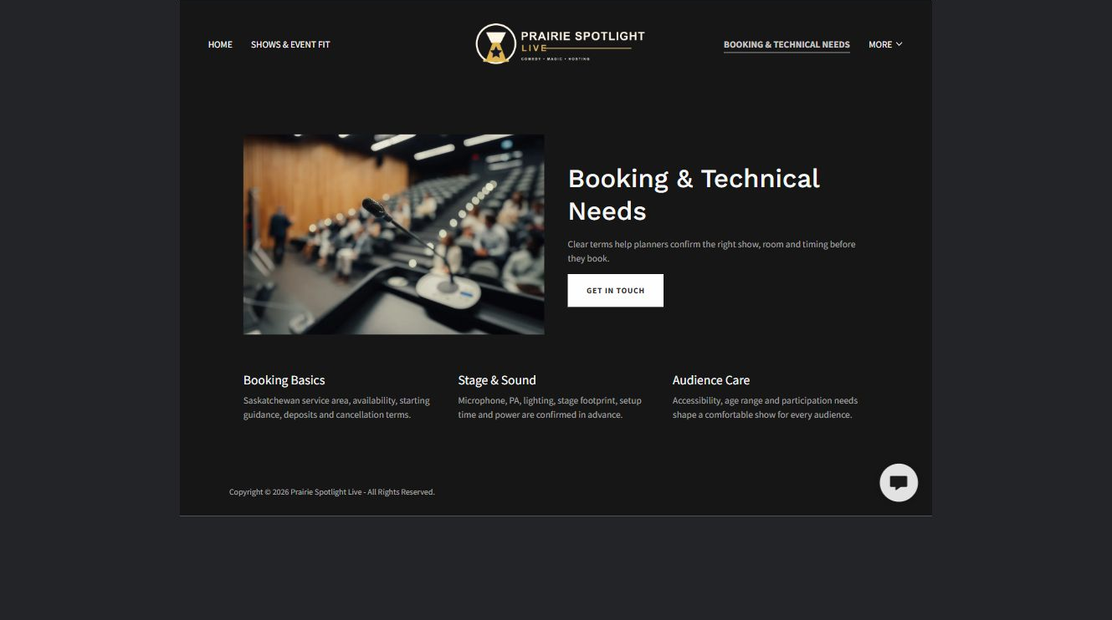
Prairie Spotlight Live example | Explore SaaSTech Website Builder

Sample wording to adapt
Share the venue requirements early
Include the space, timing, access and sound arrangements. Ask about setup and weather alternatives for outdoor events. Responsibilities and technical needs should be agreed before the date is confirmed.

Pause and plan
What must someone provide, and what happens after they send it? Separate a request from a confirmed booking, order or place. Decide what information should stay out of a public form.

WRITE YOUR PAGE

Booking and technical needs
Write for your visitor. Be specific about what they need to know and what happens next. You can revise the wording after the workshop.
Your page headline

Your opening paragraph

Information to request and how you will reply or confirm

Button or link wording and where it should lead

Photo idea caption and permission or credit needed

Facts to verify or questions to resolve

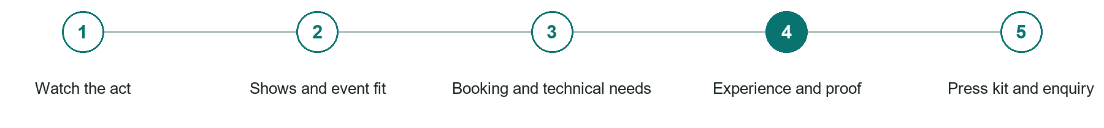
LOOK AND LEARN

Experience and proof

The job of this page
Present an accurate biography, notable work, client or venue testimonials, awards, media, insurance where relevant, and permission-based event photographs.
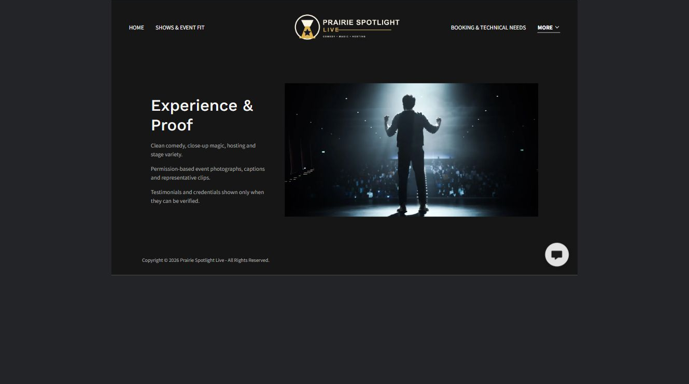
Prairie Spotlight Live example | Explore SaaSTech Website Builder

Sample wording to adapt
Experience you can check
Read permission-based event examples and verified feedback. Captions should identify what the performer actually provided. This fictional demonstration does not claim real clients or awards.

Pause and plan
Which examples best support this page? Explain the context, your contribution and the permissions or credits needed. Label illustrative work and distinguish it from genuine completed projects or customer results.

WRITE YOUR PAGE

Experience and proof
Write for your visitor. Be specific about what they need to know and what happens next. You can revise the wording after the workshop.
Your page headline

Your opening paragraph

Examples captions context and evidence to include

Button or link wording and where it should lead

Photo idea caption and permission or credit needed

Facts to verify or questions to resolve

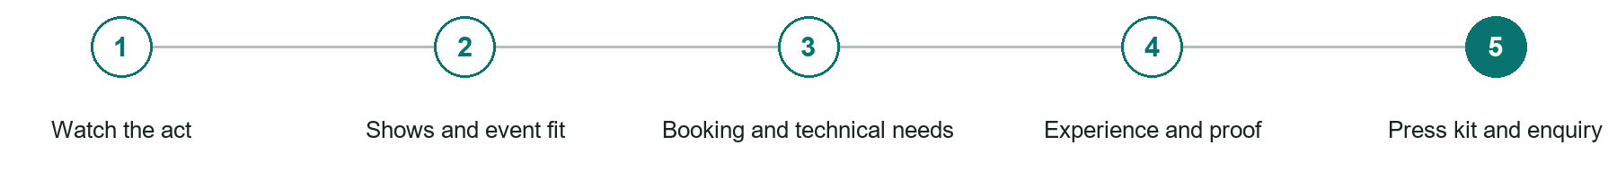
LOOK AND LEARN

Press kit and enquiry

The job of this page
Provide approved biographies, photographs, technical documents, social links, contact details, and a form that collects the date, venue, audience, format, and budget guidance.
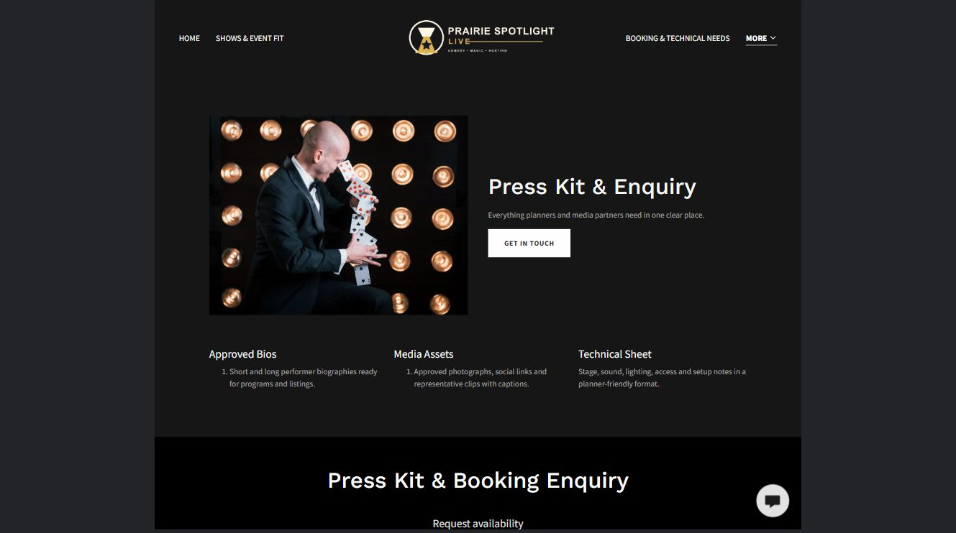
Prairie Spotlight Live example | Explore SaaSTech Website Builder

Sample wording to adapt
Start a booking enquiry
Send the event date, venue, audience and format you are considering. Ask for current press materials if needed. A request does not reserve the act or confirm a performance.

Pause and plan
What must someone provide, and what happens after they send it? Separate a request from a confirmed booking, order or place. Decide what information should stay out of a public form.

WRITE YOUR PAGE

Press kit and enquiry
Write for your visitor. Be specific about what they need to know and what happens next. You can revise the wording after the workshop.
Your page headline

Your opening paragraph

Information to request and how you will reply or confirm

Button or link wording and where it should lead

Photo idea caption and permission or credit needed

Facts to verify or questions to resolve

WORKSHOP CLOSE

Review and next steps
Ask a partner to read your draft as a first-time visitor. Can they explain what you offer, who it is for and the next step without extra help?

Before you publish
[ ] Every page has a clear purpose and a useful next step.
[ ] Headlines are specific and the wording sounds like your business.
[ ] Names, service areas, prices, dates and policies have been checked.
[ ] Credentials, testimonials and results are genuine and permission-cleared.
[ ] Photos support the text, do not repeat needlessly and have appropriate permissions.
[ ] Forms ask only for necessary information and explain what happens next.
[ ] Links, downloads and the main visitor task work on a phone.
The most useful feedback from your workshop partner

First change to make and who will do it

Information or photographs still needed

Target review date and who will approve the final content

Keep sensitive customer, patient, employee and payment information out of this workbook. Completing it does not publish a website or connect to Website Builder.

BUILD WITH SAASTECH SERVERS

Put your draft into Website Builder
Use the content you have written to build your own site. Keep the comedians, magicians & variety entertainers demo as a reference, and replace its company name, images and claims with your verified business information.

Explore the builder
See the editor, compare available plans and decide which features your business needs. Confirm current pricing and terms before purchasing.
Website Builder overview

Create your account
Set up your SaaSTech Servers customer account using your own details. Creating an account is separate from purchasing a Website Builder plan.
Create your SaaSTech account

Choose your plan
Open the secure shop to review the plan, subscription term and final total. Use the account connected to your purchase when you open your service.
View Website Builder plans

Build and check your pages
Add the pages from this workbook. Transfer your approved wording, upload permission-cleared photos and review each page on desktop and mobile before publishing.
Return to the Website Builder guide

Using a printed workbook
Type these short addresses into your browser. The account guide includes the Create My Account button.
www.saastech.net/products/website-builder
www.saastech.net/create-account
This workbook does not create an account, purchase a plan or publish your website. Keep passwords, payment details and confidential customer information out of your draft.

