
WEBSITE PLANNING WORKSHOP

Travel Agencies & Trip Planners
Website workbook
Plan a clear website for travel agencies & trip planners. Explore a worked example, shape your own message and prepare to build with SaaSTech Servers.
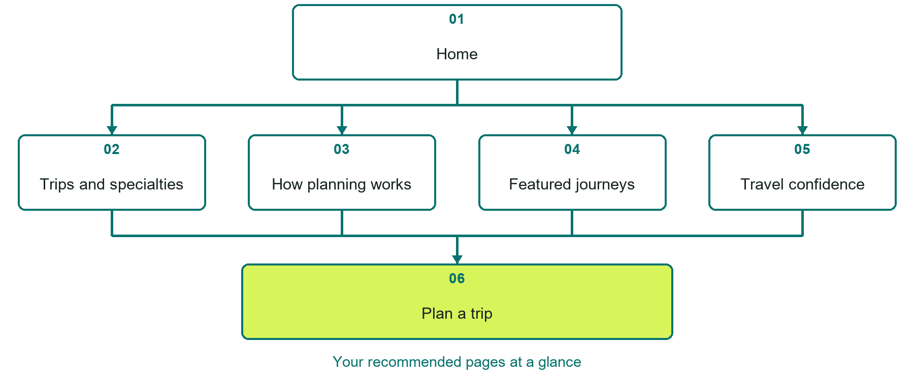

Inside this workbook
Six page examples • Practical writing exercises • A launch review
Use it in a workshop or at your own pace. Write by hand or complete the response fields in Word. The final page links to Website Builder, plans and account signup.
Example business Prairie Passage Travel

TRAVEL AGENCIES & TRIP PLANNERS

Your website brief
A SaaSTech Servers workshop for travel agencies & trip planners. Plan your website, learn from the Prairie Passage Travel example and draft content for your own business.
Each page has a reference sheet followed by a writing sheet. Demo excerpts are labelled separately from new sample wording, which may differ from the screenshot. Click a blank response line to type; longer answers may add pages. Replace fictional details and verify every claim before publishing.
Your business or organization and workshop date

Who should visit your site and what do they need

The main action you want a visitor to take

What you offer and where or how you provide it

Facts photos and permissions to gather before publishing

Workshop rhythm: review the example, write your draft and exchange feedback. Use the final review to choose your next changes. Website Builder and account links are on the last page.

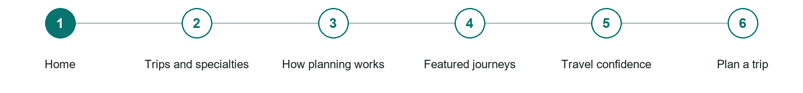
LOOK AND LEARN

Home

The job of this page
Introduce the agency, the travellers it serves, its planning approach, and the clearest next step with a coordinated logo, hero image, and consultation action.

Prairie Passage Travel example | Explore SaaSTech Website Builder

Sample wording to adapt
Plan a trip around what matters to you
Explore the travel specialties and planning process. Share your interests, approximate dates and starting point. Availability, pricing and booking conditions are confirmed with the relevant providers.

Pause and plan
Could a first-time visitor explain what you do and who it is for after one glance? Choose one main action and the strongest truthful detail that gives them confidence to continue.

WRITE YOUR PAGE

Home
Write for your visitor. Be specific about what they need to know and what happens next. You can revise the wording after the workshop.
Your page headline

Your opening paragraph

Your offer audience location and most useful supporting details

Button or link wording and where it should lead

Photo idea caption and permission or credit needed

Facts to verify or questions to resolve

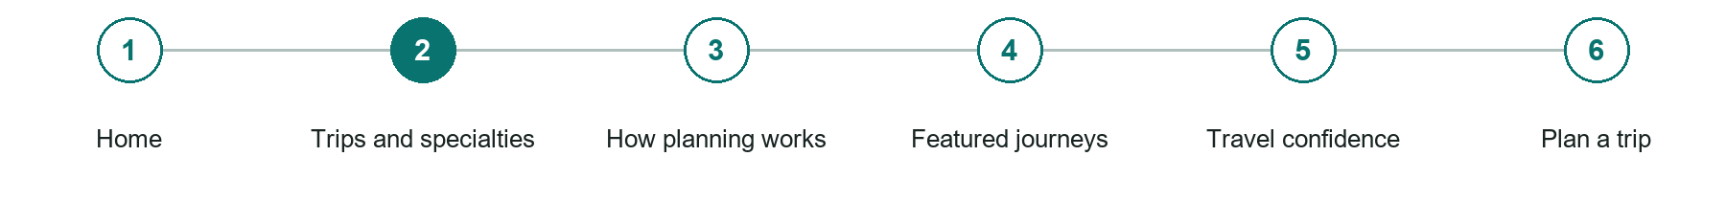
LOOK AND LEARN

Trips and specialties

The job of this page
Explain destinations, trip styles, traveller groups, departure regions, budget ranges, accessibility experience, and the planning work accepted.
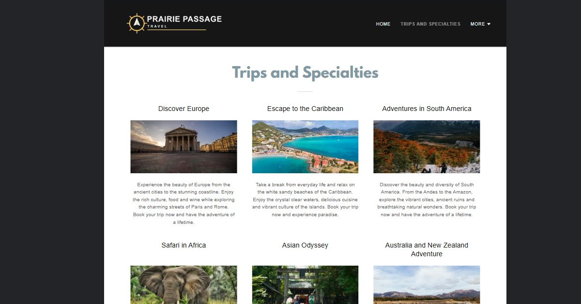
Prairie Passage Travel example | Explore SaaSTech Website Builder

Sample wording to adapt
Find a travel style that fits
Compare the types of journeys and support available. Describe the pace, interests and practical needs of your group. A featured itinerary is an idea to discuss, not a confirmed departure.

Pause and plan
What should someone know before arriving or proceeding? Clarify preparation, access and the right contact route. Verify policies and avoid promising urgent help or specialist advice the website cannot provide.

WRITE YOUR PAGE

Trips and specialties
Write for your visitor. Be specific about what they need to know and what happens next. You can revise the wording after the workshop.
Your page headline

Your opening paragraph

Preparation access policies and practical questions to answer

Button or link wording and where it should lead

Photo idea caption and permission or credit needed

Facts to verify or questions to resolve

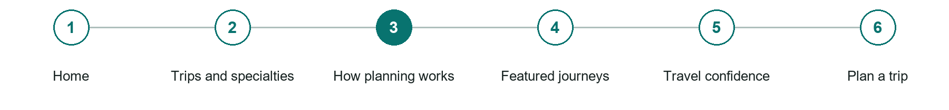
LOOK AND LEARN

How planning works

The job of this page
Describe consultation, research, proposals, planning fees, approvals, supplier booking, payments, documents, changes, and travel-day support.
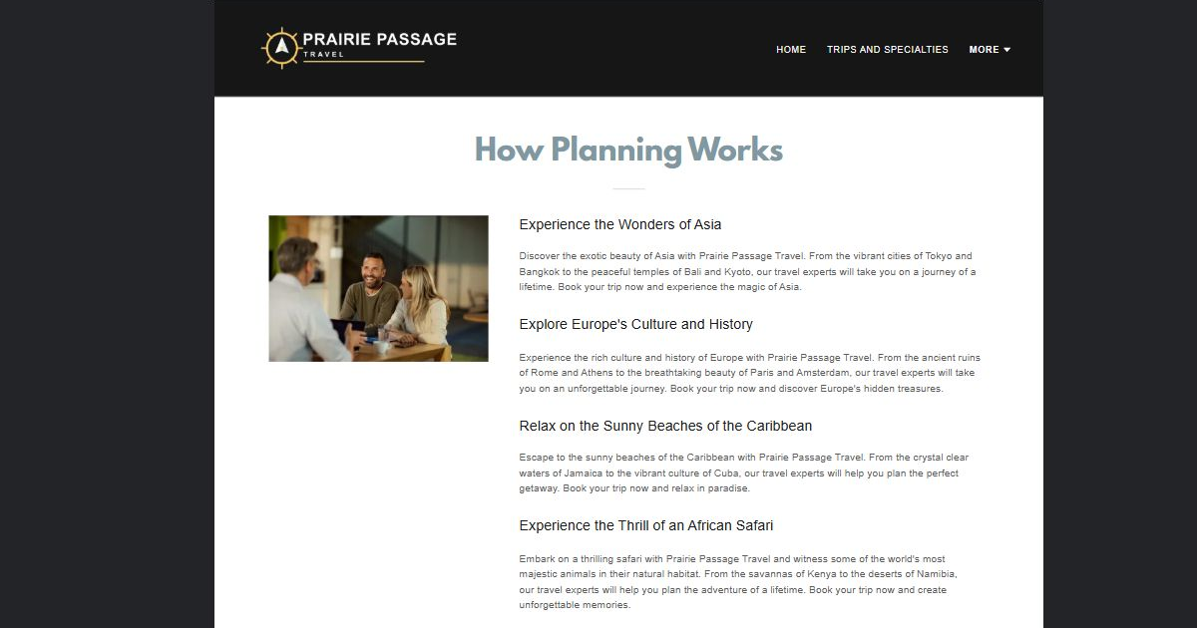
Prairie Passage Travel example | Explore SaaSTech Website Builder

Sample wording to adapt
From enquiry to an agreed itinerary
Begin with your interests and constraints, then review the proposed arrangements. Check inclusions, provider terms and payment deadlines before confirming. Changes may affect availability and price.

Pause and plan
What question brings a visitor to this page? List the details they need, the evidence you can provide and the next useful action. Remove content that does not help them decide or proceed.

WRITE YOUR PAGE

How planning works
Write for your visitor. Be specific about what they need to know and what happens next. You can revise the wording after the workshop.
Your page headline

Your opening paragraph

Key sections visitor questions and supporting details

Button or link wording and where it should lead

Photo idea caption and permission or credit needed

Facts to verify or questions to resolve

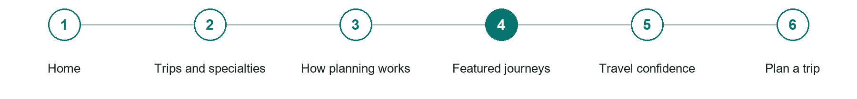
LOOK AND LEARN

Featured journeys

The job of this page
Use permission-based examples and practical itineraries to show pacing, season, transportation, accommodations, experiences, and who each journey suits.
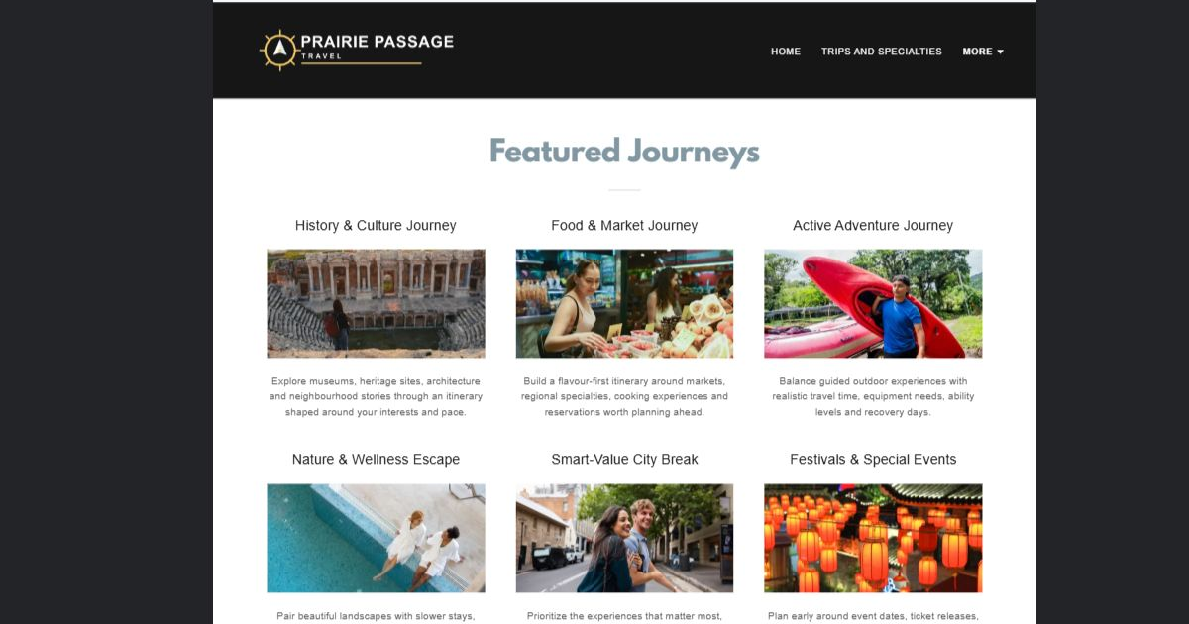
Prairie Passage Travel example | Explore SaaSTech Website Builder

Sample wording to adapt
Use these journeys as inspiration
Look at the route, pace and experiences rather than assuming fixed availability. Ask for current details and a proposal for your dates. Illustrative photographs do not establish a bookable package.

Pause and plan
What question brings a visitor to this page? List the details they need, the evidence you can provide and the next useful action. Remove content that does not help them decide or proceed.

WRITE YOUR PAGE

Featured journeys
Write for your visitor. Be specific about what they need to know and what happens next. You can revise the wording after the workshop.
Your page headline

Your opening paragraph

Key sections visitor questions and supporting details

Button or link wording and where it should lead

Photo idea caption and permission or credit needed

Facts to verify or questions to resolve

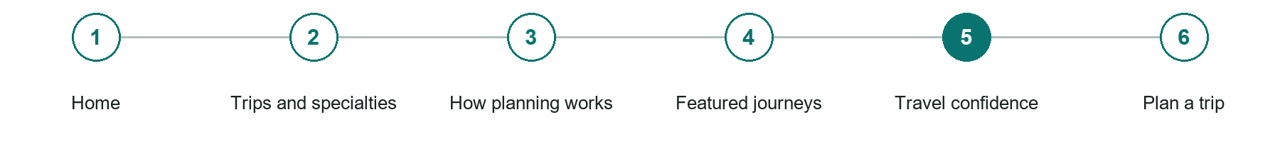
LOOK AND LEARN

Travel confidence

The job of this page
Explain credentials that can be verified, supplier relationships, insurance boundaries, documentation responsibility, accessibility, disruptions, and emergency support.
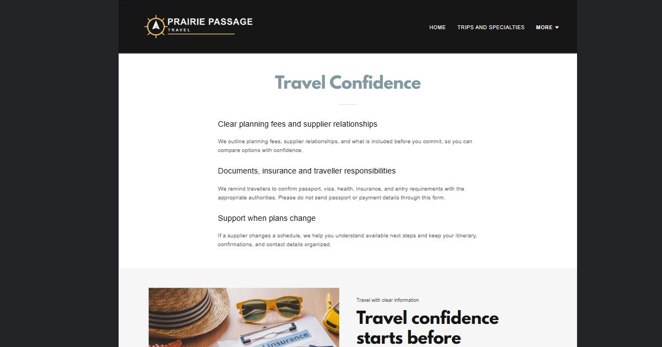
Prairie Passage Travel example | Explore SaaSTech Website Builder

Sample wording to adapt
Check the details before you book
Review the provider's current terms, required travel documents and applicable cancellation arrangements. Consult official sources for entry requirements. Do not send passport or payment details through a general enquiry.

Pause and plan
What question brings a visitor to this page? List the details they need, the evidence you can provide and the next useful action. Remove content that does not help them decide or proceed.

WRITE YOUR PAGE

Travel confidence
Write for your visitor. Be specific about what they need to know and what happens next. You can revise the wording after the workshop.
Your page headline

Your opening paragraph

Key sections visitor questions and supporting details

Button or link wording and where it should lead

Photo idea caption and permission or credit needed

Facts to verify or questions to resolve

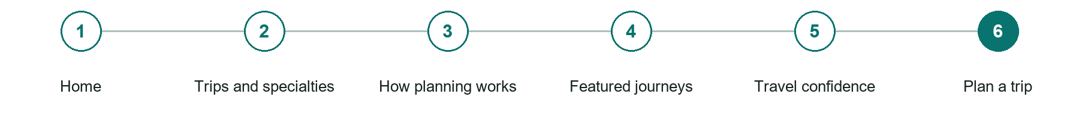
LOOK AND LEARN

Plan a trip

The job of this page
Collect destinations, flexible dates, departure point, travellers, interests, accessibility needs, budget guidance, and contact without requesting passport or payment data.
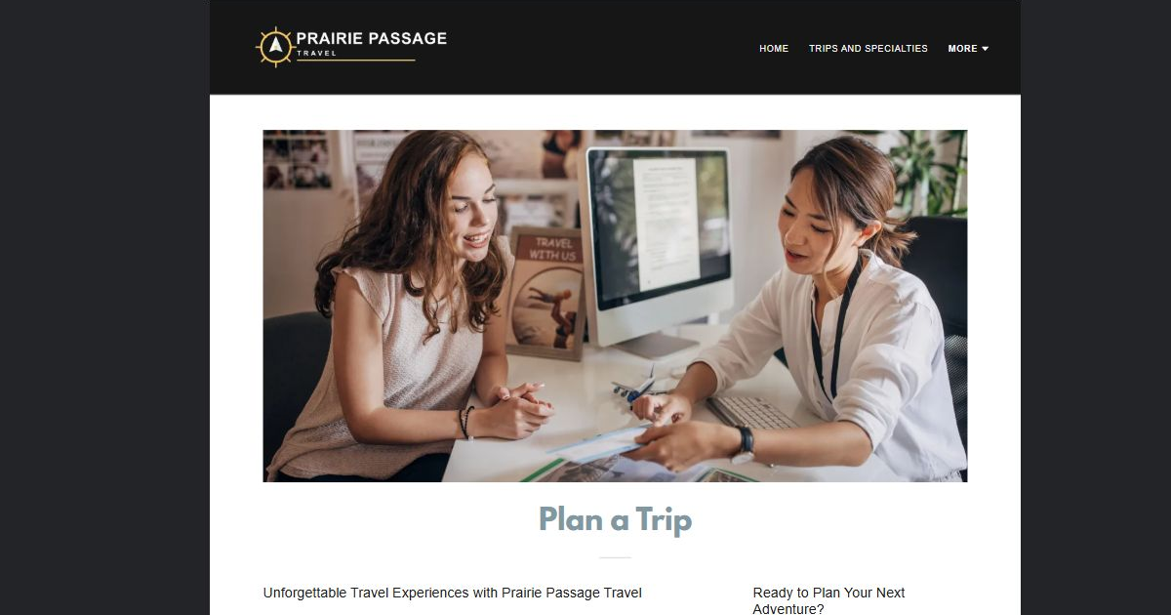
Prairie Passage Travel example | Explore SaaSTech Website Builder

Sample wording to adapt
Tell us about your trip
Include approximate dates, travellers, departure point and the experiences you want. Share a budget range if useful. The first enquiry is for planning, not a confirmed reservation.

Pause and plan
What should someone know before arriving or proceeding? Clarify preparation, access and the right contact route. Verify policies and avoid promising urgent help or specialist advice the website cannot provide.

WRITE YOUR PAGE

Plan a trip
Write for your visitor. Be specific about what they need to know and what happens next. You can revise the wording after the workshop.
Your page headline

Your opening paragraph

Preparation access policies and practical questions to answer

Button or link wording and where it should lead

Photo idea caption and permission or credit needed

Facts to verify or questions to resolve

WORKSHOP CLOSE

Review and next steps
Ask a partner to read your draft as a first-time visitor. Can they explain what you offer, who it is for and the next step without extra help?

Before you publish
[ ] Every page has a clear purpose and a useful next step.
[ ] Headlines are specific and the wording sounds like your business.
[ ] Names, service areas, prices, dates and policies have been checked.
[ ] Credentials, testimonials and results are genuine and permission-cleared.
[ ] Photos support the text, do not repeat needlessly and have appropriate permissions.
[ ] Forms ask only for necessary information and explain what happens next.
[ ] Links, downloads and the main visitor task work on a phone.
The most useful feedback from your workshop partner

First change to make and who will do it

Information or photographs still needed

Target review date and who will approve the final content

Keep sensitive customer, patient, employee and payment information out of this workbook. Completing it does not publish a website or connect to Website Builder.

BUILD WITH SAASTECH SERVERS

Put your draft into Website Builder
Use the content you have written to build your own site. Keep the travel agencies & trip planners demo as a reference, and replace its company name, images and claims with your verified business information.

Explore the builder
See the editor, compare available plans and decide which features your business needs. Confirm current pricing and terms before purchasing.
Website Builder overview

Create your account
Set up your SaaSTech Servers customer account using your own details. Creating an account is separate from purchasing a Website Builder plan.
Create your SaaSTech account

Choose your plan
Open the secure shop to review the plan, subscription term and final total. Use the account connected to your purchase when you open your service.
View Website Builder plans

Build and check your pages
Add the pages from this workbook. Transfer your approved wording, upload permission-cleared photos and review each page on desktop and mobile before publishing.
Return to the Website Builder guide

Using a printed workbook
Type these short addresses into your browser. The account guide includes the Create My Account button.
www.saastech.net/products/website-builder
www.saastech.net/create-account
This workbook does not create an account, purchase a plan or publish your website. Keep passwords, payment details and confidential customer information out of your draft.

