
WEBSITE PLANNING WORKSHOP

Transportation Services
Website workbook
Plan a clear website for transportation services. Explore a worked example, shape your own message and prepare to build with SaaSTech Servers.
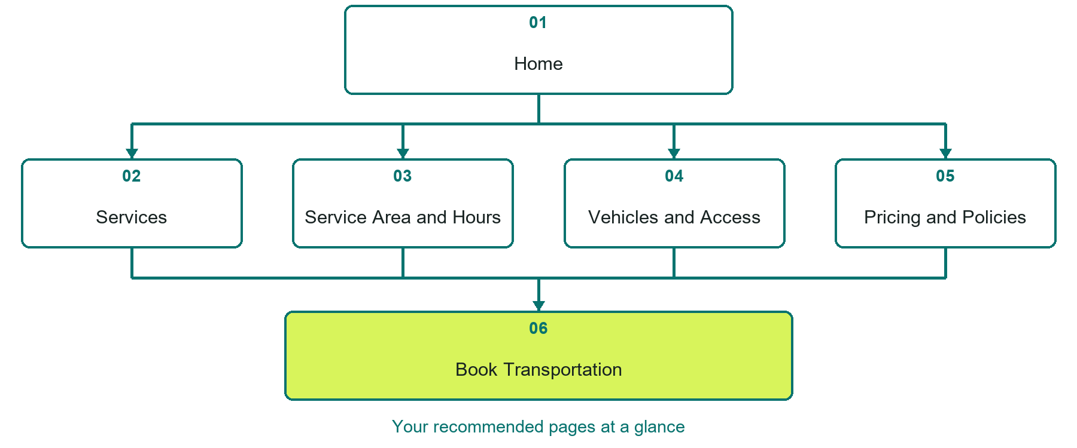

Inside this workbook
Six page examples • Practical writing exercises • A launch review
Use it in a workshop or at your own pace. Write by hand or complete the response fields in Word. The final page links to Website Builder, plans and account signup.
Example business Prairie Link Transportation

TRANSPORTATION SERVICES

Your website brief
A SaaSTech Servers workshop for transportation services. Plan your website, learn from the Prairie Link Transportation example and draft content for your own business.
Each page has a reference sheet followed by a writing sheet. Demo excerpts are labelled separately from new sample wording, which may differ from the screenshot. Click a blank response line to type; longer answers may add pages. Replace fictional details and verify every claim before publishing.
Your business or organization and workshop date

Who should visit your site and what do they need

The main action you want a visitor to take

What you offer and where or how you provide it

Facts photos and permissions to gather before publishing

Workshop rhythm: review the example, write your draft and exchange feedback. Use the final review to choose your next changes. Website Builder and account links are on the last page.

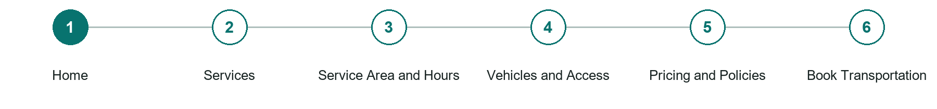
LOOK AND LEARN

Home

The job of this page
State the transportation promise, service region, main trip types, phone contact, and clearest booking action in the first screen.
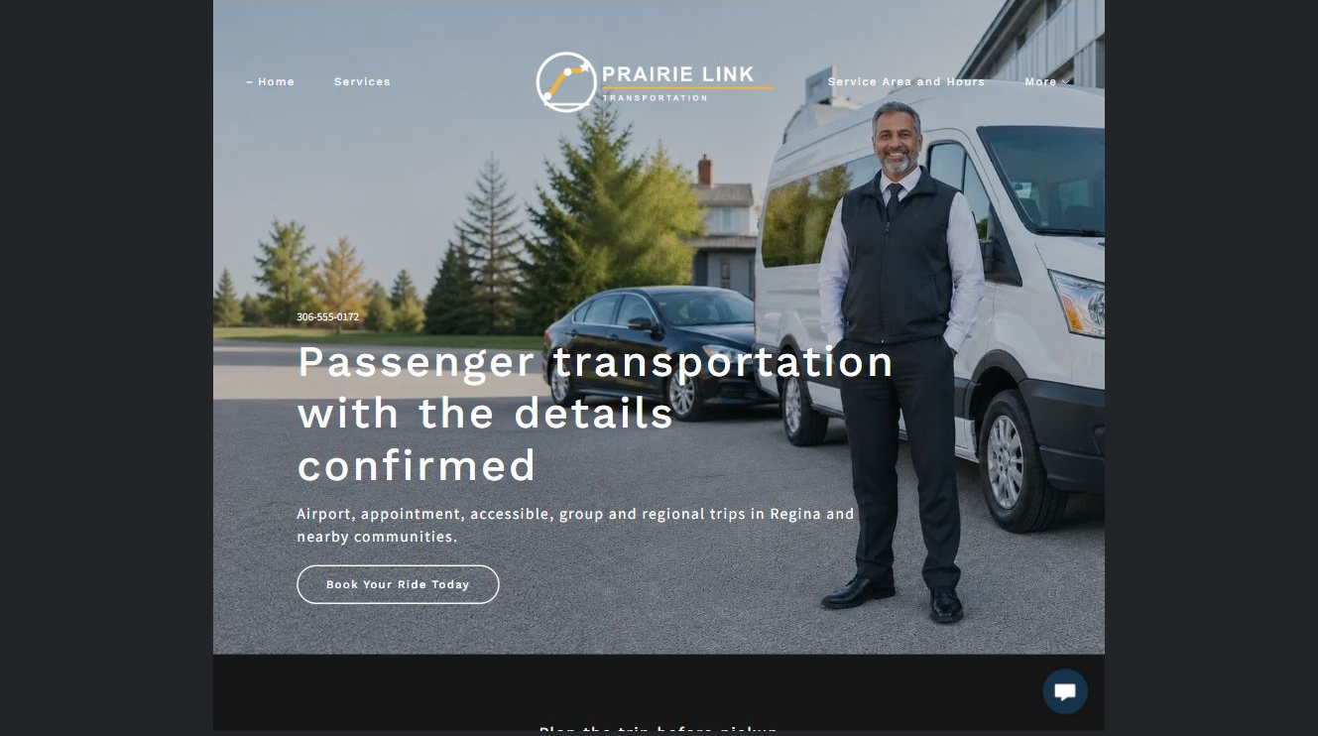
Prairie Link Transportation example | Explore SaaSTech Website Builder

Sample wording to adapt
Plan your ride with clear details
Explore the service area and transport options, then ask about your journey. Availability, vehicle suitability and pricing are confirmed before a trip is accepted.

Pause and plan
Could a first-time visitor explain what you do and who it is for after one glance? Choose one main action and the strongest truthful detail that gives them confidence to continue.

WRITE YOUR PAGE

Home
Write for your visitor. Be specific about what they need to know and what happens next. You can revise the wording after the workshop.
Your page headline

Your opening paragraph

Your offer audience location and most useful supporting details

Button or link wording and where it should lead

Photo idea caption and permission or credit needed

Facts to verify or questions to resolve

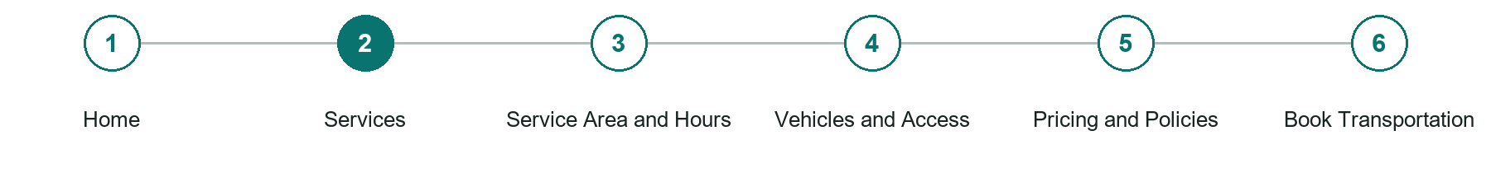
LOOK AND LEARN

Services

The job of this page
Explain airport, appointment, accessible, group, regional, courier, or delivery services actually offered and the limits of each.
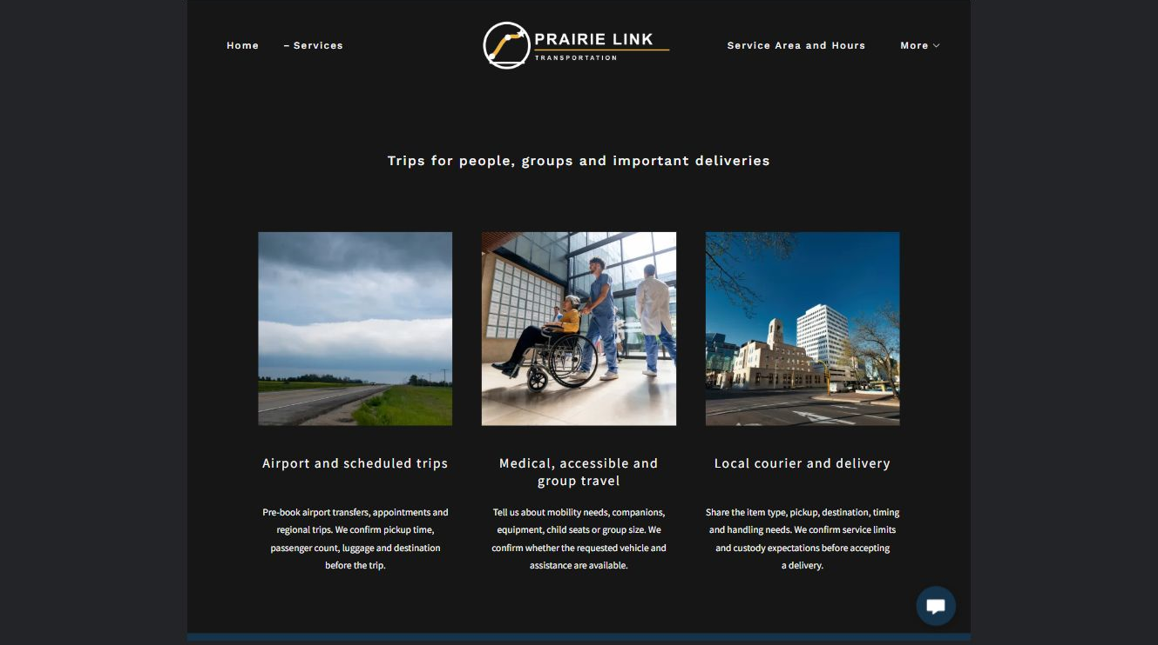
Prairie Link Transportation example | Explore SaaSTech Website Builder

Sample wording to adapt
Choose the transport you need
Describe the journey, passenger count and timing. Ask which service can accommodate the trip. A listed service is not a guarantee of availability for every location or date.

Pause and plan
Who is each option for, what does it include and where are its limits? Describe the information needed to check fit. Make the next step clear without promising an outcome before assessment.

WRITE YOUR PAGE

Services
Write for your visitor. Be specific about what they need to know and what happens next. You can revise the wording after the workshop.
Your page headline

Your opening paragraph

Service options who they suit and what each includes

Button or link wording and where it should lead

Photo idea caption and permission or credit needed

Facts to verify or questions to resolve

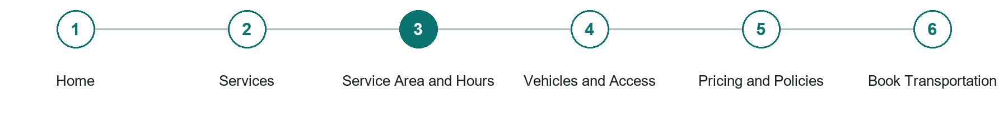
LOOK AND LEARN

Service Area and Hours

The job of this page
Publish pickup regions, destinations, operating hours, advance-booking needs, weather changes, and current contact methods.
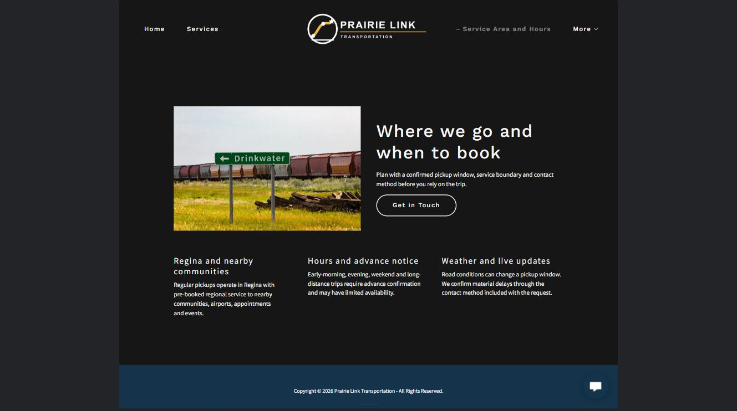
Prairie Link Transportation example | Explore SaaSTech Website Builder

Sample wording to adapt
Check the route and operating hours
Share your pickup area, destination and preferred time. Confirm coverage and any after-hours arrangements directly. Do not rely on an unconfirmed enquiry for a time-critical journey.

Pause and plan
Who is each option for, what does it include and where are its limits? Describe the information needed to check fit. Make the next step clear without promising an outcome before assessment.

WRITE YOUR PAGE

Service Area and Hours
Write for your visitor. Be specific about what they need to know and what happens next. You can revise the wording after the workshop.
Your page headline

Your opening paragraph

Service options who they suit and what each includes

Button or link wording and where it should lead

Photo idea caption and permission or credit needed

Facts to verify or questions to resolve

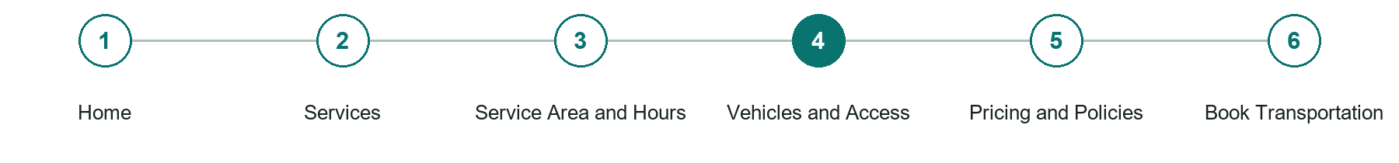
LOOK AND LEARN

Vehicles and Access

The job of this page
Show representative vehicles, passenger and luggage capacity, mobility accommodations, cleanliness, inspections, and special equipment accurately.
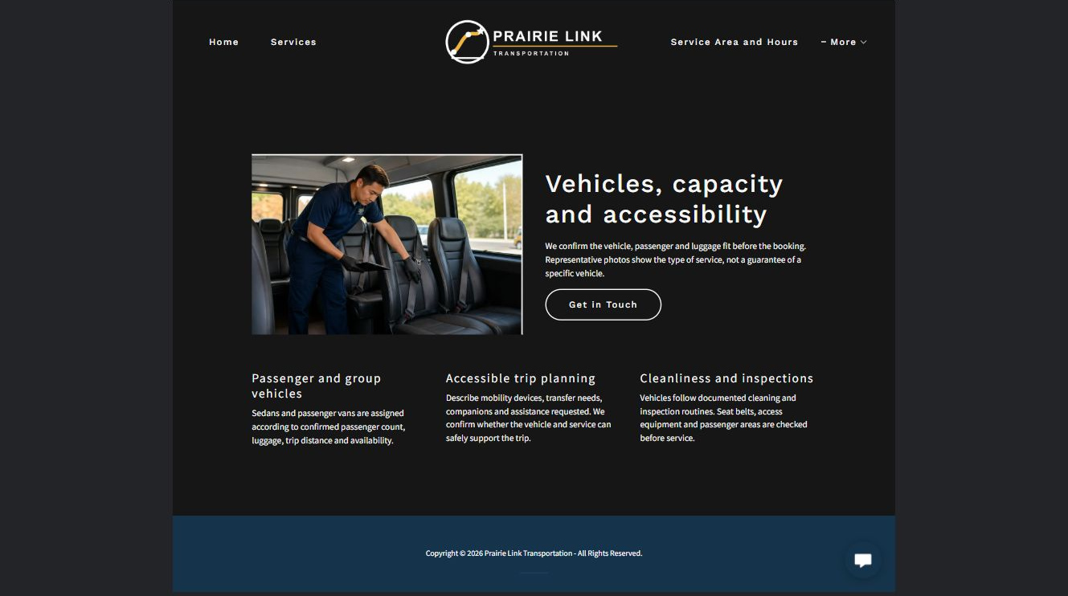
Prairie Link Transportation example | Explore SaaSTech Website Builder

Sample wording to adapt
Confirm the vehicle fits the journey
Discuss passenger numbers, luggage and practical access needs. The operator will confirm a suitable vehicle and arrangements. Photographs alone do not establish accessibility or capacity.

Pause and plan
What question brings a visitor to this page? List the details they need, the evidence you can provide and the next useful action. Remove content that does not help them decide or proceed.

WRITE YOUR PAGE

Vehicles and Access
Write for your visitor. Be specific about what they need to know and what happens next. You can revise the wording after the workshop.
Your page headline

Your opening paragraph

Key sections visitor questions and supporting details

Button or link wording and where it should lead

Photo idea caption and permission or credit needed

Facts to verify or questions to resolve

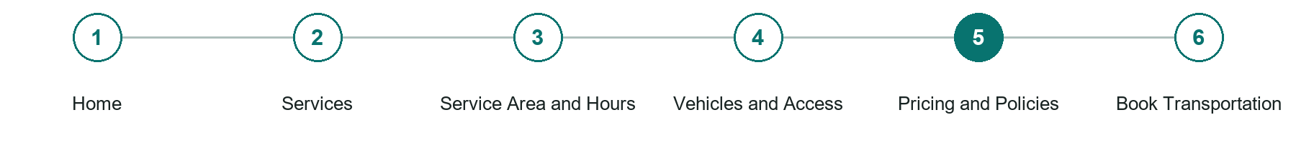
LOOK AND LEARN

Pricing and Policies

The job of this page
Explain estimates, waiting, stops, deposits, payment, receipts, cancellations, no-shows, luggage, conduct, animals, and assistance boundaries.
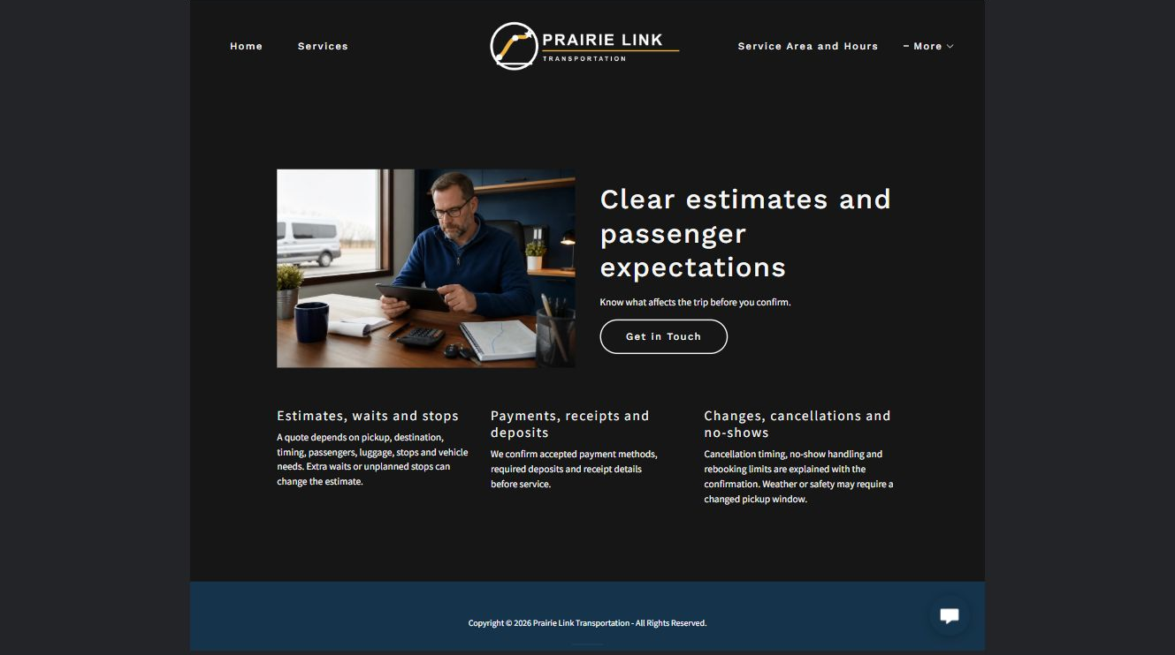
Prairie Link Transportation example | Explore SaaSTech Website Builder

Sample wording to adapt
Know the fare and terms first
Ask about the total, waiting time and any additional charges. Review changes, cancellations and payment arrangements before confirming. Example pricing is not a quote for a particular trip.

Pause and plan
What question brings a visitor to this page? List the details they need, the evidence you can provide and the next useful action. Remove content that does not help them decide or proceed.

WRITE YOUR PAGE

Pricing and Policies
Write for your visitor. Be specific about what they need to know and what happens next. You can revise the wording after the workshop.
Your page headline

Your opening paragraph

Key sections visitor questions and supporting details

Button or link wording and where it should lead

Photo idea caption and permission or credit needed

Facts to verify or questions to resolve

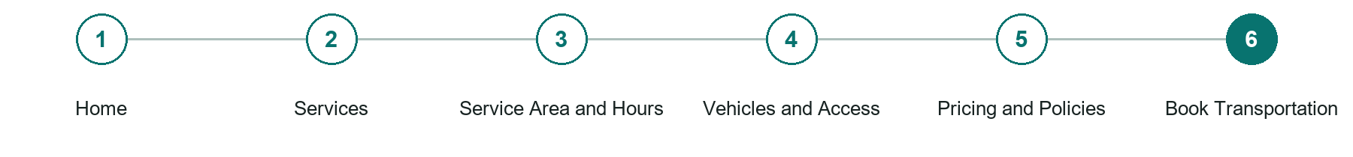
LOOK AND LEARN

Book Transportation

The job of this page
Collect date, time, pickup, destination, passengers, luggage or shipment details, accessibility needs, stops, flexibility, and contact without requesting unnecessary sensitive information.
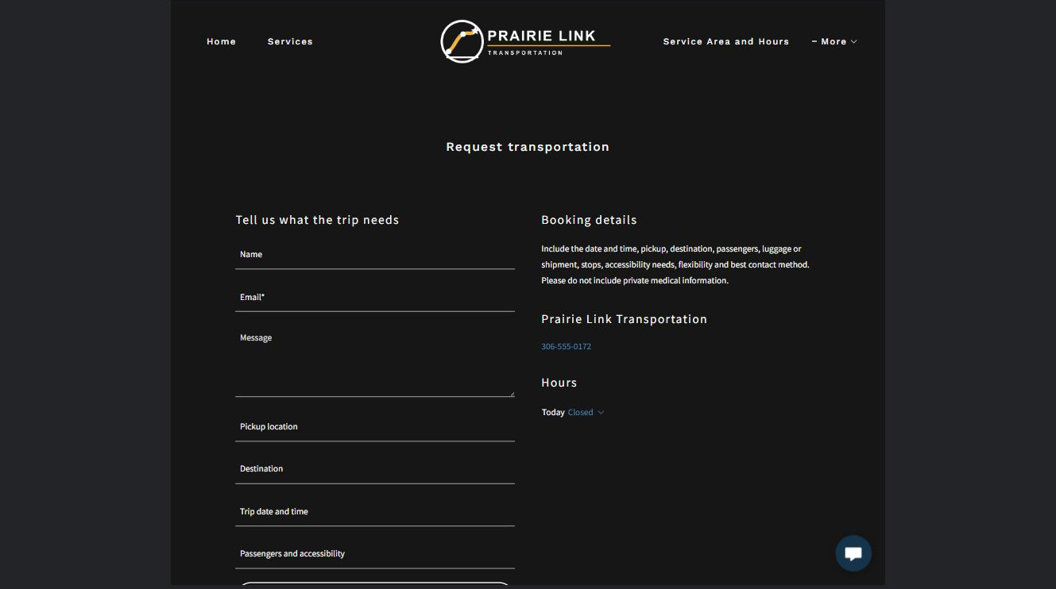
Prairie Link Transportation example | Explore SaaSTech Website Builder

Sample wording to adapt
Request your journey
Include the date, pickup area, destination, passenger count and preferred time. The operator will confirm availability and fare. A request is not a confirmed ride; do not submit sensitive information through this demo.

Pause and plan
What must someone provide, and what happens after they send it? Separate a request from a confirmed booking, order or place. Decide what information should stay out of a public form.

WRITE YOUR PAGE

Book Transportation
Write for your visitor. Be specific about what they need to know and what happens next. You can revise the wording after the workshop.
Your page headline

Your opening paragraph

Information to request and how you will reply or confirm

Button or link wording and where it should lead

Photo idea caption and permission or credit needed

Facts to verify or questions to resolve

WORKSHOP CLOSE

Review and next steps
Ask a partner to read your draft as a first-time visitor. Can they explain what you offer, who it is for and the next step without extra help?

Before you publish
[ ] Every page has a clear purpose and a useful next step.
[ ] Headlines are specific and the wording sounds like your business.
[ ] Names, service areas, prices, dates and policies have been checked.
[ ] Credentials, testimonials and results are genuine and permission-cleared.
[ ] Photos support the text, do not repeat needlessly and have appropriate permissions.
[ ] Forms ask only for necessary information and explain what happens next.
[ ] Links, downloads and the main visitor task work on a phone.
The most useful feedback from your workshop partner

First change to make and who will do it

Information or photographs still needed

Target review date and who will approve the final content

Keep sensitive customer, patient, employee and payment information out of this workbook. Completing it does not publish a website or connect to Website Builder.

BUILD WITH SAASTECH SERVERS

Put your draft into Website Builder
Use the content you have written to build your own site. Keep the transportation services demo as a reference, and replace its company name, images and claims with your verified business information.

Explore the builder
See the editor, compare available plans and decide which features your business needs. Confirm current pricing and terms before purchasing.
Website Builder overview

Create your account
Set up your SaaSTech Servers customer account using your own details. Creating an account is separate from purchasing a Website Builder plan.
Create your SaaSTech account

Choose your plan
Open the secure shop to review the plan, subscription term and final total. Use the account connected to your purchase when you open your service.
View Website Builder plans

Build and check your pages
Add the pages from this workbook. Transfer your approved wording, upload permission-cleared photos and review each page on desktop and mobile before publishing.
Return to the Website Builder guide

Using a printed workbook
Type these short addresses into your browser. The account guide includes the Create My Account button.
www.saastech.net/products/website-builder
www.saastech.net/create-account
This workbook does not create an account, purchase a plan or publish your website. Keep passwords, payment details and confidential customer information out of your draft.

