

Towing and Roadside Assistance website workbook
A printable workshop guide for planning a mobile-first towing website that routes urgent calls and scheduled transport enquiries correctly.
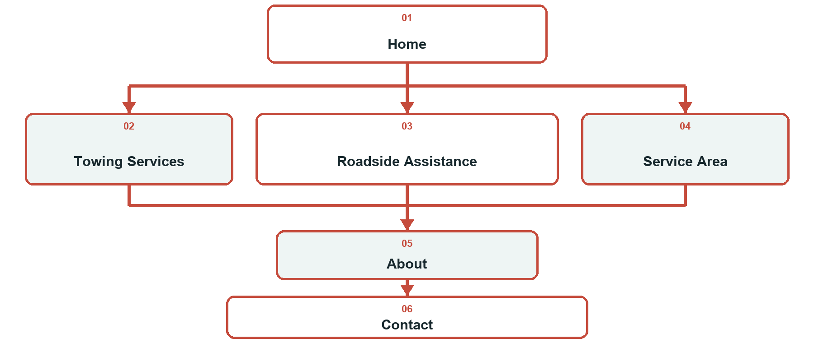
Workshop note. Prairie Rescue Towing and Roadside is a fictional learning example. Replace sample services, coverage, hours and contact details with verified business information before use. Keep urgent dispatch on a monitored phone line; a website form does not dispatch a truck or confirm availability.

How to use this workbook
☐ Give each page one clear job and one useful customer action.
☐ Put tap-to-call first for urgent towing and roadside requests.
☐ Separate scheduled vehicle transport enquiries from urgent dispatch.
☐ Use distinct, permission-cleared photos of the team, trucks and services.
☐ State coverage, hours, vehicle limits and pricing processes accurately.
☐ Review every page on desktop and mobile before publishing.
Explore Website Builder and compare plans • Open the industry guide

PAGE PLANNING

Home
Lead with the service area, operating hours and tap-to-call action. Show the operator and truck without promising an arrival time.
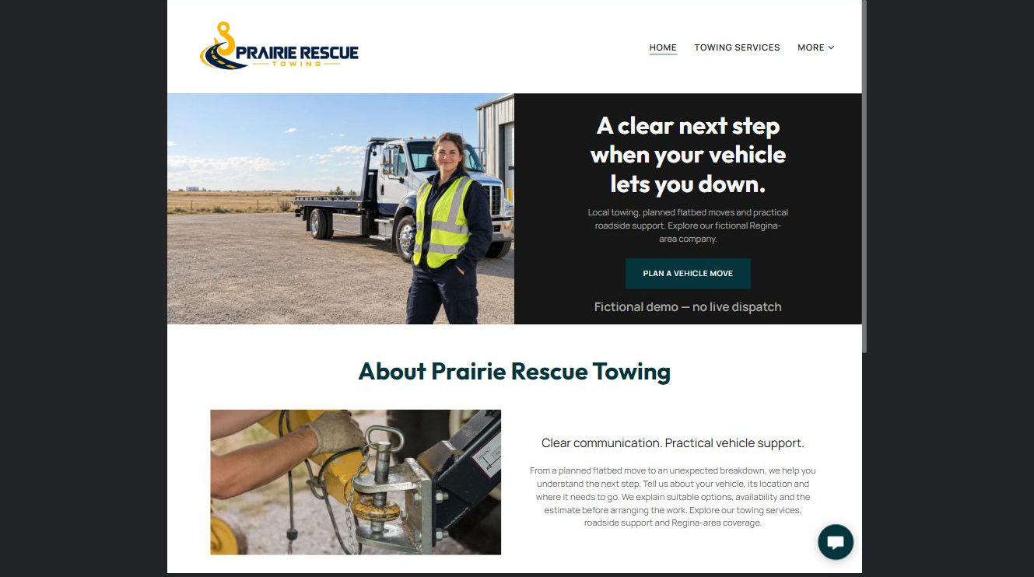

Clearly labelled sample wording
Need towing or roadside help? Call Prairie Rescue and tell us your vehicle, general location and what happened. We will confirm availability, the suitable service and the next step.

Draft your headline, service-area line and urgent call action.

Photo, proof and link checklist

PAGE PLANNING

Towing Services
Explain local towing, flatbed transport and planned moves. Help customers understand which details affect the suitable truck and estimate.
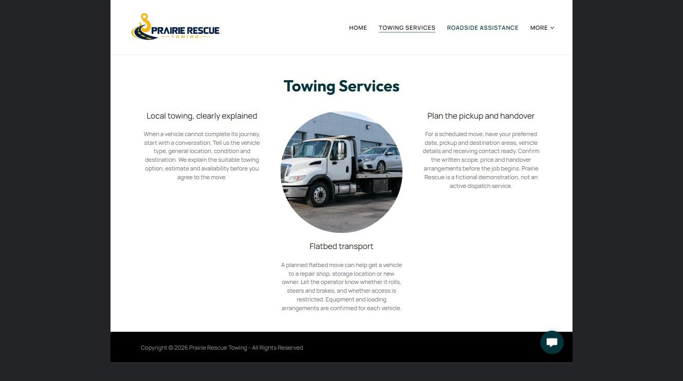

Clearly labelled sample wording
For a planned vehicle move, share the vehicle type, condition, pickup and destination areas, access concerns and preferred timing. We confirm equipment, availability and price before booking.

Draft the towing overview and information customers should prepare.

Photo, proof and link checklist

PAGE PLANNING

Roadside Assistance
Separate battery boosts, tire changes, lockout help and fuel delivery. Make clear that suitability and availability are confirmed by the operator.
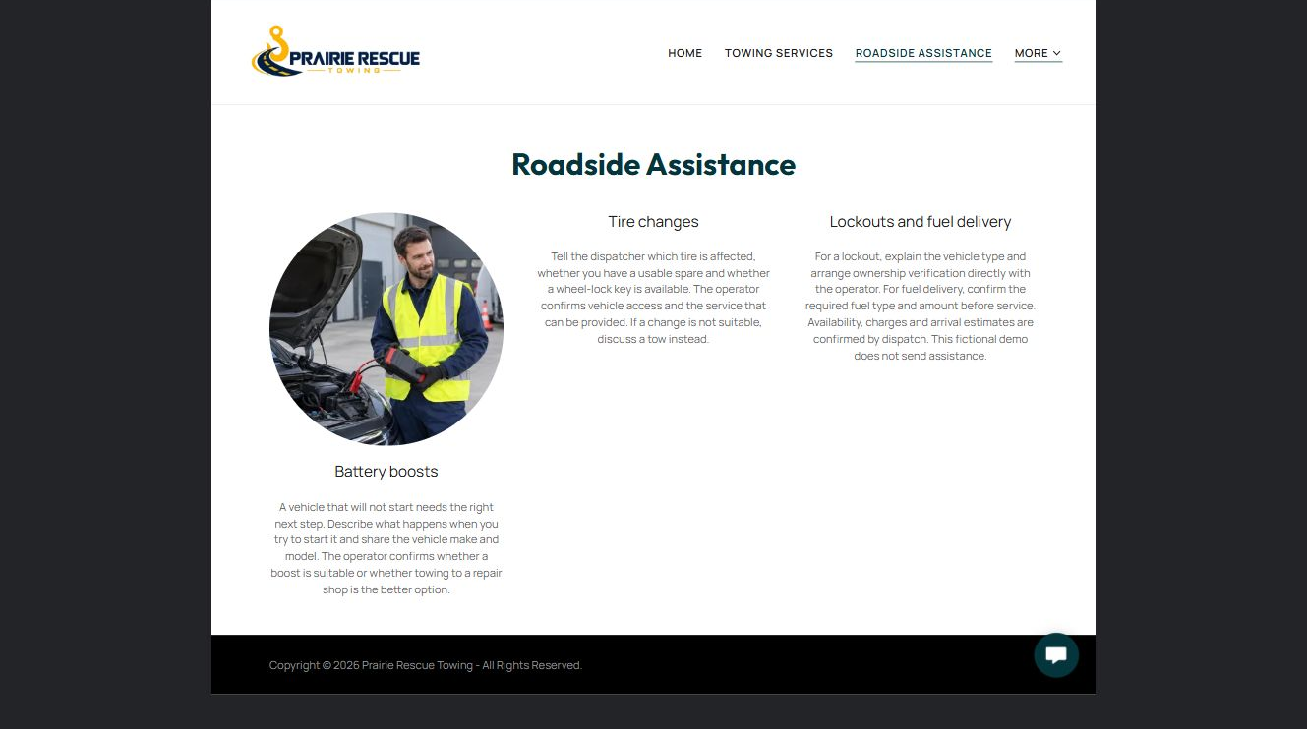

Clearly labelled sample wording
Tell us your vehicle, general location and the help you may need. For safety, move away from traffic when possible and follow emergency-service instructions when there is immediate danger.

Draft the roadside service descriptions and safety boundary.

Photo, proof and link checklist

PAGE PLANNING

Service Area
List genuine communities, routes and operating hours. Distinguish example coverage from live truck locations and avoid guaranteed arrival times.
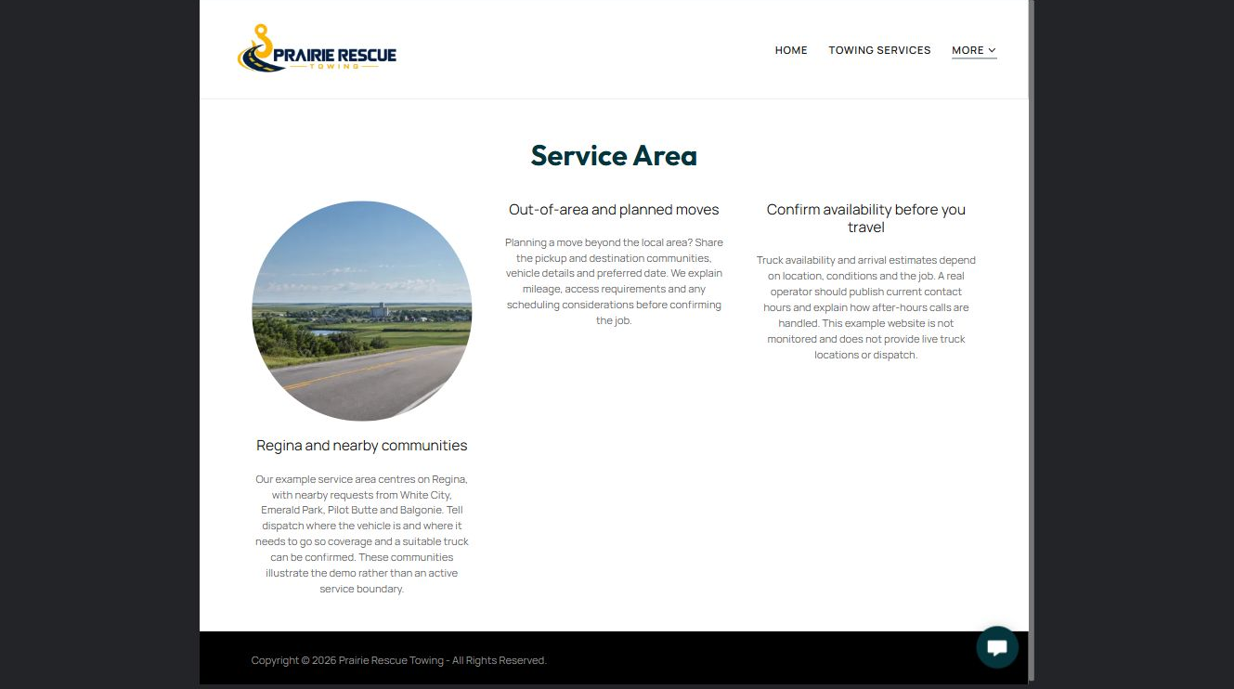

Clearly labelled sample wording
Our core service area includes Regina and nearby routes. Call with your general location so we can confirm whether a truck is available and whether distance affects the estimate.

List the verified service area, hours and out-of-area process.

Photo, proof and link checklist

PAGE PLANNING

About
Introduce the people, equipment and customer-care approach. Use verified credentials and accurate equipment details on a real company site.
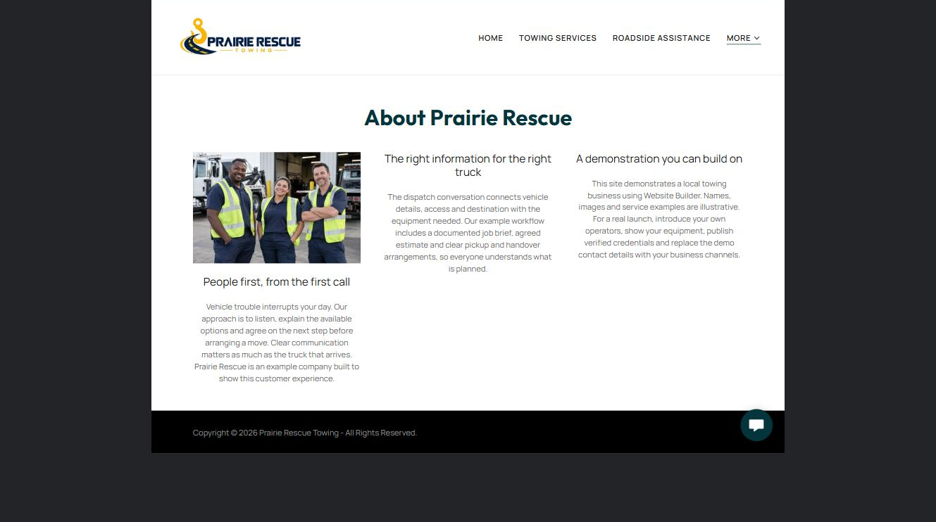

Clearly labelled sample wording
Prairie Rescue is a fictional example of an operator-led towing company. A real site should introduce the actual team, show permission-cleared truck photos and explain how calls are assessed.

Write the company story and identify every fact that needs verification.

Photo, proof and link checklist

PAGE PLANNING

Contact
Keep urgent help on the phone and use the form only for planned moves or general questions. Explain that submitting a form is not dispatch confirmation.
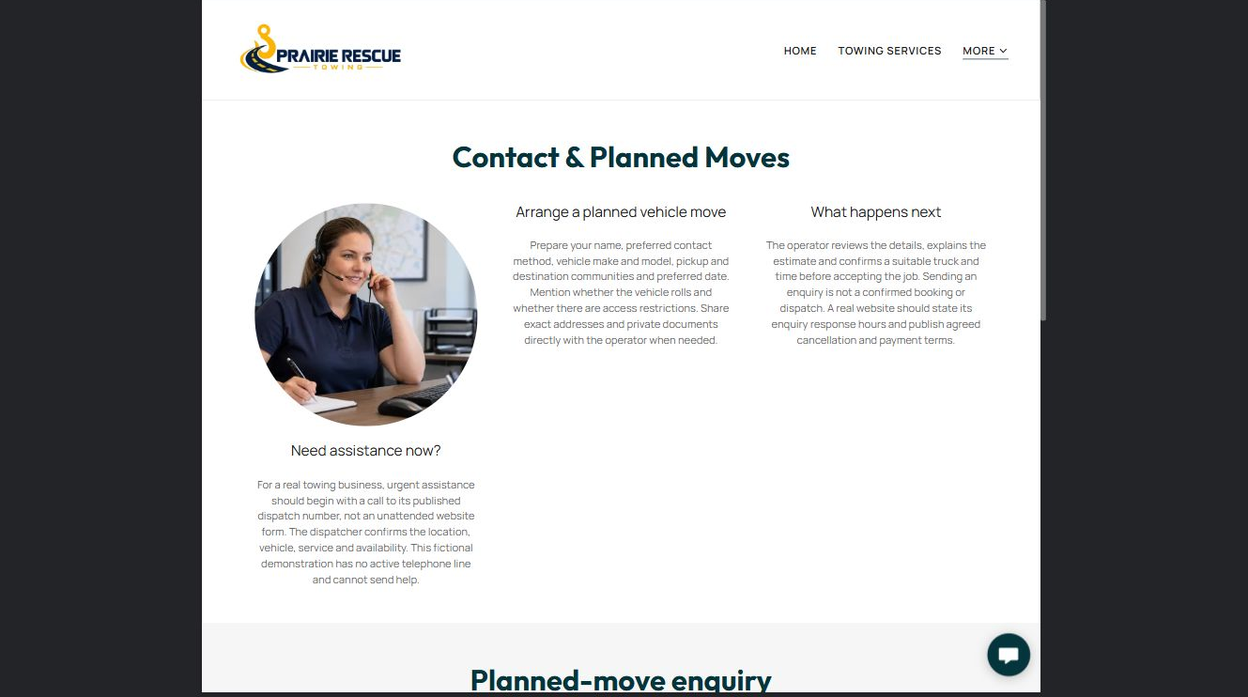

Clearly labelled sample wording
For urgent towing or roadside assistance, call the monitored dispatch number. Use this form for a planned vehicle move or a general question. We will contact you to confirm details, availability and price.

Draft the form introduction, fields, privacy boundary and confirmation message.

Photo, proof and link checklist

FINAL REVIEW

Check the complete customer journey
Ask someone unfamiliar with the business to request urgent help and plan a future vehicle move on both a phone and a desktop computer.
☐ Tap-to-call is prominent and reaches the monitored business number.
☐ Urgent requests are not directed to an unattended form.
☐ Services, coverage, hours, rates and vehicle limits are verified.
☐ Forms explain that submission is not dispatch or booking confirmation.
☐ Exact location and sensitive details are handled directly when appropriate.
☐ Every photograph is distinct, relevant and permission-cleared.
☐ The logo is readable on light and dark backgrounds.
☐ Desktop and mobile pages have been reviewed and a named backup is saved.

Changes found during review

Content owner and next review date

