
WEBSITE PLANNING WORKSHOP

Tourism & Destination Experiences
Website workbook
Plan a clear website for tourism & destination experiences. Explore a worked example, shape your own message and prepare to build with SaaSTech Servers.
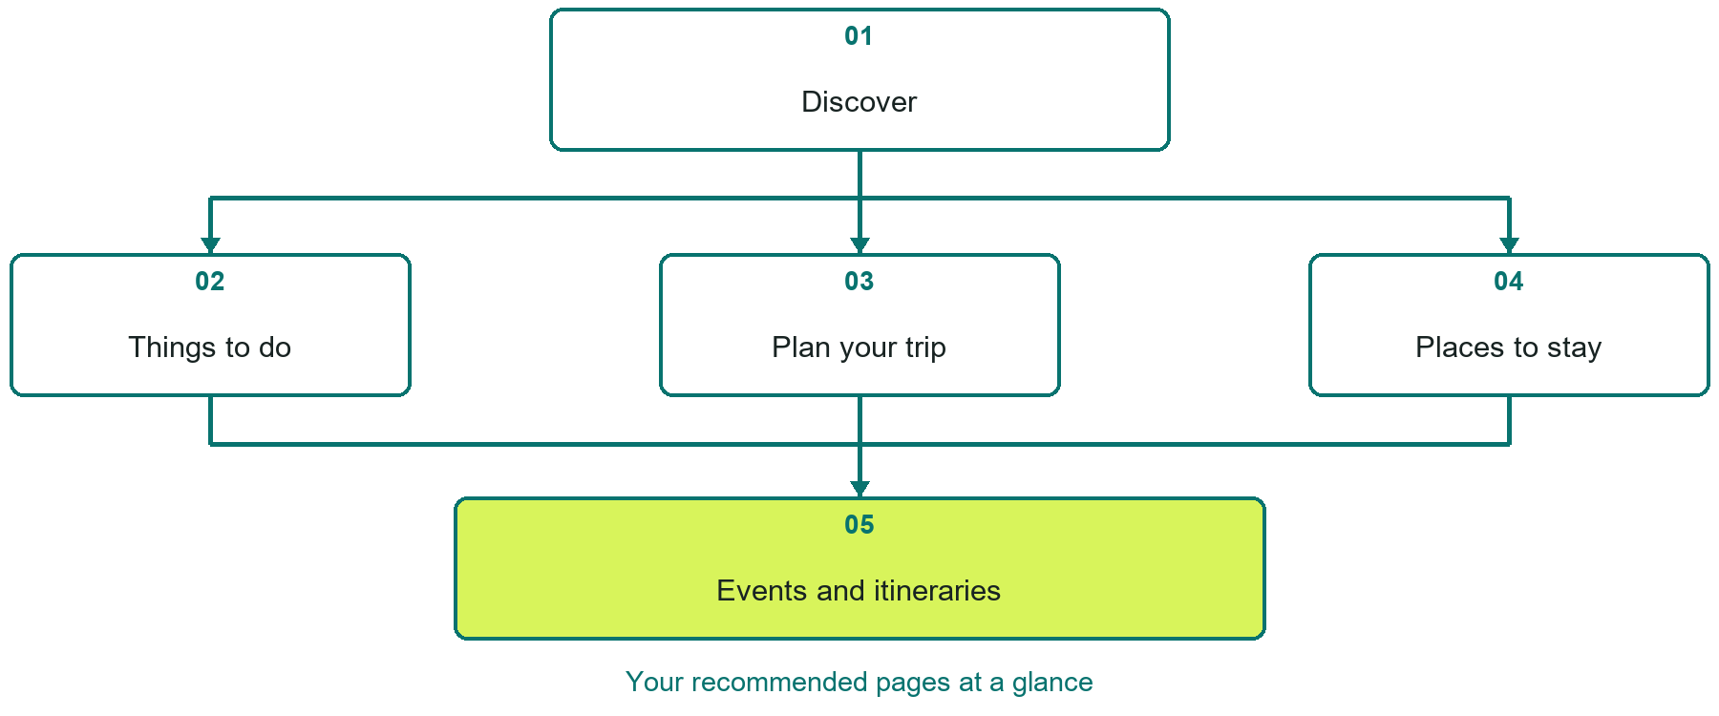

Inside this workbook
Five page examples • Practical writing exercises • A launch review
Use it in a workshop or at your own pace. Write by hand or complete the response fields in Word. The final page links to Website Builder, plans and account signup.
Example business Prairie Compass Tourism

TOURISM & DESTINATION EXPERIENCES

Your website brief
A SaaSTech Servers workshop for tourism & destination experiences. Plan your website, learn from the Prairie Compass Tourism example and draft content for your own business.
Each page has a reference sheet followed by a writing sheet. Demo excerpts are labelled separately from new sample wording, which may differ from the screenshot. Click a blank response line to type; longer answers may add pages. Replace fictional details and verify every claim before publishing.
Your business or organization and workshop date

Who should visit your site and what do they need

The main action you want a visitor to take

What you offer and where or how you provide it

Facts photos and permissions to gather before publishing

Workshop rhythm: review the example, write your draft and exchange feedback. Use the final review to choose your next changes. Website Builder and account links are on the last page.

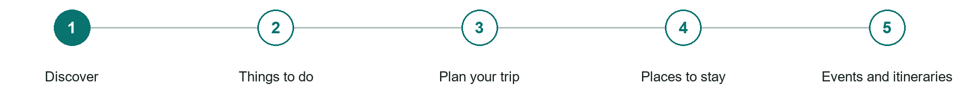
LOOK AND LEARN

Discover

The job of this page
Lead with distinctive experiences, seasons, communities, and a clear path into trip planning.
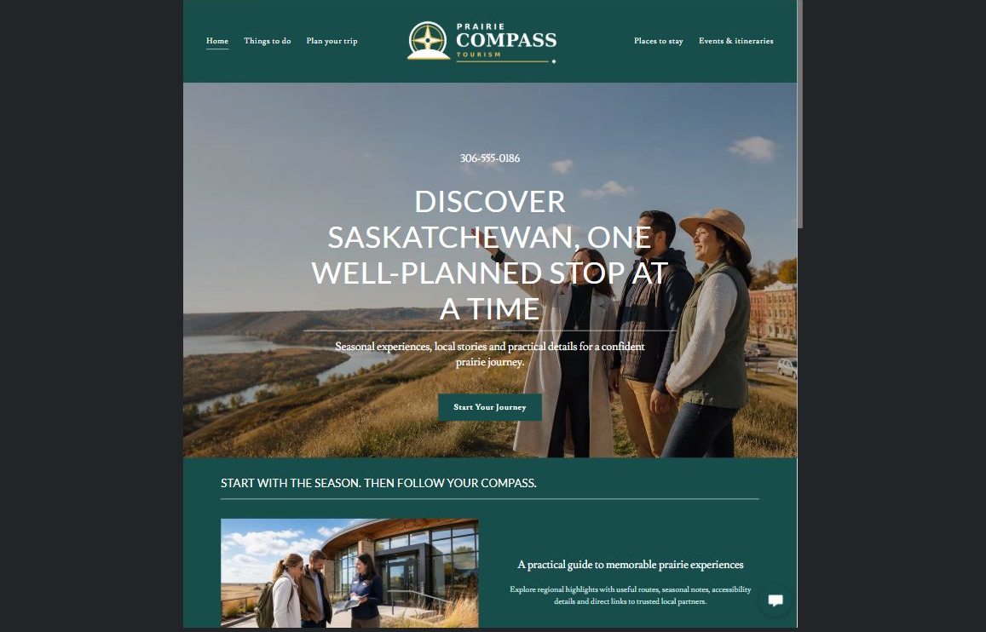
Prairie Compass Tourism example | Explore SaaSTech Website Builder

Sample wording to adapt
Plan a prairie visit around your interests
Explore places, seasonal activities and practical travel information. Check current opening dates, access and booking arrangements with the relevant operator before setting out.

Pause and plan
Could a first-time visitor explain what you do and who it is for after one glance? Choose one main action and the strongest truthful detail that gives them confidence to continue.

WRITE YOUR PAGE

Discover
Write for your visitor. Be specific about what they need to know and what happens next. You can revise the wording after the workshop.
Your page headline

Your opening paragraph

Your offer audience location and most useful supporting details

Button or link wording and where it should lead

Photo idea caption and permission or credit needed

Facts to verify or questions to resolve

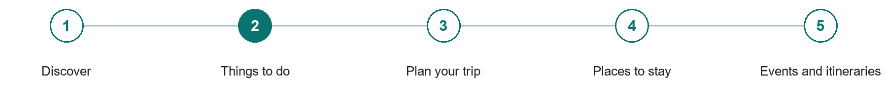
LOOK AND LEARN

Things to do

The job of this page
Organize attractions, outdoor activities, culture, food, and events by visitor interest and season.
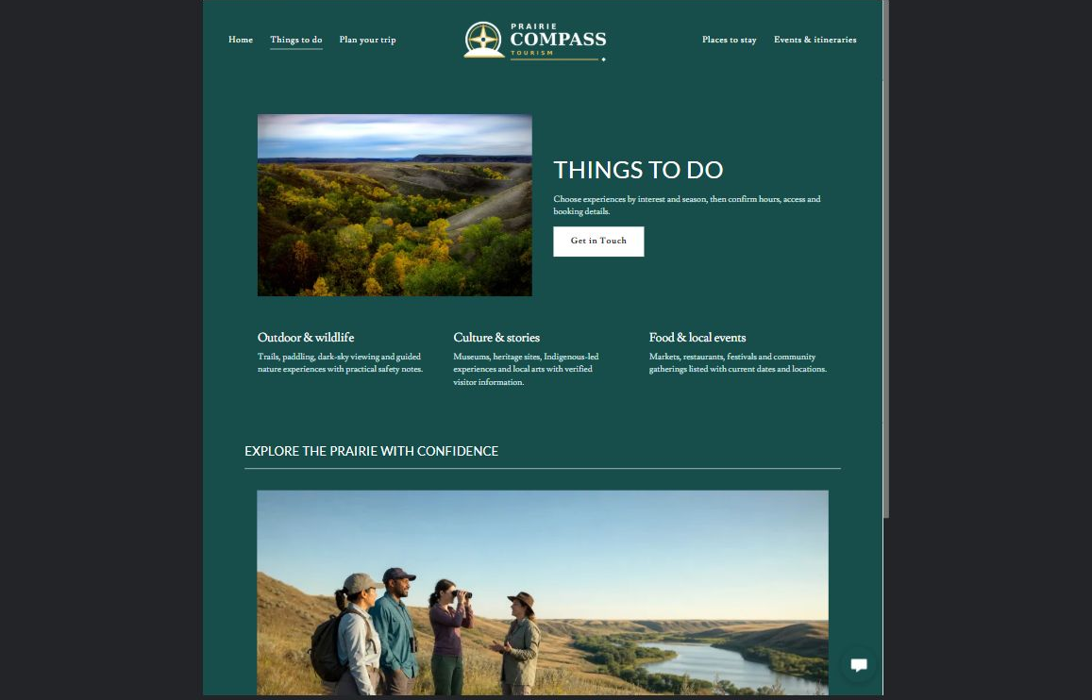
Prairie Compass Tourism example | Explore SaaSTech Website Builder

Sample wording to adapt
Choose the experiences that suit your trip
Browse outdoor activities, local stories, food and events. Read the access and seasonal details before adding a stop. Contact the operator for current availability and any participation requirements.

Pause and plan
What question brings a visitor to this page? List the details they need, the evidence you can provide and the next useful action. Remove content that does not help them decide or proceed.

WRITE YOUR PAGE

Things to do
Write for your visitor. Be specific about what they need to know and what happens next. You can revise the wording after the workshop.
Your page headline

Your opening paragraph

Key sections visitor questions and supporting details

Button or link wording and where it should lead

Photo idea caption and permission or credit needed

Facts to verify or questions to resolve

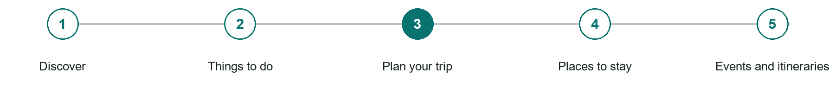
LOOK AND LEARN

Plan your trip

The job of this page
Explain routes, distances, weather realities, accessibility, visitor services, and practical travel considerations.
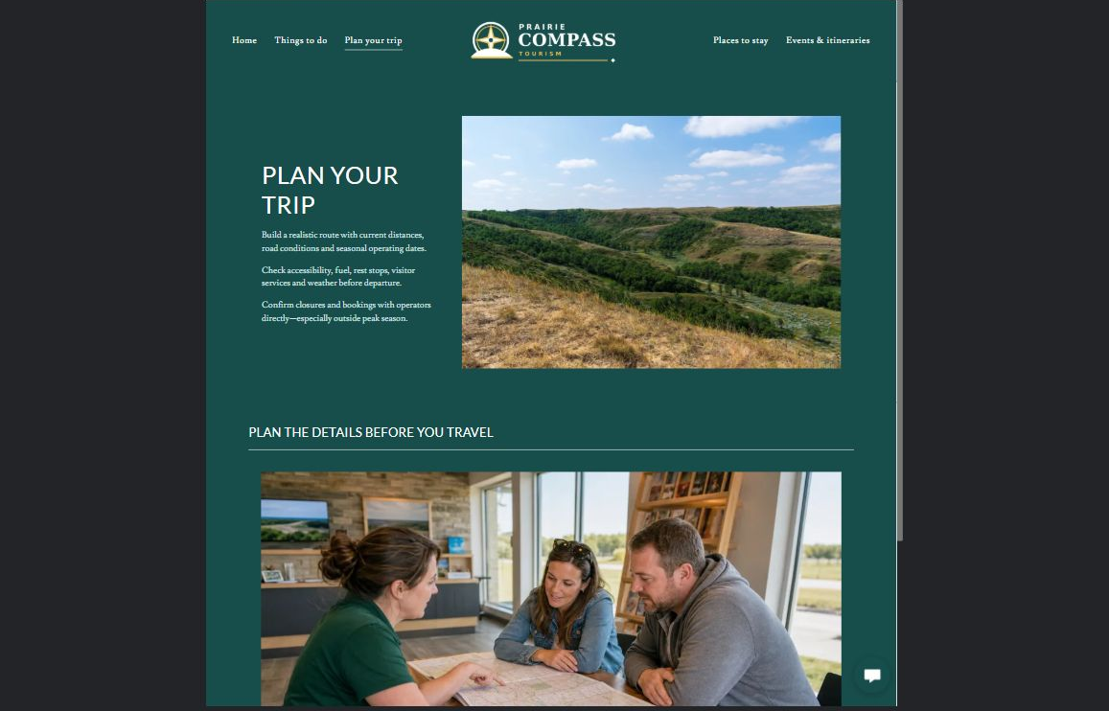
Prairie Compass Tourism example | Explore SaaSTech Website Builder

Sample wording to adapt
Plan the details before you travel
Allow realistic time between stops and confirm opening hours, transport and accommodation. Keep an alternative for weather-sensitive activities. Check current information with the providers before departure.

Pause and plan
What should someone know before arriving or proceeding? Clarify preparation, access and the right contact route. Verify policies and avoid promising urgent help or specialist advice the website cannot provide.

WRITE YOUR PAGE

Plan your trip
Write for your visitor. Be specific about what they need to know and what happens next. You can revise the wording after the workshop.
Your page headline

Your opening paragraph

Preparation access policies and practical questions to answer

Button or link wording and where it should lead

Photo idea caption and permission or credit needed

Facts to verify or questions to resolve

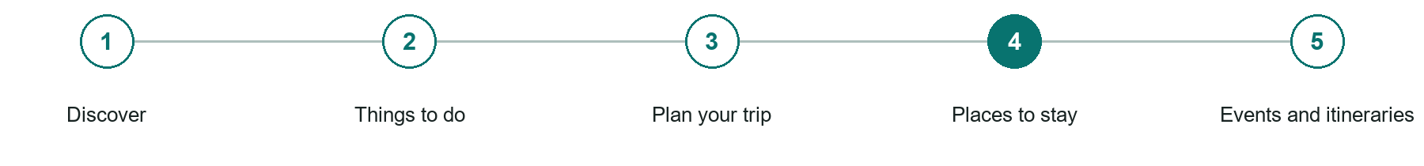
LOOK AND LEARN

Places to stay

The job of this page
Present current accommodation choices with location, season, amenities, and a direct booking or partner link.
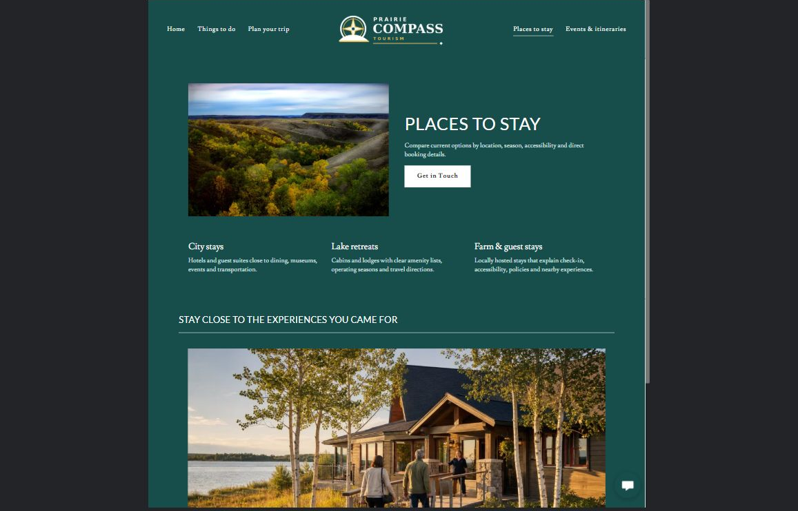
Prairie Compass Tourism example | Explore SaaSTech Website Builder

Sample wording to adapt
Stay close to what you want to explore
Compare locations and practical facilities, then check dates and prices directly with the accommodation provider. A featured property is not a guarantee of availability or an included booking.

Pause and plan
What question brings a visitor to this page? List the details they need, the evidence you can provide and the next useful action. Remove content that does not help them decide or proceed.

WRITE YOUR PAGE

Places to stay
Write for your visitor. Be specific about what they need to know and what happens next. You can revise the wording after the workshop.
Your page headline

Your opening paragraph

Key sections visitor questions and supporting details

Button or link wording and where it should lead

Photo idea caption and permission or credit needed

Facts to verify or questions to resolve

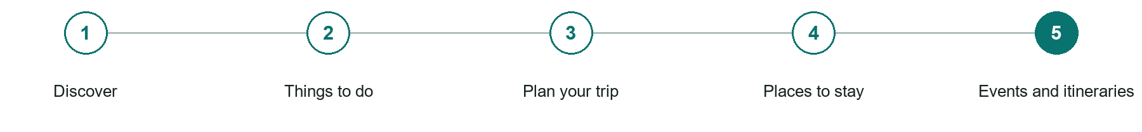
LOOK AND LEARN

Events and itineraries

The job of this page
Publish dated events and realistic itineraries that connect experiences without overpromising travel time.
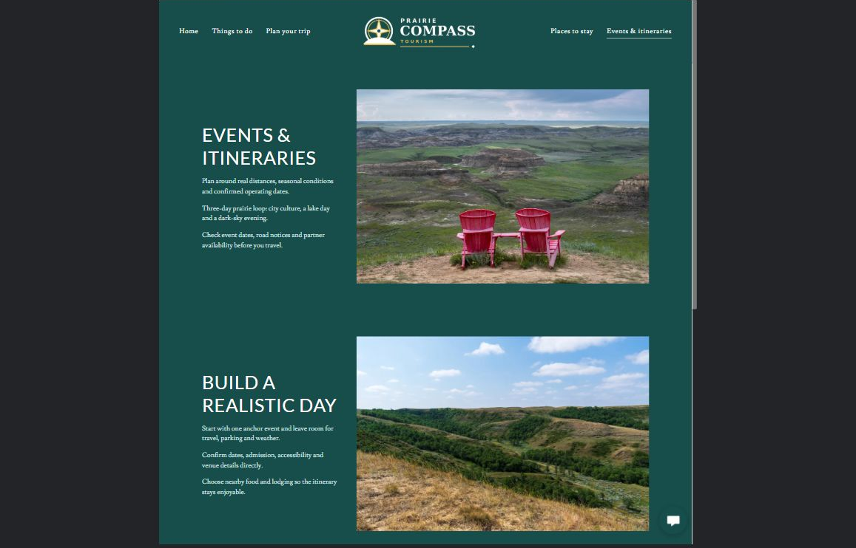
Prairie Compass Tourism example | Explore SaaSTech Website Builder

Sample wording to adapt
Build a realistic day
Choose a few stops with time for travel and breaks. Verify event dates and entry requirements before making arrangements. Illustrative itineraries are ideas to adapt, not confirmed reservations.

Pause and plan
Which dates and locations need to stay current? Decide who will update changes and where visitors should check before travelling. Separate archived information and illustrative schedules from current availability.

WRITE YOUR PAGE

Events and itineraries
Write for your visitor. Be specific about what they need to know and what happens next. You can revise the wording after the workshop.
Your page headline

Your opening paragraph

Dates locations update process and participation details

Button or link wording and where it should lead

Photo idea caption and permission or credit needed

Facts to verify or questions to resolve

WORKSHOP CLOSE

Review and next steps
Ask a partner to read your draft as a first-time visitor. Can they explain what you offer, who it is for and the next step without extra help?

Before you publish
[ ] Every page has a clear purpose and a useful next step.
[ ] Headlines are specific and the wording sounds like your business.
[ ] Names, service areas, prices, dates and policies have been checked.
[ ] Credentials, testimonials and results are genuine and permission-cleared.
[ ] Photos support the text, do not repeat needlessly and have appropriate permissions.
[ ] Forms ask only for necessary information and explain what happens next.
[ ] Links, downloads and the main visitor task work on a phone.
The most useful feedback from your workshop partner

First change to make and who will do it

Information or photographs still needed

Target review date and who will approve the final content

Keep sensitive customer, patient, employee and payment information out of this workbook. Completing it does not publish a website or connect to Website Builder.

BUILD WITH SAASTECH SERVERS

Put your draft into Website Builder
Use the content you have written to build your own site. Keep the tourism & destination experiences demo as a reference, and replace its company name, images and claims with your verified business information.

Explore the builder
See the editor, compare available plans and decide which features your business needs. Confirm current pricing and terms before purchasing.
Website Builder overview

Create your account
Set up your SaaSTech Servers customer account using your own details. Creating an account is separate from purchasing a Website Builder plan.
Create your SaaSTech account

Choose your plan
Open the secure shop to review the plan, subscription term and final total. Use the account connected to your purchase when you open your service.
View Website Builder plans

Build and check your pages
Add the pages from this workbook. Transfer your approved wording, upload permission-cleared photos and review each page on desktop and mobile before publishing.
Return to the Website Builder guide

Using a printed workbook
Type these short addresses into your browser. The account guide includes the Create My Account button.
www.saastech.net/products/website-builder
www.saastech.net/create-account
This workbook does not create an account, purchase a plan or publish your website. Keep passwords, payment details and confidential customer information out of your draft.

