

Tire Repair Shops
Website workbook
A practical workshop for a 6-page website. Study the example, plan the content and draft your own version in Word or on paper.
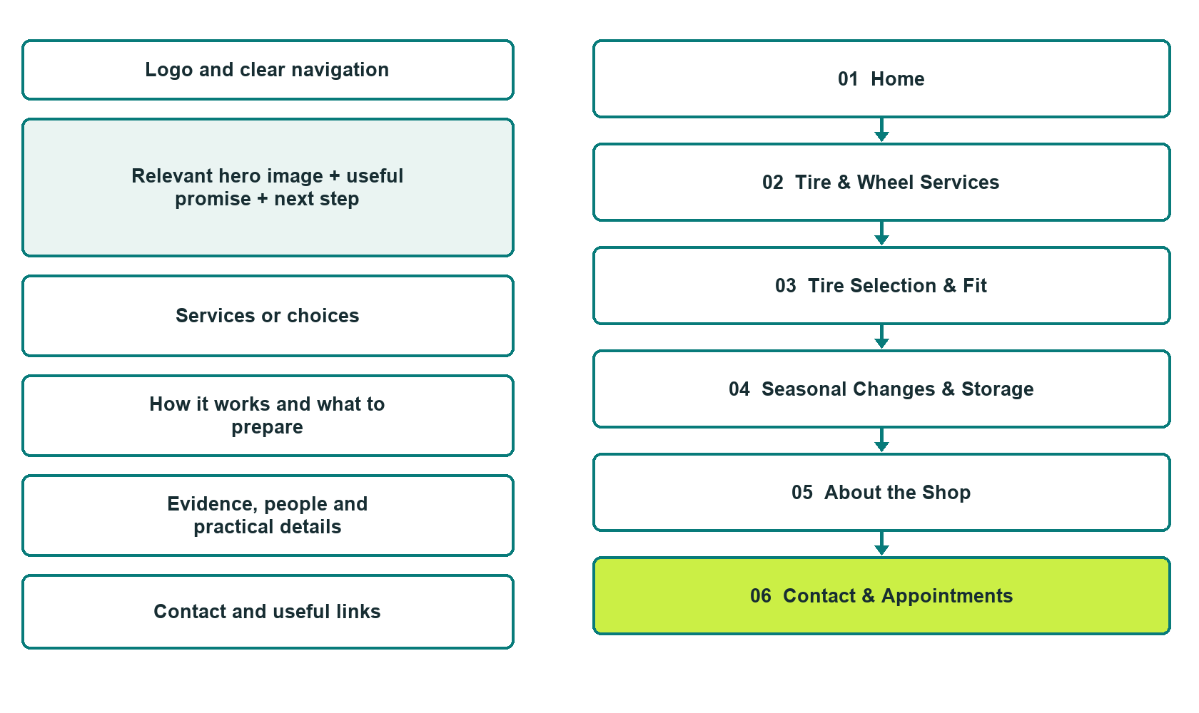

Plan → Draft → Build → Test
Demo-capture edition: actual Website Builder desktop previews and excerpts of the example wording. See each matching mobile preview in the industry page gallery. The example business and its AI-generated photographs are fictional.
Explore Website Builder and compare plans

Before you build
Your business supplies the facts. Prairie Tread Tire Centre is a fictional teaching example, not a live service.

□ Request a tire-service appointment
□ Technician-confirmed fitment and repair decisions
□ Clear estimates and approval of additional work
□ Choose original photographs and confirm permission to use them.
□ Keep private customer records out of public website forms.

Your audience and the action you want them to take

Facts to verify and people who must approve them
Create your SaaSTech account

01 Home
Give this page one clear job in the customer journey.
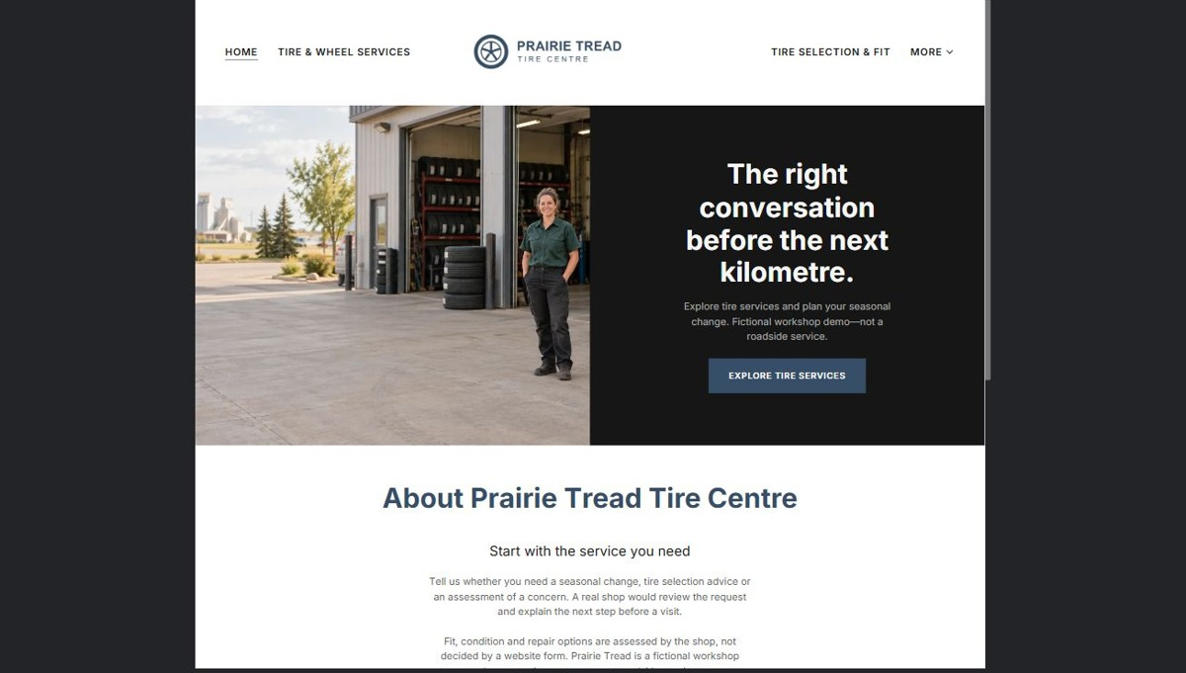
Actual desktop preview - unpublished fictional demonstration

Demo wording excerpt to adapt and verify
The right conversation before the next kilometre.
Explore tire services and plan your seasonal change. Fictional workshop demo—not a roadside service.
Tell us whether you need a seasonal change, tire selection advice or an assessment of a concern. A real shop would review the request and explain the next step before a visit.
Fit, condition and repair options are assessed by the shop, not decided by a website form. Prairie Tread is a fictional workshop demonstration, not an urgent roadside service.
Suggested button: Explore tire services

Website advice
Introduce fictional Prairie Tread Tire Centre. Highlight verified service categories and a clear appointment-request action. Do not imply emergency roadside coverage or same-day availability unless the real operator supports it.

Your draft: Home
Write in the voice of your own business. Use facts you can verify, not promises copied from the example.

Headline and short introduction

Main content and details visitors need

Button wording and destination

Photo choice, permission and facts still to confirm
Partner check: can someone unfamiliar with the business find a useful next step?

02 Tire & Wheel Services
Give this page one clear job in the customer journey.
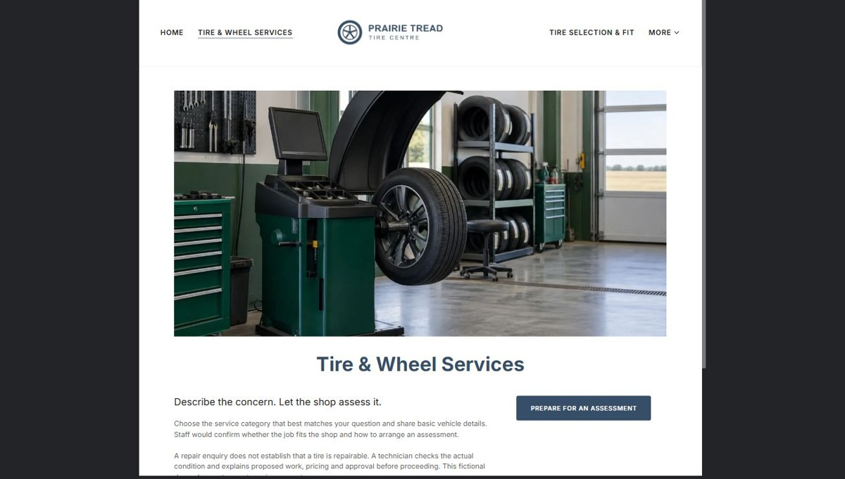
Actual desktop preview - unpublished fictional demonstration

Demo wording excerpt to adapt and verify
Describe the concern. Let the shop assess it.
Choose the service category that best matches your question and share basic vehicle details. Staff would confirm whether the job fits the shop and how to arrange an assessment.
A repair enquiry does not establish that a tire is repairable. A technician checks the actual condition and explains proposed work, pricing and approval before proceeding. This fictional demo does not accept service requests.
Suggested button: Prepare for an assessment

Website advice
Explain inspection, balancing, wheel services and tire-repair assessments only where provided. State that technicians assess suitability; do not promise every damaged tire can be repaired or publish do-it-yourself safety instructions.

Your draft: Tire & Wheel Services
Write in the voice of your own business. Use facts you can verify, not promises copied from the example.

Headline and short introduction

Main content and details visitors need

Button wording and destination

Photo choice, permission and facts still to confirm
Partner check: can someone unfamiliar with the business find a useful next step?

03 Tire Selection & Fit
Give this page one clear job in the customer journey.
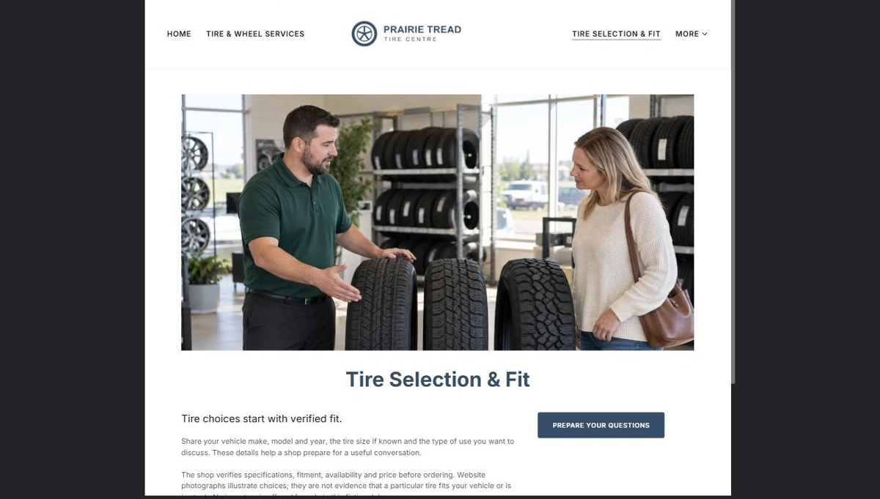
Actual desktop preview - unpublished fictional demonstration

Demo wording excerpt to adapt and verify
Tire choices start with verified fit.
Share your vehicle make, model and year, the tire size if known and the type of use you want to discuss. These details help a shop prepare for a useful conversation.
The shop verifies specifications, fitment, availability and price before ordering. Website photographs illustrate choices; they are not evidence that a particular tire fits your vehicle or is in stock. No inventory is offered for sale in this fictional demo.
Suggested button: Prepare your questions

Website advice
Explain the information staff needs to discuss compatible options: vehicle details, current tire size when known and intended use. Staff verifies fitment, specifications, availability and price before ordering; do not invent brand authorizations or live stock.

Your draft: Tire Selection & Fit
Write in the voice of your own business. Use facts you can verify, not promises copied from the example.

Headline and short introduction

Main content and details visitors need

Button wording and destination

Photo choice, permission and facts still to confirm
Partner check: can someone unfamiliar with the business find a useful next step?

04 Seasonal Changes & Storage
Give this page one clear job in the customer journey.
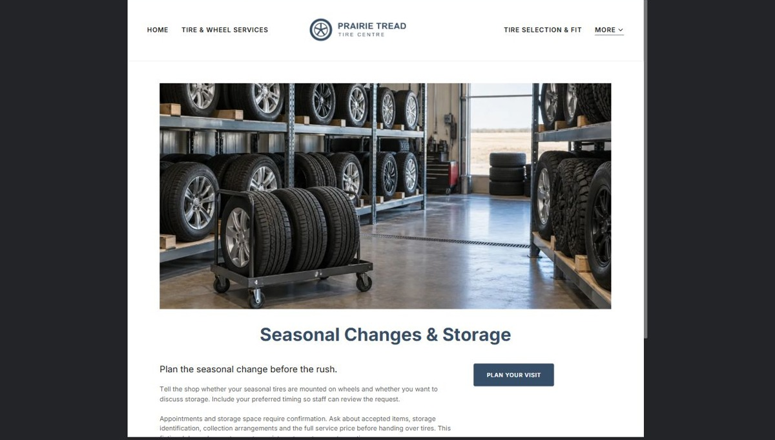
Actual desktop preview - unpublished fictional demonstration

Demo wording excerpt to adapt and verify
Plan the seasonal change before the rush.
Tell the shop whether your seasonal tires are mounted on wheels and whether you want to discuss storage. Include your preferred timing so staff can review the request.
Appointments and storage space require confirmation. Ask about accepted items, storage identification, collection arrangements and the full service price before handing over tires. This fictional demo does not accept appointments or store customer tires.
Suggested button: Plan your visit

Website advice
Describe on-rim and off-rim service requests, preparation steps and optional storage if offered. Explain how appointment and storage space are confirmed without publishing invented fees, capacities or turnaround times.

Your draft: Seasonal Changes & Storage
Write in the voice of your own business. Use facts you can verify, not promises copied from the example.

Headline and short introduction

Main content and details visitors need

Button wording and destination

Photo choice, permission and facts still to confirm
Partner check: can someone unfamiliar with the business find a useful next step?

05 About the Shop
Give this page one clear job in the customer journey.
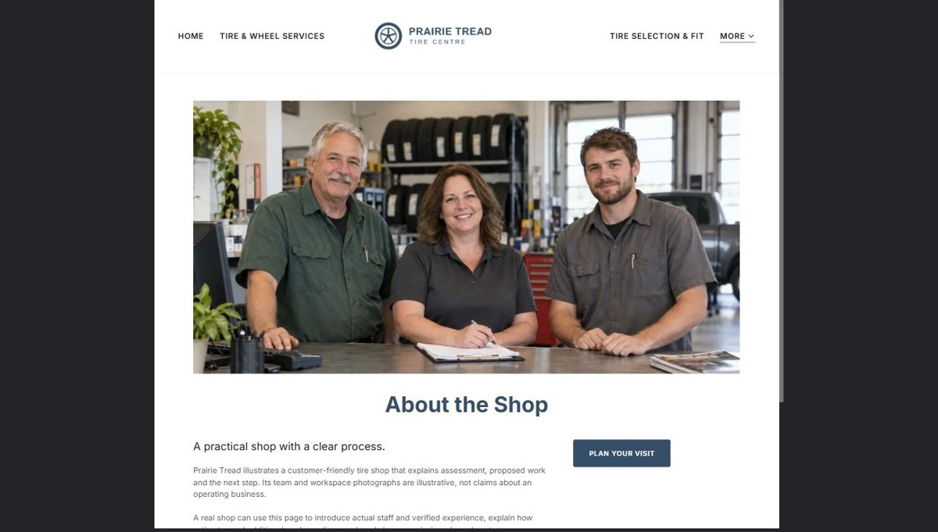
Actual desktop preview - unpublished fictional demonstration

Demo wording excerpt to adapt and verify
A practical shop with a clear process.
Prairie Tread illustrates a customer-friendly tire shop that explains assessment, proposed work and the next step. Its team and workspace photographs are illustrative, not claims about an operating business.
A real shop can use this page to introduce actual staff and verified experience, explain how estimates and additional work are discussed, and share permission-cleared customer comments. Clear expectations help customers arrive prepared.
Suggested button: Plan your visit

Website advice
Introduce the people and service process with original shop photography and verified experience. Use real qualifications only; explain how estimates and additional work are discussed with customers.

Your draft: About the Shop
Write in the voice of your own business. Use facts you can verify, not promises copied from the example.

Headline and short introduction

Main content and details visitors need

Button wording and destination

Photo choice, permission and facts still to confirm
Partner check: can someone unfamiliar with the business find a useful next step?

06 Contact & Appointments
Give this page one clear job in the customer journey.
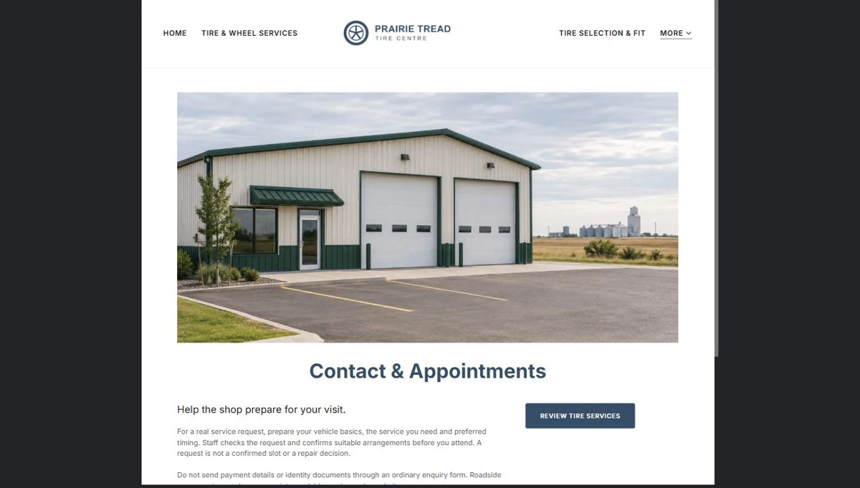
Actual desktop preview - unpublished fictional demonstration

Demo wording excerpt to adapt and verify
Help the shop prepare for your visit.
For a real service request, prepare your vehicle basics, the service you need and preferred timing. Staff checks the request and confirms suitable arrangements before you attend. A request is not a confirmed slot or a repair decision.
Do not send payment details or identity documents through an ordinary enquiry form. Roadside emergencies need an appropriate roadside service, not a website message.
This fictional workshop demo has no operating shop, contact form or appointment service. No requests, bookings or payments are accepted.
Suggested button: Review tire services

Website advice
Publish confirmed hours, directions and contact options. Collect vehicle basics, service need and preferred timing. State that requests need confirmation and that the form is not monitored for urgent roadside assistance.

Your draft: Contact & Appointments
Write in the voice of your own business. Use facts you can verify, not promises copied from the example.

Headline and short introduction

Main content and details visitors need

Button wording and destination

Photo choice, permission and facts still to confirm
Partner check: can someone unfamiliar with the business find a useful next step?

Test before publishing
Review the whole journey on a desktop and phone. The industry page pairs each desktop capture with its mobile preview and provides the complete sample page copy.
□ Verify all services, stock statements, storage claims and appointment rules with the operator.
□ Test the request form and explicitly separate requests from confirmed bookings.
□ Do not include blanket repair promises, unverified fitment recommendations or emergency response claims.
□ Keep vehicle documents, payment details and private customer records off public forms.
□ Use compressed, distinct images and test directions and contact links on a phone.
□ Check every link, form destination, download and confirmation message.
□ Check logo contrast, hero framing, text sizes and image loading.
□ Save a named backup and assign a content-review date.

Changes to finish and person responsible

Approval and next review date
Website Builder plans and signup

