

Tattoo & Piercing Studios
Website workbook
A practical workshop for a 6-page website. Study the example, plan the content and draft your own version in Word or on paper.
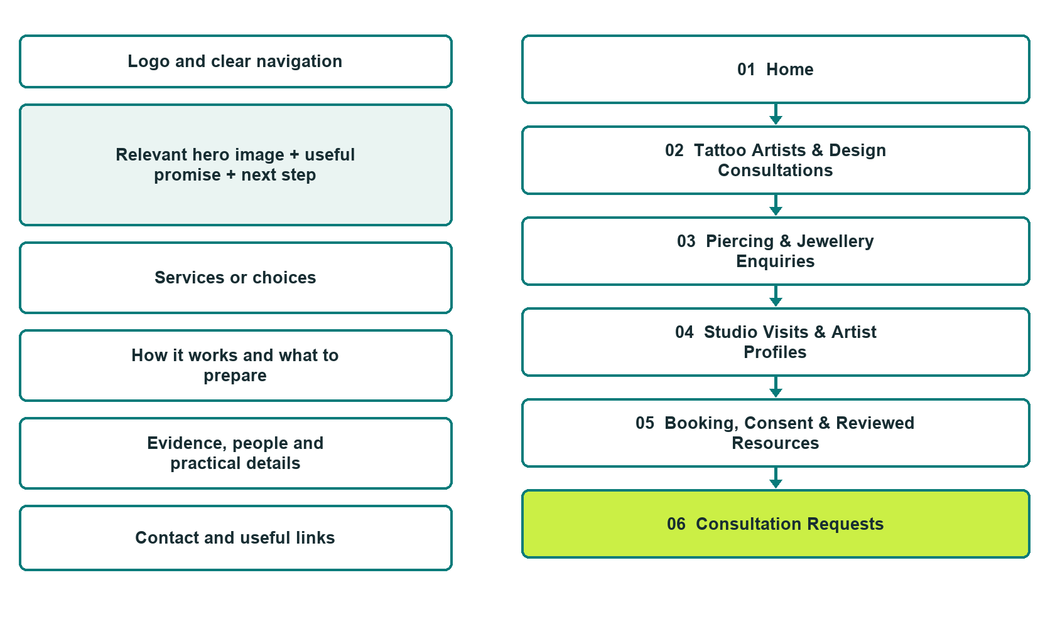

Plan → Draft → Build → Test
Captured demo edition. Study the unpublished six-page Website Builder example. Paired desktop and mobile previews, Editor Highlights, Themes and Paint comparisons appear on the industry page.
Explore Website Builder and compare plans

Before you build
Your business supplies the facts. Prairie Ink & Adornment is a fictional teaching example. Keep the demo unpublished, with no fabricated contact details, bookings or payments. Do not submit the demo form.

□ Ask about a tattoo or piercing consultation
□ Verified business identity, services and current contact information
□ A clear enquiry, review and confirmation process
□ Choose original photographs and confirm permission to use them.
□ Keep private customer records out of public website forms.

Your audience and the action you want them to take

Facts to verify and people who must approve them
Create your SaaSTech account

01 Home
Give this page one clear job in the customer journey.
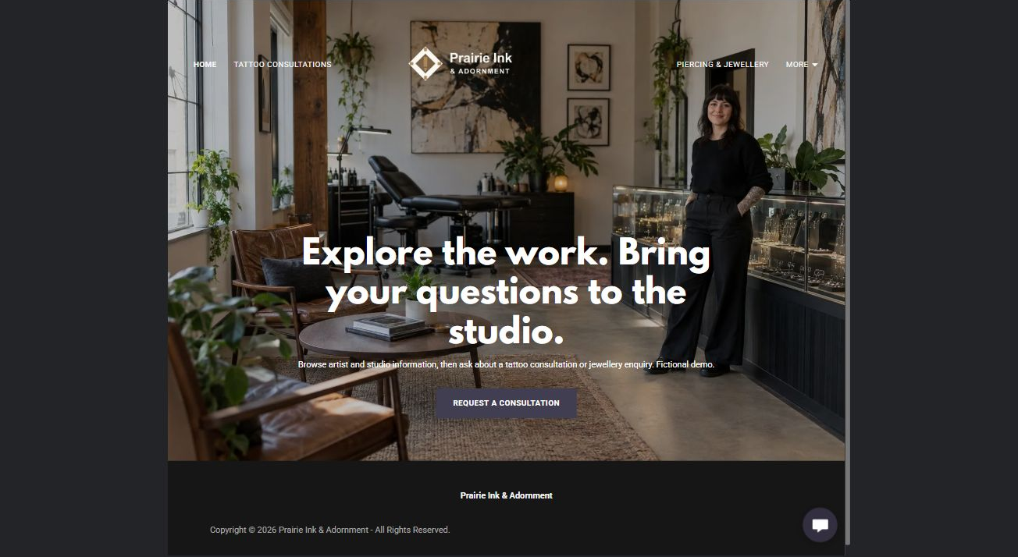
Actual desktop Website Builder preview. Open the industry gallery for the paired mobile view.

Sample wording — adapt and verify
Explore the work. Bring your questions to the studio.
Browse artist and studio information, then ask about a tattoo consultation or jewellery enquiry. Fictional demo.
The studio confirms service scope, private consultation requirements and booking terms before an appointment is accepted.
Home button: Request a consultation. It opens Consultation Requests in the unpublished demo.

Website advice
Separate tattoo design consultations and piercing-service enquiries with original permission-cleared portfolios and operator-reviewed studio policies.

Your draft: Home
Write in the voice of your own business. Use facts you can verify, not promises copied from the example.

Headline and short introduction

Main content and details visitors need

Button wording and destination

Photo choice, permission and facts still to confirm
Partner check: can someone unfamiliar with the business find a useful next step?

02 Tattoo Artists & Design Consultations
Give this page one clear job in the customer journey.
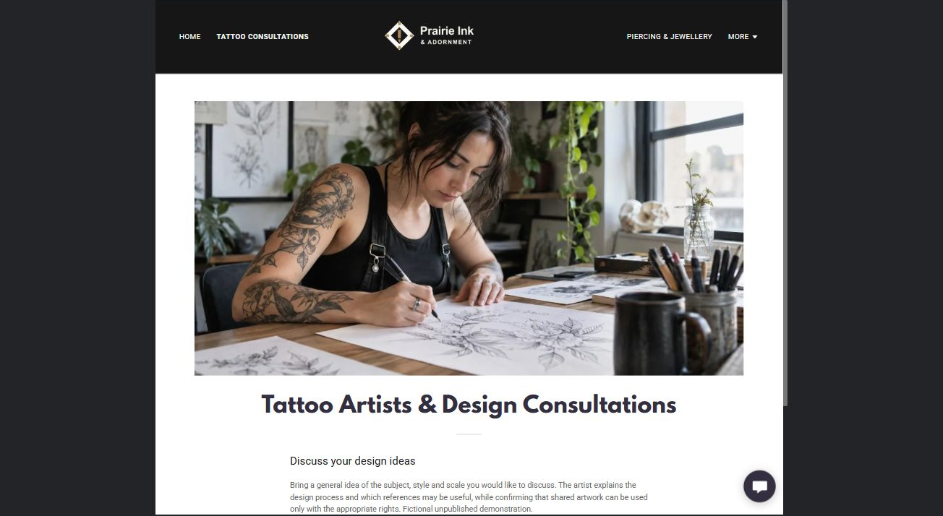
Actual desktop Website Builder preview. Open the industry gallery for the paired mobile view.

Sample wording — adapt and verify
Tattoo Artists & Design Consultations
Bring a general idea of the subject, style and scale you would like to discuss.
The artist explains the design process and which references may be useful, while confirming that shared artwork can be used only with the appropriate rights.
Suggested button: Ask about a tattoo or piercing consultation

Website advice
Present original credited portfolios and explain concept review without promising identical reproduction of another artist’s work.

Your draft: Tattoo Artists & Design Consultations
Write in the voice of your own business. Use facts you can verify, not promises copied from the example.

Headline and short introduction

Main content and details visitors need

Button wording and destination

Photo choice, permission and facts still to confirm
Partner check: can someone unfamiliar with the business find a useful next step?

03 Piercing & Jewellery Enquiries
Give this page one clear job in the customer journey.
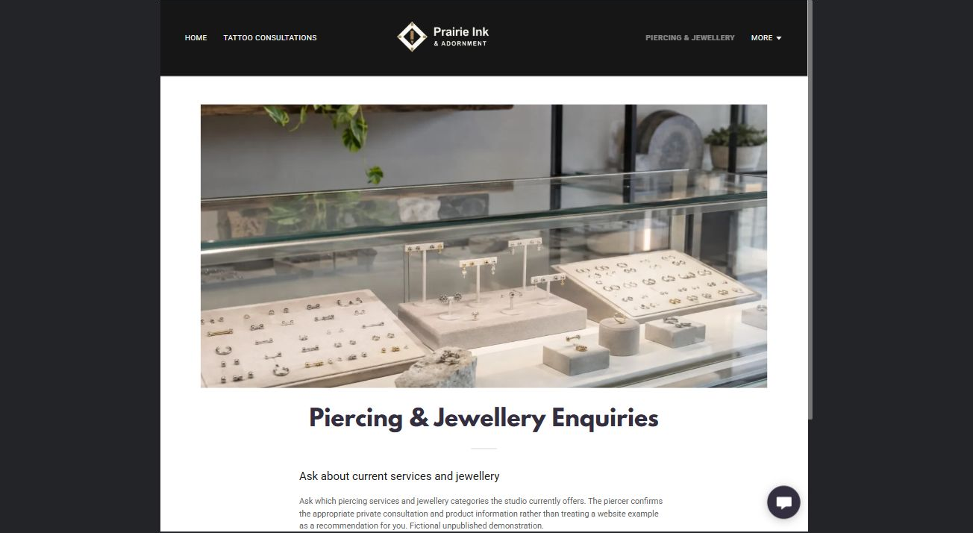
Actual desktop Website Builder preview. Open the industry gallery for the paired mobile view.

Sample wording — adapt and verify
Piercing & Jewellery Enquiries
Ask which piercing services and jewellery categories the studio currently offers.
The piercer confirms the appropriate private consultation and product information rather than treating a website example as a recommendation for you.
Suggested button: Ask about a tattoo or piercing consultation

Website advice
Separate piercing appointments, jewellery browsing and existing-client questions without suitability or material guarantees.

Your draft: Piercing & Jewellery Enquiries
Write in the voice of your own business. Use facts you can verify, not promises copied from the example.

Headline and short introduction

Main content and details visitors need

Button wording and destination

Photo choice, permission and facts still to confirm
Partner check: can someone unfamiliar with the business find a useful next step?

04 Studio Visits & Artist Profiles
Give this page one clear job in the customer journey.
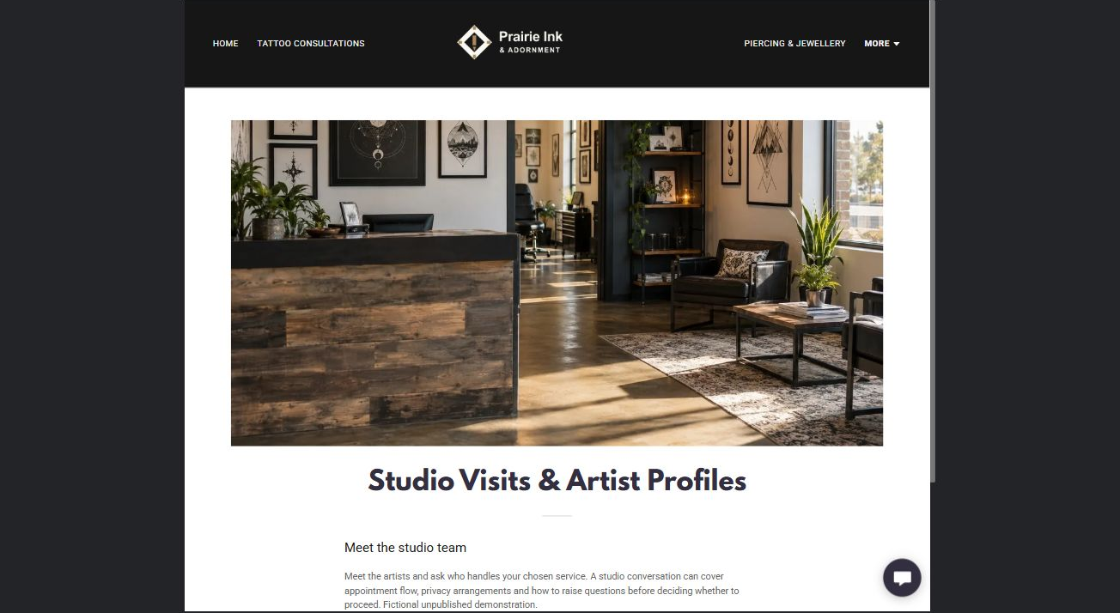
Actual desktop Website Builder preview. Open the industry gallery for the paired mobile view.

Sample wording — adapt and verify
Studio Visits & Artist Profiles
Meet the artists and ask who handles your chosen service.
A studio conversation can cover appointment flow, privacy arrangements and how to raise questions before deciding whether to proceed.
Suggested button: Ask about a tattoo or piercing consultation

Website advice
Describe the physical setting and verified staff responsibilities without invented credentials or inspection claims.

Your draft: Studio Visits & Artist Profiles
Write in the voice of your own business. Use facts you can verify, not promises copied from the example.

Headline and short introduction

Main content and details visitors need

Button wording and destination

Photo choice, permission and facts still to confirm
Partner check: can someone unfamiliar with the business find a useful next step?

05 Booking, Consent & Reviewed Resources
Give this page one clear job in the customer journey.
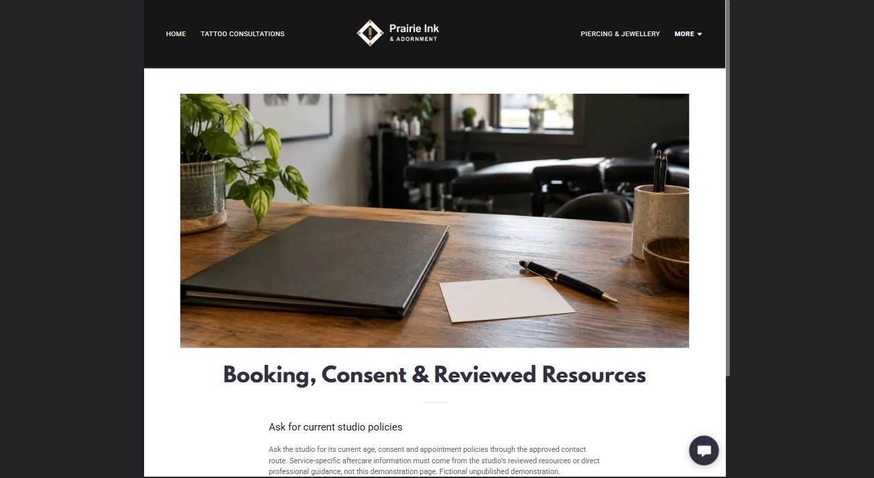
Actual desktop Website Builder preview. Open the industry gallery for the paired mobile view.

Sample wording — adapt and verify
Booking, Consent & Reviewed Resources
Ask the studio for its current age, consent and appointment policies through the approved contact route.
Service-specific aftercare information must come from the studio’s reviewed resources or direct professional guidance, not this demonstration page.
Suggested button: Ask about a tattoo or piercing consultation

Website advice
Create a policy and resource index requiring local operator review; do not draft consent or aftercare instructions.

Your draft: Booking, Consent & Reviewed Resources
Write in the voice of your own business. Use facts you can verify, not promises copied from the example.

Headline and short introduction

Main content and details visitors need

Button wording and destination

Photo choice, permission and facts still to confirm
Partner check: can someone unfamiliar with the business find a useful next step?

06 Consultation Requests
Give this page one clear job in the customer journey.
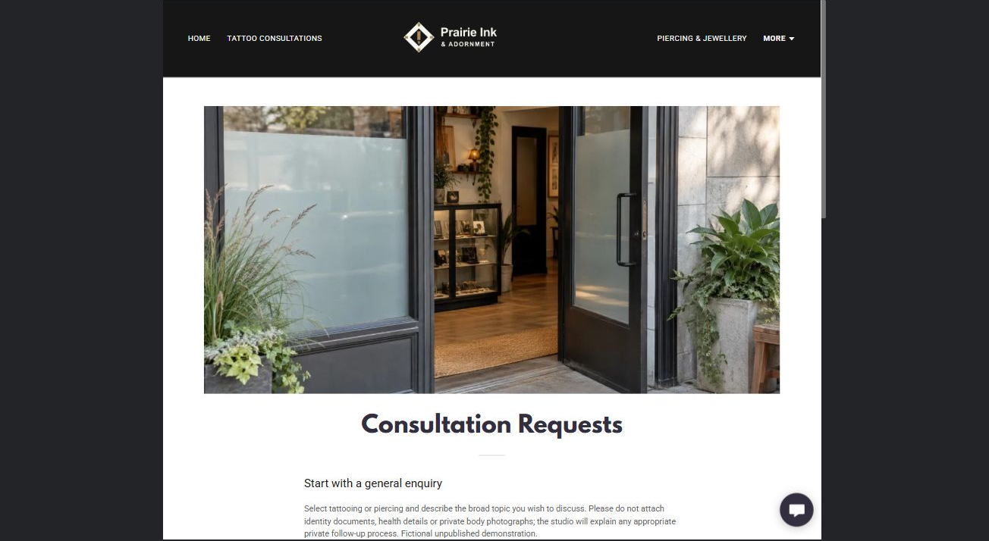
Actual desktop Website Builder preview. Open the industry gallery for the paired mobile view.

Sample wording — adapt and verify
Consultation Requests
Select tattooing or piercing and describe the broad topic you wish to discuss.
Please do not attach identity documents, health details or private body photographs; the studio will explain any appropriate private follow-up process.
Suggested button: Ask about a tattoo or piercing consultation

Website advice
The actual demo form uses Name, required Email, general tattoo or piercing interest, and other notes. Phone and attachments are off. Do not send identity documents, health histories or private body photographs. Its recipient is blank; no submission or delivery test was performed. Confirm delivery and privacy wording before a real launch. An enquiry does not confirm an appointment.

Your draft: Consultation Requests
Write in the voice of your own business. Use facts you can verify, not promises copied from the example.

Headline and short introduction

Main content and details visitors need

Button wording and destination

Photo choice, permission and facts still to confirm
Partner check: can someone unfamiliar with the business find a useful next step?

Test before publishing
Review the captured journey on desktop and phone. The fictional demo remains unpublished. Review the intended recipient, privacy wording, operator approval and confirmation process before any real launch.
□ Fictional demonstration only. Verify local age and consent requirements, artist roles, studio policies and service availability. No procedure, medical or aftercare advice. Publish only professionally reviewed aftercare resources; do not collect identity documents, health histories or intimate images through public forms.
□ Verify every service description, contact route and operating detail.
□ Replace fictional identity and example information before a live launch.
□ Visually check the demonstration form, links and downloads on desktop and mobile without submitting the form.
□ Keep confidential records in approved private systems.
□ Obtain operator approval for public wording and images.
□ Confirm the intended private form recipient before launch. Keep attachments off and review the confirmation message; an enquiry must not imply a booking or accepted order.
□ Check logo contrast, hero framing, text sizes and image loading.
□ Save a named backup and assign a content-review date.

Changes to finish and person responsible

Approval and next review date
Website Builder plans and signup

