
WEBSITE PLANNING WORKSHOP

Sports Clubs & Teams
Website workbook
Plan a clear website for sports clubs & teams. Explore a worked example, shape your own message and prepare to build with SaaSTech Servers.
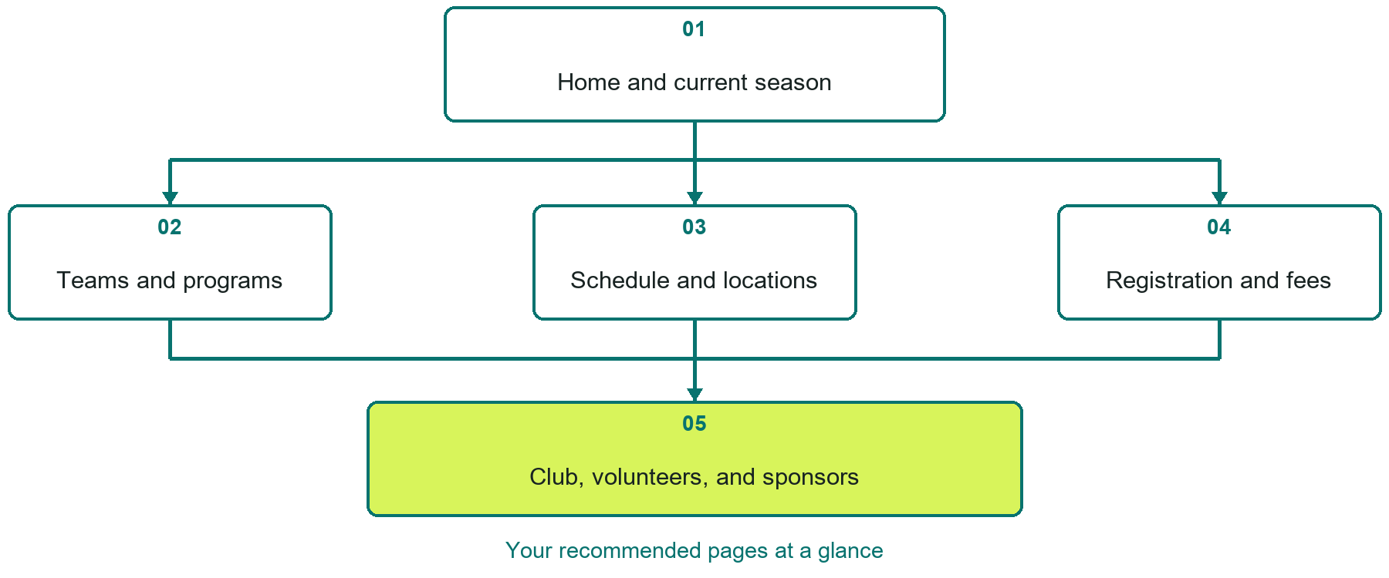

Inside this workbook
Five page examples • Practical writing exercises • A launch review
Use it in a workshop or at your own pace. Write by hand or complete the response fields in Word. The final page links to Website Builder, plans and account signup.
Example business Prairie Summit Athletics

SPORTS CLUBS & TEAMS

Your website brief
A SaaSTech Servers workshop for sports clubs & teams. Plan your website, learn from the Prairie Summit Athletics example and draft content for your own business.
Each page has a reference sheet followed by a writing sheet. Demo excerpts are labelled separately from new sample wording, which may differ from the screenshot. Click a blank response line to type; longer answers may add pages. Replace fictional details and verify every claim before publishing.
Your business or organization and workshop date

Who should visit your site and what do they need

The main action you want a visitor to take

What you offer and where or how you provide it

Facts photos and permissions to gather before publishing

Workshop rhythm: review the example, write your draft and exchange feedback. Use the final review to choose your next changes. Website Builder and account links are on the last page.

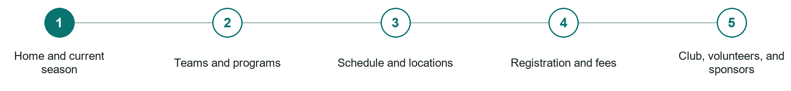
LOOK AND LEARN

Home and current season

The job of this page
Lead with registration status, the next important date, schedule access, locations, and current announcements.
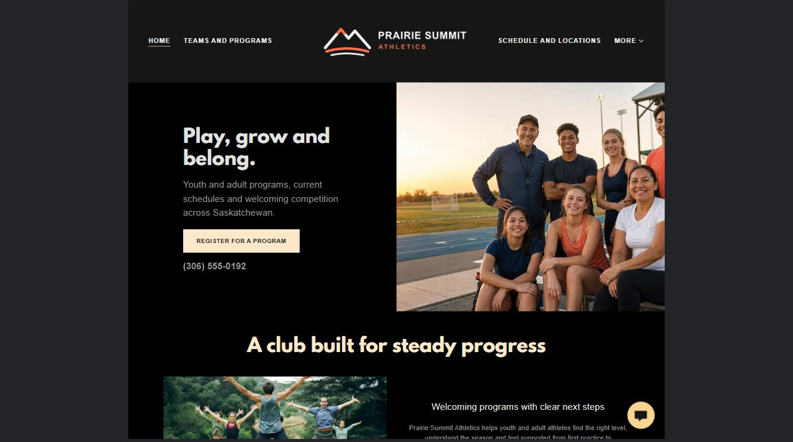
Prairie Summit Athletics example | Explore SaaSTech Website Builder

Sample wording to adapt
Find your place this season
Explore the teams, programs and current season information. Check eligibility, schedules and registration steps before joining. Contact the club with practical participation questions.

Pause and plan
Which dates and locations need to stay current? Decide who will update changes and where visitors should check before travelling. Separate archived information and illustrative schedules from current availability.

WRITE YOUR PAGE

Home and current season
Write for your visitor. Be specific about what they need to know and what happens next. You can revise the wording after the workshop.
Your page headline

Your opening paragraph

Dates locations update process and participation details

Button or link wording and where it should lead

Photo idea caption and permission or credit needed

Facts to verify or questions to resolve

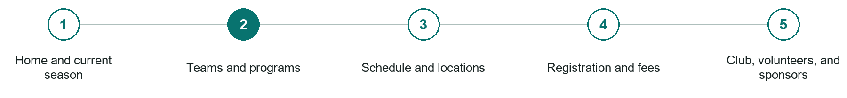
LOOK AND LEARN

Teams and programs

The job of this page
Describe age groups, levels, seasons, eligibility, coaches, capacity, and the commitment expected.
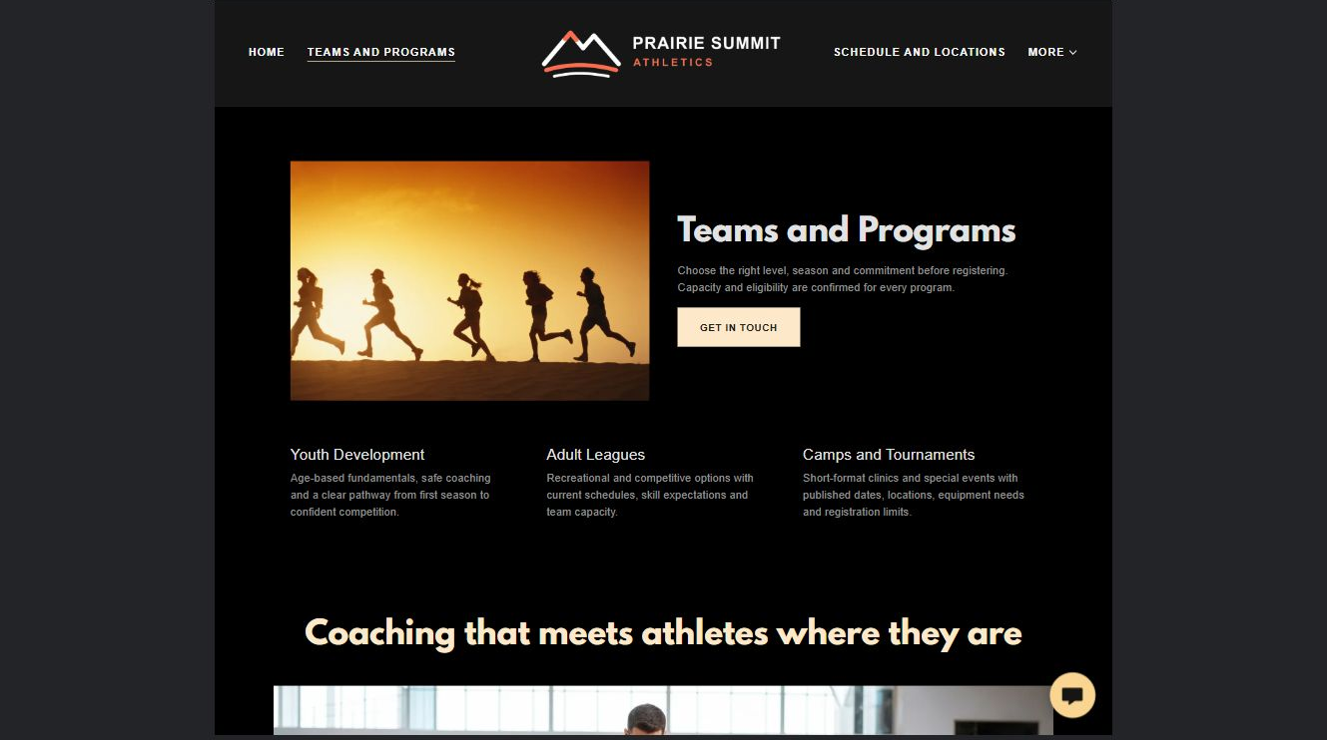
Prairie Summit Athletics example | Explore SaaSTech Website Builder

Sample wording to adapt
Choose a team or program
Read the age group, experience level and commitment for each option. Ask about current capacity and the registration process. A program listing does not guarantee a place.

Pause and plan
Which names, roles and qualifications can you verify? What would help a visitor feel comfortable contacting you? Obtain permission for portraits and describe actual experience without unsupported claims.

WRITE YOUR PAGE

Teams and programs
Write for your visitor. Be specific about what they need to know and what happens next. You can revise the wording after the workshop.
Your page headline

Your opening paragraph

People roles approach and verified credentials to introduce

Button or link wording and where it should lead

Photo idea caption and permission or credit needed

Facts to verify or questions to resolve

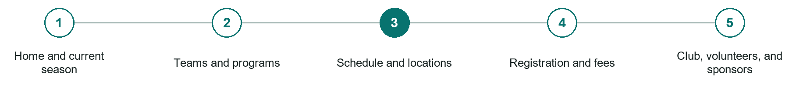
LOOK AND LEARN

Schedule and locations

The job of this page
Publish current games, practices, tournaments, venue maps, weather policies, and update times.
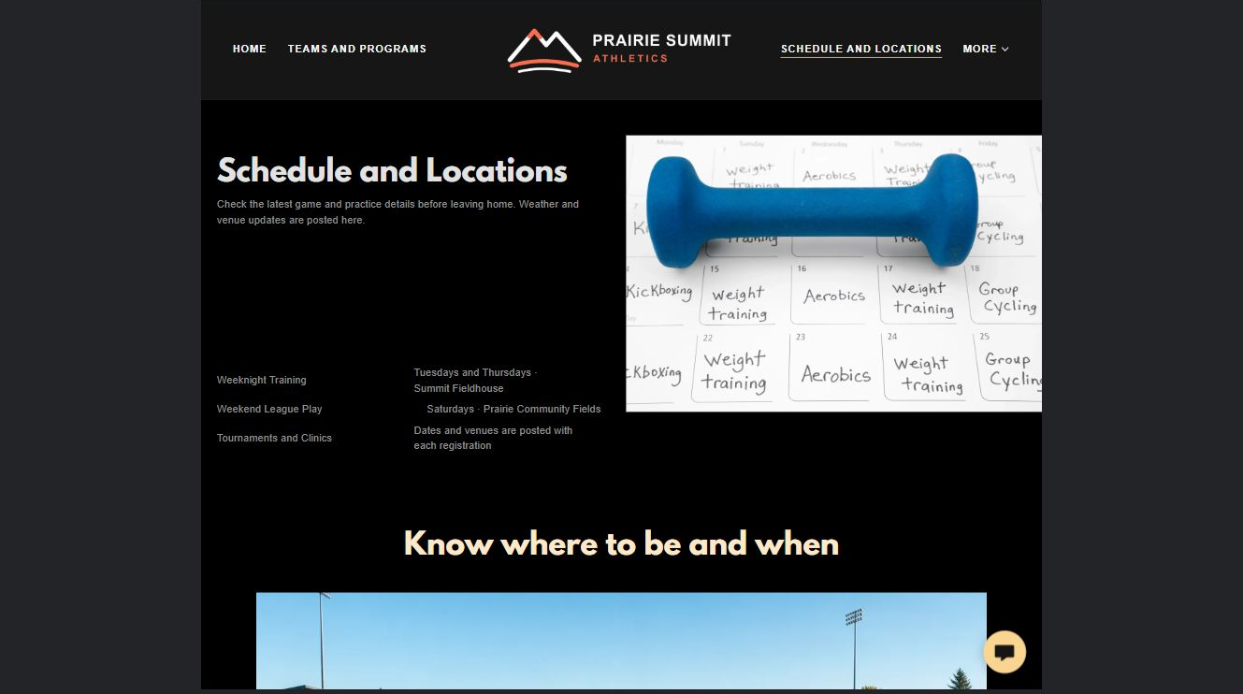
Prairie Summit Athletics example | Explore SaaSTech Website Builder

Sample wording to adapt
Check the latest schedule
Confirm the date, time and location before travelling. Follow the club's current update channel for changes. Keep archived fixtures separate from the active season.

Pause and plan
Which dates and locations need to stay current? Decide who will update changes and where visitors should check before travelling. Separate archived information and illustrative schedules from current availability.

WRITE YOUR PAGE

Schedule and locations
Write for your visitor. Be specific about what they need to know and what happens next. You can revise the wording after the workshop.
Your page headline

Your opening paragraph

Dates locations update process and participation details

Button or link wording and where it should lead

Photo idea caption and permission or credit needed

Facts to verify or questions to resolve

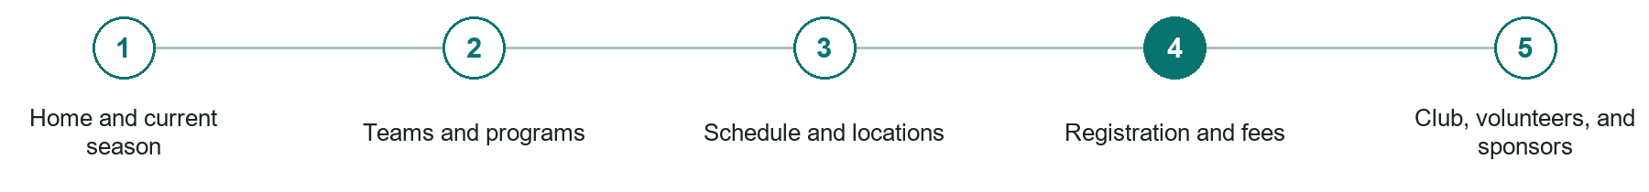
LOOK AND LEARN

Registration and fees

The job of this page
Explain costs, deadlines, equipment, waivers, refunds, financial assistance, and what happens after registration.
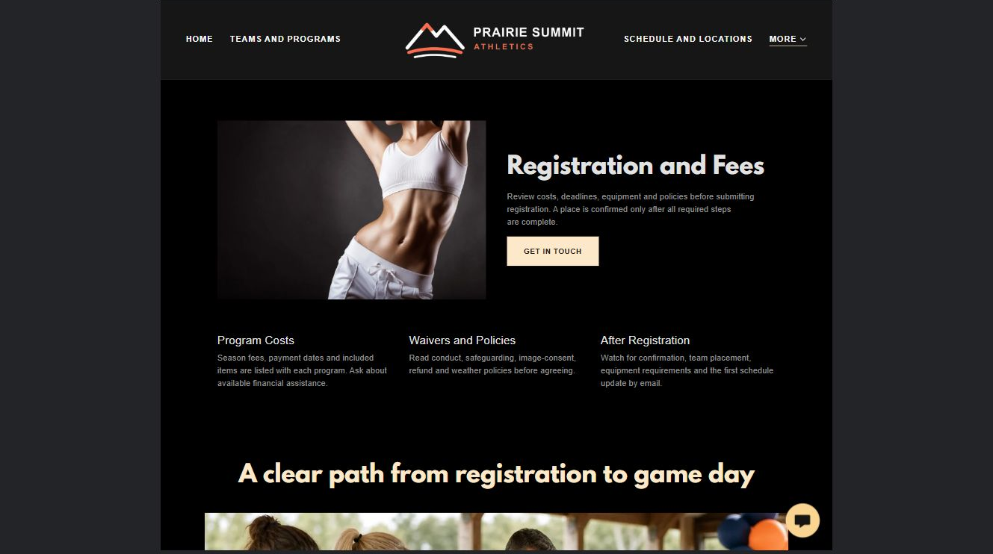
Prairie Summit Athletics example | Explore SaaSTech Website Builder

Sample wording to adapt
Know what registration includes
Review fees, equipment needs, deadlines and applicable policies before registering. Ask how a place is confirmed. Use the club's approved private process for sensitive participant information.

Pause and plan
What must someone provide, and what happens after they send it? Separate a request from a confirmed booking, order or place. Decide what information should stay out of a public form.

WRITE YOUR PAGE

Registration and fees
Write for your visitor. Be specific about what they need to know and what happens next. You can revise the wording after the workshop.
Your page headline

Your opening paragraph

Information to request and how you will reply or confirm

Button or link wording and where it should lead

Photo idea caption and permission or credit needed

Facts to verify or questions to resolve

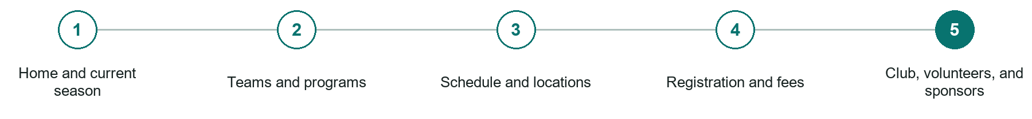
LOOK AND LEARN

Club volunteers and sponsors

The job of this page
Show governance, conduct, safeguarding, volunteer roles, sponsorship options, and contact paths.
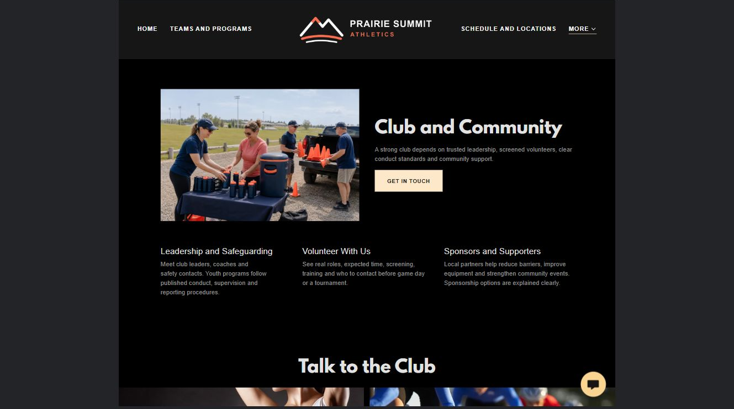
Prairie Summit Athletics example | Explore SaaSTech Website Builder

Sample wording to adapt
Support the club community
Explore volunteer roles and sponsorship opportunities. Ask about responsibilities, time commitments and any screening requirements before taking part. Publish volunteer or player photographs only with permission.

Pause and plan
What question brings a visitor to this page? List the details they need, the evidence you can provide and the next useful action. Remove content that does not help them decide or proceed.

WRITE YOUR PAGE

Club volunteers and sponsors
Write for your visitor. Be specific about what they need to know and what happens next. You can revise the wording after the workshop.
Your page headline

Your opening paragraph

Key sections visitor questions and supporting details

Button or link wording and where it should lead

Photo idea caption and permission or credit needed

Facts to verify or questions to resolve

WORKSHOP CLOSE

Review and next steps
Ask a partner to read your draft as a first-time visitor. Can they explain what you offer, who it is for and the next step without extra help?

Before you publish
[ ] Every page has a clear purpose and a useful next step.
[ ] Headlines are specific and the wording sounds like your business.
[ ] Names, service areas, prices, dates and policies have been checked.
[ ] Credentials, testimonials and results are genuine and permission-cleared.
[ ] Photos support the text, do not repeat needlessly and have appropriate permissions.
[ ] Forms ask only for necessary information and explain what happens next.
[ ] Links, downloads and the main visitor task work on a phone.
The most useful feedback from your workshop partner

First change to make and who will do it

Information or photographs still needed

Target review date and who will approve the final content

Keep sensitive customer, patient, employee and payment information out of this workbook. Completing it does not publish a website or connect to Website Builder.

BUILD WITH SAASTECH SERVERS

Put your draft into Website Builder
Use the content you have written to build your own site. Keep the sports clubs & teams demo as a reference, and replace its company name, images and claims with your verified business information.

Explore the builder
See the editor, compare available plans and decide which features your business needs. Confirm current pricing and terms before purchasing.
Website Builder overview

Create your account
Set up your SaaSTech Servers customer account using your own details. Creating an account is separate from purchasing a Website Builder plan.
Create your SaaSTech account

Choose your plan
Open the secure shop to review the plan, subscription term and final total. Use the account connected to your purchase when you open your service.
View Website Builder plans

Build and check your pages
Add the pages from this workbook. Transfer your approved wording, upload permission-cleared photos and review each page on desktop and mobile before publishing.
Return to the Website Builder guide

Using a printed workbook
Type these short addresses into your browser. The account guide includes the Create My Account button.
www.saastech.net/products/website-builder
www.saastech.net/create-account
This workbook does not create an account, purchase a plan or publish your website. Keep passwords, payment details and confidential customer information out of your draft.

