

Solar, Backup Power & EV Charging Installers
Website workbook
A practical workshop for a 6-page website. Study the example, plan the content and draft your own version in Word or on paper.
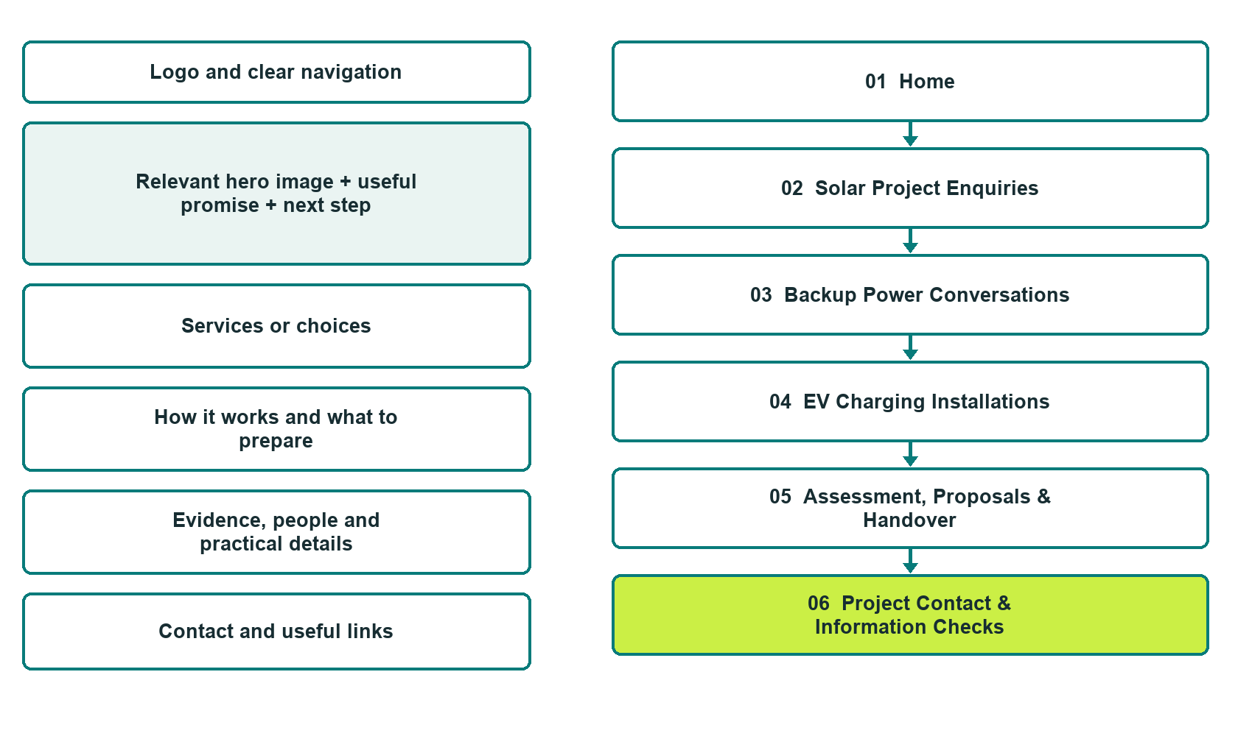

Plan → Draft → Build → Test
Captured demo edition. Study the unpublished six-page Website Builder example. Paired desktop/mobile previews, Editor Highlights, Themes and Paint comparisons appear on the industry page.
Explore Website Builder and compare plans

Before you build
Your business supplies the facts. Prairie Current Projects is a fictional teaching example, not a live service.

□ Request a project assessment conversation
□ Verified business identity, services and current contact information
□ A clear enquiry, review and confirmation process
□ Choose original photographs and confirm permission to use them.
□ Keep private customer records out of public website forms.

Your audience and the action you want them to take

Facts to verify and people who must approve them
Create your SaaSTech account

01 Home
Give this page one clear job in the customer journey.
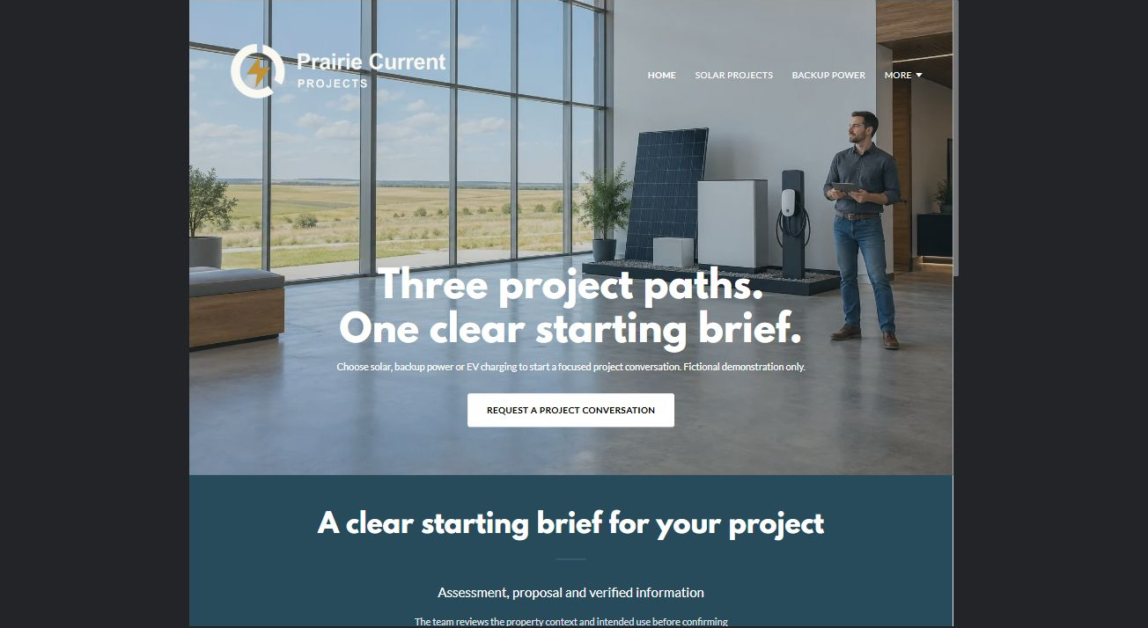
Actual desktop Website Builder preview. Open the industry gallery for the paired mobile view.

Sample wording — adapt and verify
Three project paths. One clear starting brief.
Choose solar, backup power or EV charging to start a focused project conversation.
The team reviews the property context and intended use before confirming assessment requirements and any proposal.
Suggested Home button: Request a project conversation. Route to the reviewed project-enquiry form.

Website advice
Separate solar generation, backup-power and EV-charging projects with qualified assessment, proposal review and verified equipment information.

Your draft: Home
Write in the voice of your own business. Use facts you can verify, not promises copied from the example.

Headline and short introduction

Main content and details visitors need

Button wording and destination

Photo choice, permission and facts still to confirm
Partner check: can someone unfamiliar with the business find a useful next step?

02 Solar Project Enquiries
Give this page one clear job in the customer journey.
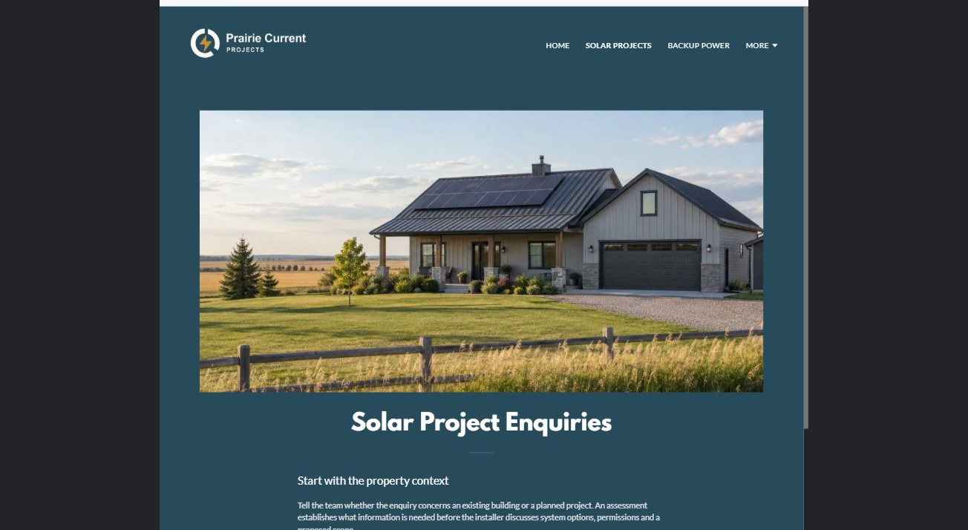
Actual desktop Website Builder preview. Open the industry gallery for the paired mobile view.

Sample wording — adapt and verify
Start with the property context
Tell the team whether the enquiry concerns an existing building or a planned project.
An assessment establishes what information is needed before the installer discusses system options, permissions and a proposed scope.
Suggested Home button: Request a project conversation. Route to the reviewed project-enquiry form.

Website advice
Discuss property context and project goals without estimating production, payback or incentive eligibility.

Your draft: Solar Project Enquiries
Write in the voice of your own business. Use facts you can verify, not promises copied from the example.

Headline and short introduction

Main content and details visitors need

Button wording and destination

Photo choice, permission and facts still to confirm
Partner check: can someone unfamiliar with the business find a useful next step?

03 Backup Power Conversations
Give this page one clear job in the customer journey.
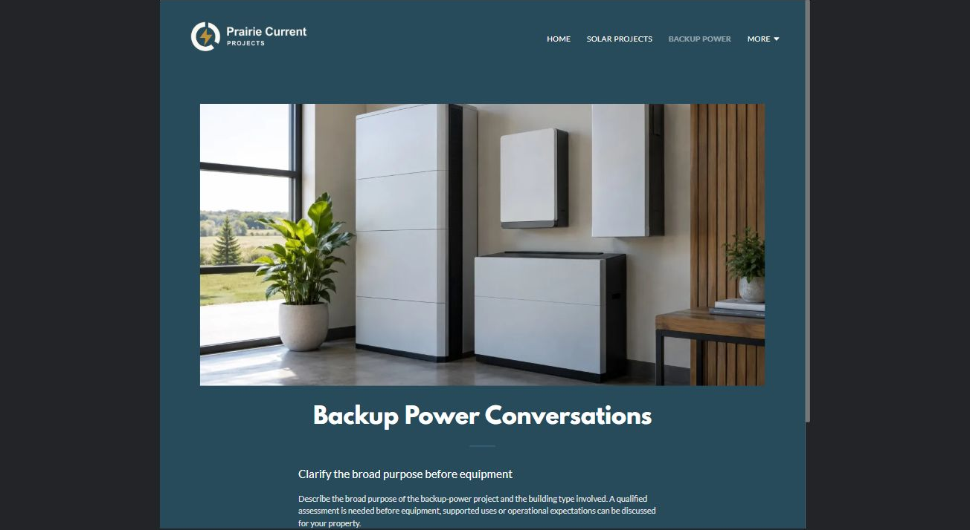
Actual desktop Website Builder preview. Open the industry gallery for the paired mobile view.

Sample wording — adapt and verify
Clarify the broad purpose before equipment
Describe the broad purpose of the backup-power project and the building type involved.
A qualified assessment is needed before equipment, supported uses or operational expectations can be discussed for your property.
Suggested Home button: Request a project conversation. Route to the reviewed project-enquiry form.

Website advice
Distinguish backup-power project planning from solar and avoid equipment sizing or runtime promises.

Your draft: Backup Power Conversations
Write in the voice of your own business. Use facts you can verify, not promises copied from the example.

Headline and short introduction

Main content and details visitors need

Button wording and destination

Photo choice, permission and facts still to confirm
Partner check: can someone unfamiliar with the business find a useful next step?

04 EV Charging Installations
Give this page one clear job in the customer journey.
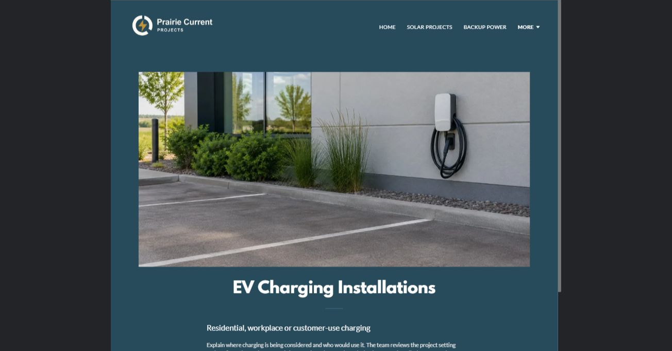
Actual desktop Website Builder preview. Open the industry gallery for the paired mobile view.

Sample wording — adapt and verify
Residential, workplace or customer-use charging
Explain where charging is being considered and who would use it.
The team reviews the project setting and confirms the equipment and site questions that need resolution before an installation proposal is prepared.
Suggested Home button: Request a project conversation. Route to the reviewed project-enquiry form.

Website advice
Separate residential, workplace and customer-use charging enquiries without promising vehicle compatibility.

Your draft: EV Charging Installations
Write in the voice of your own business. Use facts you can verify, not promises copied from the example.

Headline and short introduction

Main content and details visitors need

Button wording and destination

Photo choice, permission and facts still to confirm
Partner check: can someone unfamiliar with the business find a useful next step?

05 Assessment, Proposals & Handover
Give this page one clear job in the customer journey.
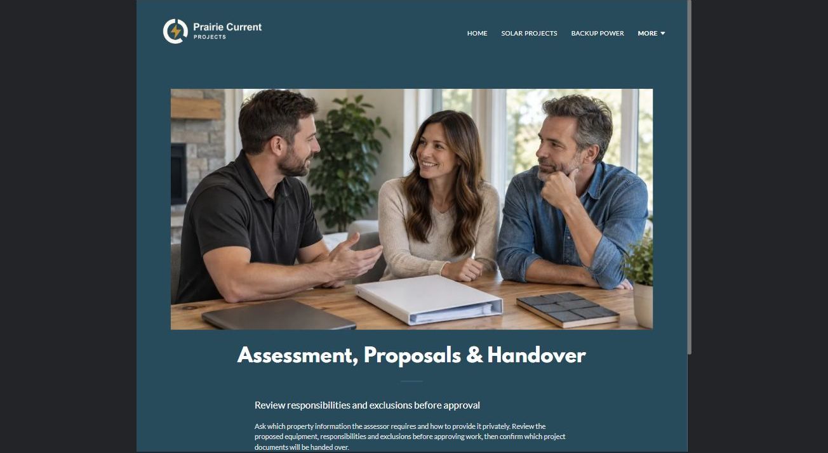
Actual desktop Website Builder preview. Open the industry gallery for the paired mobile view.

Sample wording — adapt and verify
Review responsibilities and exclusions before approval
Ask which property information the assessor requires and how to provide it privately.
Review the proposed equipment, responsibilities and exclusions before approving work, then confirm which project documents will be handed over.
Suggested Home button: Request a project conversation. Route to the reviewed project-enquiry form.

Website advice
Explain records, scope decisions, applicable external approvals and handover documents at a nontechnical level.

Your draft: Assessment, Proposals & Handover
Write in the voice of your own business. Use facts you can verify, not promises copied from the example.

Headline and short introduction

Main content and details visitors need

Button wording and destination

Photo choice, permission and facts still to confirm
Partner check: can someone unfamiliar with the business find a useful next step?

06 Project Contact & Information Checks
Give this page one clear job in the customer journey.
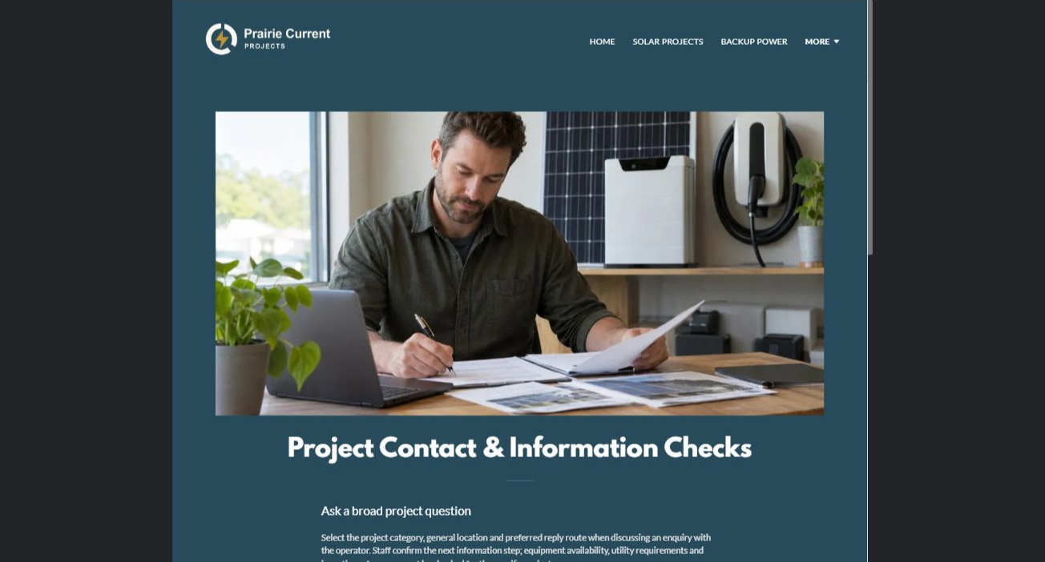
Actual desktop Website Builder preview. Open the industry gallery for the paired mobile view.

Sample wording — adapt and verify
Ask a broad project question
When discussing a project with the operator, explain the project category, general location and preferred reply method.
Staff confirm the next conversation; any equipment availability, utility requirement or incentive information must be checked for the specific project.
Suggested Home button: Request a project conversation. Route to the reviewed project-enquiry form.

Website advice
The actual demo form uses Name, required Email and a broad project-question field. Attachments are off. Keep private utility records, access codes, identity and payment information out of public forms. It is not an urgent contact route. An enquiry does not confirm feasibility, availability or an appointment. Confirm the recipient, privacy wording and follow-up process before publication; no submission or delivery test has been performed.

Your draft: Project Contact & Information Checks
Write in the voice of your own business. Use facts you can verify, not promises copied from the example.

Headline and short introduction

Main content and details visitors need

Button wording and destination

Photo choice, permission and facts still to confirm
Partner check: can someone unfamiliar with the business find a useful next step?

Test before publishing
Review the captured journey on a desktop and phone. The fictional demo remains unpublished. Its forms have not been submitted or delivery-tested; verify delivery, privacy wording and operator approval before a real launch.
□ Fictional demonstration only. Verify electrical qualifications, equipment claims, permits, utility processes and any incentive references. No wiring, sizing, installation or emergency-use advice; no guaranteed savings, autonomy, eligibility or approval. Do not request utility account documents in public forms.
□ Verify every service description, contact route and operating detail.
□ Replace fictional identity and example information before a live launch.
□ Test enquiries, links and downloads on desktop and mobile.
□ Keep confidential records in approved private systems.
□ Obtain operator approval for public wording and images.
□ Check every link, form destination, download and confirmation message.
□ Check logo contrast, hero framing, text sizes and image loading.
□ Save a named backup and assign a content-review date.

Changes to finish and person responsible

Approval and next review date
Website Builder plans and signup

