

Self-Storage Facilities
Website workbook
A practical workshop for a 6-page website. Study the example, plan the content and draft your own version in Word or on paper.
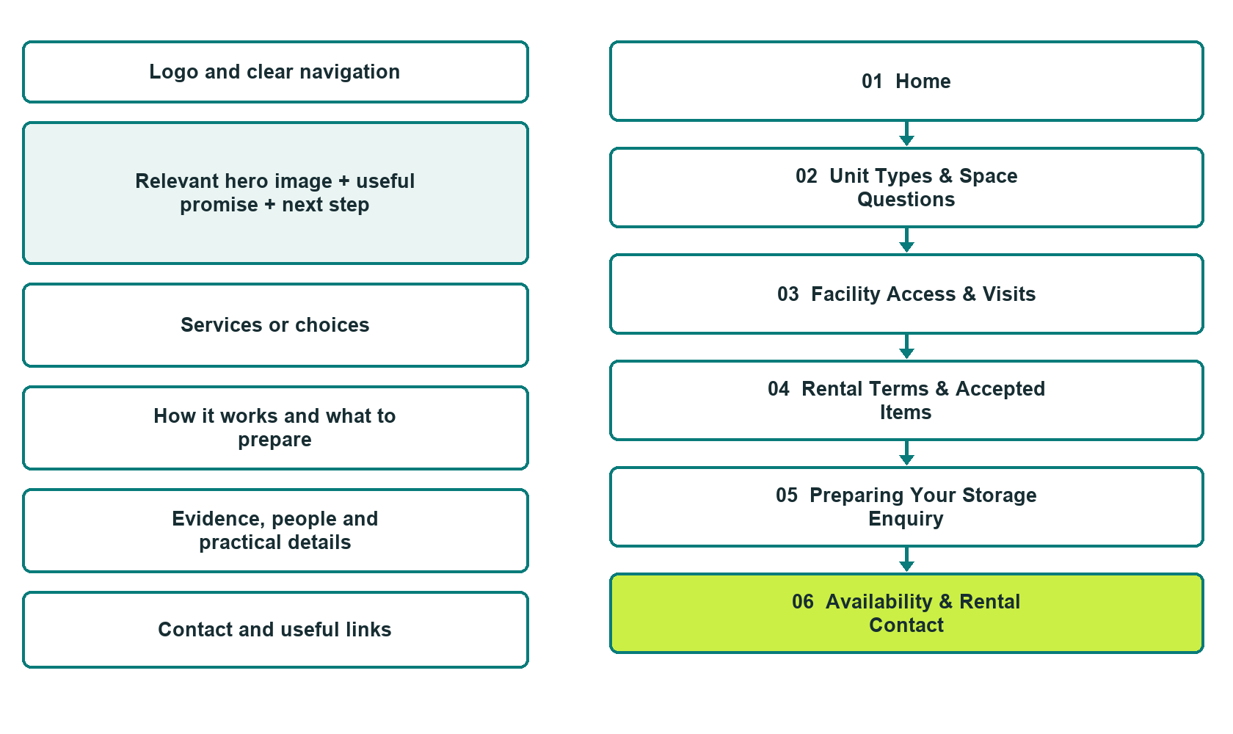

Plan → Draft → Build → Test
Six-page Builder edition with authentic desktop previews. Compare each page with its mobile view in the industry guide.
Explore Website Builder and compare plans

Before you build
Your business supplies the facts. Prairie Quarter Storage is a fictional teaching example, not a live service.

□ Ask about unit availability
□ Verified business identity, services and current contact information
□ A clear enquiry, review and confirmation process
□ Choose original photographs and confirm permission to use them.
□ Keep private customer records out of public website forms.

Your audience and the action you want them to take

Facts to verify and people who must approve them
Create your SaaSTech account

01 Home
Give this page one clear job in the customer journey.
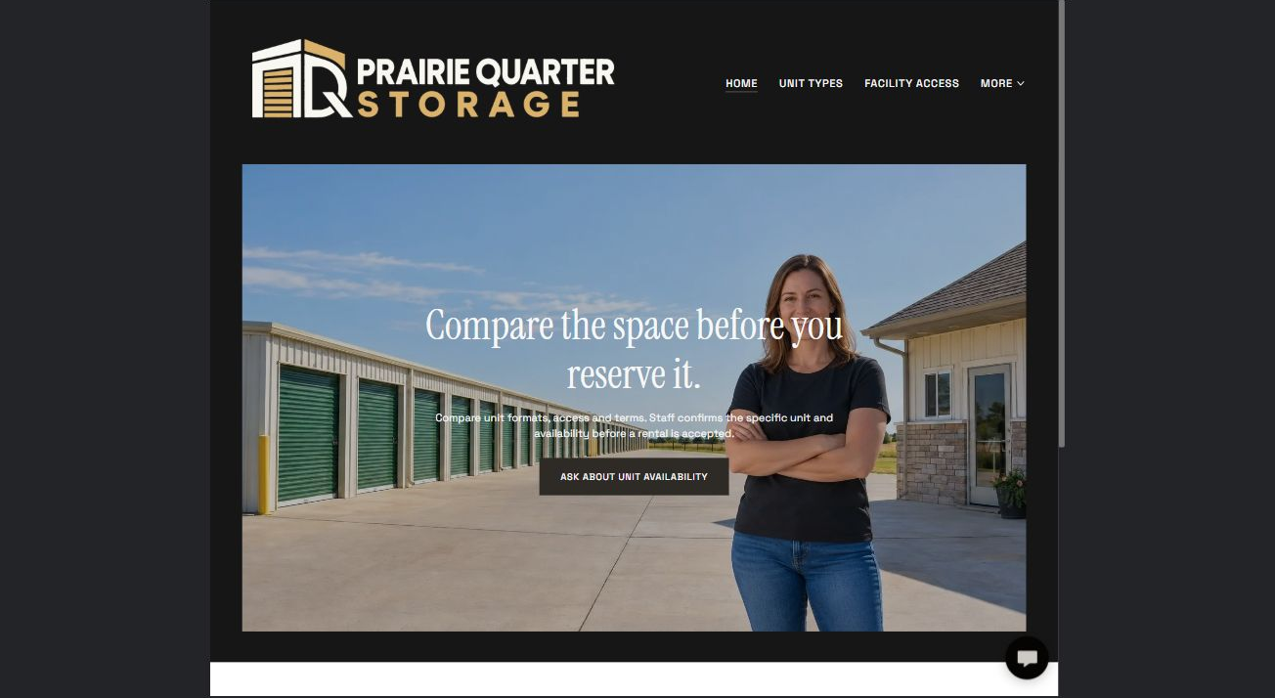
Actual Website Builder desktop preview with AI-generated demonstration photography

Sample wording — adapt and verify
Compare the space before you reserve it.
Compare the facility’s verified unit formats and prepare questions about access and rental terms.
Staff confirms the specific unit, current availability and agreement details before a reservation or rental is accepted.
Suggested button: Ask about unit availability. Link to the Storage Enquiry form on Availability & Contact.

Website advice
Explain unit formats, approximate-space discussions, access arrangements and rental enquiries without presenting moving services or live inventory.

Your draft: Home
Write in the voice of your own business. Use facts you can verify, not promises copied from the example.

Headline and short introduction

Main content and details visitors need

Button wording and destination

Photo choice, permission and facts still to confirm
Partner check: can someone unfamiliar with the business find a useful next step?

02 Unit Types & Space Questions
Give this page one clear job in the customer journey.
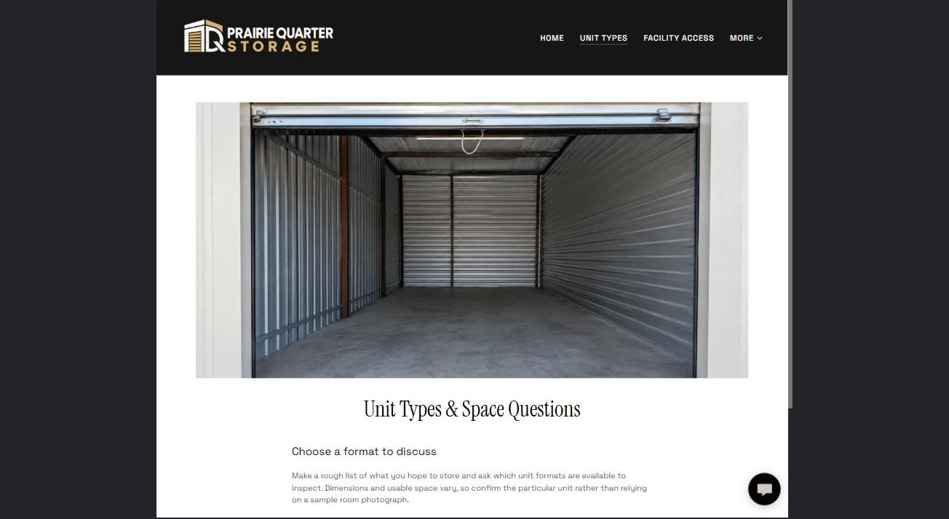
Actual Website Builder desktop preview with AI-generated demonstration photography

Sample wording — adapt and verify
Choose a format to discuss
Make a rough list of what you hope to store and ask which unit formats are available to inspect.
Dimensions and usable space vary, so confirm the particular unit rather than relying on a sample room photograph.
Suggested button: Ask about unit availability

Website advice
Separate indoor-access and drive-up formats where offered, with verified dimensions and no guaranteed capacity estimates.

Your draft: Unit Types & Space Questions
Write in the voice of your own business. Use facts you can verify, not promises copied from the example.

Headline and short introduction

Main content and details visitors need

Button wording and destination

Photo choice, permission and facts still to confirm
Partner check: can someone unfamiliar with the business find a useful next step?

03 Facility Access & Visits
Give this page one clear job in the customer journey.
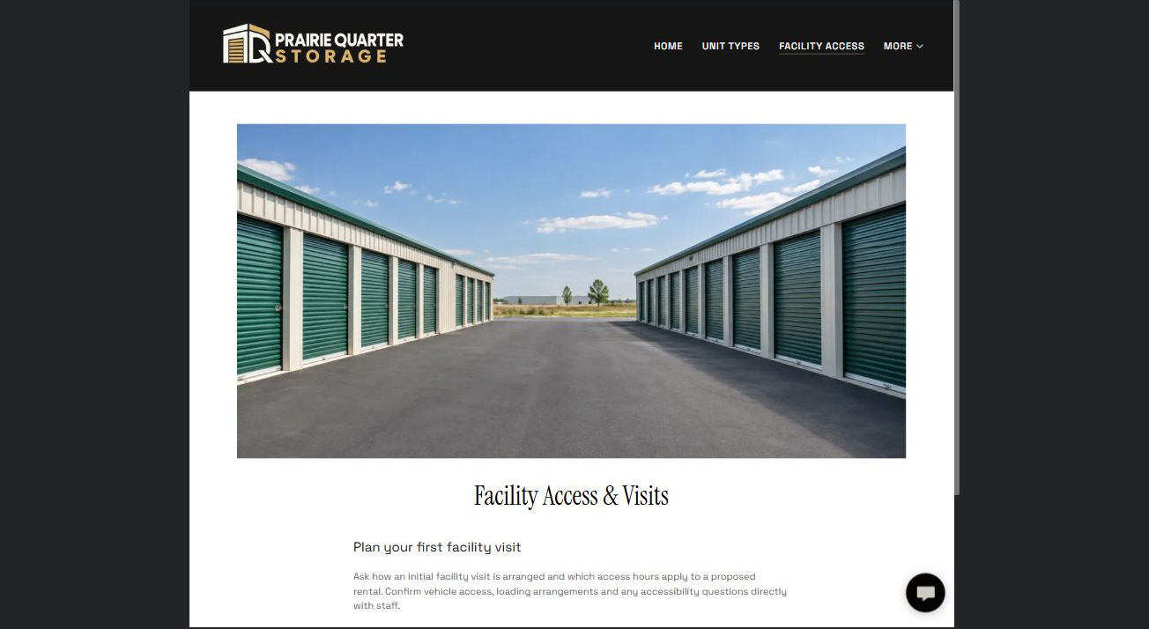
Actual Website Builder desktop preview with AI-generated demonstration photography

Sample wording — adapt and verify
Plan your first facility visit
Ask how an initial facility visit is arranged and which access hours apply to a proposed rental.
Confirm vehicle access, loading arrangements and any accessibility questions directly with staff.
Suggested button: Ask about unit availability

Website advice
Explain visitor arrangements and operator-approved access information without exposing access controls.

Your draft: Facility Access & Visits
Write in the voice of your own business. Use facts you can verify, not promises copied from the example.

Headline and short introduction

Main content and details visitors need

Button wording and destination

Photo choice, permission and facts still to confirm
Partner check: can someone unfamiliar with the business find a useful next step?

04 Rental Terms & Accepted Items
Give this page one clear job in the customer journey.
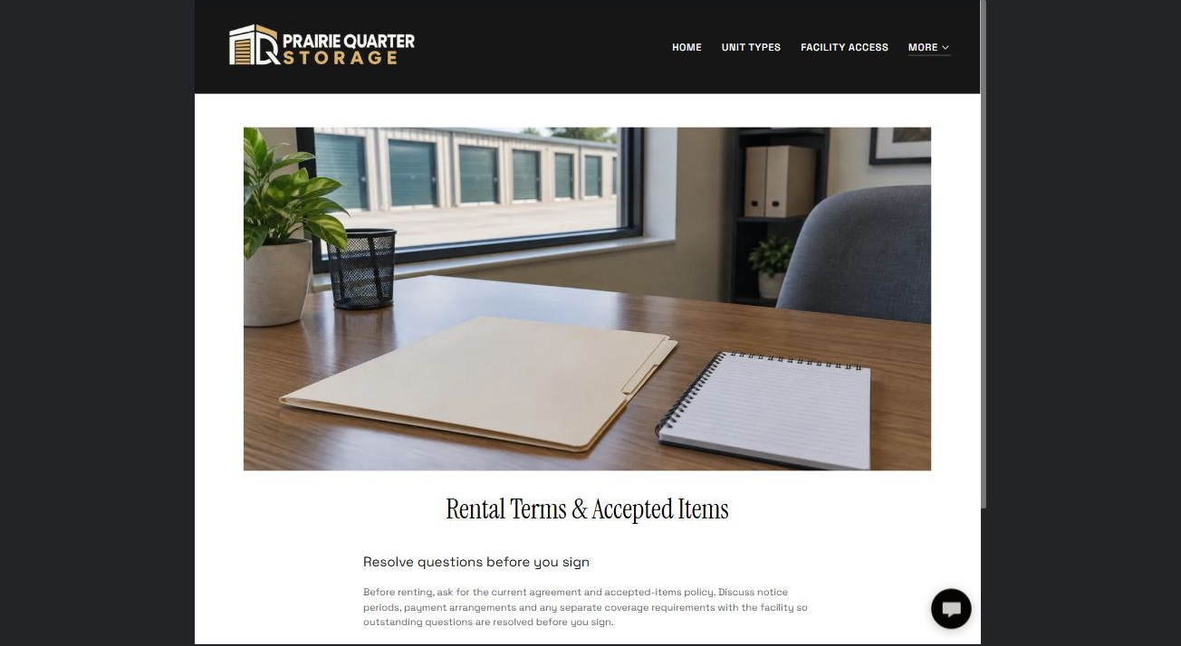
Actual Website Builder desktop preview with AI-generated demonstration photography

Sample wording — adapt and verify
Resolve questions before you sign
Before renting, ask for the current agreement and accepted-items policy.
Discuss notice periods, payment arrangements and any separate coverage requirements with the facility so outstanding questions are resolved before you sign.
Suggested button: Ask about unit availability

Website advice
Provide a reviewed policy index and questions to ask, not legal interpretations or storage safety advice.

Your draft: Rental Terms & Accepted Items
Write in the voice of your own business. Use facts you can verify, not promises copied from the example.

Headline and short introduction

Main content and details visitors need

Button wording and destination

Photo choice, permission and facts still to confirm
Partner check: can someone unfamiliar with the business find a useful next step?

05 Preparing Your Storage Enquiry
Give this page one clear job in the customer journey.
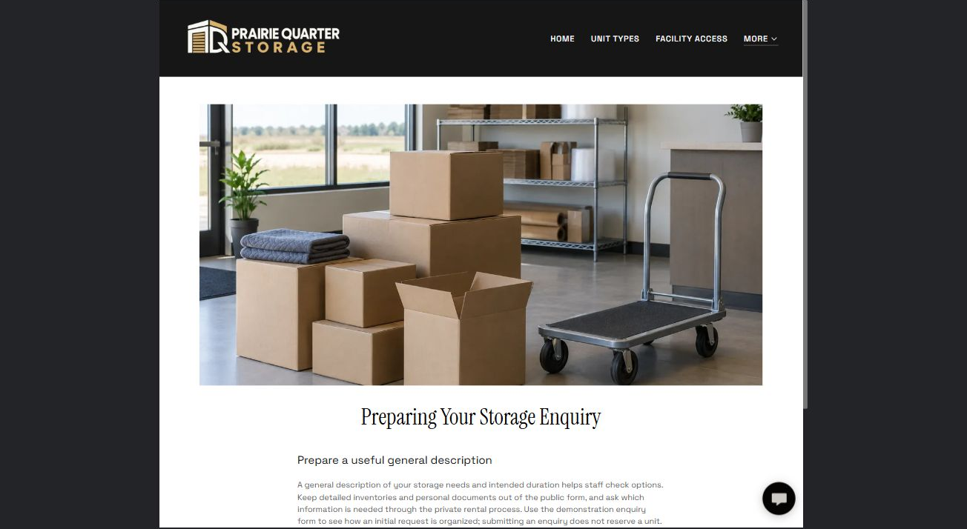
Actual Website Builder desktop preview with AI-generated demonstration photography

Sample wording — adapt and verify
Prepare a useful general description
A general description of your storage needs and intended duration helps staff check options.
Keep detailed inventories and personal documents out of the public form, and ask which information is needed through the private rental process.
Suggested button: Ask about unit availability

Website advice
Help customers summarize intended use, duration and access needs without requesting a valuable-goods inventory publicly.

Your draft: Preparing Your Storage Enquiry
Write in the voice of your own business. Use facts you can verify, not promises copied from the example.

Headline and short introduction

Main content and details visitors need

Button wording and destination

Photo choice, permission and facts still to confirm
Partner check: can someone unfamiliar with the business find a useful next step?

06 Availability & Rental Contact
Give this page one clear job in the customer journey.
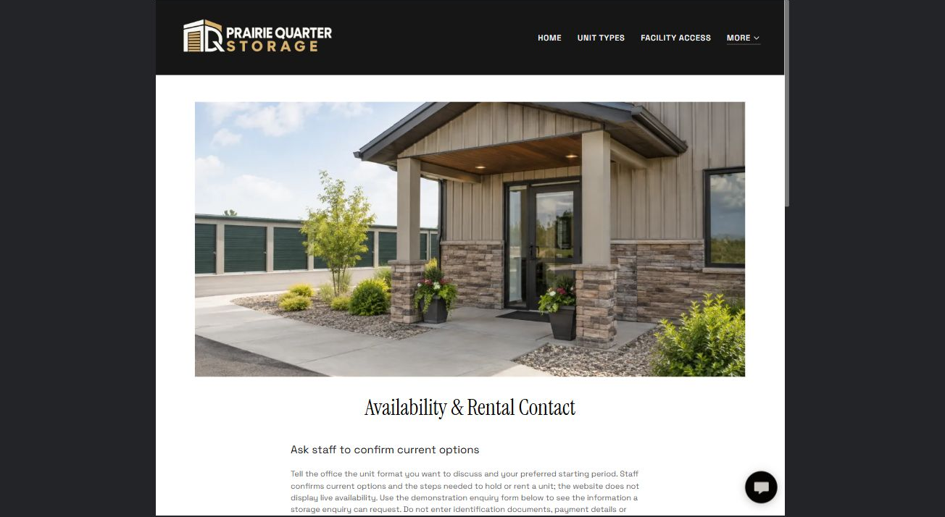
Actual Website Builder desktop preview with AI-generated demonstration photography

Sample wording — adapt and verify
Ask staff to confirm current options
Tell the office the unit format you want to discuss and your preferred starting period.
Staff confirms current options and the steps needed to hold or rent a unit; the website does not display live availability.
Suggested button: Ask about unit availability

Website advice
Add the Storage Enquiry form with Name, required Email, optional Phone, unit type or general storage needs, and preferred start period and duration. Keep attachments off. Warn against sending IDs, payment details or detailed inventories. An enquiry is not a reservation; staff confirms availability and terms. Keep this fictional demo unpublished and test with non-sensitive sample data before launch.

Your draft: Availability & Rental Contact
Write in the voice of your own business. Use facts you can verify, not promises copied from the example.

Headline and short introduction

Main content and details visitors need

Button wording and destination

Photo choice, permission and facts still to confirm
Partner check: can someone unfamiliar with the business find a useful next step?

Test before publishing
Review the whole journey on a desktop and phone. The industry guide pairs each desktop preview with its matching mobile view. Verify the form destination before any real launch.
□ Fictional demonstration only. Verify unit dimensions, access hours, restrictions, accessibility, rental terms and availability. Do not claim climate control, security performance or insurance coverage without evidence; never publish access codes or tenant details.
□ Verify every service description, contact route and operating detail.
□ Replace fictional identity and example information before a live launch.
□ Test enquiries, links and downloads on desktop and mobile.
□ Keep confidential records in approved private systems.
□ Obtain operator approval for public wording and images.
□ Check every link, form destination, download and confirmation message.
□ Check logo contrast, hero framing, text sizes and image loading.
□ Save a named backup and assign a content-review date.

Changes to finish and person responsible

Approval and next review date
Website Builder plans and signup

