

Seed Cleaning Plants website workbook
A printable SaaSTech Servers workshop guide for planning a useful seed-cleaning website, studying the Prairie Select example and drafting your own wording.
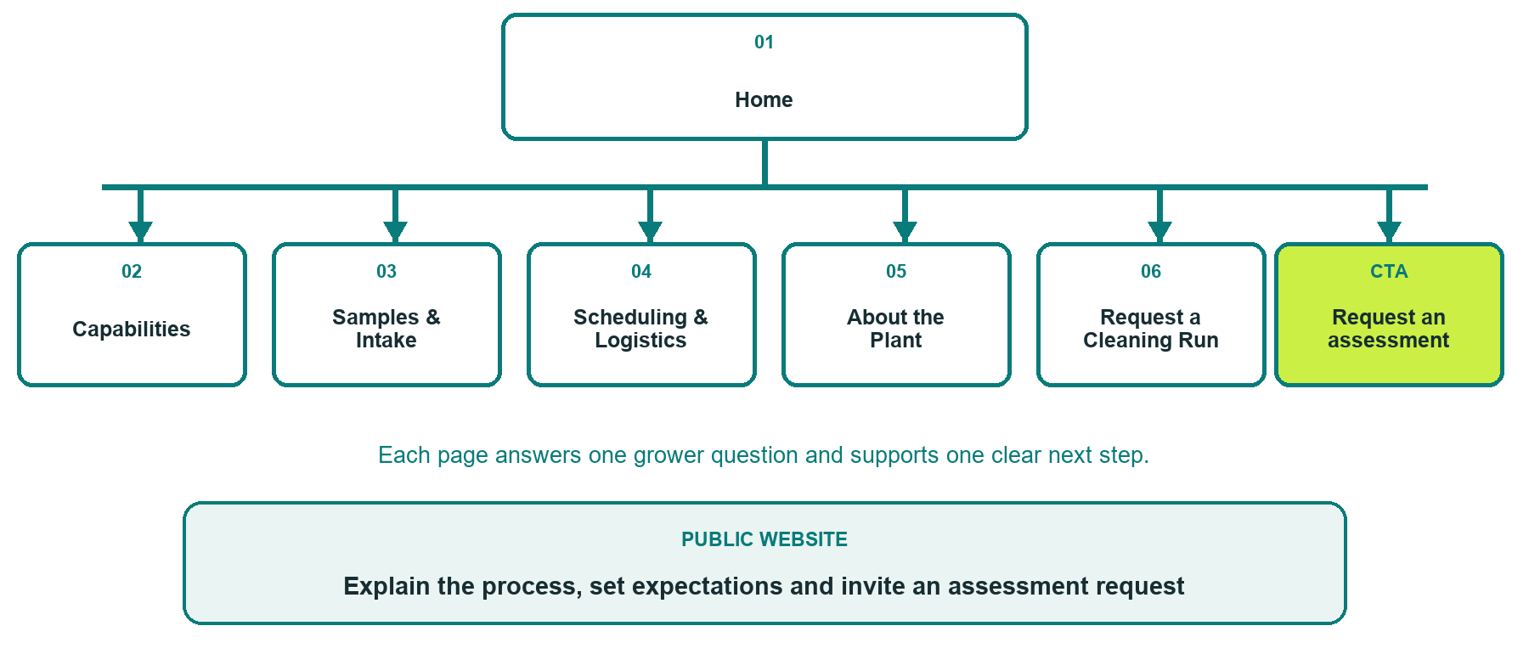

Inside this workbook
Six page examples, practical website advice, writing exercises, photo planning and a final desktop/mobile review
Explore Website Builder and compare plans
Open the Seed Cleaning Plants industry guide

WORKSHOP START

Define the grower journey
A useful seed-cleaning website explains fit, process and timing without presenting estimates as guaranteed outcomes.
□ Choose one grower question for each page.
□ Confirm accepted crops, service area, seasonal capacity and contact details.
□ Gather distinct, permission-cleared photos that match each page.
□ Separate public education from private lot, treatment and payment records.
□ Assign an owner and review date for every operational claim.

What should a first-time grower understand or do

Business facts, photos and approvals still needed

PAGE 1

Home
Show who the plant serves and the primary assessment request in the first screen. Add your verified service area, not an assumed location.
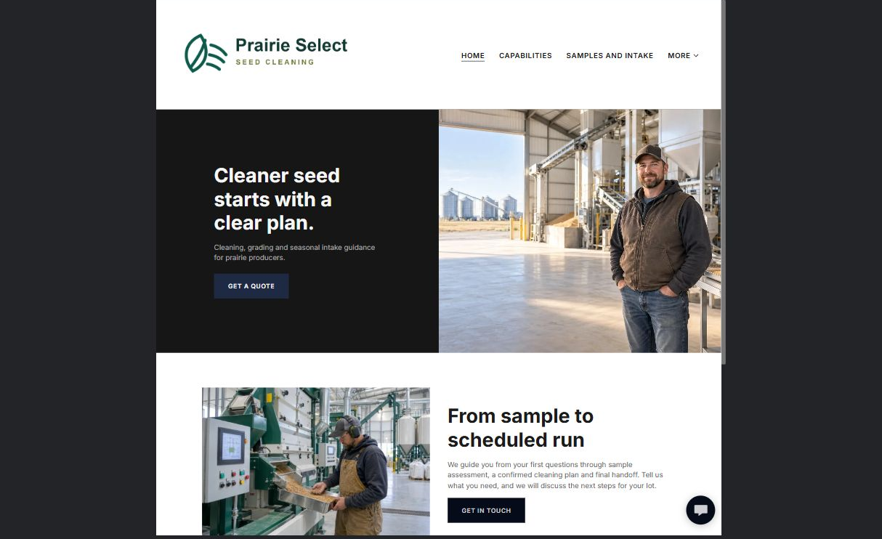

From the Prairie Select demo
Cleaner seed starts with a clear plan. Cleaning, grading and seasonal intake guidance for prairie producers.

Draft your own page wording

Photos, proof, links and approvals to prepare

PAGE 2

Capabilities
Group capabilities by customer need. Explain how sample assessment determines the final process; do not promise grades or germination results.
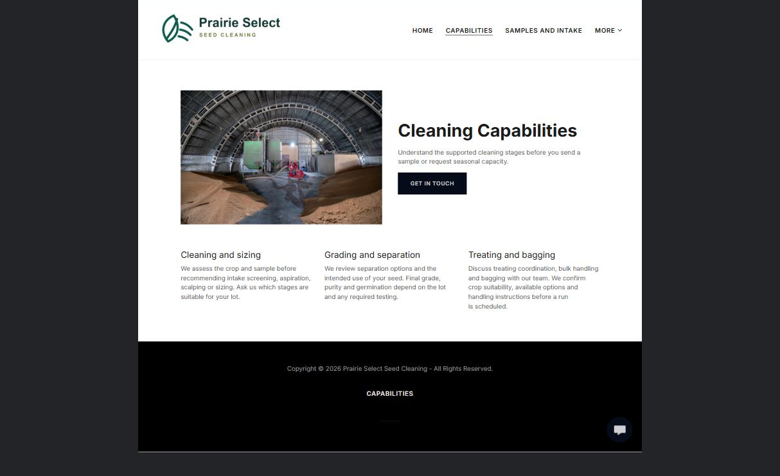

From the Prairie Select demo
We assess the crop and sample before recommending intake screening, aspiration, scalping or sizing. Ask us which stages are suitable for your lot.

Draft your own page wording

Photos, proof, links and approvals to prepare

PAGE 3

Samples and Intake
Explain sample preparation and lot identification. Confirm your plant's actual sample-size and packaging instructions before publishing them.
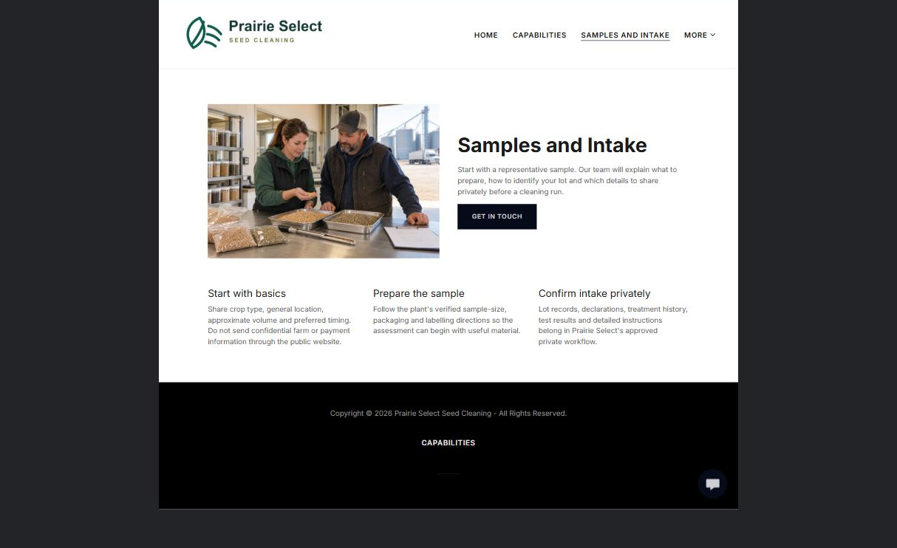

From the Prairie Select demo
Start with a representative sample. Our team will explain what to prepare, how to identify your lot and which details to share privately before a cleaning run.

Draft your own page wording

Photos, proof, links and approvals to prepare

PAGE 4

Scheduling and Logistics
Set expectations for seasonal demand, delivery and pickup. Make the distinction between a requested window and a confirmed booking clear.
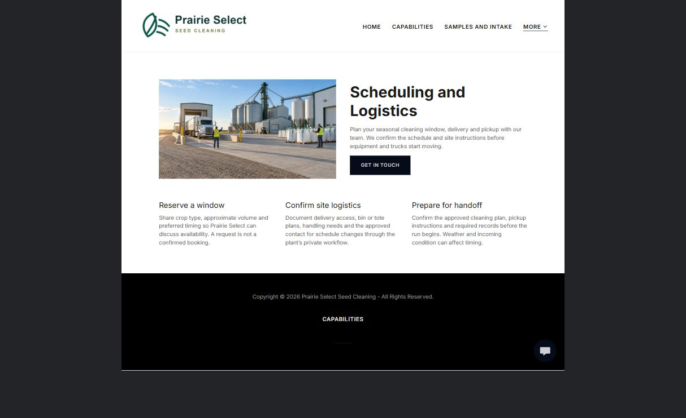

From the Prairie Select demo
Plan your seasonal cleaning window, delivery and pickup with our team. We confirm the schedule and site instructions before equipment and trucks start moving.

Draft your own page wording

Photos, proof, links and approvals to prepare

PAGE 5

About the Plant
Show the people and facility behind the service. Replace the fictional demo identity with verified experience, responsibilities and relevant photos.
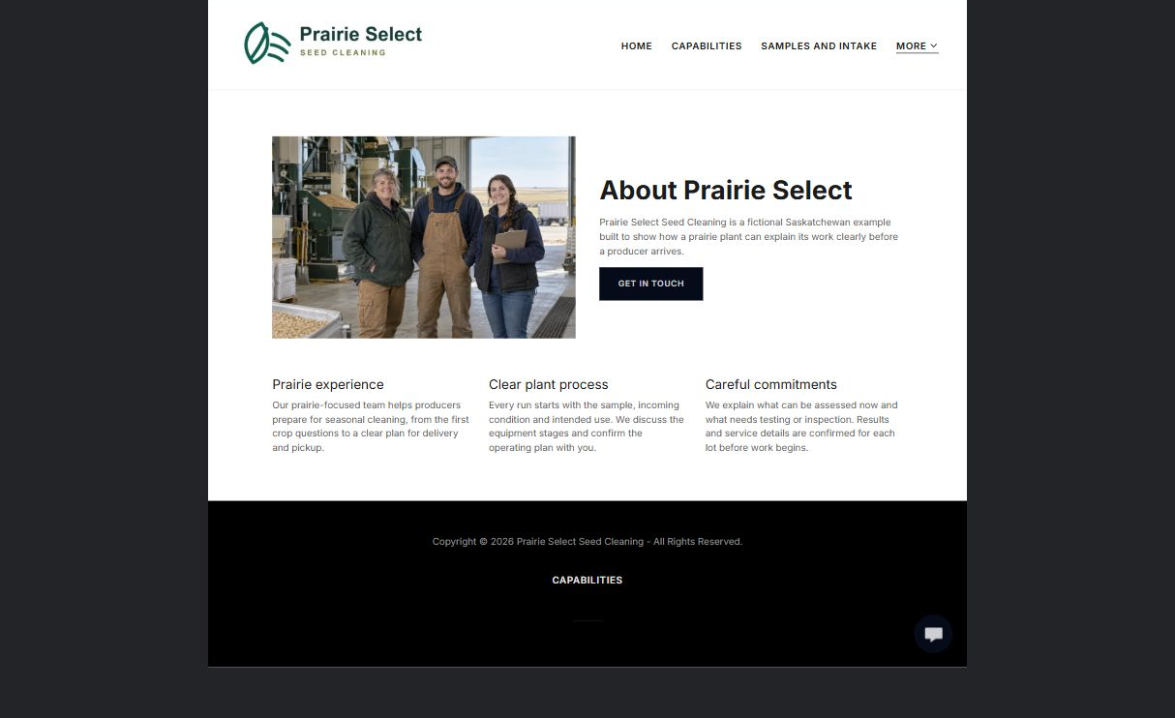

From the Prairie Select demo
Our prairie-focused team helps producers prepare for seasonal cleaning, from the first crop questions to a clear plan for delivery and pickup.

Draft your own page wording

Photos, proof, links and approvals to prepare

PAGE 6

Request a Cleaning Run
Ask only for initial enquiry details. Configure and test the real recipient privately before launch; this example form is labelled demo only.
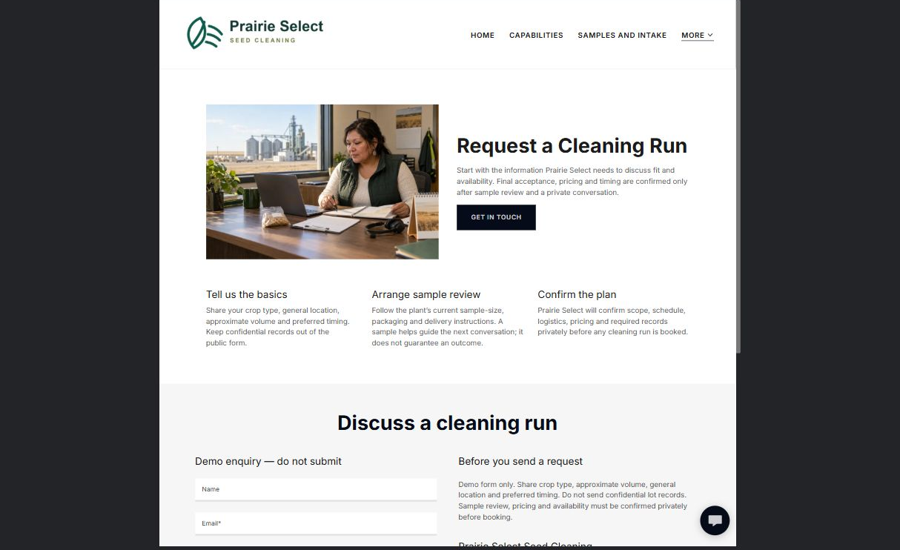

From the Prairie Select demo
Start with the information Prairie Select needs to discuss fit and availability. Final acceptance, pricing and timing are confirmed only after sample review and a private conversation.

Draft your own page wording

Photos, proof, links and approvals to prepare

FINAL REVIEW

Test the complete customer journey
Ask someone unfamiliar with the plant to identify whether the service may fit, understand the assessment process and request a next step.
□ Each page has one clear purpose and one primary action.
□ Desktop and mobile previews are readable and use the correct logo contrast.
□ Every photo is relevant, distinct and permission-cleared.
□ Capabilities, timing and outcome wording explains what must be assessed or confirmed.
□ Service area, seasonal details and contact paths are current.
□ A clearly named backup and future content-review date are recorded.

Changes found during review

Content owner and next review date

