

RV Parks & Campgrounds
Website workbook
A practical workshop for a 6-page website. Study the example, plan the content and draft your own version in Word or on paper.
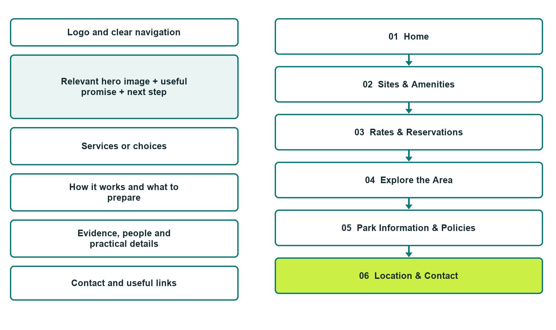

Plan → Draft → Build → Test
Demo-capture edition: actual Website Builder desktop previews and excerpts of the example wording. See each matching mobile preview in the industry page gallery. The example park and its AI-generated photographs are fictional.
Explore Website Builder and compare plans

Before you build
Your business supplies the facts. Prairie Trails RV Park is a fictional teaching example, not a live service.

□ Check site fit and request a stay
□ Accurate site dimensions, hookups and access information
□ Clear reservation and written-confirmation process
□ Choose original photographs and confirm permission to use them.
□ Keep private customer records out of public website forms.

Your audience and the action you want them to take

Facts to verify and people who must approve them
Create your SaaSTech account

01 Home
Give this page one clear job in the customer journey.
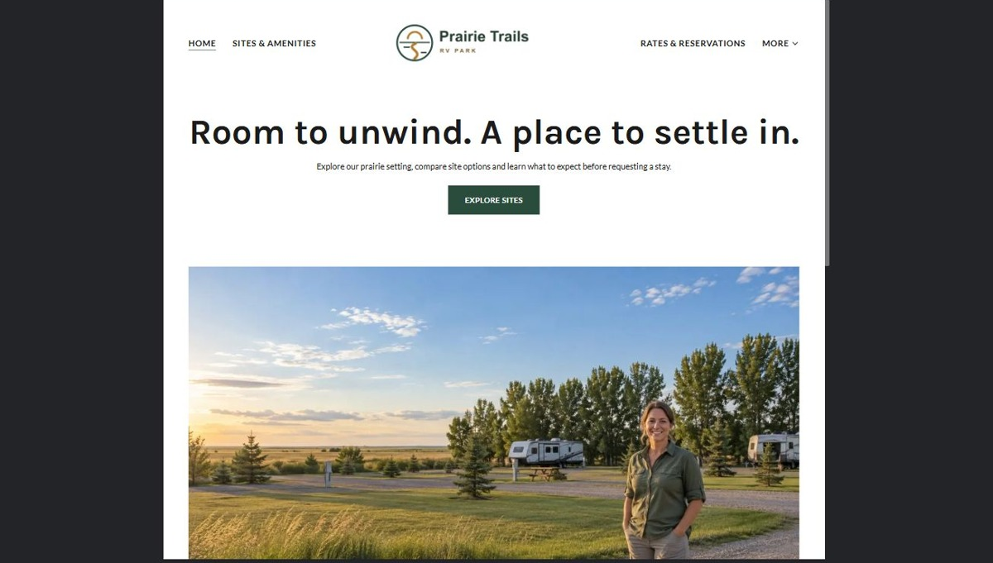
Actual desktop preview - unpublished fictional demonstration

Demo wording excerpt to adapt and verify
Room to unwind. A place to settle in.
Explore our prairie setting, compare site options and learn what to expect before requesting a stay.
A good stay begins with a site that suits your setup. Review access, usable space and the amenities that matter to you, then tell the host about your RV and preferred dates.
Suggested button: Explore sites

Website advice
Introduce Prairie Trails RV Park as a fictional Saskatchewan campground. Show the prairie setting, explain who the park suits and offer two clear paths: explore sites or review how to request a stay.

Your draft: Home
Write in the voice of your own business. Use facts you can verify, not promises copied from the example.

Headline and short introduction

Main content and details visitors need

Button wording and destination

Photo choice, permission and facts still to confirm
Partner check: can someone unfamiliar with the business find a useful next step?

02 Sites & Amenities
Give this page one clear job in the customer journey.
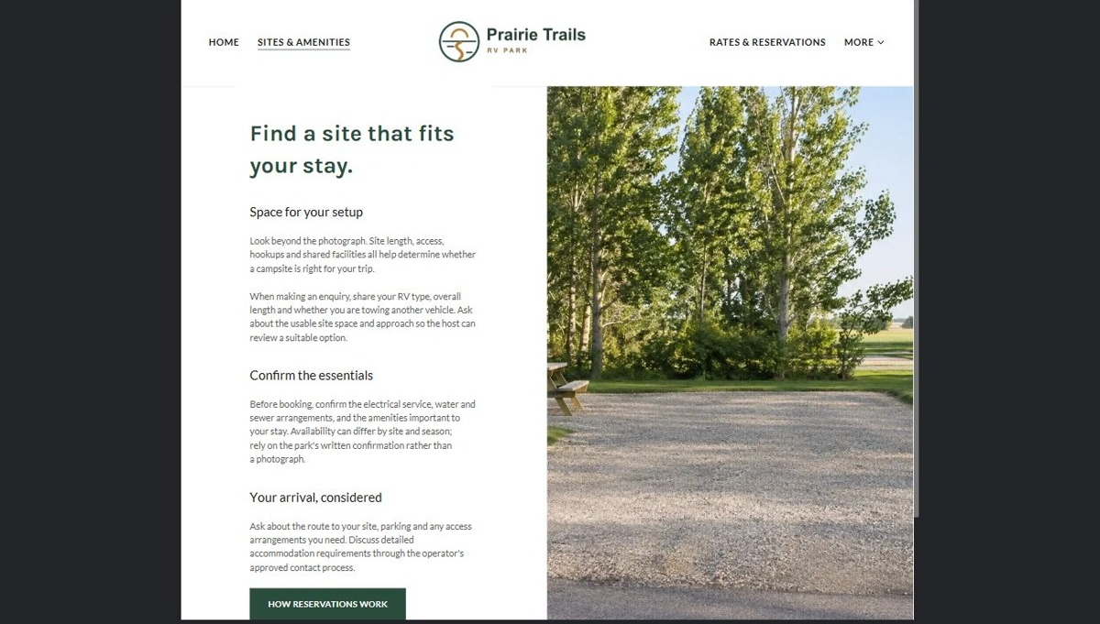
Actual desktop preview - unpublished fictional demonstration

Demo wording excerpt to adapt and verify
Find a site that fits your stay.
Look beyond the photograph. Site length, access, hookups and shared facilities all help determine whether a campsite is right for your trip.
When making an enquiry, share your RV type, overall length and whether you are towing another vehicle. Ask about the usable site space and approach so the host can review a suitable option.
Suggested button: How reservations work

Website advice
Describe the site categories, usable lengths, access, hookups and shared amenities the real operator can verify. Separate pull-through, back-in and tent options where offered. Explain seasonal availability and access limitations without promising that a site fits every rig.

Your draft: Sites & Amenities
Write in the voice of your own business. Use facts you can verify, not promises copied from the example.

Headline and short introduction

Main content and details visitors need

Button wording and destination

Photo choice, permission and facts still to confirm
Partner check: can someone unfamiliar with the business find a useful next step?

03 Rates & Reservations
Give this page one clear job in the customer journey.
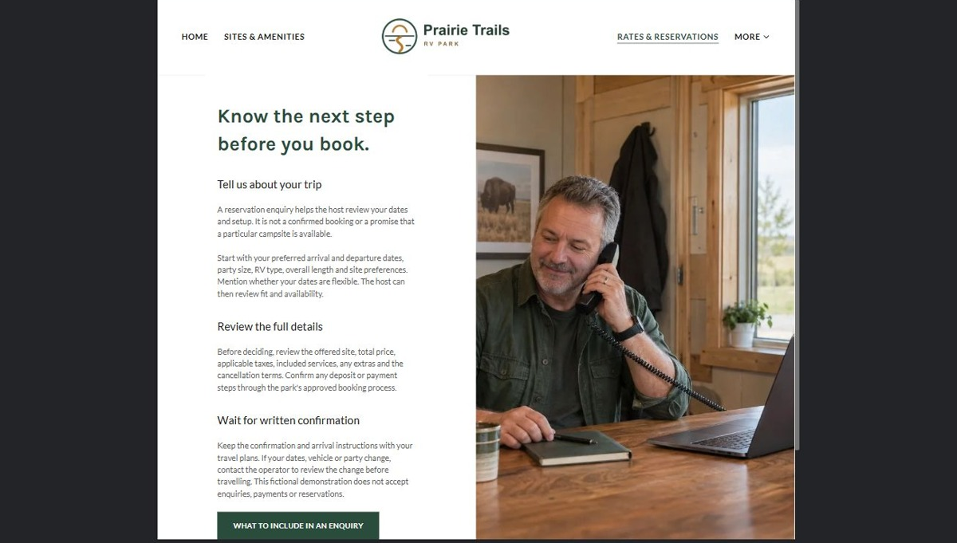
Actual desktop preview - unpublished fictional demonstration

Demo wording excerpt to adapt and verify
Know the next step before you book.
A reservation enquiry helps the host review your dates and setup. It is not a confirmed booking or a promise that a particular campsite is available.
Start with your preferred arrival and departure dates, party size, RV type, overall length and site preferences. Mention whether your dates are flexible. The host can then review fit and availability.
Suggested button: What to include in an enquiry

Website advice
Explain nightly, weekly or seasonal options only where offered, what is included and how taxes, extras and deposits are confirmed. Outline enquiry, staff review and written confirmation. Never show sample availability or an unconnected calendar as a live booking system.

Your draft: Rates & Reservations
Write in the voice of your own business. Use facts you can verify, not promises copied from the example.

Headline and short introduction

Main content and details visitors need

Button wording and destination

Photo choice, permission and facts still to confirm
Partner check: can someone unfamiliar with the business find a useful next step?

04 Explore the Area
Give this page one clear job in the customer journey.
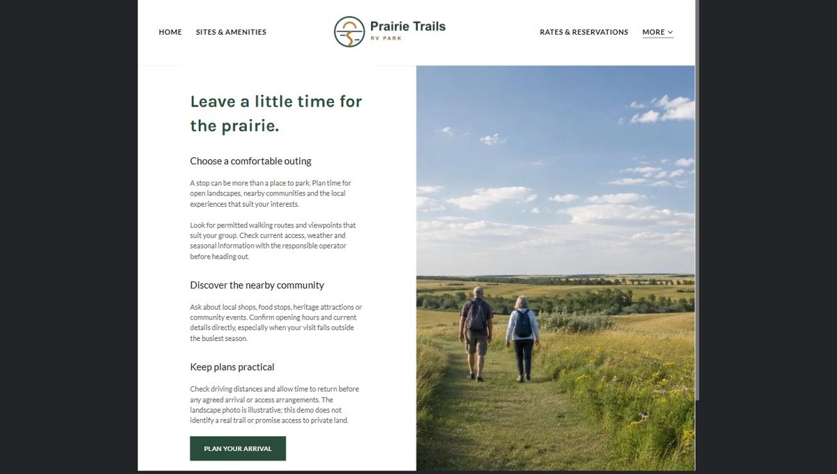
Actual desktop preview - unpublished fictional demonstration

Demo wording excerpt to adapt and verify
Leave a little time for the prairie.
A stop can be more than a place to park. Plan time for open landscapes, nearby communities and the local experiences that suit your interests.
Look for permitted walking routes and viewpoints that suit your group. Check current access, weather and seasonal information with the responsible operator before heading out.
Suggested button: Plan your arrival

Website advice
Introduce nearby communities, prairie walks, local attractions and useful travel stops with distinct photographs. Verify names, distances, access, seasonal hours and permissions before linking to real places. Avoid invented endorsements or attractions.

Your draft: Explore the Area
Write in the voice of your own business. Use facts you can verify, not promises copied from the example.

Headline and short introduction

Main content and details visitors need

Button wording and destination

Photo choice, permission and facts still to confirm
Partner check: can someone unfamiliar with the business find a useful next step?

05 Park Information & Policies
Give this page one clear job in the customer journey.
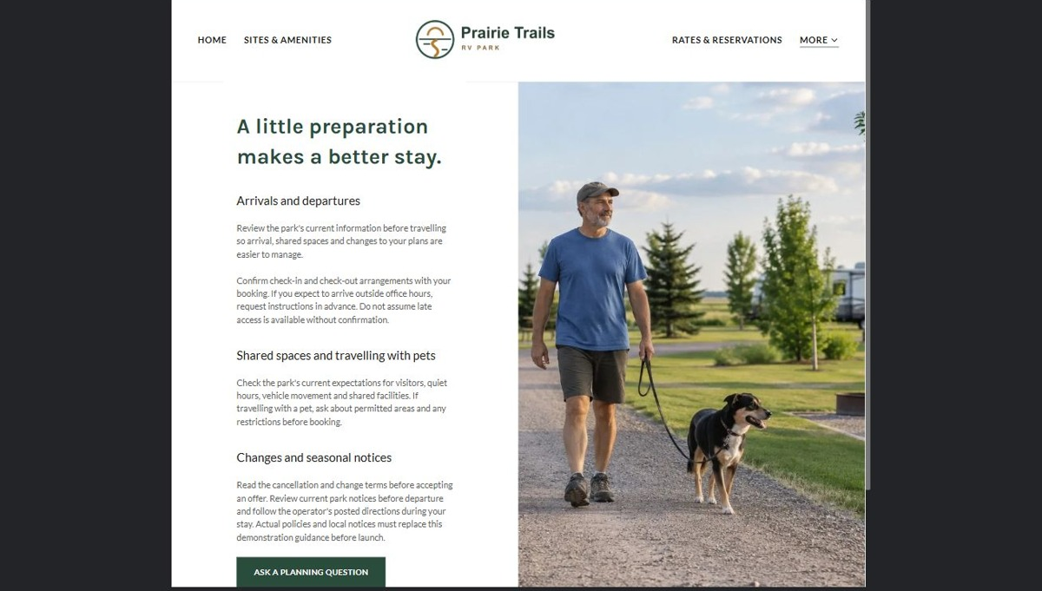
Actual desktop preview - unpublished fictional demonstration

Demo wording excerpt to adapt and verify
A little preparation makes a better stay.
Review the park's current information before travelling so arrival, shared spaces and changes to your plans are easier to manage.
Confirm check-in and check-out arrangements with your booking. If you expect to arrive outside office hours, request instructions in advance. Do not assume late access is available without confirmation.
Suggested button: Ask a planning question

Website advice
Make arrival and departure, late arrival, pets, visitors, quiet hours, cancellations, accessibility and current park notices easy to find. Replace sample guidance with operator-approved policies and verified local information before launch.

Your draft: Park Information & Policies
Write in the voice of your own business. Use facts you can verify, not promises copied from the example.

Headline and short introduction

Main content and details visitors need

Button wording and destination

Photo choice, permission and facts still to confirm
Partner check: can someone unfamiliar with the business find a useful next step?

06 Location & Contact
Give this page one clear job in the customer journey.
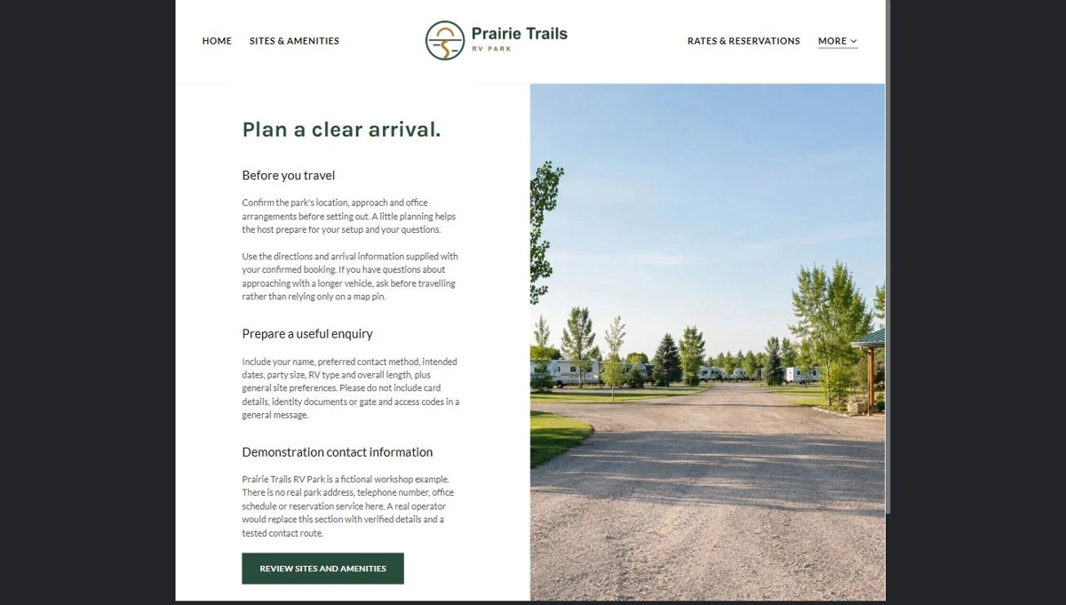
Actual desktop preview - unpublished fictional demonstration

Demo wording excerpt to adapt and verify
Plan a clear arrival.
Confirm the park's location, approach and office arrangements before setting out. A little planning helps the host prepare for your setup and your questions.
Use the directions and arrival information supplied with your confirmed booking. If you have questions about approaching with a longer vehicle, ask before travelling rather than relying only on a map pin.
Suggested button: Review sites and amenities

Website advice
Publish the confirmed address, approach directions, office hours and general contact methods. Request only contact details, intended dates, party size, RV type and length, and site preferences. Staff must confirm fit, availability and the full price before a stay is booked.

Your draft: Location & Contact
Write in the voice of your own business. Use facts you can verify, not promises copied from the example.

Headline and short introduction

Main content and details visitors need

Button wording and destination

Photo choice, permission and facts still to confirm
Partner check: can someone unfamiliar with the business find a useful next step?

Test before publishing
Review the whole journey on a desktop and phone. The industry page pairs each desktop capture with its mobile preview and provides the complete sample page copy.
□ Test navigation, enquiry forms, contact links and arrival directions on a phone.
□ Have the operator verify site lengths, hookups, accessibility, amenities, operating season and every advertised rate.
□ Test the full enquiry-to-confirmation workflow; a submission must not imply that a campsite is reserved.
□ Keep card details, identity documents, gate codes and sensitive guest needs out of ordinary public forms.
□ Replace fictional Prairie Trails details and sample policies before accepting guests or payments.
□ Compress photographs, check mobile crops and confirm every image supports its page without unnecessary repetition.
□ Check every link, form destination, download and confirmation message.
□ Check logo contrast, hero framing, text sizes and image loading.
□ Save a named backup and assign a content-review date.

Changes to finish and person responsible

Approval and next review date
Website Builder plans and signup

