

Roofers, Siding & Gutter Contractors
Website workbook
A practical workshop for a 5-page website. Study the example, plan the content and draft your own version in Word or on paper.
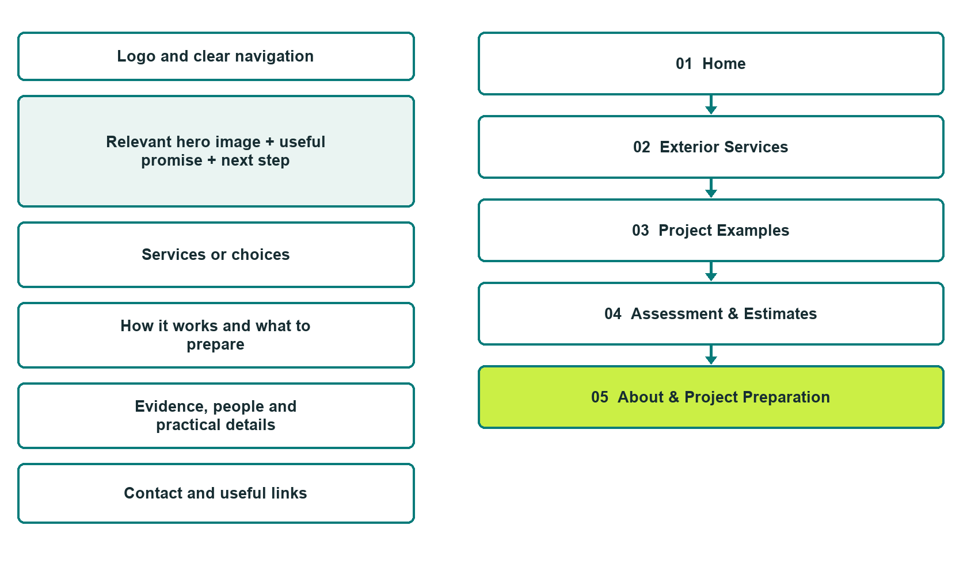

Plan → Draft → Build → Test
Demo-capture edition: actual Website Builder desktop previews and clearly labelled sample wording to adapt. See each matching mobile preview in the industry page gallery. The example business and its AI-generated photographs are fictional.
Explore Website Builder and compare plans

Before you build
Your business supplies the facts. Prairie Shield Exteriors is a fictional teaching example, not a live service.

□ Request an exterior project assessment
□ Verified business identity and current contact information
□ Clear request and confirmation process
□ Choose original photographs and confirm permission to use them.
□ Keep private customer records out of public website forms.

Your audience and the action you want them to take

Facts to verify and people who must approve them
Create your SaaSTech account

01 Home
Give this page one clear job in the customer journey.
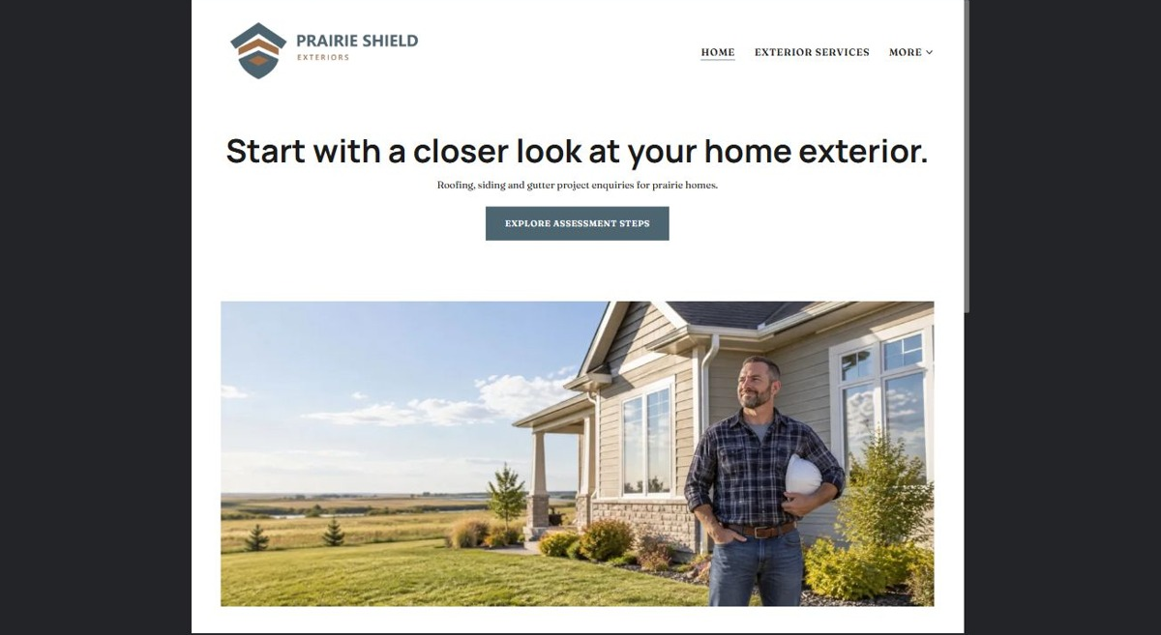
Actual desktop preview - unpublished fictional demonstration

Sample wording — adapt and verify
Start with a closer look at your home exterior.
Explore exterior project services and see how an assessment enquiry begins. Tell the team the project type and general location so the next step can be discussed.
Contact the team to discuss your questions and confirm what happens next. Please wait for a direct response before making arrangements.
Suggested button: Request an exterior project assessment

Website advice
Separate exterior service types and present verified project examples with clear estimate and approval steps. Avoid guarantees not supported by the contractor.

Your draft: Home
Write in the voice of your own business. Use facts you can verify, not promises copied from the example.

Headline and short introduction

Main content and details visitors need

Button wording and destination

Photo choice, permission and facts still to confirm
Partner check: can someone unfamiliar with the business find a useful next step?

02 Exterior Services
Give this page one clear job in the customer journey.
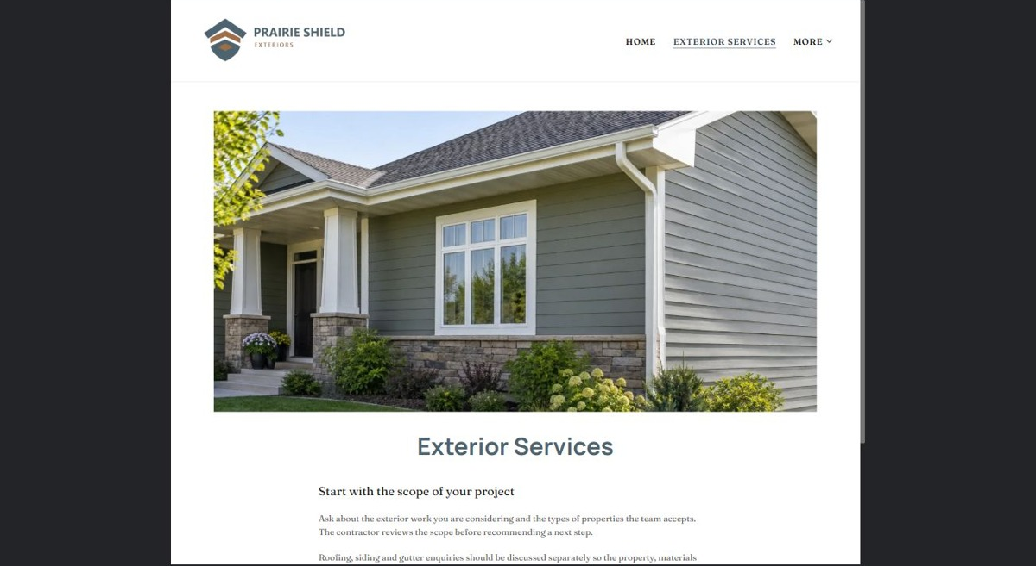
Actual desktop preview - unpublished fictional demonstration

Sample wording — adapt and verify
Exterior Services
Ask about the exterior work you are considering and the types of properties the team accepts. The contractor reviews the scope before recommending a next step.
Contact the team to discuss your questions and confirm what happens next. Please wait for a direct response before making arrangements.
Suggested button: Contact the team

Website advice
Group roofing, siding and gutter work only where offered. Explain assessment and exclusions without technical how-to instructions.

Your draft: Exterior Services
Write in the voice of your own business. Use facts you can verify, not promises copied from the example.

Headline and short introduction

Main content and details visitors need

Button wording and destination

Photo choice, permission and facts still to confirm
Partner check: can someone unfamiliar with the business find a useful next step?

03 Project Examples
Give this page one clear job in the customer journey.
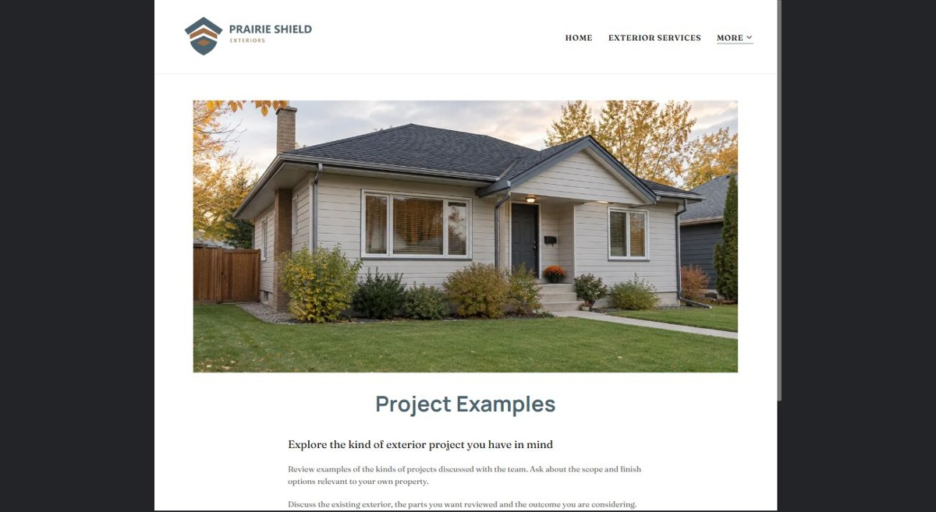
Actual desktop preview - unpublished fictional demonstration

Sample wording — adapt and verify
Project Examples
Review examples of the kinds of projects discussed with the team. Ask about the scope and finish options relevant to your own property.
Contact the team to discuss your questions and confirm what happens next. Please wait for a direct response before making arrangements.
Suggested button: Contact the team

Website advice
Use genuine completed work with permission, distinct photos and factual descriptions. Label illustrations as examples.

Your draft: Project Examples
Write in the voice of your own business. Use facts you can verify, not promises copied from the example.

Headline and short introduction

Main content and details visitors need

Button wording and destination

Photo choice, permission and facts still to confirm
Partner check: can someone unfamiliar with the business find a useful next step?

04 Assessment & Estimates
Give this page one clear job in the customer journey.
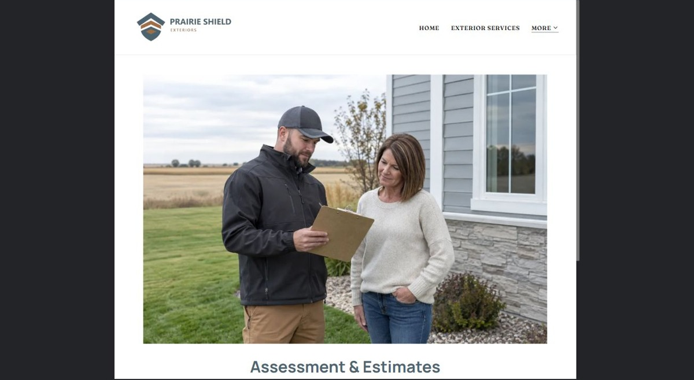
Actual desktop preview - unpublished fictional demonstration

Sample wording — adapt and verify
Assessment & Estimates
Share a short description of the project and your preferred timing. The team explains how an assessment is arranged and how any proposal is reviewed.
Contact the team to discuss your questions and confirm what happens next. Please wait for a direct response before making arrangements.
Suggested button: Contact the team

Website advice
Explain site review, estimate preparation, questions and written acceptance. Do not imply a web form creates an accepted job.

Your draft: Assessment & Estimates
Write in the voice of your own business. Use facts you can verify, not promises copied from the example.

Headline and short introduction

Main content and details visitors need

Button wording and destination

Photo choice, permission and facts still to confirm
Partner check: can someone unfamiliar with the business find a useful next step?

05 About & Project Preparation
Give this page one clear job in the customer journey.
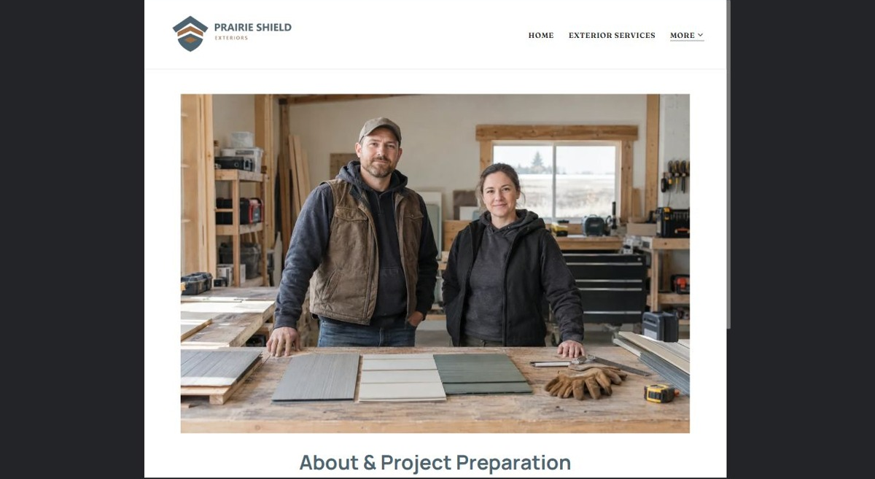
Actual desktop preview - unpublished fictional demonstration

Sample wording — adapt and verify
About & Project Preparation
Meet the people who coordinate project enquiries and communication. Before work is scheduled, confirm access, scope and the arrangements explained by the contractor.
Contact the team to discuss your questions and confirm what happens next. Please wait for a direct response before making arrangements.
Suggested button: Contact the team

Website advice
Introduce verified team roles and explain approved customer preparation information.

Your draft: About & Project Preparation
Write in the voice of your own business. Use facts you can verify, not promises copied from the example.

Headline and short introduction

Main content and details visitors need

Button wording and destination

Photo choice, permission and facts still to confirm
Partner check: can someone unfamiliar with the business find a useful next step?

Test before publishing
Review the whole journey on a desktop and phone. The industry page pairs each desktop capture with its mobile preview and provides the complete sample page copy.
□ This fictional example provides no construction or safety instructions. Verify qualifications, warranties, scope and insurance claims with the contractor before publishing.
□ Verify contact routes, hours, location and every offered service.
□ Remove invented prices, claims, testimonials and availability.
□ Keep sensitive records and payment details out of ordinary public forms.
□ Check all image permissions, downloads and page links on a phone.
□ Check every link, form destination, download and confirmation message.
□ Check logo contrast, hero framing, text sizes and image loading.
□ Save a named backup and assign a content-review date.

Changes to finish and person responsible

Approval and next review date
Website Builder plans and signup

