
WEBSITE PLANNING WORKSHOP

Résumés & Personal Portfolios
Website workbook
Plan a clear website for résumés & personal portfolios. Explore a worked example, shape your own message and prepare to build with SaaSTech Servers.
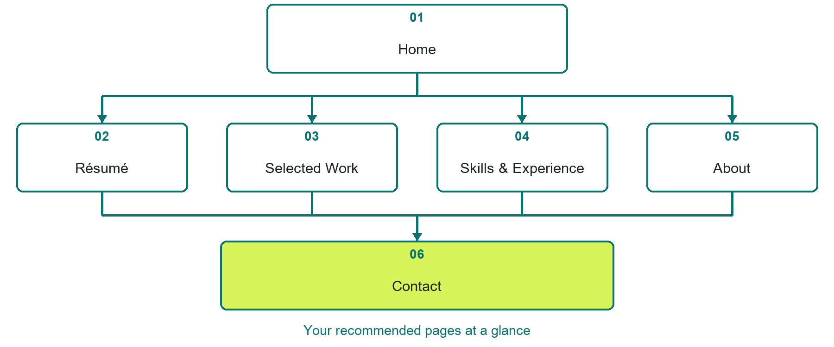

Inside this workbook
Six page examples • Practical writing exercises • A launch review
Use it in a workshop or at your own pace. Write by hand or complete the response fields in Word. The final page links to Website Builder, plans and account signup.
Example business Jordan Ellis

RÉSUMÉS & PERSONAL PORTFOLIOS

Your website brief
A SaaSTech Servers workshop for résumés & personal portfolios. Plan your website, learn from the Jordan Ellis example and draft content for your own business.
Each page has a reference sheet followed by a writing sheet. Demo excerpts are labelled separately from new sample wording, which may differ from the screenshot. Click a blank response line to type; longer answers may add pages. Replace fictional details and verify every claim before publishing.
Your business or organization and workshop date

Who should visit your site and what do they need

The main action you want a visitor to take

What you offer and where or how you provide it

Facts photos and permissions to gather before publishing

Workshop rhythm: review the example, write your draft and exchange feedback. Use the final review to choose your next changes. Website Builder and account links are on the last page.

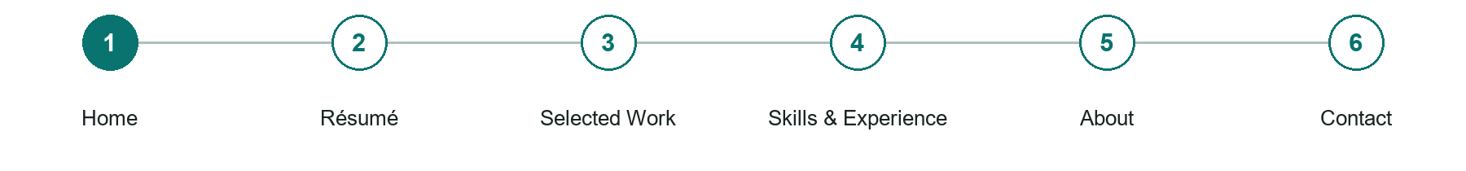
LOOK AND LEARN

Home

The job of this page
Introduce your name, professional focus and the opportunities you want. Link to selected work and your current résumé; a portrait is optional.
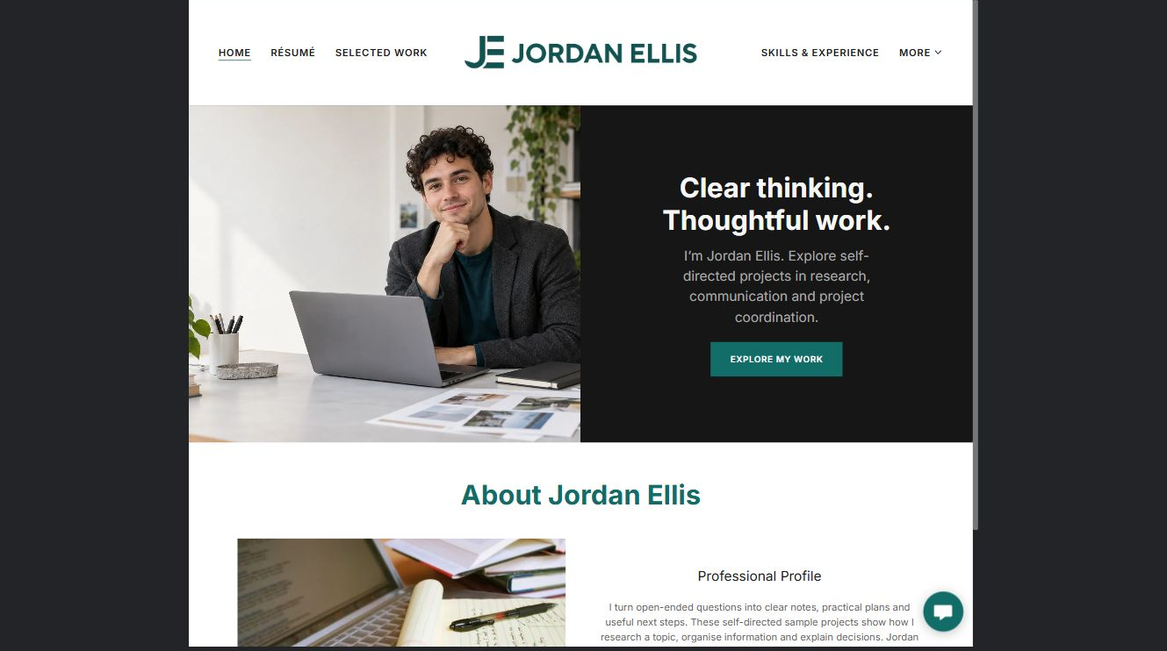
Jordan Ellis example | Explore SaaSTech Website Builder

Demo text example
Clear thinking. Thoughtful work.
I'm Jordan Ellis. Explore self-directed projects in research, communication and project coordination.

Pause and plan
Could a first-time visitor explain what you do and who it is for after one glance? Choose one main action and the strongest truthful detail that gives them confidence to continue.

WRITE YOUR PAGE

Home
Write for your visitor. Be specific about what they need to know and what happens next. You can revise the wording after the workshop.
Your page headline

Your opening paragraph

Your offer audience location and most useful supporting details

Button or link wording and where it should lead

Photo idea caption and permission or credit needed

Facts to verify or questions to resolve

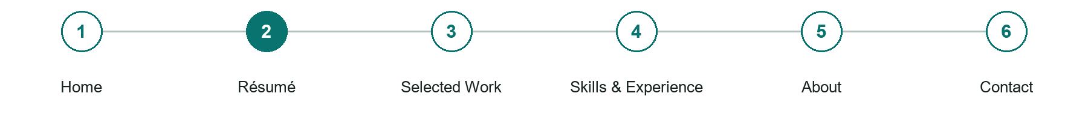
LOOK AND LEARN

Résumé

The job of this page
Present readable experience, education and skills in page text, with an accessible PDF download. Keep dates and claims consistent with applications and professional profiles.
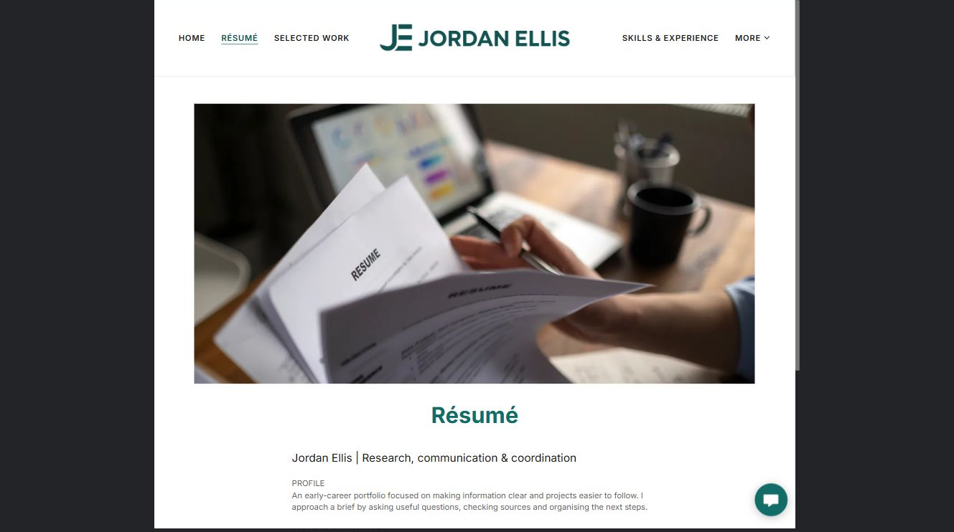
Jordan Ellis example | Explore SaaSTech Website Builder

Demo text example
Jordan Ellis
Research, communication & coordination — An early-career portfolio focused on making information clear and projects easier to follow.

Pause and plan
What question brings a visitor to this page? List the details they need, the evidence you can provide and the next useful action. Remove content that does not help them decide or proceed.

WRITE YOUR PAGE

Résumé
Write for your visitor. Be specific about what they need to know and what happens next. You can revise the wording after the workshop.
Your page headline

Your opening paragraph

Key sections visitor questions and supporting details

Button or link wording and where it should lead

Photo idea caption and permission or credit needed

Facts to verify or questions to resolve

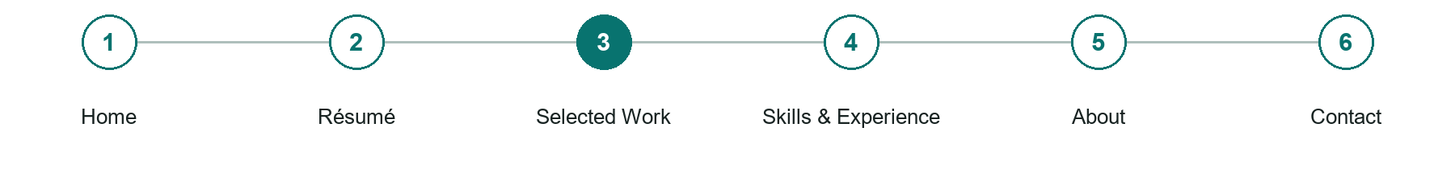
LOOK AND LEARN

Selected Work

The job of this page
Choose a few relevant projects. Explain the brief, your contribution, approach and outcome. Label coursework and self-directed projects honestly and distinguish your work from the team's.
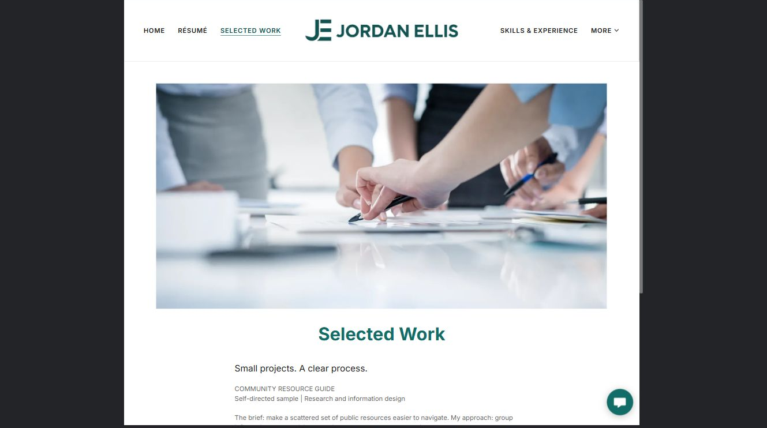
Jordan Ellis example | Explore SaaSTech Website Builder

Demo text example
Small projects. A clear process.
COMMUNITY RESOURCE GUIDE

Pause and plan
Which examples best support this page? Explain the context, your contribution and the permissions or credits needed. Label illustrative work and distinguish it from genuine completed projects or customer results.

WRITE YOUR PAGE

Selected Work
Write for your visitor. Be specific about what they need to know and what happens next. You can revise the wording after the workshop.
Your page headline

Your opening paragraph

Examples captions context and evidence to include

Button or link wording and where it should lead

Photo idea caption and permission or credit needed

Facts to verify or questions to resolve

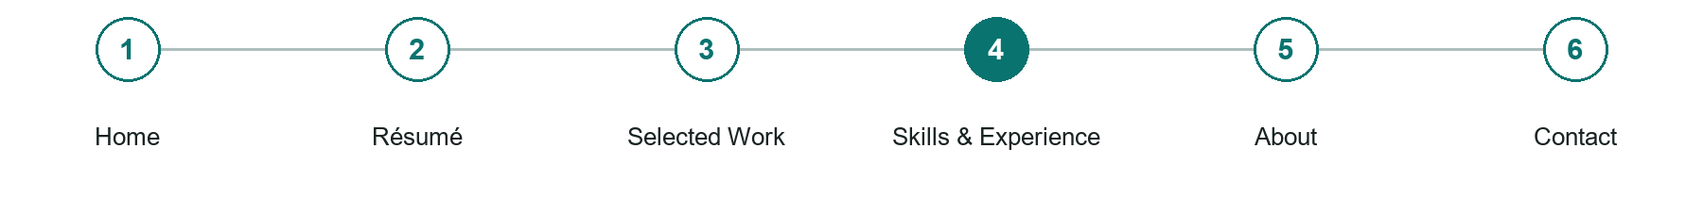
LOOK AND LEARN

Skills Experience

The job of this page
Connect skills to concrete examples rather than rating yourself with arbitrary percentage bars. Include verified credentials and relevant volunteer experience.
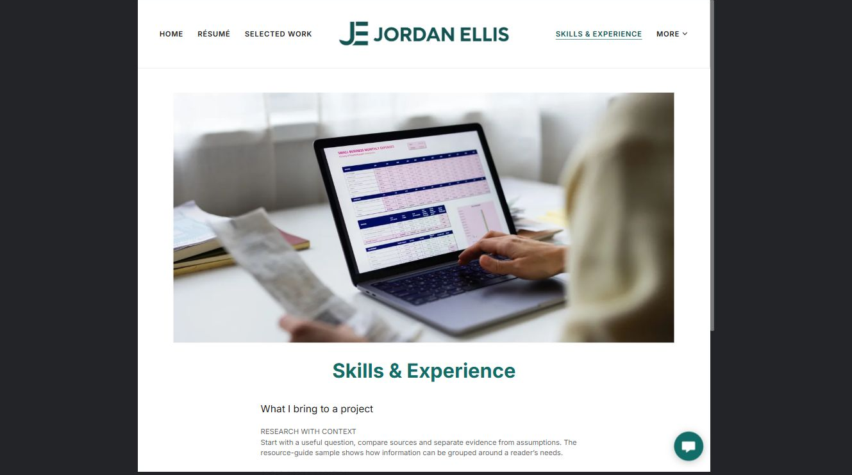
Jordan Ellis example | Explore SaaSTech Website Builder

Demo text example
What I bring to a project
Start with a useful question, compare sources and separate evidence from assumptions.

Pause and plan
What question brings a visitor to this page? List the details they need, the evidence you can provide and the next useful action. Remove content that does not help them decide or proceed.

WRITE YOUR PAGE

Skills Experience
Write for your visitor. Be specific about what they need to know and what happens next. You can revise the wording after the workshop.
Your page headline

Your opening paragraph

Key sections visitor questions and supporting details

Button or link wording and where it should lead

Photo idea caption and permission or credit needed

Facts to verify or questions to resolve

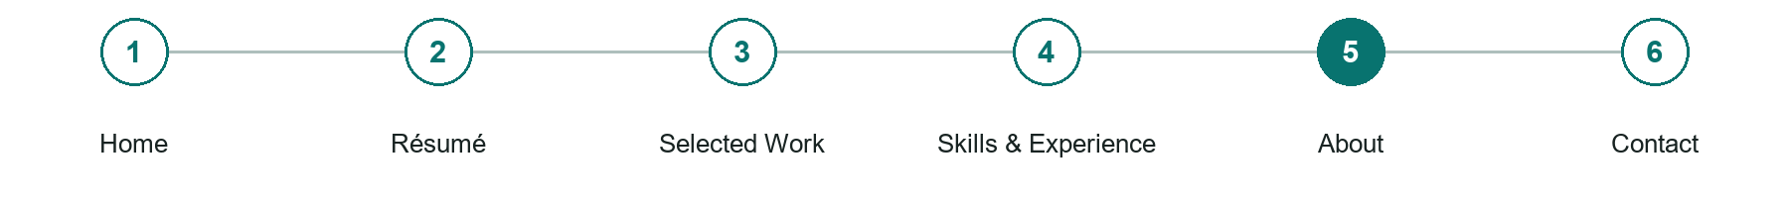
LOOK AND LEARN

About

The job of this page
Explain your interests, working approach and career direction in your own voice. Include only background you are comfortable making public.
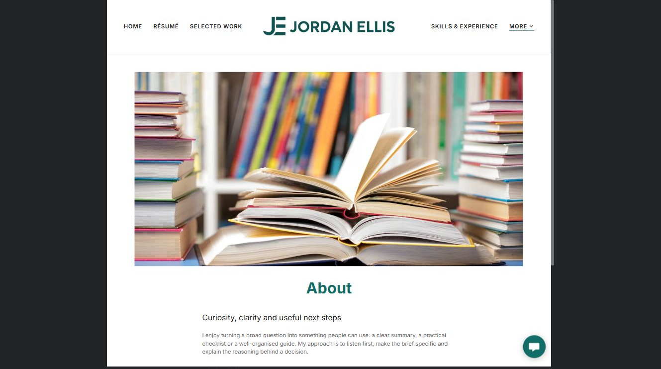
Jordan Ellis example | Explore SaaSTech Website Builder

Demo text example
Curiosity, clarity and useful next steps
I enjoy turning a broad question into something people can use: a clear summary, a practical checklist or a well-organised guide.

Pause and plan
Which names, roles and qualifications can you verify? What would help a visitor feel comfortable contacting you? Obtain permission for portraits and describe actual experience without unsupported claims.

WRITE YOUR PAGE

About
Write for your visitor. Be specific about what they need to know and what happens next. You can revise the wording after the workshop.
Your page headline

Your opening paragraph

People roles approach and verified credentials to introduce

Button or link wording and where it should lead

Photo idea caption and permission or credit needed

Facts to verify or questions to resolve

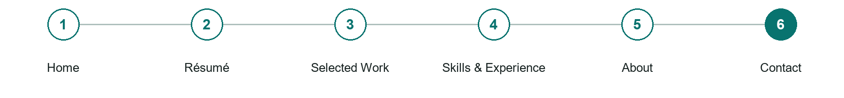
LOOK AND LEARN

Contact

The job of this page
Offer a professional email address or a short form for name, email and message. Share a general location if useful, not a home address or sensitive personal details.
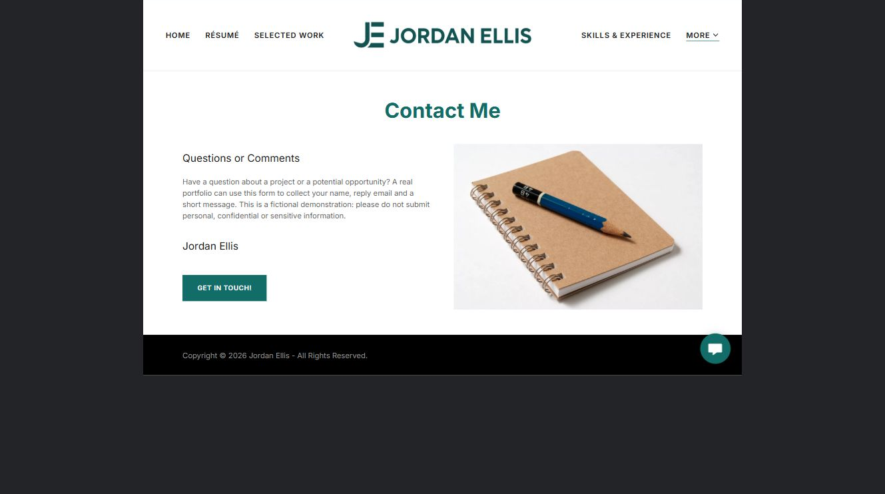
Jordan Ellis example | Explore SaaSTech Website Builder

Demo text example
Questions or Comments
Have a question about a project or a potential opportunity? A real portfolio can use this form to collect your name, reply email and a short message.

Pause and plan
What must someone provide, and what happens after they send it? Separate a request from a confirmed booking, order or place. Decide what information should stay out of a public form.

WRITE YOUR PAGE

Contact
Write for your visitor. Be specific about what they need to know and what happens next. You can revise the wording after the workshop.
Your page headline

Your opening paragraph

Information to request and how you will reply or confirm

Button or link wording and where it should lead

Photo idea caption and permission or credit needed

Facts to verify or questions to resolve

WORKSHOP CLOSE

Review and next steps
Ask a partner to read your draft as a first-time visitor. Can they explain what you offer, who it is for and the next step without extra help?

Before you publish
[ ] Every page has a clear purpose and a useful next step.
[ ] Headlines are specific and the wording sounds like your business.
[ ] Names, service areas, prices, dates and policies have been checked.
[ ] Credentials, testimonials and results are genuine and permission-cleared.
[ ] Photos support the text, do not repeat needlessly and have appropriate permissions.
[ ] Forms ask only for necessary information and explain what happens next.
[ ] Links, downloads and the main visitor task work on a phone.
The most useful feedback from your workshop partner

First change to make and who will do it

Information or photographs still needed

Target review date and who will approve the final content

Keep sensitive customer, patient, employee and payment information out of this workbook. Completing it does not publish a website or connect to Website Builder.

BUILD WITH SAASTECH SERVERS

Put your draft into Website Builder
Use the content you have written to build your own site. Keep the résumés & personal portfolios demo as a reference, and replace its company name, images and claims with your verified business information.

Explore the builder
See the editor, compare available plans and decide which features your business needs. Confirm current pricing and terms before purchasing.
Website Builder overview

Create your account
Set up your SaaSTech Servers customer account using your own details. Creating an account is separate from purchasing a Website Builder plan.
Create your SaaSTech account

Choose your plan
Open the secure shop to review the plan, subscription term and final total. Use the account connected to your purchase when you open your service.
View Website Builder plans

Build and check your pages
Add the pages from this workbook. Transfer your approved wording, upload permission-cleared photos and review each page on desktop and mobile before publishing.
Return to the Website Builder guide

Using a printed workbook
Type these short addresses into your browser. The account guide includes the Create My Account button.
www.saastech.net/products/website-builder
www.saastech.net/create-account
This workbook does not create an account, purchase a plan or publish your website. Keep passwords, payment details and confidential customer information out of your draft.

