
WEBSITE PLANNING WORKSHOP

Restaurants
Website workbook
Plan a clear website for restaurants. Explore a worked example, shape your own message and prepare to build with SaaSTech Servers.
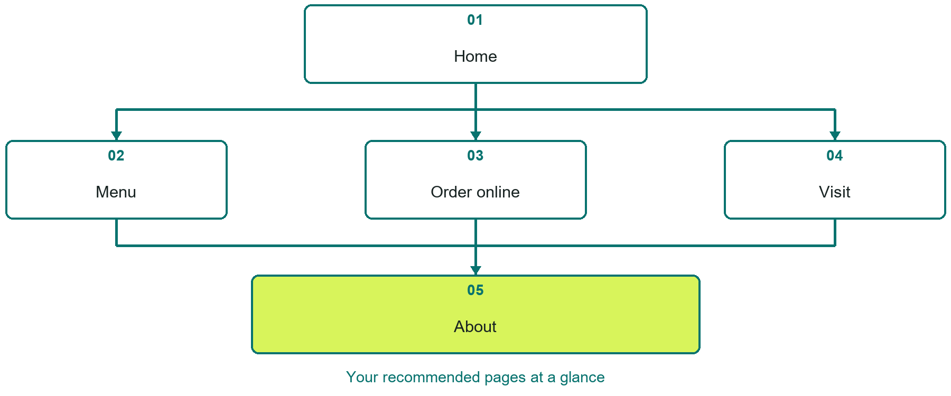

Inside this workbook
Five page examples • Practical writing exercises • A launch review
Use it in a workshop or at your own pace. Write by hand or complete the response fields in Word. The final page links to Website Builder, plans and account signup.
Example business Prairie Hearth Kitchen

RESTAURANTS

Your website brief
A SaaSTech Servers workshop for restaurants. Plan your website, learn from the Prairie Hearth Kitchen example and draft content for your own business.
Each page has a reference sheet followed by a writing sheet. Demo excerpts are labelled separately from new sample wording, which may differ from the screenshot. Click a blank response line to type; longer answers may add pages. Replace fictional details and verify every claim before publishing.
Your business or organization and workshop date

Who should visit your site and what do they need

The main action you want a visitor to take

What you offer and where or how you provide it

Facts photos and permissions to gather before publishing

Workshop rhythm: review the example, write your draft and exchange feedback. Use the final review to choose your next changes. Website Builder and account links are on the last page.

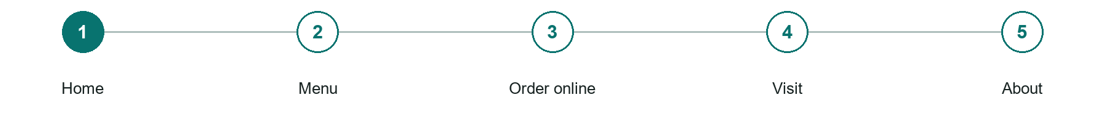
LOOK AND LEARN

Home

The job of this page
Show the food, location, current hours, and one primary menu or ordering action.

Prairie Hearth Kitchen example | Explore SaaSTech Website Builder

Sample wording to adapt
A table for your next gathering
Explore the current menu, plan a visit or check the ordering options. Confirm opening hours and availability before travelling. Contact the restaurant directly with ingredient or access questions.

Pause and plan
Could a first-time visitor explain what you do and who it is for after one glance? Choose one main action and the strongest truthful detail that gives them confidence to continue.

WRITE YOUR PAGE

Home
Write for your visitor. Be specific about what they need to know and what happens next. You can revise the wording after the workshop.
Your page headline

Your opening paragraph

Your offer audience location and most useful supporting details

Button or link wording and where it should lead

Photo idea caption and permission or credit needed

Facts to verify or questions to resolve

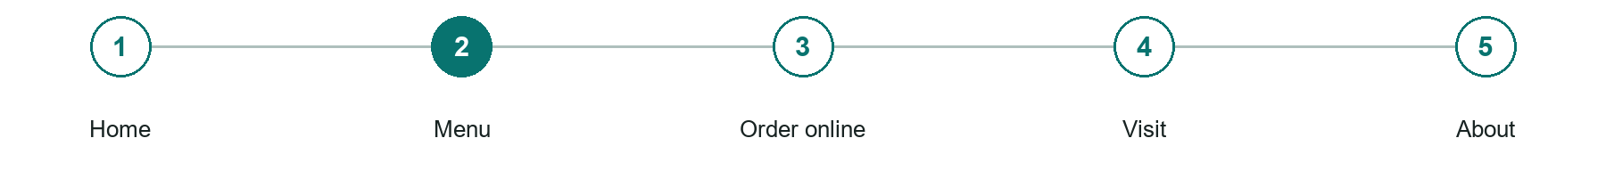
LOOK AND LEARN

Menu

The job of this page
Publish readable categories, current prices, dietary information, and availability notes.
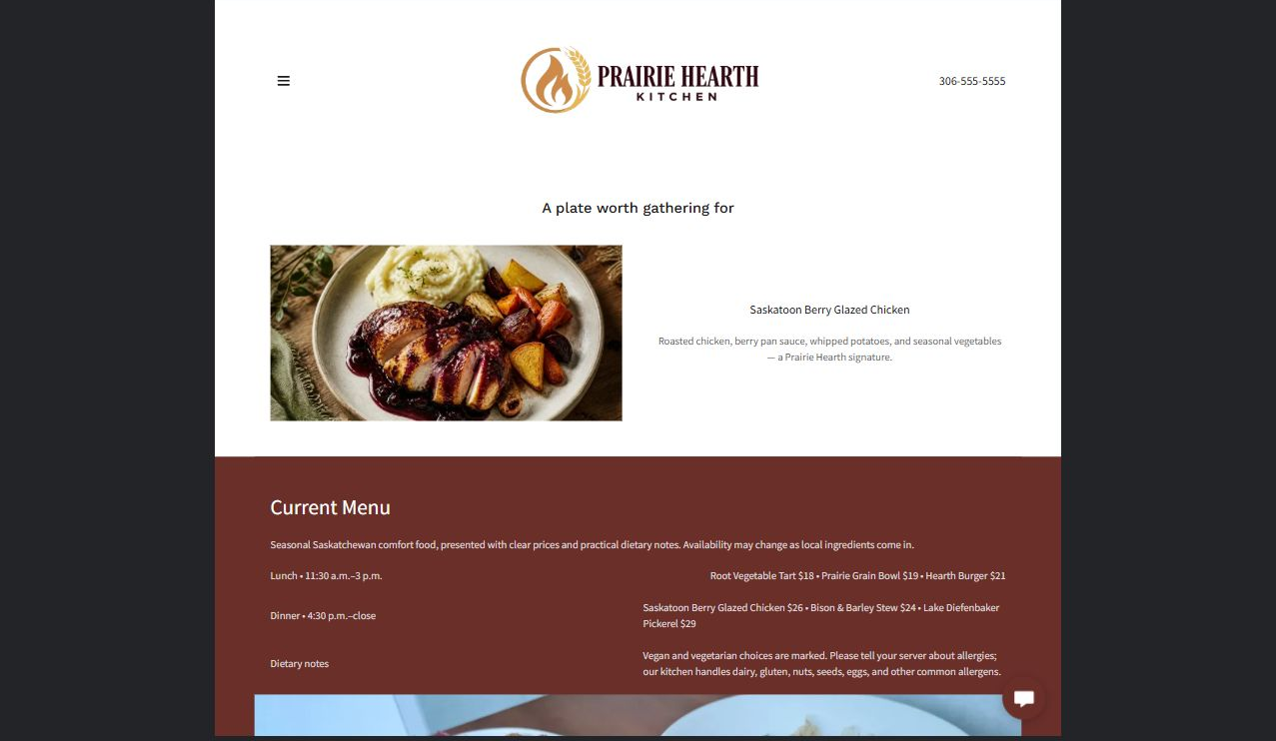
Prairie Hearth Kitchen example | Explore SaaSTech Website Builder

Sample wording to adapt
A plate worth gathering for
Browse the current dishes and prices, then ask the team about ingredients and availability. Menu items may change. Discuss dietary requirements directly with the restaurant rather than assuming an item is suitable.

Pause and plan
What is included and what needs separate confirmation? Make quantities, timing, exclusions and price conditions understandable. Avoid implying that an example price or image guarantees availability.

WRITE YOUR PAGE

Menu
Write for your visitor. Be specific about what they need to know and what happens next. You can revise the wording after the workshop.
Your page headline

Your opening paragraph

Options inclusions price conditions and availability details

Button or link wording and where it should lead

Photo idea caption and permission or credit needed

Facts to verify or questions to resolve

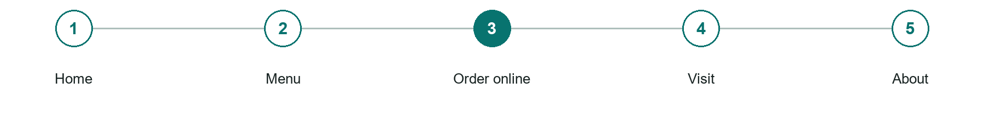
LOOK AND LEARN

Order online

The job of this page
Present items, pickup or delivery expectations, payment, and order cutoffs clearly.
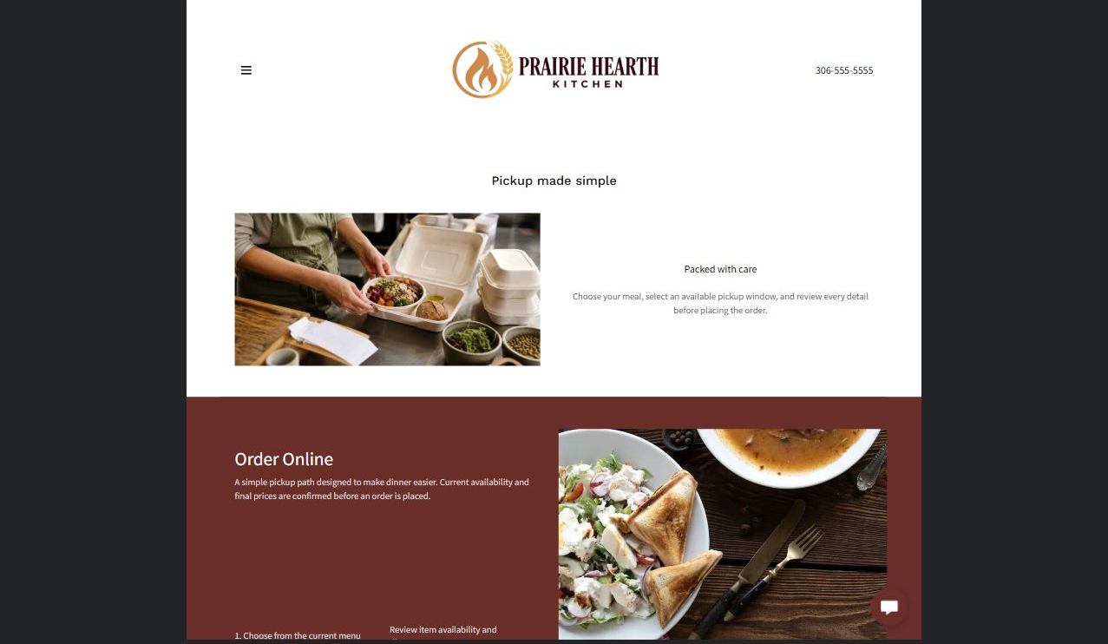
Prairie Hearth Kitchen example | Explore SaaSTech Website Builder

Demo text example
Pickup made simple
Packed with care

Pause and plan
What question brings a visitor to this page? List the details they need, the evidence you can provide and the next useful action. Remove content that does not help them decide or proceed.

WRITE YOUR PAGE

Order online
Write for your visitor. Be specific about what they need to know and what happens next. You can revise the wording after the workshop.
Your page headline

Your opening paragraph

Key sections visitor questions and supporting details

Button or link wording and where it should lead

Photo idea caption and permission or credit needed

Facts to verify or questions to resolve

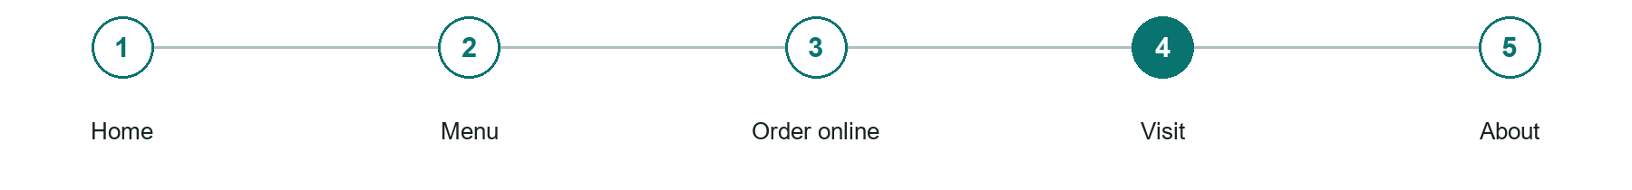
LOOK AND LEARN

Visit

The job of this page
Provide address, map, parking or access details, hours, phone number, and reservation policy.
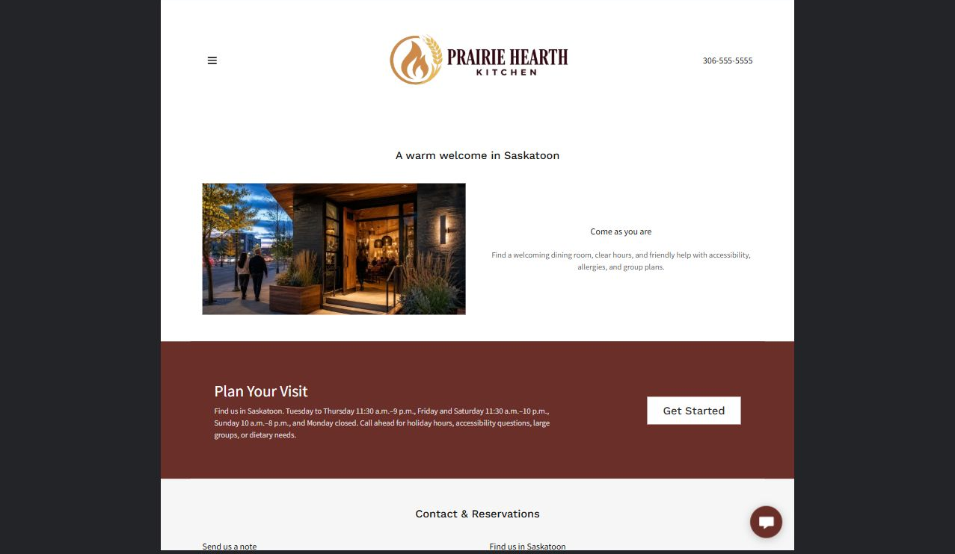
Prairie Hearth Kitchen example | Explore SaaSTech Website Builder

Demo text example
A warm welcome in Saskatoon
Come as you are

Pause and plan
What should someone know before arriving or proceeding? Clarify preparation, access and the right contact route. Verify policies and avoid promising urgent help or specialist advice the website cannot provide.

WRITE YOUR PAGE

Visit
Write for your visitor. Be specific about what they need to know and what happens next. You can revise the wording after the workshop.
Your page headline

Your opening paragraph

Preparation access policies and practical questions to answer

Button or link wording and where it should lead

Photo idea caption and permission or credit needed

Facts to verify or questions to resolve

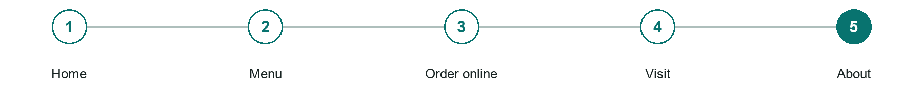
LOOK AND LEARN

About

The job of this page
Tell the restaurant's story briefly and connect it to the food and customer experience.
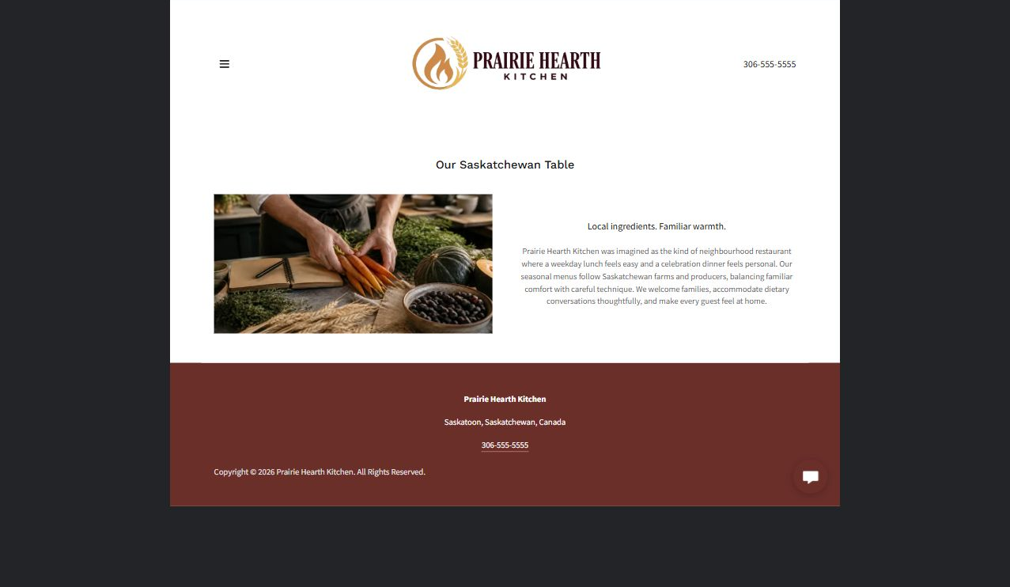
Prairie Hearth Kitchen example | Explore SaaSTech Website Builder

Demo text example
Our Saskatchewan Table
Local ingredients. Familiar warmth.

Pause and plan
Which names, roles and qualifications can you verify? What would help a visitor feel comfortable contacting you? Obtain permission for portraits and describe actual experience without unsupported claims.

WRITE YOUR PAGE

About
Write for your visitor. Be specific about what they need to know and what happens next. You can revise the wording after the workshop.
Your page headline

Your opening paragraph

People roles approach and verified credentials to introduce

Button or link wording and where it should lead

Photo idea caption and permission or credit needed

Facts to verify or questions to resolve

WORKSHOP CLOSE

Review and next steps
Ask a partner to read your draft as a first-time visitor. Can they explain what you offer, who it is for and the next step without extra help?

Before you publish
[ ] Every page has a clear purpose and a useful next step.
[ ] Headlines are specific and the wording sounds like your business.
[ ] Names, service areas, prices, dates and policies have been checked.
[ ] Credentials, testimonials and results are genuine and permission-cleared.
[ ] Photos support the text, do not repeat needlessly and have appropriate permissions.
[ ] Forms ask only for necessary information and explain what happens next.
[ ] Links, downloads and the main visitor task work on a phone.
The most useful feedback from your workshop partner

First change to make and who will do it

Information or photographs still needed

Target review date and who will approve the final content

Keep sensitive customer, patient, employee and payment information out of this workbook. Completing it does not publish a website or connect to Website Builder.

BUILD WITH SAASTECH SERVERS

Put your draft into Website Builder
Use the content you have written to build your own site. Keep the restaurants demo as a reference, and replace its company name, images and claims with your verified business information.

Explore the builder
See the editor, compare available plans and decide which features your business needs. Confirm current pricing and terms before purchasing.
Website Builder overview

Create your account
Set up your SaaSTech Servers customer account using your own details. Creating an account is separate from purchasing a Website Builder plan.
Create your SaaSTech account

Choose your plan
Open the secure shop to review the plan, subscription term and final total. Use the account connected to your purchase when you open your service.
View Website Builder plans

Build and check your pages
Add the pages from this workbook. Transfer your approved wording, upload permission-cleared photos and review each page on desktop and mobile before publishing.
Return to the Website Builder guide

Using a printed workbook
Type these short addresses into your browser. The account guide includes the Create My Account button.
www.saastech.net/products/website-builder
www.saastech.net/create-account
This workbook does not create an account, purchase a plan or publish your website. Keep passwords, payment details and confidential customer information out of your draft.

