
WEBSITE PLANNING WORKSHOP

Equipment & Party Rentals
Website workbook
Plan a clear website for equipment & party rentals. Explore a worked example, shape your own message and prepare to build with SaaSTech Servers.
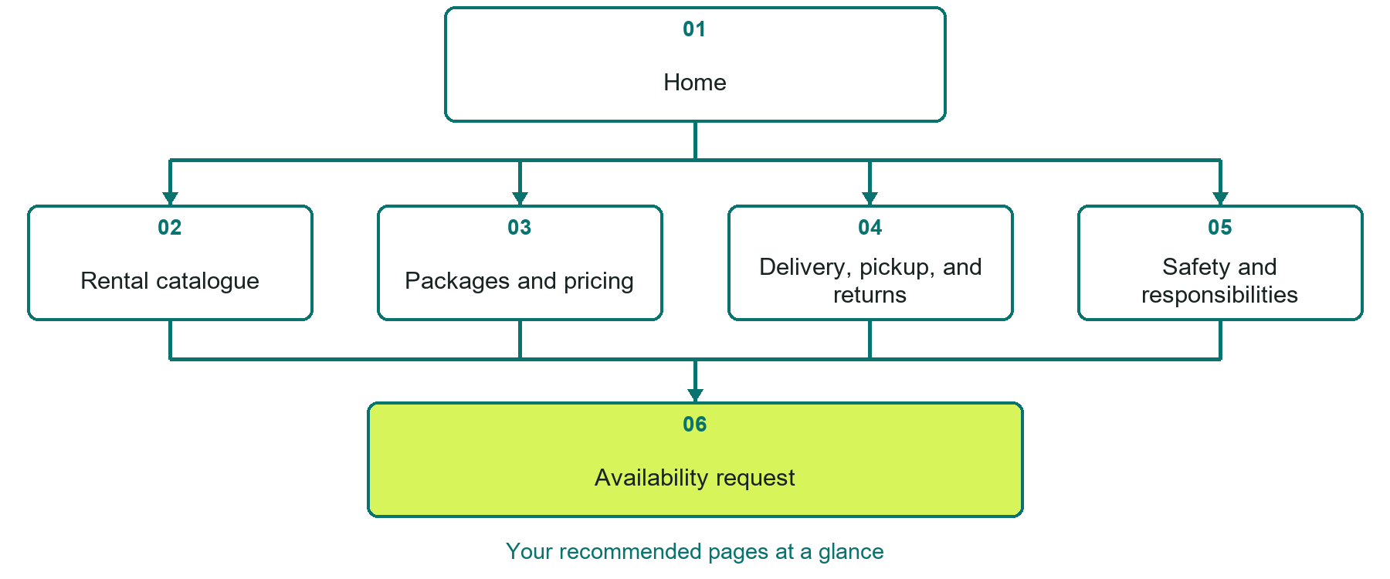

Inside this workbook
Six page examples • Practical writing exercises • A launch review
Use it in a workshop or at your own pace. Write by hand or complete the response fields in Word. The final page links to Website Builder, plans and account signup.
Example business Prairie Gather Rentals

EQUIPMENT & PARTY RENTALS

Your website brief
A SaaSTech Servers workshop for equipment & party rentals. Plan your website, learn from the Prairie Gather Rentals example and draft content for your own business.
Each page has a reference sheet followed by a writing sheet. Demo excerpts are labelled separately from new sample wording, which may differ from the screenshot. Click a blank response line to type; longer answers may add pages. Replace fictional details and verify every claim before publishing.
Your business or organization and workshop date

Who should visit your site and what do they need

The main action you want a visitor to take

What you offer and where or how you provide it

Facts photos and permissions to gather before publishing

Workshop rhythm: review the example, write your draft and exchange feedback. Use the final review to choose your next changes. Website Builder and account links are on the last page.

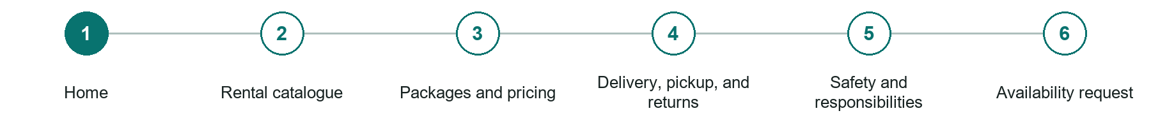
LOOK AND LEARN

Home

The job of this page
Introduce the rental business, service area and event types. Lead visitors to the catalogue and explain that availability must be confirmed.
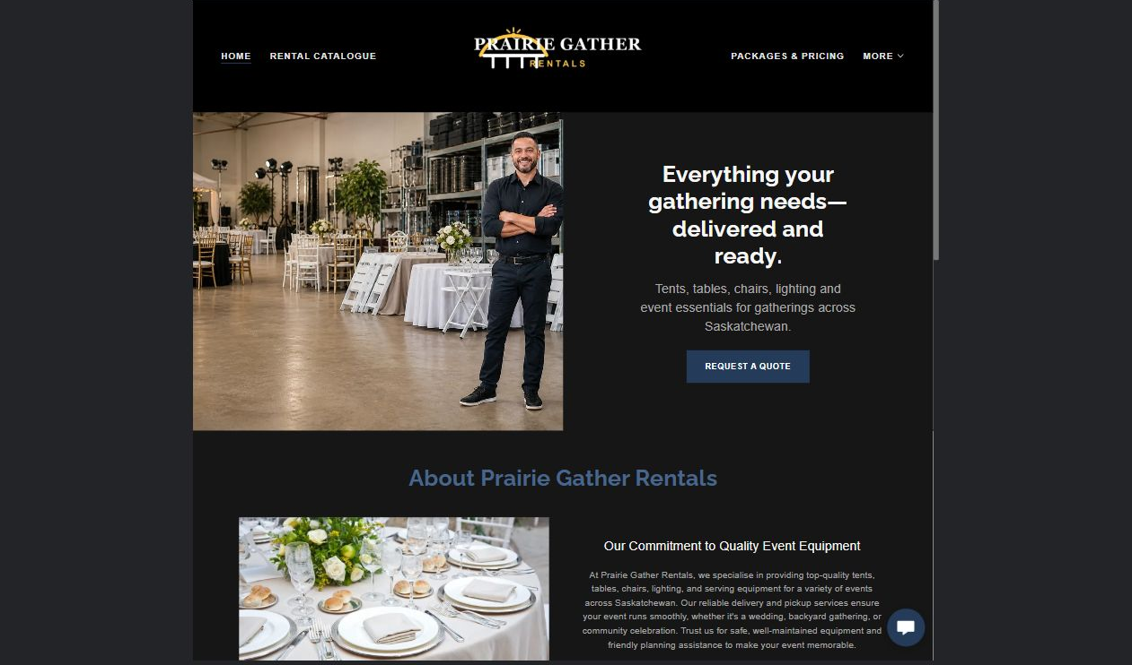
Prairie Gather Rentals example | Explore SaaSTech Website Builder

Sample wording to adapt
Plan the pieces for your gathering
Explore the rental range and ask about your event date. Quantities, delivery and pricing are confirmed in a written proposal. A catalogue image does not guarantee availability.

Pause and plan
Could a first-time visitor explain what you do and who it is for after one glance? Choose one main action and the strongest truthful detail that gives them confidence to continue.

WRITE YOUR PAGE

Home
Write for your visitor. Be specific about what they need to know and what happens next. You can revise the wording after the workshop.
Your page headline

Your opening paragraph

Your offer audience location and most useful supporting details

Button or link wording and where it should lead

Photo idea caption and permission or credit needed

Facts to verify or questions to resolve

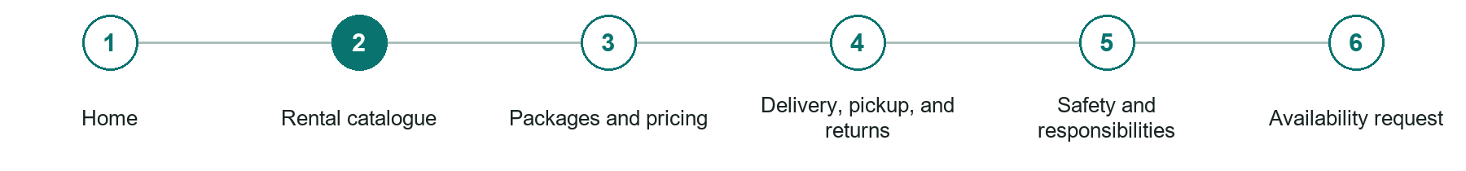
LOOK AND LEARN

Rental catalogue

The job of this page
Organize current inventory by customer task with specifications, dimensions, capacity, included parts, condition, compatibility, and accurate photographs.
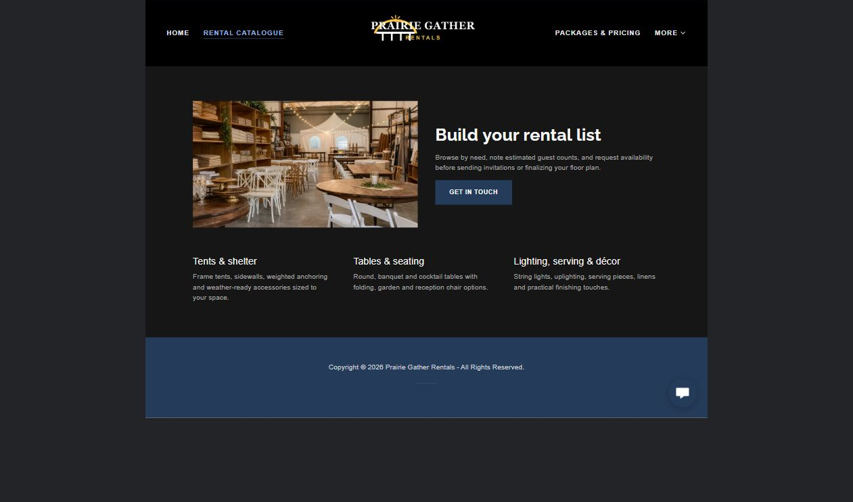
Prairie Gather Rentals example | Explore SaaSTech Website Builder

Sample wording to adapt
Build a useful rental list
Note the item, quantity and intended use for each selection. Ask about dimensions and current availability. The rental team will confirm which pieces suit the event and requested date.

Pause and plan
What is included and what needs separate confirmation? Make quantities, timing, exclusions and price conditions understandable. Avoid implying that an example price or image guarantees availability.

WRITE YOUR PAGE

Rental catalogue
Write for your visitor. Be specific about what they need to know and what happens next. You can revise the wording after the workshop.
Your page headline

Your opening paragraph

Options inclusions price conditions and availability details

Button or link wording and where it should lead

Photo idea caption and permission or credit needed

Facts to verify or questions to resolve

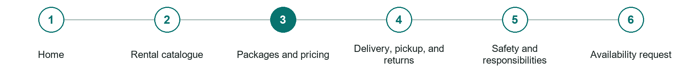
LOOK AND LEARN

Packages and pricing

The job of this page
Explain rental periods, package contents, quantity tiers, deposits, taxes, consumables, optional accessories, setup, delivery, and late fees.
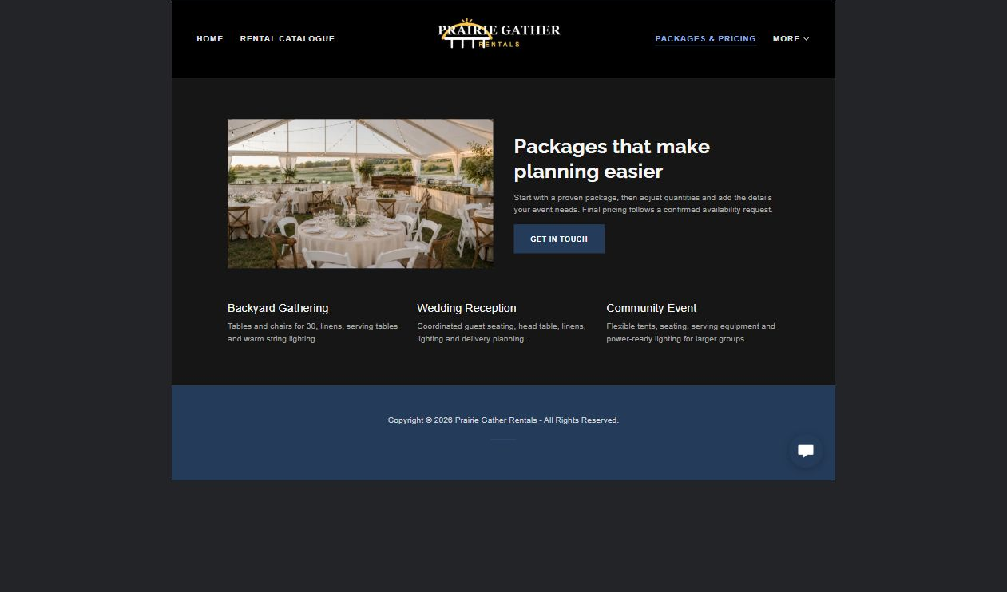
Prairie Gather Rentals example | Explore SaaSTech Website Builder

Sample wording to adapt
Confirm the complete rental cost
Review quantities, rental duration and any delivery, setup or collection charges. Ask about deposits and changes before accepting. A sample package is not a confirmed quote.

Pause and plan
What is included and what needs separate confirmation? Make quantities, timing, exclusions and price conditions understandable. Avoid implying that an example price or image guarantees availability.

WRITE YOUR PAGE

Packages and pricing
Write for your visitor. Be specific about what they need to know and what happens next. You can revise the wording after the workshop.
Your page headline

Your opening paragraph

Options inclusions price conditions and availability details

Button or link wording and where it should lead

Photo idea caption and permission or credit needed

Facts to verify or questions to resolve

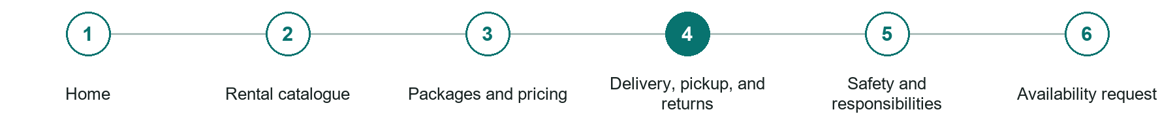
LOOK AND LEARN

Delivery pickup and returns

The job of this page
Publish service areas, scheduling windows, site access needs, identification, inspections, cleaning, fuel or charging, and return expectations.
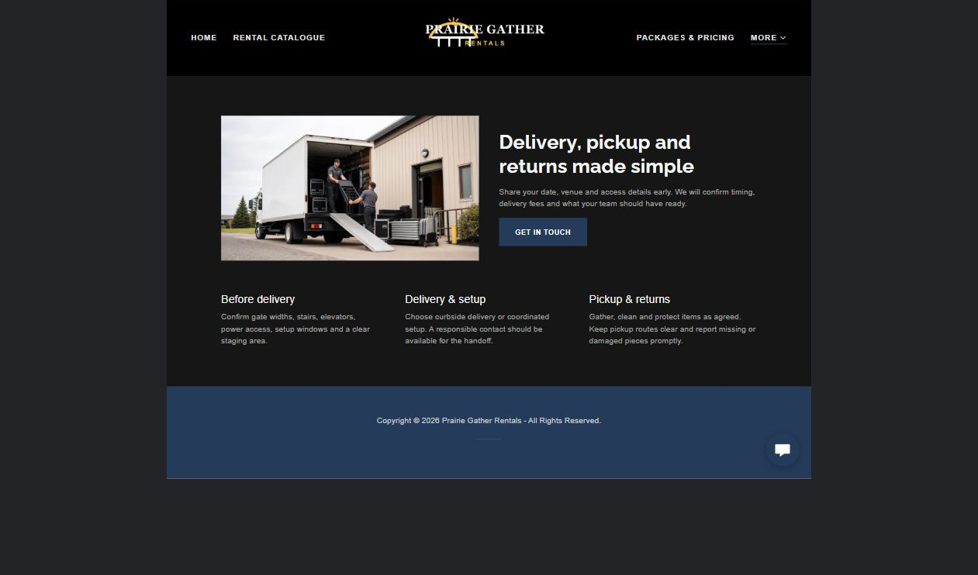
Prairie Gather Rentals example | Explore SaaSTech Website Builder

Sample wording to adapt
Plan delivery and returns
Agree the address, access, arrival window and collection arrangements. Confirm who handles setup and how items should be returned. Share access instructions privately after the booking is agreed.

Pause and plan
What should someone know before arriving or proceeding? Clarify preparation, access and the right contact route. Verify policies and avoid promising urgent help or specialist advice the website cannot provide.

WRITE YOUR PAGE

Delivery pickup and returns
Write for your visitor. Be specific about what they need to know and what happens next. You can revise the wording after the workshop.
Your page headline

Your opening paragraph

Preparation access policies and practical questions to answer

Button or link wording and where it should lead

Photo idea caption and permission or credit needed

Facts to verify or questions to resolve

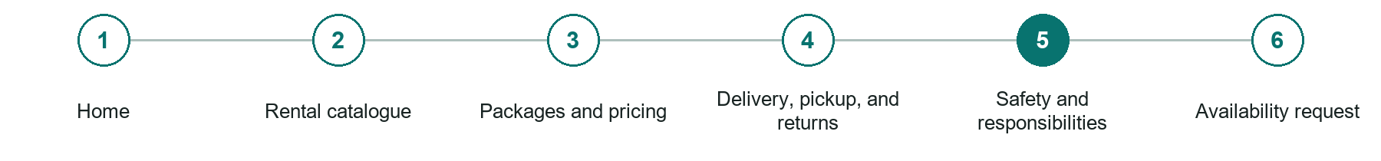
LOOK AND LEARN

Safety and responsibilities

The job of this page
State training, operator requirements, prohibited uses, weather limits, damage, loss, insurance, waivers, and emergency contact procedures.
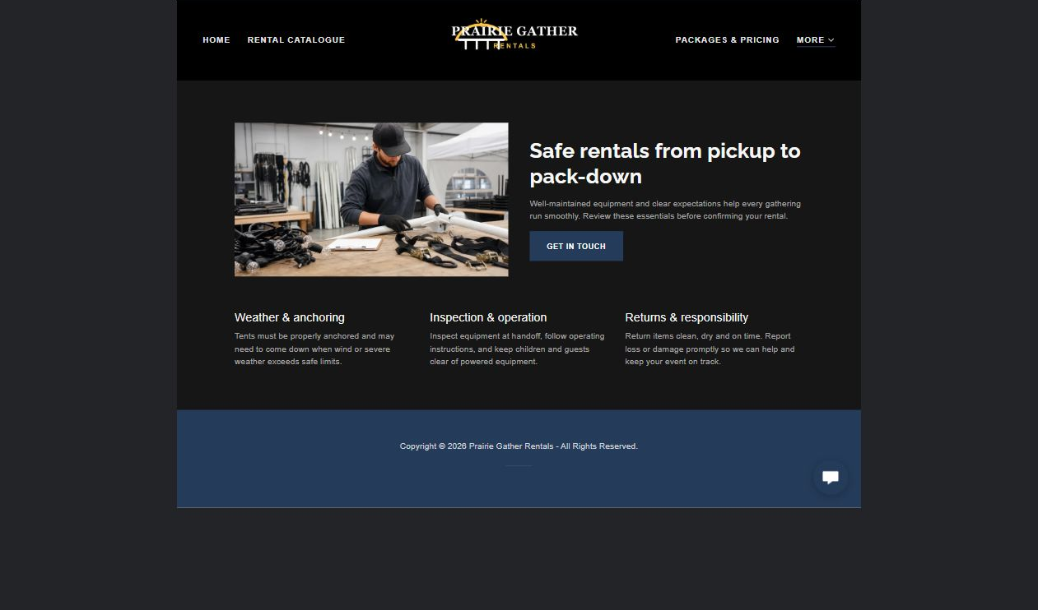
Prairie Gather Rentals example | Explore SaaSTech Website Builder

Sample wording to adapt
Understand your responsibilities
Read the item's handling guidance and agreed return conditions. Ask about damage, loss and unsuitable uses before accepting the rental. Do not assume every item is appropriate for every venue.

Pause and plan
What should someone know before arriving or proceeding? Clarify preparation, access and the right contact route. Verify policies and avoid promising urgent help or specialist advice the website cannot provide.

WRITE YOUR PAGE

Safety and responsibilities
Write for your visitor. Be specific about what they need to know and what happens next. You can revise the wording after the workshop.
Your page headline

Your opening paragraph

Preparation access policies and practical questions to answer

Button or link wording and where it should lead

Photo idea caption and permission or credit needed

Facts to verify or questions to resolve

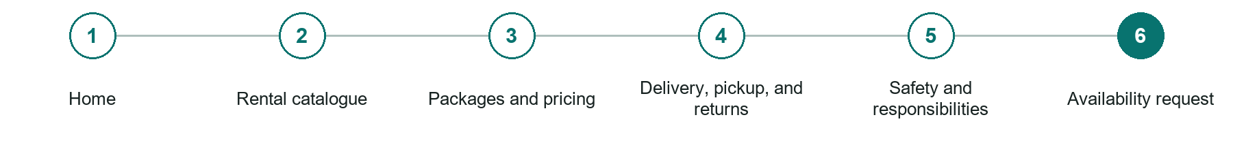
LOOK AND LEARN

Availability request

The job of this page
Collect dates, item quantities, project or event type, location, delivery, setup, compatibility, responsible renter, and contact details.
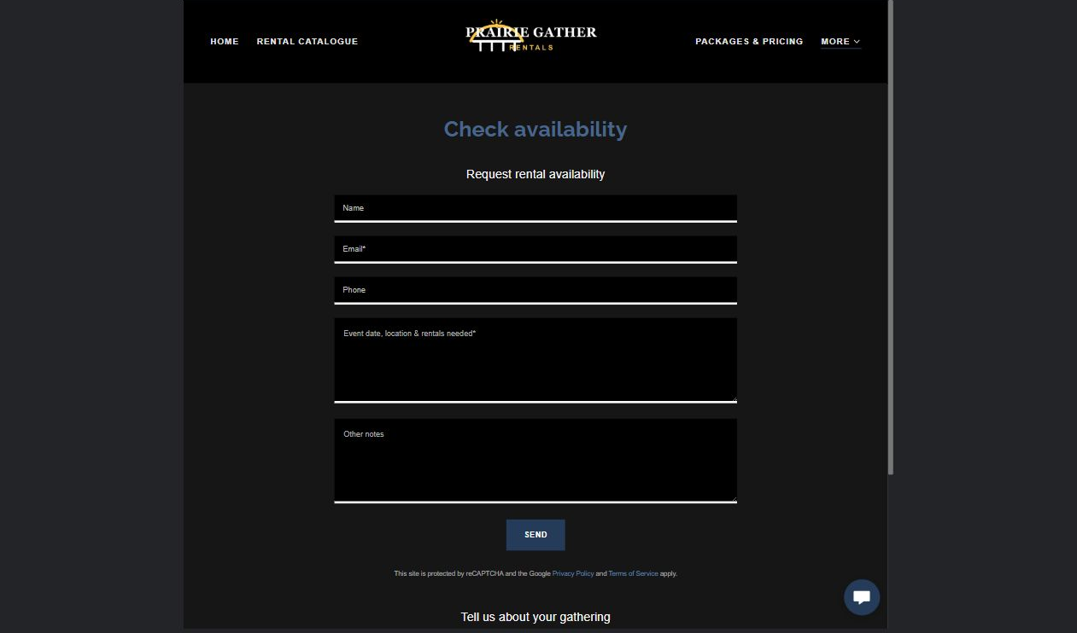
Prairie Gather Rentals example | Explore SaaSTech Website Builder

Sample wording to adapt
Check availability for your event
Send the date, location, item list and quantities. Include delivery or pickup preferences. Wait for written confirmation before treating the items as reserved.

Pause and plan
What must someone provide, and what happens after they send it? Separate a request from a confirmed booking, order or place. Decide what information should stay out of a public form.

WRITE YOUR PAGE

Availability request
Write for your visitor. Be specific about what they need to know and what happens next. You can revise the wording after the workshop.
Your page headline

Your opening paragraph

Information to request and how you will reply or confirm

Button or link wording and where it should lead

Photo idea caption and permission or credit needed

Facts to verify or questions to resolve

WORKSHOP CLOSE

Review and next steps
Ask a partner to read your draft as a first-time visitor. Can they explain what you offer, who it is for and the next step without extra help?

Before you publish
[ ] Every page has a clear purpose and a useful next step.
[ ] Headlines are specific and the wording sounds like your business.
[ ] Names, service areas, prices, dates and policies have been checked.
[ ] Credentials, testimonials and results are genuine and permission-cleared.
[ ] Photos support the text, do not repeat needlessly and have appropriate permissions.
[ ] Forms ask only for necessary information and explain what happens next.
[ ] Links, downloads and the main visitor task work on a phone.
The most useful feedback from your workshop partner

First change to make and who will do it

Information or photographs still needed

Target review date and who will approve the final content

Keep sensitive customer, patient, employee and payment information out of this workbook. Completing it does not publish a website or connect to Website Builder.

BUILD WITH SAASTECH SERVERS

Put your draft into Website Builder
Use the content you have written to build your own site. Keep the equipment & party rentals demo as a reference, and replace its company name, images and claims with your verified business information.

Explore the builder
See the editor, compare available plans and decide which features your business needs. Confirm current pricing and terms before purchasing.
Website Builder overview

Create your account
Set up your SaaSTech Servers customer account using your own details. Creating an account is separate from purchasing a Website Builder plan.
Create your SaaSTech account

Choose your plan
Open the secure shop to review the plan, subscription term and final total. Use the account connected to your purchase when you open your service.
View Website Builder plans

Build and check your pages
Add the pages from this workbook. Transfer your approved wording, upload permission-cleared photos and review each page on desktop and mobile before publishing.
Return to the Website Builder guide

Using a printed workbook
Type these short addresses into your browser. The account guide includes the Create My Account button.
www.saastech.net/products/website-builder
www.saastech.net/create-account
This workbook does not create an account, purchase a plan or publish your website. Keep passwords, payment details and confidential customer information out of your draft.

