

Regional Airports
Website workbook
A practical workshop for a 6-page website. Study the example, plan the content and draft your own version in Word or on paper.
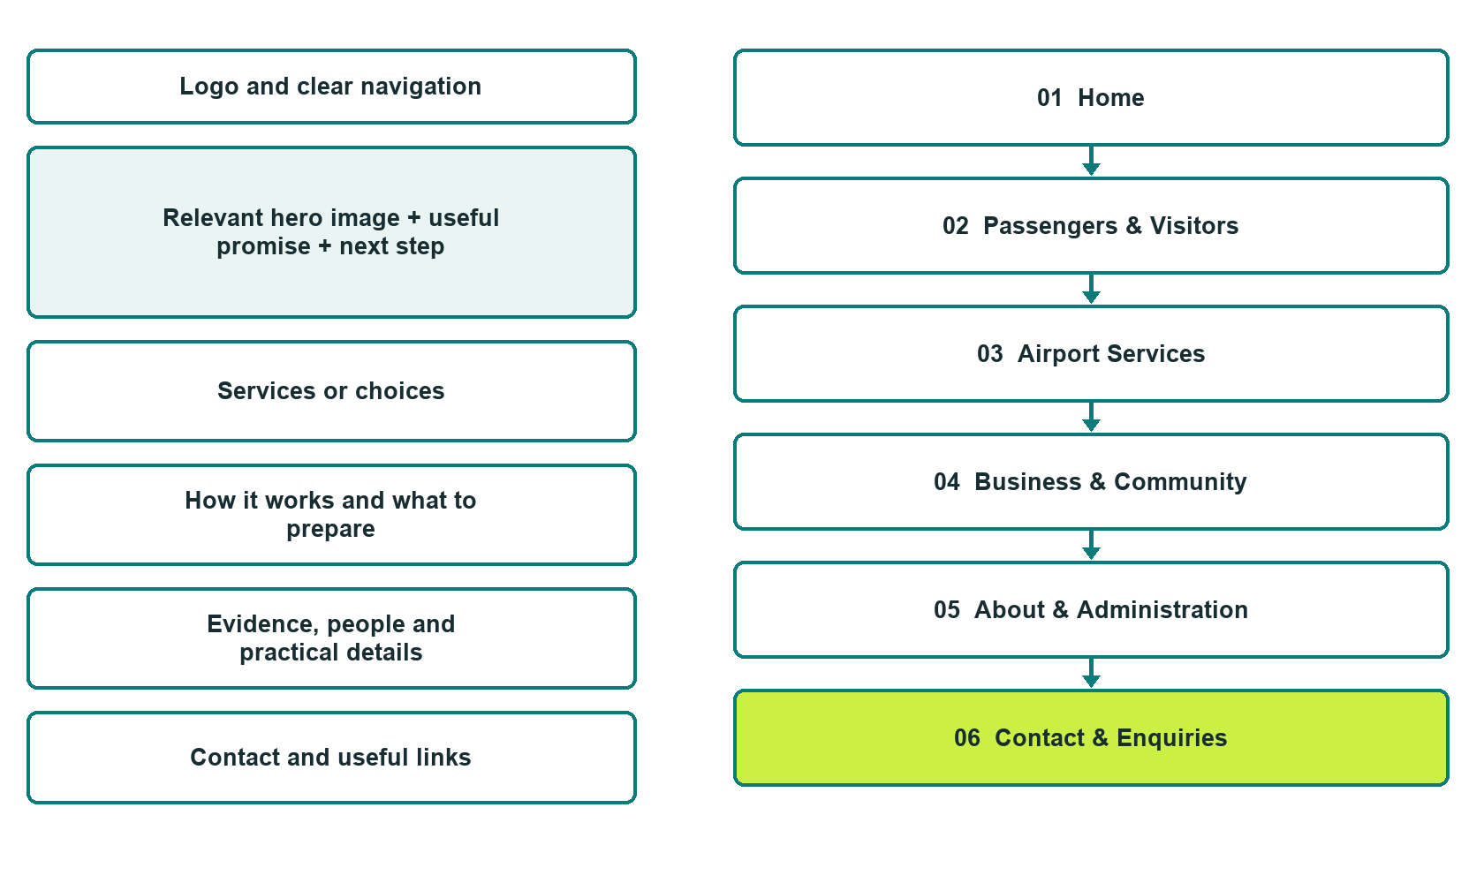

Plan → Draft → Build → Test
Demo-capture edition: actual Website Builder desktop previews and excerpts of the example wording. See each matching mobile preview in the industry page gallery. The example business and its AI-generated photographs are fictional.
Explore Website Builder and compare plans

Before you build
Your business supplies the facts. Prairie Gateway Regional Airport is a fictional teaching example, not a live service.

□ Find visitor information or contact airport administration
□ Verified business identity and current contact information
□ Clear request and confirmation process
□ Choose original photographs and confirm permission to use them.
□ Keep private customer records out of public website forms.

Your audience and the action you want them to take

Facts to verify and people who must approve them
Create your SaaSTech account

01 Home
Give this page one clear job in the customer journey.
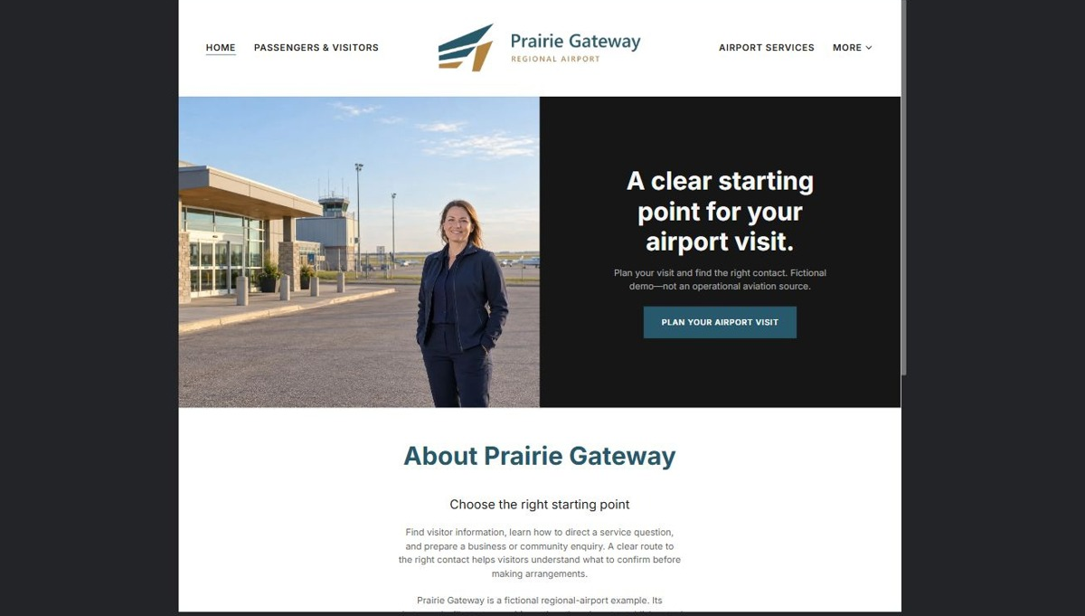
Actual desktop preview - unpublished fictional demonstration

Demo wording excerpt to adapt and verify
A clear starting point for your airport visit.
Plan your visit and find the right contact. Fictional demo—not an operational aviation source.
Find visitor information, learn how to direct a service question, and prepare a business or community enquiry. A clear route to the right contact helps visitors understand what to confirm before making arrangements.
Prairie Gateway is a fictional regional-airport example. Its photographs illustrate a prairie setting; they do not establish actual facilities, services or flight availability.
Suggested button: Plan your airport visit

Website advice
Separate passenger and visitor guidance, business services and administration contacts. Publish only verified services, access information and operator-approved updates.

Your draft: Home
Write in the voice of your own business. Use facts you can verify, not promises copied from the example.

Headline and short introduction

Main content and details visitors need

Button wording and destination

Photo choice, permission and facts still to confirm
Partner check: can someone unfamiliar with the business find a useful next step?

02 Passengers & Visitors
Give this page one clear job in the customer journey.
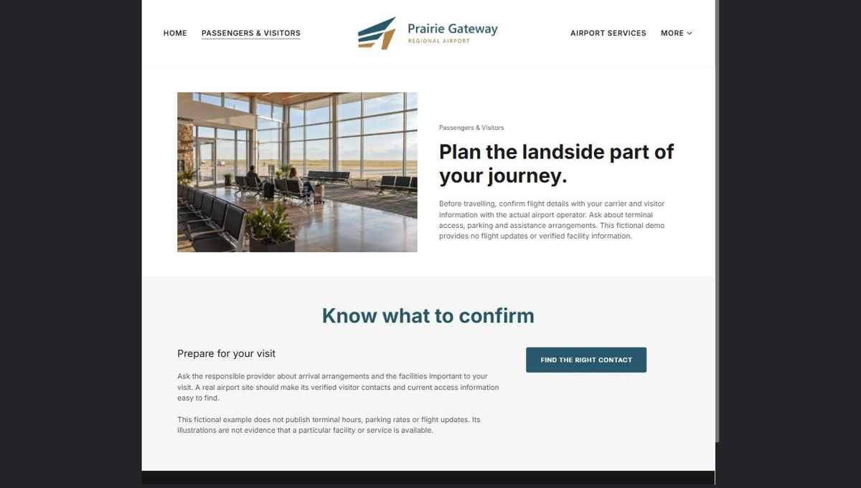
Actual desktop preview - unpublished fictional demonstration

Demo wording excerpt to adapt and verify
Plan the landside part of your journey.
Before travelling, confirm flight details with your carrier and visitor information with the actual airport operator. Ask about terminal access, parking and assistance arrangements. This fictional demo provides no flight updates or verified facility information.
Ask the responsible provider about arrival arrangements and the facilities important to your visit. A real airport site should make its verified visitor contacts and current access information easy to find.
This fictional example does not publish terminal hours, parking rates or flight updates. Its illustrations are not evidence that a particular facility or service is available.
Suggested button: Find the right contact

Website advice
Help visitors plan the landside part of a journey. Confirm terminal access, parking, accessibility and where to ask travel questions.

Your draft: Passengers & Visitors
Write in the voice of your own business. Use facts you can verify, not promises copied from the example.

Headline and short introduction

Main content and details visitors need

Button wording and destination

Photo choice, permission and facts still to confirm
Partner check: can someone unfamiliar with the business find a useful next step?

03 Airport Services
Give this page one clear job in the customer journey.
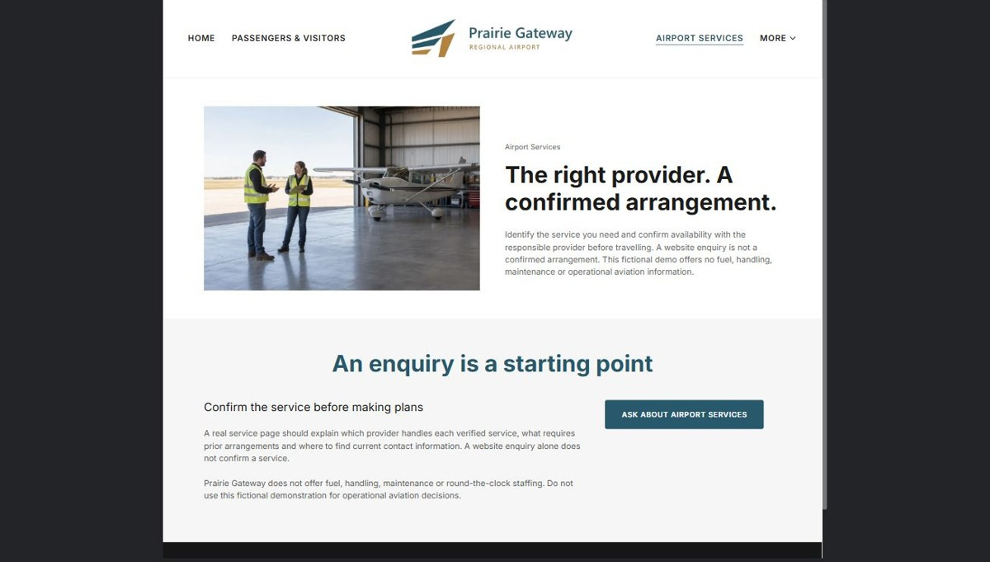
Actual desktop preview - unpublished fictional demonstration

Demo wording excerpt to adapt and verify
The right provider. A confirmed arrangement.
Identify the service you need and confirm availability with the responsible provider before travelling. A website enquiry is not a confirmed arrangement. This fictional demo offers no fuel, handling, maintenance or operational aviation information.
A real service page should explain which provider handles each verified service, what requires prior arrangements and where to find current contact information. A website enquiry alone does not confirm a service.
Prairie Gateway does not offer fuel, handling, maintenance or round-the-clock staffing. Do not use this fictional demonstration for operational aviation decisions.
Suggested button: Ask about airport services

Website advice
Explain verified services and the correct service-provider contact. Distinguish public information from arrangements that require prior confirmation. Do not imply fuel, handling, scheduled flights or round-the-clock staffing without operator approval.

Your draft: Airport Services
Write in the voice of your own business. Use facts you can verify, not promises copied from the example.

Headline and short introduction

Main content and details visitors need

Button wording and destination

Photo choice, permission and facts still to confirm
Partner check: can someone unfamiliar with the business find a useful next step?

04 Business & Community
Give this page one clear job in the customer journey.
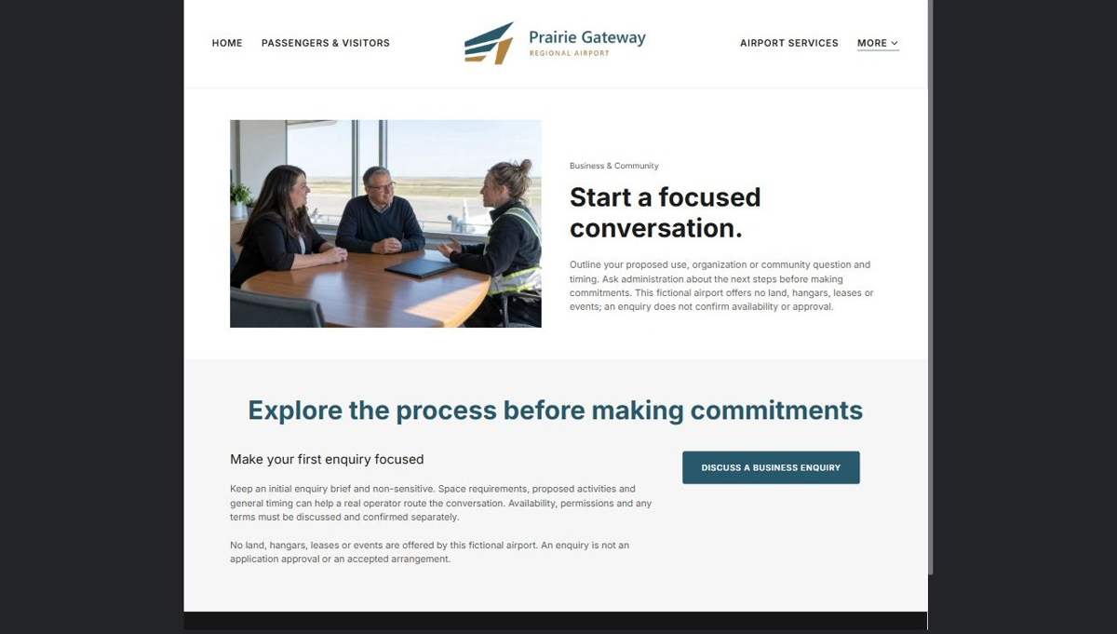
Actual desktop preview - unpublished fictional demonstration

Demo wording excerpt to adapt and verify
Start a focused conversation.
Outline your proposed use, organization or community question and timing. Ask administration about the next steps before making commitments. This fictional airport offers no land, hangars, leases or events; an enquiry does not confirm availability or approval.
Keep an initial enquiry brief and non-sensitive. Space requirements, proposed activities and general timing can help a real operator route the conversation. Availability, permissions and any terms must be discussed and confirmed separately.
No land, hangars, leases or events are offered by this fictional airport. An enquiry is not an application approval or an accepted arrangement.
Suggested button: Discuss a business enquiry

Website advice
Introduce approved commercial enquiry paths, community information and space enquiries. Do not suggest land, hangars or leases are available without verification.

Your draft: Business & Community
Write in the voice of your own business. Use facts you can verify, not promises copied from the example.

Headline and short introduction

Main content and details visitors need

Button wording and destination

Photo choice, permission and facts still to confirm
Partner check: can someone unfamiliar with the business find a useful next step?

05 About & Administration
Give this page one clear job in the customer journey.
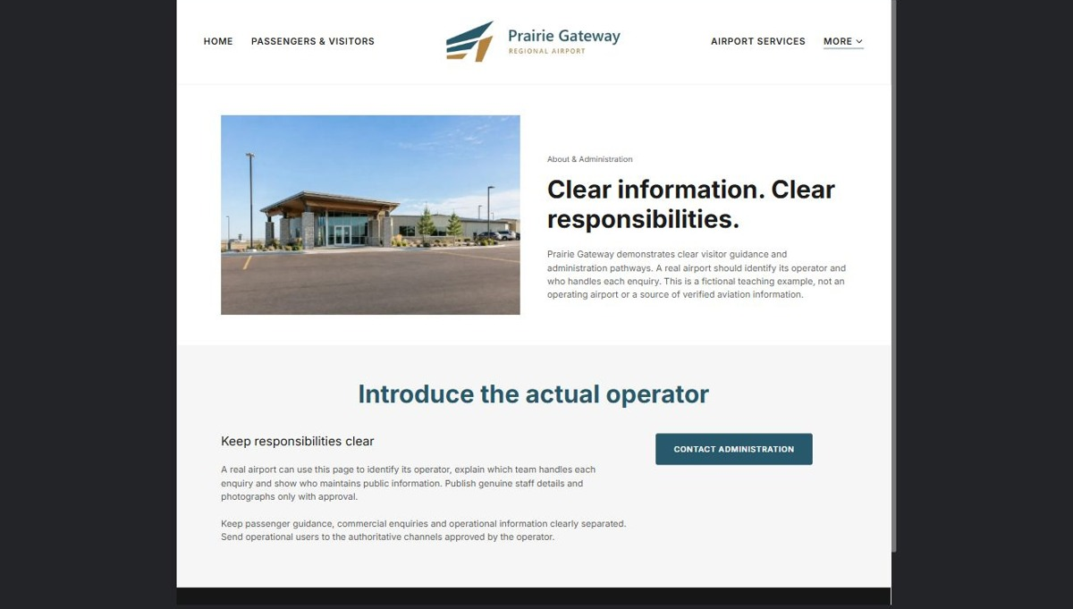
Actual desktop preview - unpublished fictional demonstration

Demo wording excerpt to adapt and verify
Clear information. Clear responsibilities.
Prairie Gateway demonstrates clear visitor guidance and administration pathways. A real airport should identify its operator and who handles each enquiry. This is a fictional teaching example, not an operating airport or a source of verified aviation information.
A real airport can use this page to identify its operator, explain which team handles each enquiry and show who maintains public information. Publish genuine staff details and photographs only with approval.
Keep passenger guidance, commercial enquiries and operational information clearly separated. Send operational users to the authoritative channels approved by the operator.
Suggested button: Contact administration

Website advice
Show the airport’s actual operator, management contacts and publication responsibilities. Keep safety-sensitive information out of general marketing content.

Your draft: About & Administration
Write in the voice of your own business. Use facts you can verify, not promises copied from the example.

Headline and short introduction

Main content and details visitors need

Button wording and destination

Photo choice, permission and facts still to confirm
Partner check: can someone unfamiliar with the business find a useful next step?

06 Contact & Enquiries
Give this page one clear job in the customer journey.
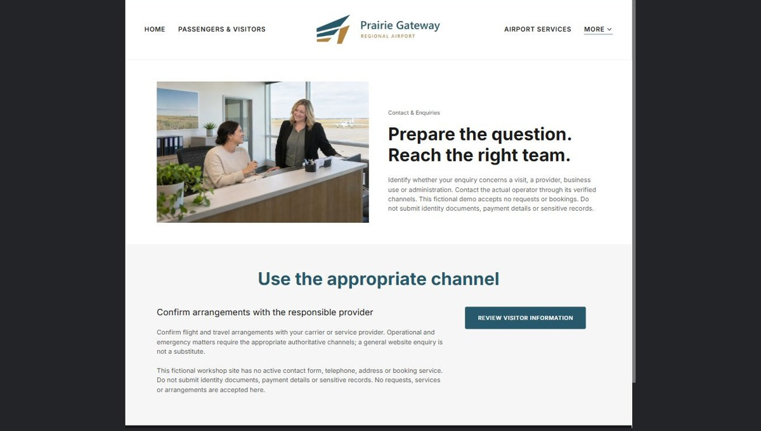
Actual desktop preview - unpublished fictional demonstration

Demo wording excerpt to adapt and verify
Prepare the question. Reach the right team.
Identify whether your enquiry concerns a visit, a provider, business use or administration. Contact the actual operator through its verified channels. This fictional demo accepts no requests or bookings. Do not submit identity documents, payment details or sensitive records.
Confirm flight and travel arrangements with your carrier or service provider. Operational and emergency matters require the appropriate authoritative channels; a general website enquiry is not a substitute.
This fictional workshop site has no active contact form, telephone, address or booking service. Do not submit identity documents, payment details or sensitive records. No requests, services or arrangements are accepted here.
Suggested button: Review visitor information

Website advice
Give the verified address, hours and correct contact path. Collect only the minimum information needed for a first response; make confirmation requirements clear.

Your draft: Contact & Enquiries
Write in the voice of your own business. Use facts you can verify, not promises copied from the example.

Headline and short introduction

Main content and details visitors need

Button wording and destination

Photo choice, permission and facts still to confirm
Partner check: can someone unfamiliar with the business find a useful next step?

Test before publishing
Review the whole journey on a desktop and phone. The industry page pairs each desktop capture with its mobile preview and provides the complete sample page copy.
□ This demonstration is not a source of flight status, weather, runway conditions, navigation, emergency response or operational aviation information. Direct aviation users to the operator-approved authoritative channels.
□ Verify contact routes, hours, location and every offered service.
□ Remove invented prices, claims, testimonials and availability.
□ Keep sensitive records and payment details out of ordinary public forms.
□ Check all image permissions, downloads and page links on a phone.
□ Check every link, form destination, download and confirmation message.
□ Check logo contrast, hero framing, text sizes and image loading.
□ Save a named backup and assign a content-review date.

Changes to finish and person responsible

Approval and next review date
Website Builder plans and signup

