
WEBSITE PLANNING WORKSHOP

Real Estate Agents
Website workbook
Plan a clear website for real estate agents. Explore a worked example, shape your own message and prepare to build with SaaSTech Servers.
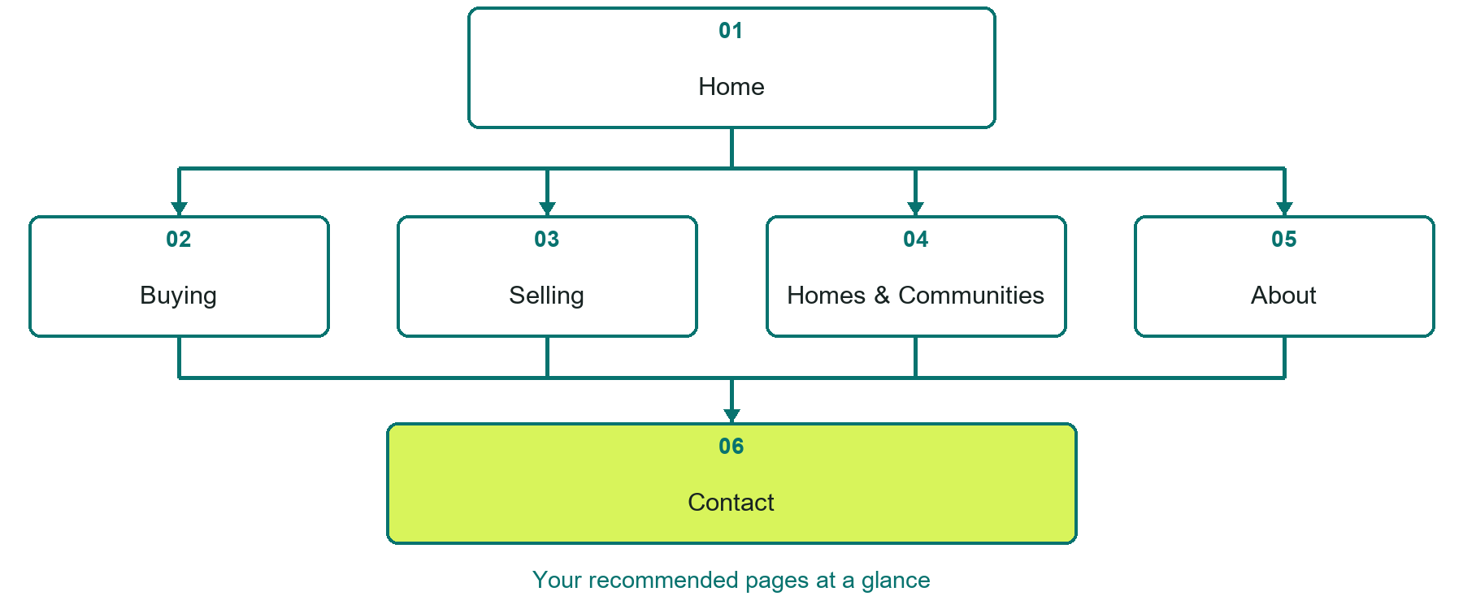

Inside this workbook
Six page examples • Practical writing exercises • A launch review
Use it in a workshop or at your own pace. Write by hand or complete the response fields in Word. The final page links to Website Builder, plans and account signup.
Example business Prairie Key Homes

REAL ESTATE AGENTS

Your website brief
A SaaSTech Servers workshop for real estate agents. Plan your website, learn from the Prairie Key Homes example and draft content for your own business.
Each page has a reference sheet followed by a writing sheet. Demo excerpts are labelled separately from new sample wording, which may differ from the screenshot. Click a blank response line to type; longer answers may add pages. Replace fictional details and verify every claim before publishing.
Your business or organization and workshop date

Who should visit your site and what do they need

The main action you want a visitor to take

What you offer and where or how you provide it

Facts photos and permissions to gather before publishing

Workshop rhythm: review the example, write your draft and exchange feedback. Use the final review to choose your next changes. Website Builder and account links are on the last page.

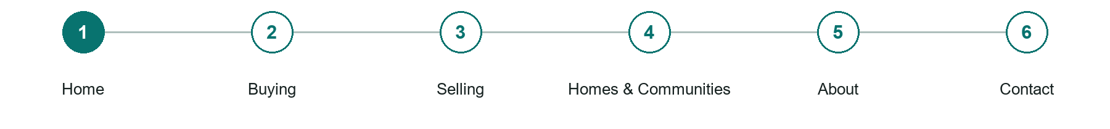
LOOK AND LEARN

Home

The job of this page
Introduce the agent, actual service area and a clear buyer or seller conversation path. Use an approved cover image and distinguish examples from available properties.
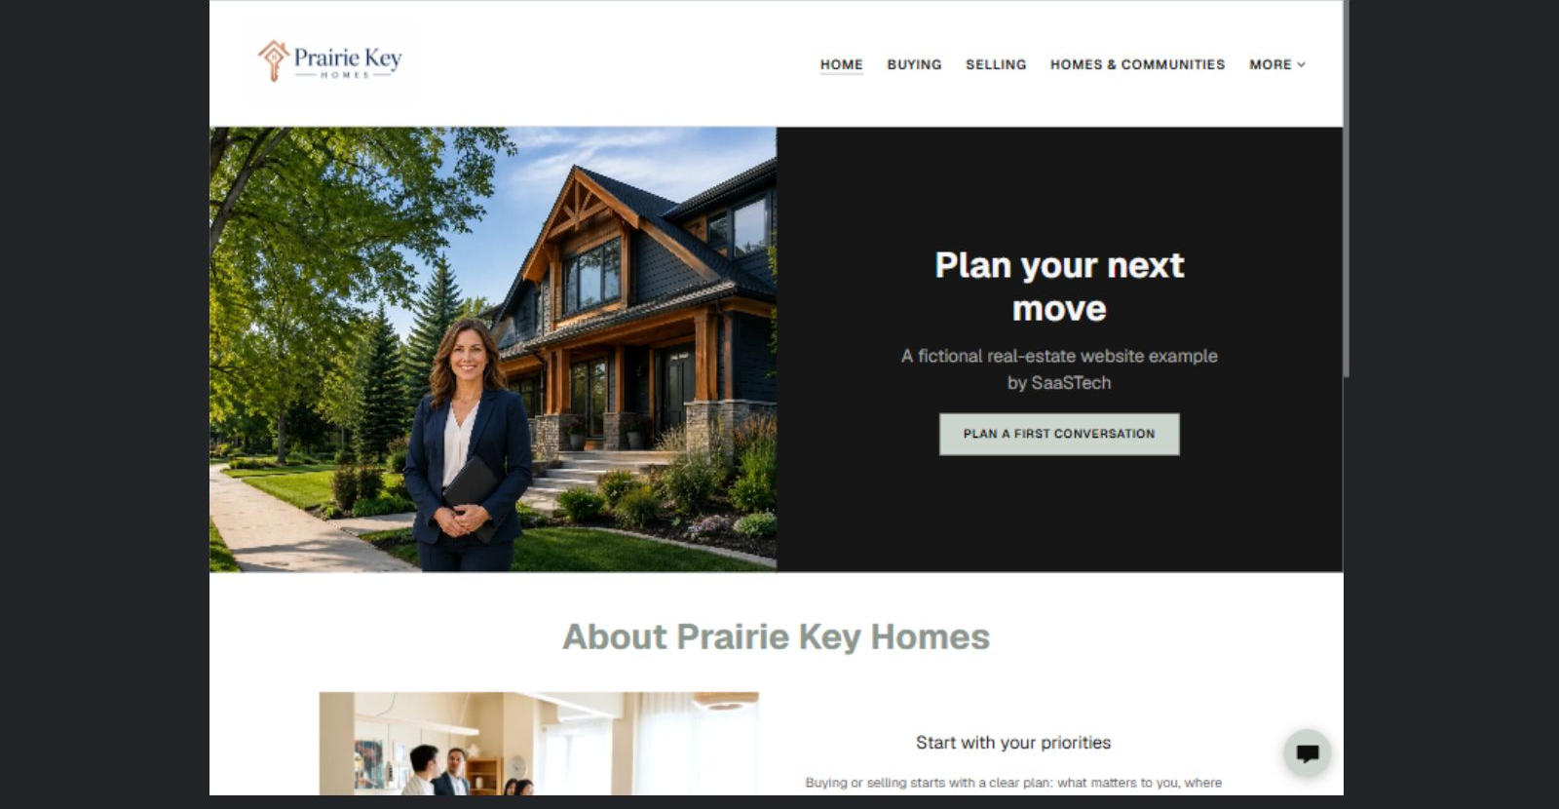
Prairie Key Homes example | Explore SaaSTech Website Builder

Demo text example
Plan your next move
A fictional real-estate website example by SaaSTech

Pause and plan
Could a first-time visitor explain what you do and who it is for after one glance? Choose one main action and the strongest truthful detail that gives them confidence to continue.

WRITE YOUR PAGE

Home
Write for your visitor. Be specific about what they need to know and what happens next. You can revise the wording after the workshop.
Your page headline

Your opening paragraph

Your offer audience location and most useful supporting details

Button or link wording and where it should lead

Photo idea caption and permission or credit needed

Facts to verify or questions to resolve

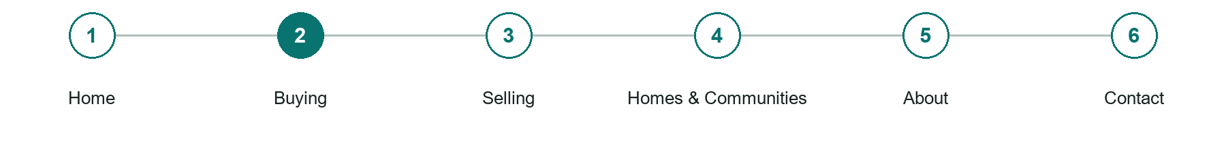
LOOK AND LEARN

Buying

The job of this page
Help visitors organize priorities, prepare viewing questions and understand the next conversation without replacing professional financial or legal advice.
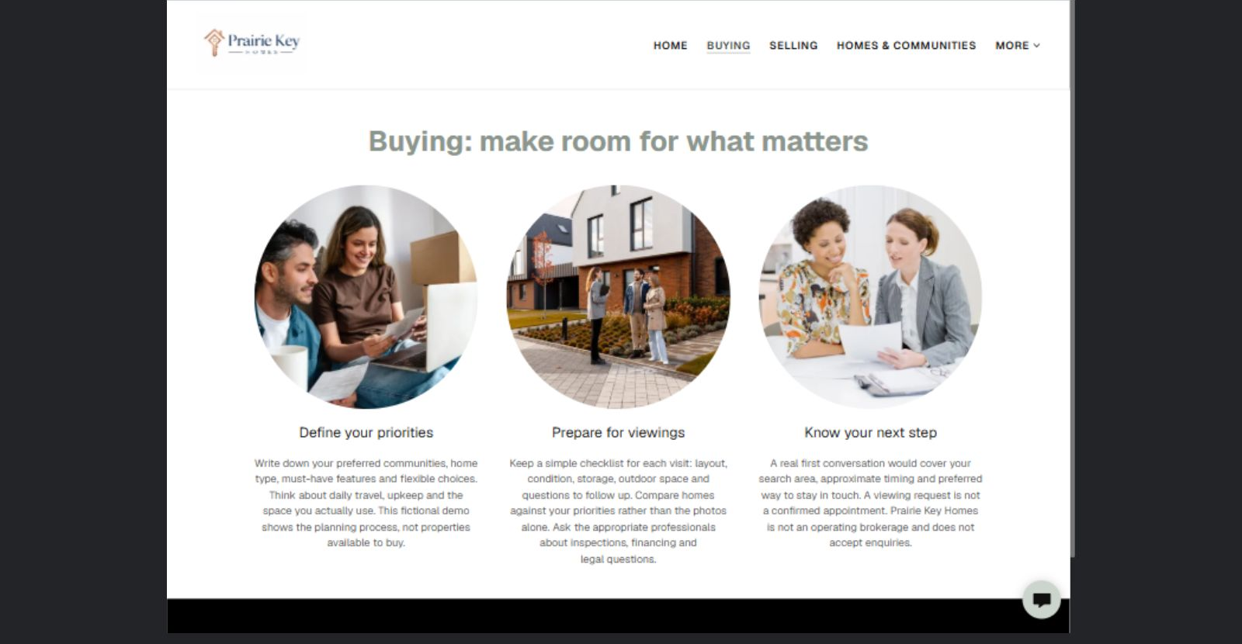
Prairie Key Homes example | Explore SaaSTech Website Builder

Sample wording to adapt
Buying begins with your priorities
List the home features that matter most, your preferred communities and approximate timing. Use those priorities to compare viewings. Discuss financing, inspections and legal questions with the appropriate professionals.

Pause and plan
What question brings a visitor to this page? List the details they need, the evidence you can provide and the next useful action. Remove content that does not help them decide or proceed.

WRITE YOUR PAGE

Buying
Write for your visitor. Be specific about what they need to know and what happens next. You can revise the wording after the workshop.
Your page headline

Your opening paragraph

Key sections visitor questions and supporting details

Button or link wording and where it should lead

Photo idea caption and permission or credit needed

Facts to verify or questions to resolve

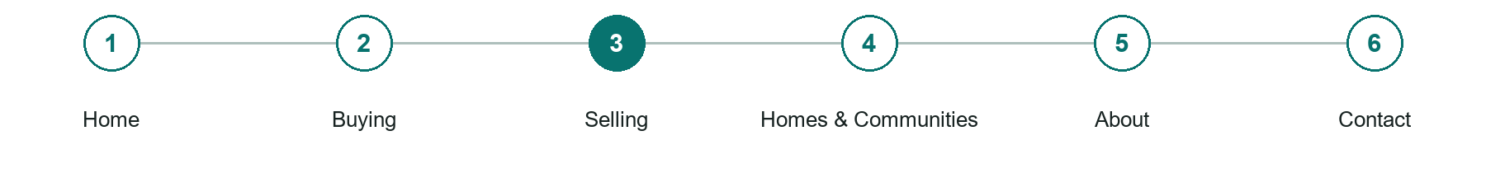
LOOK AND LEARN

Selling

The job of this page
Explain preparation, photography, marketing planning and communication without guaranteeing a price or sale date.
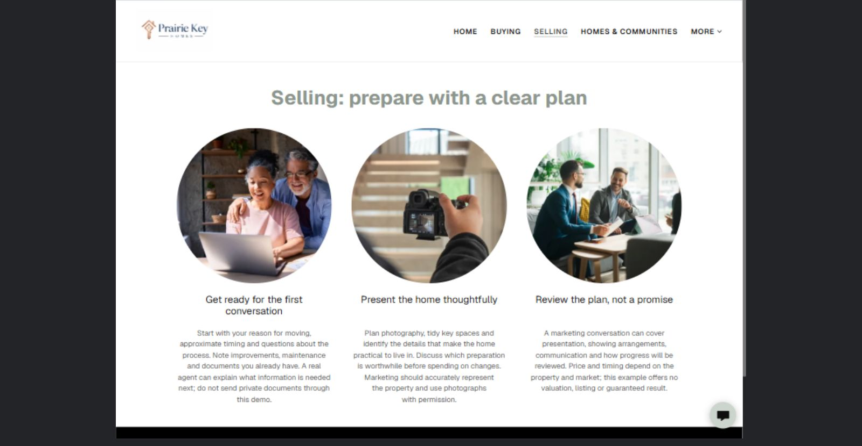
Prairie Key Homes example | Explore SaaSTech Website Builder

Sample wording to adapt
Prepare for a selling conversation
Start with your moving plans, timing and questions. A real agent can explain the information needed next. Do not send identity documents or financial records through a general enquiry form.

Pause and plan
What question brings a visitor to this page? List the details they need, the evidence you can provide and the next useful action. Remove content that does not help them decide or proceed.

WRITE YOUR PAGE

Selling
Write for your visitor. Be specific about what they need to know and what happens next. You can revise the wording after the workshop.
Your page headline

Your opening paragraph

Key sections visitor questions and supporting details

Button or link wording and where it should lead

Photo idea caption and permission or credit needed

Facts to verify or questions to resolve

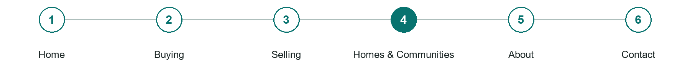
LOOK AND LEARN

Homes Communities

The job of this page
Present current authorized property information and objective local amenities. Label illustrative photography clearly; do not imply a live listings feed unless one is connected and tested.
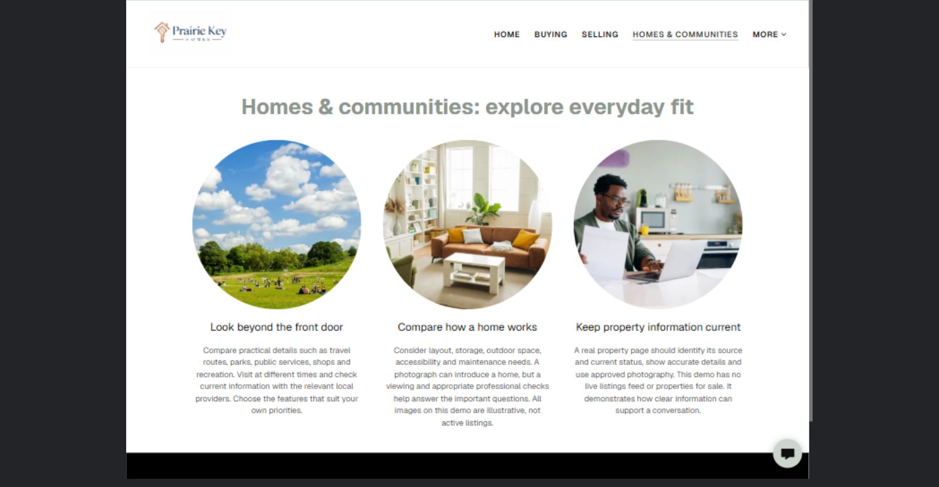
Prairie Key Homes example | Explore SaaSTech Website Builder

Sample wording to adapt
Look beyond the front door
Consider travel, services, shops and the way a home fits everyday life. Check current details with the relevant providers. The images in this demonstration are illustrative and are not properties for sale.

Pause and plan
Could a first-time visitor explain what you do and who it is for after one glance? Choose one main action and the strongest truthful detail that gives them confidence to continue.

WRITE YOUR PAGE

Homes Communities
Write for your visitor. Be specific about what they need to know and what happens next. You can revise the wording after the workshop.
Your page headline

Your opening paragraph

Your offer audience location and most useful supporting details

Button or link wording and where it should lead

Photo idea caption and permission or credit needed

Facts to verify or questions to resolve

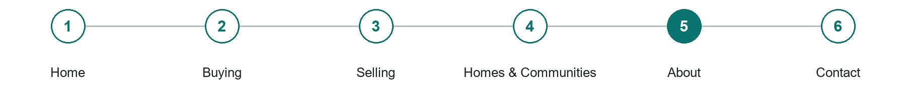
LOOK AND LEARN

About

The job of this page
Use verified agent and brokerage identities, approved photographs, relevant experience and a clear service approach. Do not invent awards, credentials or reviews.
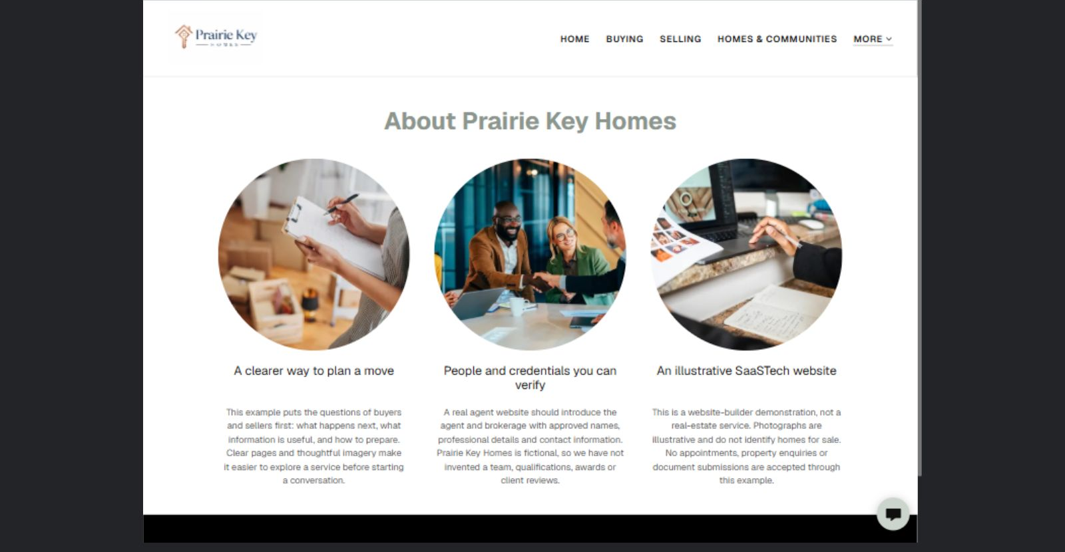
Prairie Key Homes example | Explore SaaSTech Website Builder

Sample wording to adapt
People and credentials you can verify
A real agent page should identify the agent and brokerage and provide current professional details. Prairie Key Homes is a fictional example, not an operating brokerage or a source of property valuations.

Pause and plan
Which names, roles and qualifications can you verify? What would help a visitor feel comfortable contacting you? Obtain permission for portraits and describe actual experience without unsupported claims.

WRITE YOUR PAGE

About
Write for your visitor. Be specific about what they need to know and what happens next. You can revise the wording after the workshop.
Your page headline

Your opening paragraph

People roles approach and verified credentials to introduce

Button or link wording and where it should lead

Photo idea caption and permission or credit needed

Facts to verify or questions to resolve

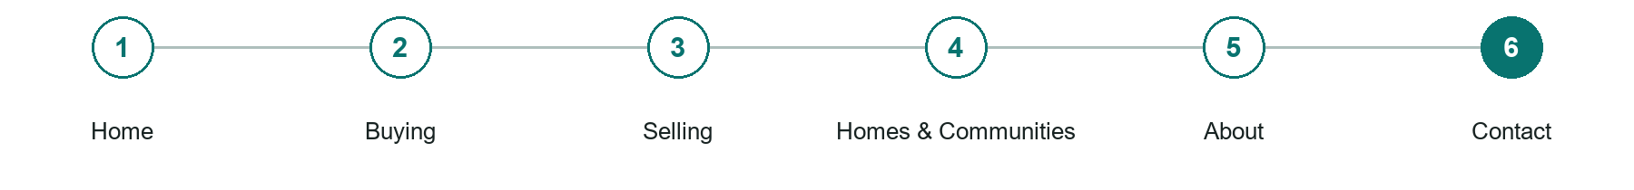
LOOK AND LEARN

Contact

The job of this page
Ask for name, contact method, buying or selling interest, community and approximate timing. Keep identity documents and financial records out of a general enquiry form, and explain that requests are not confirmed appointments.
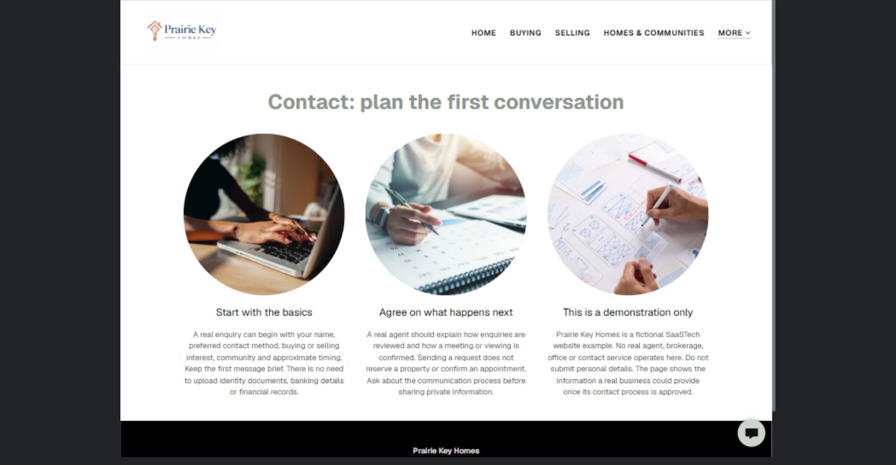
Prairie Key Homes example | Explore SaaSTech Website Builder

Sample wording to adapt
Plan the first conversation
Share your buying or selling interest, community, approximate timing and preferred contact method. The agent will explain the next step. A request does not reserve a property or confirm a viewing.

Pause and plan
What must someone provide, and what happens after they send it? Separate a request from a confirmed booking, order or place. Decide what information should stay out of a public form.

WRITE YOUR PAGE

Contact
Write for your visitor. Be specific about what they need to know and what happens next. You can revise the wording after the workshop.
Your page headline

Your opening paragraph

Information to request and how you will reply or confirm

Button or link wording and where it should lead

Photo idea caption and permission or credit needed

Facts to verify or questions to resolve

WORKSHOP CLOSE

Review and next steps
Ask a partner to read your draft as a first-time visitor. Can they explain what you offer, who it is for and the next step without extra help?

Before you publish
[ ] Every page has a clear purpose and a useful next step.
[ ] Headlines are specific and the wording sounds like your business.
[ ] Names, service areas, prices, dates and policies have been checked.
[ ] Credentials, testimonials and results are genuine and permission-cleared.
[ ] Photos support the text, do not repeat needlessly and have appropriate permissions.
[ ] Forms ask only for necessary information and explain what happens next.
[ ] Links, downloads and the main visitor task work on a phone.
The most useful feedback from your workshop partner

First change to make and who will do it

Information or photographs still needed

Target review date and who will approve the final content

Keep sensitive customer, patient, employee and payment information out of this workbook. Completing it does not publish a website or connect to Website Builder.

BUILD WITH SAASTECH SERVERS

Put your draft into Website Builder
Use the content you have written to build your own site. Keep the real estate agents demo as a reference, and replace its company name, images and claims with your verified business information.

Explore the builder
See the editor, compare available plans and decide which features your business needs. Confirm current pricing and terms before purchasing.
Website Builder overview

Create your account
Set up your SaaSTech Servers customer account using your own details. Creating an account is separate from purchasing a Website Builder plan.
Create your SaaSTech account

Choose your plan
Open the secure shop to review the plan, subscription term and final total. Use the account connected to your purchase when you open your service.
View Website Builder plans

Build and check your pages
Add the pages from this workbook. Transfer your approved wording, upload permission-cleared photos and review each page on desktop and mobile before publishing.
Return to the Website Builder guide

Using a printed workbook
Type these short addresses into your browser. The account guide includes the Create My Account button.
www.saastech.net/products/website-builder
www.saastech.net/create-account
This workbook does not create an account, purchase a plan or publish your website. Keep passwords, payment details and confidential customer information out of your draft.

