

Property & Condominium Management
Website workbook
A practical workshop for a 5-page website. Study the example, plan the content and draft your own version in Word or on paper.
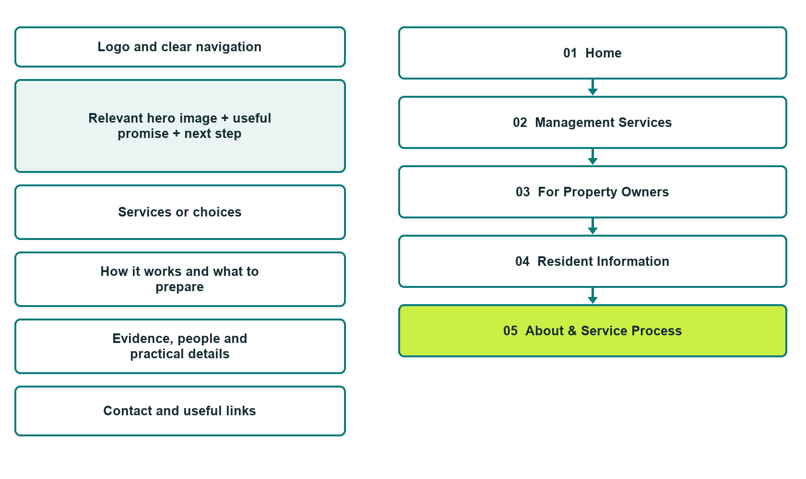

Plan → Draft → Build → Test
Demo-capture edition: actual Website Builder desktop previews and excerpts of the example wording. See each matching mobile preview in the industry page gallery. The example business and its AI-generated photographs are fictional.
Explore Website Builder and compare plans

Before you build
Your business supplies the facts. Prairie Corner Property Management is a fictional teaching example, not a live service.

□ Discuss a property management enquiry
□ Verified business identity and current contact information
□ Clear request and confirmation process
□ Choose original photographs and confirm permission to use them.
□ Keep private customer records out of public website forms.

Your audience and the action you want them to take

Facts to verify and people who must approve them
Create your SaaSTech account

01 Home
Give this page one clear job in the customer journey.
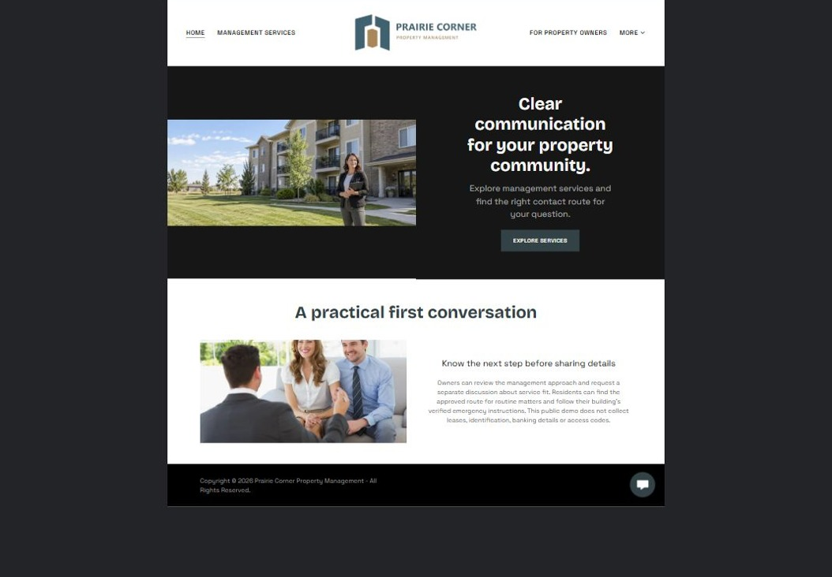
Actual desktop preview - unpublished fictional demonstration

Demo wording excerpt to adapt and verify
Clear communication for your property community.
Explore management services and find the right contact route for your question.
Owners can review the management approach and request a separate discussion about service fit. Residents can find the approved route for routine matters and follow their building’s verified emergency instructions. This public demo does not collect leases, identification, banking details or access codes.
Suggested button: Explore services

Website advice
Separate prospective-owner enquiries from resident support and approved emergency procedures. Explain service scope and private portal handoffs.

Your draft: Home
Write in the voice of your own business. Use facts you can verify, not promises copied from the example.

Headline and short introduction

Main content and details visitors need

Button wording and destination

Photo choice, permission and facts still to confirm
Partner check: can someone unfamiliar with the business find a useful next step?

02 Management Services
Give this page one clear job in the customer journey.
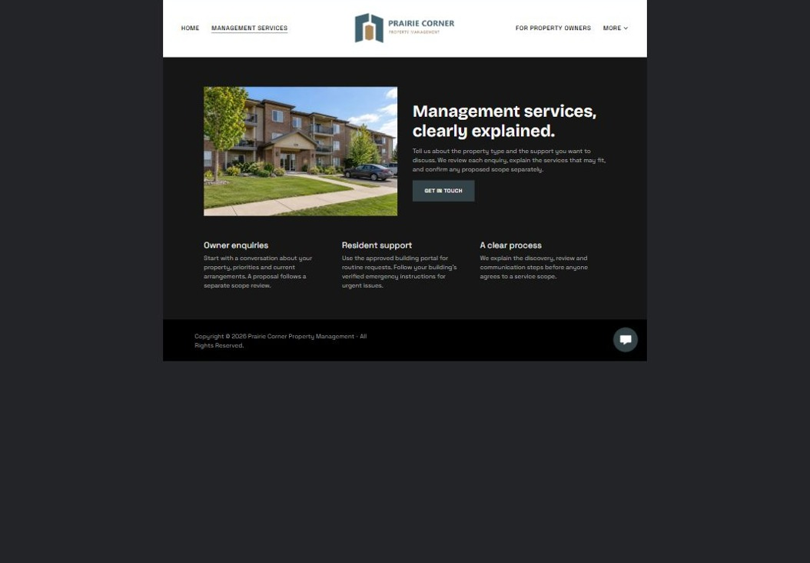
Actual desktop preview - unpublished fictional demonstration

Demo wording excerpt to adapt and verify
Management services, clearly explained.
Tell us about the property type and the support you want to discuss. We review each enquiry, explain the services that may fit, and confirm any proposed scope separately.
Owner enquiries, resident support and the service process each have a distinct route. A private conversation confirms what the team can take on.
Suggested button: For property owners

Website advice
Describe verified service packages, property types and area coverage. Avoid implying guaranteed occupancy or returns.

Your draft: Management Services
Write in the voice of your own business. Use facts you can verify, not promises copied from the example.

Headline and short introduction

Main content and details visitors need

Button wording and destination

Photo choice, permission and facts still to confirm
Partner check: can someone unfamiliar with the business find a useful next step?

03 For Property Owners
Give this page one clear job in the customer journey.
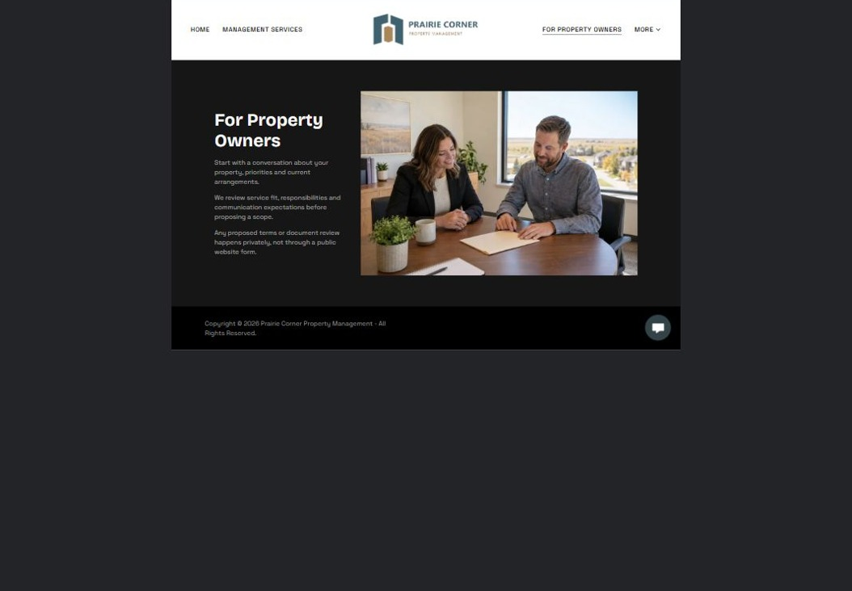
Actual desktop preview - unpublished fictional demonstration

Demo wording excerpt to adapt and verify
For Property Owners
Start with a conversation about your property, priorities and current arrangements.
We review service fit, responsibilities and communication expectations before proposing a scope. Any proposed terms or document review happens privately, not through a public website form.
Suggested button: Arrange a private discussion

Website advice
Explain discovery, scope review and proposal steps. Keep financial and legal documents in private systems.

Your draft: For Property Owners
Write in the voice of your own business. Use facts you can verify, not promises copied from the example.

Headline and short introduction

Main content and details visitors need

Button wording and destination

Photo choice, permission and facts still to confirm
Partner check: can someone unfamiliar with the business find a useful next step?

04 Resident Information
Give this page one clear job in the customer journey.
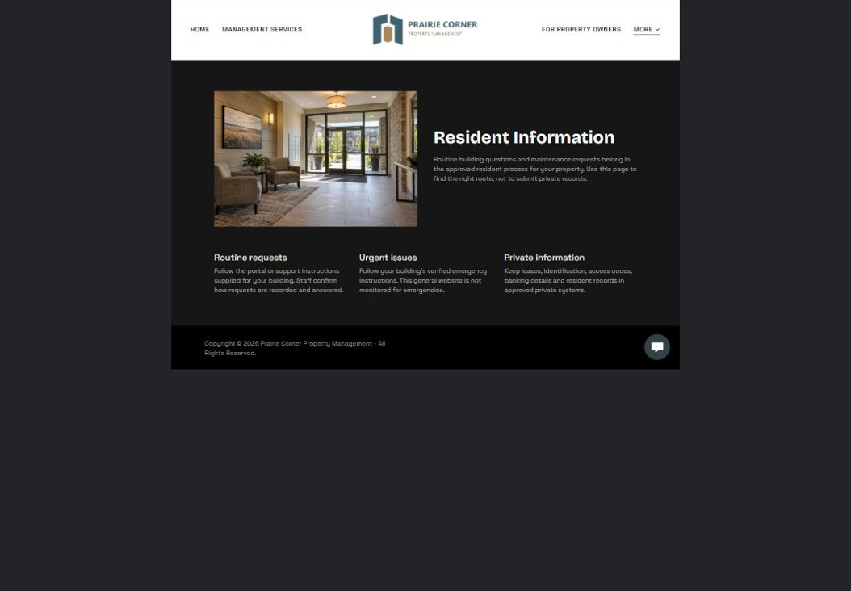
Actual desktop preview - unpublished fictional demonstration

Demo wording excerpt to adapt and verify
Resident Information
Routine building questions and maintenance requests belong in the approved resident process for your property. Use this page to find the right route, not to submit private records.
Follow the portal or support instructions supplied for your building. Staff confirm how requests are recorded and answered. Urgent issues follow the building’s verified emergency instructions.
Suggested button: Follow the approved resident route

Website advice
Provide a clearly maintained path to the approved resident portal and maintenance process, distinct from emergencies.

Your draft: Resident Information
Write in the voice of your own business. Use facts you can verify, not promises copied from the example.

Headline and short introduction

Main content and details visitors need

Button wording and destination

Photo choice, permission and facts still to confirm
Partner check: can someone unfamiliar with the business find a useful next step?

05 About & Service Process
Give this page one clear job in the customer journey.
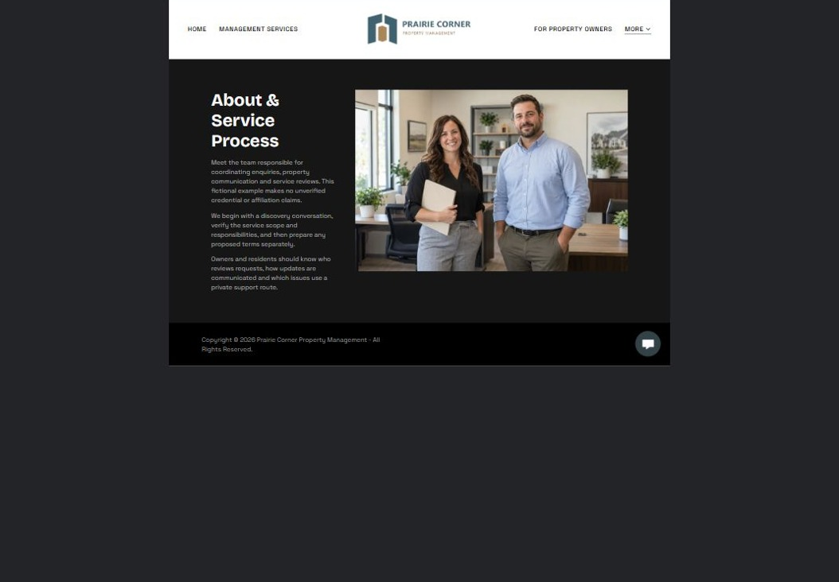
Actual desktop preview - unpublished fictional demonstration

Demo wording excerpt to adapt and verify
About & Service Process
Meet the team responsible for coordinating enquiries, property communication and service reviews. This fictional example makes no unverified credential or affiliation claims.
We begin with a discovery conversation, verify the service scope and responsibilities, and then prepare any proposed terms separately.
Suggested button: Review the process

Website advice
Show the team, verified experience and communication responsibilities. Publish only approved affiliation claims.

Your draft: About & Service Process
Write in the voice of your own business. Use facts you can verify, not promises copied from the example.

Headline and short introduction

Main content and details visitors need

Button wording and destination

Photo choice, permission and facts still to confirm
Partner check: can someone unfamiliar with the business find a useful next step?

Test before publishing
Review the whole journey on a desktop and phone. The industry page pairs each desktop capture with its mobile preview and provides the complete sample page copy.
□ Fictional management example only. Verify licensing, service scope and emergency instructions with the operator. Do not collect leases, identity documents, entry codes or banking information on public forms.
□ Verify contact routes, hours, location and every offered service.
□ Remove invented prices, claims, testimonials and availability.
□ Keep sensitive records and payment details out of ordinary public forms.
□ Check all image permissions, downloads and page links on a phone.
□ Check every link, form destination, download and confirmation message.
□ Check logo contrast, hero framing, text sizes and image loading.
□ Save a named backup and assign a content-review date.

Changes to finish and person responsible

Approval and next review date
Website Builder plans and signup

