
WEBSITE PLANNING WORKSHOP

Programmers & Software Developers
Website workbook
Plan a clear website for programmers & software developers. Explore a worked example, shape your own message and prepare to build with SaaSTech Servers.
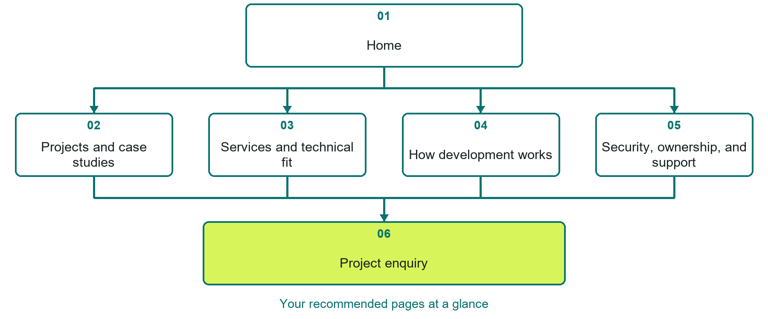

Inside this workbook
Six page examples • Practical writing exercises • A launch review
Use it in a workshop or at your own pace. Write by hand or complete the response fields in Word. The final page links to Website Builder, plans and account signup.
Example business Copperline Software Studio

PROGRAMMERS & SOFTWARE DEVELOPERS

Your website brief
A SaaSTech Servers workshop for programmers & software developers. Plan your website, learn from the Copperline Software Studio example and draft content for your own business.
Each page has a reference sheet followed by a writing sheet. Demo excerpts are labelled separately from new sample wording, which may differ from the screenshot. Click a blank response line to type; longer answers may add pages. Replace fictional details and verify every claim before publishing.
Your business or organization and workshop date

Who should visit your site and what do they need

The main action you want a visitor to take

What you offer and where or how you provide it

Facts photos and permissions to gather before publishing

Workshop rhythm: review the example, write your draft and exchange feedback. Use the final review to choose your next changes. Website Builder and account links are on the last page.

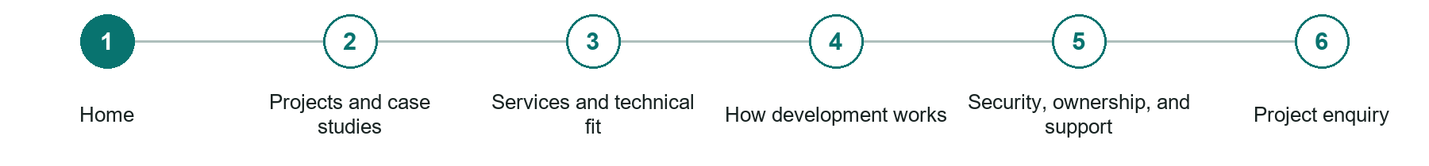
LOOK AND LEARN

Home

The job of this page
Lead with the business problem Copperline solves, the clearest client outcome, a coordinated studio identity, and one direct path to discuss a project.

Copperline Software Studio example | Explore SaaSTech Website Builder

Sample wording to adapt
Software work starts with a clear problem
Explore the project examples and development approach. Tell us what users need to do and what is not working today. We will discuss fit and scope before proposing a solution.

Pause and plan
Could a first-time visitor explain what you do and who it is for after one glance? Choose one main action and the strongest truthful detail that gives them confidence to continue.

WRITE YOUR PAGE

Home
Write for your visitor. Be specific about what they need to know and what happens next. You can revise the wording after the workshop.
Your page headline

Your opening paragraph

Your offer audience location and most useful supporting details

Button or link wording and where it should lead

Photo idea caption and permission or credit needed

Facts to verify or questions to resolve

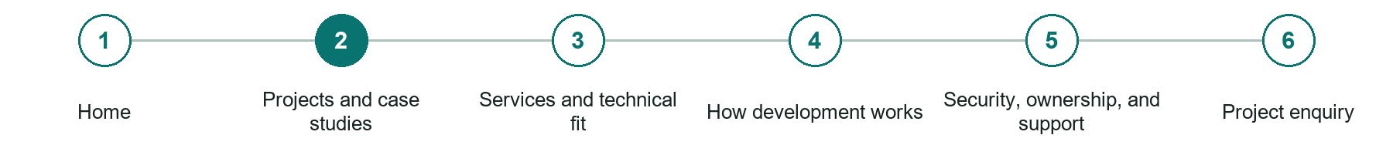
LOOK AND LEARN

Projects and case studies

The job of this page
Explain the problem, users, constraints, role, architecture at an appropriate level, delivery process, and measurable result without exposing client secrets.
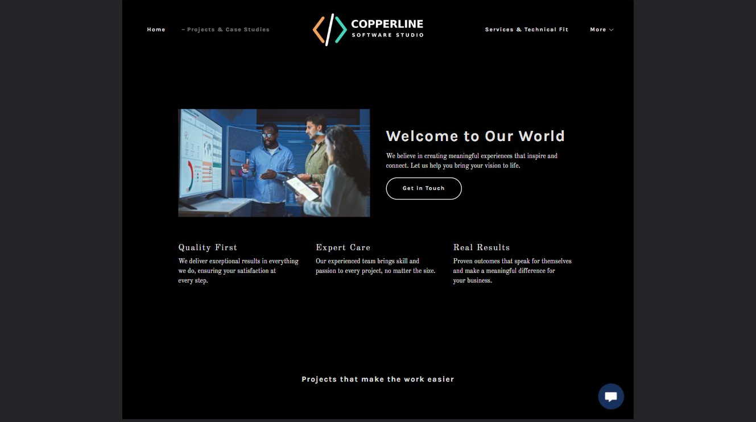
Copperline Software Studio example | Explore SaaSTech Website Builder

Sample wording to adapt
Read the project in context
A useful case study explains the brief, technical decisions and individual contribution. Results should be supported and client details shared only with permission. Sample projects are labelled as examples.

Pause and plan
Which examples best support this page? Explain the context, your contribution and the permissions or credits needed. Label illustrative work and distinguish it from genuine completed projects or customer results.

WRITE YOUR PAGE

Projects and case studies
Write for your visitor. Be specific about what they need to know and what happens next. You can revise the wording after the workshop.
Your page headline

Your opening paragraph

Examples captions context and evidence to include

Button or link wording and where it should lead

Photo idea caption and permission or credit needed

Facts to verify or questions to resolve

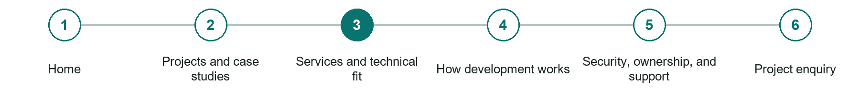
LOOK AND LEARN

Services and technical fit

The job of this page
Define the applications, integrations, automation, APIs, maintenance, audits, and platforms accepted, along with projects that require another specialist.
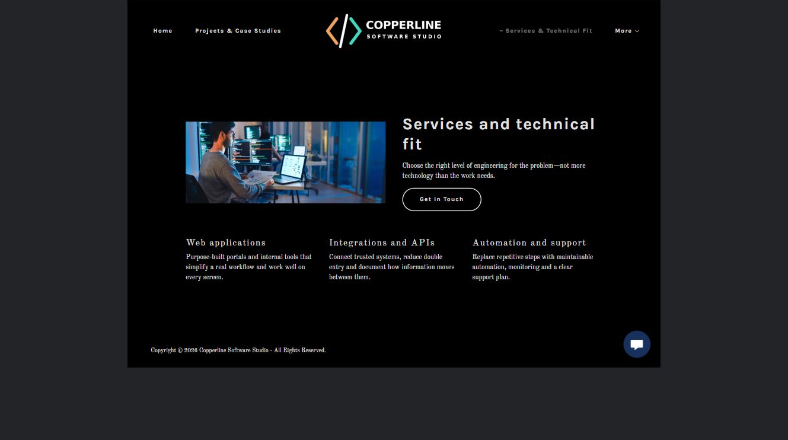
Copperline Software Studio example | Explore SaaSTech Website Builder

Sample wording to adapt
Check the technical fit
Describe the application, existing systems and required integrations. We will clarify responsibilities and constraints before estimating. A technology list does not imply every integration is already available.

Pause and plan
Who is each option for, what does it include and where are its limits? Describe the information needed to check fit. Make the next step clear without promising an outcome before assessment.

WRITE YOUR PAGE

Services and technical fit
Write for your visitor. Be specific about what they need to know and what happens next. You can revise the wording after the workshop.
Your page headline

Your opening paragraph

Service options who they suit and what each includes

Button or link wording and where it should lead

Photo idea caption and permission or credit needed

Facts to verify or questions to resolve

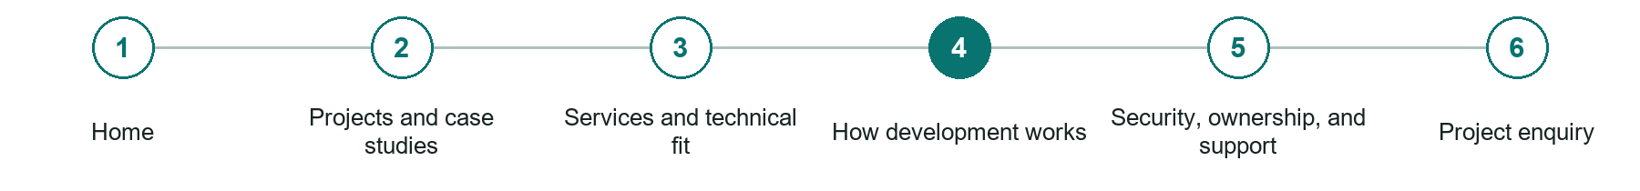
LOOK AND LEARN

How development works

The job of this page
Describe discovery, requirements, estimates, milestones, prototypes, testing, approvals, deployment, documentation, training, and change requests.
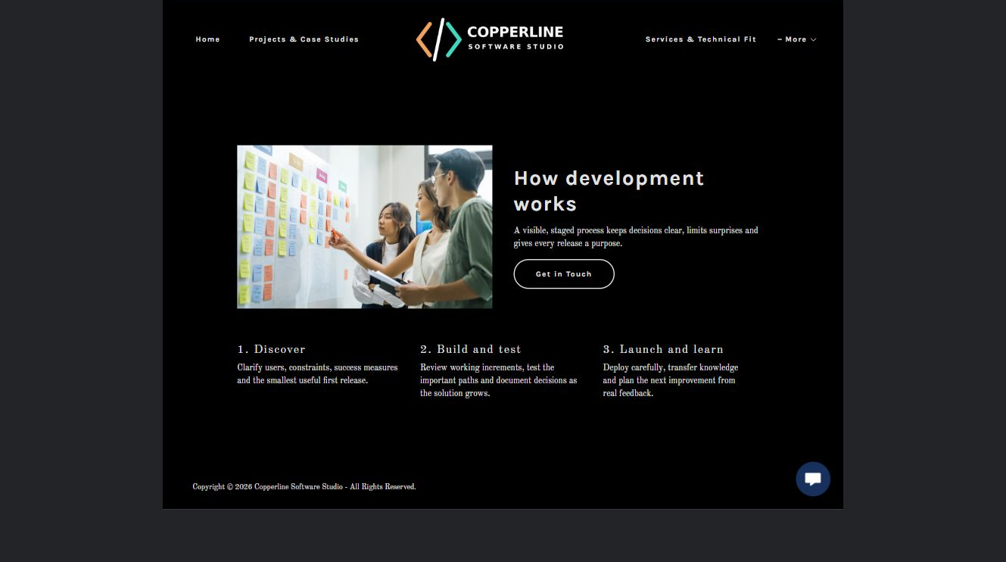
Copperline Software Studio example | Explore SaaSTech Website Builder

Sample wording to adapt
Agree the work in manageable steps
Clarify requirements, review a proposed scope and test the important user tasks. Confirm milestones and acceptance criteria together. New requirements are discussed before changing the delivery plan.

Pause and plan
What question brings a visitor to this page? List the details they need, the evidence you can provide and the next useful action. Remove content that does not help them decide or proceed.

WRITE YOUR PAGE

How development works
Write for your visitor. Be specific about what they need to know and what happens next. You can revise the wording after the workshop.
Your page headline

Your opening paragraph

Key sections visitor questions and supporting details

Button or link wording and where it should lead

Photo idea caption and permission or credit needed

Facts to verify or questions to resolve

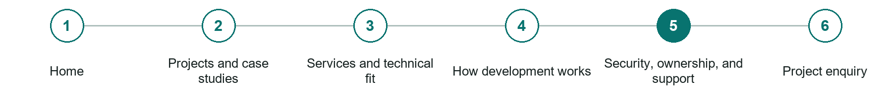
LOOK AND LEARN

Security ownership and support

The job of this page
Set expectations for access, credentials, backups, dependencies, source ownership, licensing, warranties, maintenance, incident response, and end-of-service handoff.
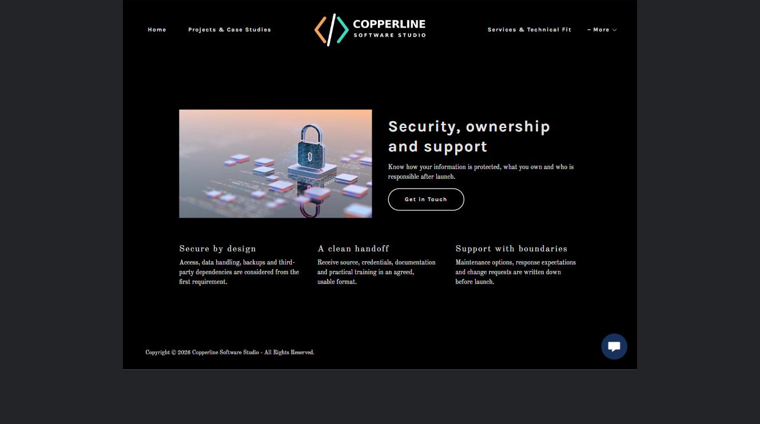
Copperline Software Studio example | Explore SaaSTech Website Builder

Sample wording to adapt
Clarify ownership and support
Agree source-code access, hosting responsibility, maintenance and the handover process in writing. Arrange credentials securely. Do not send passwords or production data through an initial project enquiry.

Pause and plan
Who is each option for, what does it include and where are its limits? Describe the information needed to check fit. Make the next step clear without promising an outcome before assessment.

WRITE YOUR PAGE

Security ownership and support
Write for your visitor. Be specific about what they need to know and what happens next. You can revise the wording after the workshop.
Your page headline

Your opening paragraph

Service options who they suit and what each includes

Button or link wording and where it should lead

Photo idea caption and permission or credit needed

Facts to verify or questions to resolve

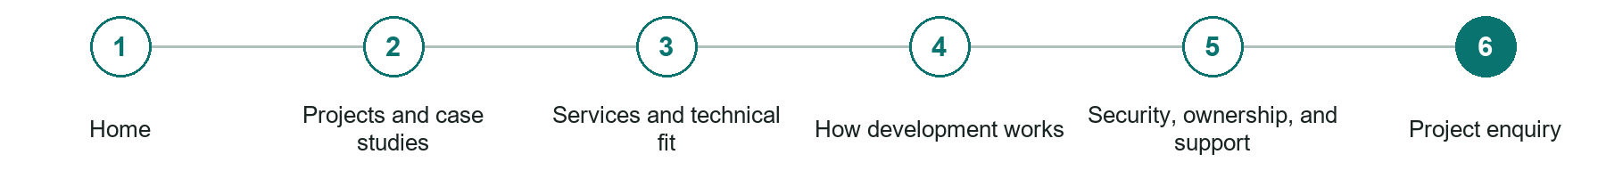
LOOK AND LEARN

Project enquiry

The job of this page
Ask for the business goal, users, existing systems, required integrations, constraints, decision process, desired timing, budget guidance, and responsible technical contacts.
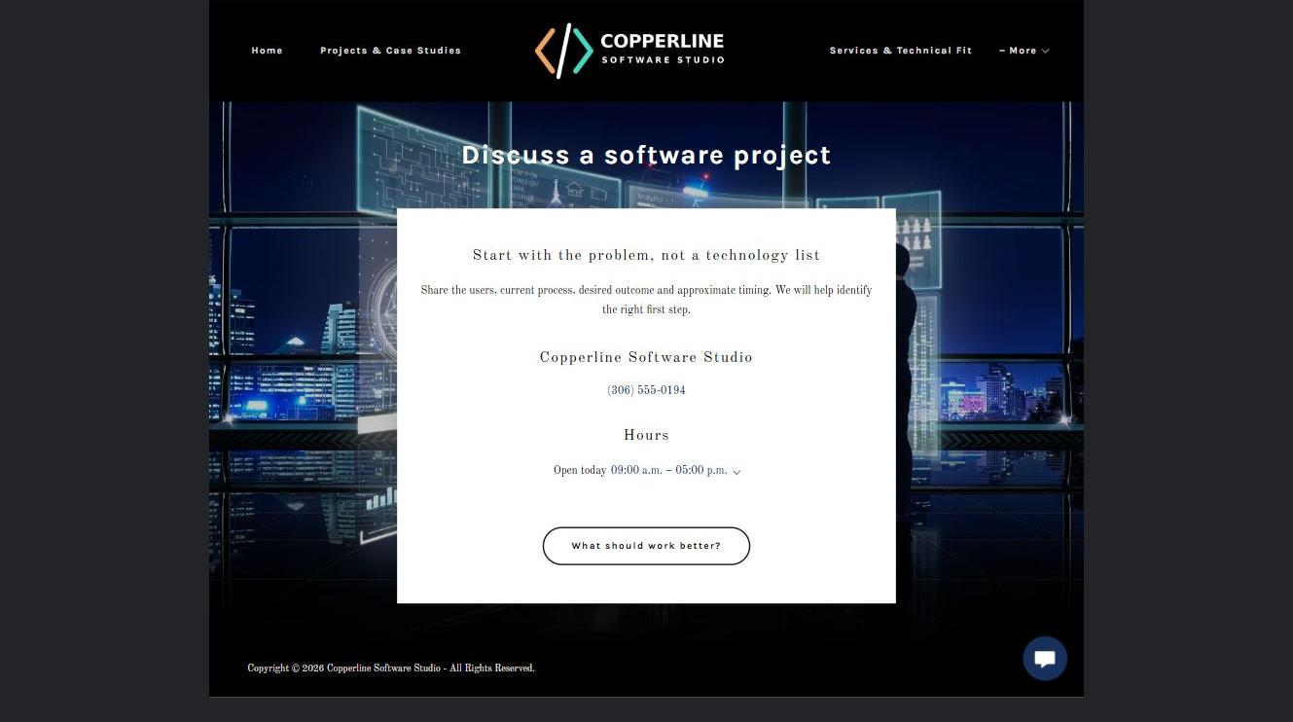
Copperline Software Studio example | Explore SaaSTech Website Builder

Sample wording to adapt
Describe the project
Share the user problem, existing system, required outcome and approximate timing. Mention important constraints without uploading confidential data. The next conversation will establish feasibility and an appropriate scope.

Pause and plan
What must someone provide, and what happens after they send it? Separate a request from a confirmed booking, order or place. Decide what information should stay out of a public form.

WRITE YOUR PAGE

Project enquiry
Write for your visitor. Be specific about what they need to know and what happens next. You can revise the wording after the workshop.
Your page headline

Your opening paragraph

Information to request and how you will reply or confirm

Button or link wording and where it should lead

Photo idea caption and permission or credit needed

Facts to verify or questions to resolve

WORKSHOP CLOSE

Review and next steps
Ask a partner to read your draft as a first-time visitor. Can they explain what you offer, who it is for and the next step without extra help?

Before you publish
[ ] Every page has a clear purpose and a useful next step.
[ ] Headlines are specific and the wording sounds like your business.
[ ] Names, service areas, prices, dates and policies have been checked.
[ ] Credentials, testimonials and results are genuine and permission-cleared.
[ ] Photos support the text, do not repeat needlessly and have appropriate permissions.
[ ] Forms ask only for necessary information and explain what happens next.
[ ] Links, downloads and the main visitor task work on a phone.
The most useful feedback from your workshop partner

First change to make and who will do it

Information or photographs still needed

Target review date and who will approve the final content

Keep sensitive customer, patient, employee and payment information out of this workbook. Completing it does not publish a website or connect to Website Builder.

BUILD WITH SAASTECH SERVERS

Put your draft into Website Builder
Use the content you have written to build your own site. Keep the programmers & software developers demo as a reference, and replace its company name, images and claims with your verified business information.

Explore the builder
See the editor, compare available plans and decide which features your business needs. Confirm current pricing and terms before purchasing.
Website Builder overview

Create your account
Set up your SaaSTech Servers customer account using your own details. Creating an account is separate from purchasing a Website Builder plan.
Create your SaaSTech account

Choose your plan
Open the secure shop to review the plan, subscription term and final total. Use the account connected to your purchase when you open your service.
View Website Builder plans

Build and check your pages
Add the pages from this workbook. Transfer your approved wording, upload permission-cleared photos and review each page on desktop and mobile before publishing.
Return to the Website Builder guide

Using a printed workbook
Type these short addresses into your browser. The account guide includes the Create My Account button.
www.saastech.net/products/website-builder
www.saastech.net/create-account
This workbook does not create an account, purchase a plan or publish your website. Keep passwords, payment details and confidential customer information out of your draft.

