
WEBSITE PLANNING WORKSHOP

Plumbers & Heating Contractors
Website workbook
Plan a clear website for plumbers & heating contractors. Explore a worked example, shape your own message and prepare to build with SaaSTech Servers.
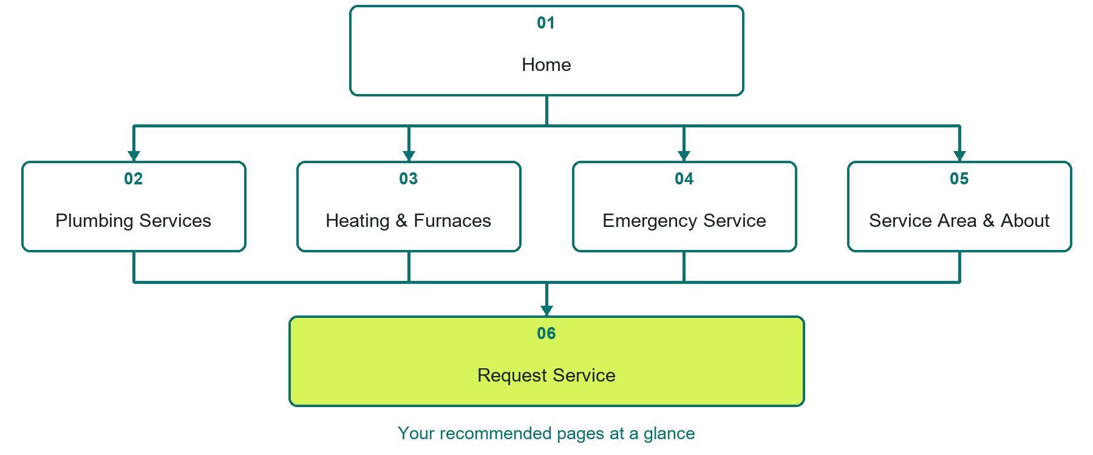

Inside this workbook
Six page examples • Practical writing exercises • A launch review
Use it in a workshop or at your own pace. Write by hand or complete the response fields in Word. The final page links to Website Builder, plans and account signup.
Example business Prairie Flow Plumbing & Heating

PLUMBERS & HEATING CONTRACTORS

Your website brief
A SaaSTech Servers workshop for plumbers & heating contractors. Plan your website, learn from the Prairie Flow Plumbing & Heating example and draft content for your own business.
Each page has a reference sheet followed by a writing sheet. Demo excerpts are labelled separately from new sample wording, which may differ from the screenshot. Click a blank response line to type; longer answers may add pages. Replace fictional details and verify every claim before publishing.
Your business or organization and workshop date

Who should visit your site and what do they need

The main action you want a visitor to take

What you offer and where or how you provide it

Facts photos and permissions to gather before publishing

Workshop rhythm: review the example, write your draft and exchange feedback. Use the final review to choose your next changes. Website Builder and account links are on the last page.

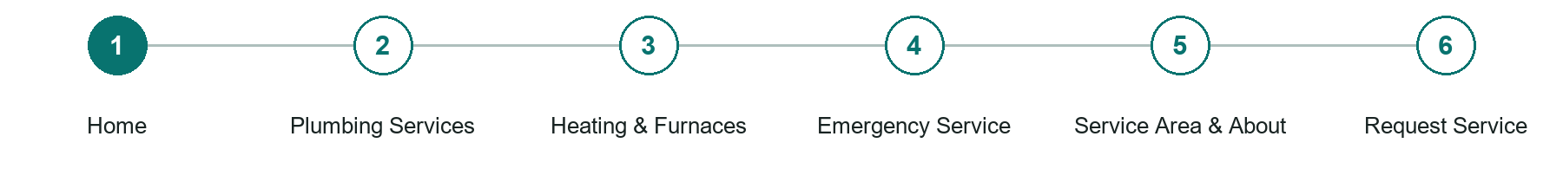
LOOK AND LEARN

Home

The job of this page
State whether emergency service is available, where the company works, and how to contact it.
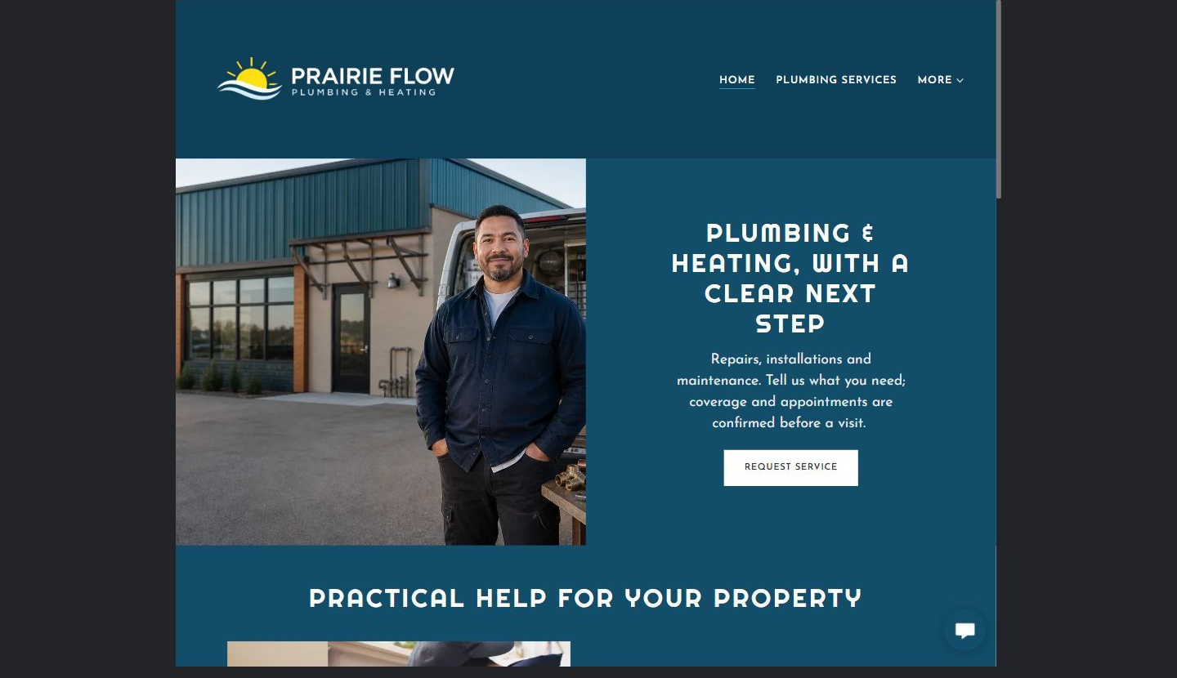
Prairie Flow Plumbing & Heating example | Explore SaaSTech Website Builder

Demo text example
Repairs, installations and maintenance.
Tell us what you need; coverage and appointments are confirmed before a visit.

Pause and plan
Could a first-time visitor explain what you do and who it is for after one glance? Choose one main action and the strongest truthful detail that gives them confidence to continue.

WRITE YOUR PAGE

Home
Write for your visitor. Be specific about what they need to know and what happens next. You can revise the wording after the workshop.
Your page headline

Your opening paragraph

Your offer audience location and most useful supporting details

Button or link wording and where it should lead

Photo idea caption and permission or credit needed

Facts to verify or questions to resolve

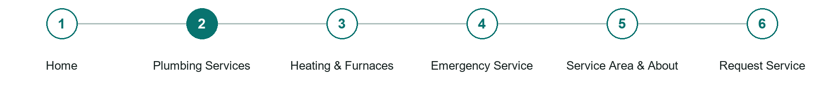
LOOK AND LEARN

Plumbing Services

The job of this page
Organize everyday repairs, maintenance, installations, and upgrades into clear choices.
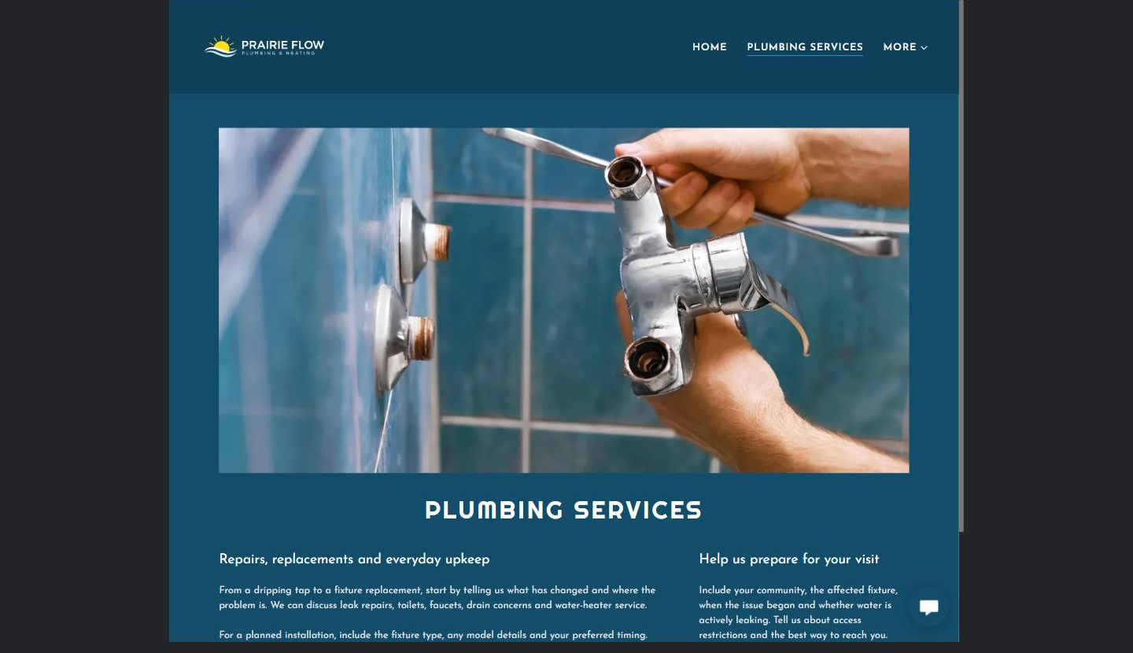
Prairie Flow Plumbing & Heating example | Explore SaaSTech Website Builder

Sample wording to adapt
Repairs and everyday upkeep
Describe the fixture or plumbing concern, when it began and your community. For planned work, include the fixture type and preferred timing. The business will confirm scope and appointment arrangements separately.

Pause and plan
Who is each option for, what does it include and where are its limits? Describe the information needed to check fit. Make the next step clear without promising an outcome before assessment.

WRITE YOUR PAGE

Plumbing Services
Write for your visitor. Be specific about what they need to know and what happens next. You can revise the wording after the workshop.
Your page headline

Your opening paragraph

Service options who they suit and what each includes

Button or link wording and where it should lead

Photo idea caption and permission or credit needed

Facts to verify or questions to resolve

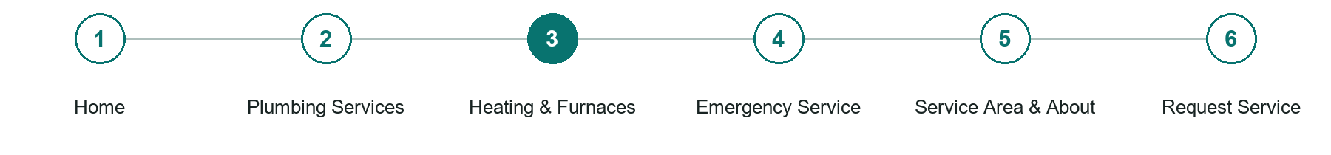
LOOK AND LEARN

Heating Furnaces

The job of this page
Separate seasonal heating service, maintenance, installation, and upgrade enquiries from plumbing work.
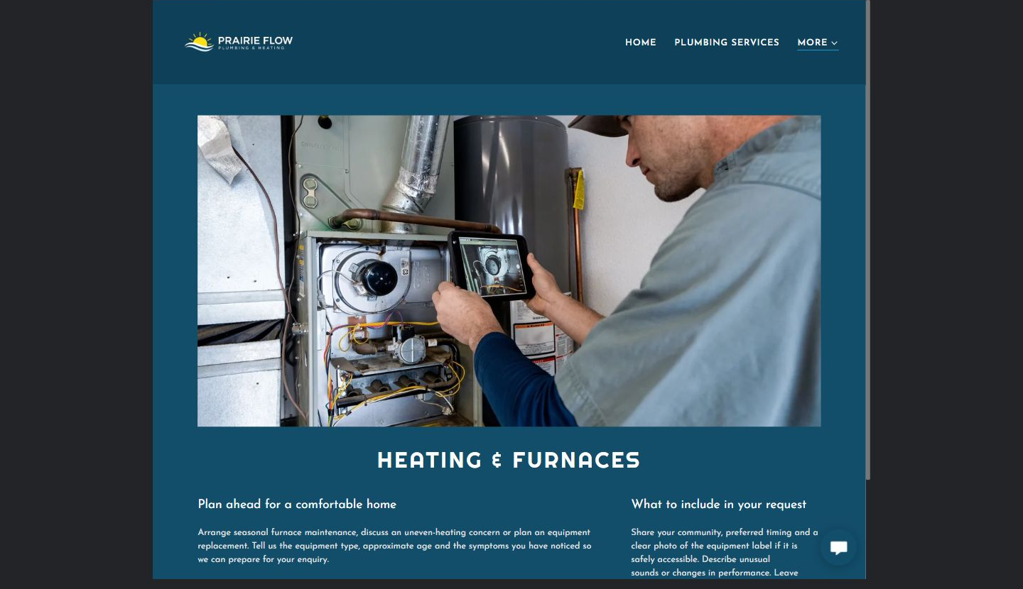
Prairie Flow Plumbing & Heating example | Explore SaaSTech Website Builder

Sample wording to adapt
Plan ahead for your heating needs
Describe the equipment, its approximate age and the changes you have noticed. Ask about maintenance or a replacement assessment. The technician must assess the situation before recommending work or confirming an estimate.

Pause and plan
What question brings a visitor to this page? List the details they need, the evidence you can provide and the next useful action. Remove content that does not help them decide or proceed.

WRITE YOUR PAGE

Heating Furnaces
Write for your visitor. Be specific about what they need to know and what happens next. You can revise the wording after the workshop.
Your page headline

Your opening paragraph

Key sections visitor questions and supporting details

Button or link wording and where it should lead

Photo idea caption and permission or credit needed

Facts to verify or questions to resolve

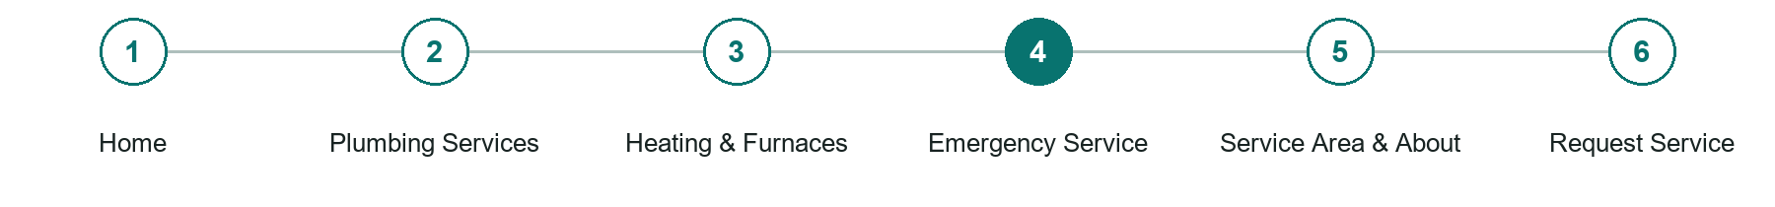
LOOK AND LEARN

Emergency Service

The job of this page
Explain availability honestly and give safe, nontechnical steps customers can take while waiting.
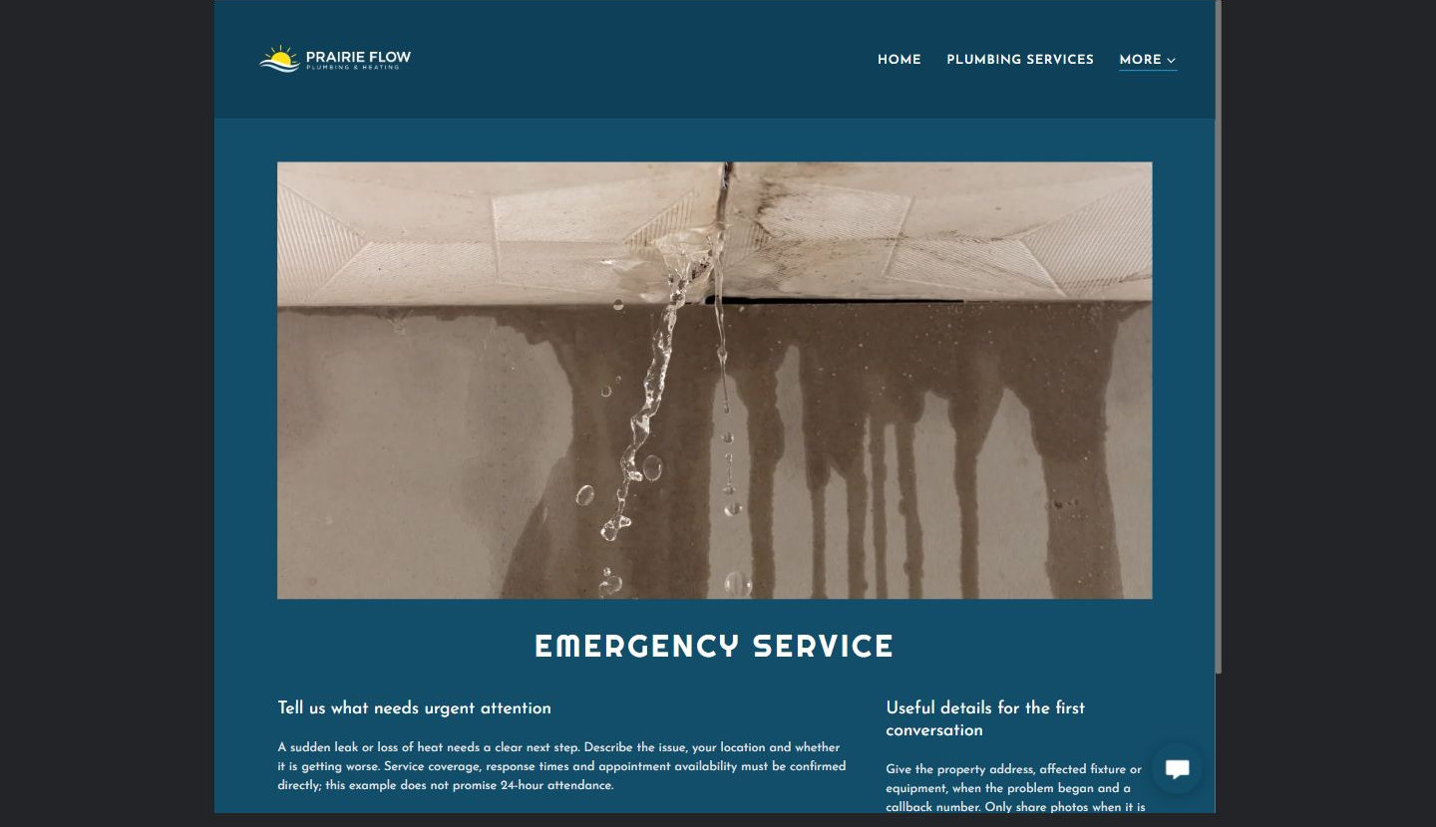
Prairie Flow Plumbing & Heating example | Explore SaaSTech Website Builder

Sample wording to adapt
Tell us what needs urgent attention
Describe the problem and your location when calling the business. Confirm response availability directly; this example does not promise round-the-clock attendance. Use the appropriate emergency service for immediate danger.

Pause and plan
What should someone know before arriving or proceeding? Clarify preparation, access and the right contact route. Verify policies and avoid promising urgent help or specialist advice the website cannot provide.

WRITE YOUR PAGE

Emergency Service
Write for your visitor. Be specific about what they need to know and what happens next. You can revise the wording after the workshop.
Your page headline

Your opening paragraph

Preparation access policies and practical questions to answer

Button or link wording and where it should lead

Photo idea caption and permission or credit needed

Facts to verify or questions to resolve

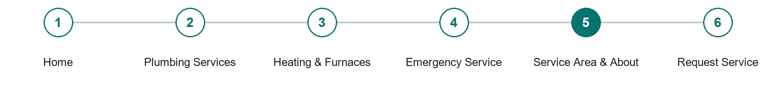
LOOK AND LEARN

Service Area About

The job of this page
Show experience, service boundaries, respect for the property, and other proof customers can verify.
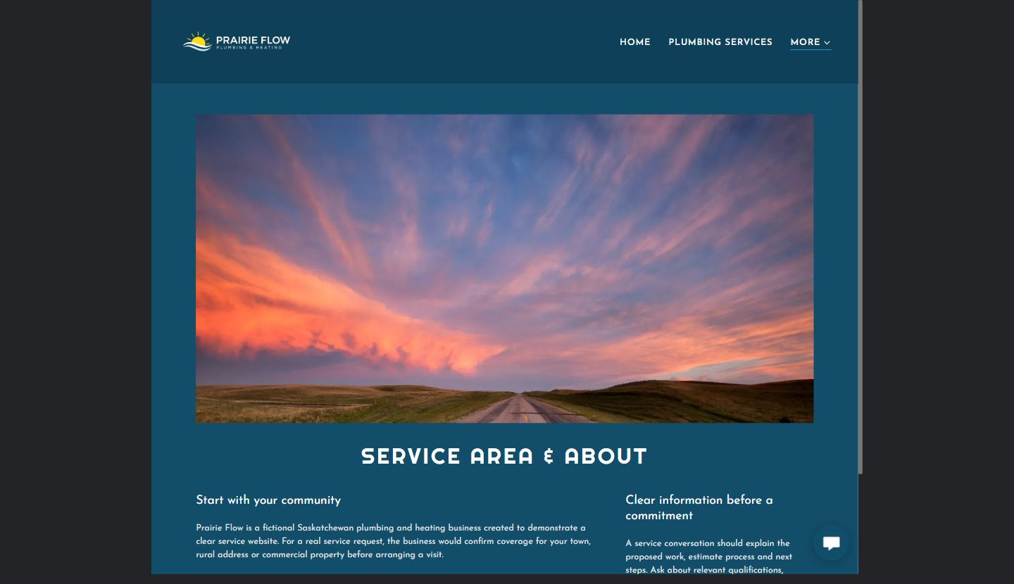
Prairie Flow Plumbing & Heating example | Explore SaaSTech Website Builder

Sample wording to adapt
Start with your community
Ask whether your town, rural address or commercial property is covered before arranging a visit. A service conversation should explain the work, estimate process and next steps.

Pause and plan
Which names, roles and qualifications can you verify? What would help a visitor feel comfortable contacting you? Obtain permission for portraits and describe actual experience without unsupported claims.

WRITE YOUR PAGE

Service Area About
Write for your visitor. Be specific about what they need to know and what happens next. You can revise the wording after the workshop.
Your page headline

Your opening paragraph

People roles approach and verified credentials to introduce

Button or link wording and where it should lead

Photo idea caption and permission or credit needed

Facts to verify or questions to resolve

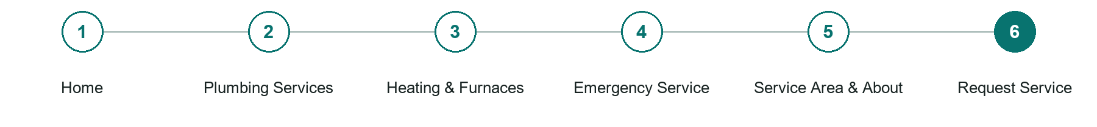
LOOK AND LEARN

Request Service

The job of this page
Collect the problem, address, preferred timing, and best contact method without promising an appointment before confirmation.
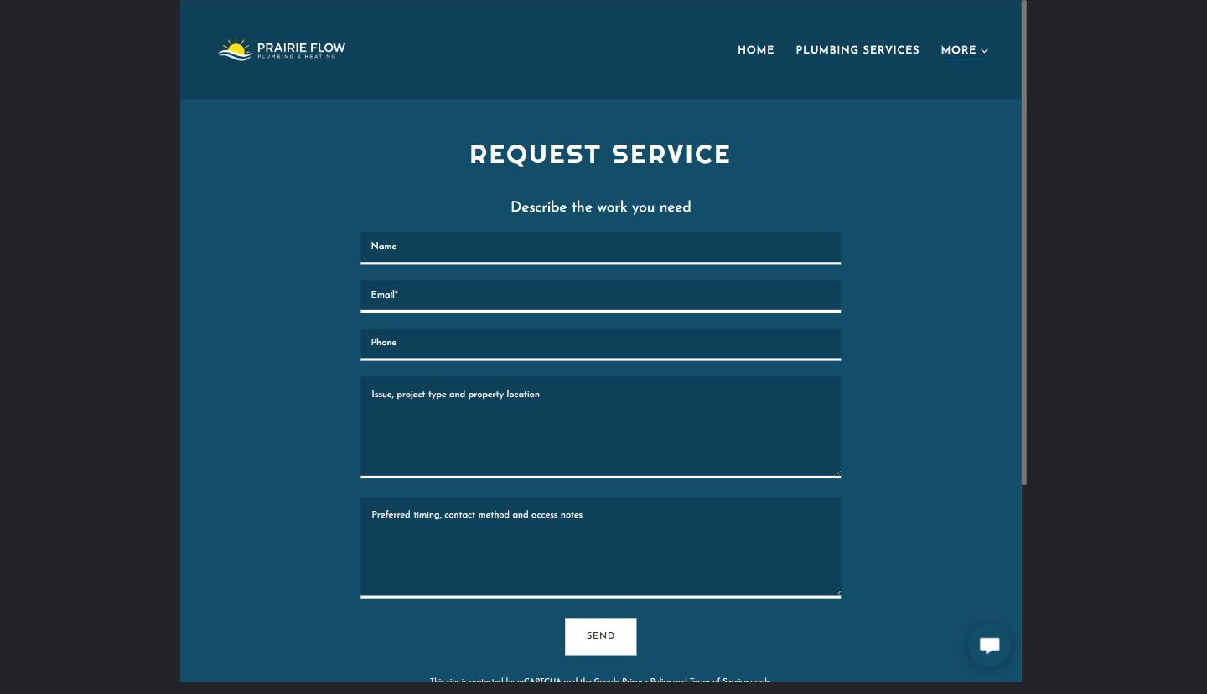
Prairie Flow Plumbing & Heating example | Explore SaaSTech Website Builder

Sample wording to adapt
Describe the work you need
Include your community, the affected fixture or equipment, preferred timing and a reply method. An enquiry is not a confirmed appointment. Do not include private access codes in the public form.

Pause and plan
What must someone provide, and what happens after they send it? Separate a request from a confirmed booking, order or place. Decide what information should stay out of a public form.

WRITE YOUR PAGE

Request Service
Write for your visitor. Be specific about what they need to know and what happens next. You can revise the wording after the workshop.
Your page headline

Your opening paragraph

Information to request and how you will reply or confirm

Button or link wording and where it should lead

Photo idea caption and permission or credit needed

Facts to verify or questions to resolve

WORKSHOP CLOSE

Review and next steps
Ask a partner to read your draft as a first-time visitor. Can they explain what you offer, who it is for and the next step without extra help?

Before you publish
[ ] Every page has a clear purpose and a useful next step.
[ ] Headlines are specific and the wording sounds like your business.
[ ] Names, service areas, prices, dates and policies have been checked.
[ ] Credentials, testimonials and results are genuine and permission-cleared.
[ ] Photos support the text, do not repeat needlessly and have appropriate permissions.
[ ] Forms ask only for necessary information and explain what happens next.
[ ] Links, downloads and the main visitor task work on a phone.
The most useful feedback from your workshop partner

First change to make and who will do it

Information or photographs still needed

Target review date and who will approve the final content

Keep sensitive customer, patient, employee and payment information out of this workbook. Completing it does not publish a website or connect to Website Builder.

BUILD WITH SAASTECH SERVERS

Put your draft into Website Builder
Use the content you have written to build your own site. Keep the plumbers & heating contractors demo as a reference, and replace its company name, images and claims with your verified business information.

Explore the builder
See the editor, compare available plans and decide which features your business needs. Confirm current pricing and terms before purchasing.
Website Builder overview

Create your account
Set up your SaaSTech Servers customer account using your own details. Creating an account is separate from purchasing a Website Builder plan.
Create your SaaSTech account

Choose your plan
Open the secure shop to review the plan, subscription term and final total. Use the account connected to your purchase when you open your service.
View Website Builder plans

Build and check your pages
Add the pages from this workbook. Transfer your approved wording, upload permission-cleared photos and review each page on desktop and mobile before publishing.
Return to the Website Builder guide

Using a printed workbook
Type these short addresses into your browser. The account guide includes the Create My Account button.
www.saastech.net/products/website-builder
www.saastech.net/create-account
This workbook does not create an account, purchase a plan or publish your website. Keep passwords, payment details and confidential customer information out of your draft.

