

Physiotherapy, Chiropractic & Massage Clinics
Website workbook
A practical workshop for a 5-page website. Study the example, plan the content and draft your own version in Word or on paper.
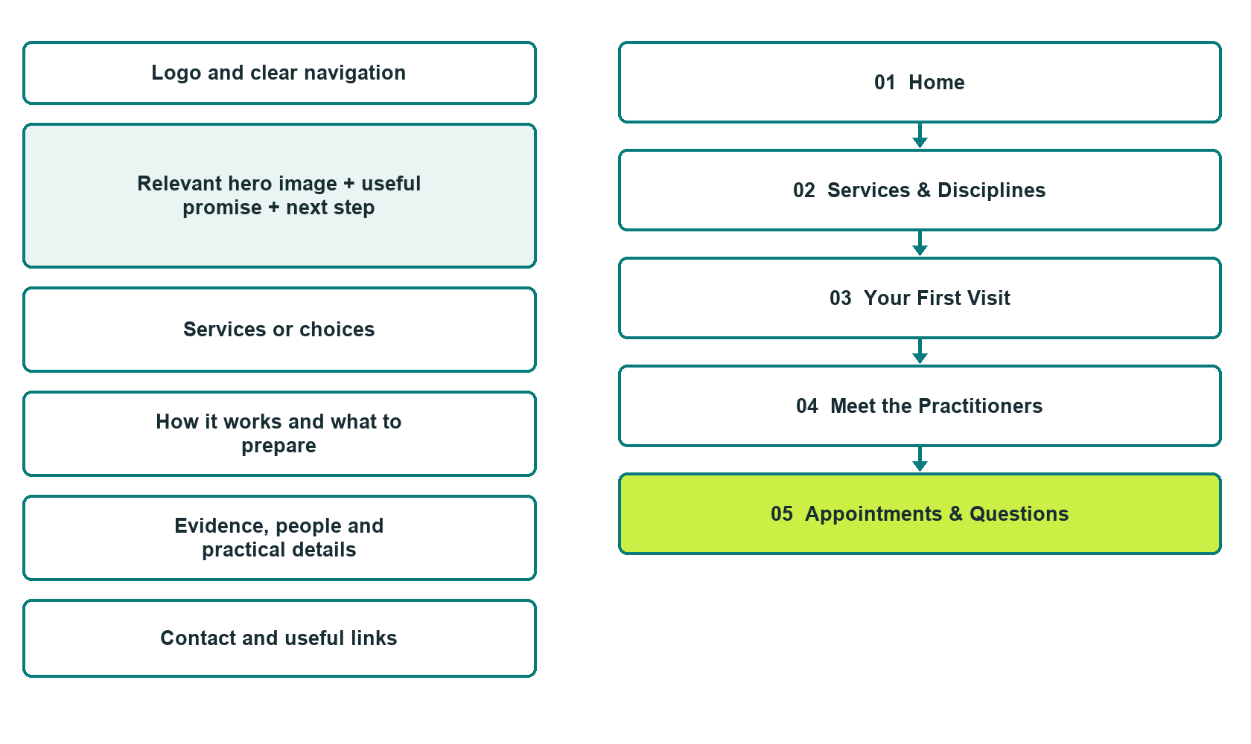

Plan → Draft → Build → Test
Demo-capture edition: actual Website Builder desktop previews and clearly labelled sample wording to adapt. See each matching mobile preview in the industry page gallery. The example business and its AI-generated photographs are fictional.
Explore Website Builder and compare plans

Before you build
Your business supplies the facts. Prairie Movement Clinic is a fictional teaching example, not a live service.

□ Ask about a first appointment
□ Verified business identity and current contact information
□ Clear request and confirmation process
□ Choose original photographs and confirm permission to use them.
□ Keep private customer records out of public website forms.

Your audience and the action you want them to take

Facts to verify and people who must approve them
Create your SaaSTech account

01 Home
Give this page one clear job in the customer journey.
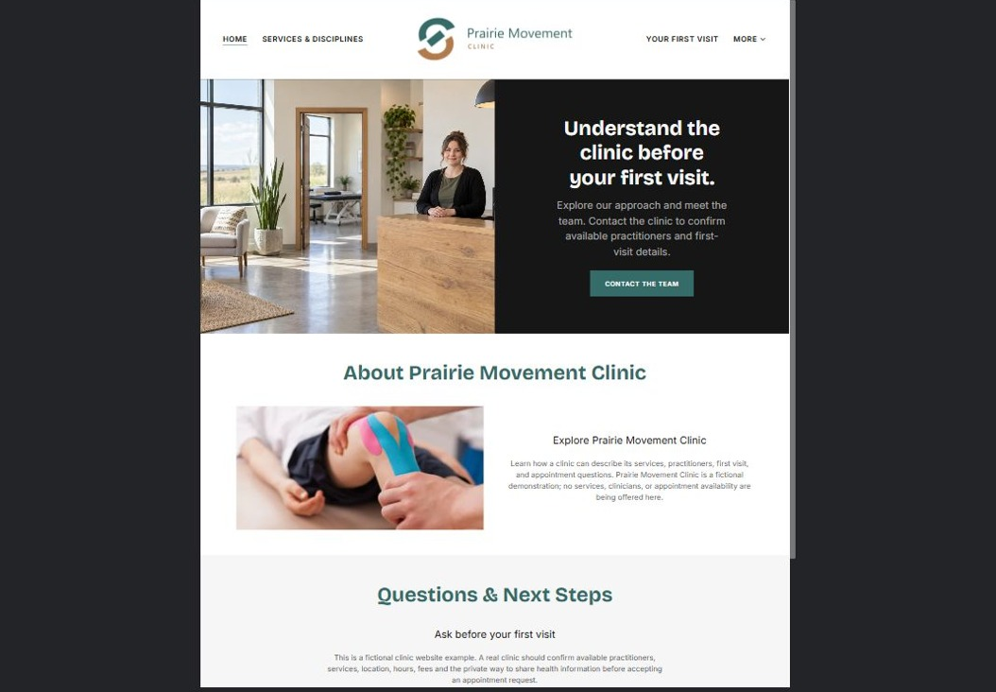
Actual desktop preview - unpublished fictional demonstration

Sample wording — adapt and verify
Understand the clinic before your first visit.
Explore our approach, meet the team and learn what to ask before your first appointment. Contact the clinic to confirm which practitioner and appointment type can address your enquiry.
Contact the team to discuss your questions and confirm what happens next. Please wait for a direct response before making arrangements.
Suggested button: Ask about a first appointment

Website advice
Separate the disciplines actually offered, introduce verified practitioners and explain first-visit arrangements without promising outcomes.

Your draft: Home
Write in the voice of your own business. Use facts you can verify, not promises copied from the example.

Headline and short introduction

Main content and details visitors need

Button wording and destination

Photo choice, permission and facts still to confirm
Partner check: can someone unfamiliar with the business find a useful next step?

02 Services & Disciplines
Give this page one clear job in the customer journey.
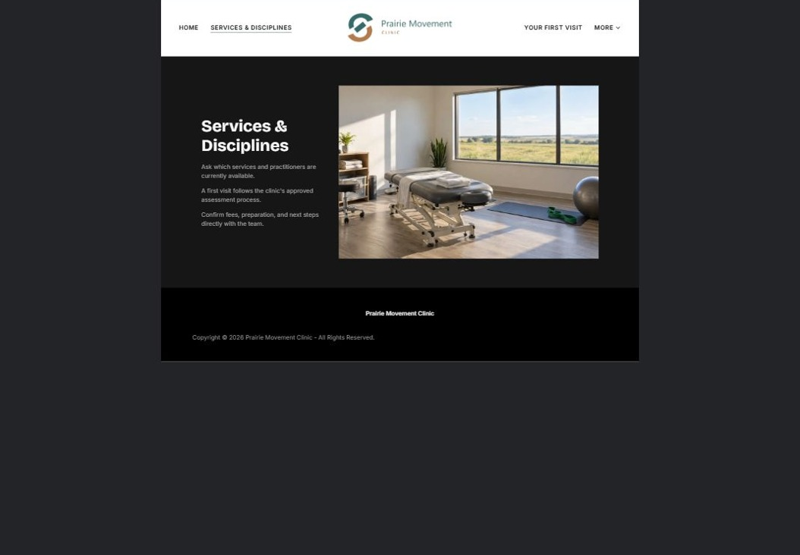
Actual desktop preview - unpublished fictional demonstration

Sample wording — adapt and verify
Services & Disciplines
Ask about the services available and how the first appointment is arranged. A practitioner reviews individual needs through the clinic’s approved assessment process.
Contact the team to discuss your questions and confirm what happens next. Please wait for a direct response before making arrangements.
Suggested button: Contact the team

Website advice
Give each verified discipline its own short explanation and practitioner link. Explain the assessment process without diagnosing visitors or guaranteeing results.

Your draft: Services & Disciplines
Write in the voice of your own business. Use facts you can verify, not promises copied from the example.

Headline and short introduction

Main content and details visitors need

Button wording and destination

Photo choice, permission and facts still to confirm
Partner check: can someone unfamiliar with the business find a useful next step?

03 Your First Visit
Give this page one clear job in the customer journey.
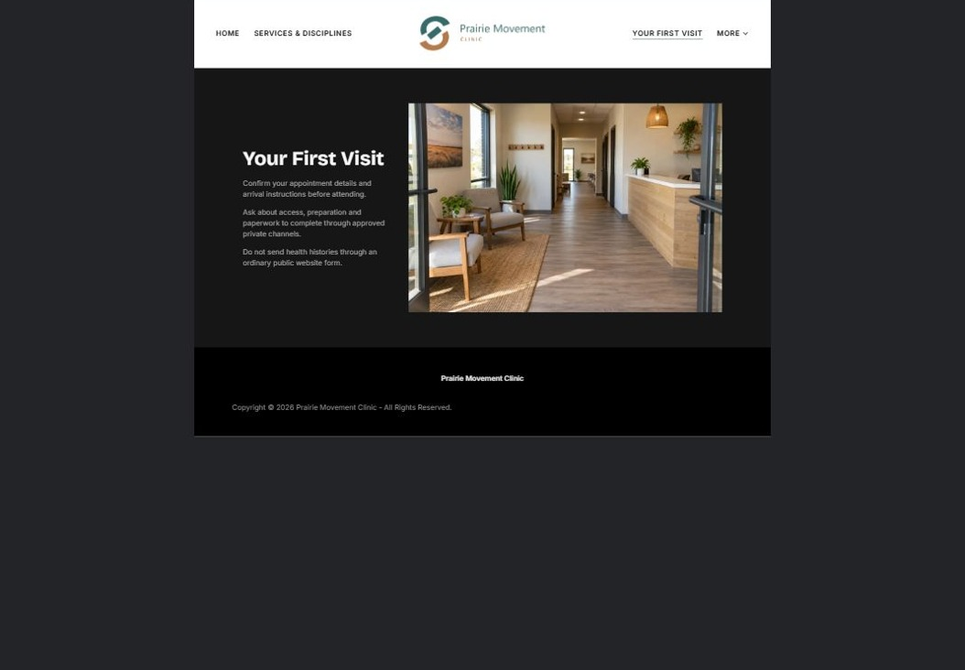
Actual desktop preview - unpublished fictional demonstration

Sample wording — adapt and verify
Your First Visit
Before attending, confirm your appointment details, arrival instructions and any information the clinic asks you to provide privately. Contact the team if you have questions about access or preparation.
Contact the team to discuss your questions and confirm what happens next. Please wait for a direct response before making arrangements.
Suggested button: Contact the team

Website advice
Explain arrival, accessibility, paperwork and how fees are confirmed. Do not collect health histories through a public contact form.

Your draft: Your First Visit
Write in the voice of your own business. Use facts you can verify, not promises copied from the example.

Headline and short introduction

Main content and details visitors need

Button wording and destination

Photo choice, permission and facts still to confirm
Partner check: can someone unfamiliar with the business find a useful next step?

04 Meet the Practitioners
Give this page one clear job in the customer journey.
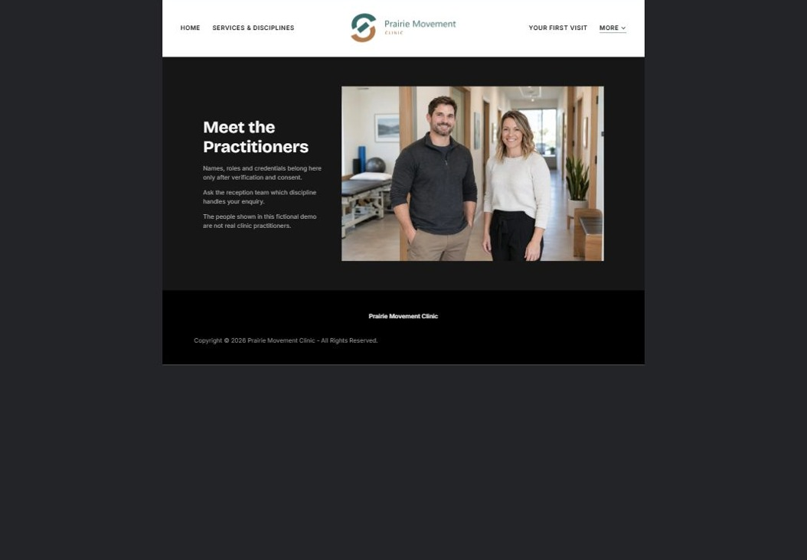
Actual desktop preview - unpublished fictional demonstration

Sample wording — adapt and verify
Meet the Practitioners
Get to know the people at the clinic and the disciplines they provide. Ask the reception team who to contact when you are unsure where to begin.
Contact the team to discuss your questions and confirm what happens next. Please wait for a direct response before making arrangements.
Suggested button: Contact the team

Website advice
Publish names, roles and credentials only with verification and consent. Use distinct portraits and explain who handles general enquiries.

Your draft: Meet the Practitioners
Write in the voice of your own business. Use facts you can verify, not promises copied from the example.

Headline and short introduction

Main content and details visitors need

Button wording and destination

Photo choice, permission and facts still to confirm
Partner check: can someone unfamiliar with the business find a useful next step?

05 Appointments & Questions
Give this page one clear job in the customer journey.
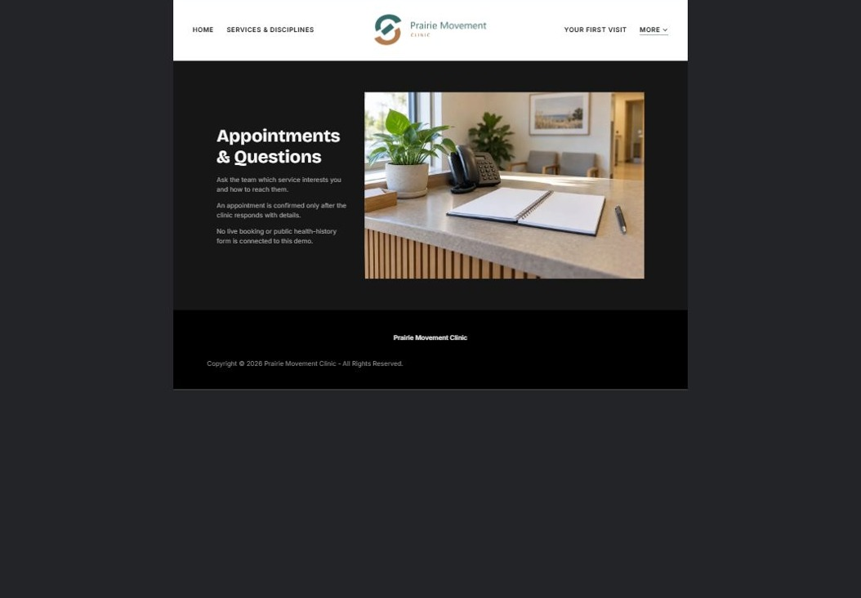
Actual desktop preview - unpublished fictional demonstration

Sample wording — adapt and verify
Appointments & Questions
Tell the reception team which service interests you and how to contact you. Your appointment is confirmed only after the clinic responds with the details.
Contact the team to discuss your questions and confirm what happens next. Please wait for a direct response before making arrangements.
Suggested button: Contact the team

Website advice
Distinguish appointment requests from confirmations. Publish operator-approved fees and cancellation terms only after review.

Your draft: Appointments & Questions
Write in the voice of your own business. Use facts you can verify, not promises copied from the example.

Headline and short introduction

Main content and details visitors need

Button wording and destination

Photo choice, permission and facts still to confirm
Partner check: can someone unfamiliar with the business find a useful next step?

Test before publishing
Review the whole journey on a desktop and phone. The industry page pairs each desktop capture with its mobile preview and provides the complete sample page copy.
□ This fictional clinic provides no diagnosis or treatment advice. Verify practitioner credentials and scope locally; keep health histories in the clinic’s approved private intake system.
□ Verify contact routes, hours, location and every offered service.
□ Remove invented prices, claims, testimonials and availability.
□ Keep sensitive records and payment details out of ordinary public forms.
□ Check all image permissions, downloads and page links on a phone.
□ Check every link, form destination, download and confirmation message.
□ Check logo contrast, hero framing, text sizes and image loading.
□ Save a named backup and assign a content-review date.

Changes to finish and person responsible

Approval and next review date
Website Builder plans and signup

