

Pharmacy website workshop workbook
SaaSTech Servers helps you turn a four page website outline into a useful first draft. Use the Prairie Care example to discuss your own pharmacy’s public information, then write your approved content in the spaces provided.
Type into the response lines in Microsoft Word, or print and complete by hand. Keep patient and prescription information out of this document.

Your workshop outcome
Prepare Home, Pharmacy Services, About Our Team and Contact and Visit. Identify the facts, photographs and approvals needed before you build. The screenshots show the fictional demo; the examples are not claims about your business.
Your pharmacy and workshop date

Who visits your website and what they need first

Your main next step for visitors

Explore Website Builder plans

Home
Make the pharmacy name, service area and main next step easy to find. Use one strong photograph, readable branding and a clear link to contact details. Keep a real business’s verified hours and phone number current.


Actual Prairie Care demo wording
Your neighbourhood pharmacy, thoughtfully connected

Draft your home page
What is your main message? Which verified detail helps visitors take the next step?
Headline

Your page content

Image idea and permission needed

Next action and its destination

Facts to verify and reviewer

Pharmacy Services
Describe the services you actually provide in language visitors understand. Confirm availability, appointment requirements and any fees with the pharmacy. Keep personal advice and prescription details in approved private channels.


Actual Prairie Care demo wording
Before visiting, ask the pharmacy which services it offers, whether an appointment is needed and what to bring. Availability, eligibility and fees should be confirmed directly with the pharmacy team. This example website does not offer live bookings.

Draft your pharmacy services page
Which services can you accurately describe? Who verifies each description?
Headline

Your page content

Image idea and permission needed

Next action and its destination

Facts to verify and reviewer

About Our Team
Introduce real staff only with permission. Verify roles and qualifications, give each person a distinct portrait and explain who handles general enquiries. Avoid invented testimonials or credentials.


Actual Prairie Care demo wording
Maya represents the welcoming assistant who helps with general enquiries, finding the right team member and non-clinical store information. She does not provide clinical advice. This fictional profile shows how a pharmacy can explain staff roles clearly.

Draft your about our team page
Who will you introduce and what may you say about their role?
Headline

Your page content

Image idea and permission needed

Next action and its destination

Facts to verify and reviewer

Contact and Visit
Give visitors verified ways to contact and find you. Explain accessibility, hours and what to confirm before travelling. A general contact form should not be presented as a secure clinical or prescription service.
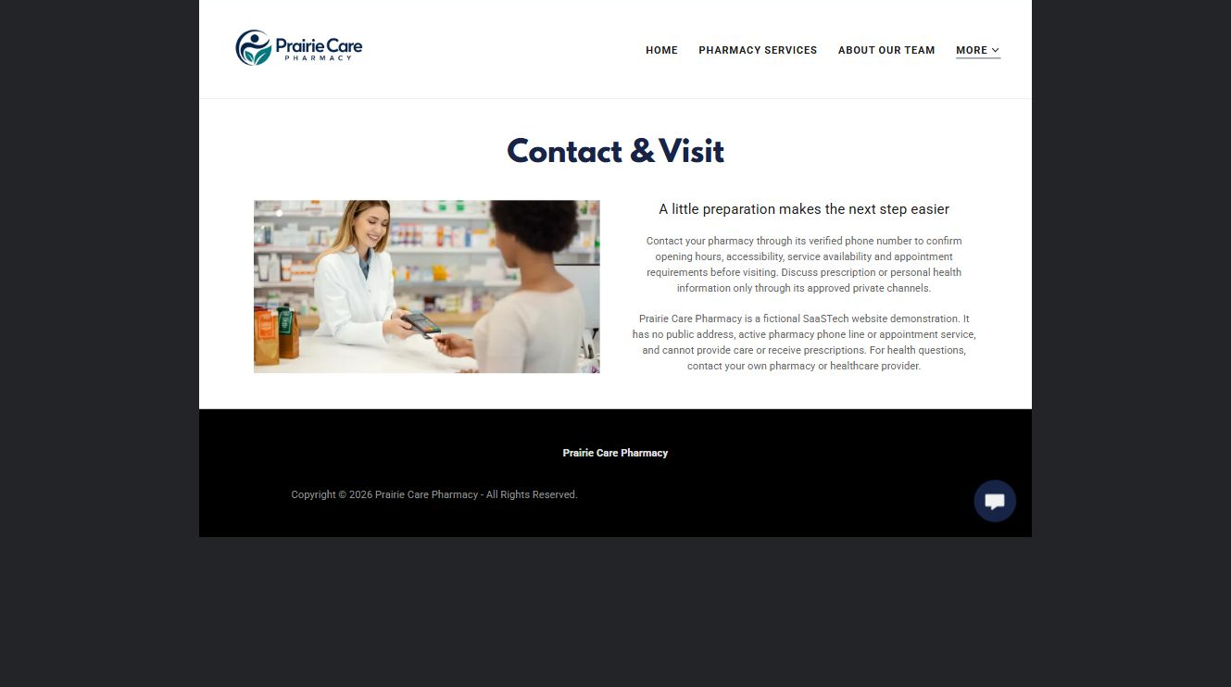

Actual Prairie Care demo wording
Contact your pharmacy through its verified phone number to confirm opening hours, accessibility, service availability and appointment requirements before visiting. Discuss prescription or personal health information only through its approved private channels.

Draft your contact and visit page
What contact details can you verify? Where should private questions be directed?
Headline

Your page content

Image idea and permission needed

Next action and its destination

Facts to verify and reviewer

Prepare to build and review
Work through the guide, add your approved text and images, then test the result before publication. Keep a named backup before changing themes or major sections.
Your chosen plan and why it meets your needs

Content and images still to gather

People responsible and target review date

Phone testing notes and remaining fixes

Website Builder information and plan selection
Return to the pharmacy industry guide

