
WEBSITE PLANNING WORKSHOP

Pet Groomers
Website workbook
Plan a clear website for pet groomers. Explore a worked example, shape your own message and prepare to build with SaaSTech Servers.
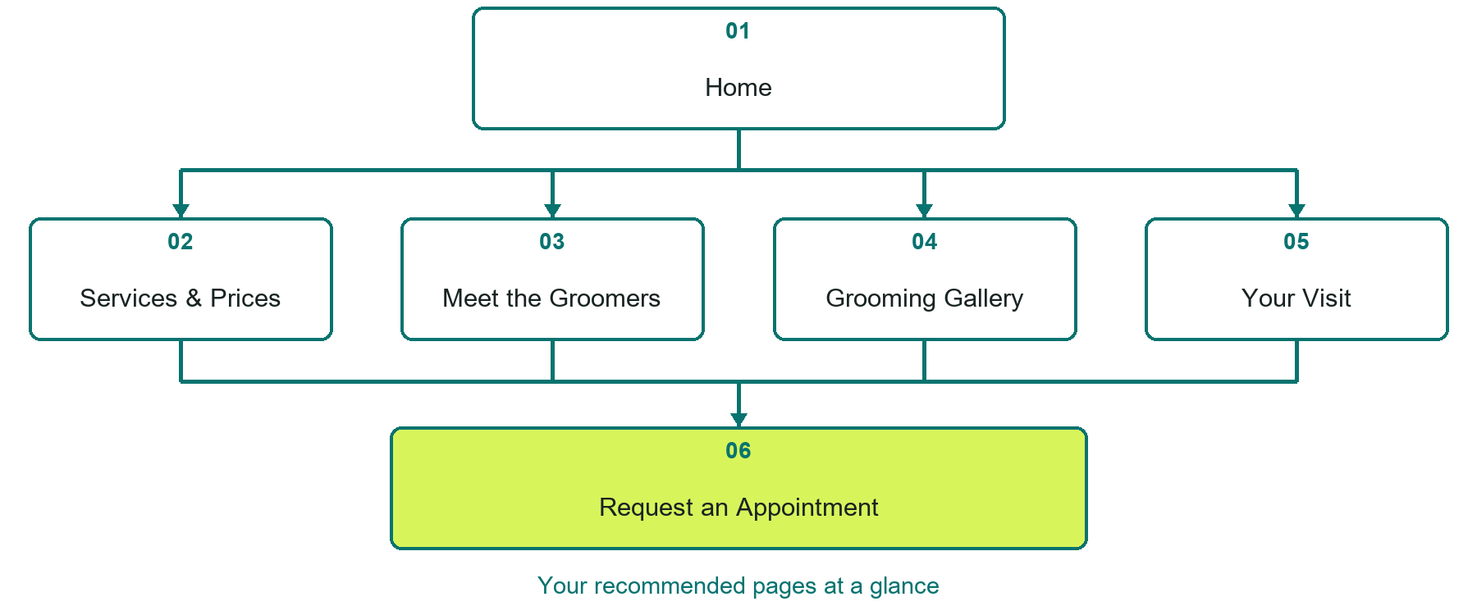

Inside this workbook
Six page examples • Practical writing exercises • A launch review
Use it in a workshop or at your own pace. Write by hand or complete the response fields in Word. The final page links to Website Builder, plans and account signup.
Example business Prairie Paws Grooming

PET GROOMERS

Your website brief
A SaaSTech Servers workshop for pet groomers. Plan your website, learn from the Prairie Paws Grooming example and draft content for your own business.
Each page has a reference sheet followed by a writing sheet. Demo excerpts are labelled separately from new sample wording, which may differ from the screenshot. Click a blank response line to type; longer answers may add pages. Replace fictional details and verify every claim before publishing.
Your business or organization and workshop date

Who should visit your site and what do they need

The main action you want a visitor to take

What you offer and where or how you provide it

Facts photos and permissions to gather before publishing

Workshop rhythm: review the example, write your draft and exchange feedback. Use the final review to choose your next changes. Website Builder and account links are on the last page.

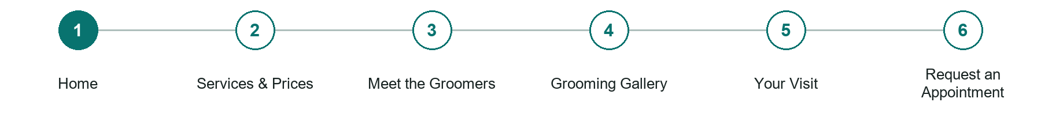
LOOK AND LEARN

Home

The job of this page
Introduce the studio with a groomer and dog in context, the service area and one appointment-request action.
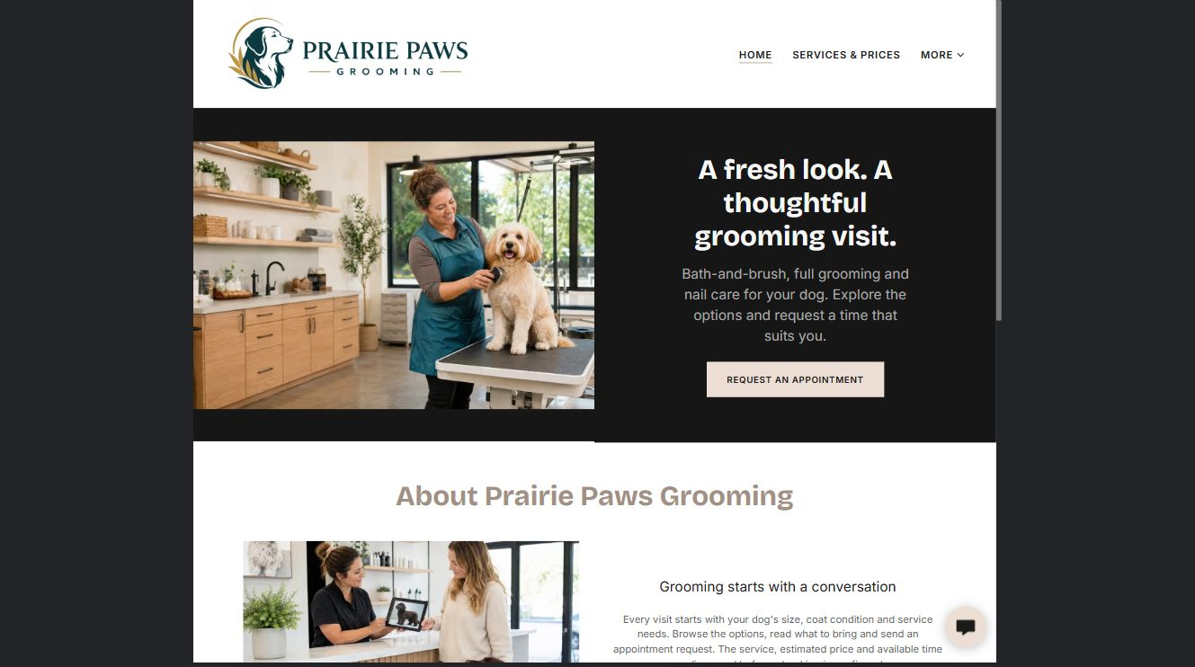
Prairie Paws Grooming example | Explore SaaSTech Website Builder

Demo text example
A fresh look. A thoughtful grooming visit.
Bath-and-brush, full grooming and nail care for your dog. Explore the options and request a time that suits you.

Pause and plan
Could a first-time visitor explain what you do and who it is for after one glance? Choose one main action and the strongest truthful detail that gives them confidence to continue.

WRITE YOUR PAGE

Home
Write for your visitor. Be specific about what they need to know and what happens next. You can revise the wording after the workshop.
Your page headline

Your opening paragraph

Your offer audience location and most useful supporting details

Button or link wording and where it should lead

Photo idea caption and permission or credit needed

Facts to verify or questions to resolve

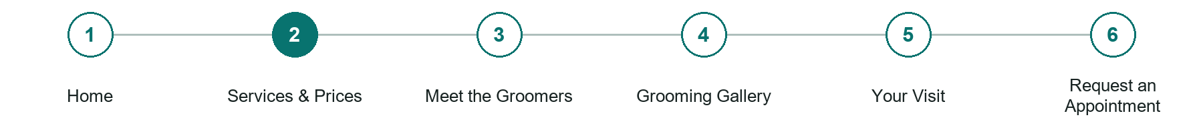
LOOK AND LEARN

Services Prices

The job of this page
Explain bath and brush, full grooming and nail-care options actually offered. State what affects estimates and what requires consultation.
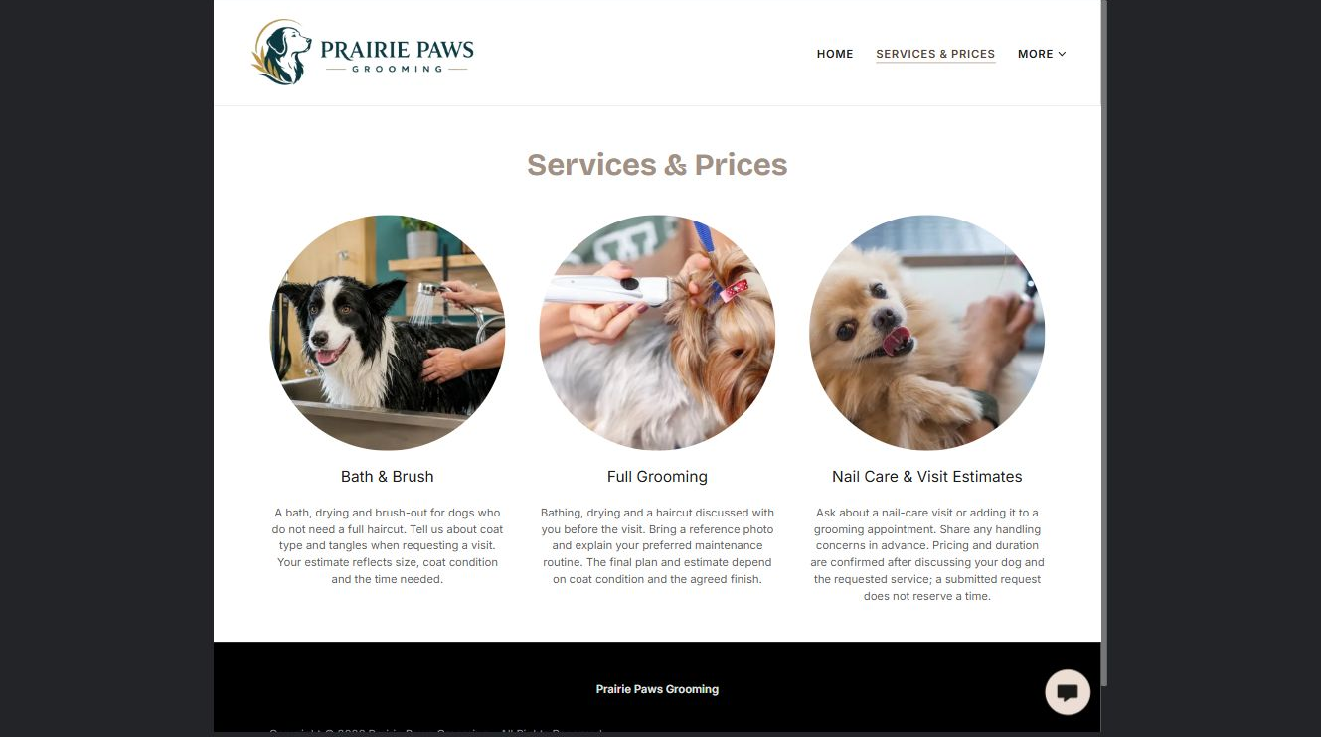
Prairie Paws Grooming example | Explore SaaSTech Website Builder

Demo text example
Bath & Brush
A bath, drying and brush-out for dogs who do not need a full haircut. Tell us about coat type and tangles when requesting a visit.

Pause and plan
What is included and what needs separate confirmation? Make quantities, timing, exclusions and price conditions understandable. Avoid implying that an example price or image guarantees availability.

WRITE YOUR PAGE

Services Prices
Write for your visitor. Be specific about what they need to know and what happens next. You can revise the wording after the workshop.
Your page headline

Your opening paragraph

Options inclusions price conditions and availability details

Button or link wording and where it should lead

Photo idea caption and permission or credit needed

Facts to verify or questions to resolve

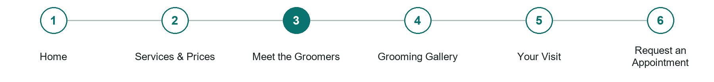
LOOK AND LEARN

Meet the Groomers

The job of this page
Introduce the team with distinct approved portraits, specialties and verified training. Do not invent credentials.
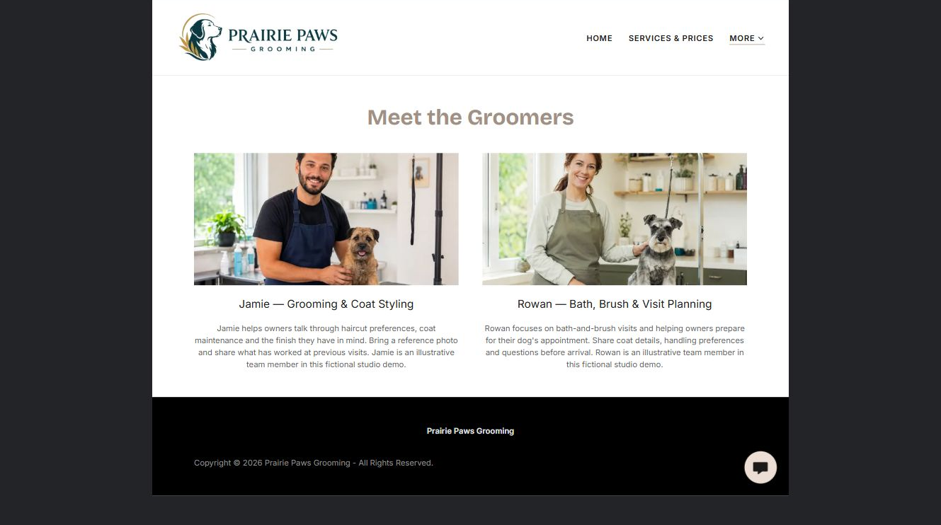
Prairie Paws Grooming example | Explore SaaSTech Website Builder

Sample wording to adapt
Meet Jamie and Rowan
Discuss haircut preferences with Jamie, or ask Rowan about bath-and-brush visits. Share the finish you have in mind and any handling preferences. These are fictional team profiles with illustrative portraits.

Pause and plan
Which names, roles and qualifications can you verify? What would help a visitor feel comfortable contacting you? Obtain permission for portraits and describe actual experience without unsupported claims.

WRITE YOUR PAGE

Meet the Groomers
Write for your visitor. Be specific about what they need to know and what happens next. You can revise the wording after the workshop.
Your page headline

Your opening paragraph

People roles approach and verified credentials to introduce

Button or link wording and where it should lead

Photo idea caption and permission or credit needed

Facts to verify or questions to resolve

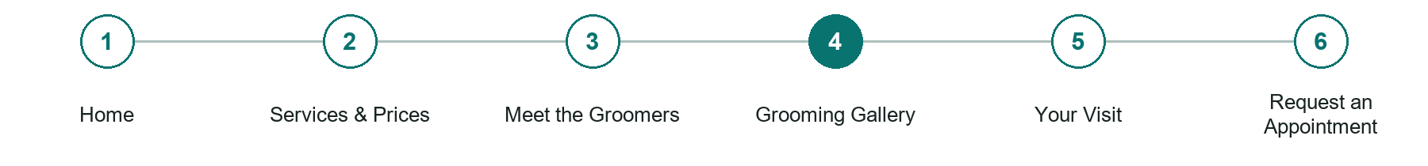
LOOK AND LEARN

Grooming Gallery

The job of this page
Show varied, permission-cleared grooming examples with useful captions. Label illustrative photos rather than implying a real client portfolio.
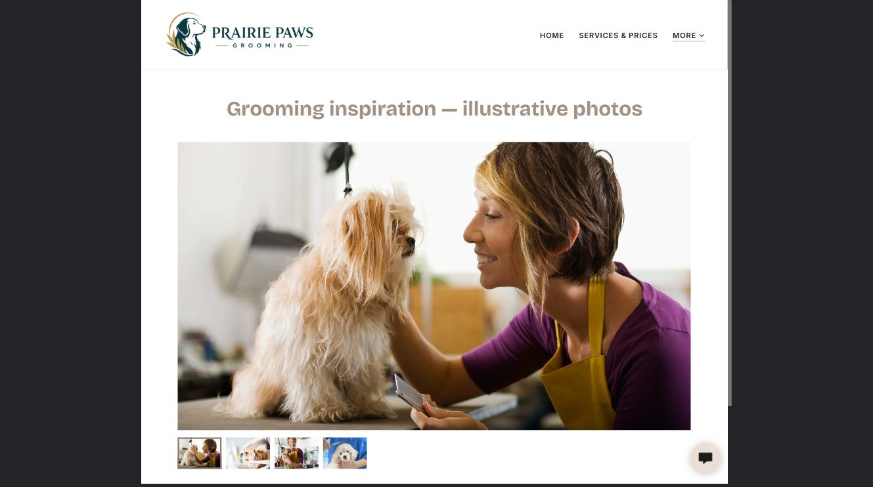
Prairie Paws Grooming example | Explore SaaSTech Website Builder

Sample wording to adapt
Grooming inspiration
Browse coat styles and finishes to help explain what you have in mind. Bring a reference photograph to your consultation. These illustrative images are not before-and-after results or a promise of the same finish for every dog.

Pause and plan
Which examples best support this page? Explain the context, your contribution and the permissions or credits needed. Label illustrative work and distinguish it from genuine completed projects or customer results.

WRITE YOUR PAGE

Grooming Gallery
Write for your visitor. Be specific about what they need to know and what happens next. You can revise the wording after the workshop.
Your page headline

Your opening paragraph

Examples captions context and evidence to include

Button or link wording and where it should lead

Photo idea caption and permission or credit needed

Facts to verify or questions to resolve

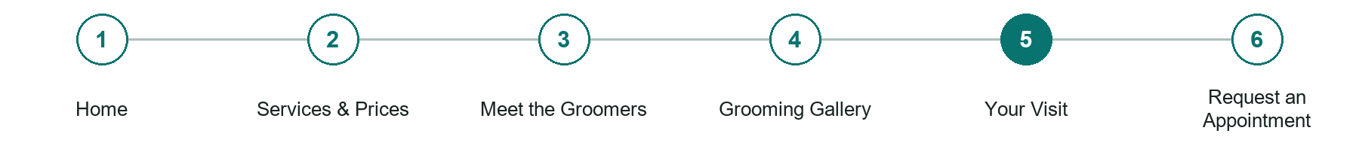
LOOK AND LEARN

Your Visit

The job of this page
Explain arrival, preparation, collection, access and the business's actual cancellation process. Arrange individual care discussions privately.
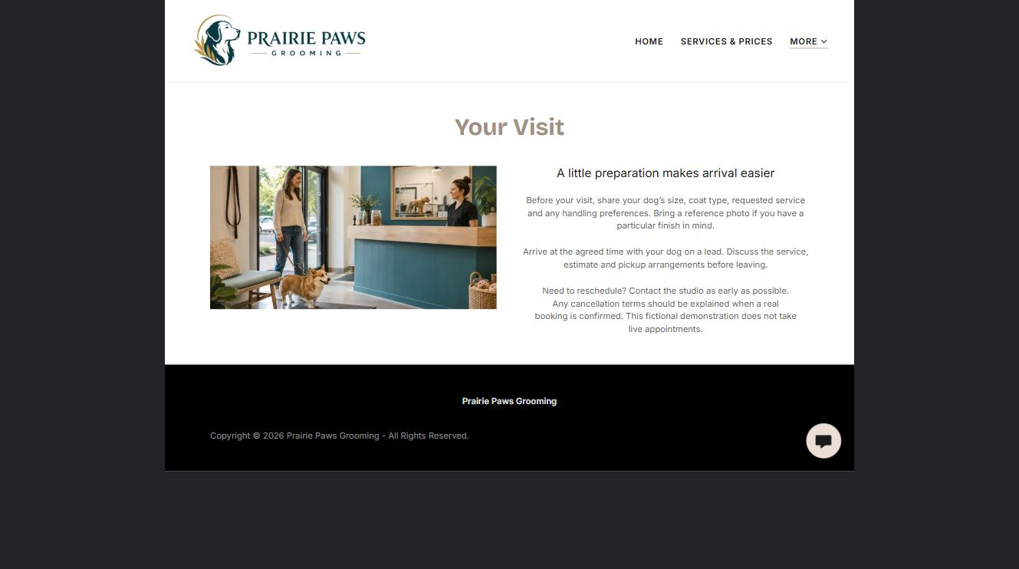
Prairie Paws Grooming example | Explore SaaSTech Website Builder

Demo text example
A little preparation makes arrival easier
Before your visit, share your dog's size, coat type, requested service and any handling preferences. Bring a reference photo if you have a particular finish in mind.

Pause and plan
What should someone know before arriving or proceeding? Clarify preparation, access and the right contact route. Verify policies and avoid promising urgent help or specialist advice the website cannot provide.

WRITE YOUR PAGE

Your Visit
Write for your visitor. Be specific about what they need to know and what happens next. You can revise the wording after the workshop.
Your page headline

Your opening paragraph

Preparation access policies and practical questions to answer

Button or link wording and where it should lead

Photo idea caption and permission or credit needed

Facts to verify or questions to resolve

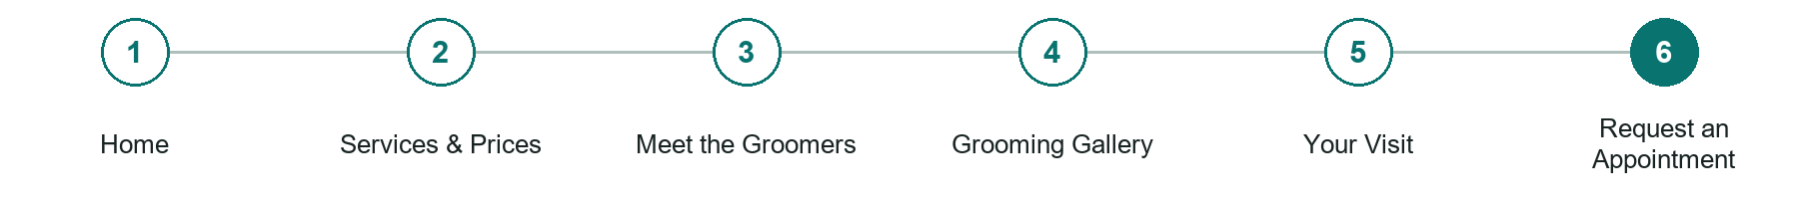
LOOK AND LEARN

Request an Appointment

The job of this page
Ask for owner contact details, dog size or breed, service interest and preferred days. Explain that the studio confirms suitability, timing and price.
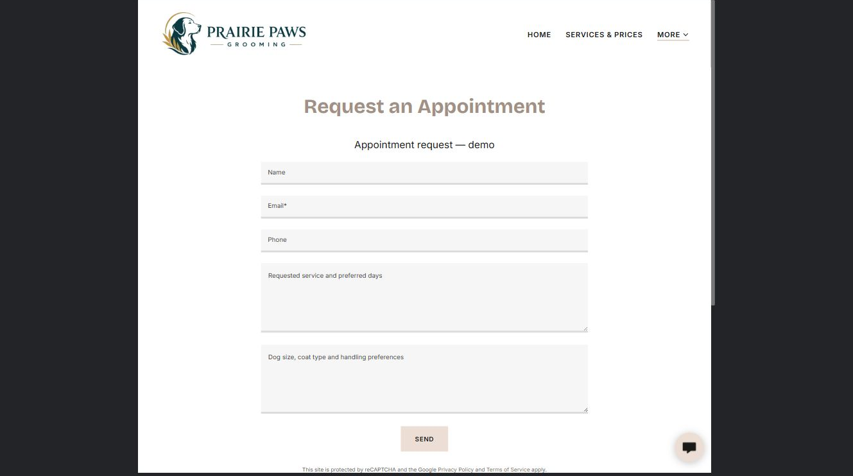
Prairie Paws Grooming example | Explore SaaSTech Website Builder

Sample wording to adapt
Request a grooming appointment
Tell us your dog's size and coat type, the service you are considering and your preferred days. We will confirm the service, estimate and available time separately. Please do not treat a request as a confirmed booking.

Pause and plan
What must someone provide, and what happens after they send it? Separate a request from a confirmed booking, order or place. Decide what information should stay out of a public form.

WRITE YOUR PAGE

Request an Appointment
Write for your visitor. Be specific about what they need to know and what happens next. You can revise the wording after the workshop.
Your page headline

Your opening paragraph

Information to request and how you will reply or confirm

Button or link wording and where it should lead

Photo idea caption and permission or credit needed

Facts to verify or questions to resolve

WORKSHOP CLOSE

Review and next steps
Ask a partner to read your draft as a first-time visitor. Can they explain what you offer, who it is for and the next step without extra help?

Before you publish
[ ] Every page has a clear purpose and a useful next step.
[ ] Headlines are specific and the wording sounds like your business.
[ ] Names, service areas, prices, dates and policies have been checked.
[ ] Credentials, testimonials and results are genuine and permission-cleared.
[ ] Photos support the text, do not repeat needlessly and have appropriate permissions.
[ ] Forms ask only for necessary information and explain what happens next.
[ ] Links, downloads and the main visitor task work on a phone.
The most useful feedback from your workshop partner

First change to make and who will do it

Information or photographs still needed

Target review date and who will approve the final content

Keep sensitive customer, patient, employee and payment information out of this workbook. Completing it does not publish a website or connect to Website Builder.

BUILD WITH SAASTECH SERVERS

Put your draft into Website Builder
Use the content you have written to build your own site. Keep the pet groomers demo as a reference, and replace its company name, images and claims with your verified business information.

Explore the builder
See the editor, compare available plans and decide which features your business needs. Confirm current pricing and terms before purchasing.
Website Builder overview

Create your account
Set up your SaaSTech Servers customer account using your own details. Creating an account is separate from purchasing a Website Builder plan.
Create your SaaSTech account

Choose your plan
Open the secure shop to review the plan, subscription term and final total. Use the account connected to your purchase when you open your service.
View Website Builder plans

Build and check your pages
Add the pages from this workbook. Transfer your approved wording, upload permission-cleared photos and review each page on desktop and mobile before publishing.
Return to the Website Builder guide

Using a printed workbook
Type these short addresses into your browser. The account guide includes the Create My Account button.
www.saastech.net/products/website-builder
www.saastech.net/create-account
This workbook does not create an account, purchase a plan or publish your website. Keep passwords, payment details and confidential customer information out of your draft.

