

Pet Boarding, Daycare & Training
Website workbook
A practical workshop for a 6-page website. Study the example, plan the content and draft your own version in Word or on paper.
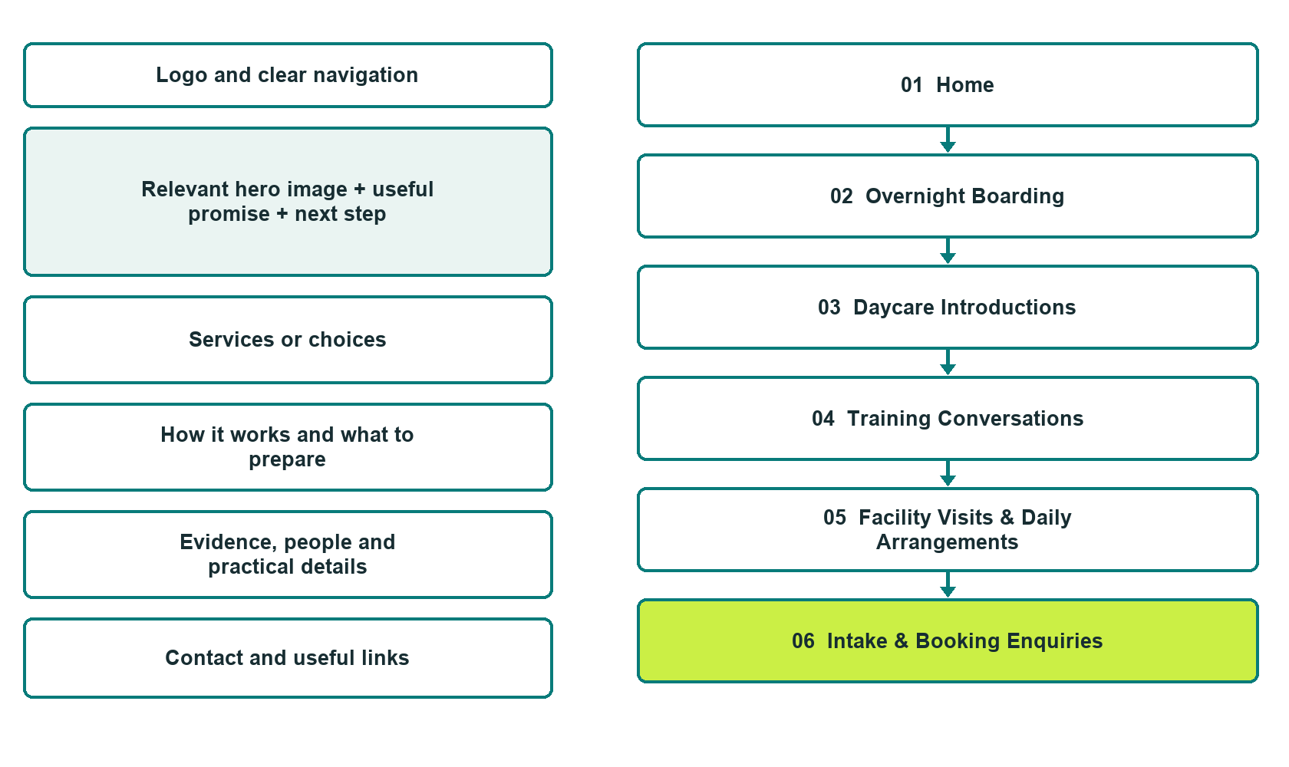

Plan → Draft → Build → Test
Demo-capture edition: actual Website Builder desktop previews and excerpts of the example wording. See each matching mobile preview in the industry page gallery. The example business and its AI-generated photographs are fictional.
Explore Website Builder and compare plans

Before you build
Your business supplies the facts. Prairie Meadow Paws is a fictional teaching example, not a live service.
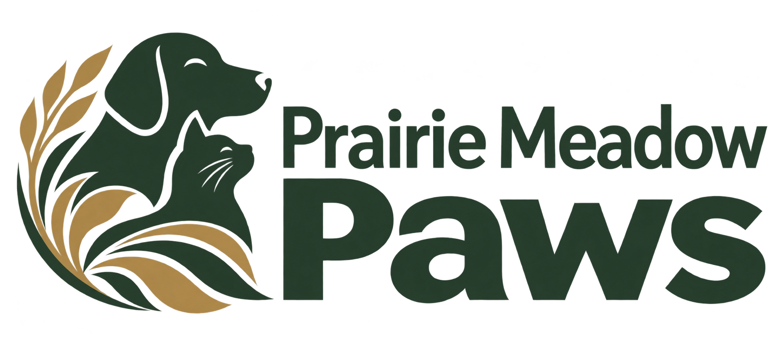
□ Ask about a stay, daycare or training
□ Verified business identity, services and current contact information
□ A clear enquiry, review and confirmation process
□ Choose original photographs and confirm permission to use them.
□ Keep private customer records out of public website forms.

Your audience and the action you want them to take

Facts to verify and people who must approve them
Create your SaaSTech account

01 Home
Give this page one clear job in the customer journey.
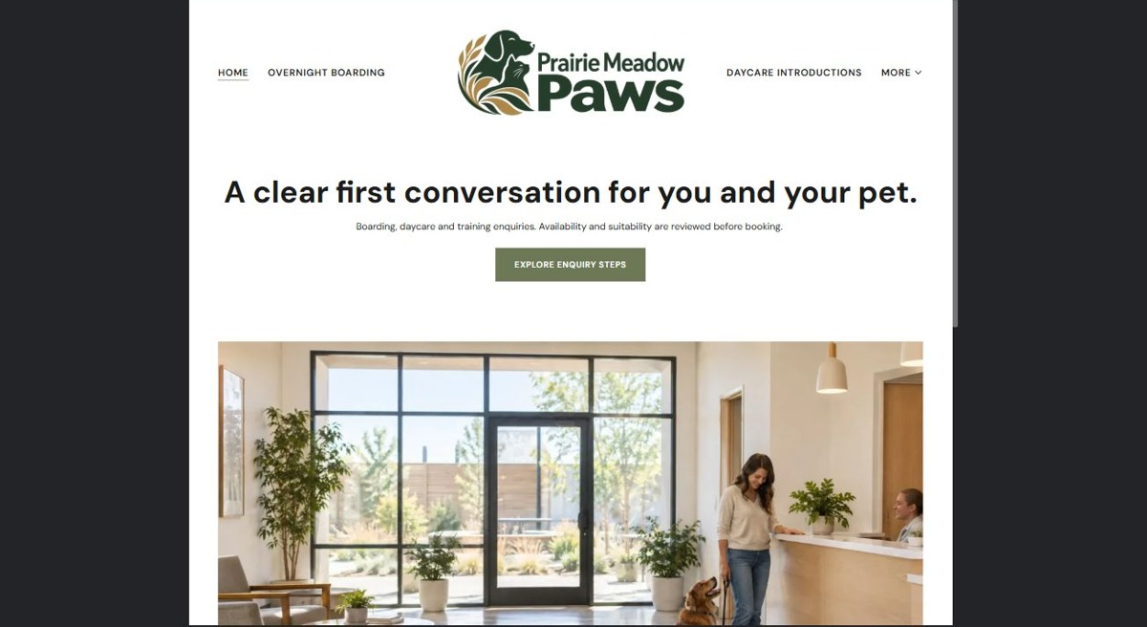
Actual desktop preview - unpublished fictional demonstration

Demo wording excerpt to adapt and verify
A clear first conversation for you and your pet.
Boarding, daycare and training enquiries. Availability and suitability are reviewed before booking.
Explore overnight stays, daytime care and training as separate services with different intake conversations. Ask about current availability, the relevant suitability process and how to arrange a facility visit. This is a fictional Saskatchewan demonstration, not a live pet-care booking service. Detailed pet records belong in the operator-approved private intake process.
Suggested button: Explore enquiry steps

Website advice
Introduce the three services and guide visitors to the enquiry process. Availability and suitability are reviewed before booking.

Your draft: Home
Write in the voice of your own business. Use facts you can verify, not promises copied from the example.

Headline and short introduction

Main content and details visitors need

Button wording and destination

Photo choice, permission and facts still to confirm
Partner check: can someone unfamiliar with the business find a useful next step?

02 Overnight Boarding
Give this page one clear job in the customer journey.
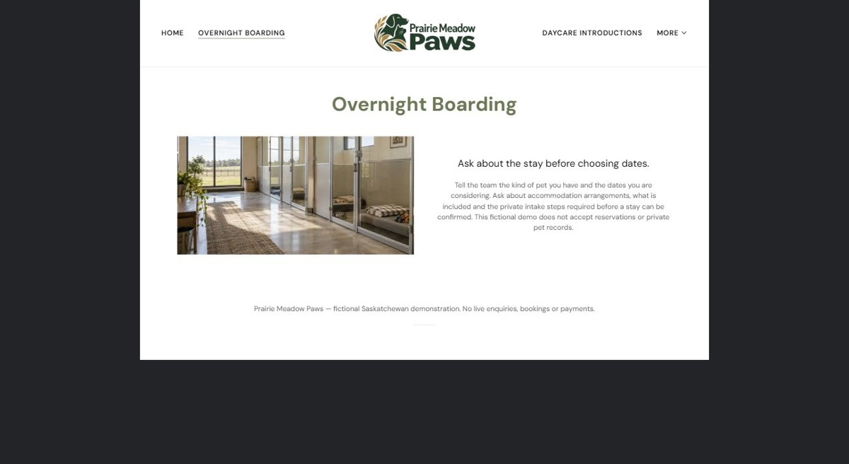
Actual desktop preview - unpublished fictional demonstration

Demo wording excerpt to adapt and verify
Ask about the stay before choosing dates.
Tell the team the kind of pet you have and the dates you are considering. Ask about accommodation arrangements, what is included and the private intake steps required before a stay can be confirmed. This fictional demo does not accept reservations or private pet records.
Navigation: guide visitors to the next relevant page; this demo page has no separate enquiry button.

Website advice
Explain accommodation enquiries, what visitors should ask and the private intake steps before staff can confirm a stay.

Your draft: Overnight Boarding
Write in the voice of your own business. Use facts you can verify, not promises copied from the example.

Headline and short introduction

Main content and details visitors need

Button wording and destination

Photo choice, permission and facts still to confirm
Partner check: can someone unfamiliar with the business find a useful next step?

03 Daycare Introductions
Give this page one clear job in the customer journey.
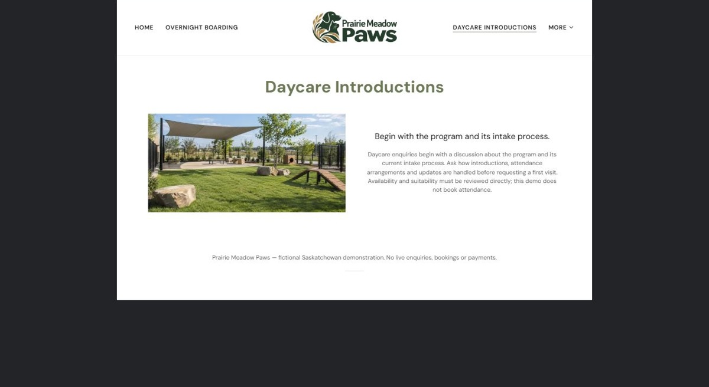
Actual desktop preview - unpublished fictional demonstration

Demo wording excerpt to adapt and verify
Begin with the program and its intake process.
Daycare enquiries begin with a discussion about the program and its current intake process. Ask how introductions, attendance arrangements and updates are handled before requesting a first visit. Availability and suitability must be reviewed directly; this demo does not book attendance.
Navigation: guide visitors to the next relevant page; this demo page has no separate enquiry button.

Website advice
Explain the daycare introduction process and questions to discuss before requesting a first visit. Do not imply a place is automatically confirmed.

Your draft: Daycare Introductions
Write in the voice of your own business. Use facts you can verify, not promises copied from the example.

Headline and short introduction

Main content and details visitors need

Button wording and destination

Photo choice, permission and facts still to confirm
Partner check: can someone unfamiliar with the business find a useful next step?

04 Training Conversations
Give this page one clear job in the customer journey.
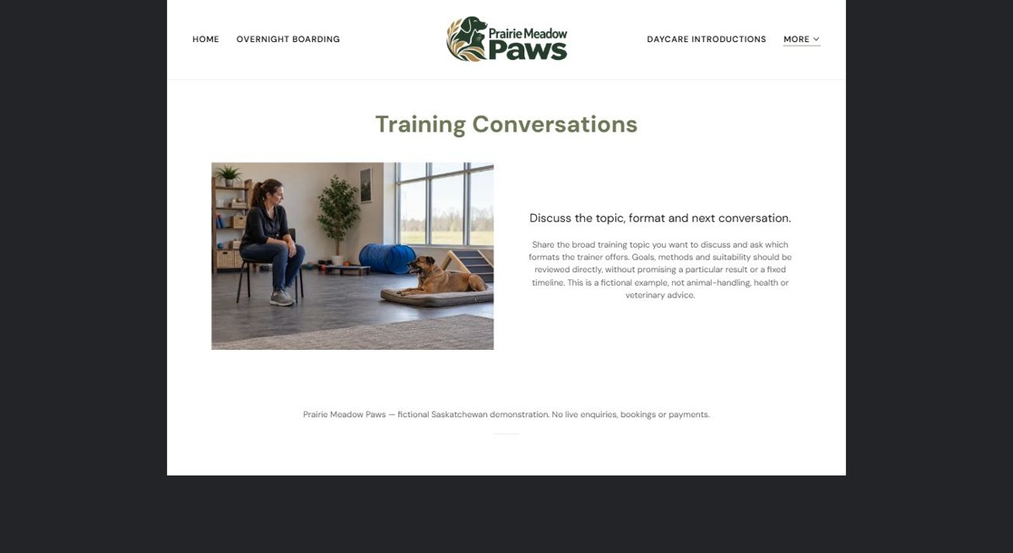
Actual desktop preview - unpublished fictional demonstration

Demo wording excerpt to adapt and verify
Discuss the topic, format and next conversation.
Share the broad training topic you want to discuss and ask which formats the trainer offers. Goals, methods and suitability should be reviewed directly, without promising a particular result or a fixed timeline. This is a fictional example, not animal-handling, health or veterinary advice.
Navigation: guide visitors to the next relevant page; this demo page has no separate enquiry button.

Website advice
Separate training enquiries from boarding and daycare. Describe formats and the consultation process without guaranteed outcomes or veterinary advice.

Your draft: Training Conversations
Write in the voice of your own business. Use facts you can verify, not promises copied from the example.

Headline and short introduction

Main content and details visitors need

Button wording and destination

Photo choice, permission and facts still to confirm
Partner check: can someone unfamiliar with the business find a useful next step?

05 Facility Visits & Daily Arrangements
Give this page one clear job in the customer journey.
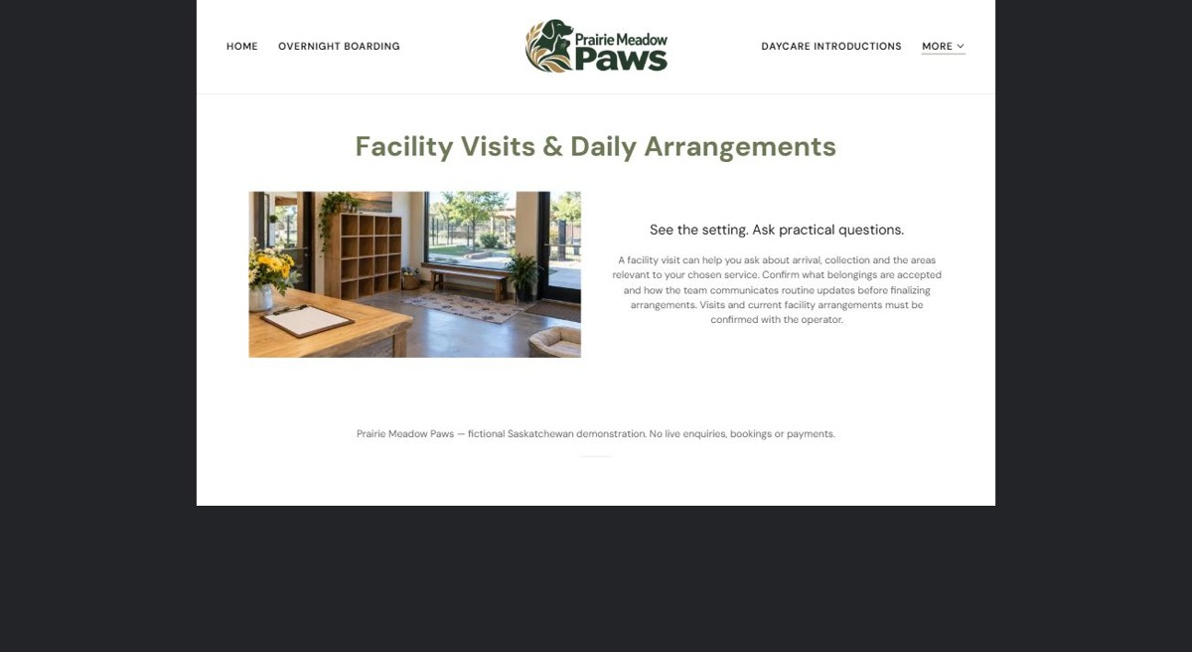
Actual desktop preview - unpublished fictional demonstration

Demo wording excerpt to adapt and verify
See the setting. Ask practical questions.
A facility visit can help you ask about arrival, collection and the areas relevant to your chosen service. Confirm what belongings are accepted and how the team communicates routine updates before finalizing arrangements. Visits and current facility arrangements must be confirmed with the operator.
Navigation: guide visitors to the next relevant page; this demo page has no separate enquiry button.

Website advice
Help visitors ask about arrival, collection, belongings, communication and facility visits, using operator-approved details.

Your draft: Facility Visits & Daily Arrangements
Write in the voice of your own business. Use facts you can verify, not promises copied from the example.

Headline and short introduction

Main content and details visitors need

Button wording and destination

Photo choice, permission and facts still to confirm
Partner check: can someone unfamiliar with the business find a useful next step?

06 Intake & Booking Enquiries
Give this page one clear job in the customer journey.
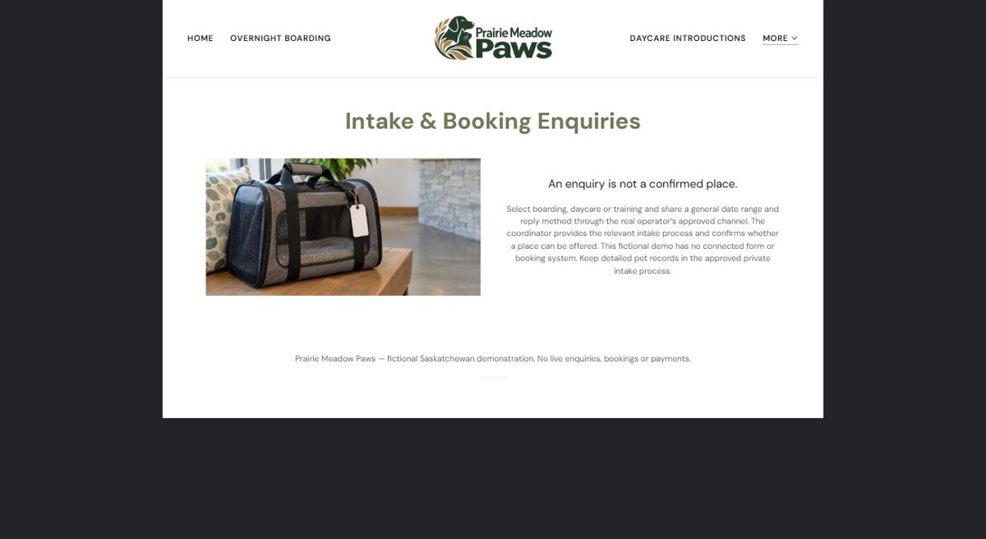
Actual desktop preview - unpublished fictional demonstration

Demo wording excerpt to adapt and verify
An enquiry is not a confirmed place.
Select boarding, daycare or training and share a general date range and reply method through the real operator’s approved channel. The coordinator provides the relevant intake process and confirms whether a place can be offered. This fictional demo has no connected form or booking system. Keep detailed pet records in the approved private intake process.
Navigation: guide visitors to the next relevant page; this demo page has no separate enquiry button.

Website advice
Explain the enquiry-to-confirmation sequence and keep detailed pet records in an approved private intake process. The demo has no connected form or booking system.

Your draft: Intake & Booking Enquiries
Write in the voice of your own business. Use facts you can verify, not promises copied from the example.

Headline and short introduction

Main content and details visitors need

Button wording and destination

Photo choice, permission and facts still to confirm
Partner check: can someone unfamiliar with the business find a useful next step?

Test before publishing
Review the whole journey on a desktop and phone. The industry page pairs each desktop capture with its mobile preview and provides the complete sample page copy.
□ Fictional demonstration only. Verify accepted animals, staffing, facility arrangements and intake requirements. Do not promise behavioural outcomes or provide veterinary, handling or health advice; detailed pet records belong in the approved private intake process.
□ Verify every service description, contact route and operating detail.
□ Replace fictional identity and example information before a live launch.
□ Test enquiries, links and downloads on desktop and mobile.
□ Keep confidential records in approved private systems.
□ Obtain operator approval for public wording and images.
□ Check every link, form destination, download and confirmation message.
□ Check logo contrast, hero framing, text sizes and image loading.
□ Save a named backup and assign a content-review date.

Changes to finish and person responsible

Approval and next review date
Website Builder plans and signup

