

Pest Control & Exterminators
Website workbook
A practical workshop for a 5-page website. Study the example, plan the content and draft your own version in Word or on paper.
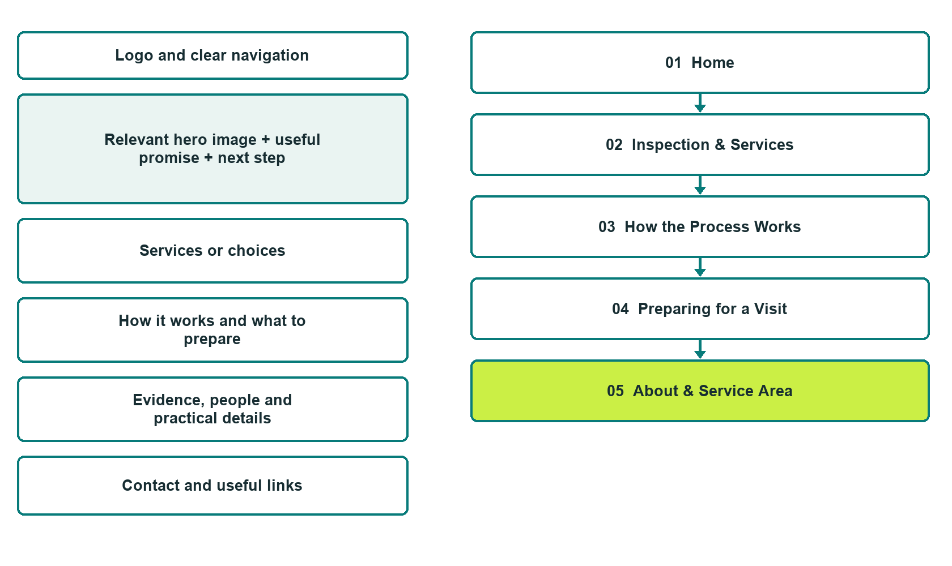

Plan → Draft → Build → Test
Demo-capture edition: actual Website Builder desktop previews and excerpts of the example wording. See each matching mobile preview in the industry page gallery. The example business and its AI-generated photographs are fictional.
Explore Website Builder and compare plans

Before you build
Your business supplies the facts. Prairie Clear Pest Services is a fictional teaching example, not a live service.
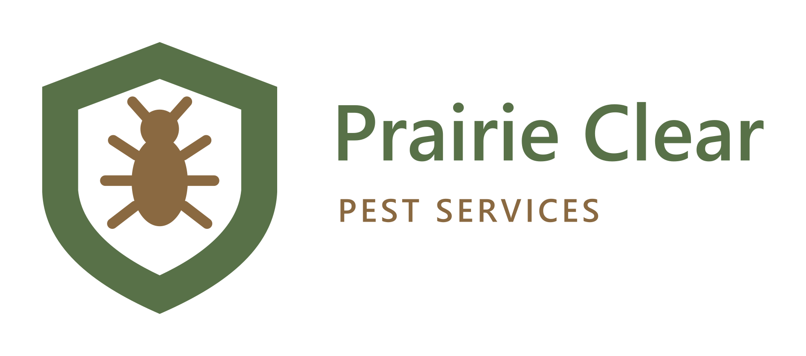
□ Request a pest inspection discussion
□ Verified business identity and current contact information
□ Clear request and confirmation process
□ Choose original photographs and confirm permission to use them.
□ Keep private customer records out of public website forms.

Your audience and the action you want them to take

Facts to verify and people who must approve them
Create your SaaSTech account

01 Home
Give this page one clear job in the customer journey.
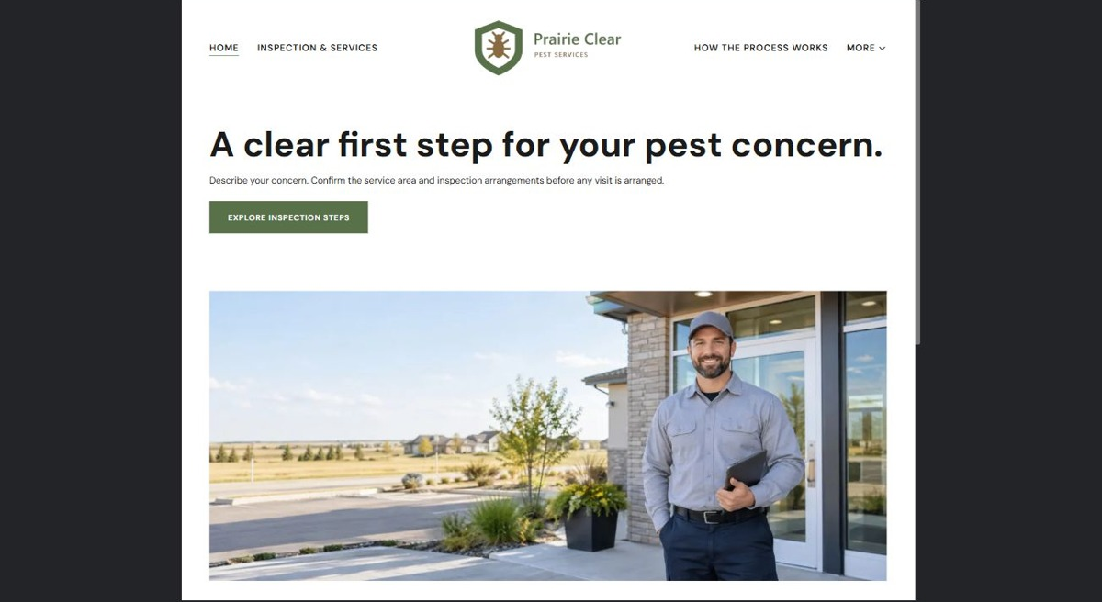
Actual desktop preview - unpublished fictional demonstration

Demo wording excerpt to adapt and verify
A clear first step for your pest concern.
Describe your concern. Confirm the service area and inspection arrangements before any visit is arranged.
Use Inspection & Services to understand the assessment approach. An enquiry starts a discussion; it does not identify the cause or confirm a visit.
Suggested button: Explore inspection steps

Website advice
Explain verified inspection and service categories, what happens next and operator-approved preparation. Avoid identification certainty, pesticide instructions or eradication guarantees.

Your draft: Home
Write in the voice of your own business. Use facts you can verify, not promises copied from the example.

Headline and short introduction

Main content and details visitors need

Button wording and destination

Photo choice, permission and facts still to confirm
Partner check: can someone unfamiliar with the business find a useful next step?

02 Inspection & Services
Give this page one clear job in the customer journey.
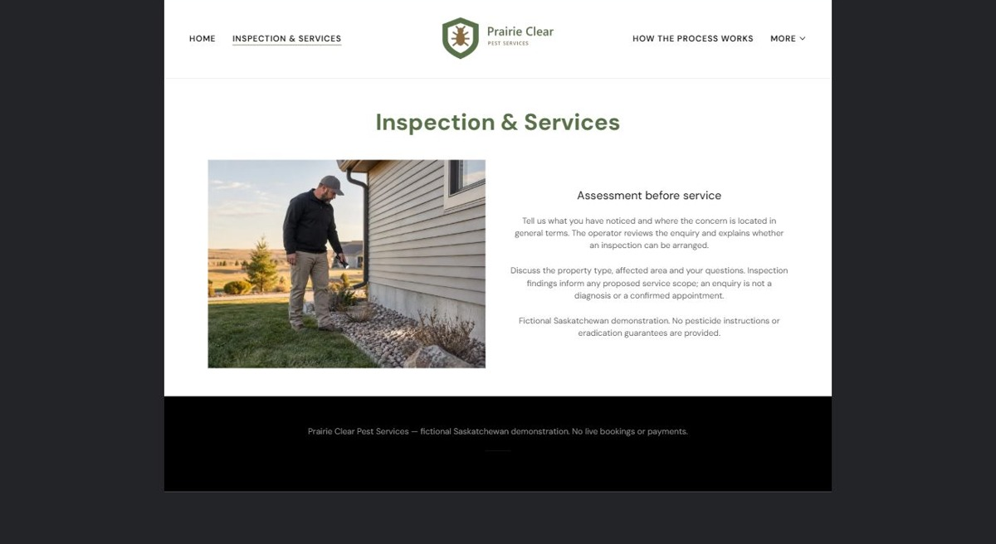
Actual desktop preview - unpublished fictional demonstration

Demo wording excerpt to adapt and verify
Assessment before service
Tell us what you have noticed and where the concern is located in general terms. The operator reviews the enquiry and explains whether an inspection can be arranged.
Discuss the property type, affected area and your questions. Inspection findings inform any proposed service scope; an enquiry is not a diagnosis or a confirmed appointment.
Navigation: guide visitors to the next relevant page; this demo page has no separate enquiry button.

Website advice
Explain the situations the operator accepts and how assessment precedes any service decision.

Your draft: Inspection & Services
Write in the voice of your own business. Use facts you can verify, not promises copied from the example.

Headline and short introduction

Main content and details visitors need

Button wording and destination

Photo choice, permission and facts still to confirm
Partner check: can someone unfamiliar with the business find a useful next step?

03 How the Process Works
Give this page one clear job in the customer journey.
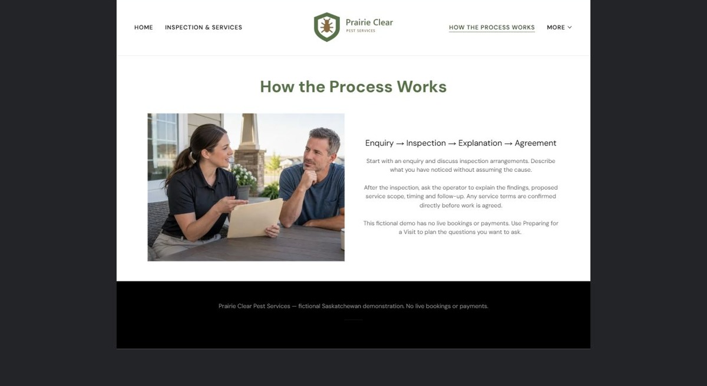
Actual desktop preview - unpublished fictional demonstration

Demo wording excerpt to adapt and verify
Enquiry → Inspection → Explanation → Agreement
Start with an enquiry and discuss inspection arrangements. Describe what you have noticed without assuming the cause.
After the inspection, ask the operator to explain the findings, proposed service scope, timing and follow-up. Any service terms are confirmed directly before work is agreed.
Navigation: guide visitors to the next relevant page; this demo page has no separate enquiry button.

Website advice
Describe contact, inspection, explanation and agreed action without publishing treatment instructions.

Your draft: How the Process Works
Write in the voice of your own business. Use facts you can verify, not promises copied from the example.

Headline and short introduction

Main content and details visitors need

Button wording and destination

Photo choice, permission and facts still to confirm
Partner check: can someone unfamiliar with the business find a useful next step?

04 Preparing for a Visit
Give this page one clear job in the customer journey.
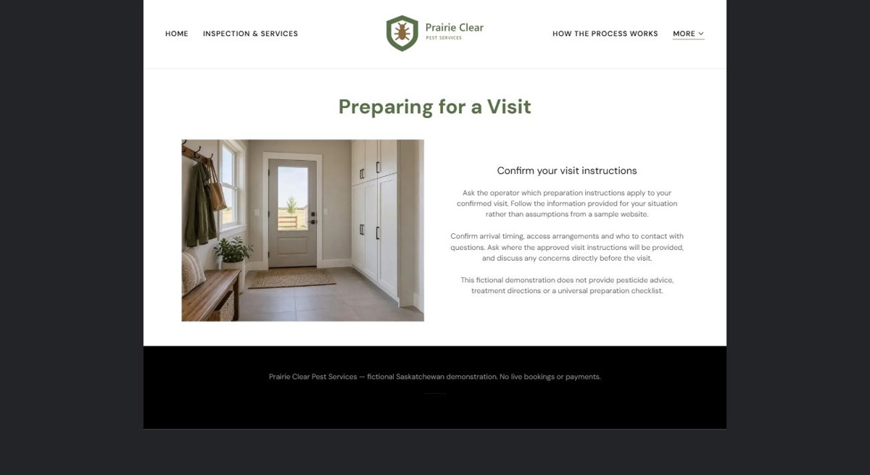
Actual desktop preview - unpublished fictional demonstration

Demo wording excerpt to adapt and verify
Confirm your visit instructions
Ask the operator which preparation instructions apply to your confirmed visit. Follow the information provided for your situation rather than assumptions from a sample website.
Confirm arrival timing, access arrangements and who to contact with questions. Ask where the approved visit instructions will be provided, and discuss any concerns directly before the visit.
Navigation: guide visitors to the next relevant page; this demo page has no separate enquiry button.

Website advice
Publish only preparation instructions approved for the specific service. Avoid generic chemical or animal-safety advice.

Your draft: Preparing for a Visit
Write in the voice of your own business. Use facts you can verify, not promises copied from the example.

Headline and short introduction

Main content and details visitors need

Button wording and destination

Photo choice, permission and facts still to confirm
Partner check: can someone unfamiliar with the business find a useful next step?

05 About & Service Area
Give this page one clear job in the customer journey.
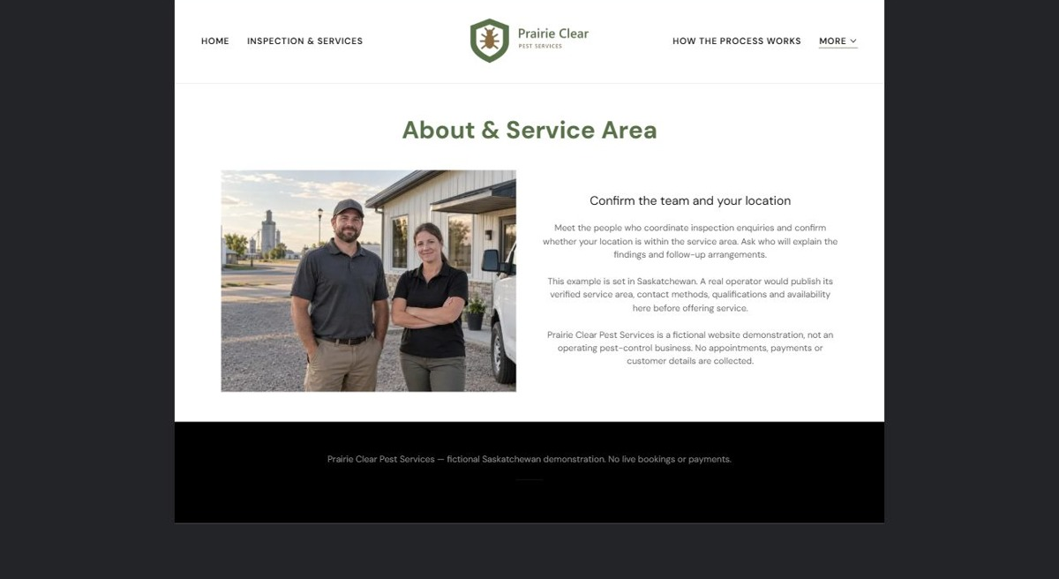
Actual desktop preview - unpublished fictional demonstration

Demo wording excerpt to adapt and verify
Confirm the team and your location
Meet the people who coordinate inspection enquiries and confirm whether your location is within the service area. Ask who will explain the findings and follow-up arrangements.
This example is set in Saskatchewan. A real operator would publish its verified service area, contact methods, qualifications and availability here before offering service.
Navigation: guide visitors to the next relevant page; this demo page has no separate enquiry button.

Website advice
Show verified team credentials and service boundaries without invented certifications.

Your draft: About & Service Area
Write in the voice of your own business. Use facts you can verify, not promises copied from the example.

Headline and short introduction

Main content and details visitors need

Button wording and destination

Photo choice, permission and facts still to confirm
Partner check: can someone unfamiliar with the business find a useful next step?

Test before publishing
Review the whole journey on a desktop and phone. The industry page pairs each desktop capture with its mobile preview and provides the complete sample page copy.
□ No pest diagnosis, chemical-use or safety advice is provided by this fictional guide. Qualified operators must approve all service, preparation, licensing and treatment wording.
□ Verify contact routes, hours, location and every offered service.
□ Remove invented prices, claims, testimonials and availability.
□ Keep sensitive records and payment details out of ordinary public forms.
□ Check all image permissions, downloads and page links on a phone.
□ Check every link, form destination, download and confirmation message.
□ Check logo contrast, hero framing, text sizes and image loading.
□ Save a named backup and assign a content-review date.

Changes to finish and person responsible

Approval and next review date
Website Builder plans and signup

