
WEBSITE PLANNING WORKSHOP

Bands, Musicians & Actors
Website workbook
Plan a clear website for bands, musicians & actors. Explore a worked example, shape your own message and prepare to build with SaaSTech Servers.
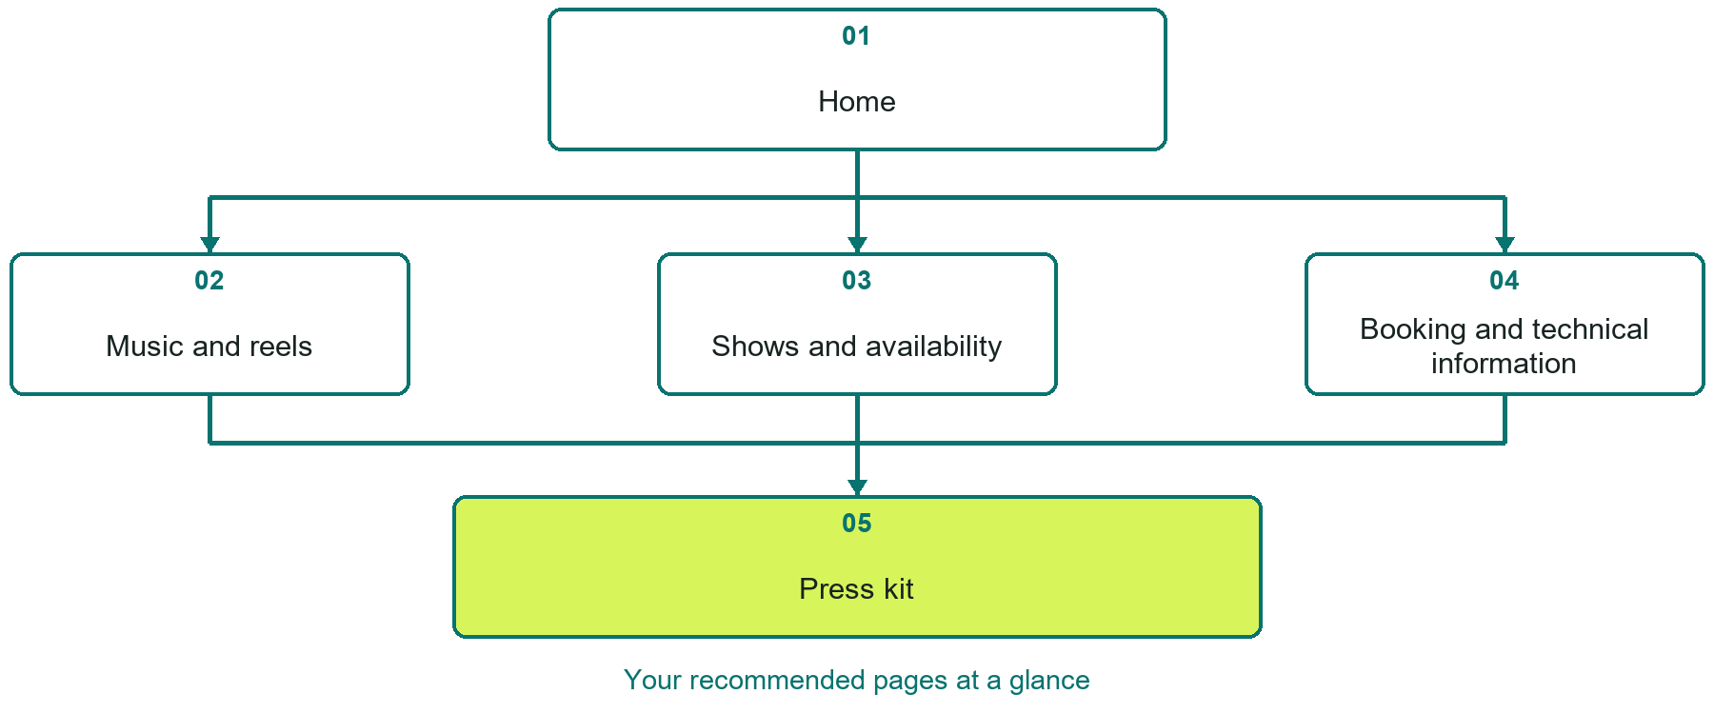

Inside this workbook
Five page examples • Practical writing exercises • A launch review
Use it in a workshop or at your own pace. Write by hand or complete the response fields in Word. The final page links to Website Builder, plans and account signup.
Example business Northern Stage Collective

BANDS, MUSICIANS & ACTORS

Your website brief
A SaaSTech Servers workshop for bands, musicians & actors. Plan your website, learn from the Northern Stage Collective example and draft content for your own business.
Each page has a reference sheet followed by a writing sheet. Demo excerpts are labelled separately from new sample wording, which may differ from the screenshot. Click a blank response line to type; longer answers may add pages. Replace fictional details and verify every claim before publishing.
Your business or organization and workshop date

Who should visit your site and what do they need

The main action you want a visitor to take

What you offer and where or how you provide it

Facts photos and permissions to gather before publishing

Workshop rhythm: review the example, write your draft and exchange feedback. Use the final review to choose your next changes. Website Builder and account links are on the last page.

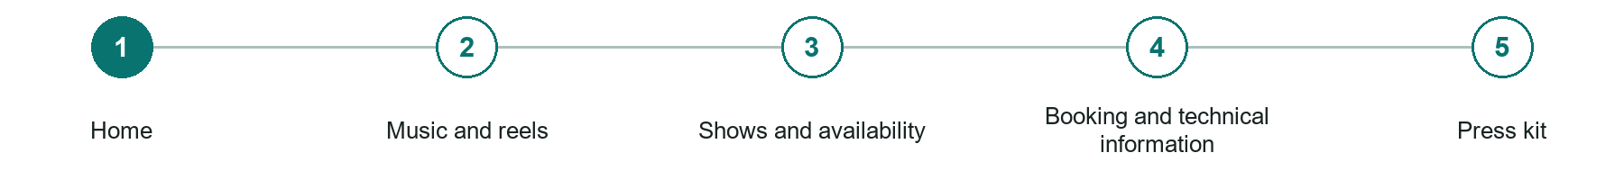
LOOK AND LEARN

Home

The job of this page
Introduce the performance style, coordinated logo and hero, audience fit, and a direct booking action. Add a featured reel only when rights-cleared recordings are ready.
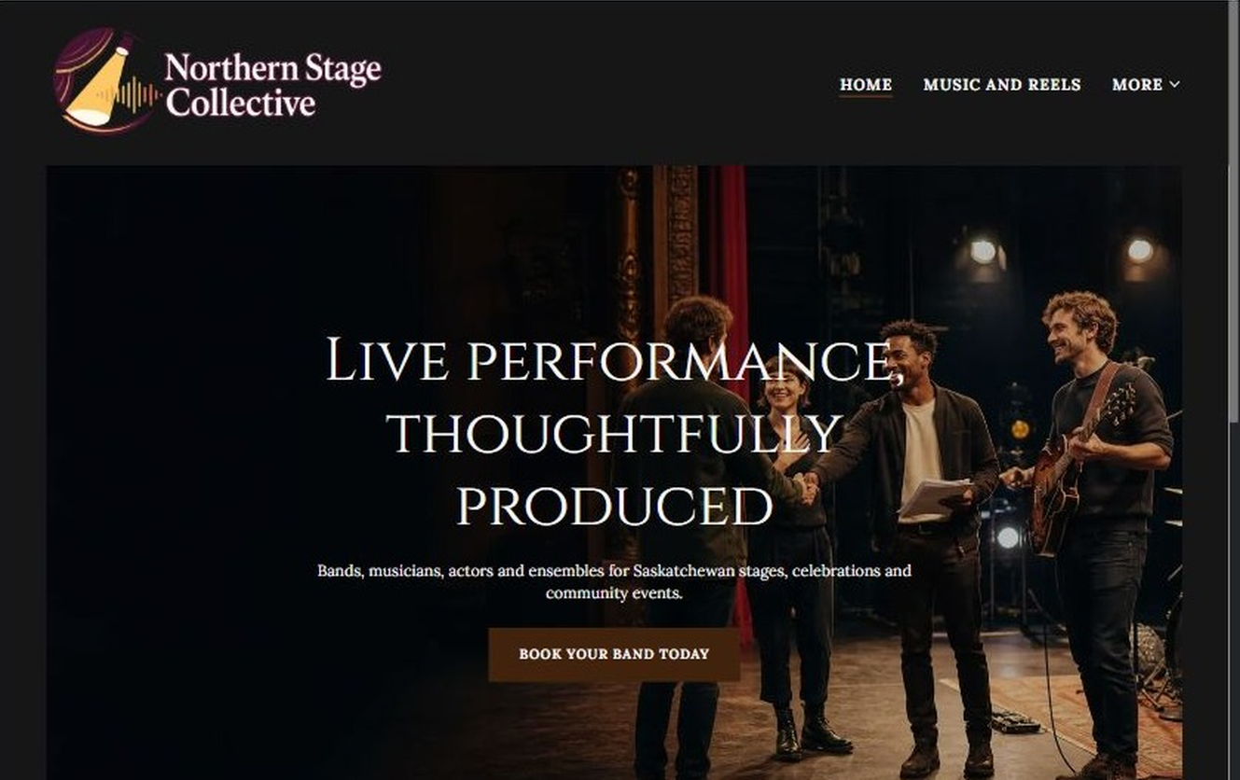
Northern Stage Collective example | Explore SaaSTech Website Builder

Sample wording to adapt
Live performance, thoughtfully produced
Bands, musicians, actors and ensembles for Saskatchewan stages, celebrations and community events. Explore the formats, check availability and request a booking proposal.

Pause and plan
Could a first-time visitor explain what you do and who it is for after one glance? Choose one main action and the strongest truthful detail that gives them confidence to continue.

WRITE YOUR PAGE

Home
Write for your visitor. Be specific about what they need to know and what happens next. You can revise the wording after the workshop.
Your page headline

Your opening paragraph

Your offer audience location and most useful supporting details

Button or link wording and where it should lead

Photo idea caption and permission or credit needed

Facts to verify or questions to resolve

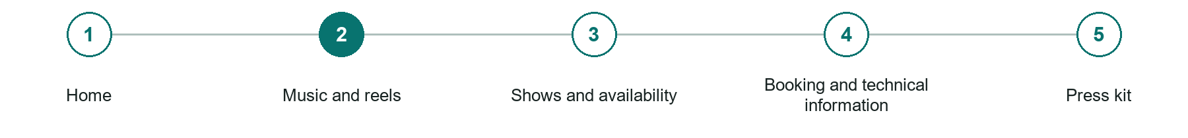
LOOK AND LEARN

Music and reels

The job of this page
Explain acoustic, ensemble and storytelling formats. Publish approved recordings and accurate credits when available; clearly label demonstration content.
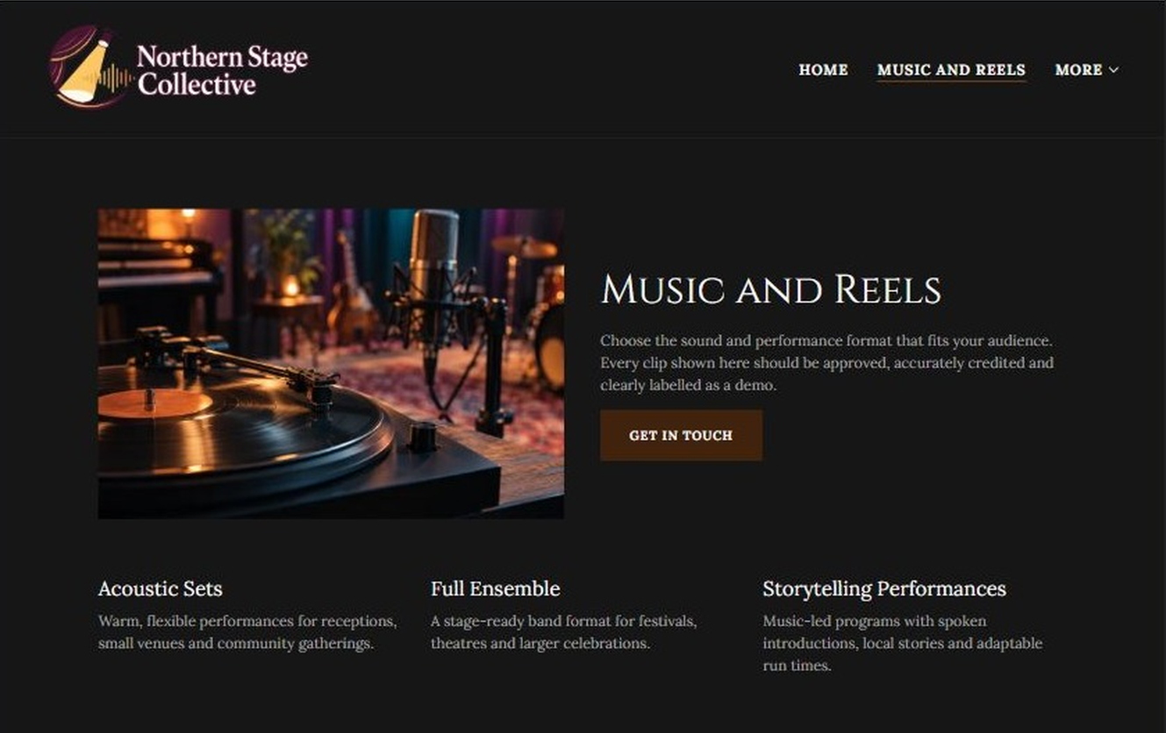
Northern Stage Collective example | Explore SaaSTech Website Builder

Sample wording to adapt
Music and Reels
Choose the sound and performance format that fits your audience. Every clip should be approved, accurately credited and clearly labelled as a demo.

Pause and plan
Which examples best support this page? Explain the context, your contribution and the permissions or credits needed. Label illustrative work and distinguish it from genuine completed projects or customer results.

WRITE YOUR PAGE

Music and reels
Write for your visitor. Be specific about what they need to know and what happens next. You can revise the wording after the workshop.
Your page headline

Your opening paragraph

Examples captions context and evidence to include

Button or link wording and where it should lead

Photo idea caption and permission or credit needed

Facts to verify or questions to resolve

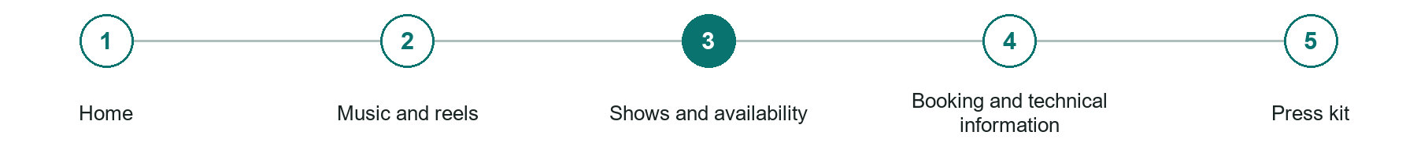
LOOK AND LEARN

Shows and availability

The job of this page
State whether dates are announced, explain the service region and booking windows, and keep venue, ticket and cancellation details current.
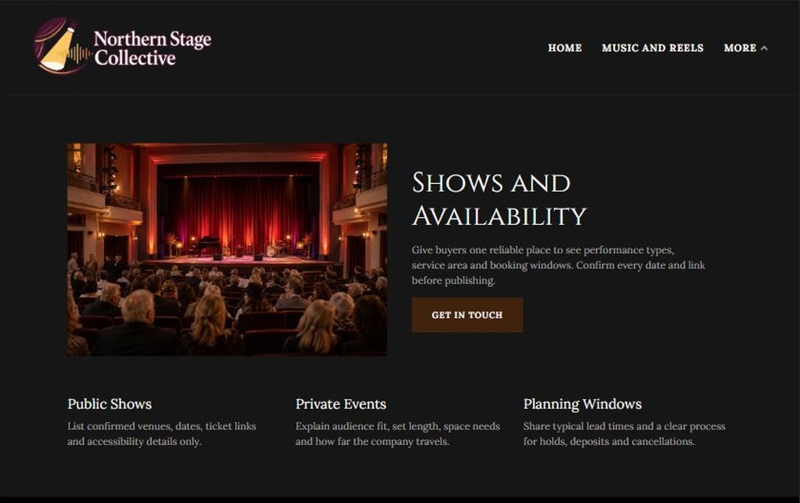
Northern Stage Collective example | Explore SaaSTech Website Builder

Sample wording to adapt
Shows and Availability
Give buyers one reliable place to see performance types, service area and booking windows. Confirm every date and link before publishing.

Pause and plan
Which dates and locations need to stay current? Decide who will update changes and where visitors should check before travelling. Separate archived information and illustrative schedules from current availability.

WRITE YOUR PAGE

Shows and availability
Write for your visitor. Be specific about what they need to know and what happens next. You can revise the wording after the workshop.
Your page headline

Your opening paragraph

Dates locations update process and participation details

Button or link wording and where it should lead

Photo idea caption and permission or credit needed

Facts to verify or questions to resolve

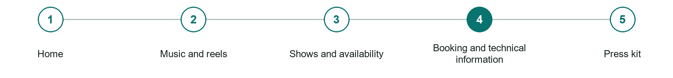
LOOK AND LEARN

Booking and technical information

The job of this page
Explain stage, sound, travel and agreement requirements. Ask for date, location, audience, format, duration and budget in the enquiry form.
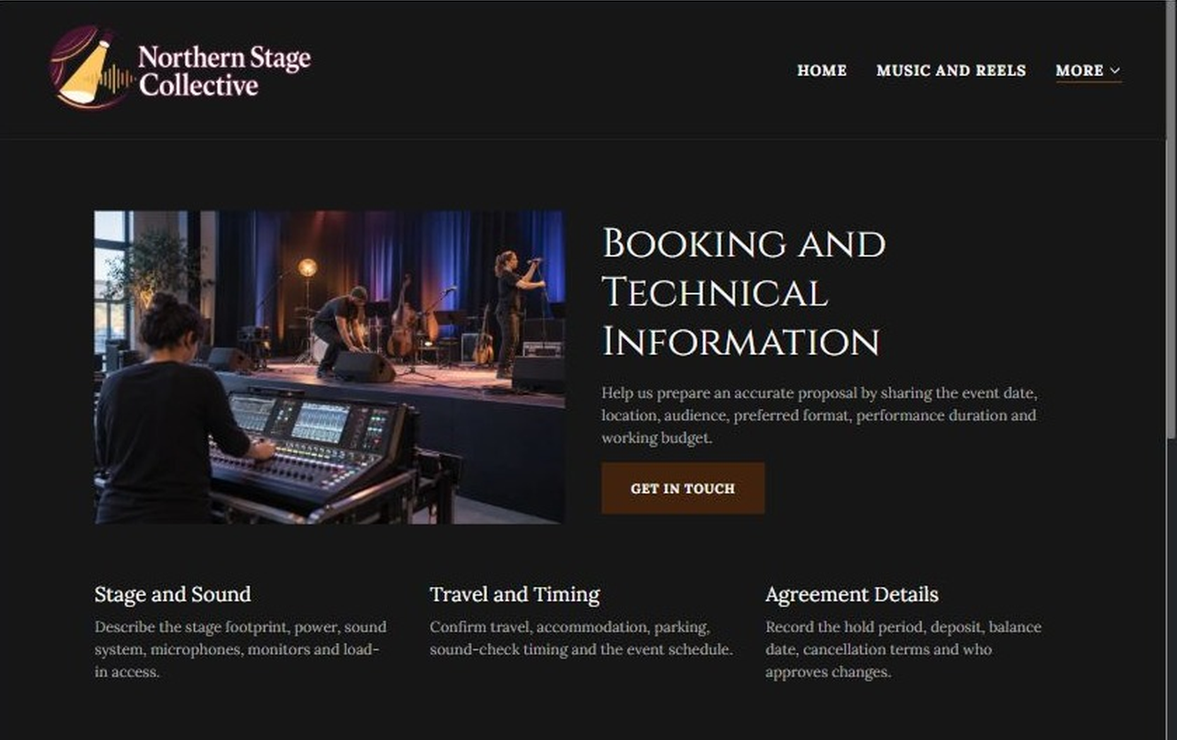
Northern Stage Collective example | Explore SaaSTech Website Builder

Sample wording to adapt
Request a booking proposal
Share the event date, location, audience size, performance format, approximate duration and working budget. The company then confirms availability and the next planning steps.

Pause and plan
What must someone provide, and what happens after they send it? Separate a request from a confirmed booking, order or place. Decide what information should stay out of a public form.

WRITE YOUR PAGE

Booking and technical information
Write for your visitor. Be specific about what they need to know and what happens next. You can revise the wording after the workshop.
Your page headline

Your opening paragraph

Information to request and how you will reply or confirm

Button or link wording and where it should lead

Photo idea caption and permission or credit needed

Facts to verify or questions to resolve

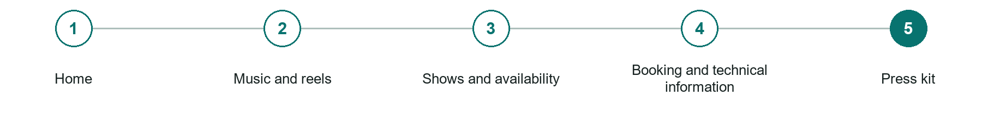
LOOK AND LEARN

Press kit

The job of this page
Provide a short biography, promotional-asset guidance, media contacts and permissions. Add downloads or a shop only when approved assets and real products are ready.
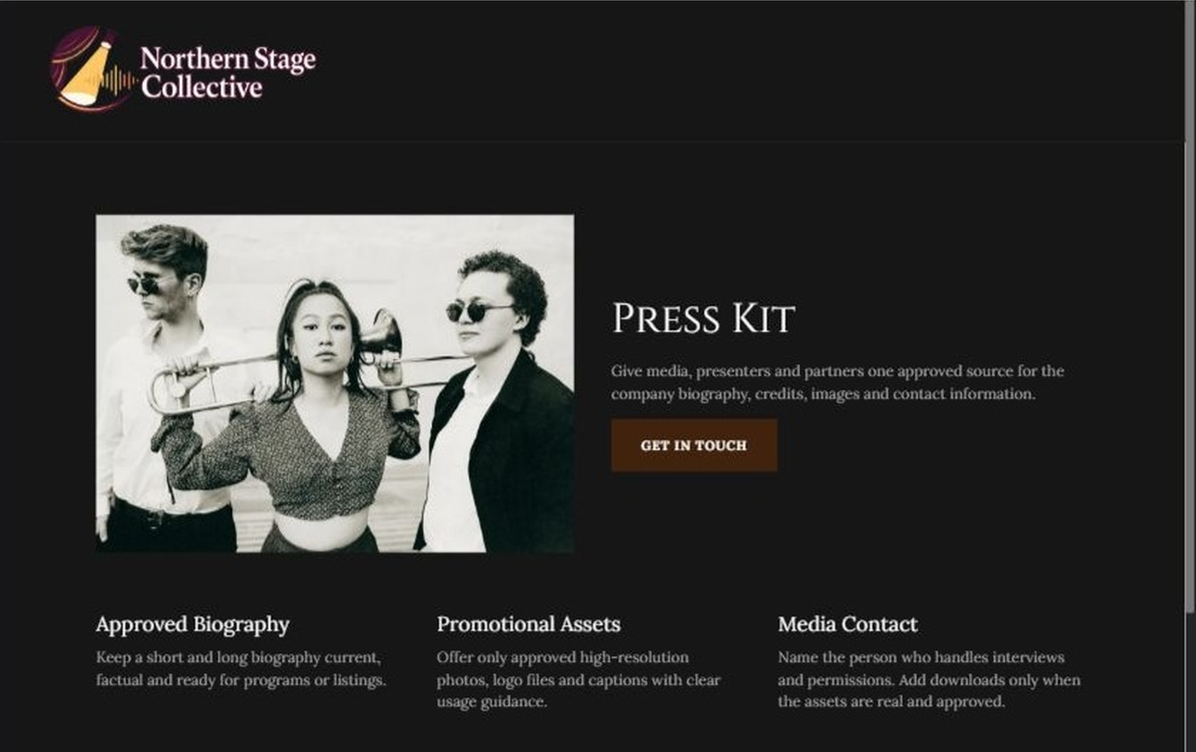
Northern Stage Collective example | Explore SaaSTech Website Builder

Sample wording to adapt
Press Kit
Give media, presenters and partners one approved source for the company biography, credits, images and contact information. Use only approved photographs and supplied credits.

Pause and plan
Which examples best support this page? Explain the context, your contribution and the permissions or credits needed. Label illustrative work and distinguish it from genuine completed projects or customer results.

WRITE YOUR PAGE

Press kit
Write for your visitor. Be specific about what they need to know and what happens next. You can revise the wording after the workshop.
Your page headline

Your opening paragraph

Examples captions context and evidence to include

Button or link wording and where it should lead

Photo idea caption and permission or credit needed

Facts to verify or questions to resolve

WORKSHOP CLOSE

Review and next steps
Ask a partner to read your draft as a first-time visitor. Can they explain what you offer, who it is for and the next step without extra help?

Before you publish
[ ] Every page has a clear purpose and a useful next step.
[ ] Headlines are specific and the wording sounds like your business.
[ ] Names, service areas, prices, dates and policies have been checked.
[ ] Credentials, testimonials and results are genuine and permission-cleared.
[ ] Photos support the text, do not repeat needlessly and have appropriate permissions.
[ ] Forms ask only for necessary information and explain what happens next.
[ ] Links, downloads and the main visitor task work on a phone.
The most useful feedback from your workshop partner

First change to make and who will do it

Information or photographs still needed

Target review date and who will approve the final content

Keep sensitive customer, patient, employee and payment information out of this workbook. Completing it does not publish a website or connect to Website Builder.

BUILD WITH SAASTECH SERVERS

Put your draft into Website Builder
Use the content you have written to build your own site. Keep the bands, musicians & actors demo as a reference, and replace its company name, images and claims with your verified business information.

Explore the builder
See the editor, compare available plans and decide which features your business needs. Confirm current pricing and terms before purchasing.
Website Builder overview

Create your account
Set up your SaaSTech Servers customer account using your own details. Creating an account is separate from purchasing a Website Builder plan.
Create your SaaSTech account

Choose your plan
Open the secure shop to review the plan, subscription term and final total. Use the account connected to your purchase when you open your service.
View Website Builder plans

Build and check your pages
Add the pages from this workbook. Transfer your approved wording, upload permission-cleared photos and review each page on desktop and mobile before publishing.
Return to the Website Builder guide

Using a printed workbook
Type these short addresses into your browser. The account guide includes the Create My Account button.
www.saastech.net/products/website-builder
www.saastech.net/create-account
This workbook does not create an account, purchase a plan or publish your website. Keep passwords, payment details and confidential customer information out of your draft.

