

Outdoor Outfitters & Guide Services
Website workbook
A practical workshop for a 6-page website. Study the example, plan the content and draft your own version in Word or on paper.
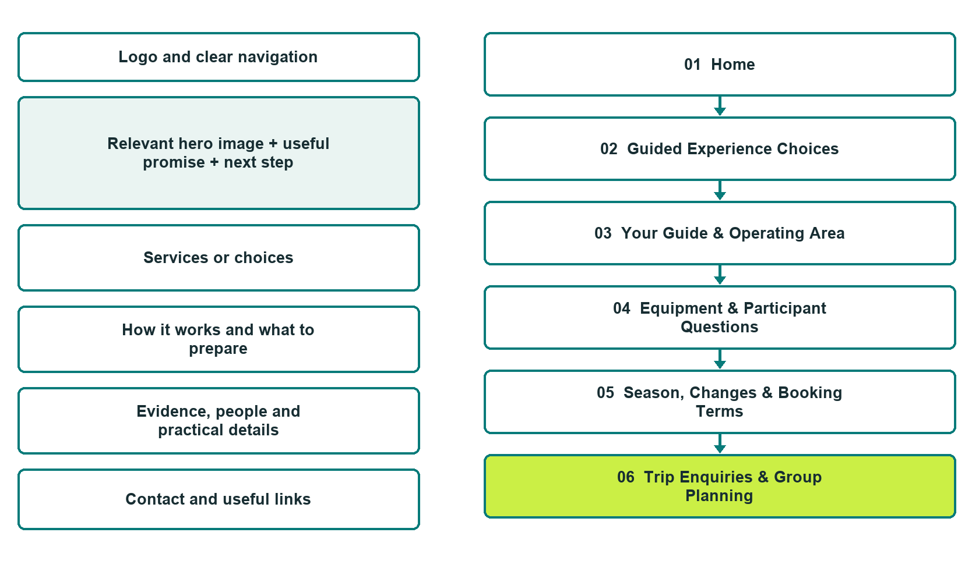

Plan → Draft → Build → Test
Captured demo edition. Study the unpublished six-page example. Desktop and mobile pairs, Editor Highlights, Themes and Paint settings appear in the industry gallery.
Explore Website Builder and compare plans

Before you build
Your business supplies the facts. Prairie Horizon Outfitters is a fictional teaching example. Keep the demo unpublished, with no fabricated contact details, bookings or payments. Do not submit the demo form.

□ Discuss a guided outing
□ Verified business identity, services and current contact information
□ A clear enquiry, review and confirmation process
□ Choose original photographs and confirm permission to use them.
□ Keep private customer records out of public website forms.

Your audience and the action you want them to take

Facts to verify and people who must approve them
Create your SaaSTech account

01 Home
Give this page one clear job in the customer journey.
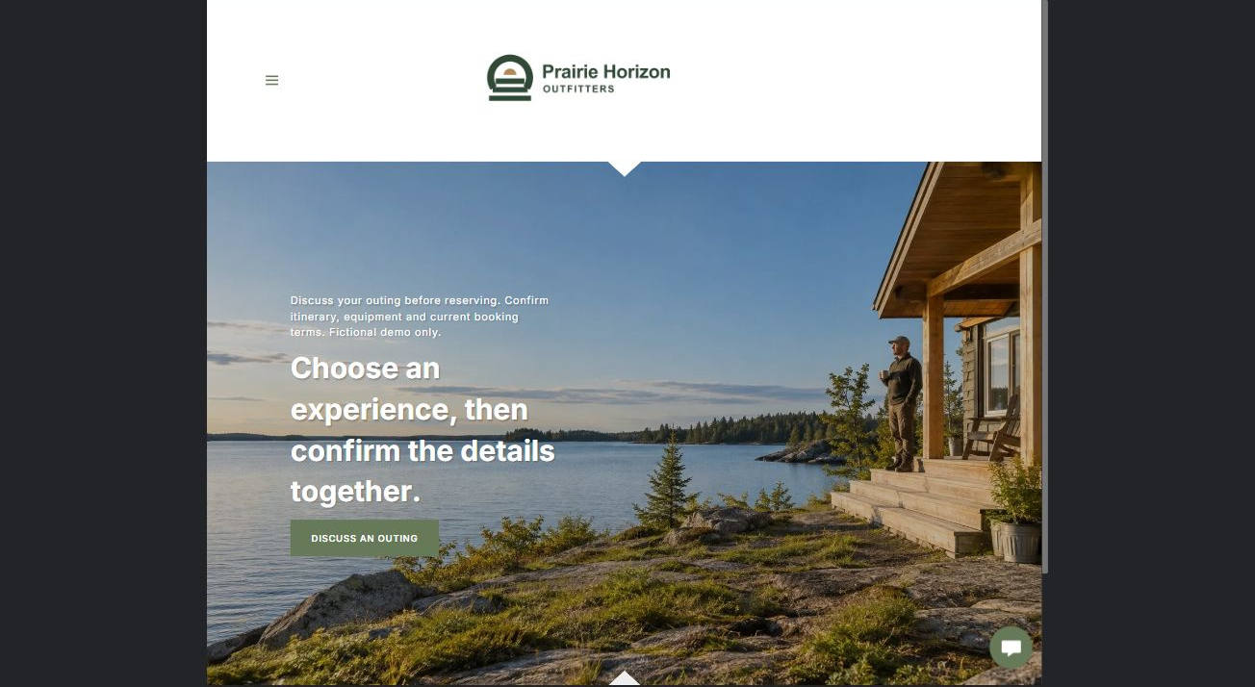
Actual desktop Website Builder preview. The industry gallery includes its paired mobile view.

Sample wording — adapt and verify
Choose an experience, then confirm the details together.
Explore the types of outings the operator offers and the questions to ask before reserving.
The guide confirms the actual itinerary, suitability conversation, conditions-dependent arrangements and booking terms for each proposed experience.
Home button: Discuss an outing. Link to Trip Enquiries.

Website advice
Present operator-verified guided experiences, suitability conversations, equipment arrangements and booking steps without promising conditions or unverified permits.

Your draft: Home
Write in the voice of your own business. Use facts you can verify, not promises copied from the example.

Headline and short introduction

Main content and details visitors need

Button wording and destination

Photo choice, permission and facts still to confirm
Partner check: can someone unfamiliar with the business find a useful next step?

02 Guided Experience Choices
Give this page one clear job in the customer journey.
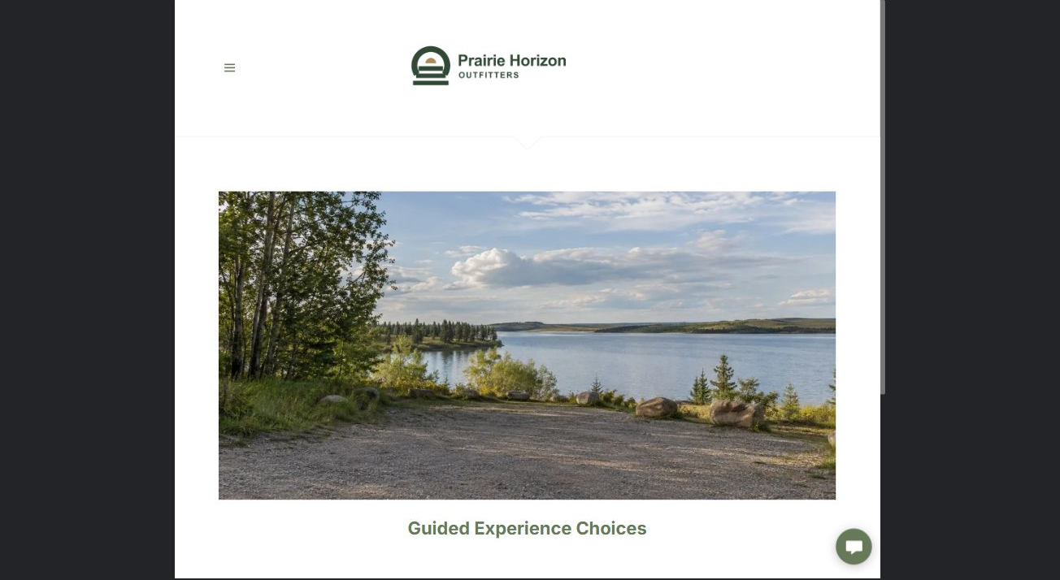
Actual desktop Website Builder preview. The industry gallery includes its paired mobile view.

Sample wording — adapt and verify
Guided Experience Choices
Compare the general setting, format and duration of the experiences you want to discuss.
The operator confirms which outings are currently offered and explains how an example differs from the itinerary proposed for your group.
Suggested button: Discuss a guided outing

Website advice
Describe distinct operator-approved outing categories and make itinerary examples explicitly illustrative.

Your draft: Guided Experience Choices
Write in the voice of your own business. Use facts you can verify, not promises copied from the example.

Headline and short introduction

Main content and details visitors need

Button wording and destination

Photo choice, permission and facts still to confirm
Partner check: can someone unfamiliar with the business find a useful next step?

03 Your Guide & Operating Area
Give this page one clear job in the customer journey.
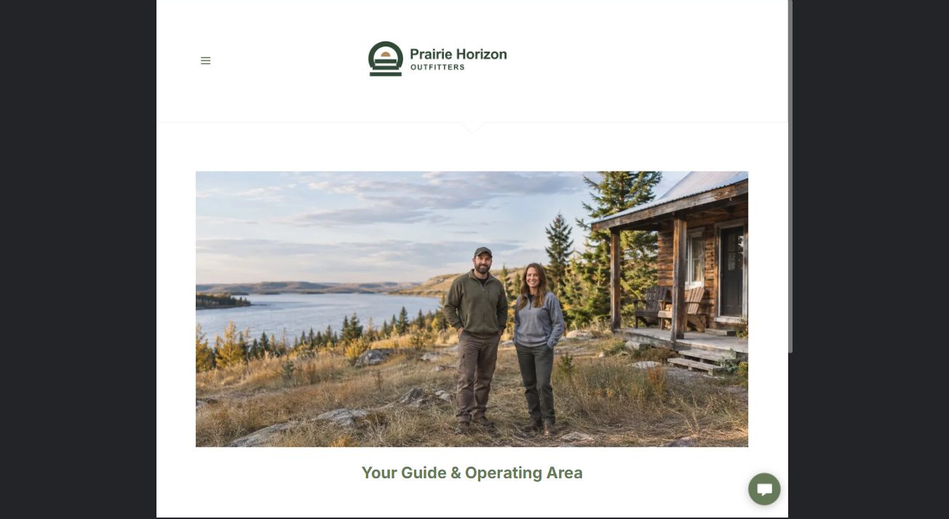
Actual desktop Website Builder preview. The industry gallery includes its paired mobile view.

Sample wording — adapt and verify
Your Guide & Operating Area
Meet the guides and ask about their role in your proposed outing.
Confirm the operating area and which permissions or arrangements apply to that experience rather than assuming public access from a landscape photograph.
Suggested button: Discuss a guided outing

Website advice
Publish verified guide identities and operating boundaries without invented qualifications or access rights.

Your draft: Your Guide & Operating Area
Write in the voice of your own business. Use facts you can verify, not promises copied from the example.

Headline and short introduction

Main content and details visitors need

Button wording and destination

Photo choice, permission and facts still to confirm
Partner check: can someone unfamiliar with the business find a useful next step?

04 Equipment & Participant Questions
Give this page one clear job in the customer journey.
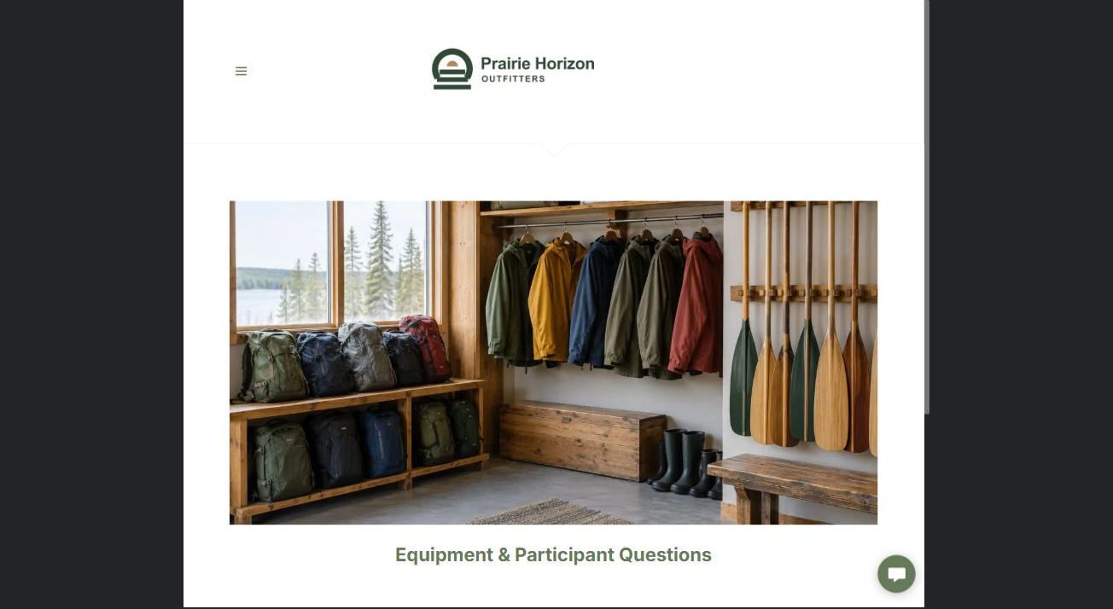
Actual desktop Website Builder preview. The industry gallery includes its paired mobile view.

Sample wording — adapt and verify
Equipment & Participant Questions
Ask for the outing-specific list of what is supplied and what participants are expected to arrange.
The guide handles suitability and any private participant questions directly before a place is confirmed.
Suggested button: Discuss a guided outing

Website advice
Separate supplied equipment, rental enquiries and participant requirements; do not give selection or use instructions.

Your draft: Equipment & Participant Questions
Write in the voice of your own business. Use facts you can verify, not promises copied from the example.

Headline and short introduction

Main content and details visitors need

Button wording and destination

Photo choice, permission and facts still to confirm
Partner check: can someone unfamiliar with the business find a useful next step?

05 Season, Changes & Booking Terms
Give this page one clear job in the customer journey.
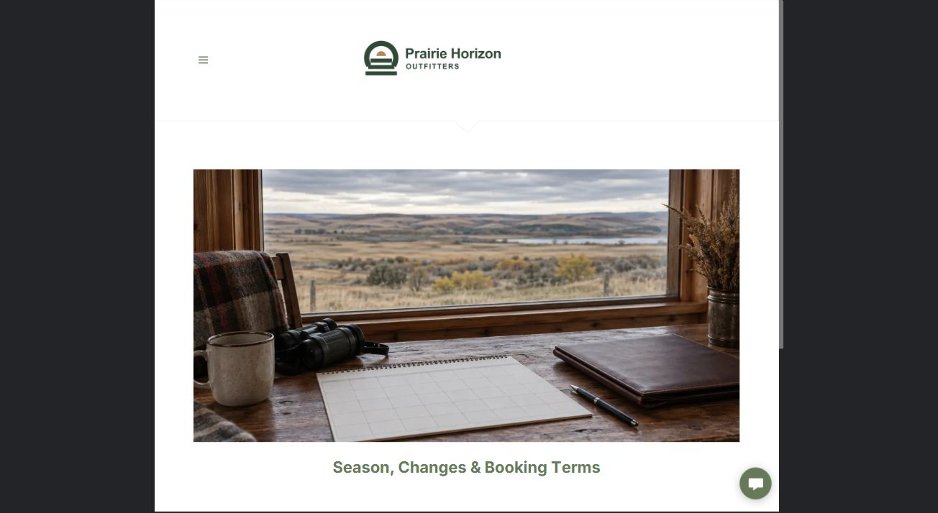
Actual desktop Website Builder preview. The industry gallery includes its paired mobile view.

Sample wording — adapt and verify
Season, Changes & Booking Terms
Discuss your preferred dates and ask how proposed plans may change with operating conditions.
Read the current change and cancellation terms before accepting, and confirm which details will appear in the final booking information.
Suggested button: Discuss a guided outing

Website advice
Explain requested dates, conditions-dependent plans, cancellation terms and written confirmation without weather assurances.

Your draft: Season, Changes & Booking Terms
Write in the voice of your own business. Use facts you can verify, not promises copied from the example.

Headline and short introduction

Main content and details visitors need

Button wording and destination

Photo choice, permission and facts still to confirm
Partner check: can someone unfamiliar with the business find a useful next step?

06 Trip Enquiries & Group Planning
Give this page one clear job in the customer journey.
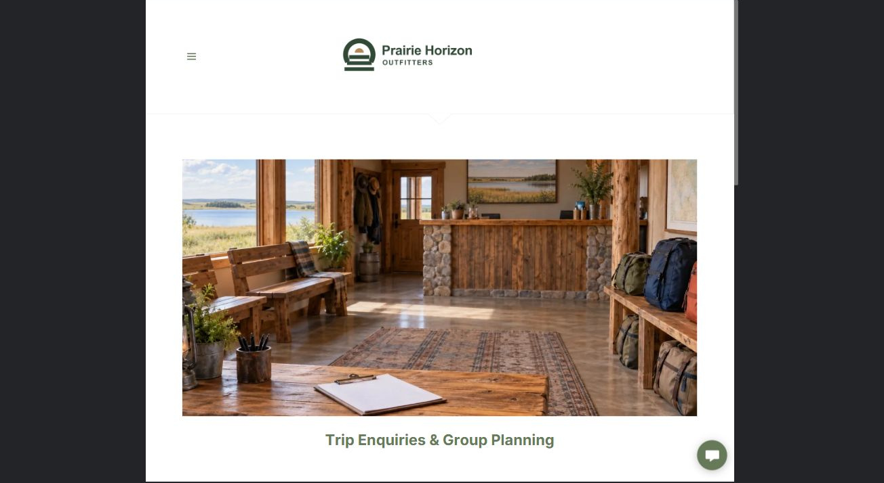
Actual desktop Website Builder preview. The industry gallery includes its paired mobile view.

Sample wording — adapt and verify
Trip Enquiries & Group Planning
Tell the coordinator the experience that interests you, approximate group size and preferred period.
Do not send health details, identity documents or children’s information through the public form; any necessary private intake follows the operator’s approved process.
Suggested button: Discuss a guided outing

Website advice
The demo form has Name, required Email, required Experience interest, and optional Group size & preferred period. Phone and attachments are off; the recipient is blank. No submission or delivery test was performed. Do not request health details, identity documents or private child information. An enquiry does not reserve an outing. Configure delivery and consent before any real launch.

Your draft: Trip Enquiries & Group Planning
Write in the voice of your own business. Use facts you can verify, not promises copied from the example.

Headline and short introduction

Main content and details visitors need

Button wording and destination

Photo choice, permission and facts still to confirm
Partner check: can someone unfamiliar with the business find a useful next step?

Test before publishing
Review the captured journey on desktop and phone. This fictional demo is unpublished. Verify guide roles, operating permissions, booking terms and form delivery before a real launch.
□ Fictional demonstration only. Verify guide roles, permits, operating areas, season, equipment and booking policies before publication. No route, survival, medical, wildlife-handling or safety instructions; do not imply guaranteed wildlife sightings, conditions or accessibility. Private participant information must use an approved intake route.
□ Verify every service description, contact route and operating detail.
□ Replace fictional identity and example information before a live launch.
□ Visually check the demonstration form, links and downloads on desktop and mobile without submitting the form.
□ Keep confidential records in approved private systems.
□ Obtain operator approval for public wording and images.
□ Confirm the intended private form recipient before launch. Keep attachments off and review the confirmation message; an enquiry must not imply a booking or accepted order.
□ Check logo contrast, hero framing, text sizes and image loading.
□ Save a named backup and assign a content-review date.

Changes to finish and person responsible

Approval and next review date
Website Builder plans and signup

