

Optometrists & Optical Stores
Website workbook
A practical workshop for a 6-page website. Study the example, plan the content and draft your own version in Word or on paper.
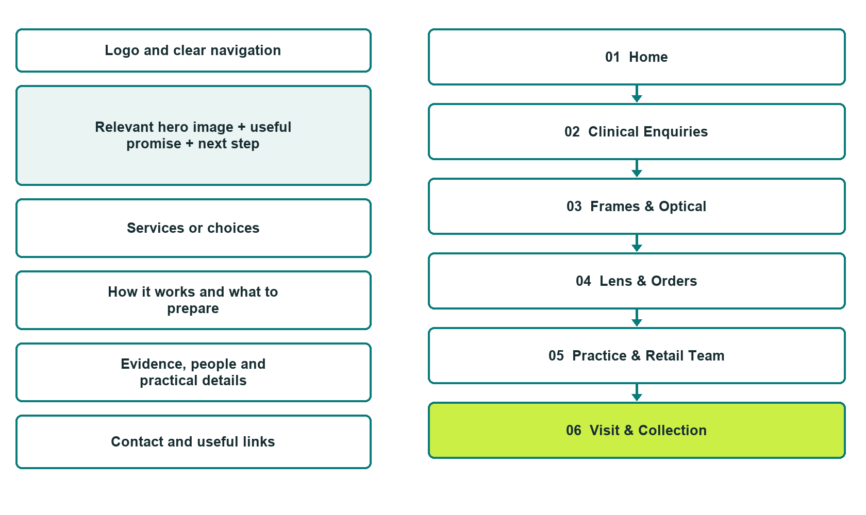

Plan → Draft → Build → Test
Demo-capture edition: actual Website Builder desktop previews and clearly labelled sample wording to adapt. See each matching mobile preview in the industry page gallery. The example business and its AI-generated photographs are fictional.
Explore Website Builder and compare plans

Before you build
Your business supplies the facts. Prairie Window Eye & Optical is a fictional teaching example, not a live service.

□ Choose an appointment or eyewear enquiry
□ Verified business identity, services and current contact information
□ A clear enquiry, review and confirmation process
□ Choose original photographs and confirm permission to use them.
□ Keep private customer records out of public website forms.

Your audience and the action you want them to take

Facts to verify and people who must approve them
Create your SaaSTech account

01 Home
Give this page one clear job in the customer journey.
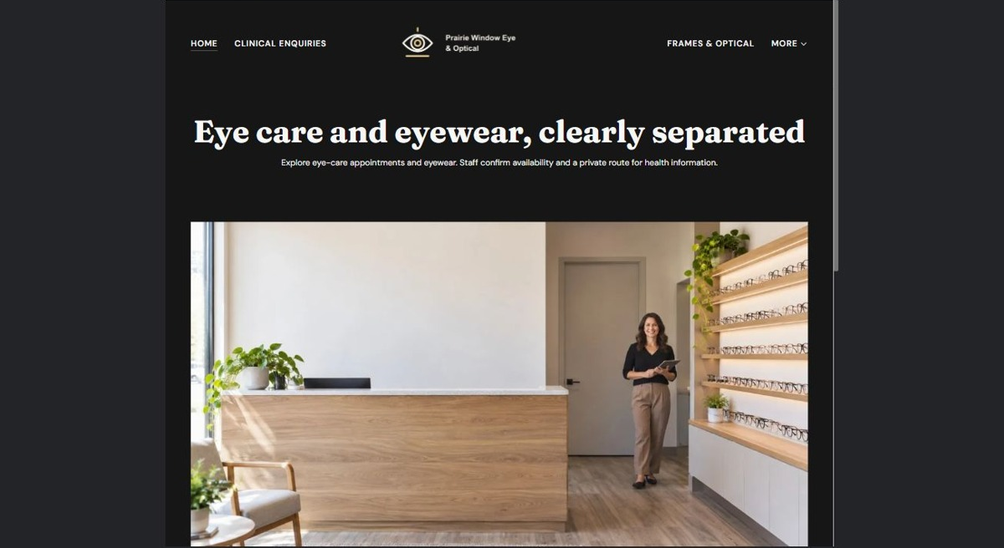
Actual desktop preview - unpublished fictional demonstration

Sample wording — adapt and verify
Two clear paths: eye-care appointments and eyewear browsing.
Choose the appointment pathway for practice enquiries or the optical pathway for frames and retail arrangements.
Staff confirms who can handle your question and how private information should be provided.
Suggested button: Choose an appointment or eyewear enquiry

Website advice
Separate clinical appointment coordination from retail frame, lens and order enquiries, with verified professional roles and private clinical information handling.

Your draft: Home
Write in the voice of your own business. Use facts you can verify, not promises copied from the example.

Headline and short introduction

Main content and details visitors need

Button wording and destination

Photo choice, permission and facts still to confirm
Partner check: can someone unfamiliar with the business find a useful next step?

02 Clinical Enquiries
Give this page one clear job in the customer journey.
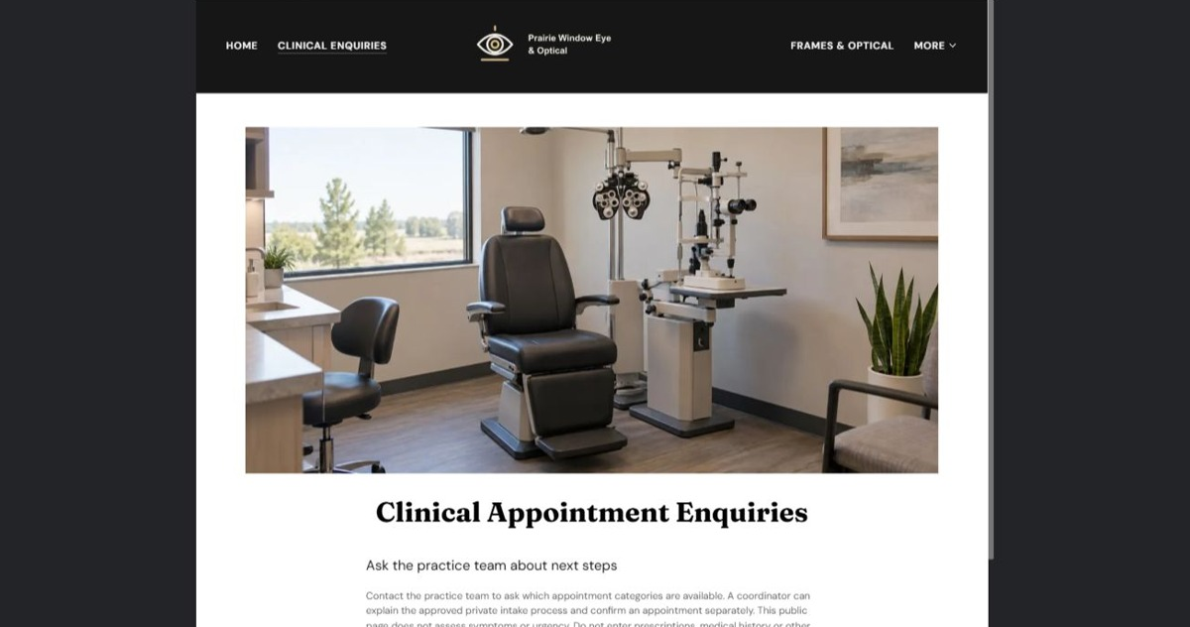
Actual desktop preview - unpublished fictional demonstration

Sample wording — adapt and verify
Clinical Appointment Enquiries
Contact the practice team to ask which appointment categories are available.
The coordinator explains the private intake process and confirms an appointment separately; this website does not assess symptoms or urgency.
Suggested button: Choose an appointment or eyewear enquiry

Website advice
Explain access to verified practice services without performing triage or collecting clinical details publicly.

Your draft: Clinical Enquiries
Write in the voice of your own business. Use facts you can verify, not promises copied from the example.

Headline and short introduction

Main content and details visitors need

Button wording and destination

Photo choice, permission and facts still to confirm
Partner check: can someone unfamiliar with the business find a useful next step?

03 Frames & Optical
Give this page one clear job in the customer journey.
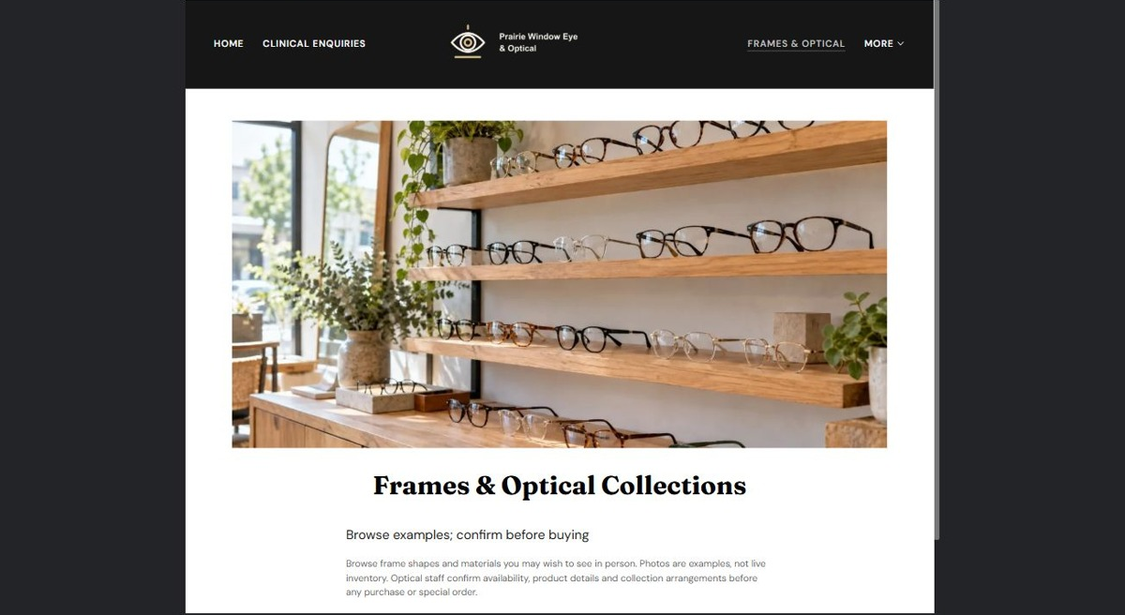
Actual desktop preview - unpublished fictional demonstration

Sample wording — adapt and verify
Frames & Optical Collections
Browse frame styles and note the shapes or materials you would like to see in person.
Displayed examples are not live stock, and staff confirms availability and the relevant product details before purchase.
Suggested button: Choose an appointment or eyewear enquiry

Website advice
Present eyewear as a retail collection, with fit and product questions handled by the appropriate staff.

Your draft: Frames & Optical
Write in the voice of your own business. Use facts you can verify, not promises copied from the example.

Headline and short introduction

Main content and details visitors need

Button wording and destination

Photo choice, permission and facts still to confirm
Partner check: can someone unfamiliar with the business find a useful next step?

04 Lens & Orders
Give this page one clear job in the customer journey.
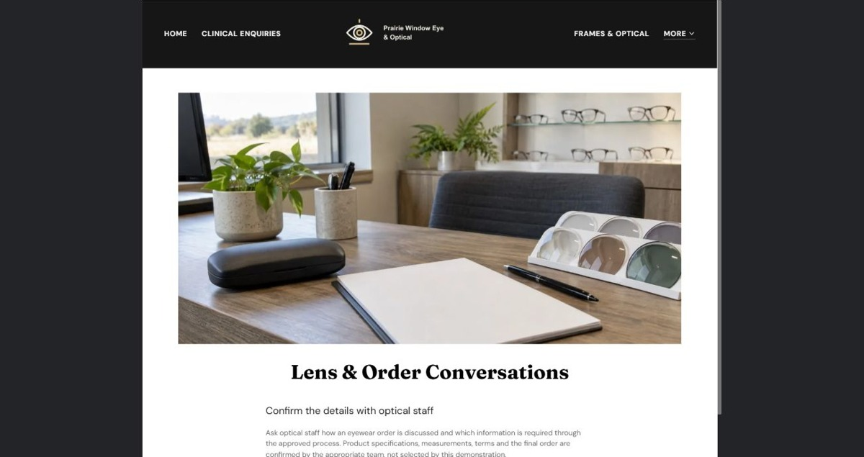
Actual desktop preview - unpublished fictional demonstration

Sample wording — adapt and verify
Lens & Order Conversations
Ask optical staff how an eyewear order is discussed and which information is required through the approved process.
Product specifications, measurements, terms and the final order are confirmed by the appropriate team, not selected by this demonstration.
Suggested button: Choose an appointment or eyewear enquiry

Website advice
Keep retail specification and order coordination separate from clinical advice or prescription interpretation.

Your draft: Lens & Orders
Write in the voice of your own business. Use facts you can verify, not promises copied from the example.

Headline and short introduction

Main content and details visitors need

Button wording and destination

Photo choice, permission and facts still to confirm
Partner check: can someone unfamiliar with the business find a useful next step?

05 Practice & Retail Team
Give this page one clear job in the customer journey.
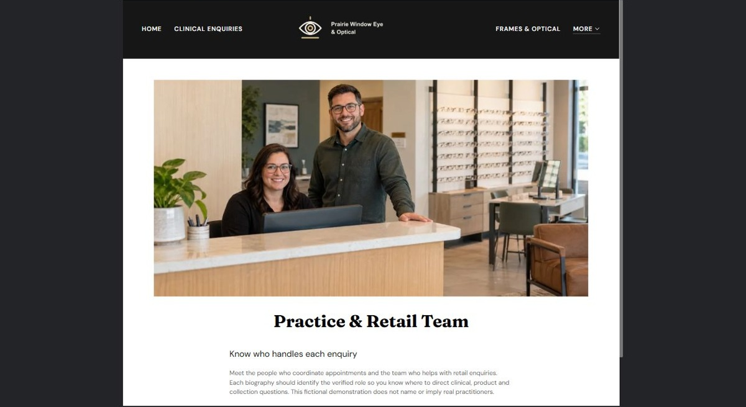
Actual desktop preview - unpublished fictional demonstration

Sample wording — adapt and verify
Practice & Retail Team
Meet the people who coordinate appointments and the team who helps with retail enquiries.
Each biography should identify the verified role so you know where to direct clinical, product and collection questions.
Suggested button: Choose an appointment or eyewear enquiry

Website advice
Identify verified clinical professionals and optical retail roles distinctly, without invented qualifications.

Your draft: Practice & Retail Team
Write in the voice of your own business. Use facts you can verify, not promises copied from the example.

Headline and short introduction

Main content and details visitors need

Button wording and destination

Photo choice, permission and facts still to confirm
Partner check: can someone unfamiliar with the business find a useful next step?

06 Visit & Collection
Give this page one clear job in the customer journey.
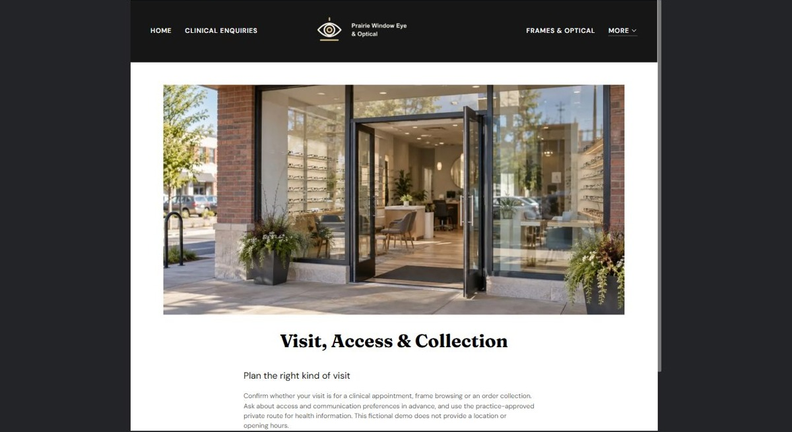
Actual desktop preview - unpublished fictional demonstration

Sample wording — adapt and verify
Visit, Access & Collection
Confirm whether your visit is for a clinical appointment, frame browsing or an order collection.
Ask about access and communication preferences in advance, and use the practice-approved private route for health information.
Suggested button: Choose an appointment or eyewear enquiry

Website advice
Provide reviewed arrival details and separate practice visits from eyewear collection appointments.

Your draft: Visit & Collection
Write in the voice of your own business. Use facts you can verify, not promises copied from the example.

Headline and short introduction

Main content and details visitors need

Button wording and destination

Photo choice, permission and facts still to confirm
Partner check: can someone unfamiliar with the business find a useful next step?

Test before publishing
Review the whole journey on a desktop and phone. The industry page pairs each desktop capture with its mobile preview and provides the complete sample page copy.
□ Fictional practice and store demonstration. Verify professional registration, clinical services, retail scope and all product claims. No diagnosis, treatment, lens recommendation or outcome claim is provided; public forms must not collect symptoms, prescriptions or medical histories. Clinical and retail services are not interchangeable.
□ Verify every service description, contact route and operating detail.
□ Replace fictional identity and example information before a live launch.
□ Test enquiries, links and downloads on desktop and mobile.
□ Keep confidential records in approved private systems.
□ Obtain operator approval for public wording and images.
□ Check every link, form destination, download and confirmation message.
□ Check logo contrast, hero framing, text sizes and image loading.
□ Save a named backup and assign a content-review date.

Changes to finish and person responsible

Approval and next review date
Website Builder plans and signup

