
WEBSITE PLANNING WORKSHOP

Nonprofits & Community Organizations
Website workbook
Plan a clear website for nonprofits & community organizations. Explore a worked example, shape your own message and prepare to build with SaaSTech Servers.
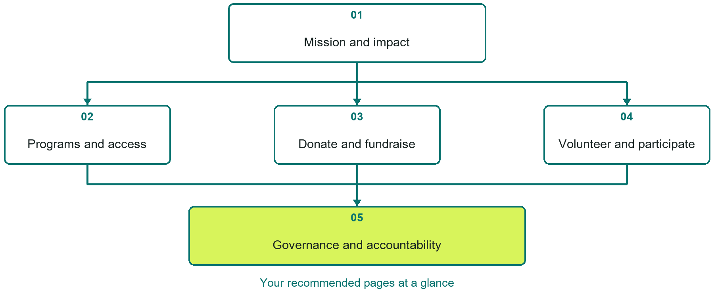

Inside this workbook
Five page examples • Practical writing exercises • A launch review
Use it in a workshop or at your own pace. Write by hand or complete the response fields in Word. The final page links to Website Builder, plans and account signup.
Example business Prairie Neighbours Community Foundation

NONPROFITS & COMMUNITY ORGANIZATIONS

Your website brief
A SaaSTech Servers workshop for nonprofits & community organizations. Plan your website, learn from the Prairie Neighbours Community Foundation example and draft content for your own business.
Each page has a reference sheet followed by a writing sheet. Demo excerpts are labelled separately from new sample wording, which may differ from the screenshot. Click a blank response line to type; longer answers may add pages. Replace fictional details and verify every claim before publishing.
Your business or organization and workshop date

Who should visit your site and what do they need

The main action you want a visitor to take

What you offer and where or how you provide it

Facts photos and permissions to gather before publishing

Workshop rhythm: review the example, write your draft and exchange feedback. Use the final review to choose your next changes. Website Builder and account links are on the last page.

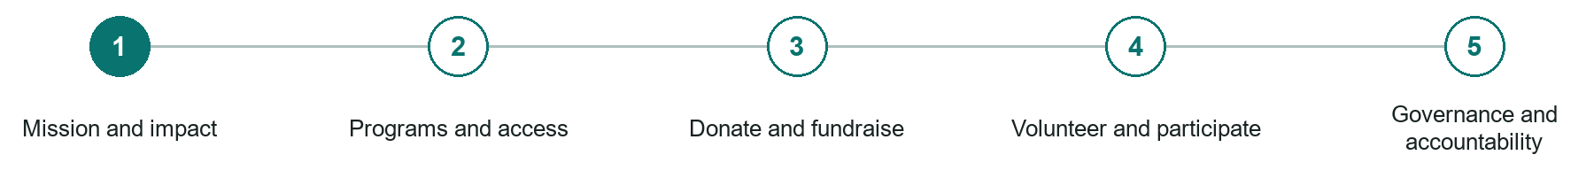
LOOK AND LEARN

Mission and impact

The job of this page
Explain the community need, programs, who benefits, intended outcomes, and evidence of recent work.
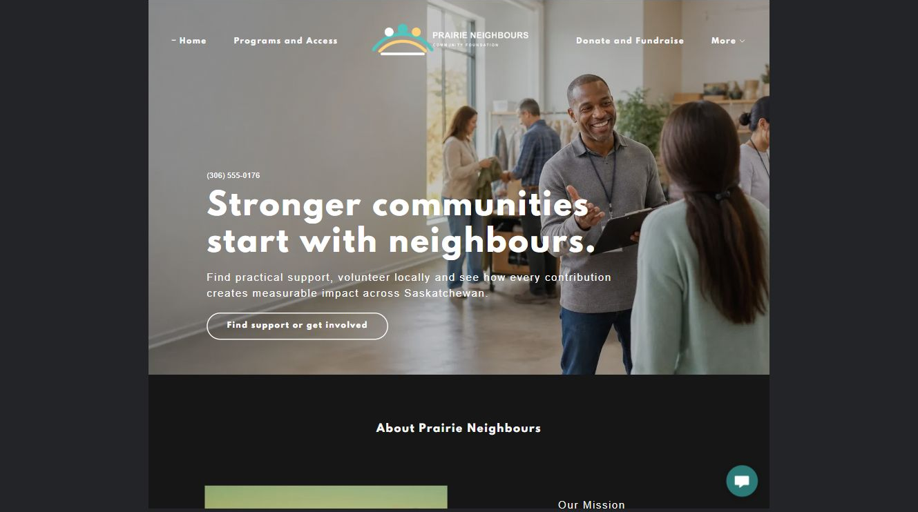
Prairie Neighbours Community Foundation example | Explore SaaSTech Website Builder

Sample wording to adapt
Understand the work and how to help
Learn who the programs serve and how support is used. Read dated impact information with its evidence. Choose the appropriate route to request help, volunteer or contribute.

Pause and plan
Could a first-time visitor explain what you do and who it is for after one glance? Choose one main action and the strongest truthful detail that gives them confidence to continue.

WRITE YOUR PAGE

Mission and impact
Write for your visitor. Be specific about what they need to know and what happens next. You can revise the wording after the workshop.
Your page headline

Your opening paragraph

Your offer audience location and most useful supporting details

Button or link wording and where it should lead

Photo idea caption and permission or credit needed

Facts to verify or questions to resolve

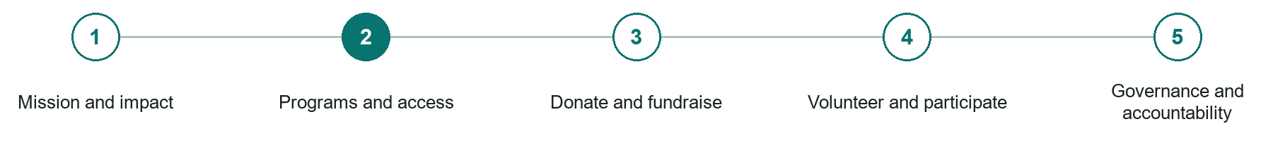
LOOK AND LEARN

Programs and access

The job of this page
Describe eligibility, locations, schedules, costs, referrals, accessibility, and how someone asks for help.
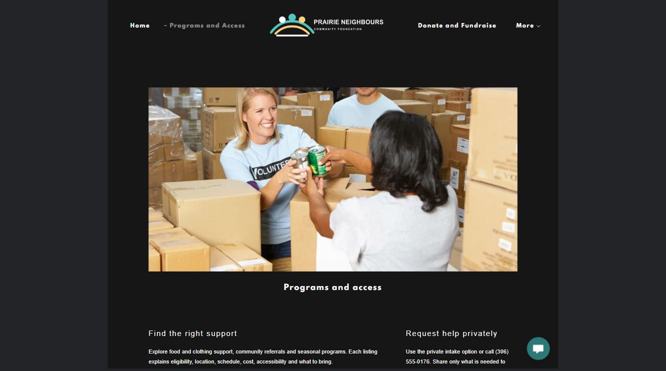
Prairie Neighbours Community Foundation example | Explore SaaSTech Website Builder

Sample wording to adapt
Find the right program
Check eligibility, access arrangements and how to begin. Contact the program team if you are unsure which option fits. Keep sensitive personal circumstances out of a general website enquiry.

Pause and plan
Who is each option for, what does it include and where are its limits? Describe the information needed to check fit. Make the next step clear without promising an outcome before assessment.

WRITE YOUR PAGE

Programs and access
Write for your visitor. Be specific about what they need to know and what happens next. You can revise the wording after the workshop.
Your page headline

Your opening paragraph

Service options who they suit and what each includes

Button or link wording and where it should lead

Photo idea caption and permission or credit needed

Facts to verify or questions to resolve

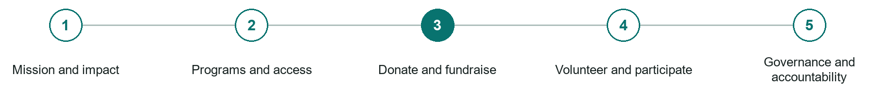
LOOK AND LEARN

Donate and fundraise

The job of this page
State how funds are used, available giving methods, receipting boundaries, recurring terms, and campaign goals.
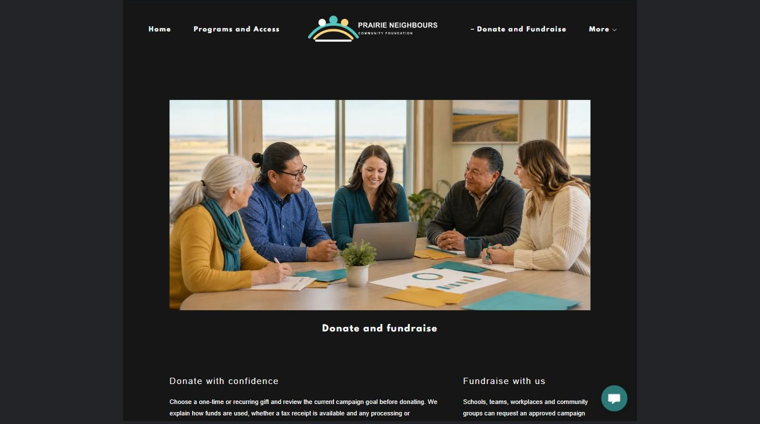
Prairie Neighbours Community Foundation example | Explore SaaSTech Website Builder

Sample wording to adapt
Choose how you want to contribute
Read how donations are used and which payment methods are available. Confirm receipting and fundraising details before contributing. This example does not claim registered charity status or accept donations.

Pause and plan
What question brings a visitor to this page? List the details they need, the evidence you can provide and the next useful action. Remove content that does not help them decide or proceed.

WRITE YOUR PAGE

Donate and fundraise
Write for your visitor. Be specific about what they need to know and what happens next. You can revise the wording after the workshop.
Your page headline

Your opening paragraph

Key sections visitor questions and supporting details

Button or link wording and where it should lead

Photo idea caption and permission or credit needed

Facts to verify or questions to resolve

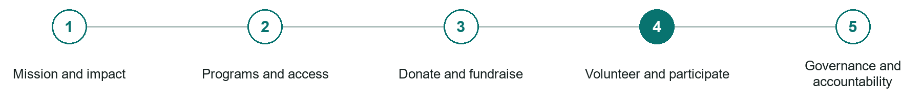
LOOK AND LEARN

Volunteer and participate

The job of this page
Publish real roles, time commitments, screening, training, events, and the next step.
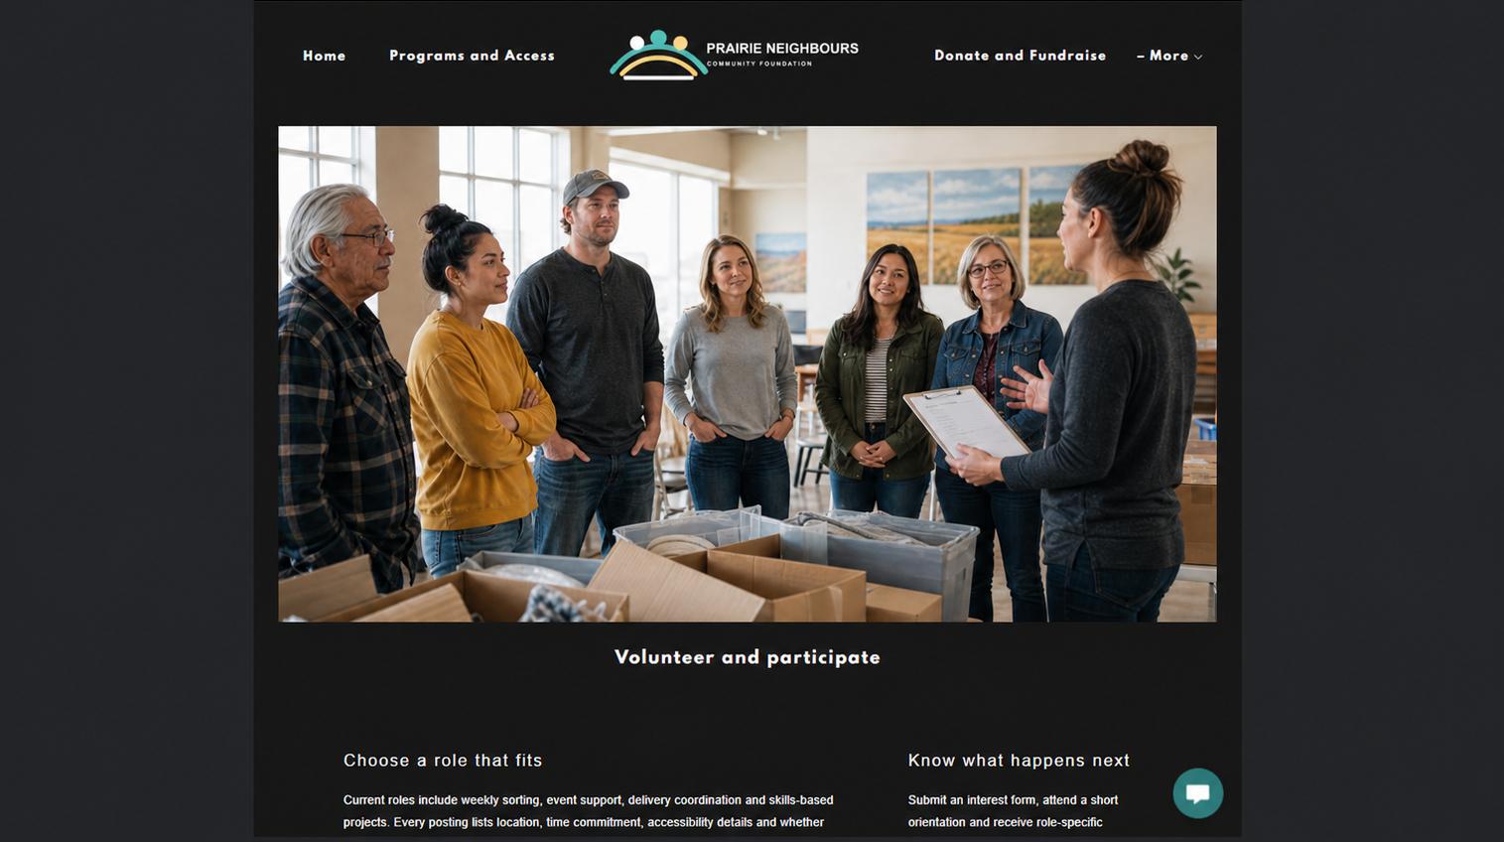
Prairie Neighbours Community Foundation example | Explore SaaSTech Website Builder

Sample wording to adapt
Find a way to take part
Explore roles, time commitments and the next application step. Ask about training and screening where relevant. A volunteer enquiry is not confirmation of a placement.

Pause and plan
What question brings a visitor to this page? List the details they need, the evidence you can provide and the next useful action. Remove content that does not help them decide or proceed.

WRITE YOUR PAGE

Volunteer and participate
Write for your visitor. Be specific about what they need to know and what happens next. You can revise the wording after the workshop.
Your page headline

Your opening paragraph

Key sections visitor questions and supporting details

Button or link wording and where it should lead

Photo idea caption and permission or credit needed

Facts to verify or questions to resolve

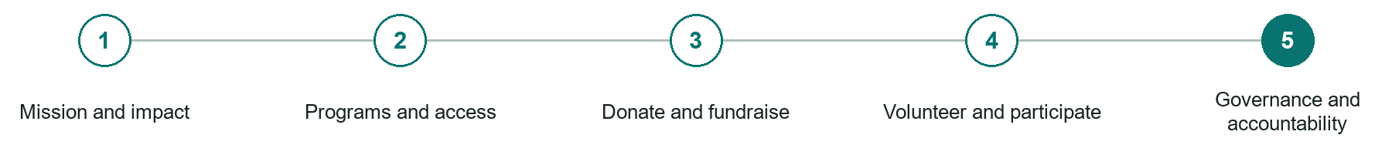
LOOK AND LEARN

Governance and accountability

The job of this page
Identify leadership, charitable or nonprofit status, reports, policies, partners, contacts, and complaint channels.
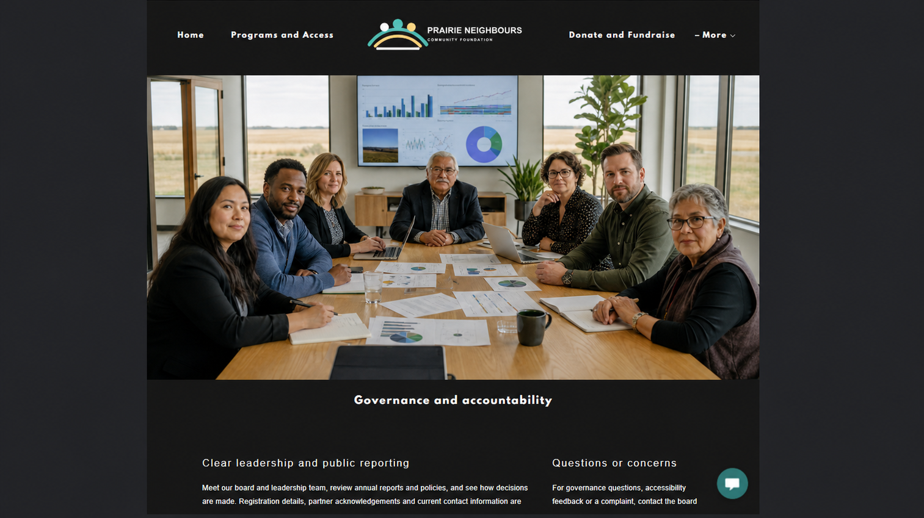
Prairie Neighbours Community Foundation example | Explore SaaSTech Website Builder

Sample wording to adapt
See how decisions and resources are managed
Find the organization's leadership, reports and accountability information. Check the reporting period and contact the team with questions. Publish accurate documents rather than unsupported impact claims.

Pause and plan
What question brings a visitor to this page? List the details they need, the evidence you can provide and the next useful action. Remove content that does not help them decide or proceed.

WRITE YOUR PAGE

Governance and accountability
Write for your visitor. Be specific about what they need to know and what happens next. You can revise the wording after the workshop.
Your page headline

Your opening paragraph

Key sections visitor questions and supporting details

Button or link wording and where it should lead

Photo idea caption and permission or credit needed

Facts to verify or questions to resolve

WORKSHOP CLOSE

Review and next steps
Ask a partner to read your draft as a first-time visitor. Can they explain what you offer, who it is for and the next step without extra help?

Before you publish
[ ] Every page has a clear purpose and a useful next step.
[ ] Headlines are specific and the wording sounds like your business.
[ ] Names, service areas, prices, dates and policies have been checked.
[ ] Credentials, testimonials and results are genuine and permission-cleared.
[ ] Photos support the text, do not repeat needlessly and have appropriate permissions.
[ ] Forms ask only for necessary information and explain what happens next.
[ ] Links, downloads and the main visitor task work on a phone.
The most useful feedback from your workshop partner

First change to make and who will do it

Information or photographs still needed

Target review date and who will approve the final content

Keep sensitive customer, patient, employee and payment information out of this workbook. Completing it does not publish a website or connect to Website Builder.

BUILD WITH SAASTECH SERVERS

Put your draft into Website Builder
Use the content you have written to build your own site. Keep the nonprofits & community organizations demo as a reference, and replace its company name, images and claims with your verified business information.

Explore the builder
See the editor, compare available plans and decide which features your business needs. Confirm current pricing and terms before purchasing.
Website Builder overview

Create your account
Set up your SaaSTech Servers customer account using your own details. Creating an account is separate from purchasing a Website Builder plan.
Create your SaaSTech account

Choose your plan
Open the secure shop to review the plan, subscription term and final total. Use the account connected to your purchase when you open your service.
View Website Builder plans

Build and check your pages
Add the pages from this workbook. Transfer your approved wording, upload permission-cleared photos and review each page on desktop and mobile before publishing.
Return to the Website Builder guide

Using a printed workbook
Type these short addresses into your browser. The account guide includes the Create My Account button.
www.saastech.net/products/website-builder
www.saastech.net/create-account
This workbook does not create an account, purchase a plan or publish your website. Keep passwords, payment details and confidential customer information out of your draft.

