
WEBSITE PLANNING WORKSHOP

Newspapers & Media
Website workbook
Plan a clear website for newspapers & media. Explore a worked example, shape your own message and prepare to build with SaaSTech Servers.
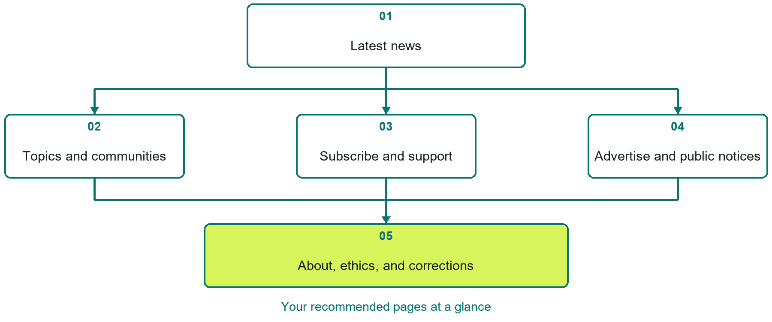

Inside this workbook
Five page examples • Practical writing exercises • A launch review
Use it in a workshop or at your own pace. Write by hand or complete the response fields in Word. The final page links to Website Builder, plans and account signup.
Example business Prairie Beacon News

NEWSPAPERS & MEDIA

Your website brief
A SaaSTech Servers workshop for newspapers & media. Plan your website, learn from the Prairie Beacon News example and draft content for your own business.
Each page has a reference sheet followed by a writing sheet. Demo excerpts are labelled separately from new sample wording, which may differ from the screenshot. Click a blank response line to type; longer answers may add pages. Replace fictional details and verify every claim before publishing.
Your business or organization and workshop date

Who should visit your site and what do they need

The main action you want a visitor to take

What you offer and where or how you provide it

Facts photos and permissions to gather before publishing

Workshop rhythm: review the example, write your draft and exchange feedback. Use the final review to choose your next changes. Website Builder and account links are on the last page.

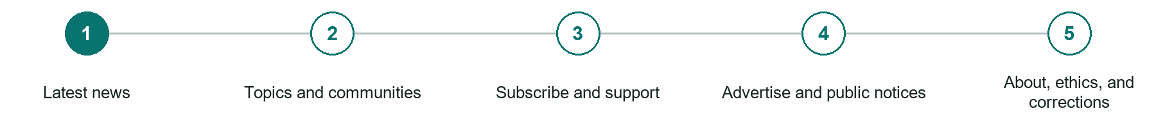
LOOK AND LEARN

Latest news

The job of this page
Lead with current reporting and make publication time, author, category, and updates immediately clear.

Prairie Beacon News example | Explore SaaSTech Website Builder

Sample wording to adapt
Follow the stories that affect your community
Browse the latest reporting by topic and location. Check the publication date and any updates. News, opinion and sponsored material should be clearly distinguished.

Pause and plan
Which dates and locations need to stay current? Decide who will update changes and where visitors should check before travelling. Separate archived information and illustrative schedules from current availability.

WRITE YOUR PAGE

Latest news
Write for your visitor. Be specific about what they need to know and what happens next. You can revise the wording after the workshop.
Your page headline

Your opening paragraph

Dates locations update process and participation details

Button or link wording and where it should lead

Photo idea caption and permission or credit needed

Facts to verify or questions to resolve

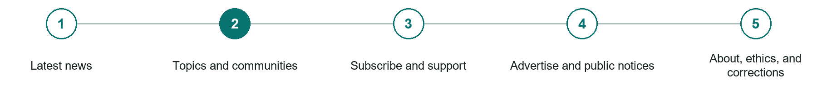
LOOK AND LEARN

Topics and communities

The job of this page
Organize coverage by beat, location, and ongoing issue so reporting remains useful after the front page changes.
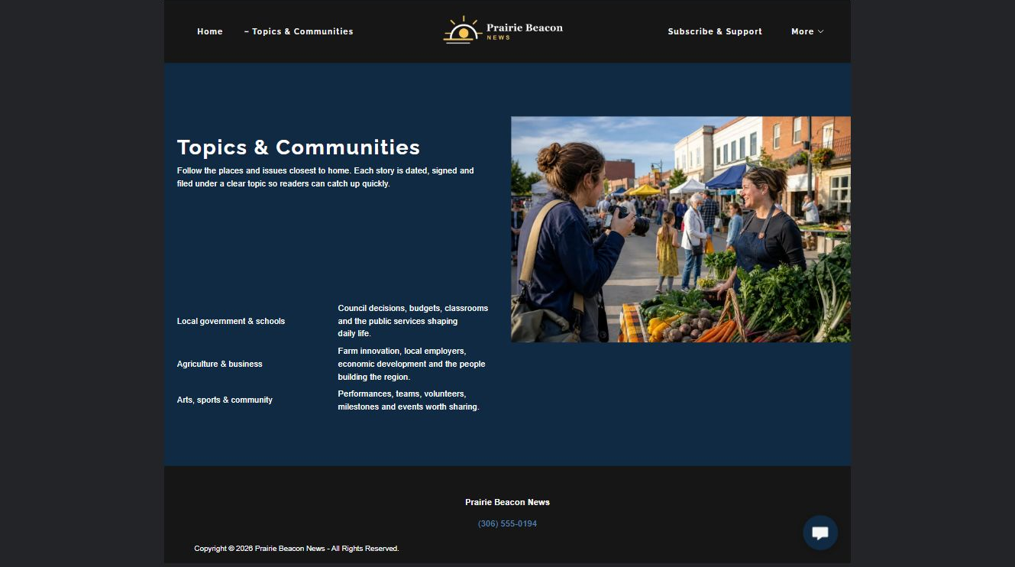
Prairie Beacon News example | Explore SaaSTech Website Builder

Sample wording to adapt
Find coverage close to your interests
Choose a community or topic to browse related reporting. Use descriptive article titles and publication dates to find the right story. Older coverage remains part of the archive, not a current notice.

Pause and plan
What question brings a visitor to this page? List the details they need, the evidence you can provide and the next useful action. Remove content that does not help them decide or proceed.

WRITE YOUR PAGE

Topics and communities
Write for your visitor. Be specific about what they need to know and what happens next. You can revise the wording after the workshop.
Your page headline

Your opening paragraph

Key sections visitor questions and supporting details

Button or link wording and where it should lead

Photo idea caption and permission or credit needed

Facts to verify or questions to resolve

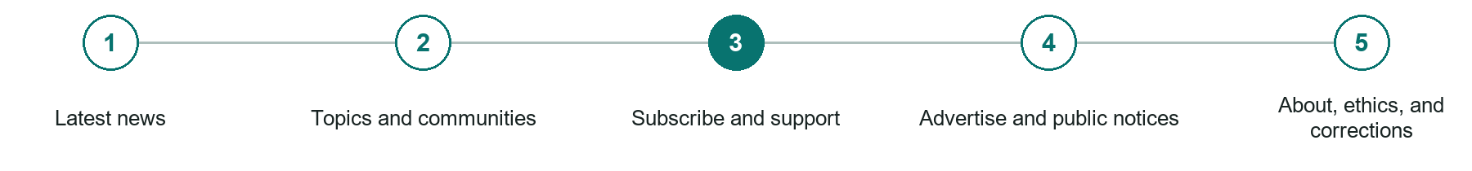
LOOK AND LEARN

Subscribe and support

The job of this page
Explain free and paid options, delivery, renewal, cancellation, donations, and what reader support funds.
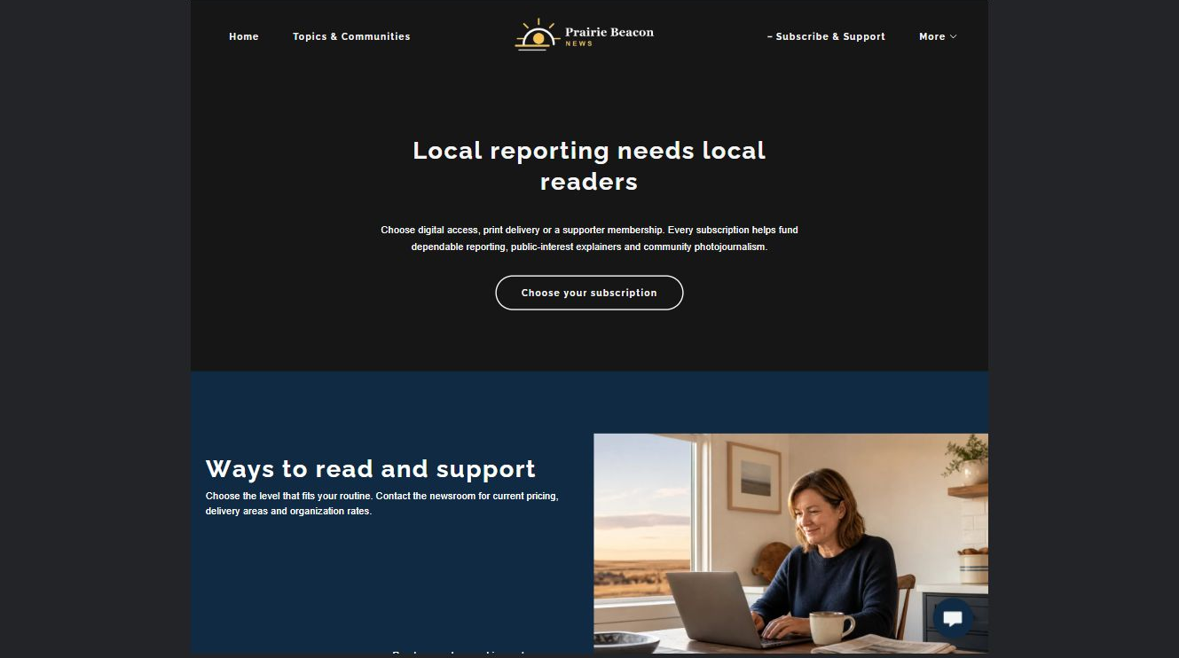
Prairie Beacon News example | Explore SaaSTech Website Builder

Sample wording to adapt
Choose how to support local reporting
Review subscription options, what each includes and how renewal works. Confirm the price and cancellation terms before paying. This demonstration does not accept real subscriptions.

Pause and plan
Who is each option for, what does it include and where are its limits? Describe the information needed to check fit. Make the next step clear without promising an outcome before assessment.

WRITE YOUR PAGE

Subscribe and support
Write for your visitor. Be specific about what they need to know and what happens next. You can revise the wording after the workshop.
Your page headline

Your opening paragraph

Service options who they suit and what each includes

Button or link wording and where it should lead

Photo idea caption and permission or credit needed

Facts to verify or questions to resolve

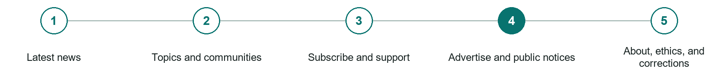
LOOK AND LEARN

Advertise and public notices

The job of this page
Publish formats, audience information, deadlines, labelling standards, contacts, and submission requirements.
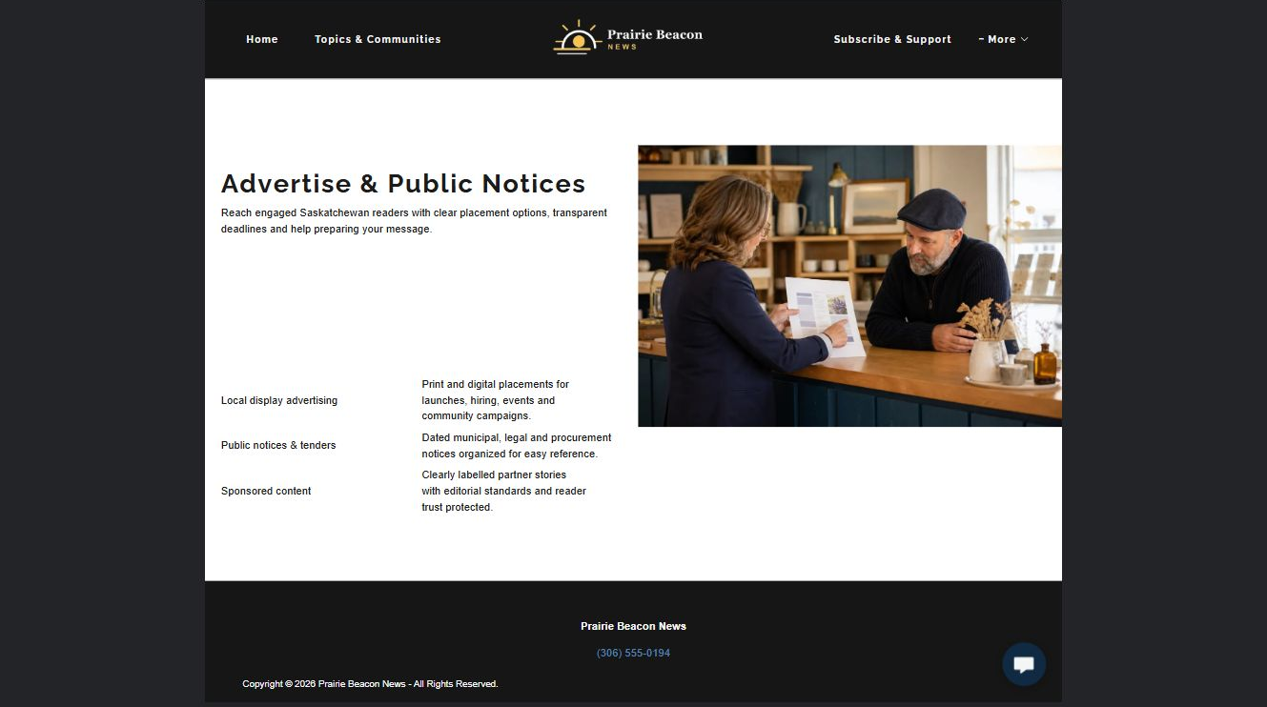
Prairie Beacon News example | Explore SaaSTech Website Builder

Sample wording to adapt
Plan an advertisement or public notice
Share the intended publication date, format and enquiry details. Confirm specifications, deadlines and approval requirements with the publication. An enquiry is not acceptance or a guarantee of placement.

Pause and plan
Which dates and locations need to stay current? Decide who will update changes and where visitors should check before travelling. Separate archived information and illustrative schedules from current availability.

WRITE YOUR PAGE

Advertise and public notices
Write for your visitor. Be specific about what they need to know and what happens next. You can revise the wording after the workshop.
Your page headline

Your opening paragraph

Dates locations update process and participation details

Button or link wording and where it should lead

Photo idea caption and permission or credit needed

Facts to verify or questions to resolve

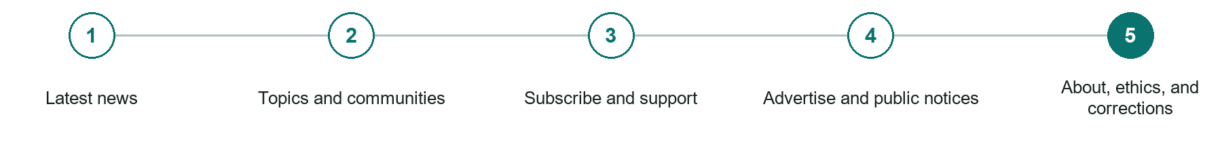
LOOK AND LEARN

About ethics and corrections

The job of this page
Identify ownership, newsroom contacts, editorial standards, corrections, privacy, and how to submit a confidential lead.
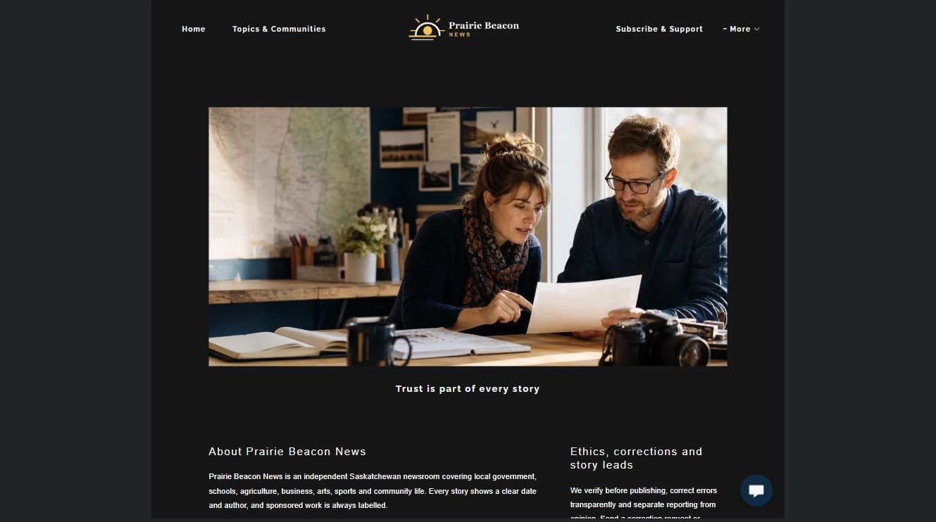
Prairie Beacon News example | Explore SaaSTech Website Builder

Sample wording to adapt
Ask a question or request a correction
Identify the article, publication date and the issue you want reviewed. Explain the concern clearly and provide a reply address. Use the publication's approved channel for sensitive material.

Pause and plan
Which names, roles and qualifications can you verify? What would help a visitor feel comfortable contacting you? Obtain permission for portraits and describe actual experience without unsupported claims.

WRITE YOUR PAGE

About ethics and corrections
Write for your visitor. Be specific about what they need to know and what happens next. You can revise the wording after the workshop.
Your page headline

Your opening paragraph

People roles approach and verified credentials to introduce

Button or link wording and where it should lead

Photo idea caption and permission or credit needed

Facts to verify or questions to resolve

WORKSHOP CLOSE

Review and next steps
Ask a partner to read your draft as a first-time visitor. Can they explain what you offer, who it is for and the next step without extra help?

Before you publish
[ ] Every page has a clear purpose and a useful next step.
[ ] Headlines are specific and the wording sounds like your business.
[ ] Names, service areas, prices, dates and policies have been checked.
[ ] Credentials, testimonials and results are genuine and permission-cleared.
[ ] Photos support the text, do not repeat needlessly and have appropriate permissions.
[ ] Forms ask only for necessary information and explain what happens next.
[ ] Links, downloads and the main visitor task work on a phone.
The most useful feedback from your workshop partner

First change to make and who will do it

Information or photographs still needed

Target review date and who will approve the final content

Keep sensitive customer, patient, employee and payment information out of this workbook. Completing it does not publish a website or connect to Website Builder.

BUILD WITH SAASTECH SERVERS

Put your draft into Website Builder
Use the content you have written to build your own site. Keep the newspapers & media demo as a reference, and replace its company name, images and claims with your verified business information.

Explore the builder
See the editor, compare available plans and decide which features your business needs. Confirm current pricing and terms before purchasing.
Website Builder overview

Create your account
Set up your SaaSTech Servers customer account using your own details. Creating an account is separate from purchasing a Website Builder plan.
Create your SaaSTech account

Choose your plan
Open the secure shop to review the plan, subscription term and final total. Use the account connected to your purchase when you open your service.
View Website Builder plans

Build and check your pages
Add the pages from this workbook. Transfer your approved wording, upload permission-cleared photos and review each page on desktop and mobile before publishing.
Return to the Website Builder guide

Using a printed workbook
Type these short addresses into your browser. The account guide includes the Create My Account button.
www.saastech.net/products/website-builder
www.saastech.net/create-account
This workbook does not create an account, purchase a plan or publish your website. Keep passwords, payment details and confidential customer information out of your draft.

