
WEBSITE PLANNING WORKSHOP

Municipal Government
Website workbook
Plan a clear website for municipal government. Explore a worked example, shape your own message and prepare to build with SaaSTech Servers.
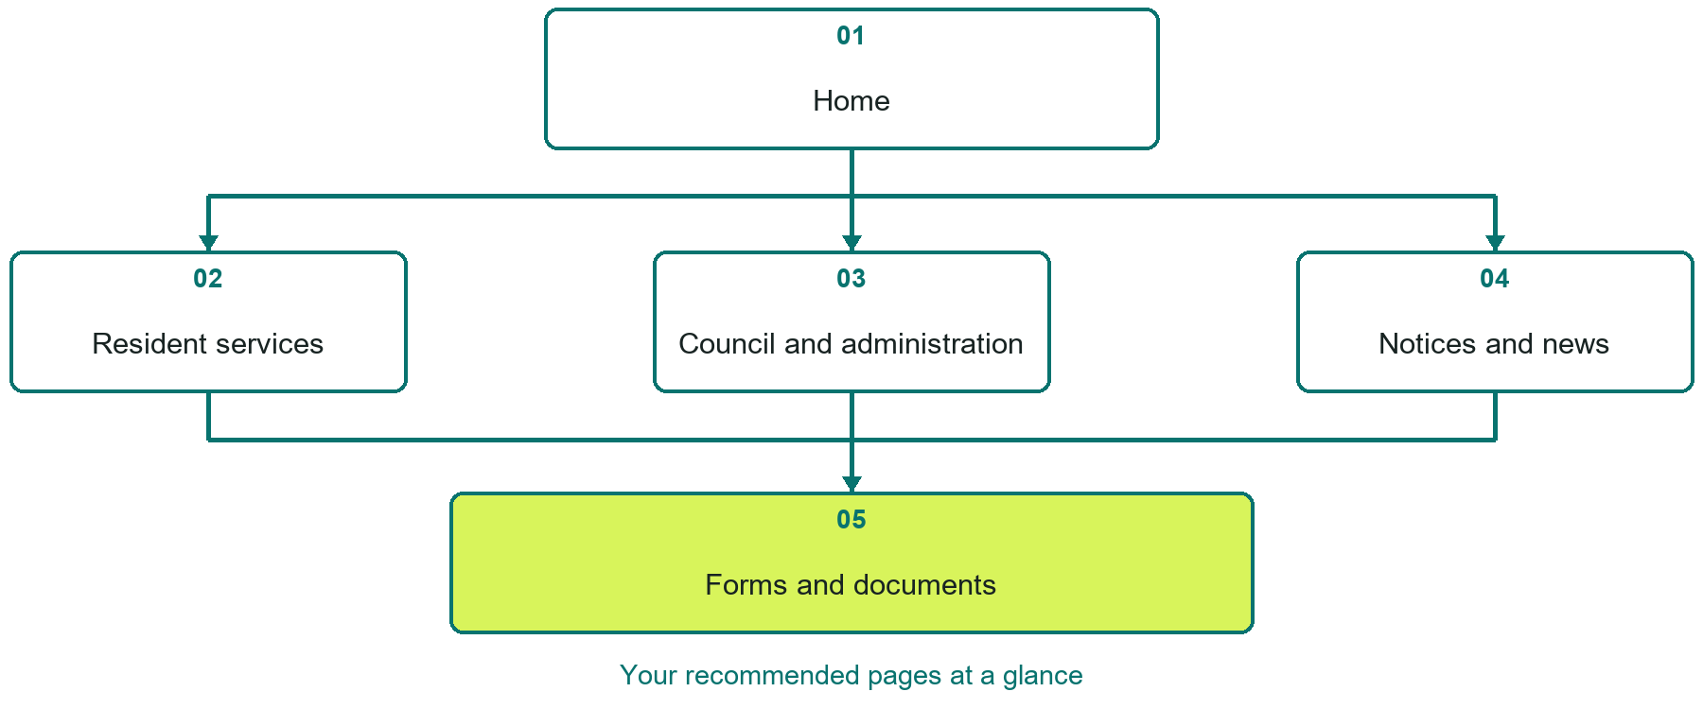

Inside this workbook
Five page examples • Practical writing exercises • A launch review
Use it in a workshop or at your own pace. Write by hand or complete the response fields in Word. The final page links to Website Builder, plans and account signup.
Example business Town of Willow Crossing

MUNICIPAL GOVERNMENT

Your website brief
A SaaSTech Servers workshop for municipal government. Plan your website, learn from the Town of Willow Crossing example and draft content for your own business.
Each page has a reference sheet followed by a writing sheet. Demo excerpts are labelled separately from new sample wording, which may differ from the screenshot. Click a blank response line to type; longer answers may add pages. Replace fictional details and verify every claim before publishing.
Your business or organization and workshop date

Who should visit your site and what do they need

The main action you want a visitor to take

What you offer and where or how you provide it

Facts photos and permissions to gather before publishing

Workshop rhythm: review the example, write your draft and exchange feedback. Use the final review to choose your next changes. Website Builder and account links are on the last page.

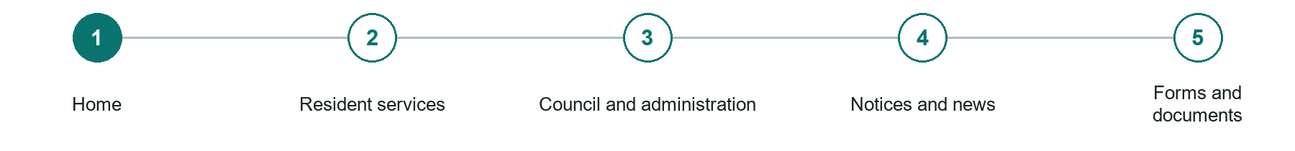
LOOK AND LEARN

Home

The job of this page
Lead with current notices, essential contacts, emergency information, and the most-used resident services.
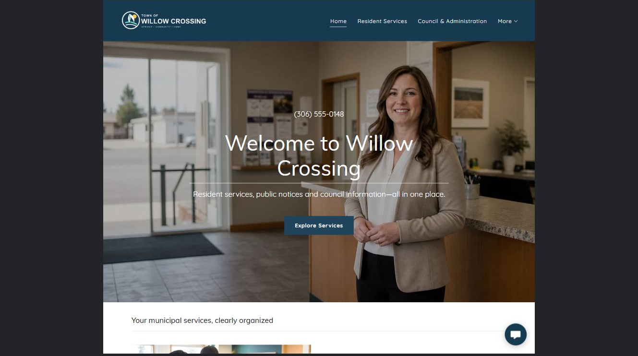
Town of Willow Crossing example | Explore SaaSTech Website Builder

Sample wording to adapt
Find the service you need
Start with resident services, current notices or council information. Each section points to the relevant instructions and contact. Use the appropriate emergency channel for urgent danger, not a routine website form.

Pause and plan
Could a first-time visitor explain what you do and who it is for after one glance? Choose one main action and the strongest truthful detail that gives them confidence to continue.

WRITE YOUR PAGE

Home
Write for your visitor. Be specific about what they need to know and what happens next. You can revise the wording after the workshop.
Your page headline

Your opening paragraph

Your offer audience location and most useful supporting details

Button or link wording and where it should lead

Photo idea caption and permission or credit needed

Facts to verify or questions to resolve

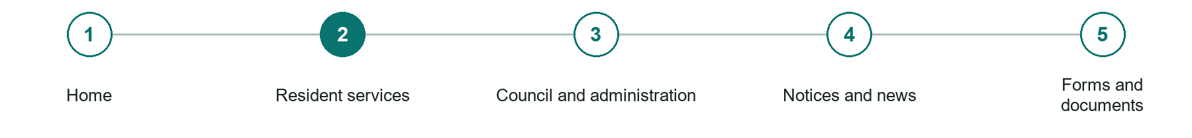
LOOK AND LEARN

Resident services

The job of this page
Organize utilities, roads, waste, permits, recreation, taxes, and other services around resident tasks.
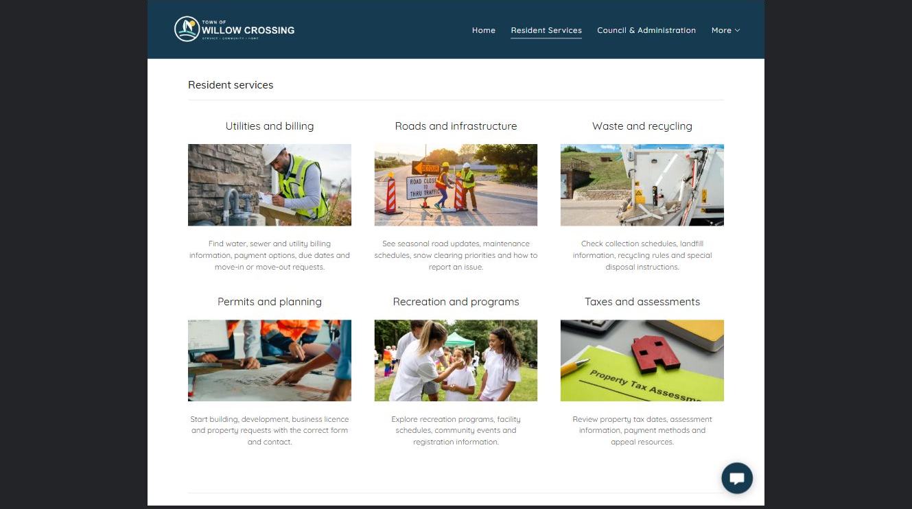
Town of Willow Crossing example | Explore SaaSTech Website Builder

Sample wording to adapt
Resident services in one place
Find information about utilities, waste collection, roads, permits and recreation. Check the instructions and current dates for your request before submitting a form or making a payment.

Pause and plan
Who is each option for, what does it include and where are its limits? Describe the information needed to check fit. Make the next step clear without promising an outcome before assessment.

WRITE YOUR PAGE

Resident services
Write for your visitor. Be specific about what they need to know and what happens next. You can revise the wording after the workshop.
Your page headline

Your opening paragraph

Service options who they suit and what each includes

Button or link wording and where it should lead

Photo idea caption and permission or credit needed

Facts to verify or questions to resolve

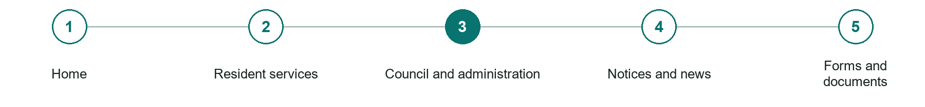
LOOK AND LEARN

Council and administration

The job of this page
Publish council contacts, meeting schedules, agendas, minutes, governance information, and office details.
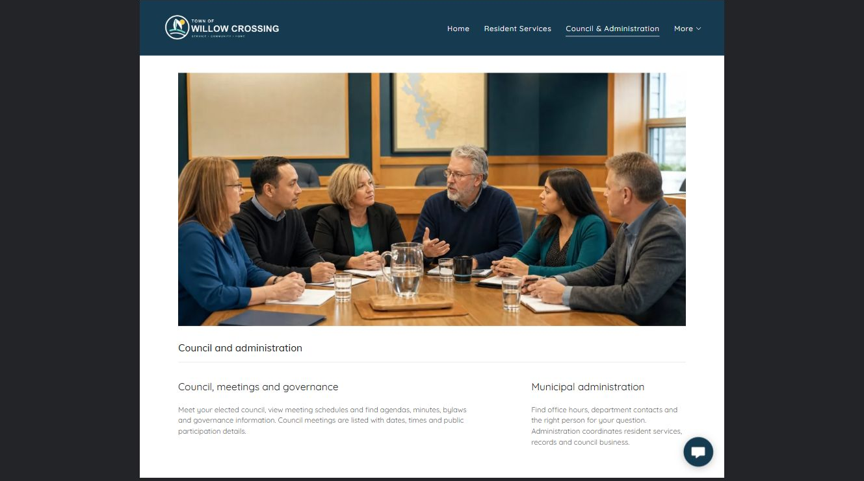
Town of Willow Crossing example | Explore SaaSTech Website Builder

Sample wording to adapt
Follow council business
Find meeting dates, agendas, minutes and public participation details. Contact administration if you need help locating a record or understanding the submission process. Check the date on each document.

Pause and plan
What question brings a visitor to this page? List the details they need, the evidence you can provide and the next useful action. Remove content that does not help them decide or proceed.

WRITE YOUR PAGE

Council and administration
Write for your visitor. Be specific about what they need to know and what happens next. You can revise the wording after the workshop.
Your page headline

Your opening paragraph

Key sections visitor questions and supporting details

Button or link wording and where it should lead

Photo idea caption and permission or credit needed

Facts to verify or questions to resolve

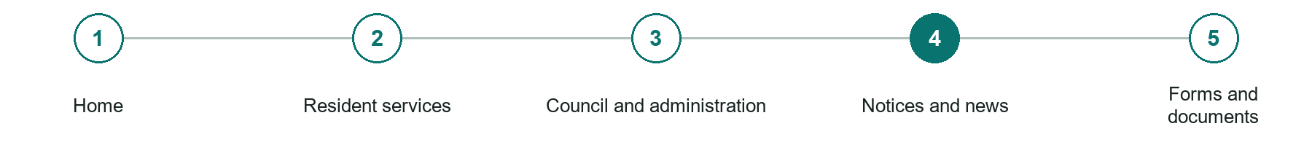
LOOK AND LEARN

Notices and news

The job of this page
Maintain dated public notices, service interruptions, tenders, events, and archived updates.
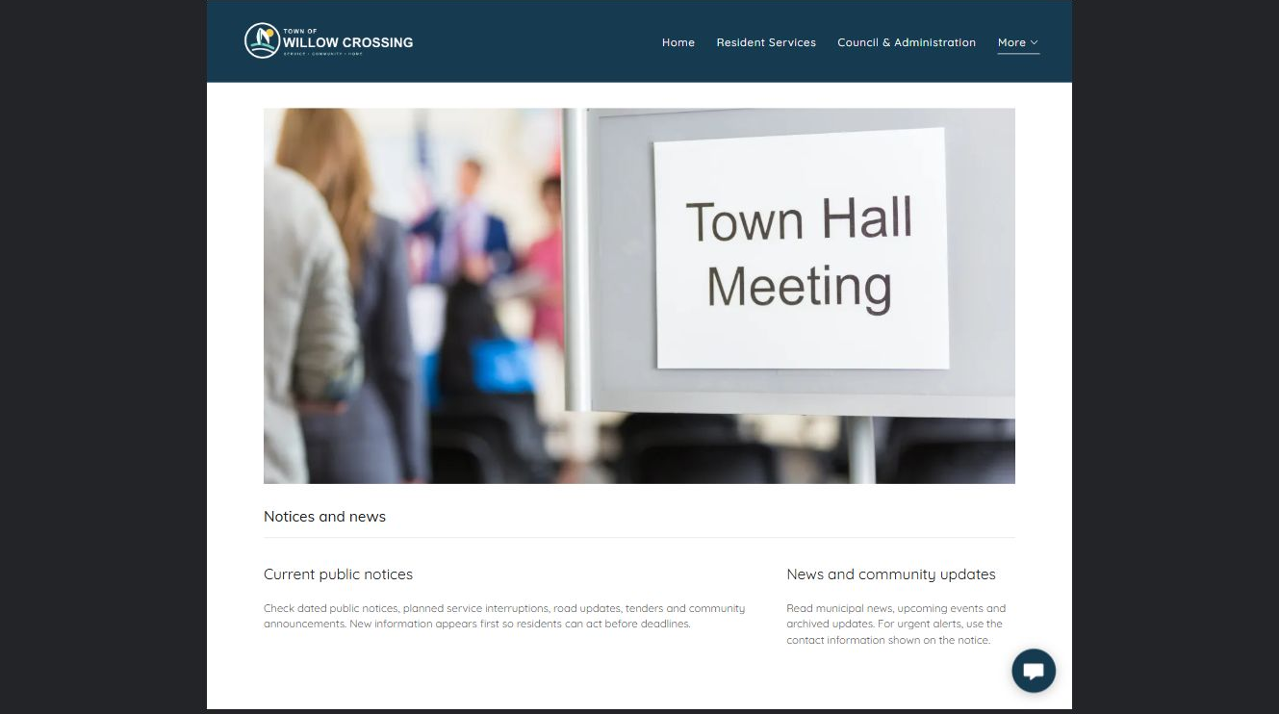
Town of Willow Crossing example | Explore SaaSTech Website Builder

Sample wording to adapt
Read the latest public notices
Check the effective dates, affected locations and required action on each notice. Older notices are kept separately for reference. Follow the contact instructions on the notice if you have questions.

Pause and plan
Which dates and locations need to stay current? Decide who will update changes and where visitors should check before travelling. Separate archived information and illustrative schedules from current availability.

WRITE YOUR PAGE

Notices and news
Write for your visitor. Be specific about what they need to know and what happens next. You can revise the wording after the workshop.
Your page headline

Your opening paragraph

Dates locations update process and participation details

Button or link wording and where it should lead

Photo idea caption and permission or credit needed

Facts to verify or questions to resolve

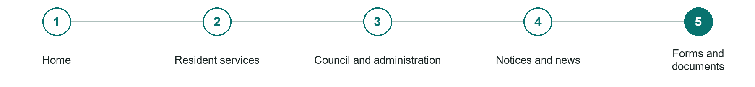
LOOK AND LEARN

Forms and documents

The job of this page
Provide accessible forms and documents with a plain-language explanation of purpose, deadline, and submission method.
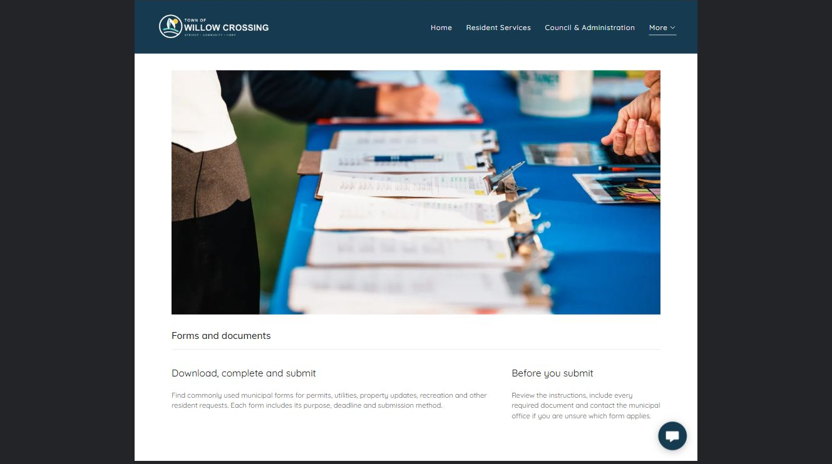
Town of Willow Crossing example | Explore SaaSTech Website Builder

Sample wording to adapt
Download, complete and submit
Choose the form for your request, read the instructions and include the required documents. Check the submission method and deadline. Contact the office if you are unsure which form applies.

Pause and plan
What question brings a visitor to this page? List the details they need, the evidence you can provide and the next useful action. Remove content that does not help them decide or proceed.

WRITE YOUR PAGE

Forms and documents
Write for your visitor. Be specific about what they need to know and what happens next. You can revise the wording after the workshop.
Your page headline

Your opening paragraph

Key sections visitor questions and supporting details

Button or link wording and where it should lead

Photo idea caption and permission or credit needed

Facts to verify or questions to resolve

WORKSHOP CLOSE

Review and next steps
Ask a partner to read your draft as a first-time visitor. Can they explain what you offer, who it is for and the next step without extra help?

Before you publish
[ ] Every page has a clear purpose and a useful next step.
[ ] Headlines are specific and the wording sounds like your business.
[ ] Names, service areas, prices, dates and policies have been checked.
[ ] Credentials, testimonials and results are genuine and permission-cleared.
[ ] Photos support the text, do not repeat needlessly and have appropriate permissions.
[ ] Forms ask only for necessary information and explain what happens next.
[ ] Links, downloads and the main visitor task work on a phone.
The most useful feedback from your workshop partner

First change to make and who will do it

Information or photographs still needed

Target review date and who will approve the final content

Keep sensitive customer, patient, employee and payment information out of this workbook. Completing it does not publish a website or connect to Website Builder.

BUILD WITH SAASTECH SERVERS

Put your draft into Website Builder
Use the content you have written to build your own site. Keep the municipal government demo as a reference, and replace its company name, images and claims with your verified business information.

Explore the builder
See the editor, compare available plans and decide which features your business needs. Confirm current pricing and terms before purchasing.
Website Builder overview

Create your account
Set up your SaaSTech Servers customer account using your own details. Creating an account is separate from purchasing a Website Builder plan.
Create your SaaSTech account

Choose your plan
Open the secure shop to review the plan, subscription term and final total. Use the account connected to your purchase when you open your service.
View Website Builder plans

Build and check your pages
Add the pages from this workbook. Transfer your approved wording, upload permission-cleared photos and review each page on desktop and mobile before publishing.
Return to the Website Builder guide

Using a printed workbook
Type these short addresses into your browser. The account guide includes the Create My Account button.
www.saastech.net/products/website-builder
www.saastech.net/create-account
This workbook does not create an account, purchase a plan or publish your website. Keep passwords, payment details and confidential customer information out of your draft.

