
WEBSITE PLANNING WORKSHOP

Medical Offices
Website workbook
Plan a clear website for medical offices. Explore a worked example, shape your own message and prepare to build with SaaSTech Servers.
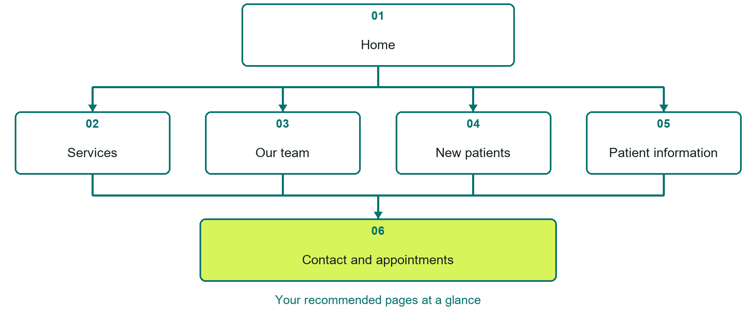

Inside this workbook
Six page examples • Practical writing exercises • A launch review
Use it in a workshop or at your own pace. Write by hand or complete the response fields in Word. The final page links to Website Builder, plans and account signup.
Example business Prairie Grove Medical Office

MEDICAL OFFICES

Your website brief
A SaaSTech Servers workshop for medical offices. Plan your website, learn from the Prairie Grove Medical Office example and draft content for your own business.
Each page has a reference sheet followed by a writing sheet. Demo excerpts are labelled separately from new sample wording, which may differ from the screenshot. Click a blank response line to type; longer answers may add pages. Replace fictional details and verify every claim before publishing.
Your business or organization and workshop date

Who should visit your site and what do they need

The main action you want a visitor to take

What you offer and where or how you provide it

Facts photos and permissions to gather before publishing

Workshop rhythm: review the example, write your draft and exchange feedback. Use the final review to choose your next changes. Website Builder and account links are on the last page.

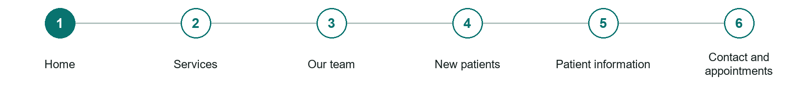
LOOK AND LEARN

Home

The job of this page
Introduce the office and community served. Make hours, location, telephone contact, new-patient status, and the appointment route easy to find.
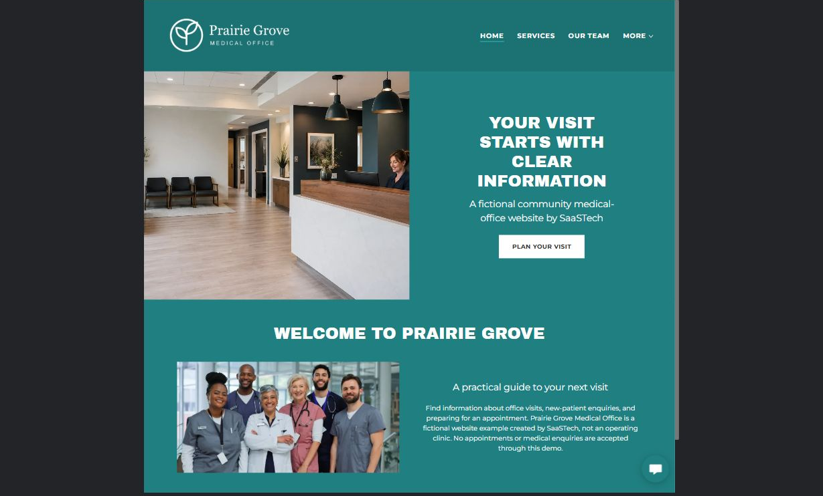
Prairie Grove Medical Office example | Explore SaaSTech Website Builder

Sample wording to adapt
Find practical information before your visit
Explore the office's services, team and new-patient information. Contact the office through its approved channel for appointment arrangements. This website is not a source of individual medical advice or emergency care.

Pause and plan
Could a first-time visitor explain what you do and who it is for after one glance? Choose one main action and the strongest truthful detail that gives them confidence to continue.

WRITE YOUR PAGE

Home
Write for your visitor. Be specific about what they need to know and what happens next. You can revise the wording after the workshop.
Your page headline

Your opening paragraph

Your offer audience location and most useful supporting details

Button or link wording and where it should lead

Photo idea caption and permission or credit needed

Facts to verify or questions to resolve

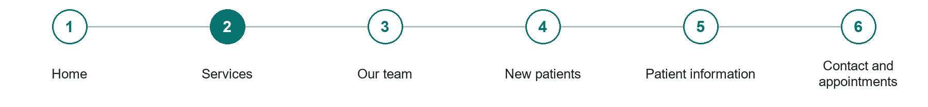
LOOK AND LEARN

Services

The job of this page
Describe only the services actually available, who they are for, referral requirements where relevant, and how to enquire. Have the practice review all descriptions before publishing.
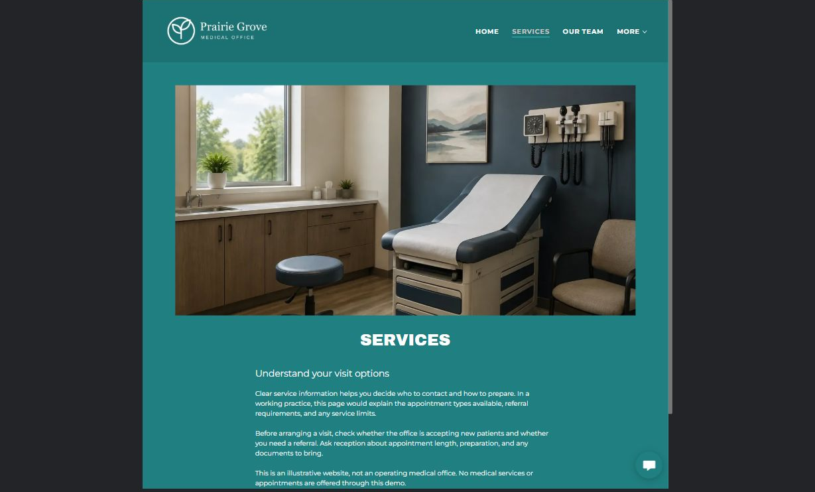
Prairie Grove Medical Office example | Explore SaaSTech Website Builder

Sample wording to adapt
Check which services are available
Read the service descriptions and ask the office about access or referral requirements. The office will confirm the appropriate next step. Do not submit symptoms or clinical records through a general enquiry form.

Pause and plan
Who is each option for, what does it include and where are its limits? Describe the information needed to check fit. Make the next step clear without promising an outcome before assessment.

WRITE YOUR PAGE

Services
Write for your visitor. Be specific about what they need to know and what happens next. You can revise the wording after the workshop.
Your page headline

Your opening paragraph

Service options who they suit and what each includes

Button or link wording and where it should lead

Photo idea caption and permission or credit needed

Facts to verify or questions to resolve

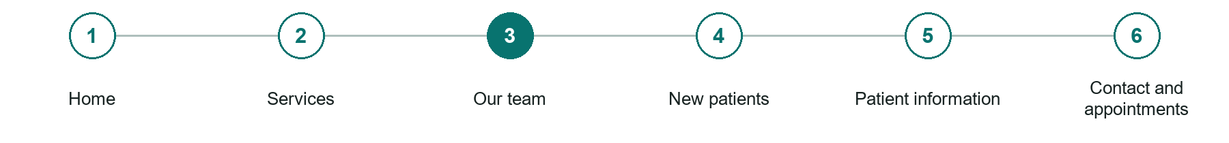
LOOK AND LEARN

Our team

The job of this page
Introduce verified professional names, roles, qualifications, languages, and areas of practice. Use approved photographs and avoid invented credentials or testimonials.
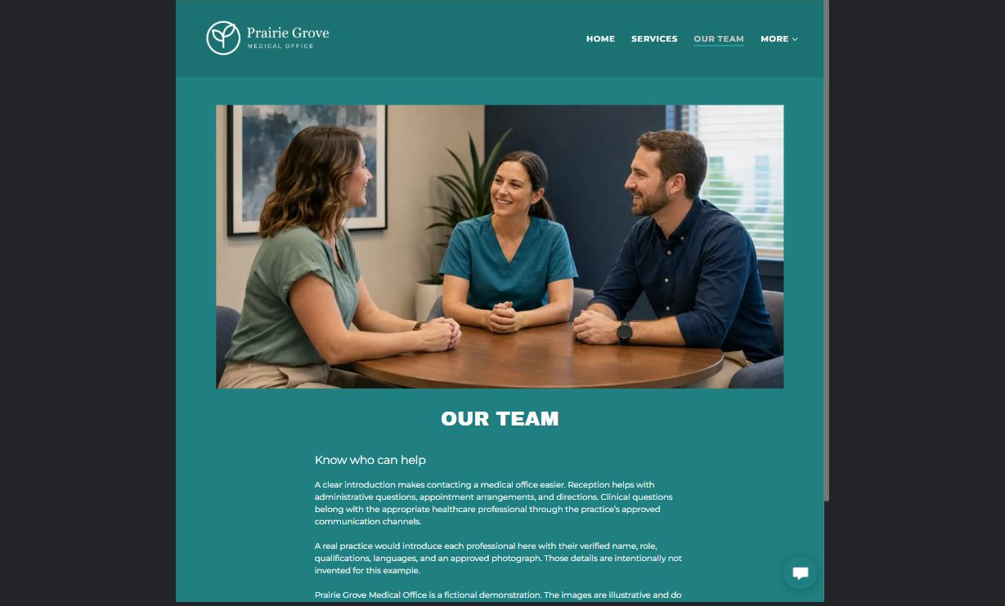
Prairie Grove Medical Office example | Explore SaaSTech Website Builder

Sample wording to adapt
Meet the care team
Find verified professional roles and qualifications and learn how the office is organized. Contact the office with practical questions about your visit. Example portraits do not identify real clinicians.

Pause and plan
Which names, roles and qualifications can you verify? What would help a visitor feel comfortable contacting you? Obtain permission for portraits and describe actual experience without unsupported claims.

WRITE YOUR PAGE

Our team
Write for your visitor. Be specific about what they need to know and what happens next. You can revise the wording after the workshop.
Your page headline

Your opening paragraph

People roles approach and verified credentials to introduce

Button or link wording and where it should lead

Photo idea caption and permission or credit needed

Facts to verify or questions to resolve

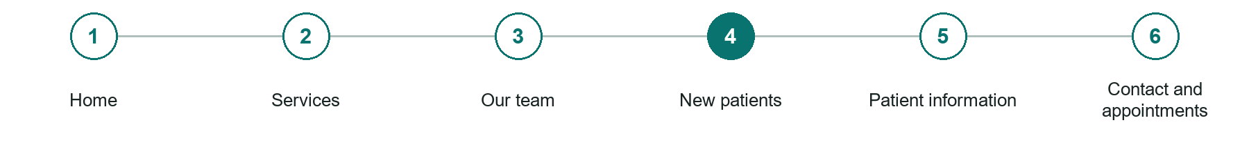
LOOK AND LEARN

New patients

The job of this page
Explain whether the practice is accepting patients, how registration and appointments work, what to bring, and how to ask about access needs. Direct intake documents to an approved process.
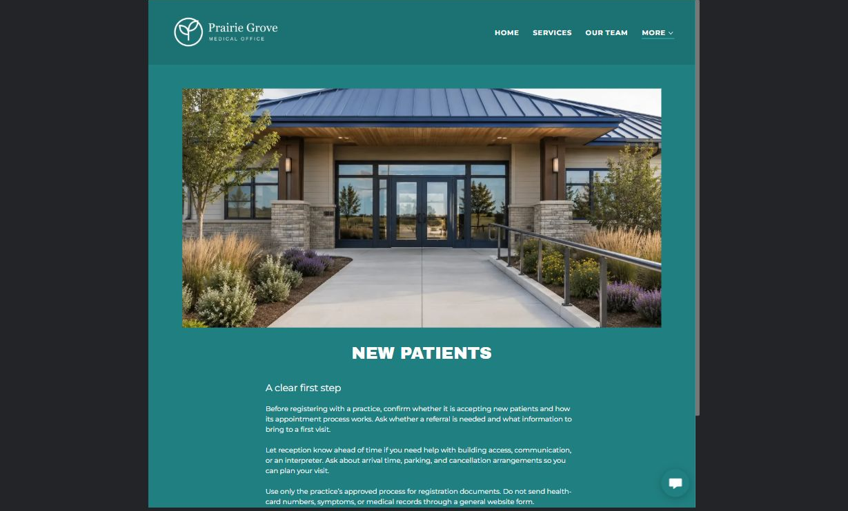
Prairie Grove Medical Office example | Explore SaaSTech Website Builder

Sample wording to adapt
Preparing as a new patient
Confirm whether new patients are being accepted and ask what information to bring. Use the office's approved private process for health records. A website enquiry does not establish care or confirm an appointment.

Pause and plan
What should someone know before arriving or proceeding? Clarify preparation, access and the right contact route. Verify policies and avoid promising urgent help or specialist advice the website cannot provide.

WRITE YOUR PAGE

New patients
Write for your visitor. Be specific about what they need to know and what happens next. You can revise the wording after the workshop.
Your page headline

Your opening paragraph

Preparation access policies and practical questions to answer

Button or link wording and where it should lead

Photo idea caption and permission or credit needed

Facts to verify or questions to resolve

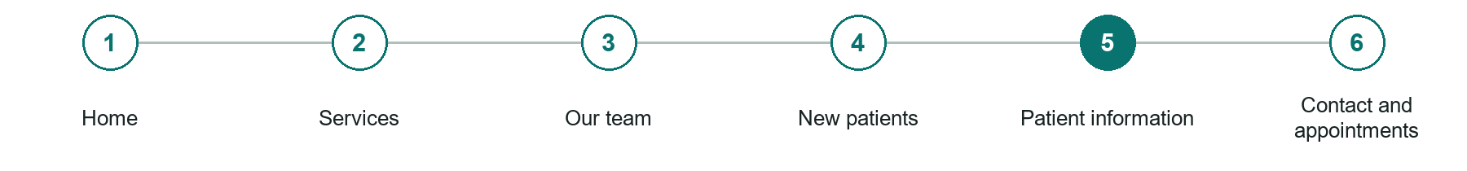
LOOK AND LEARN

Patient information

The job of this page
Provide visit preparation, office policies, cancellation instructions, and useful administrative answers. Link an approved patient portal only if one exists; do not imply the public site provides clinical messaging.
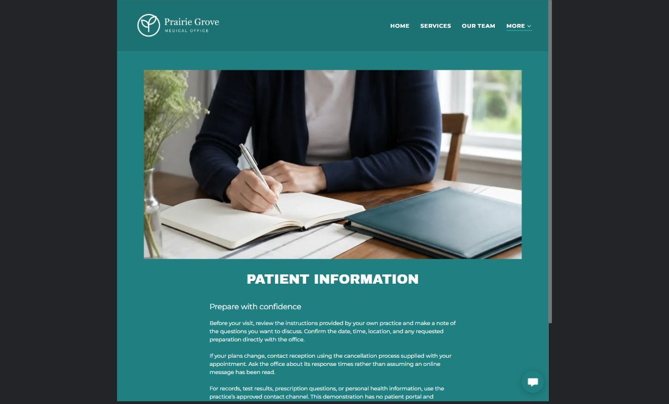
Prairie Grove Medical Office example | Explore SaaSTech Website Builder

Sample wording to adapt
Plan the practical parts of your visit
Check hours, access arrangements and the office's process for changes or cancellations. Follow the office's approved instructions for records and prescriptions. Do not use this general page for personal medical decisions.

Pause and plan
What question brings a visitor to this page? List the details they need, the evidence you can provide and the next useful action. Remove content that does not help them decide or proceed.

WRITE YOUR PAGE

Patient information
Write for your visitor. Be specific about what they need to know and what happens next. You can revise the wording after the workshop.
Your page headline

Your opening paragraph

Key sections visitor questions and supporting details

Button or link wording and where it should lead

Photo idea caption and permission or credit needed

Facts to verify or questions to resolve

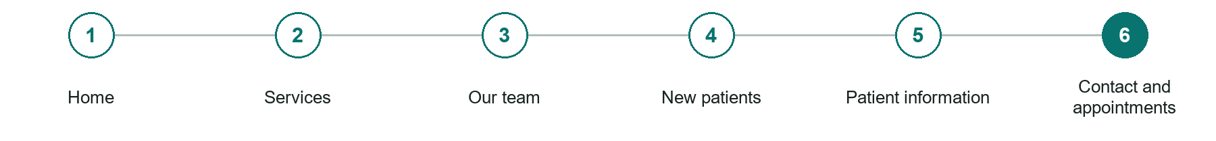
LOOK AND LEARN

Contact and appointments

The job of this page
Show address, directions, hours, phone, and the practice's appointment process. If using a callback form, request only basic contact details and preferred contact time, not symptoms, medical records, health-card numbers, or uploads. Explain that a request is not a confirmed appointment and the form is not monitored for emergencies.
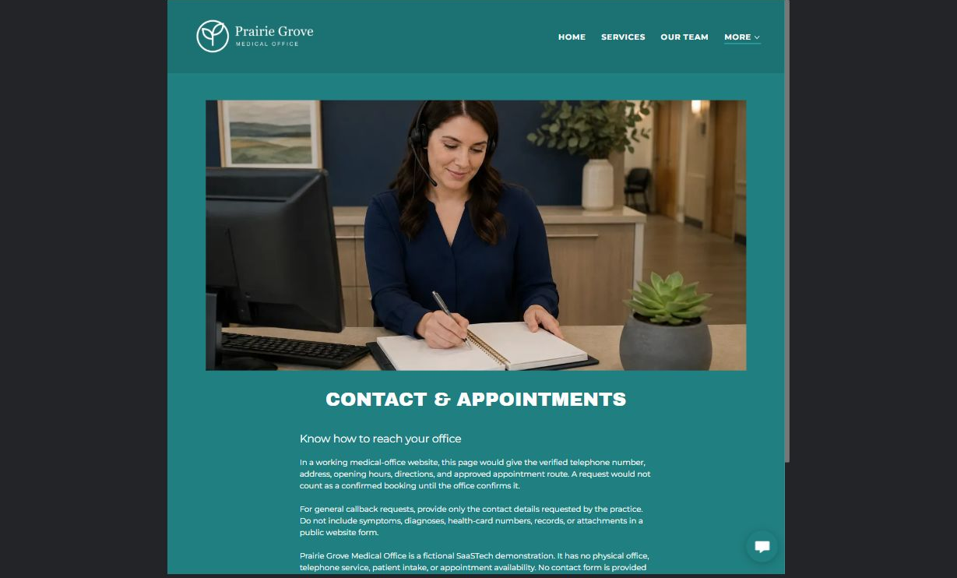
Prairie Grove Medical Office example | Explore SaaSTech Website Builder

Sample wording to adapt
Contact the office through the right channel
Use the approved appointment contact for routine arrangements. Keep health information out of a public form. For an immediate emergency, use the appropriate emergency service rather than waiting for an online reply.

Pause and plan
What must someone provide, and what happens after they send it? Separate a request from a confirmed booking, order or place. Decide what information should stay out of a public form.

WRITE YOUR PAGE

Contact and appointments
Write for your visitor. Be specific about what they need to know and what happens next. You can revise the wording after the workshop.
Your page headline

Your opening paragraph

Information to request and how you will reply or confirm

Button or link wording and where it should lead

Photo idea caption and permission or credit needed

Facts to verify or questions to resolve

WORKSHOP CLOSE

Review and next steps
Ask a partner to read your draft as a first-time visitor. Can they explain what you offer, who it is for and the next step without extra help?

Before you publish
[ ] Every page has a clear purpose and a useful next step.
[ ] Headlines are specific and the wording sounds like your business.
[ ] Names, service areas, prices, dates and policies have been checked.
[ ] Credentials, testimonials and results are genuine and permission-cleared.
[ ] Photos support the text, do not repeat needlessly and have appropriate permissions.
[ ] Forms ask only for necessary information and explain what happens next.
[ ] Links, downloads and the main visitor task work on a phone.
The most useful feedback from your workshop partner

First change to make and who will do it

Information or photographs still needed

Target review date and who will approve the final content

Keep sensitive customer, patient, employee and payment information out of this workbook. Completing it does not publish a website or connect to Website Builder.

BUILD WITH SAASTECH SERVERS

Put your draft into Website Builder
Use the content you have written to build your own site. Keep the medical offices demo as a reference, and replace its company name, images and claims with your verified business information.

Explore the builder
See the editor, compare available plans and decide which features your business needs. Confirm current pricing and terms before purchasing.
Website Builder overview

Create your account
Set up your SaaSTech Servers customer account using your own details. Creating an account is separate from purchasing a Website Builder plan.
Create your SaaSTech account

Choose your plan
Open the secure shop to review the plan, subscription term and final total. Use the account connected to your purchase when you open your service.
View Website Builder plans

Build and check your pages
Add the pages from this workbook. Transfer your approved wording, upload permission-cleared photos and review each page on desktop and mobile before publishing.
Return to the Website Builder guide

Using a printed workbook
Type these short addresses into your browser. The account guide includes the Create My Account button.
www.saastech.net/products/website-builder
www.saastech.net/create-account
This workbook does not create an account, purchase a plan or publish your website. Keep passwords, payment details and confidential customer information out of your draft.

