

Marine Services
Website workbook
A practical workshop for a 6-page website. Study the example, plan the content and draft your own version in Word or on paper.
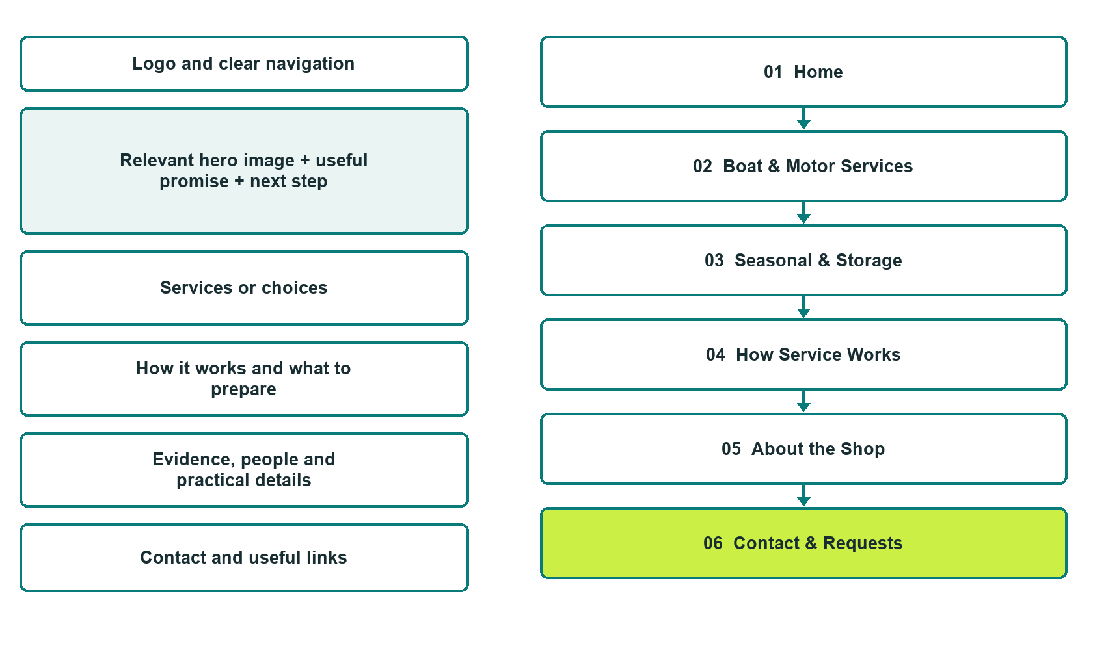

Plan → Draft → Build → Test
Demo-capture edition: actual Website Builder desktop previews and excerpts of the example wording. See each matching mobile preview in the industry page gallery. The example business and its AI-generated photographs are fictional.
Explore Website Builder and compare plans

Before you build
Your business supplies the facts. Prairie Harbour Marine is a fictional teaching example, not a live service.

□ Request a marine-service assessment
□ Clear boat and motor compatibility boundaries
□ Written assessment and work-approval process
□ Choose original photographs and confirm permission to use them.
□ Keep private customer records out of public website forms.

Your audience and the action you want them to take

Facts to verify and people who must approve them
Create your SaaSTech account

01 Home
Give this page one clear job in the customer journey.
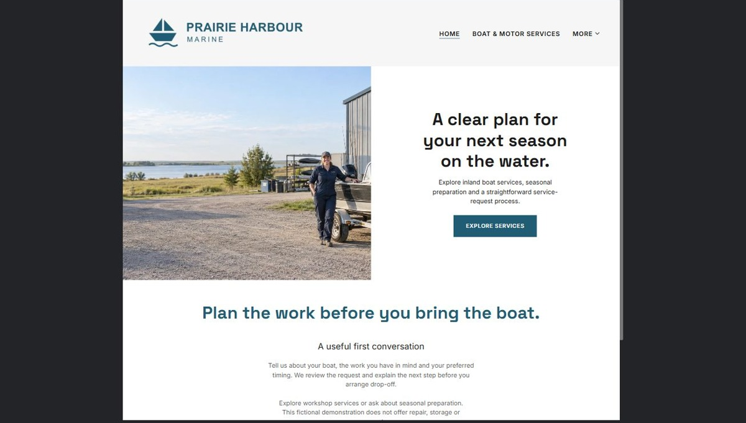
Actual desktop preview - unpublished fictional demonstration

Demo wording excerpt to adapt and verify
A clear plan for your next season on the water.
Explore inland boat services, seasonal preparation and a straightforward service-request process.
Tell us about your boat, the work you have in mind and your preferred timing. We review the request and explain the next step before you arrange drop-off.
Explore workshop services or ask about seasonal preparation. This fictional demonstration does not offer repair, storage or rescue services.
Suggested button: Explore services

Website advice
Introduce the fictional Prairie Harbour Marine as an inland Saskatchewan service shop. Lead with the work offered and a service-request button; separate repair enquiries from seasonal storage questions.

Your draft: Home
Write in the voice of your own business. Use facts you can verify, not promises copied from the example.

Headline and short introduction

Main content and details visitors need

Button wording and destination

Photo choice, permission and facts still to confirm
Partner check: can someone unfamiliar with the business find a useful next step?

02 Boat & Motor Services
Give this page one clear job in the customer journey.
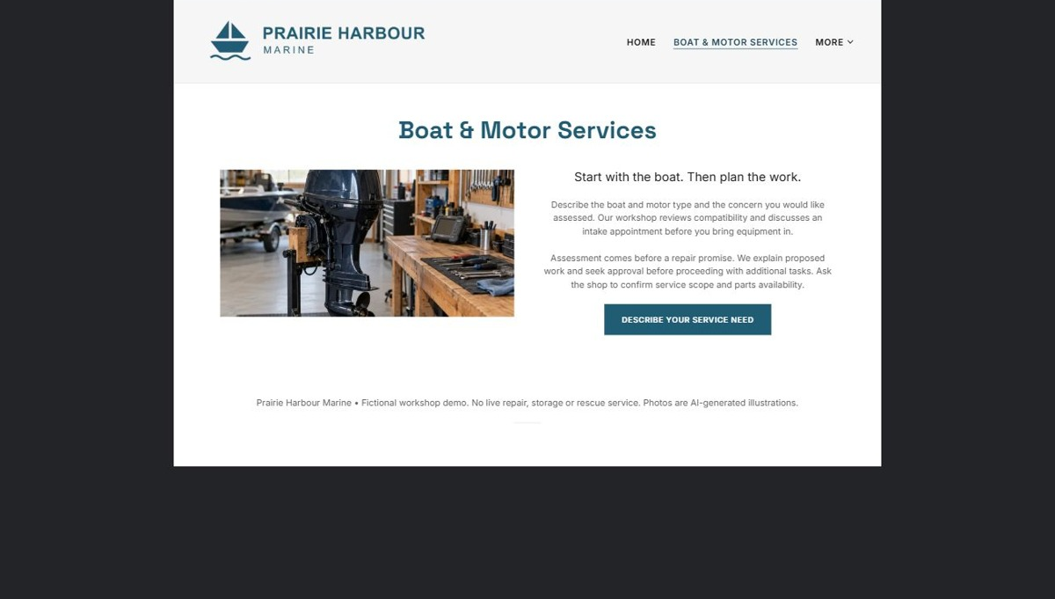
Actual desktop preview - unpublished fictional demonstration

Demo wording excerpt to adapt and verify
Start with the boat. Then plan the work.
Describe the boat and motor type and the concern you would like assessed. Our workshop reviews compatibility and discusses an intake appointment before you bring equipment in.
Assessment comes before a repair promise. We explain proposed work and seek approval before proceeding with additional tasks. Ask the shop to confirm service scope and parts availability.
Suggested button: Describe your service need

Website advice
Group verified services by customer need, such as maintenance, diagnostic assessment and accessory installation. Explain which boat and motor types the shop accepts, what happens during assessment and how additional work is approved.

Your draft: Boat & Motor Services
Write in the voice of your own business. Use facts you can verify, not promises copied from the example.

Headline and short introduction

Main content and details visitors need

Button wording and destination

Photo choice, permission and facts still to confirm
Partner check: can someone unfamiliar with the business find a useful next step?

03 Seasonal & Storage
Give this page one clear job in the customer journey.
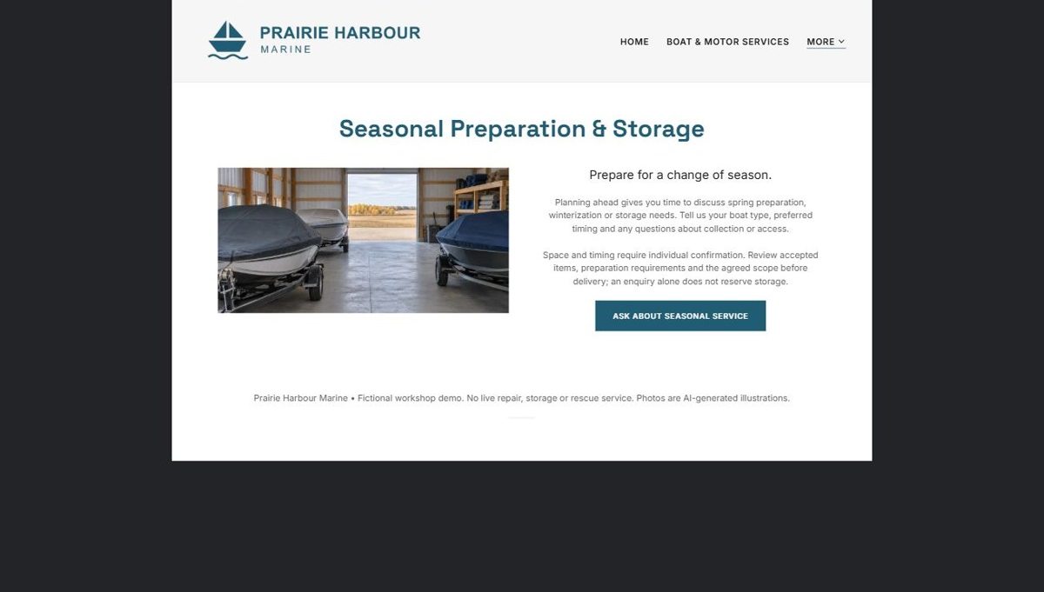
Actual desktop preview - unpublished fictional demonstration

Demo wording excerpt to adapt and verify
Prepare for a change of season.
Planning ahead gives you time to discuss spring preparation, winterization or storage needs. Tell us your boat type, preferred timing and any questions about collection or access.
Space and timing require individual confirmation. Review accepted items, preparation requirements and the agreed scope before delivery; an enquiry alone does not reserve storage.
Suggested button: Ask about seasonal service

Website advice
Describe spring preparation, winterization and storage only where actually offered. State intake steps, access arrangements and what customers must confirm. Do not imply that a request reserves storage space or guarantees weather protection.

Your draft: Seasonal & Storage
Write in the voice of your own business. Use facts you can verify, not promises copied from the example.

Headline and short introduction

Main content and details visitors need

Button wording and destination

Photo choice, permission and facts still to confirm
Partner check: can someone unfamiliar with the business find a useful next step?

04 How Service Works
Give this page one clear job in the customer journey.
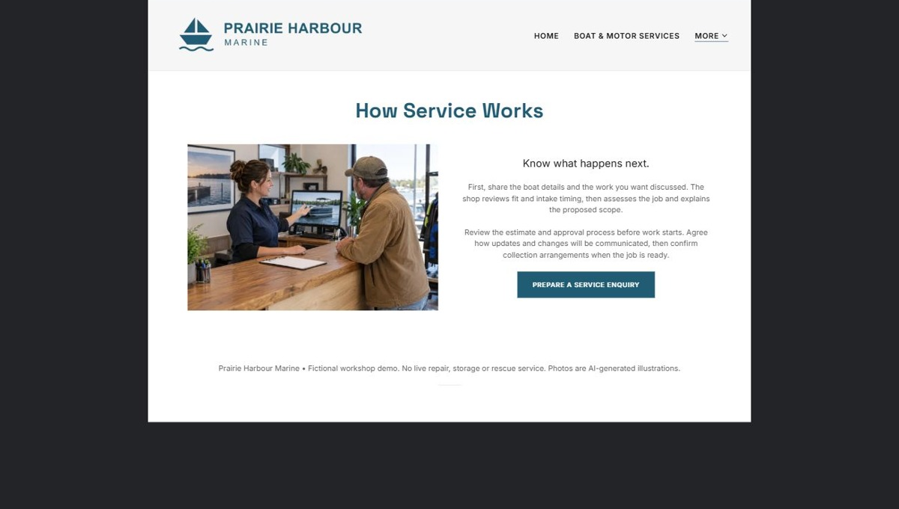
Actual desktop preview - unpublished fictional demonstration

Demo wording excerpt to adapt and verify
Know what happens next.
First, share the boat details and the work you want discussed. The shop reviews fit and intake timing, then assesses the job and explains the proposed scope.
Review the estimate and approval process before work starts. Agree how updates and changes will be communicated, then confirm collection arrangements when the job is ready.
Suggested button: Prepare a service enquiry

Website advice
Walk through request, compatibility review, intake, assessment, estimate approval, work updates and collection. Explain the difference between an initial estimate and authorized work without inventing turnaround guarantees.

Your draft: How Service Works
Write in the voice of your own business. Use facts you can verify, not promises copied from the example.

Headline and short introduction

Main content and details visitors need

Button wording and destination

Photo choice, permission and facts still to confirm
Partner check: can someone unfamiliar with the business find a useful next step?

05 About the Shop
Give this page one clear job in the customer journey.
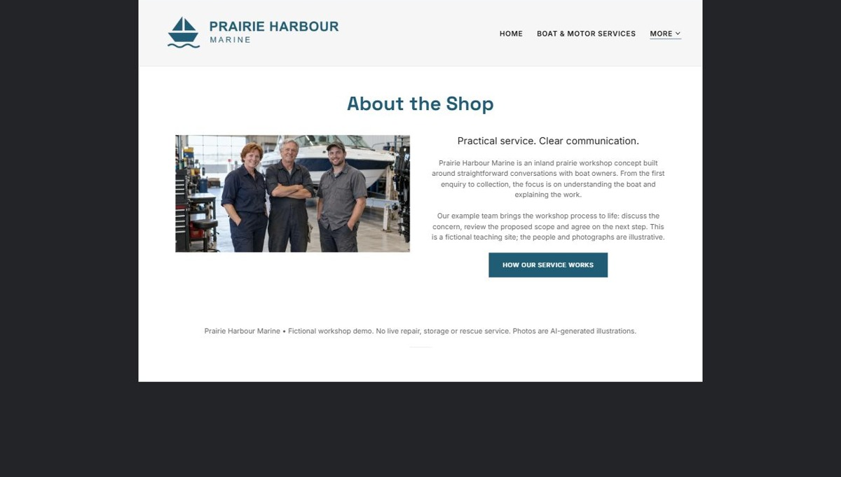
Actual desktop preview - unpublished fictional demonstration

Demo wording excerpt to adapt and verify
Practical service. Clear communication.
Prairie Harbour Marine is an inland prairie workshop concept built around straightforward conversations with boat owners. From the first enquiry to collection, the focus is on understanding the boat and explaining the work.
Our example team brings the workshop process to life: discuss the concern, review the proposed scope and agree on the next step. This is a fictional teaching site; the people and photographs are illustrative.
Suggested button: How our service works

Website advice
Introduce the people, workshop and inland boating focus. Use permission-cleared portraits and verified training; do not claim manufacturer authorization, certifications or testimonials without evidence.

Your draft: About the Shop
Write in the voice of your own business. Use facts you can verify, not promises copied from the example.

Headline and short introduction

Main content and details visitors need

Button wording and destination

Photo choice, permission and facts still to confirm
Partner check: can someone unfamiliar with the business find a useful next step?

06 Contact & Requests
Give this page one clear job in the customer journey.
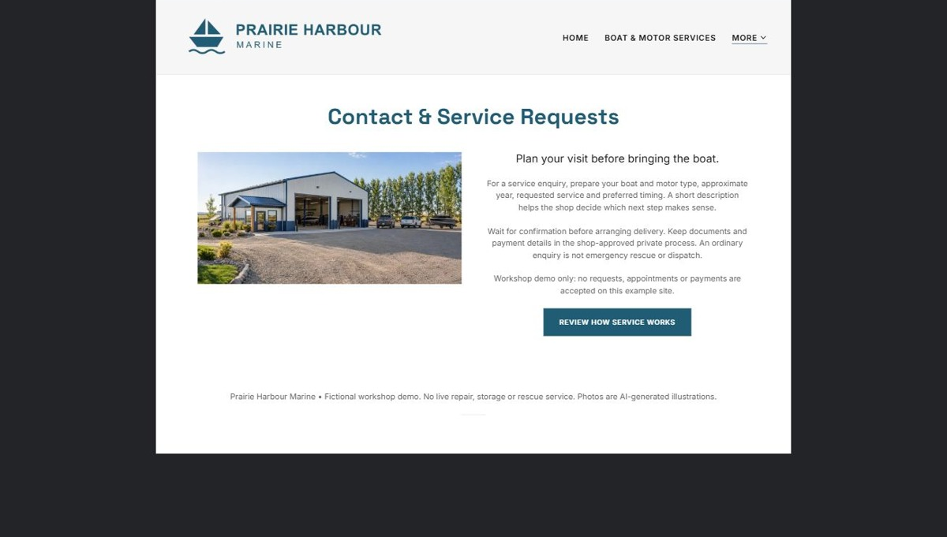
Actual desktop preview - unpublished fictional demonstration

Demo wording excerpt to adapt and verify
Plan your visit before bringing the boat.
For a service enquiry, prepare your boat and motor type, approximate year, requested service and preferred timing. A short description helps the shop decide which next step makes sense.
Wait for confirmation before arranging delivery. Keep documents and payment details in the shop-approved private process. An ordinary enquiry is not emergency rescue or dispatch.
Workshop demo only: no requests, appointments or payments are accepted on this example site.
Suggested button: Review how service works

Website advice
Show verified directions, drop-off access and hours. Collect contact details, boat/motor type, approximate year, requested service and preferred timing. Staff confirms acceptance and scheduling; the public form is not emergency rescue or dispatch.

Your draft: Contact & Requests
Write in the voice of your own business. Use facts you can verify, not promises copied from the example.

Headline and short introduction

Main content and details visitors need

Button wording and destination

Photo choice, permission and facts still to confirm
Partner check: can someone unfamiliar with the business find a useful next step?

Test before publishing
Review the whole journey on a desktop and phone. The industry page pairs each desktop capture with its mobile preview and provides the complete sample page copy.
□ Test the enquiry flow and confirmation message on a phone.
□ Confirm service scope, credentials, storage terms and seasonal dates with the operator.
□ Do not request payment cards, identity documents or access codes in a public form.
□ Verify each photo depicts the service discussed and does not imply work the shop cannot provide.
□ Replace fictional details before accepting enquiries; no live repair, storage or rescue service is offered by this demo.
□ Check every link, form destination, download and confirmation message.
□ Check logo contrast, hero framing, text sizes and image loading.
□ Save a named backup and assign a content-review date.

Changes to finish and person responsible

Approval and next review date
Website Builder plans and signup

