

Laundromats and Laundry Services
Website workbook
Plan six useful pages, study the Prairie Spin example and draft your own website. Use Word to type into the writing spaces or print this guide for a live workshop.
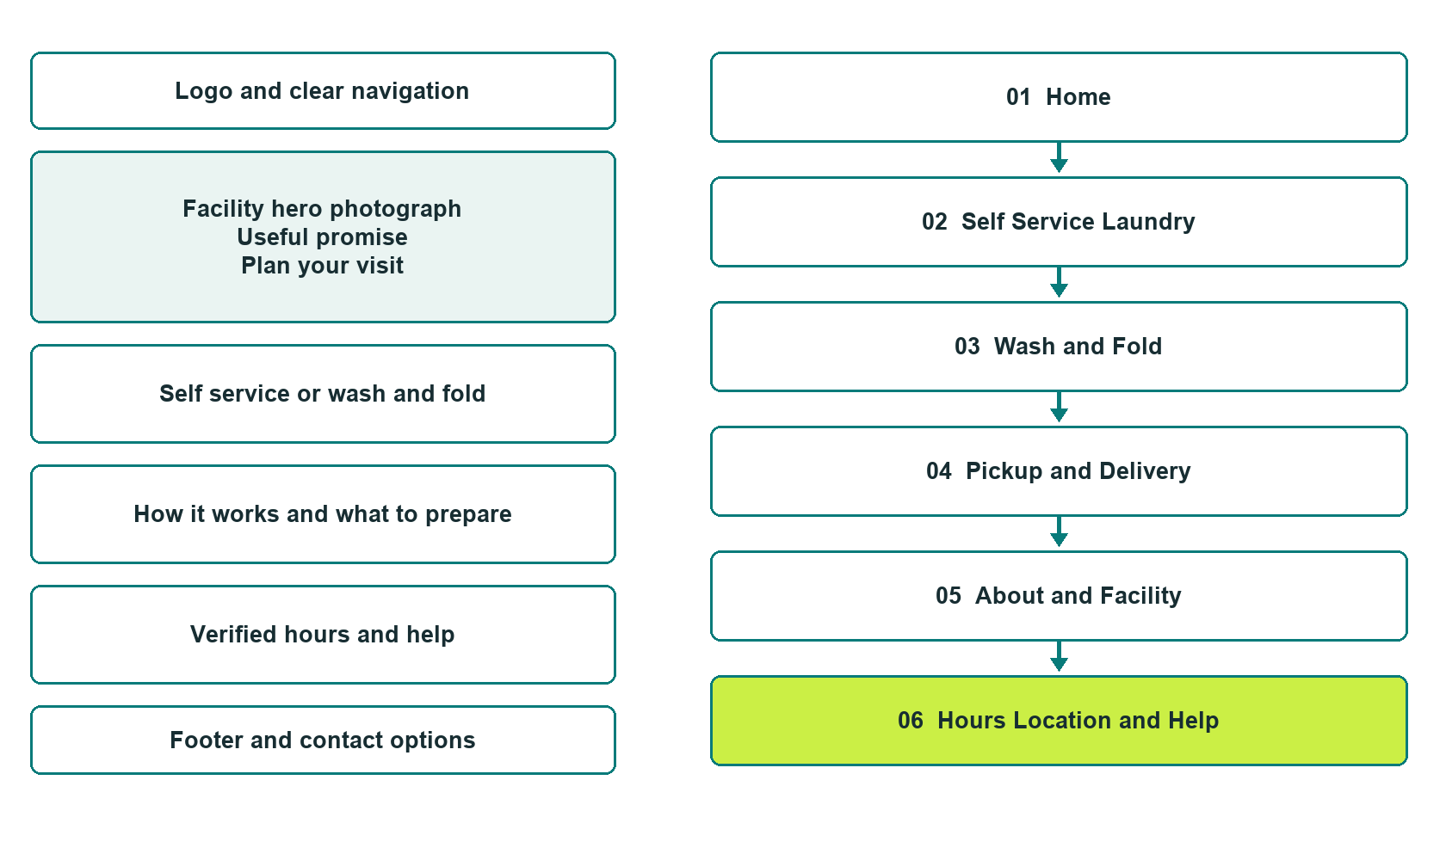

Learn then plan draft build and test
Bring verified business details, original photographs and a clear customer action.
Explore Website Builder and compare plans

Before you build
Work as the owner of your real business. Prairie Spin Laundry is a fictional teaching example; its services are not available to book.

□ Choose your main audience and service path.
□ Confirm equipment, payments, opening and attended hours, accessibility and service area.
□ Select distinct, relevant photos and confirm permission.
□ Choose a content owner and a process for keeping information current.
□ Compare Business Plus for enquiry and appointment features, then confirm current plan inclusions.

Your audience and primary action

Facts and approvals still needed
Create your SaaSTech account

Home
Help visitors choose self-service or a service enquiry, then find verified visiting details.
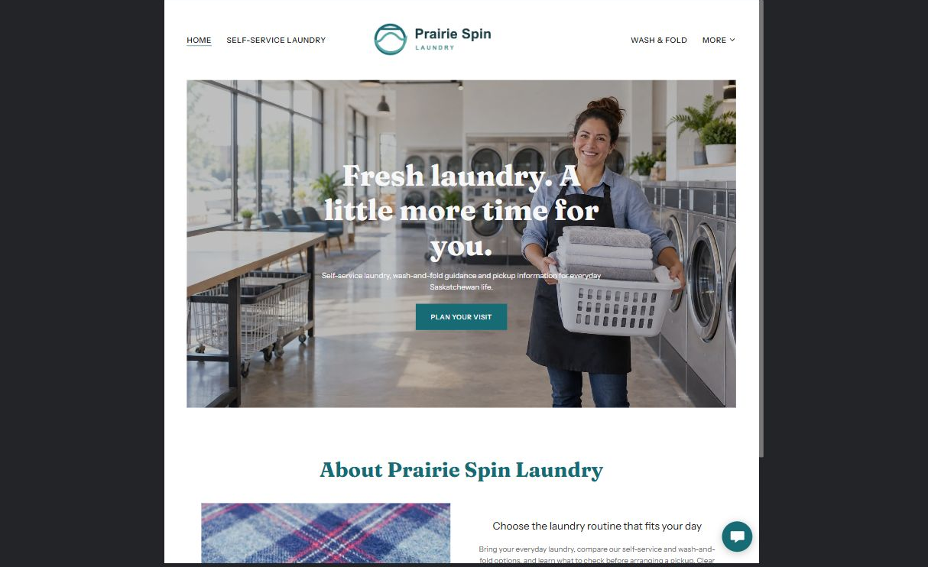

From the Prairie Spin demo
Fresh laundry. A little more time for you.
Self-service laundry, wash-and-fold guidance and pickup information for everyday Saskatchewan life.
Bring your everyday laundry, compare our self-service and wash-and-fold options, and learn what to check before arranging a pickup. Clear preparation tips and service information help make laundry day simpler. Prairie Spin Laundry is a fictional Saskatchewan business created for a SaaSTech website-building workshop; services are demonstrated, not available to book.

Website advice
Use a wide, original facility photo. Check the focal point on a phone. Make Plan your visit lead to current hours and directions.

Draft your home page
Which customer needs your laundry most, and what should they do first?

Headline and short introduction

Main content and verified details

Button wording and destination

Distinct photo and approvals
Partner check: can someone new to your business understand this page and find the next step?

Self Service Laundry
Prepare customers to choose and use your actual facility.
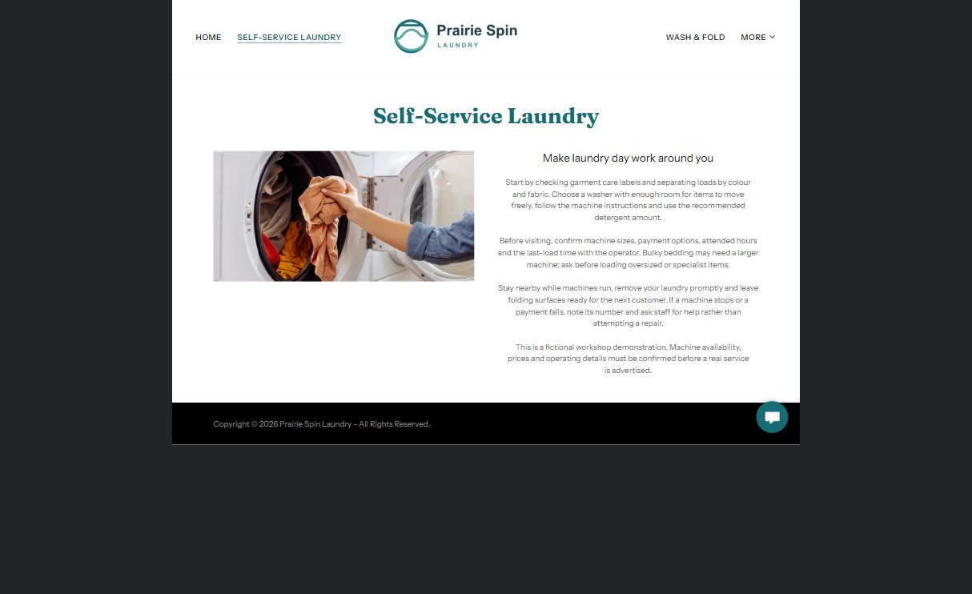

From the Prairie Spin demo
Make laundry day work around you
Start by checking garment care labels and separating loads by colour and fabric. Choose a washer with enough room for items to move freely, follow the machine instructions and use the recommended detergent amount.
Before visiting, confirm machine sizes, payment options, attended hours and the last-load time with the operator. Bulky bedding may need a larger machine; ask before loading oversized or specialist items.

Website advice
List verified machine sizes, payments and last-load guidance. Explain how to ask for help. Use manufacturer instructions rather than inventing universal cycle settings.

Draft your self service laundry page
What would a first-time visitor need to bring or check?

Headline and short introduction

Main content and verified details

Button wording and destination

Distinct photo and approvals
Partner check: can someone new to your business understand this page and find the next step?

Wash and Fold
Explain intake, suitability, turnaround and collection before customers hand over clothing.
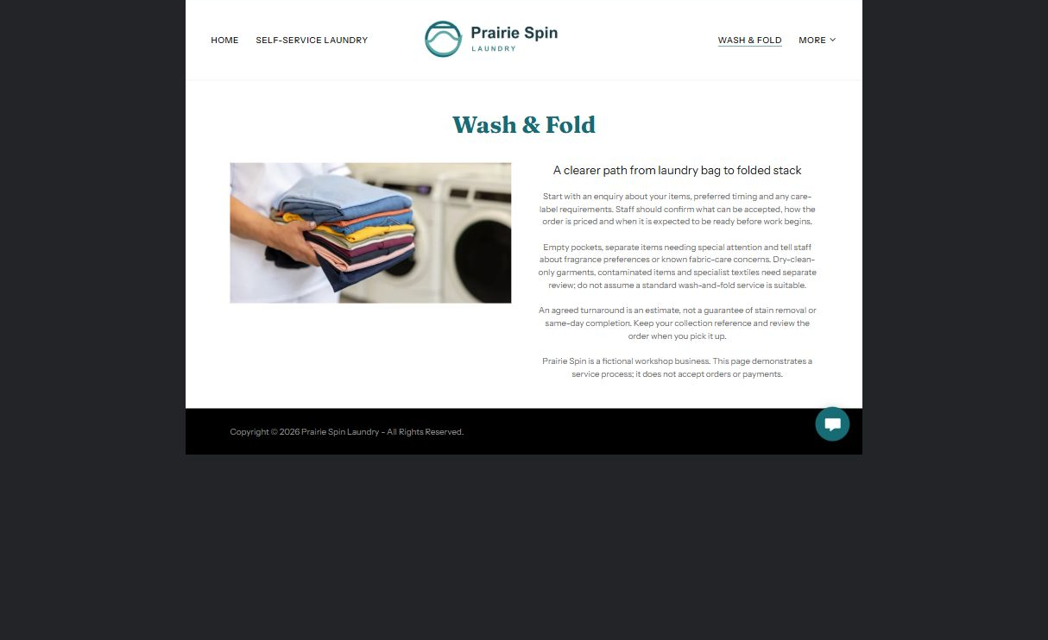

From the Prairie Spin demo
A clearer path from laundry bag to folded stack
Start with an enquiry about your items, preferred timing and any care-label requirements. Staff should confirm what can be accepted, how the order is priced and when it is expected to be ready before work begins.
An agreed turnaround is an estimate, not a guarantee of stain removal or same-day completion. Keep your collection reference and review the order when you pick it up.

Website advice
Explain accepted and excluded items, minimums and how pricing is confirmed. Never imply that every care label or stain can be handled. Show a distinct folding or handover photo.

Draft your wash and fold page
Which facts must staff confirm before accepting an order?

Headline and short introduction

Main content and verified details

Button wording and destination

Distinct photo and approvals
Partner check: can someone new to your business understand this page and find the next step?

Pickup and Delivery
Separate a requested window from a confirmed collection.
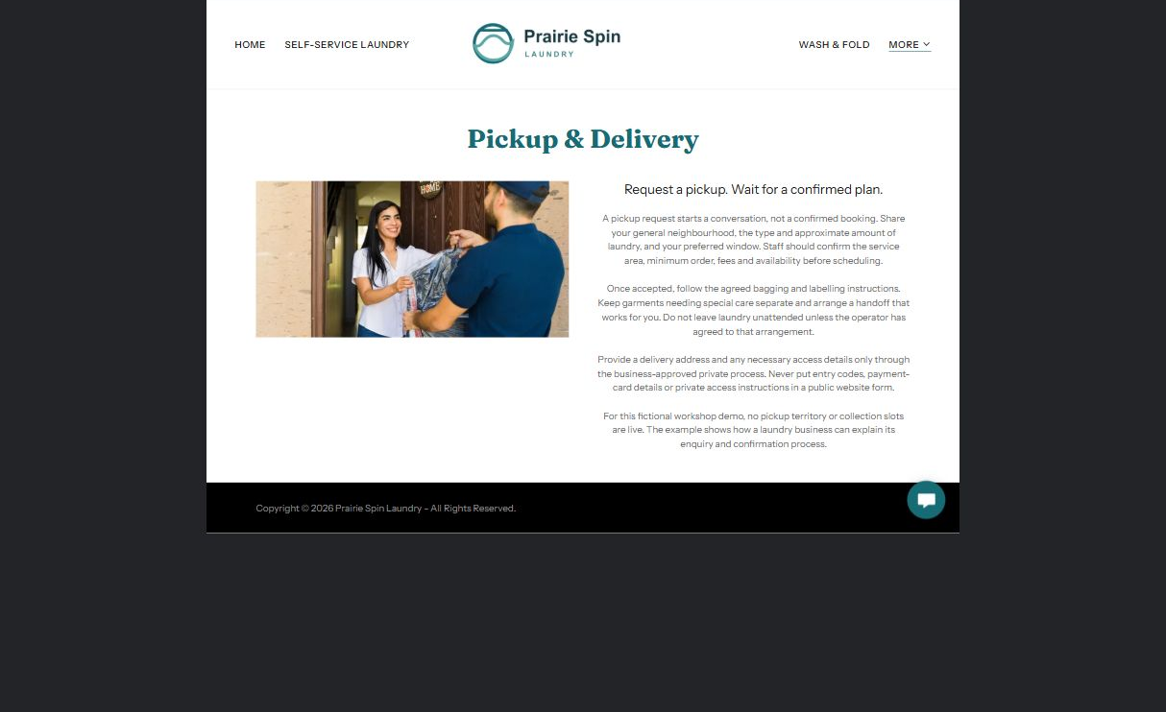

From the Prairie Spin demo
Request a pickup. Wait for a confirmed plan.
A pickup request starts a conversation, not a confirmed booking. Share your general neighbourhood, the type and approximate amount of laundry, and your preferred window. Staff should confirm the service area, minimum order, fees and availability before scheduling.
Provide a delivery address and any necessary access details only through the business-approved private process. Never put entry codes, payment-card details or private access instructions in a public website form.

Website advice
Publish only your verified area, fees and handoff process. Keep access details and payment information out of public forms. Test confirmation messages before advertising online requests.

Draft your pickup and delivery page
How will a customer know that the pickup is confirmed?

Headline and short introduction

Main content and verified details

Button wording and destination

Distinct photo and approvals
Partner check: can someone new to your business understand this page and find the next step?

About and Facility
Show the people, space and practical help behind the business.
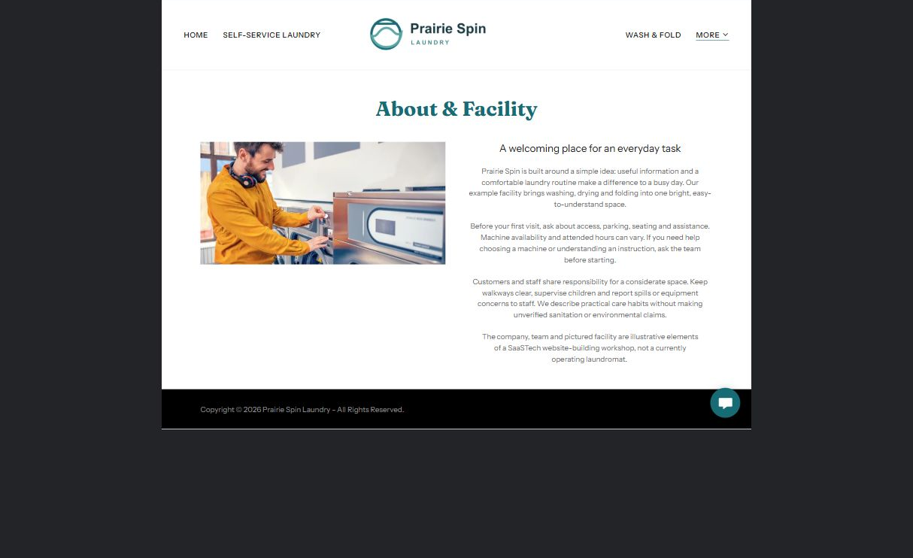

From the Prairie Spin demo
A welcoming place for an everyday task
Prairie Spin is built around a simple idea: useful information and a comfortable laundry routine make a difference to a busy day. Our example facility brings washing, drying and folding into one bright, easy-to-understand space.
Before your first visit, ask about access, parking, seating and assistance. Machine availability and attended hours can vary. If you need help choosing a machine or understanding an instruction, ask the team before starting.

Website advice
Use permission-cleared team and facility photographs. Verify access and environmental claims directly. A photo alone does not establish accessibility or sanitation standards.

Draft your about and facility page
What can your real facility demonstrate, rather than just claim?

Headline and short introduction

Main content and verified details

Button wording and destination

Distinct photo and approvals
Partner check: can someone new to your business understand this page and find the next step?

Hours Location and Help
Give customers a dependable next step before visiting or asking for assistance.
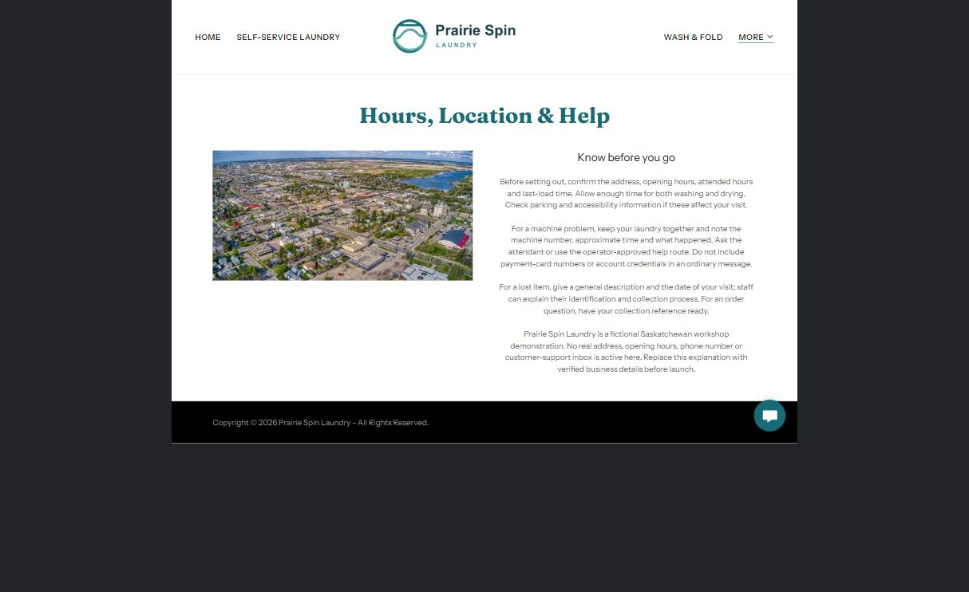

From the Prairie Spin demo
Know before you go
Before setting out, confirm the address, opening hours, attended hours and last-load time. Allow enough time for both washing and drying. Check parking and accessibility information if these affect your visit.
For a machine problem, keep your laundry together and note the machine number, approximate time and what happened. Ask the attendant or use the operator-approved help route. Do not include payment-card numbers or account credentials in an ordinary message.

Website advice
Use your actual map pin, hours and contact details only after checking them. Distinguish general opening from attended hours. Link to an approved private help route and test it on a phone.

Draft your hours location and help page
Who maintains these details and responds to each kind of question?

Headline and short introduction

Main content and verified details

Button wording and destination

Distinct photo and approvals
Partner check: can someone new to your business understand this page and find the next step?

Test before publishing
Walk through the finished site with someone unfamiliar with your business. Check the full customer journey on both desktop and phone.
□ Every page answers a distinct question and has a clear next step.
□ The hero focal point, logo contrast, text and menus work at phone width.
□ Photographs match the content and are not repeated across pages.
□ Hours, map, machine details, services and prices are verified.
□ Configured enquiries reach the right person; confirmation does not imply an unapproved booking.
□ Forms do not request payment details, entry codes or unnecessary private information.
□ Downloads open, and privacy wording and business policies have been reviewed.
□ Save a named backup and assign a future content-review date.

Changes to finish and person responsible

Approval and next review date
Website Builder plans and signup

