

Irrigation Contractors
Website workbook
A practical workshop for a 6-page website. Study the example, plan the content and draft your own version in Word or on paper.
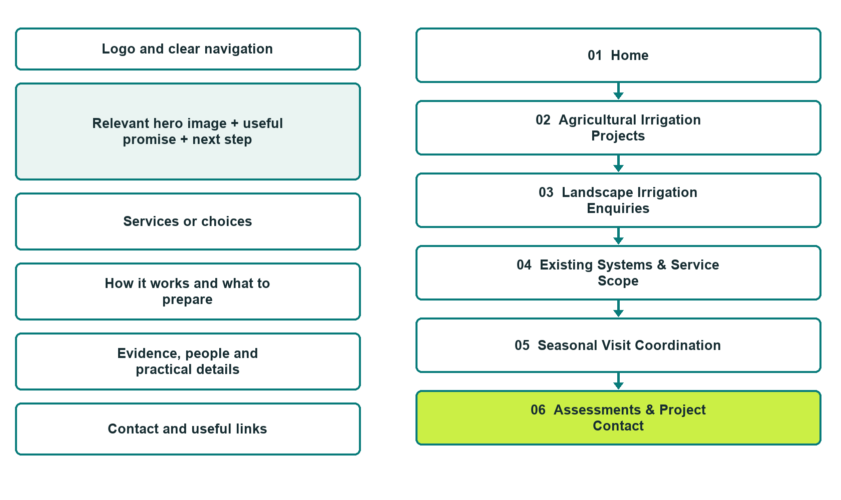

Plan → Draft → Build → Test
Captured demo edition. Study the unpublished six-page example. The gallery pairs desktop with mobile and includes Editor Highlights, Themes and Paint settings.
Explore Website Builder and compare plans

Before you build
Your business supplies the facts. Prairie Field & Garden Waterworks is a fictional teaching example, not a live service.

□ Ask about irrigation
□ Verified business identity, services and current contact information
□ A clear enquiry, review and confirmation process
□ Choose original photographs and confirm permission to use them.
□ Keep private customer records out of public website forms.

Your audience and the action you want them to take

Facts to verify and people who must approve them
Create your SaaSTech account

01 Home
Give this page one clear job in the customer journey.
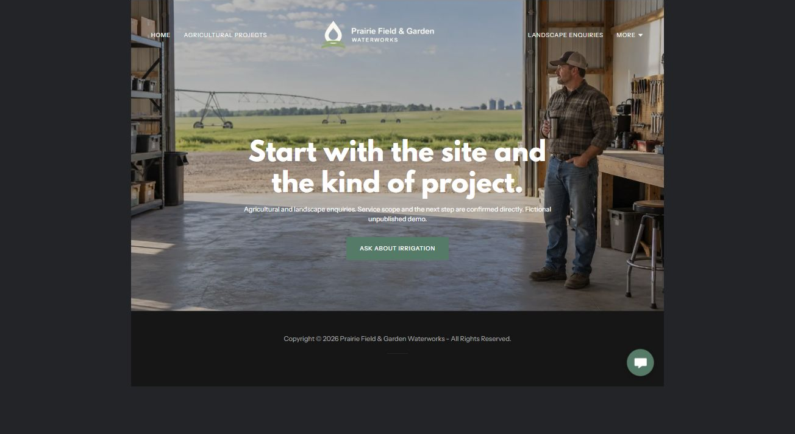
Actual desktop Website Builder preview. See the gallery for the paired mobile view.

Sample wording — adapt and verify
Start with the site and the kind of project.
Choose an agricultural or landscape enquiry and describe the general site and project stage.
The coordinator confirms whether the team covers that category before discussing assessment information, proposals or seasonal scheduling.
Suggested button: Ask about irrigation. Link to Project Contact.

Website advice
Separate agricultural irrigation from residential and commercial landscape systems, with assessment, seasonal coordination and service enquiries.

Your draft: Home
Write in the voice of your own business. Use facts you can verify, not promises copied from the example.

Headline and short introduction

Main content and details visitors need

Button wording and destination

Photo choice, permission and facts still to confirm
Partner check: can someone unfamiliar with the business find a useful next step?

02 Agricultural Irrigation Projects
Give this page one clear job in the customer journey.
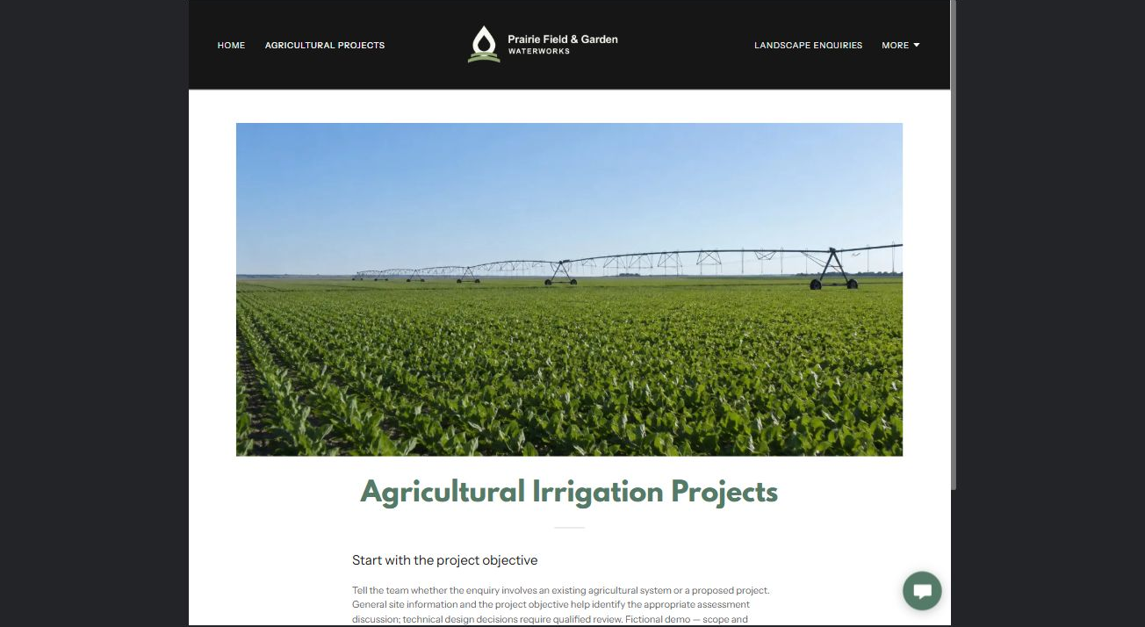
Actual desktop Website Builder preview. See the gallery for the paired mobile view.

Sample wording — adapt and verify
Agricultural Irrigation Projects
Tell the team whether the enquiry involves an existing agricultural system or a proposed project.
General site information and the project objective help identify the appropriate assessment discussion; technical design decisions require qualified review.
Suggested button: Ask about irrigation. Link to Project Contact.

Website advice
Describe supported farm project categories without engineering recommendations or yield claims.

Your draft: Agricultural Irrigation Projects
Write in the voice of your own business. Use facts you can verify, not promises copied from the example.

Headline and short introduction

Main content and details visitors need

Button wording and destination

Photo choice, permission and facts still to confirm
Partner check: can someone unfamiliar with the business find a useful next step?

03 Landscape Irrigation Enquiries
Give this page one clear job in the customer journey.
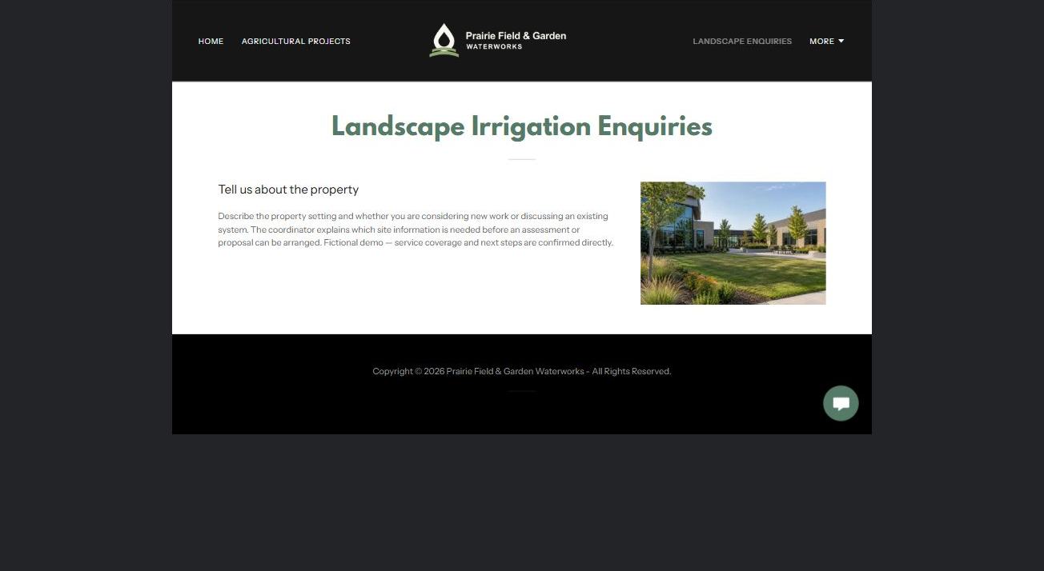
Actual desktop Website Builder preview. See the gallery for the paired mobile view.

Sample wording — adapt and verify
Landscape Irrigation Enquiries
Describe the property setting and whether you are considering new work or discussing an existing system.
The coordinator explains which site information is needed before an assessment or proposal can be arranged.
Suggested button: Ask about irrigation. Link to Project Contact.

Website advice
Separate residential gardens, commercial grounds and other verified landscape categories.

Your draft: Landscape Irrigation Enquiries
Write in the voice of your own business. Use facts you can verify, not promises copied from the example.

Headline and short introduction

Main content and details visitors need

Button wording and destination

Photo choice, permission and facts still to confirm
Partner check: can someone unfamiliar with the business find a useful next step?

04 Existing Systems & Service Scope
Give this page one clear job in the customer journey.
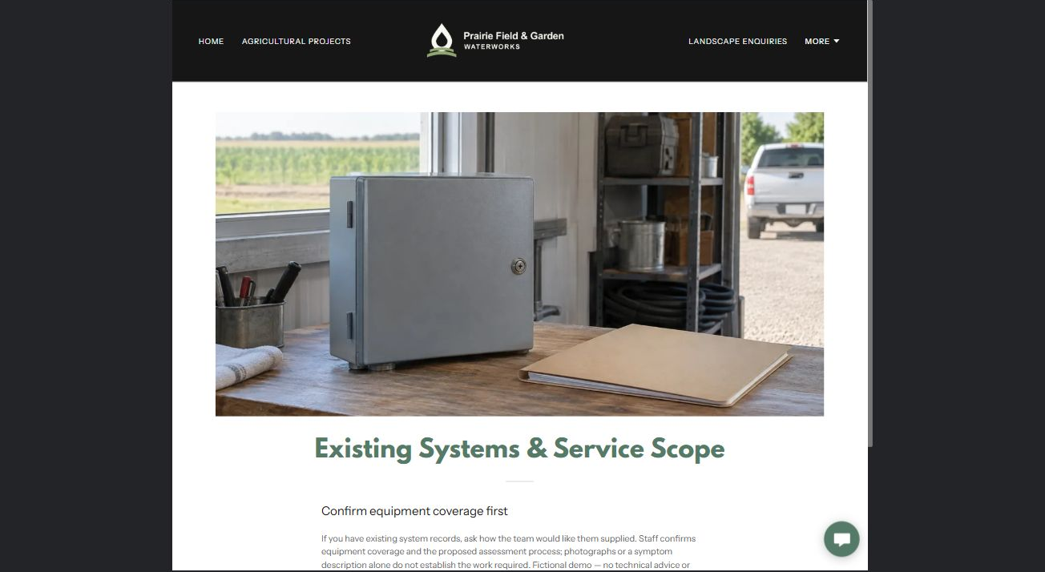
Actual desktop Website Builder preview. See the gallery for the paired mobile view.

Sample wording — adapt and verify
Existing Systems & Service Scope
If you have existing system records, ask how the team would like them supplied.
Staff confirms equipment coverage and the proposed assessment process; photographs or a symptom description alone do not establish the work required.
Suggested button: Ask about irrigation. Link to Project Contact.

Website advice
Help customers identify administrative equipment references and service categories without troubleshooting.

Your draft: Existing Systems & Service Scope
Write in the voice of your own business. Use facts you can verify, not promises copied from the example.

Headline and short introduction

Main content and details visitors need

Button wording and destination

Photo choice, permission and facts still to confirm
Partner check: can someone unfamiliar with the business find a useful next step?

05 Seasonal Visit Coordination
Give this page one clear job in the customer journey.
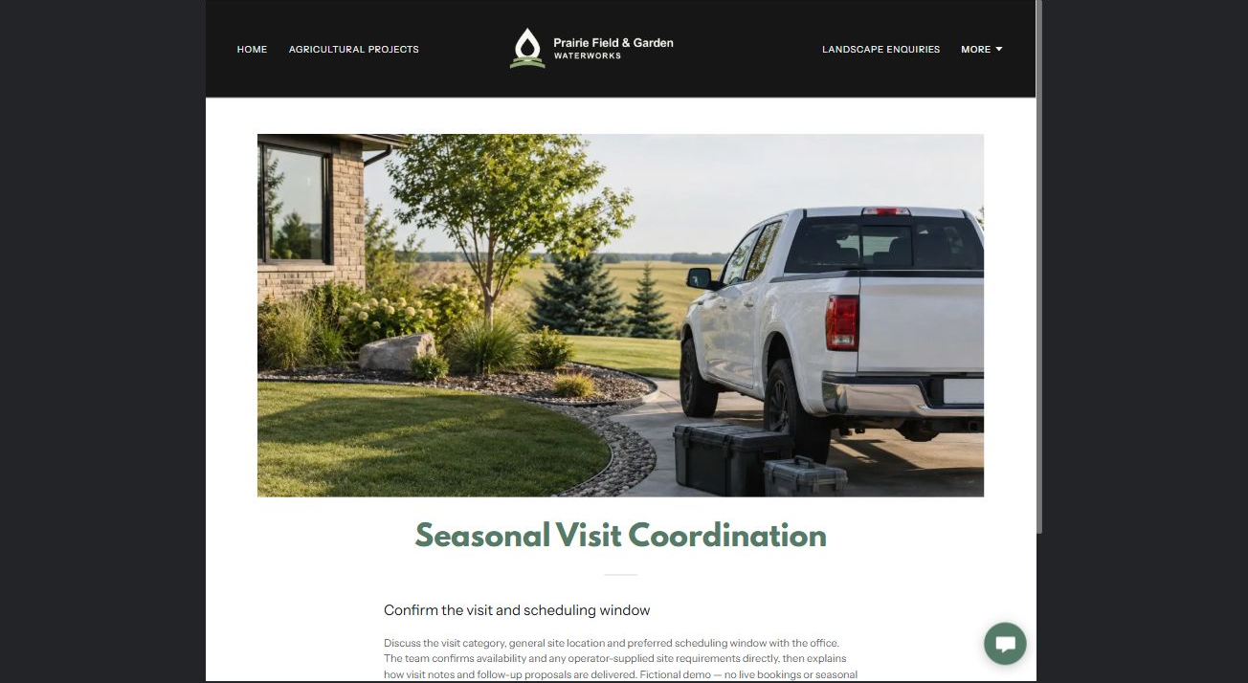
Actual desktop Website Builder preview. See the gallery for the paired mobile view.

Sample wording — adapt and verify
Seasonal Visit Coordination
Discuss the visit category, general site location and preferred scheduling window with the office.
The team confirms availability and any operator-supplied site requirements directly, then explains how visit notes and follow-up proposals are delivered.
Suggested button: Ask about irrigation. Link to Project Contact.

Website advice
Present seasonal service scheduling and handover expectations without operational instructions.

Your draft: Seasonal Visit Coordination
Write in the voice of your own business. Use facts you can verify, not promises copied from the example.

Headline and short introduction

Main content and details visitors need

Button wording and destination

Photo choice, permission and facts still to confirm
Partner check: can someone unfamiliar with the business find a useful next step?

06 Assessments & Project Contact
Give this page one clear job in the customer journey.
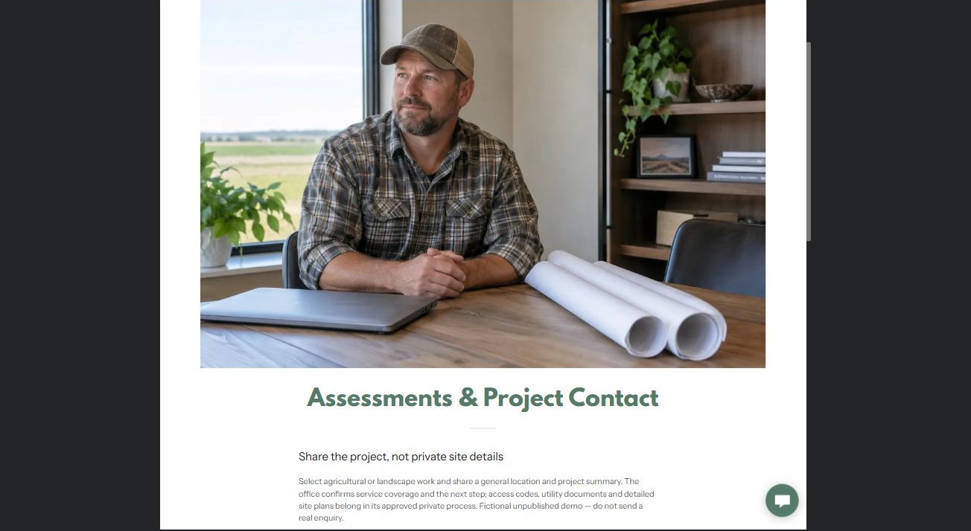
Actual desktop Website Builder preview. See the gallery for the paired mobile view.

Sample wording — adapt and verify
Assessments & Project Contact
Select agricultural or landscape work and share a general location and project summary.
The office confirms service coverage and the next step; access codes, utility documents and detailed site plans belong in its approved private process.
Suggested button: Ask about irrigation. Link to Project Contact.

Website advice
The demo form has Name, required Email, agricultural or landscape enquiry, and a general location and project summary. Phone and attachments are off; the recipient is blank. No submission or delivery test was performed. An enquiry is not a booking, estimate or approved work. Keep access codes, private plans and payment details out. Configure delivery and consent before a real launch.

Your draft: Assessments & Project Contact
Write in the voice of your own business. Use facts you can verify, not promises copied from the example.

Headline and short introduction

Main content and details visitors need

Button wording and destination

Photo choice, permission and facts still to confirm
Partner check: can someone unfamiliar with the business find a useful next step?

Test before publishing
Review the captured journey on desktop and phone. The fictional demo remains unpublished. Verify service coverage, qualifications, form delivery and operator approval before a real launch.
□ Fictional demonstration only. Verify system coverage, qualifications, water-source requirements and service areas. No design, hydraulic, electrical, winterization or water-use advice; do not promise water savings, crop results, permit approval or system performance.
□ Verify every service description, contact route and operating detail.
□ Replace fictional identity and example information before a live launch.
□ Test enquiries, links and downloads on desktop and mobile.
□ Keep confidential records in approved private systems.
□ Obtain operator approval for public wording and images.
□ Check every link, form destination, download and confirmation message.
□ Check logo contrast, hero framing, text sizes and image loading.
□ Save a named backup and assign a content-review date.

Changes to finish and person responsible

Approval and next review date
Website Builder plans and signup

