
WEBSITE PLANNING WORKSHOP

Insurance Brokers & Brokerages
Website workbook
Plan a clear website for insurance brokers & brokerages. Explore a worked example, shape your own message and prepare to build with SaaSTech Servers.
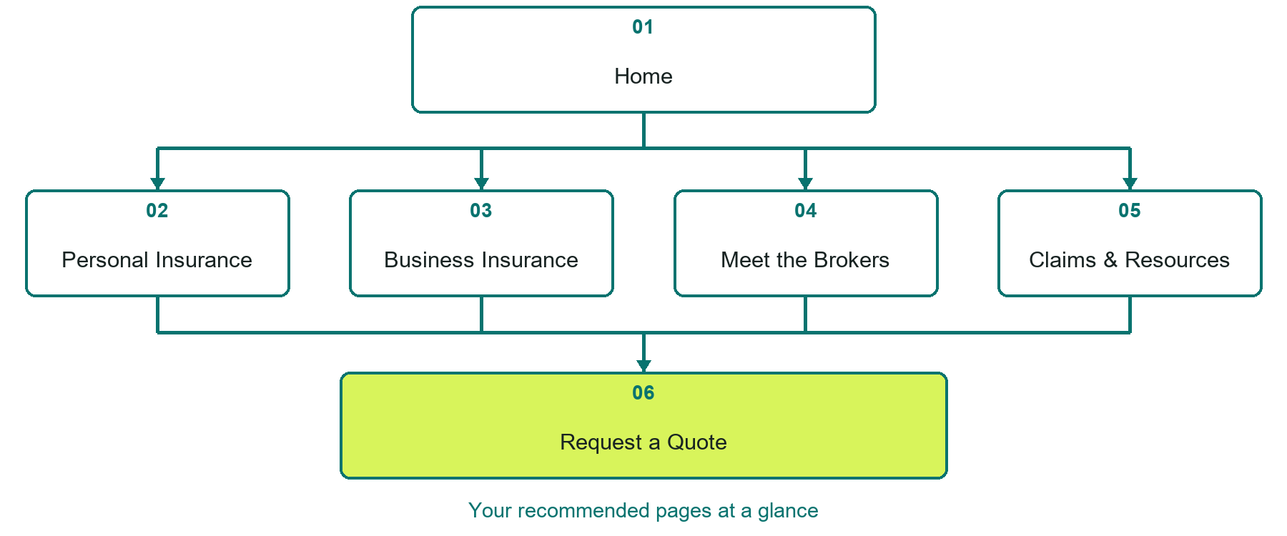

Inside this workbook
Six page examples • Practical writing exercises • A launch review
Use it in a workshop or at your own pace. Write by hand or complete the response fields in Word. The final page links to Website Builder, plans and account signup.
Example business Prairie Harbour Insurance

INSURANCE BROKERS & BROKERAGES

Your website brief
A SaaSTech Servers workshop for insurance brokers & brokerages. Plan your website, learn from the Prairie Harbour Insurance example and draft content for your own business.
Each page has a reference sheet followed by a writing sheet. Demo excerpts are labelled separately from new sample wording, which may differ from the screenshot. Click a blank response line to type; longer answers may add pages. Replace fictional details and verify every claim before publishing.
Your business or organization and workshop date

Who should visit your site and what do they need

The main action you want a visitor to take

What you offer and where or how you provide it

Facts photos and permissions to gather before publishing

Workshop rhythm: review the example, write your draft and exchange feedback. Use the final review to choose your next changes. Website Builder and account links are on the last page.

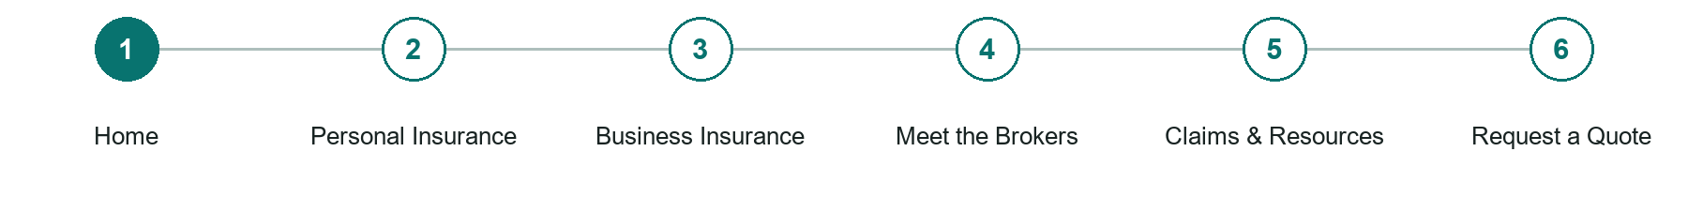
LOOK AND LEARN

Home

The job of this page
Introduce the brokerage, the communities it serves and the conversations it can help with. Use one clear next step. Verify all savings, credentials and insurer relationships before publishing.
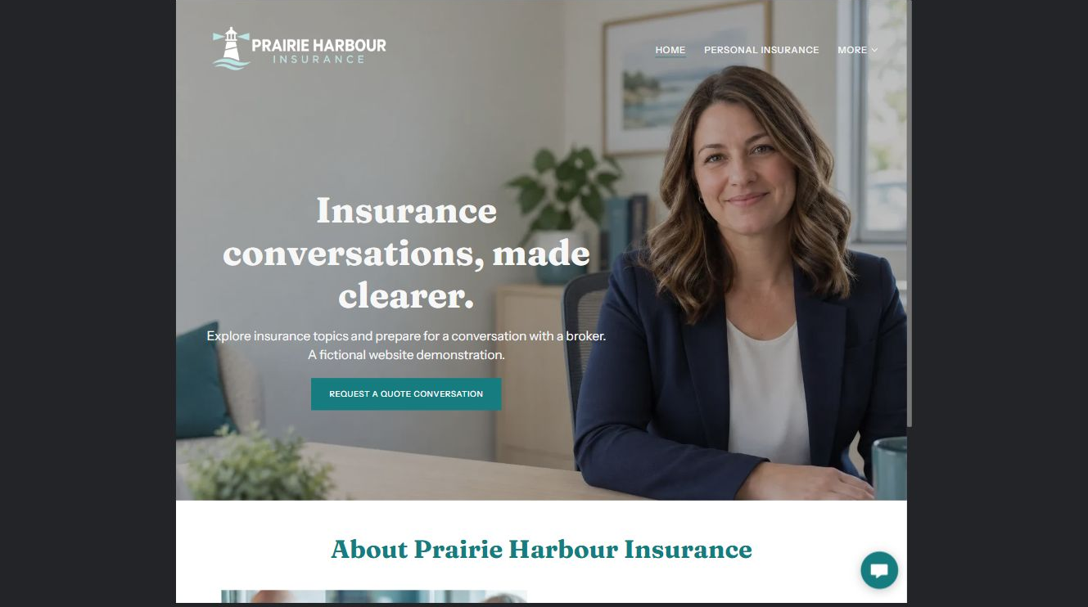
Prairie Harbour Insurance example | Explore SaaSTech Website Builder

Demo text example
Insurance conversations, made clearer.
Explore insurance topics and prepare for a conversation with a broker. A fictional website demonstration.

Pause and plan
Could a first-time visitor explain what you do and who it is for after one glance? Choose one main action and the strongest truthful detail that gives them confidence to continue.

WRITE YOUR PAGE

Home
Write for your visitor. Be specific about what they need to know and what happens next. You can revise the wording after the workshop.
Your page headline

Your opening paragraph

Your offer audience location and most useful supporting details

Button or link wording and where it should lead

Photo idea caption and permission or credit needed

Facts to verify or questions to resolve

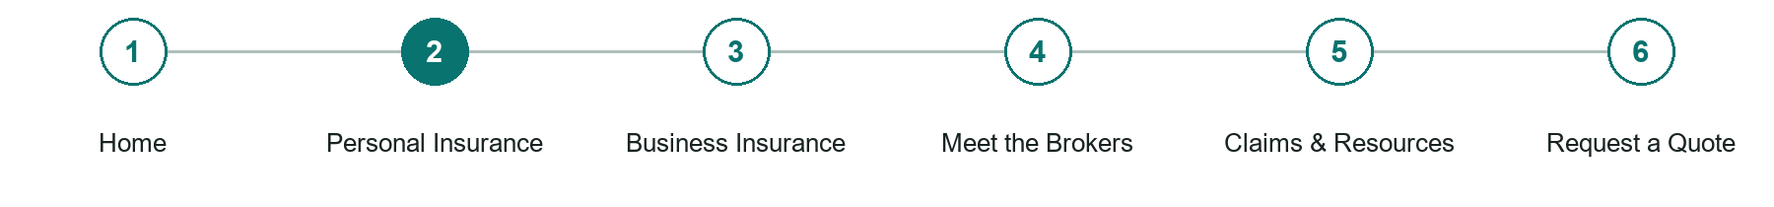
LOOK AND LEARN

Personal Insurance

The job of this page
Explain only the personal insurance categories your brokerage actually arranges. Help visitors prepare questions without promising eligibility or presenting examples as policy wording.
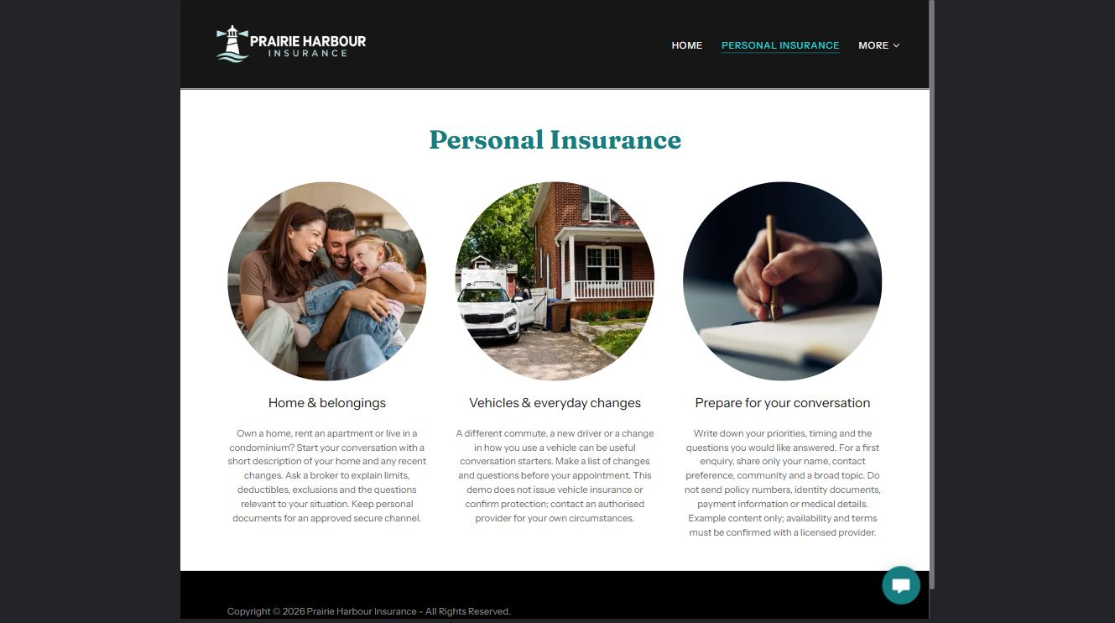
Prairie Harbour Insurance example | Explore SaaSTech Website Builder

New sample wording
Start with what you want to protect
Tell us whether your questions concern your home, belongings or a change in your everyday life. We can explain the next steps for a conversation with a broker. Any options, terms and availability require individual review.

Pause and plan
What question brings a visitor to this page? List the details they need, the evidence you can provide and the next useful action. Remove content that does not help them decide or proceed.

WRITE YOUR PAGE

Personal Insurance
Write for your visitor. Be specific about what they need to know and what happens next. You can revise the wording after the workshop.
Your page headline

Your opening paragraph

Key sections visitor questions and supporting details

Button or link wording and where it should lead

Photo idea caption and permission or credit needed

Facts to verify or questions to resolve

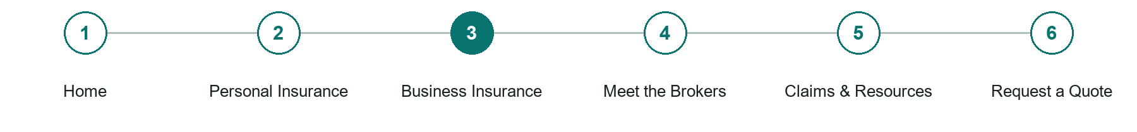
LOOK AND LEARN

Business Insurance

The job of this page
Help owners describe their activities, property and recent operational changes. Explain the conversation and review process without suggesting that one package covers every business.

Prairie Harbour Insurance example | Explore SaaSTech Website Builder

New sample wording
A conversation about your business
Start with what your business does, where it operates and what has changed. Prepare questions about property, equipment and activities so a broker can identify the information needed for a review.

Pause and plan
What question brings a visitor to this page? List the details they need, the evidence you can provide and the next useful action. Remove content that does not help them decide or proceed.

WRITE YOUR PAGE

Business Insurance
Write for your visitor. Be specific about what they need to know and what happens next. You can revise the wording after the workshop.
Your page headline

Your opening paragraph

Key sections visitor questions and supporting details

Button or link wording and where it should lead

Photo idea caption and permission or credit needed

Facts to verify or questions to resolve

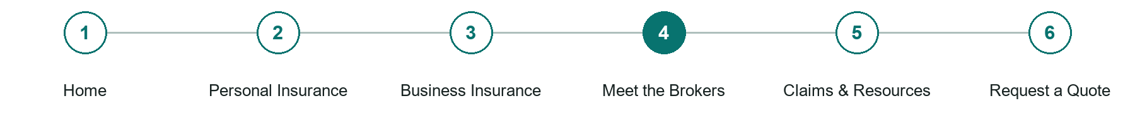
LOOK AND LEARN

Meet the Brokers

The job of this page
Use distinct portraits and verified roles. Obtain permission to publish names and photographs. Check specialties, experience and licence information. Label fictional example profiles clearly.
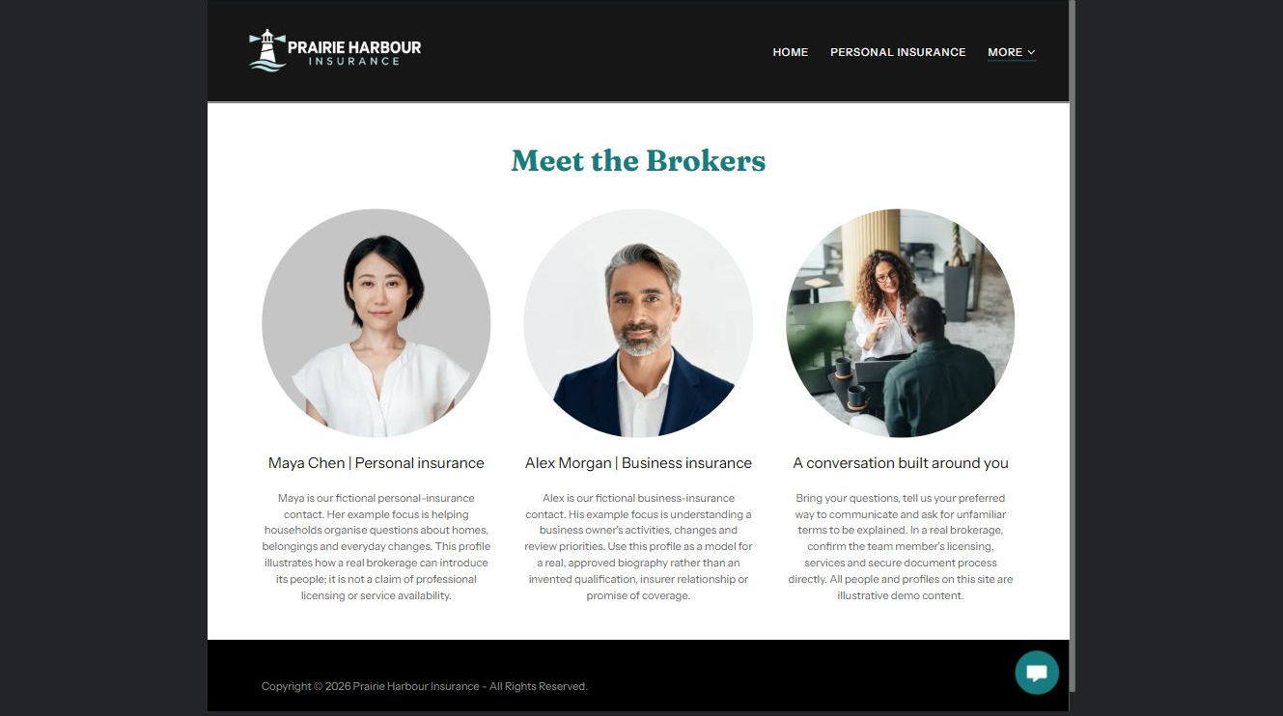
Prairie Harbour Insurance example | Explore SaaSTech Website Builder

New sample wording
Meet your first point of contact
In this fictional example, Maya introduces personal insurance conversations and Alex introduces business insurance conversations. On your own site, replace these profiles with your team's verified roles, biographies and permission-cleared portraits.

Pause and plan
What question brings a visitor to this page? List the details they need, the evidence you can provide and the next useful action. Remove content that does not help them decide or proceed.

WRITE YOUR PAGE

Meet the Brokers
Write for your visitor. Be specific about what they need to know and what happens next. You can revise the wording after the workshop.
Your page headline

Your opening paragraph

Key sections visitor questions and supporting details

Button or link wording and where it should lead

Photo idea caption and permission or credit needed

Facts to verify or questions to resolve

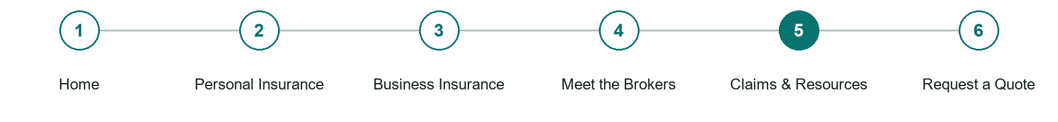
LOOK AND LEARN

Claims Resources

The job of this page
Point visitors to verified insurer contacts and explain which route to use. Keep office hours and links current. Do not receive claims documents through a basic public website form.
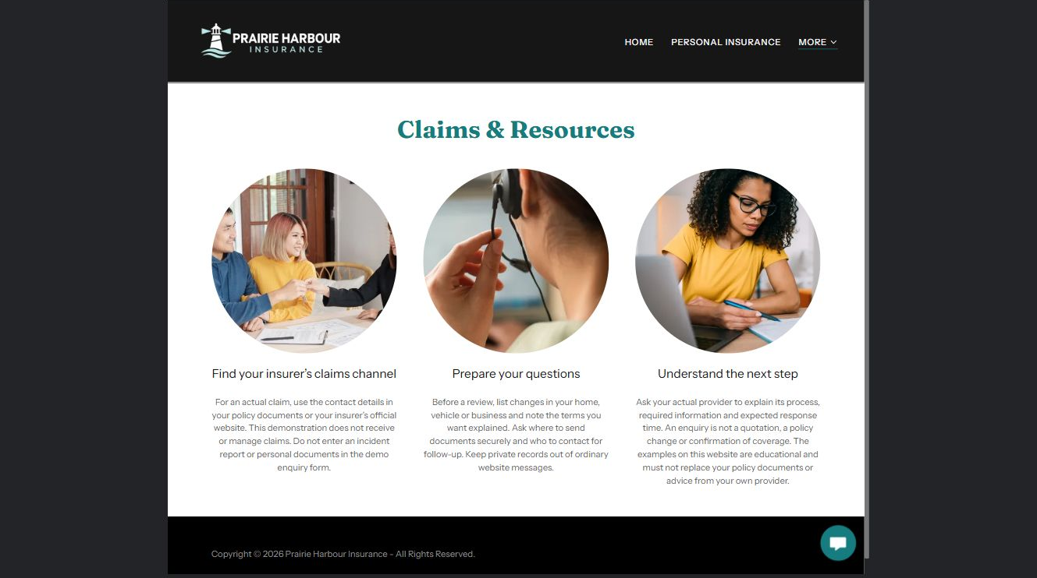
Prairie Harbour Insurance example | Explore SaaSTech Website Builder

New sample wording
Find the right next step
Use your insurer's current claims instructions and confirmed contact details. Keep a short list of questions for your conversation. This example website does not accept claims or arrange coverage; replace its placeholders with approved information before launch.

Pause and plan
What question brings a visitor to this page? List the details they need, the evidence you can provide and the next useful action. Remove content that does not help them decide or proceed.

WRITE YOUR PAGE

Claims Resources
Write for your visitor. Be specific about what they need to know and what happens next. You can revise the wording after the workshop.
Your page headline

Your opening paragraph

Key sections visitor questions and supporting details

Button or link wording and where it should lead

Photo idea caption and permission or credit needed

Facts to verify or questions to resolve

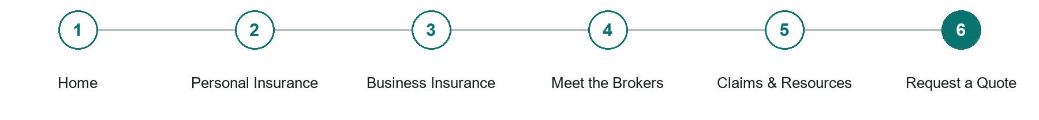
LOOK AND LEARN

Request a Quote

The job of this page
Request only contact details, general insurance interest and community. Explain the reply process. Keep policy numbers, identity documents, payment details and medical information out of a public form.
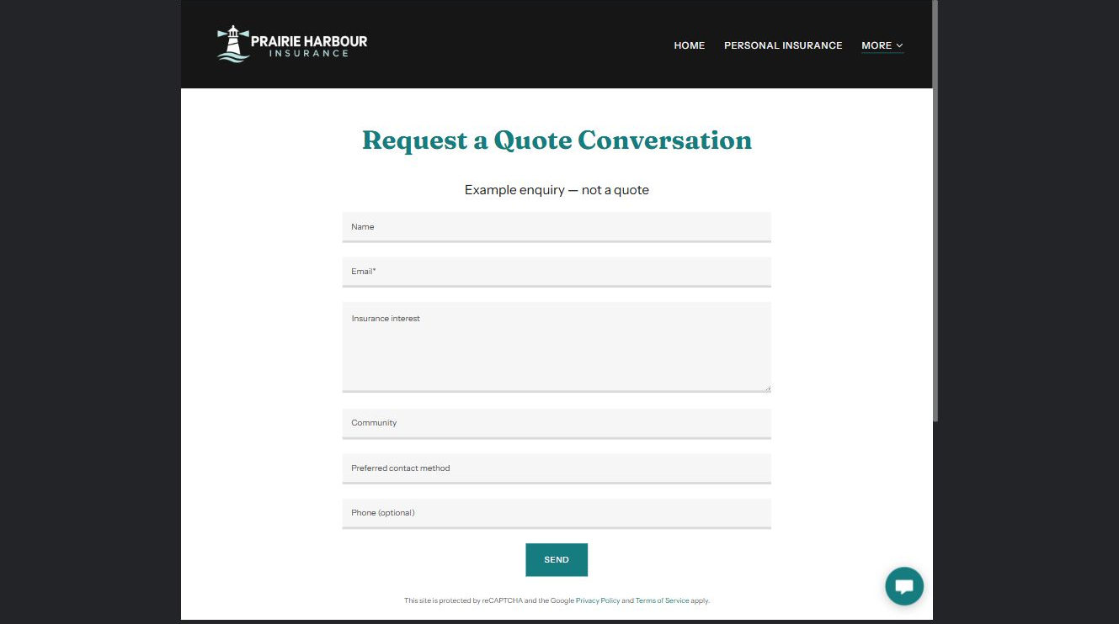
Prairie Harbour Insurance example | Explore SaaSTech Website Builder

Demo text example
Request a Quote Conversation
Example enquiry — not a quote

Pause and plan
What must someone provide, and what happens after they send it? Separate a request from a confirmed booking, order or place. Decide what information should stay out of a public form.

WRITE YOUR PAGE

Request a Quote
Write for your visitor. Be specific about what they need to know and what happens next. You can revise the wording after the workshop.
Your page headline

Your opening paragraph

Information to request and how you will reply or confirm

Button or link wording and where it should lead

Photo idea caption and permission or credit needed

Facts to verify or questions to resolve

WORKSHOP CLOSE

Review and next steps
Ask a partner to read your draft as a first-time visitor. Can they explain what you offer, who it is for and the next step without extra help?

Before you publish
[ ] Every page has a clear purpose and a useful next step.
[ ] Headlines are specific and the wording sounds like your business.
[ ] Names, service areas, prices, dates and policies have been checked.
[ ] Credentials, testimonials and results are genuine and permission-cleared.
[ ] Photos support the text, do not repeat needlessly and have appropriate permissions.
[ ] Forms ask only for necessary information and explain what happens next.
[ ] Links, downloads and the main visitor task work on a phone.
The most useful feedback from your workshop partner

First change to make and who will do it

Information or photographs still needed

Target review date and who will approve the final content

Keep sensitive customer, patient, employee and payment information out of this workbook. Completing it does not publish a website or connect to Website Builder.

BUILD WITH SAASTECH SERVERS

Put your draft into Website Builder
Use the content you have written to build your own site. Keep the insurance brokers & brokerages demo as a reference, and replace its company name, images and claims with your verified business information.

Explore the builder
See the editor, compare available plans and decide which features your business needs. Confirm current pricing and terms before purchasing.
Website Builder overview

Create your account
Set up your SaaSTech Servers customer account using your own details. Creating an account is separate from purchasing a Website Builder plan.
Create your SaaSTech account

Choose your plan
Open the secure shop to review the plan, subscription term and final total. Use the account connected to your purchase when you open your service.
View Website Builder plans

Build and check your pages
Add the pages from this workbook. Transfer your approved wording, upload permission-cleared photos and review each page on desktop and mobile before publishing.
Return to the Website Builder guide

Using a printed workbook
Type these short addresses into your browser. The account guide includes the Create My Account button.
www.saastech.net/products/website-builder
www.saastech.net/create-account
This workbook does not create an account, purchase a plan or publish your website. Keep passwords, payment details and confidential customer information out of your draft.

