

HVAC, Air Conditioning & Refrigeration
Website workbook
A practical workshop for a 6-page website. Study the example, plan the content and draft your own version in Word or on paper.
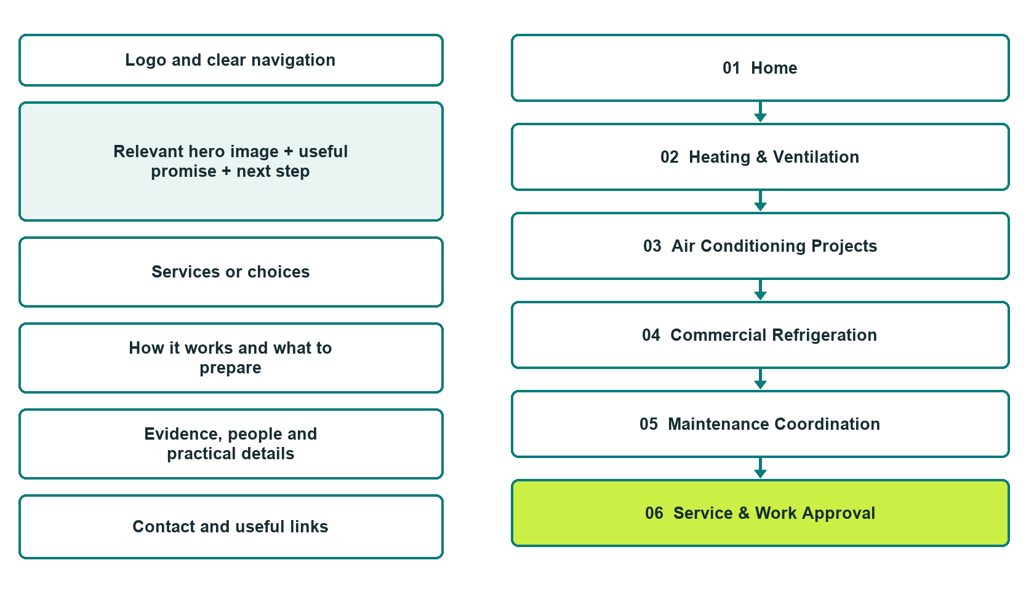

Plan → Draft → Build → Test
Demo-capture edition: actual Website Builder desktop previews and excerpts of the example wording. See each matching mobile preview in the industry page gallery. The example business and its AI-generated photographs are fictional.
Explore Website Builder and compare plans

Before you build
Your business supplies the facts. Prairie Airfield Mechanical is a fictional teaching example, not a live service.

□ Describe a system service enquiry
□ Verified business identity, services and current contact information
□ A clear enquiry, review and confirmation process
□ Choose original photographs and confirm permission to use them.
□ Keep private customer records out of public website forms.

Your audience and the action you want them to take

Facts to verify and people who must approve them
Create your SaaSTech account

01 Home
Give this page one clear job in the customer journey.
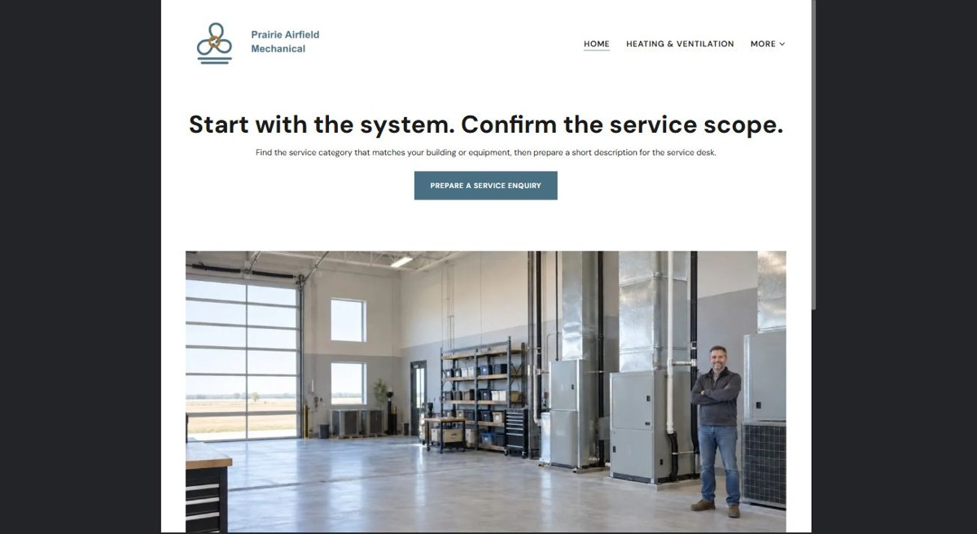
Actual desktop preview - unpublished fictional demonstration

Demo wording excerpt to adapt and verify
Start with the system. Confirm the service scope.
Find the service category that matches your building or equipment, then prepare a short description for the service desk.
Staff confirms accepted systems, assessment arrangements and the approval process before work is scheduled. This fictional Saskatchewan demo shows how to prepare a useful service enquiry without sharing access codes or requesting repair instructions.
Suggested button: Prepare a service enquiry

Website advice
Separate building HVAC, cooling installations and commercial refrigeration, with equipment acceptance, assessment and maintenance-coordination information.

Your draft: Home
Write in the voice of your own business. Use facts you can verify, not promises copied from the example.

Headline and short introduction

Main content and details visitors need

Button wording and destination

Photo choice, permission and facts still to confirm
Partner check: can someone unfamiliar with the business find a useful next step?

02 Heating & Ventilation
Give this page one clear job in the customer journey.
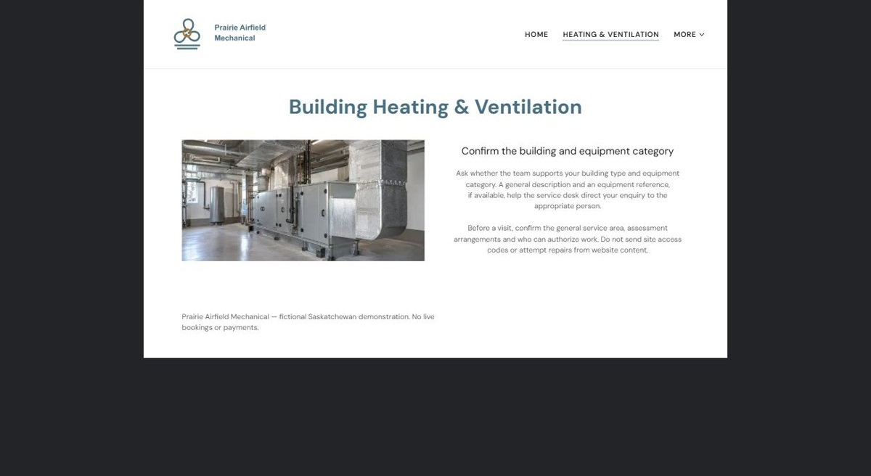
Actual desktop preview - unpublished fictional demonstration

Demo wording excerpt to adapt and verify
Confirm the building and equipment category
Ask whether the team supports your building type and equipment category. A general description and an equipment reference, if available, help the service desk direct your enquiry to the appropriate person.
Before a visit, confirm the general service area, assessment arrangements and who can authorize work. Do not send site access codes or attempt repairs from website content.
Navigation: guide visitors to the next relevant page; this demo page has no separate enquiry button.

Website advice
Describe accepted residential and light-commercial system categories, excluding unverified specialisms.

Your draft: Heating & Ventilation
Write in the voice of your own business. Use facts you can verify, not promises copied from the example.

Headline and short introduction

Main content and details visitors need

Button wording and destination

Photo choice, permission and facts still to confirm
Partner check: can someone unfamiliar with the business find a useful next step?

03 Air Conditioning Projects
Give this page one clear job in the customer journey.
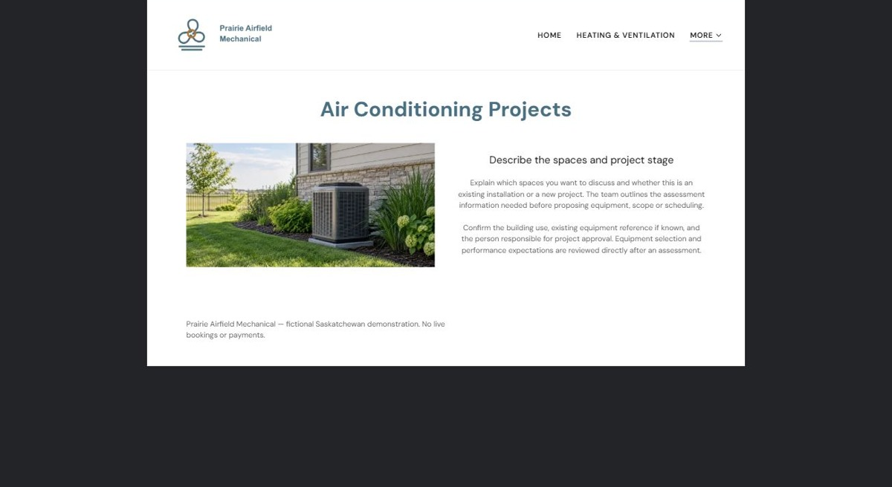
Actual desktop preview - unpublished fictional demonstration

Demo wording excerpt to adapt and verify
Describe the spaces and project stage
Explain which spaces you want to discuss and whether this is an existing installation or a new project. The team outlines the assessment information needed before proposing equipment, scope or scheduling.
Confirm the building use, existing equipment reference if known, and the person responsible for project approval. Equipment selection and performance expectations are reviewed directly after an assessment.
Navigation: guide visitors to the next relevant page; this demo page has no separate enquiry button.

Website advice
Present replacement and new-cooling enquiries as assessment-led projects rather than instant equipment recommendations.

Your draft: Air Conditioning Projects
Write in the voice of your own business. Use facts you can verify, not promises copied from the example.

Headline and short introduction

Main content and details visitors need

Button wording and destination

Photo choice, permission and facts still to confirm
Partner check: can someone unfamiliar with the business find a useful next step?

04 Commercial Refrigeration
Give this page one clear job in the customer journey.
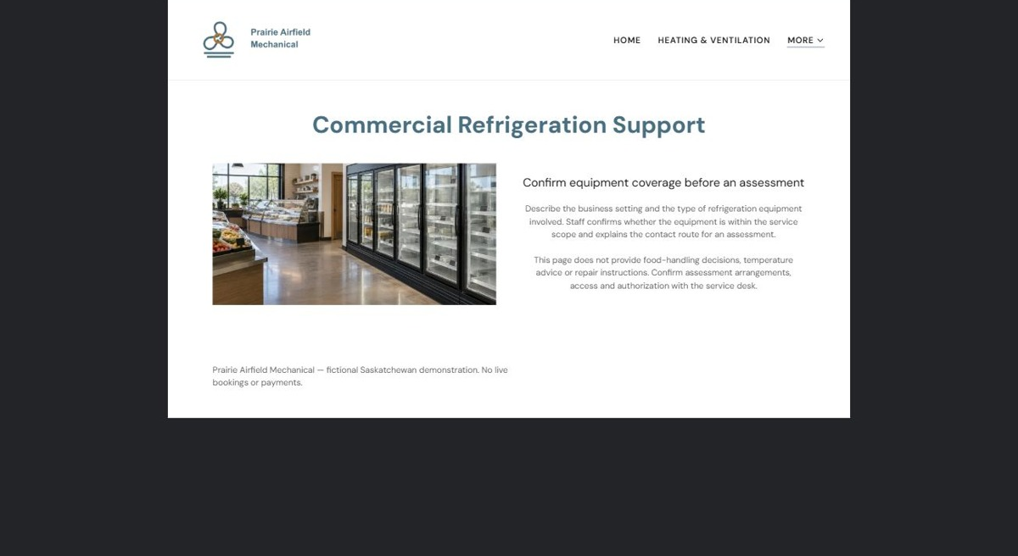
Actual desktop preview - unpublished fictional demonstration

Demo wording excerpt to adapt and verify
Confirm equipment coverage before an assessment
Describe the business setting and the type of refrigeration equipment involved. Staff confirms whether the equipment is within the service scope and explains the contact route for an assessment.
This page does not provide food-handling decisions, temperature advice or repair instructions. Confirm assessment arrangements, access and authorization with the service desk.
Navigation: guide visitors to the next relevant page; this demo page has no separate enquiry button.

Website advice
Keep cold-room and display-refrigeration enquiries distinct from household appliance service.

Your draft: Commercial Refrigeration
Write in the voice of your own business. Use facts you can verify, not promises copied from the example.

Headline and short introduction

Main content and details visitors need

Button wording and destination

Photo choice, permission and facts still to confirm
Partner check: can someone unfamiliar with the business find a useful next step?

05 Maintenance Coordination
Give this page one clear job in the customer journey.
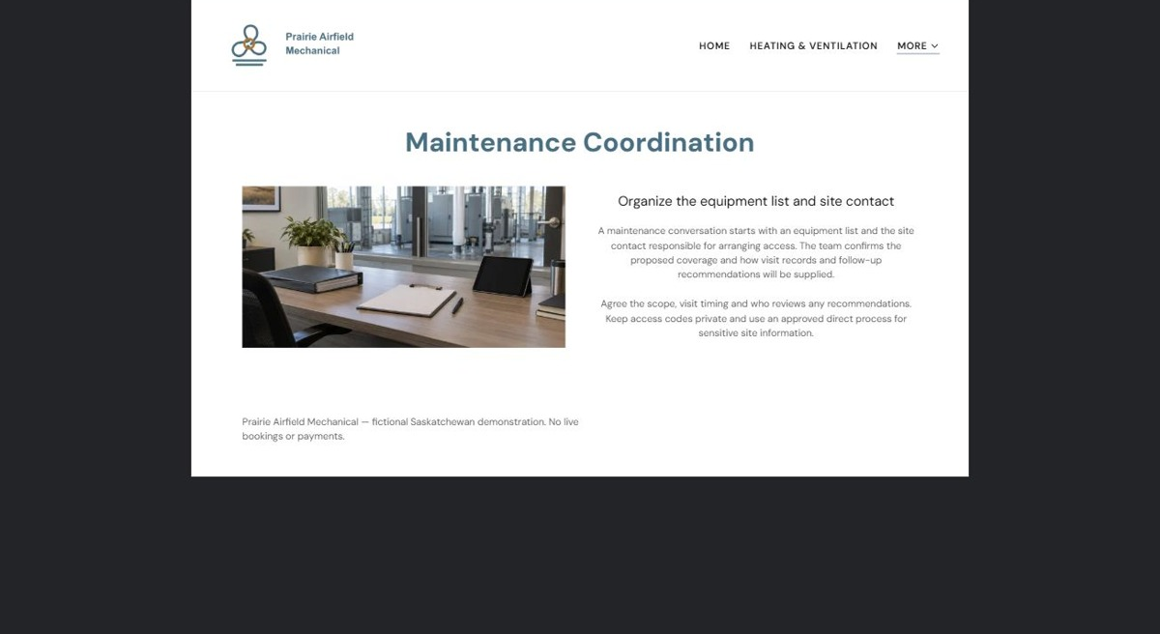
Actual desktop preview - unpublished fictional demonstration

Demo wording excerpt to adapt and verify
Organize the equipment list and site contact
A maintenance conversation starts with an equipment list and the site contact responsible for arranging access. The team confirms the proposed coverage and how visit records and follow-up recommendations will be supplied.
Agree the scope, visit timing and who reviews any recommendations. Keep access codes private and use an approved direct process for sensitive site information.
Navigation: guide visitors to the next relevant page; this demo page has no separate enquiry button.

Website advice
Explain equipment registers, site contacts, proposed visits and service-record handover at an administrative level.

Your draft: Maintenance Coordination
Write in the voice of your own business. Use facts you can verify, not promises copied from the example.

Headline and short introduction

Main content and details visitors need

Button wording and destination

Photo choice, permission and facts still to confirm
Partner check: can someone unfamiliar with the business find a useful next step?

06 Service & Work Approval
Give this page one clear job in the customer journey.
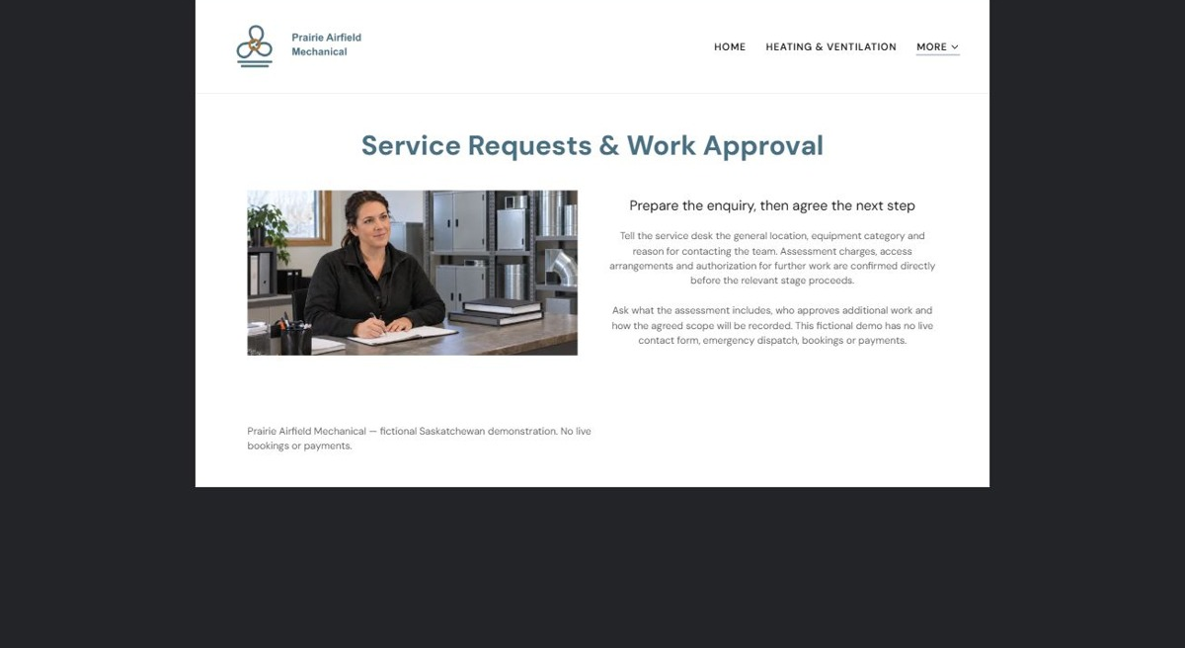
Actual desktop preview - unpublished fictional demonstration

Demo wording excerpt to adapt and verify
Prepare the enquiry, then agree the next step
Tell the service desk the general location, equipment category and reason for contacting the team. Assessment charges, access arrangements and authorization for further work are confirmed directly before the relevant stage proceeds.
Ask what the assessment includes, who approves additional work and how the agreed scope will be recorded. This fictional demo has no live contact form, emergency dispatch, bookings or payments.
Navigation: guide visitors to the next relevant page; this demo page has no separate enquiry button.

Website advice
Set out request review, assessment terms, proposed work and explicit approval without promising response times.

Your draft: Service & Work Approval
Write in the voice of your own business. Use facts you can verify, not promises copied from the example.

Headline and short introduction

Main content and details visitors need

Button wording and destination

Photo choice, permission and facts still to confirm
Partner check: can someone unfamiliar with the business find a useful next step?

Test before publishing
Review the whole journey on a desktop and phone. The industry page pairs each desktop capture with its mobile preview and provides the complete sample page copy.
□ Fictional demonstration only. Verify trade qualifications, equipment coverage, dispatch hours and service areas. No diagnosis, repair instructions, refrigerant handling guidance, performance guarantees or emergency-response promises; do not collect site access codes.
□ Verify every service description, contact route and operating detail.
□ Replace fictional identity and example information before a live launch.
□ Test enquiries, links and downloads on desktop and mobile.
□ Keep confidential records in approved private systems.
□ Obtain operator approval for public wording and images.
□ Check every link, form destination, download and confirmation message.
□ Check logo contrast, hero framing, text sizes and image loading.
□ Save a named backup and assign a content-review date.

Changes to finish and person responsible

Approval and next review date
Website Builder plans and signup

