

Hotels, Motels & Bed and Breakfasts
Website workbook
A practical workshop for a 5-page website. Study the example, plan the content and draft your own version in Word or on paper.
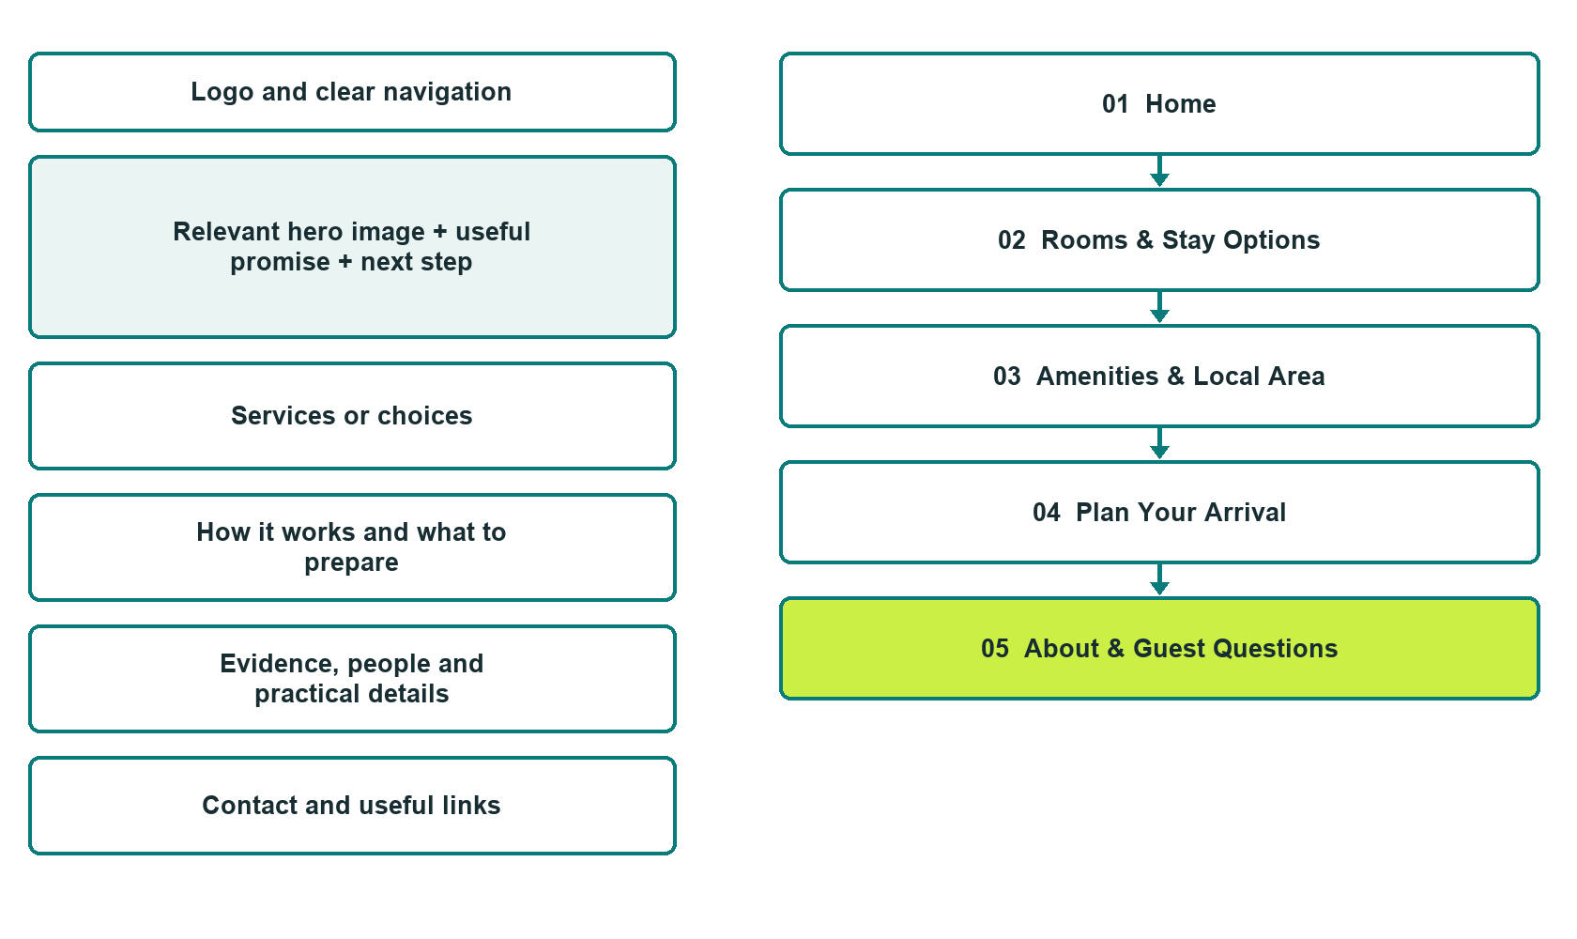

Plan → Draft → Build → Test
Demo-capture edition: actual Website Builder desktop previews and excerpts of the example wording. See each matching mobile preview in the industry page gallery. The example business and its AI-generated photographs are fictional.
Explore Website Builder and compare plans

Before you build
Your business supplies the facts. Prairie Lantern Lodge is a fictional teaching example, not a live service.

□ Check stay options and request availability
□ Verified business identity and current contact information
□ Clear request and confirmation process
□ Choose original photographs and confirm permission to use them.
□ Keep private customer records out of public website forms.

Your audience and the action you want them to take

Facts to verify and people who must approve them
Create your SaaSTech account

01 Home
Give this page one clear job in the customer journey.
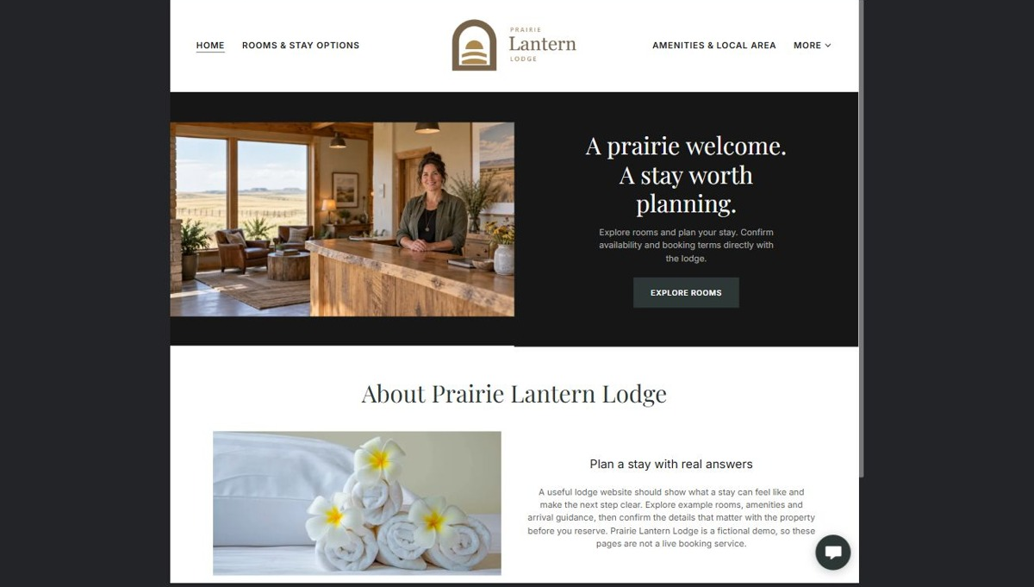
Actual desktop preview - unpublished fictional demonstration

Demo wording excerpt to adapt and verify
A prairie welcome. A stay worth planning.
Explore rooms and plan your stay. Confirm availability and booking terms directly with the lodge.
A useful lodge website should show what a stay can feel like and make the next step clear. Explore example rooms, amenities and arrival guidance, then confirm the details that matter with the property before you reserve. Prairie Lantern Lodge is a fictional demo, so these pages are not a live booking service.
Suggested button: Explore Rooms

Website advice
Show distinct rooms, verified amenities, arrival information and a trustworthy booking handoff. Keep example availability separate from actual inventory.

Your draft: Home
Write in the voice of your own business. Use facts you can verify, not promises copied from the example.

Headline and short introduction

Main content and details visitors need

Button wording and destination

Photo choice, permission and facts still to confirm
Partner check: can someone unfamiliar with the business find a useful next step?

02 Rooms & Stay Options
Give this page one clear job in the customer journey.
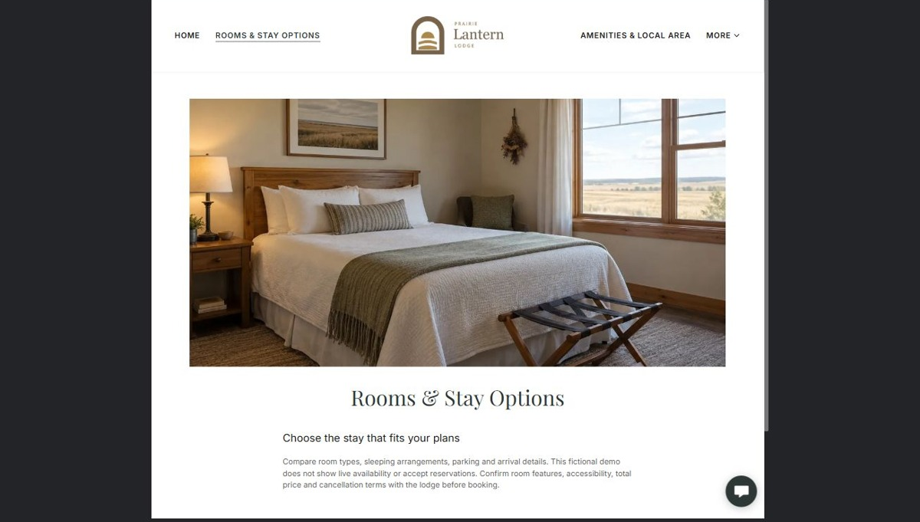
Actual desktop preview - unpublished fictional demonstration

Demo wording excerpt to adapt and verify
Choose the stay that fits your plans
Compare room types, sleeping arrangements, parking and arrival details. This fictional demo does not show live availability or accept reservations. Confirm room features, accessibility, total price and cancellation terms with the lodge before booking.
Suggested button: Ask about availability

Website advice
Use a distinct photo per actual room category. List confirmed capacity and amenities without inventing availability.

Your draft: Rooms & Stay Options
Write in the voice of your own business. Use facts you can verify, not promises copied from the example.

Headline and short introduction

Main content and details visitors need

Button wording and destination

Photo choice, permission and facts still to confirm
Partner check: can someone unfamiliar with the business find a useful next step?

03 Amenities & Local Area
Give this page one clear job in the customer journey.
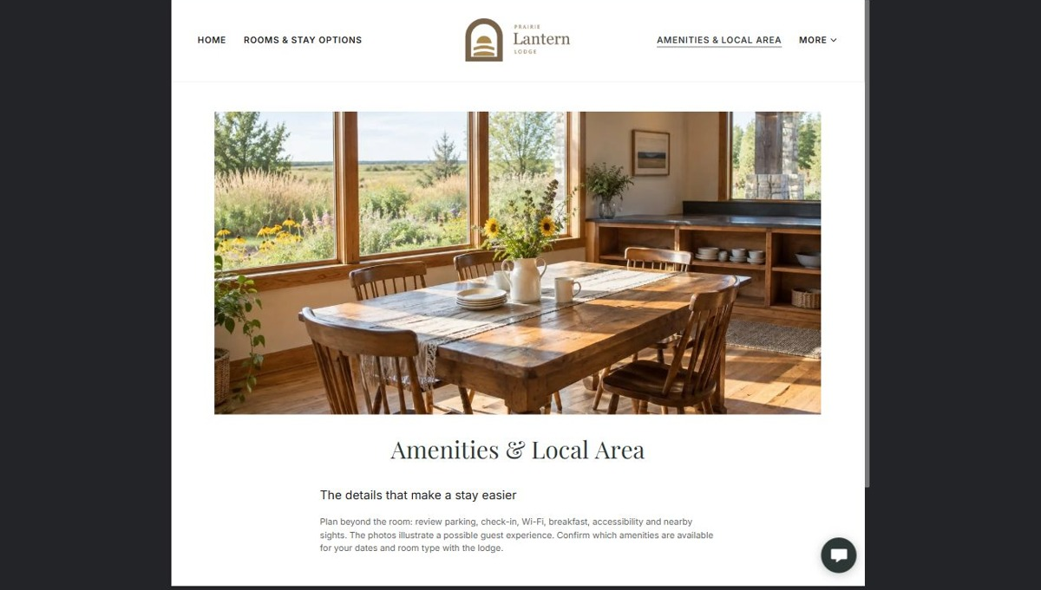
Actual desktop preview - unpublished fictional demonstration

Demo wording excerpt to adapt and verify
The details that make a stay easier
Plan beyond the room: review parking, check-in, Wi-Fi, breakfast, accessibility and nearby sights. The photos illustrate a possible guest experience. Confirm which amenities are available for your dates and room type with the lodge.
Suggested button: Confirm amenities

Website advice
Separate on-property amenities from nearby attractions. Verify access, opening times and seasonal limitations.

Your draft: Amenities & Local Area
Write in the voice of your own business. Use facts you can verify, not promises copied from the example.

Headline and short introduction

Main content and details visitors need

Button wording and destination

Photo choice, permission and facts still to confirm
Partner check: can someone unfamiliar with the business find a useful next step?

04 Plan Your Arrival
Give this page one clear job in the customer journey.
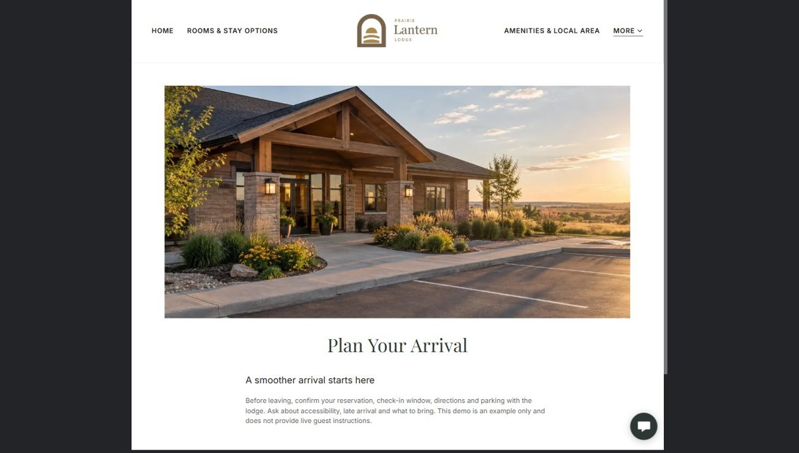
Actual desktop preview - unpublished fictional demonstration

Demo wording excerpt to adapt and verify
A smoother arrival starts here
Before leaving, confirm your reservation, check-in window, directions and parking with the lodge. Ask about accessibility, late arrival and what to bring. This demo is an example only and does not provide live guest instructions.
Suggested button: Confirm arrival details

Website advice
Explain check-in, parking, late arrival and accessibility using operator-approved details.

Your draft: Plan Your Arrival
Write in the voice of your own business. Use facts you can verify, not promises copied from the example.

Headline and short introduction

Main content and details visitors need

Button wording and destination

Photo choice, permission and facts still to confirm
Partner check: can someone unfamiliar with the business find a useful next step?

05 About & Guest Questions
Give this page one clear job in the customer journey.
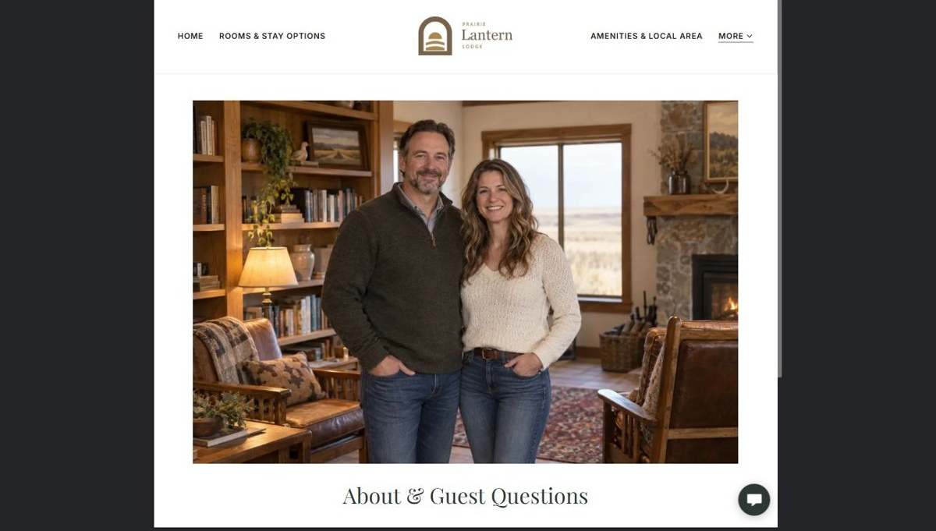
Actual desktop preview - unpublished fictional demonstration

Demo wording excerpt to adapt and verify
Meet the people behind the welcome
Prairie Lantern Lodge is a fictional example of an independent lodging business. This page shows how to introduce the hosts and answer questions before guests inquire. Ask about room types, step-free access, pets, quiet hours, check-in, parking and cancellation. Confirm every detail directly before booking; this demo takes no reservations or payments.
Suggested button: Ask a guest question

Website advice
Introduce the hosts and explain how booking questions and changes are handled. Publish genuine reviews only.

Your draft: About & Guest Questions
Write in the voice of your own business. Use facts you can verify, not promises copied from the example.

Headline and short introduction

Main content and details visitors need

Button wording and destination

Photo choice, permission and facts still to confirm
Partner check: can someone unfamiliar with the business find a useful next step?

Test before publishing
Review the whole journey on a desktop and phone. The industry page pairs each desktop capture with its mobile preview and provides the complete sample page copy.
□ No rooms can be booked through this fictional example. Verify rates, availability, accessibility, amenities and terms with the operator before launch.
□ Verify contact routes, hours, location and every offered service.
□ Remove invented prices, claims, testimonials and availability.
□ Keep sensitive records and payment details out of ordinary public forms.
□ Check all image permissions, downloads and page links on a phone.
□ Check every link, form destination, download and confirmation message.
□ Check logo contrast, hero framing, text sizes and image loading.
□ Save a named backup and assign a content-review date.

Changes to finish and person responsible

Approval and next review date
Website Builder plans and signup

