

Horse Ranches
Website workbook
A practical workshop for a 6-page website. Study the example, plan the content and draft your own version in Word or on paper.
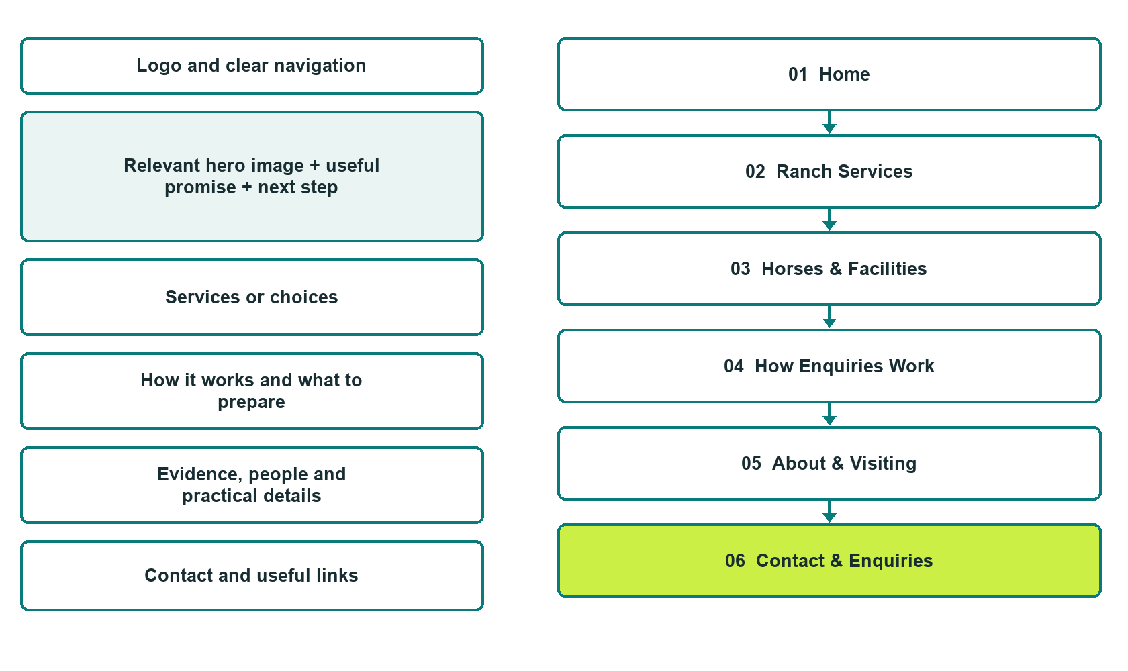

Plan → Draft → Build → Test
Demo-capture edition: actual Website Builder desktop previews and excerpts of the example wording. See each matching mobile preview in the industry page gallery. The example business and its AI-generated photographs are fictional.
Explore Website Builder and compare plans

Before you build
Your business supplies the facts. Prairie Meadow Horse Ranch is a fictional teaching example, not a live service.
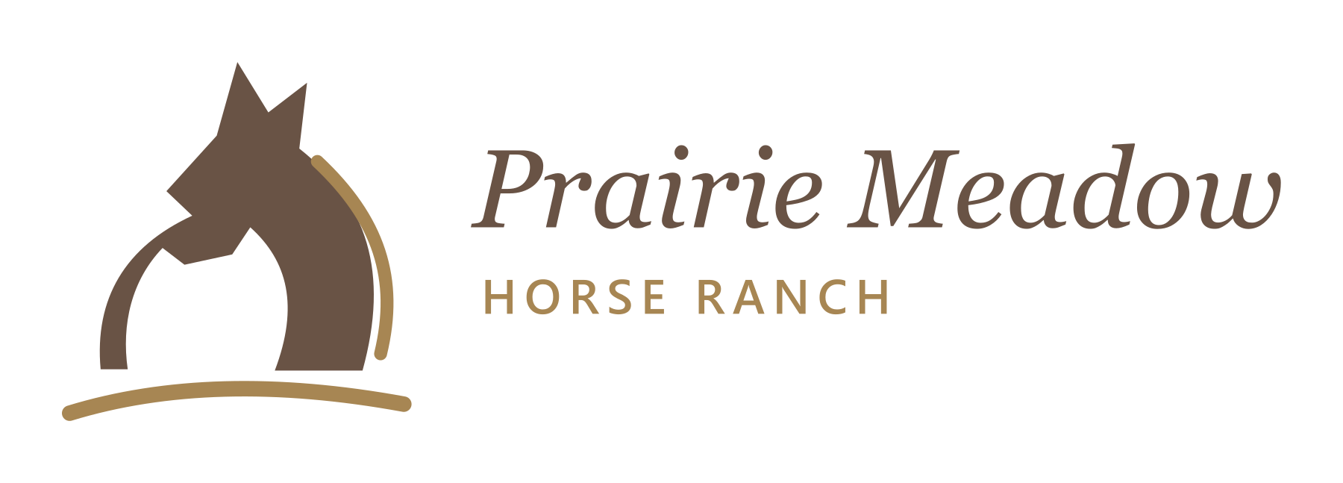
□ Ask about a ranch service or arrange a confirmed visit
□ Verified business identity and current contact information
□ Clear request and confirmation process
□ Choose original photographs and confirm permission to use them.
□ Keep private customer records out of public website forms.

Your audience and the action you want them to take

Facts to verify and people who must approve them
Create your SaaSTech account

01 Home
Give this page one clear job in the customer journey.
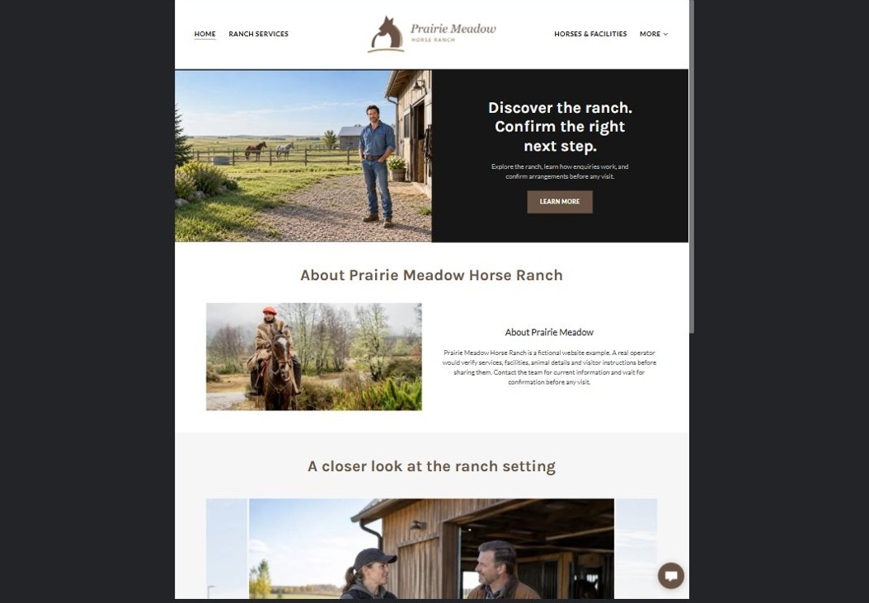
Actual desktop preview - unpublished fictional demonstration

Demo wording excerpt to adapt and verify
Discover the ranch. Confirm the right next step.
Explore the ranch, learn how enquiries work, and confirm arrangements before any visit.
Prairie Meadow Horse Ranch is a fictional website example. A real operator would verify services, facilities, animal details and visitor instructions before sharing them. Contact the team for current information and wait for confirmation before any visit.
Suggested button: Learn More

Website advice
Present only the ranch services actually offered, with distinct pages for the operation, enquiries and visiting. Keep instruction, boarding, sale and event claims verified and clearly separated.

Your draft: Home
Write in the voice of your own business. Use facts you can verify, not promises copied from the example.

Headline and short introduction

Main content and details visitors need

Button wording and destination

Photo choice, permission and facts still to confirm
Partner check: can someone unfamiliar with the business find a useful next step?

02 Ranch Services
Give this page one clear job in the customer journey.
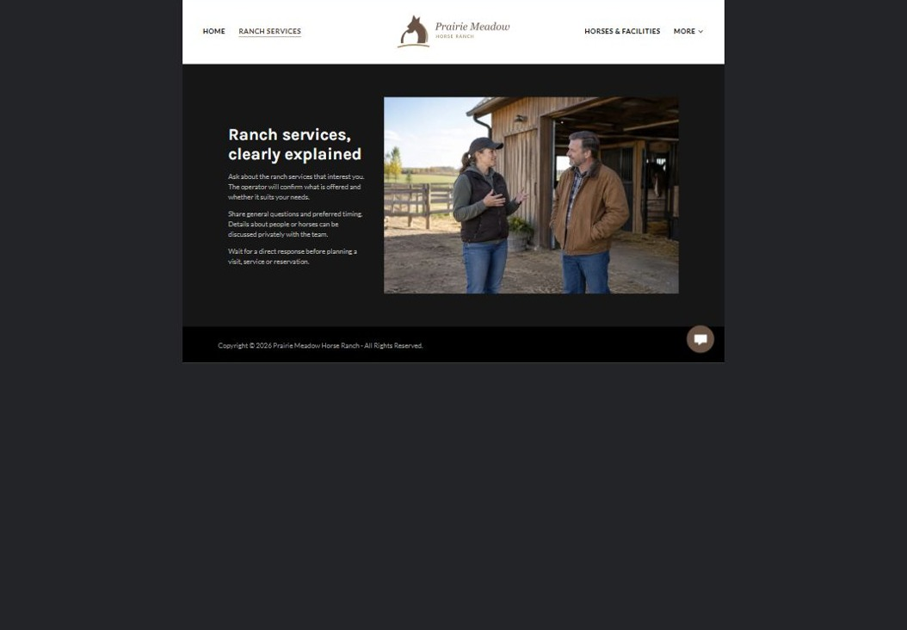
Actual desktop preview - unpublished fictional demonstration

Demo wording excerpt to adapt and verify
Ranch services, clearly explained
Ask about the ranch services that interest you. The operator will confirm what is offered and whether it suits your needs.
Share general questions and preferred timing. Details about people or horses can be discussed privately with the team. Wait for a direct response before planning a visit, service or reservation.
Suggested button: Contact the team

Website advice
Separate boarding, lessons, training or other services only where offered. Explain who handles suitability questions without promising acceptance.

Your draft: Ranch Services
Write in the voice of your own business. Use facts you can verify, not promises copied from the example.

Headline and short introduction

Main content and details visitors need

Button wording and destination

Photo choice, permission and facts still to confirm
Partner check: can someone unfamiliar with the business find a useful next step?

03 Horses & Facilities
Give this page one clear job in the customer journey.
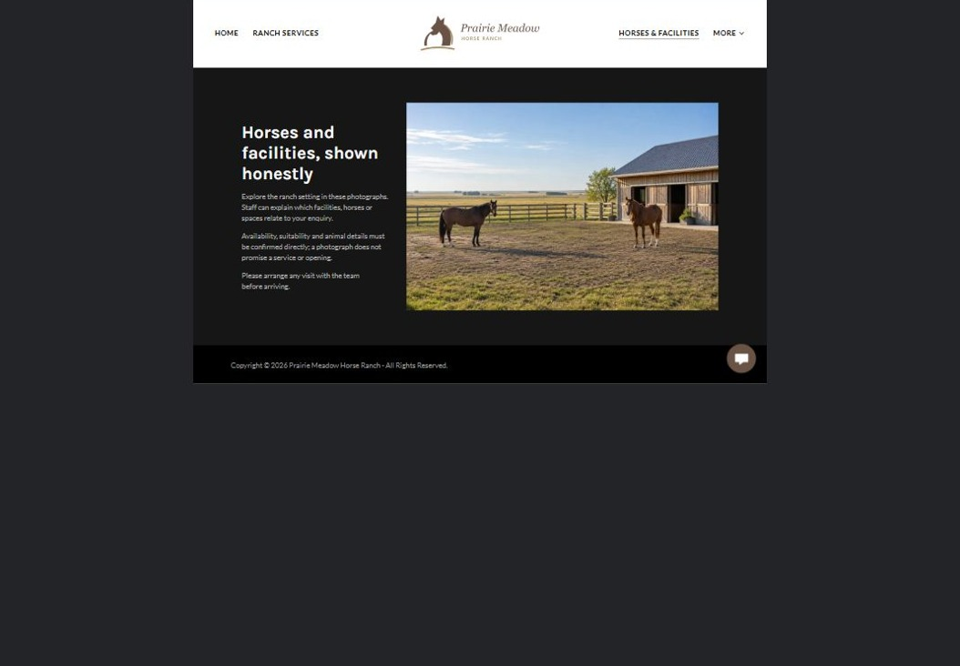
Actual desktop preview - unpublished fictional demonstration

Demo wording excerpt to adapt and verify
Horses and facilities, shown honestly
Explore the ranch setting in these photographs. Staff can explain which facilities, horses or spaces relate to your enquiry.
Availability, suitability and animal details must be confirmed directly; a photograph does not promise a service or opening. Please arrange any visit with the team before arriving.
Suggested button: Arrange a confirmed visit

Website advice
Use distinct, permission-cleared photographs and verified descriptions. Do not invent animal histories, capacities or available spaces.

Your draft: Horses & Facilities
Write in the voice of your own business. Use facts you can verify, not promises copied from the example.

Headline and short introduction

Main content and details visitors need

Button wording and destination

Photo choice, permission and facts still to confirm
Partner check: can someone unfamiliar with the business find a useful next step?

04 How Enquiries Work
Give this page one clear job in the customer journey.
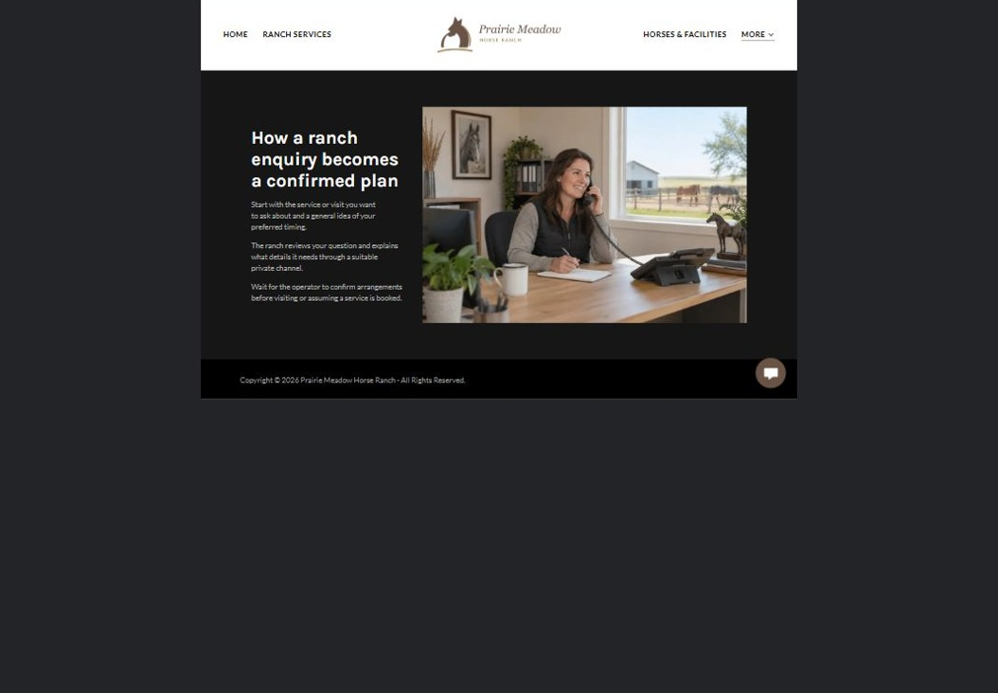
Actual desktop preview - unpublished fictional demonstration

Demo wording excerpt to adapt and verify
How a ranch enquiry becomes a confirmed plan
Start with the service or visit you want to ask about and a general idea of your preferred timing.
The ranch reviews your question and explains what details it needs through a suitable private channel. Wait for the operator to confirm arrangements before visiting or assuming a service is booked.
Suggested button: Ask about the next step

Website advice
Explain initial contact, operator review, visit arrangements and written confirmation. Keep participant and animal records private.

Your draft: How Enquiries Work
Write in the voice of your own business. Use facts you can verify, not promises copied from the example.

Headline and short introduction

Main content and details visitors need

Button wording and destination

Photo choice, permission and facts still to confirm
Partner check: can someone unfamiliar with the business find a useful next step?

05 About & Visiting
Give this page one clear job in the customer journey.
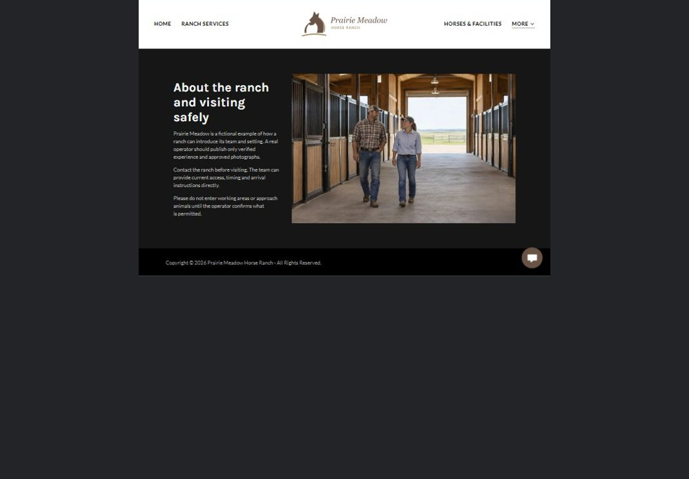
Actual desktop preview - unpublished fictional demonstration

Demo wording excerpt to adapt and verify
About the ranch and visiting safely
Prairie Meadow is a fictional example of how a ranch can introduce its team and setting. A real operator should publish only verified experience and approved photographs.
Contact the ranch before visiting. The team can provide current access, timing and arrival instructions directly. Please do not enter working areas or approach animals until the operator confirms what is permitted.
Suggested button: Confirm visit arrangements

Website advice
Introduce the actual team and approved visitor information. Publish only verified experience and safe, operator-approved arrival directions.

Your draft: About & Visiting
Write in the voice of your own business. Use facts you can verify, not promises copied from the example.

Headline and short introduction

Main content and details visitors need

Button wording and destination

Photo choice, permission and facts still to confirm
Partner check: can someone unfamiliar with the business find a useful next step?

06 Contact & Enquiries
Give this page one clear job in the customer journey.
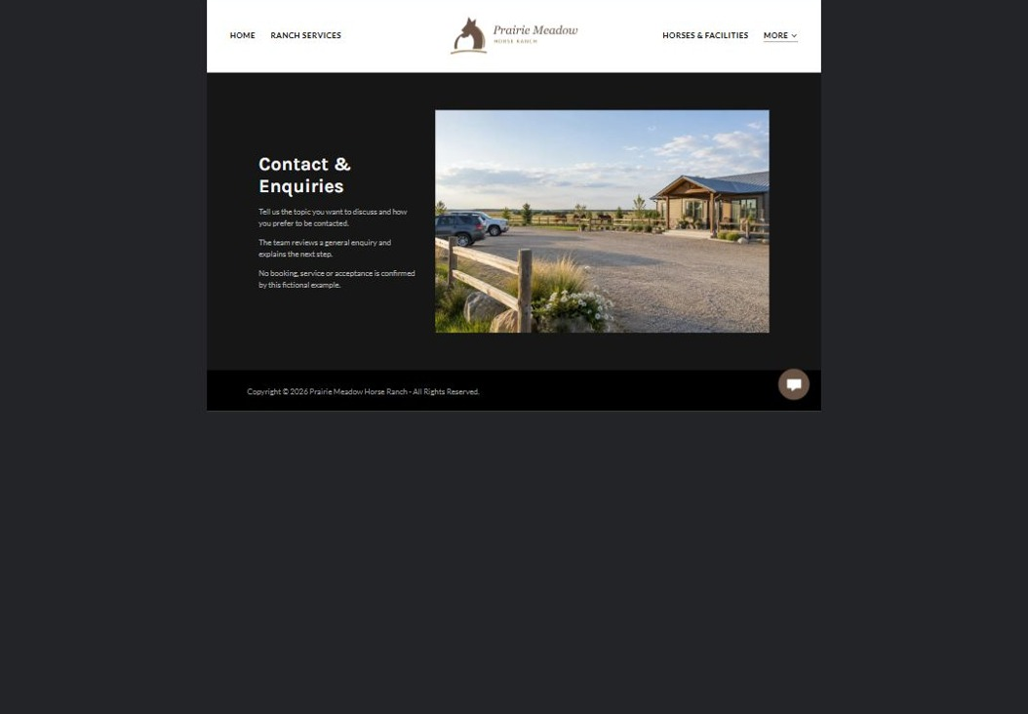
Actual desktop preview - unpublished fictional demonstration

Demo wording excerpt to adapt and verify
Contact & Enquiries
Tell us the topic you want to discuss and how you prefer to be contacted.
The team reviews a general enquiry and explains the next step. No booking, service or acceptance is confirmed by this fictional example.
Suggested button: Contact the team

Website advice
Give the verified address, hours and correct contact path. Collect only the minimum information needed for a first response; make confirmation requirements clear.

Your draft: Contact & Enquiries
Write in the voice of your own business. Use facts you can verify, not promises copied from the example.

Headline and short introduction

Main content and details visitors need

Button wording and destination

Photo choice, permission and facts still to confirm
Partner check: can someone unfamiliar with the business find a useful next step?

Test before publishing
Review the whole journey on a desktop and phone. The industry page pairs each desktop capture with its mobile preview and provides the complete sample page copy.
□ This fictional demonstration offers no horses, boarding, lessons or rides. Qualified operators must approve suitability, animal-welfare, access and safety information before launch; this is not riding or veterinary advice.
□ Verify contact routes, hours, location and every offered service.
□ Remove invented prices, claims, testimonials and availability.
□ Keep sensitive records and payment details out of ordinary public forms.
□ Check all image permissions, downloads and page links on a phone.
□ Check every link, form destination, download and confirmation message.
□ Check logo contrast, hero framing, text sizes and image loading.
□ Save a named backup and assign a content-review date.

Changes to finish and person responsible

Approval and next review date
Website Builder plans and signup

