

Home Inspectors
Website workbook
A practical workshop for a 6-page website. Study the example, plan the content and draft your own version in Word or on paper.
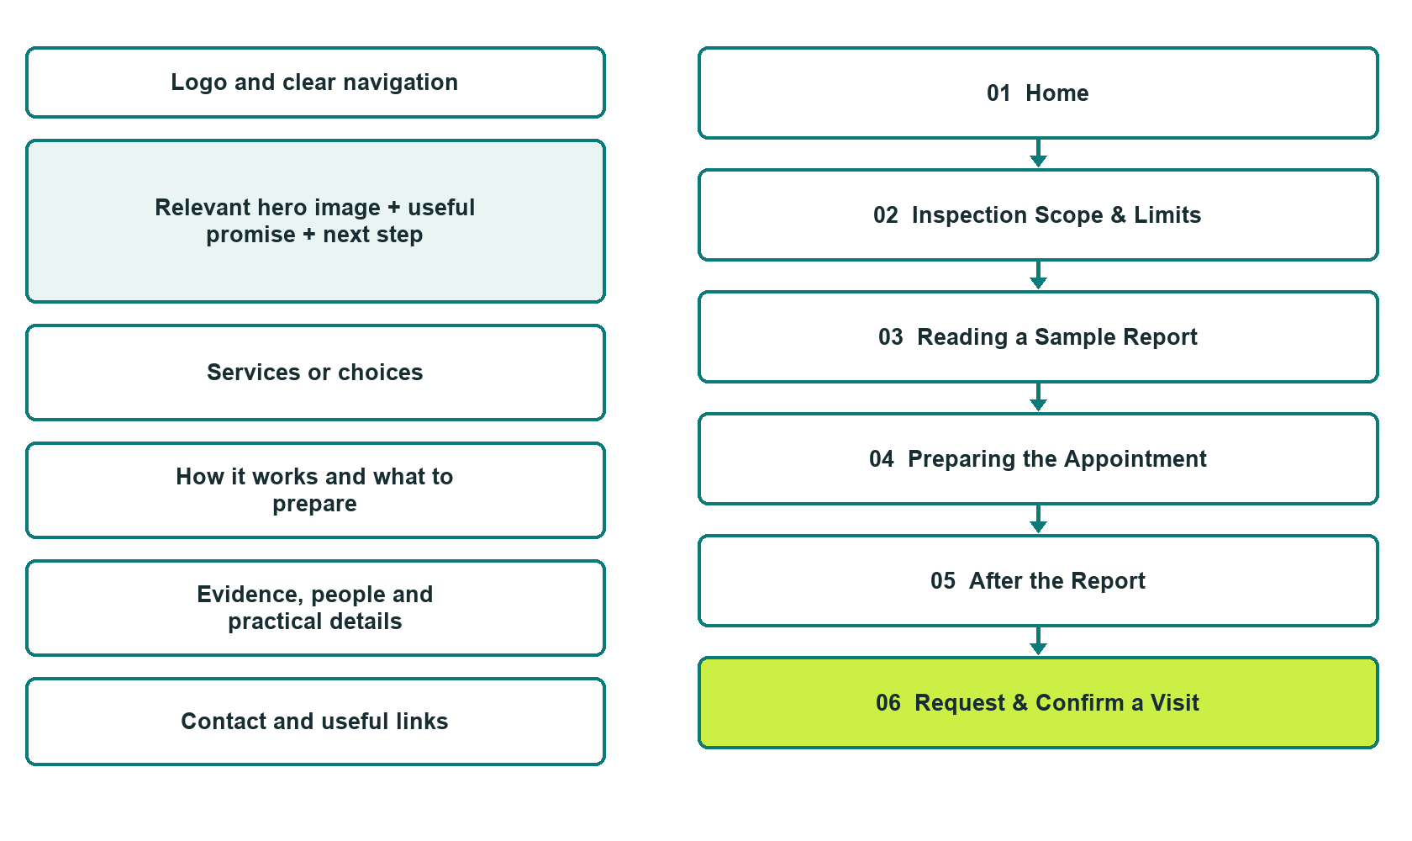

Plan → Draft → Build → Test
Demo-capture edition: actual Website Builder desktop previews and clearly labelled sample wording to adapt. See each matching mobile preview in the industry page gallery. The example business and its AI-generated photographs are fictional.
Explore Website Builder and compare plans

Before you build
Your business supplies the facts. Prairie Lantern Home Inspection is a fictional teaching example, not a live service.

□ Discuss an inspection enquiry
□ Verified business identity, services and current contact information
□ A clear enquiry, review and confirmation process
□ Choose original photographs and confirm permission to use them.
□ Keep private customer records out of public website forms.

Your audience and the action you want them to take

Facts to verify and people who must approve them
Create your SaaSTech account

01 Home
Give this page one clear job in the customer journey.
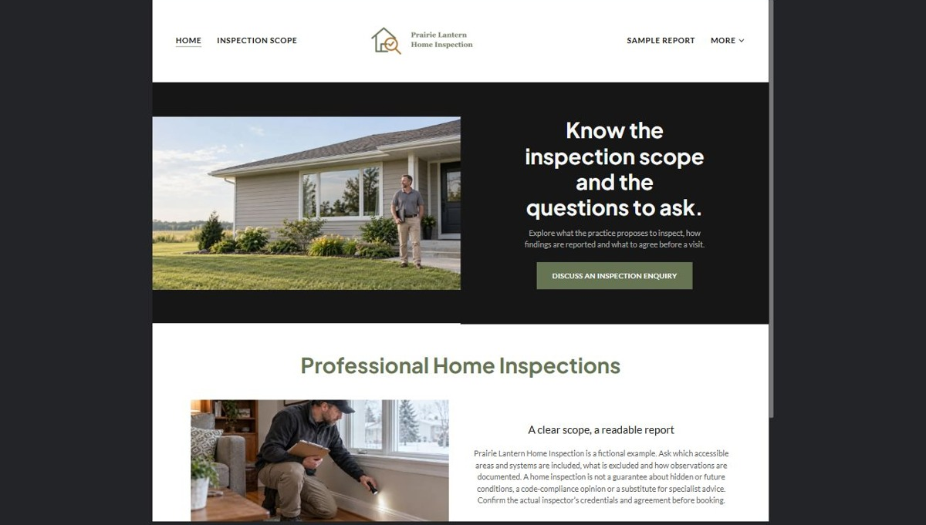
Actual desktop preview - unpublished fictional demonstration

Sample wording — adapt and verify
Know the inspection scope and the questions to ask.
Explore what the practice proposes to inspect, how findings are communicated and what must be agreed before a visit.
A clear discussion of scope and limitations helps you decide whether the offered service addresses your enquiry.
Suggested button: Discuss an inspection enquiry

Website advice
Explain operator-reviewed residential inspection services, report format, booking considerations and exclusions without guaranteeing condition or substituting for specialist advice.

Your draft: Home
Write in the voice of your own business. Use facts you can verify, not promises copied from the example.

Headline and short introduction

Main content and details visitors need

Button wording and destination

Photo choice, permission and facts still to confirm
Partner check: can someone unfamiliar with the business find a useful next step?

02 Inspection Scope & Limits
Give this page one clear job in the customer journey.
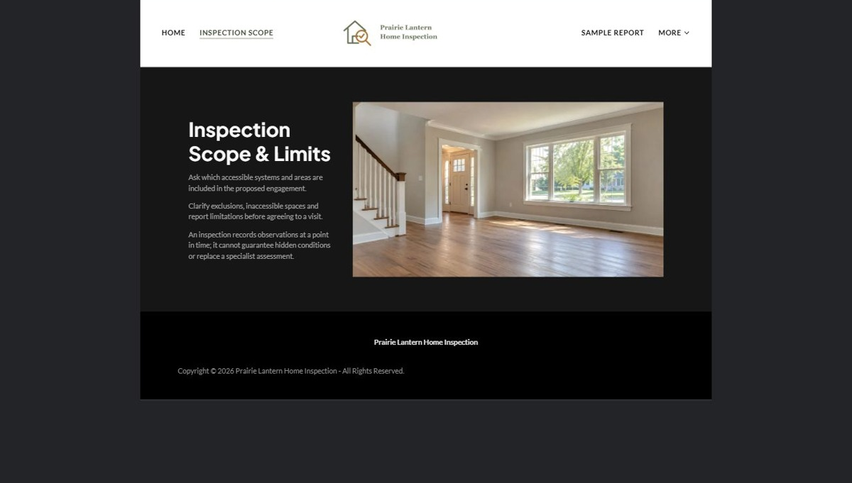
Actual desktop preview - unpublished fictional demonstration

Sample wording — adapt and verify
Inspection Scope & Limits
Ask the inspector which areas and systems are included in the proposed service.
Scope depends on the agreed engagement and access on the day; an inspection is not a guarantee about hidden or future conditions.
Suggested button: Discuss an inspection enquiry

Website advice
Describe reviewed inspection categories and make excluded or inaccessible items visible alongside the proposed scope.

Your draft: Inspection Scope & Limits
Write in the voice of your own business. Use facts you can verify, not promises copied from the example.

Headline and short introduction

Main content and details visitors need

Button wording and destination

Photo choice, permission and facts still to confirm
Partner check: can someone unfamiliar with the business find a useful next step?

03 Reading a Sample Report
Give this page one clear job in the customer journey.
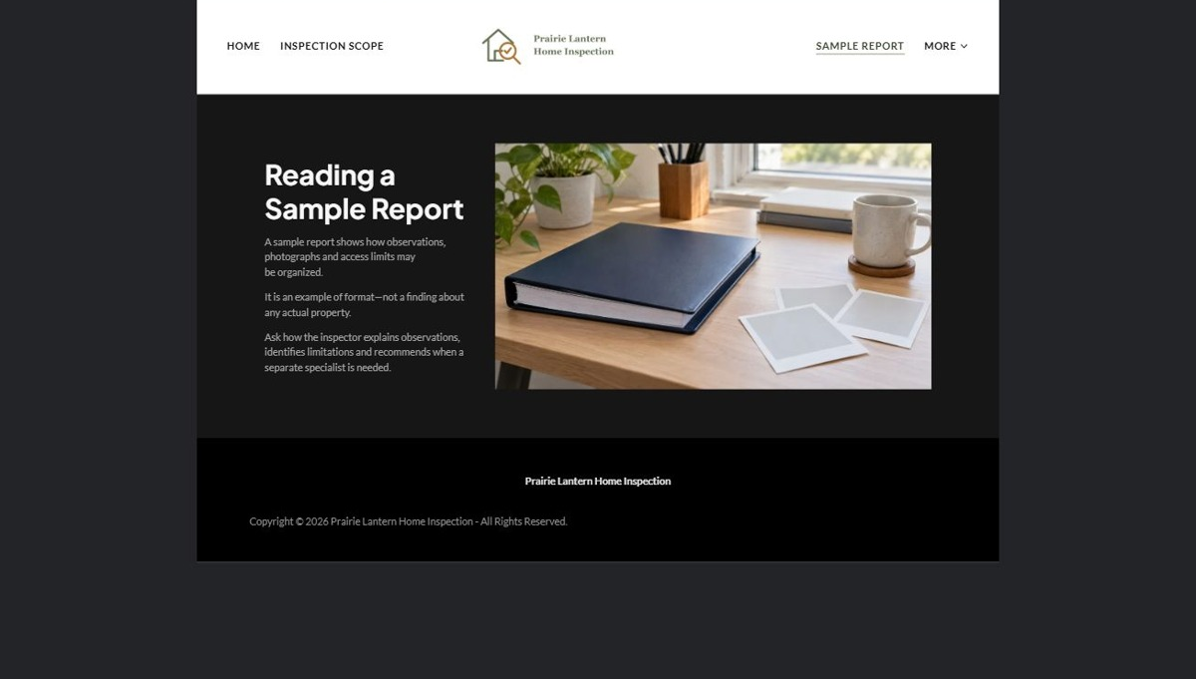
Actual desktop preview - unpublished fictional demonstration

Sample wording — adapt and verify
Reading a Sample Report
A sample can show how observations, photographs and limitations are organized.
It does not describe your property; ask how the inspector distinguishes an observation from a matter requiring another professional.
Suggested button: Discuss an inspection enquiry

Website advice
Explain a fictional report layout and how questions are handled, not how to diagnose building problems.

Your draft: Reading a Sample Report
Write in the voice of your own business. Use facts you can verify, not promises copied from the example.

Headline and short introduction

Main content and details visitors need

Button wording and destination

Photo choice, permission and facts still to confirm
Partner check: can someone unfamiliar with the business find a useful next step?

04 Preparing the Appointment
Give this page one clear job in the customer journey.
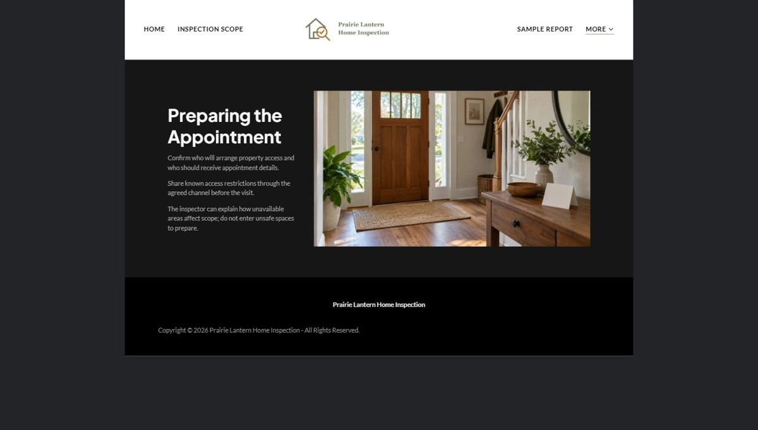
Actual desktop preview - unpublished fictional demonstration

Sample wording — adapt and verify
Preparing the Appointment
Confirm who arranges property access and which parties should receive appointment information.
Tell the coordinator about known access restrictions through the agreed route so the inspector can discuss their effect on scope.
Suggested button: Discuss an inspection enquiry

Website advice
Focus on permission, scheduling and access coordination rather than physical preparation or hazardous-area instructions.

Your draft: Preparing the Appointment
Write in the voice of your own business. Use facts you can verify, not promises copied from the example.

Headline and short introduction

Main content and details visitors need

Button wording and destination

Photo choice, permission and facts still to confirm
Partner check: can someone unfamiliar with the business find a useful next step?

05 After the Report
Give this page one clear job in the customer journey.
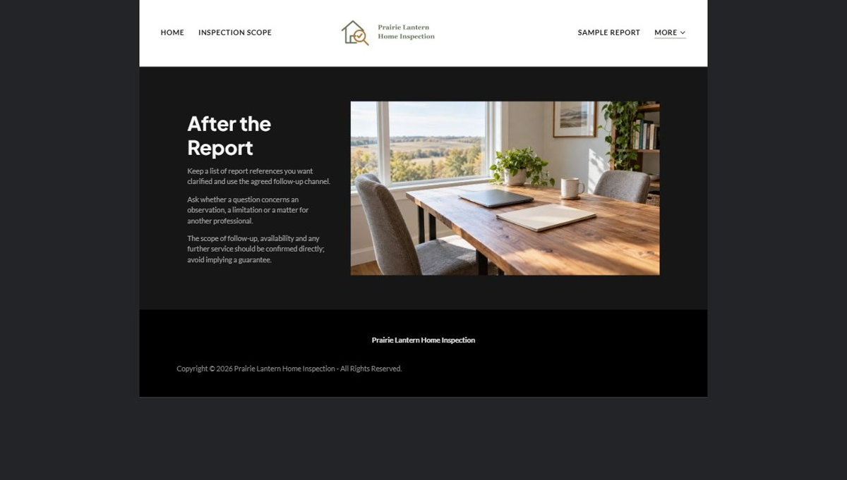
Actual desktop preview - unpublished fictional demonstration

Sample wording — adapt and verify
After the Report
Keep a list of report references you want clarified and ask how follow-up questions are submitted.
The inspector explains the limits of that conversation and when a question is outside the agreed service.
Suggested button: Discuss an inspection enquiry

Website advice
Set expectations for clarification, specialist referrals and engagement boundaries without promising unlimited follow-up.

Your draft: After the Report
Write in the voice of your own business. Use facts you can verify, not promises copied from the example.

Headline and short introduction

Main content and details visitors need

Button wording and destination

Photo choice, permission and facts still to confirm
Partner check: can someone unfamiliar with the business find a useful next step?

06 Request & Confirm a Visit
Give this page one clear job in the customer journey.
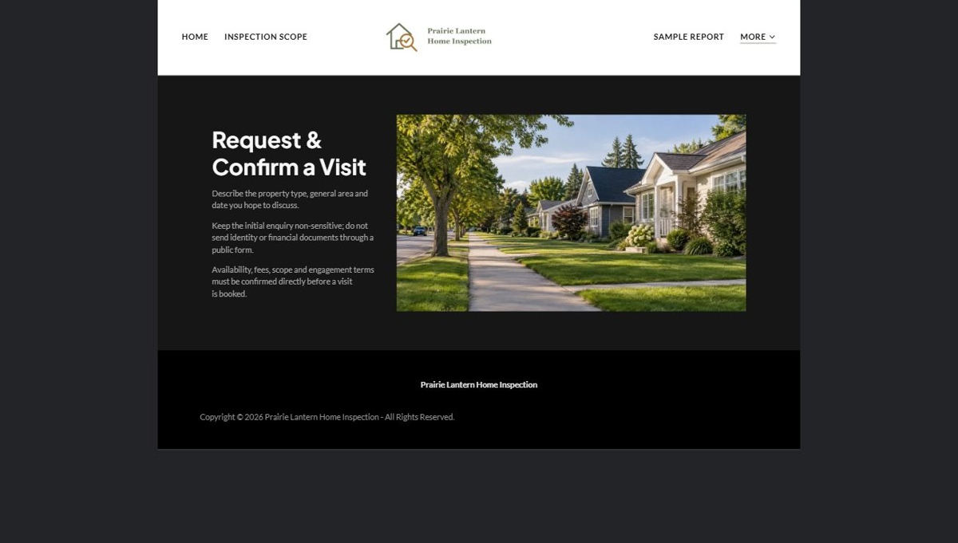
Actual desktop preview - unpublished fictional demonstration

Sample wording — adapt and verify
Request & Confirm a Visit
Describe the property type, general area and date you hope to discuss.
Availability, fees, scope and the engagement agreement must be confirmed directly before an inspection is booked.
Suggested button: Discuss an inspection enquiry

Website advice
Collect non-sensitive property basics and distinguish a requested date from an accepted engagement.

Your draft: Request & Confirm a Visit
Write in the voice of your own business. Use facts you can verify, not promises copied from the example.

Headline and short introduction

Main content and details visitors need

Button wording and destination

Photo choice, permission and facts still to confirm
Partner check: can someone unfamiliar with the business find a useful next step?

Test before publishing
Review the whole journey on a desktop and phone. The industry page pairs each desktop capture with its mobile preview and provides the complete sample page copy.
□ Fictional inspection practice. Verify credentials, service standards, insurance statements and contractual scope before launch. No condition guarantee, code-compliance opinion, specialist assessment, real-estate advice or technical safety guidance is provided.
□ Verify every service description, contact route and operating detail.
□ Replace fictional identity and example information before a live launch.
□ Test enquiries, links and downloads on desktop and mobile.
□ Keep confidential records in approved private systems.
□ Obtain operator approval for public wording and images.
□ Check every link, form destination, download and confirmation message.
□ Check logo contrast, hero framing, text sizes and image loading.
□ Save a named backup and assign a content-review date.

Changes to finish and person responsible

Approval and next review date
Website Builder plans and signup

