

Home Care & Senior Support Services
Website workbook
A practical workshop for a 5-page website. Study the example, plan the content and draft your own version in Word or on paper.
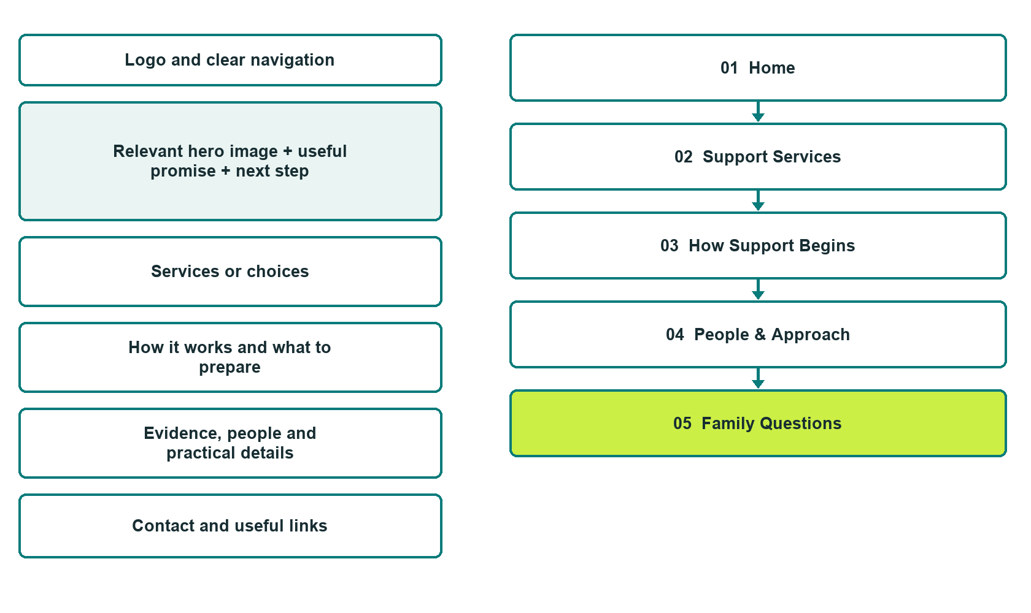

Plan → Draft → Build → Test
Demo-capture edition: actual Website Builder desktop previews and clearly labelled sample wording to adapt. See each matching mobile preview in the industry page gallery. The example business and its AI-generated photographs are fictional.
Explore Website Builder and compare plans

Before you build
Your business supplies the facts. Prairie Hearth Home Support is a fictional teaching example, not a live service.

□ Request a service discussion
□ Verified business identity and current contact information
□ Clear request and confirmation process
□ Choose original photographs and confirm permission to use them.
□ Keep private customer records out of public website forms.

Your audience and the action you want them to take

Facts to verify and people who must approve them
Create your SaaSTech account

01 Home
Give this page one clear job in the customer journey.
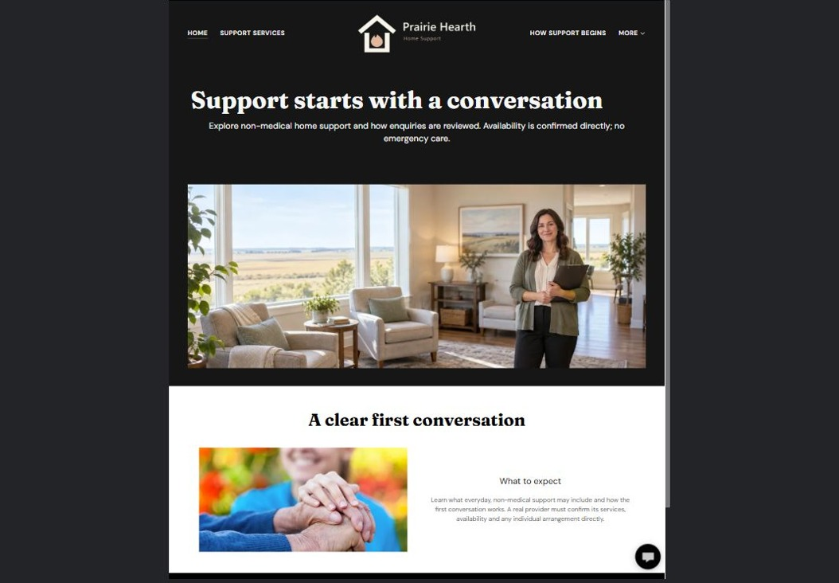
Actual desktop preview - unpublished fictional demonstration

Sample wording — adapt and verify
Understand the support and plan a conversation.
Find out which everyday support services are offered and how an initial conversation works. The coordinator reviews each enquiry before availability or any service arrangement is confirmed.
Contact the team to discuss your questions and confirm what happens next. Please wait for a direct response before making arrangements.
Suggested button: Request a service discussion

Website advice
Explain verified service boundaries, coordination and family enquiries. Separate non-medical support from regulated care, emergency response and individual care planning.

Your draft: Home
Write in the voice of your own business. Use facts you can verify, not promises copied from the example.

Headline and short introduction

Main content and details visitors need

Button wording and destination

Photo choice, permission and facts still to confirm
Partner check: can someone unfamiliar with the business find a useful next step?

02 Support Services
Give this page one clear job in the customer journey.
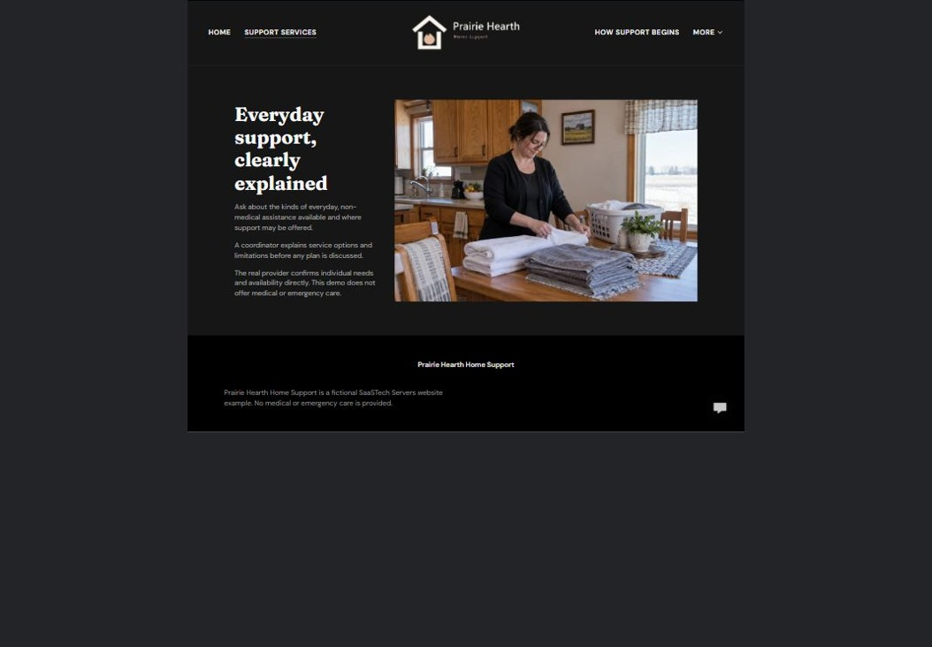
Actual desktop preview - unpublished fictional demonstration

Sample wording — adapt and verify
Support Services
Ask about the kinds of everyday assistance the team offers and the service area covered. The coordinator explains the available options and any limits before planning begins.
Contact the team to discuss your questions and confirm what happens next. Please wait for a direct response before making arrangements.
Suggested button: Contact the team

Website advice
Group actual services by daily need. State exclusions and avoid implying medical or emergency capability.

Your draft: Support Services
Write in the voice of your own business. Use facts you can verify, not promises copied from the example.

Headline and short introduction

Main content and details visitors need

Button wording and destination

Photo choice, permission and facts still to confirm
Partner check: can someone unfamiliar with the business find a useful next step?

03 How Support Begins
Give this page one clear job in the customer journey.
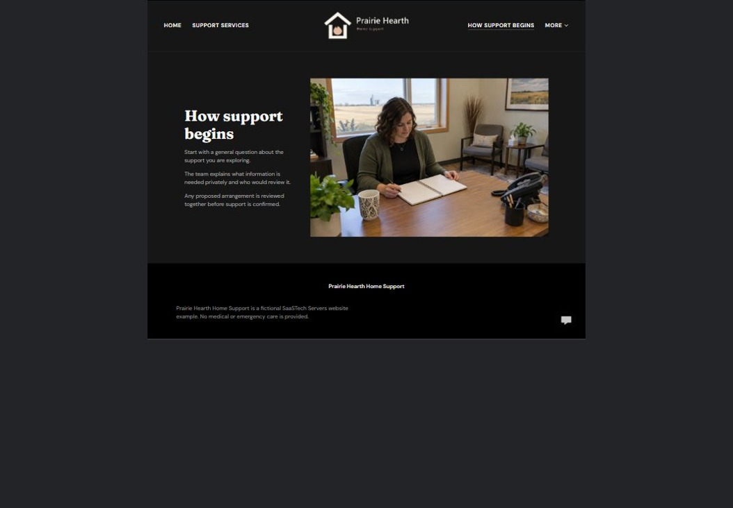
Actual desktop preview - unpublished fictional demonstration

Sample wording — adapt and verify
How Support Begins
Begin with a general question about the support you are exploring. The team explains what information is needed privately and how a proposed arrangement is reviewed.
Contact the team to discuss your questions and confirm what happens next. Please wait for a direct response before making arrangements.
Suggested button: Contact the team

Website advice
Explain enquiry, private assessment, discussion and confirmation. Do not present the public website as a care-plan tool.

Your draft: How Support Begins
Write in the voice of your own business. Use facts you can verify, not promises copied from the example.

Headline and short introduction

Main content and details visitors need

Button wording and destination

Photo choice, permission and facts still to confirm
Partner check: can someone unfamiliar with the business find a useful next step?

04 People & Approach
Give this page one clear job in the customer journey.
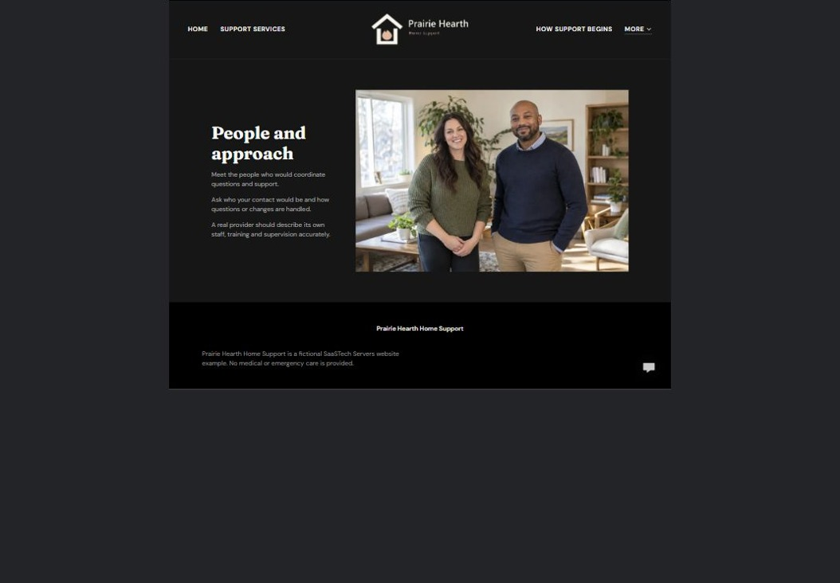
Actual desktop preview - unpublished fictional demonstration

Sample wording — adapt and verify
People & Approach
Meet the people who coordinate the service and learn how communication is organized. Ask who your contact would be and how questions or changes are handled.
Contact the team to discuss your questions and confirm what happens next. Please wait for a direct response before making arrangements.
Suggested button: Contact the team

Website advice
Introduce verified roles, supervision and approved service standards without invented certifications. Use respectful adult imagery.

Your draft: People & Approach
Write in the voice of your own business. Use facts you can verify, not promises copied from the example.

Headline and short introduction

Main content and details visitors need

Button wording and destination

Photo choice, permission and facts still to confirm
Partner check: can someone unfamiliar with the business find a useful next step?

05 Family Questions
Give this page one clear job in the customer journey.
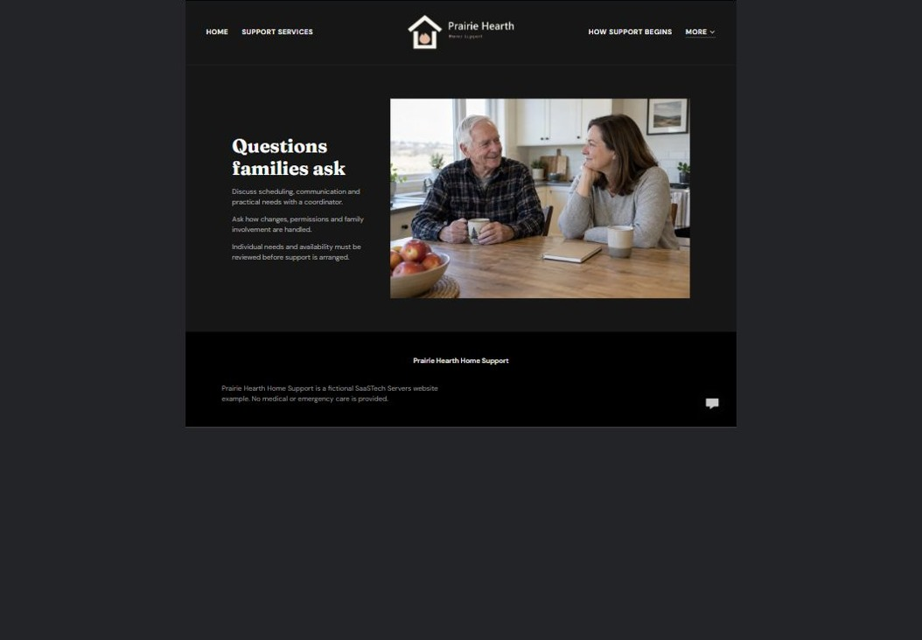
Actual desktop preview - unpublished fictional demonstration

Sample wording — adapt and verify
Questions families ask
Discuss scheduling, communication and practical questions with the coordinator. Individual needs, availability and permissions must be reviewed before support is arranged.
Contact the team to discuss your questions and confirm what happens next. Please wait for a direct response before making arrangements.
Suggested button: Contact the team

Website advice
Explain who can enquire and how consent and communication are managed under the provider’s approved process.

Your draft: Family Questions
Write in the voice of your own business. Use facts you can verify, not promises copied from the example.

Headline and short introduction

Main content and details visitors need

Button wording and destination

Photo choice, permission and facts still to confirm
Partner check: can someone unfamiliar with the business find a useful next step?

Test before publishing
Review the whole journey on a desktop and phone. The industry page pairs each desktop capture with its mobile preview and provides the complete sample page copy.
□ No care is provided by this fictional example. Have the provider verify service scope, qualifications and safeguarding information. Keep health, identity and household-access information out of public forms.
□ Verify contact routes, hours, location and every offered service.
□ Remove invented prices, claims, testimonials and availability.
□ Keep sensitive records and payment details out of ordinary public forms.
□ Check all image permissions, downloads and page links on a phone.
□ Check every link, form destination, download and confirmation message.
□ Check logo contrast, hero framing, text sizes and image loading.
□ Save a named backup and assign a content-review date.

Changes to finish and person responsible

Approval and next review date
Website Builder plans and signup

