

Golf Courses website workbook
Use this print-ready workshop guide to study the Prairie Fairway example, plan five useful pages and draft wording for a real club.
Prairie Fairway Golf Club is a fictional workshop example. Replace every sample detail with current, approved course information. Keep payment, membership and customer records in approved private systems.
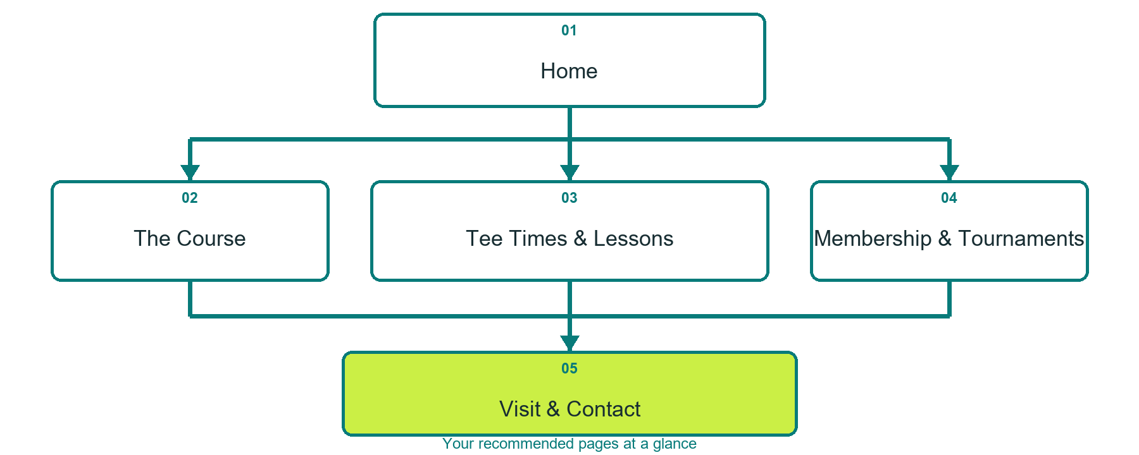

Inside this workbook
Five page examples • Practical writing exercises • A launch review
Use it in a workshop or at your own pace. Write by hand or complete the response fields in Word.

How to use this workbook
□ Choose one visitor task for each page.
□ Gather current course facts and permission-cleared photographs.
□ State clearly where tee times, lessons and tournament enquiries are confirmed.
□ Keep sample prices, dates and policies out until the club verifies them.
□ Test the finished journey on desktop and mobile.
Explore Website Builder and compare plans
Open the Golf Courses industry guide

What should a visitor be able to do after using the website

Course facts, photographs and booking details to confirm

Workshop decisions and follow up owner

PAGE 1

Home
Introduce the course, season and clearest next step. Let the hero establish place and welcome without hiding practical information.
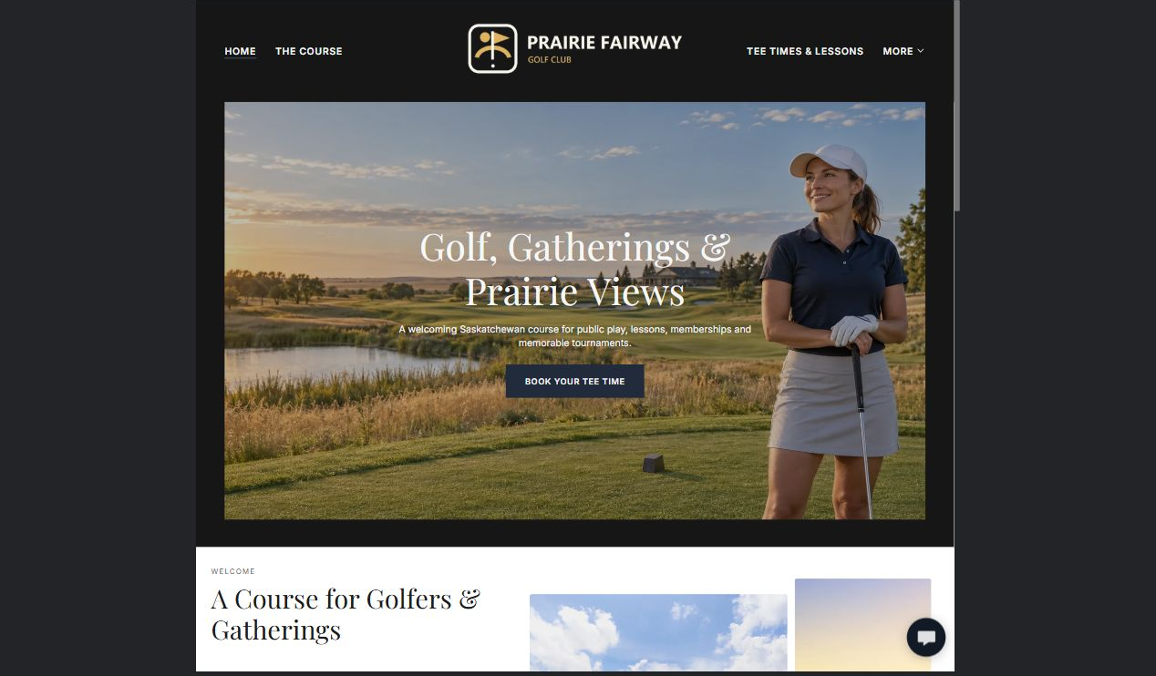

Clearly labelled sample wording
Sample wording: Golf, gatherings and prairie views. Explore the course, compare ways to play and choose the right next step for a round, lesson or event.

Draft your own page copy

Photographs, proof and links to prepare

PAGE 2

The Course
Explain the layout, practice areas, amenities, access and policies using verified facts and distinct images.
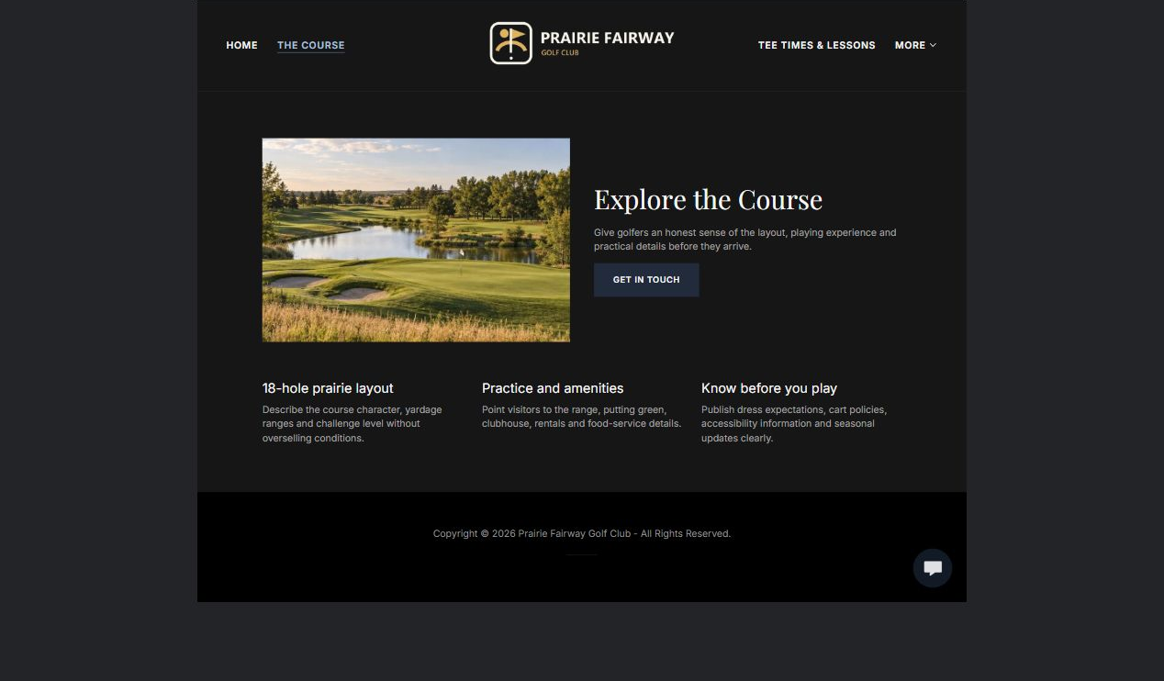

Clearly labelled sample wording
Sample wording: Give golfers an honest sense of the playing experience and the practical details they should know before arriving.

Draft your own page copy

Photographs, proof and links to prepare

PAGE 3

Tee Times and Lessons
Separate live tee-time booking from lesson enquiries. Explain availability, group size, arrival and confirmation.
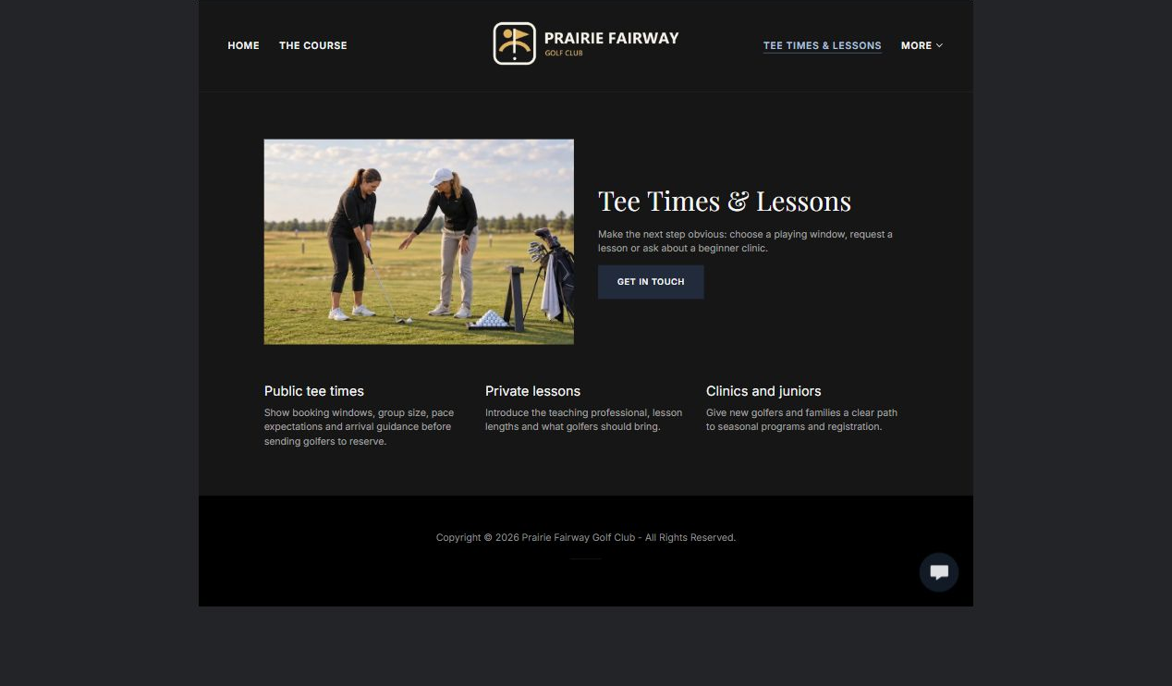

Clearly labelled sample wording
Sample wording: Choose a playing window, request a lesson or ask about a beginner clinic. The club confirms the correct booking route.

Draft your own page copy

Photographs, proof and links to prepare

PAGE 4

Membership and Tournaments
Help members and organisers compare options without inventing rates, capacity or availability.
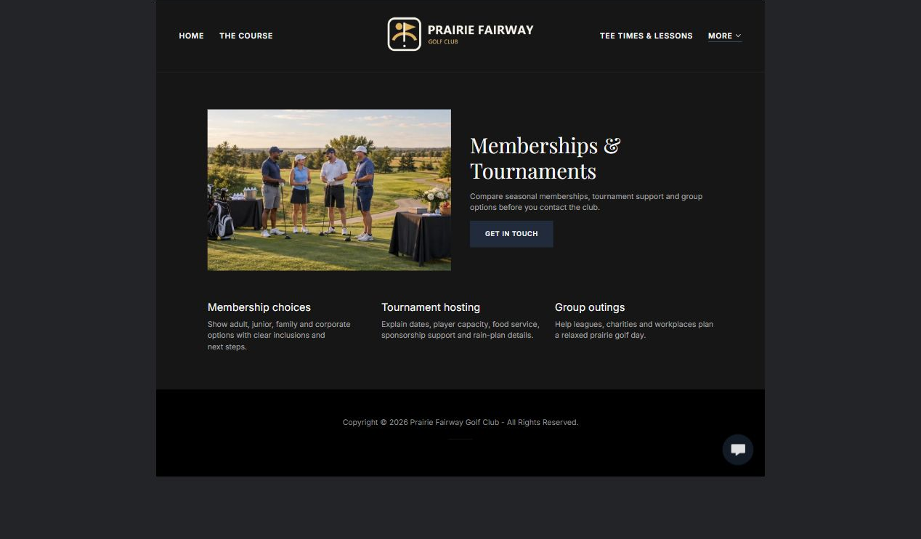

Clearly labelled sample wording
Sample wording: Tell us the date, player count, format and event needs. We will confirm availability and prepare the next step.

Draft your own page copy

Photographs, proof and links to prepare

PAGE 5

Visit and Contact
Publish current directions, seasonal hours, accessibility and contact routes. Make the form useful but not sensitive.
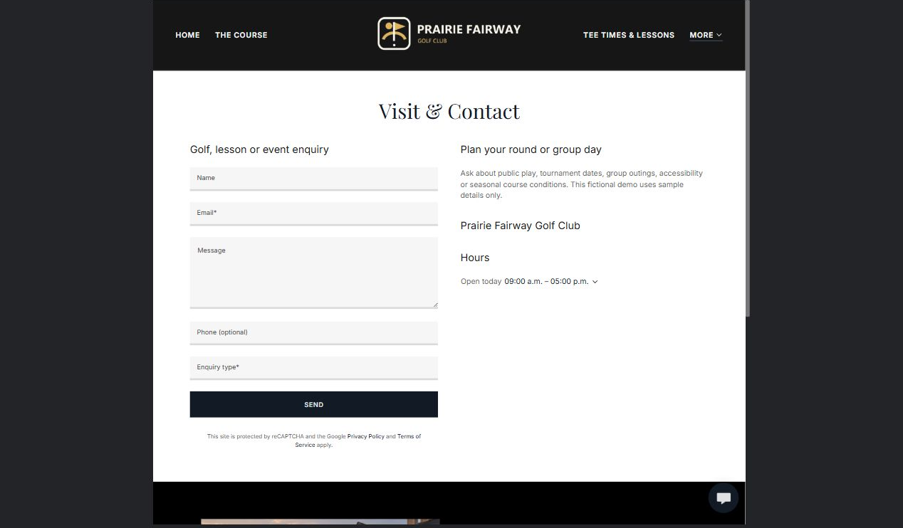

Clearly labelled sample wording
Sample wording: Ask about public play, group outings, accessibility or current course conditions. Staff will follow up through the selected route.

Draft your own page copy

Photographs, proof and links to prepare

FINAL REVIEW

Test the visitor journey
Ask someone unfamiliar with the club to plan a round, lesson or event using only the website.
□ Each page has one clear purpose and next action.
□ Desktop and mobile previews are readable.
□ Logo contrast works on light and dark backgrounds.
□ Every photograph is relevant, distinct and permission-cleared.
□ Tee-time, lesson and tournament wording matches the real confirmation process.
□ Course facts, hours, policies and accessibility details are verified.
□ A named backup and future review owner are recorded.

Changes found during review

Content owner and next review date

