

Gas Stations & Highway Service Centres
Website workbook
A practical SaaSTech Servers workshop: learn from the Prairie Junction demo, plan six useful pages and draft your own website.
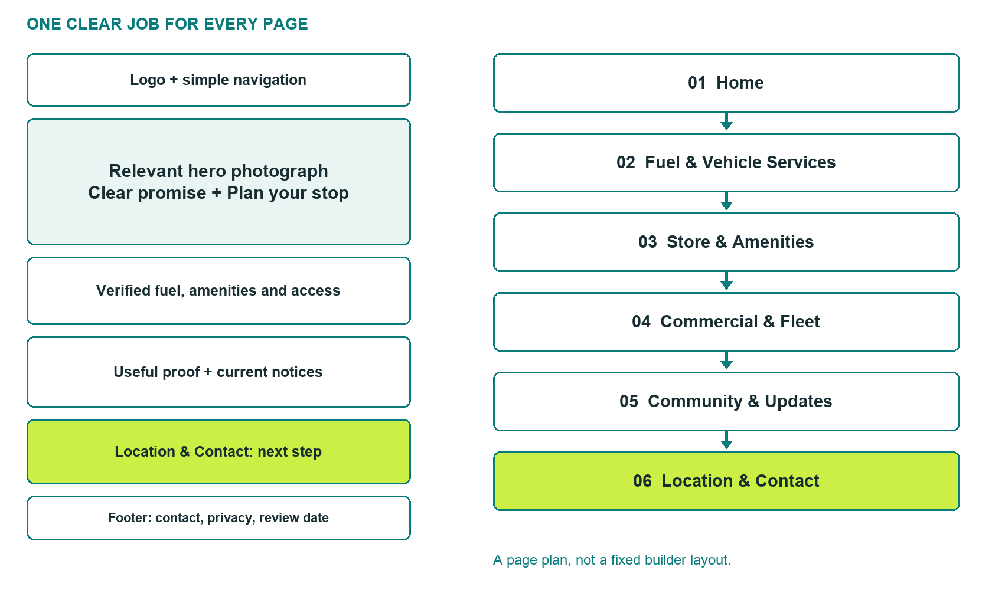

Learn → plan → draft → build → test
Bring verified business details, distinct photos and a clear customer action. This guide is editable in Word and printable for handwritten workshop notes.
Explore Website Builder and compare plans

BEFORE YOU BUILD

Plan a useful stop
Work as the owner of your real business. Prairie Junction is a fictional teaching example, not a real station or an operating-services promise.

□ Decide who the website serves: local drivers, highway travellers or working vehicles.
□ Confirm actual location, hours, fuel/service availability and contact responsibility.
□ Choose Business as a starting point for an information-led site; compare current plan features before buying.
□ Keep card numbers, credentials and account applications out of public forms.
□ Prepare six different photos, with permission to use people and branding.

Your audience and primary customer action

Verified facts, sources and person responsible
View the industry guide and recommended plan
Create your SaaSTech account

PAGE 1 · STUDY THE EXAMPLE

Home
Give a traveller a clear reason to stop, then direct them to confirmed visiting details.
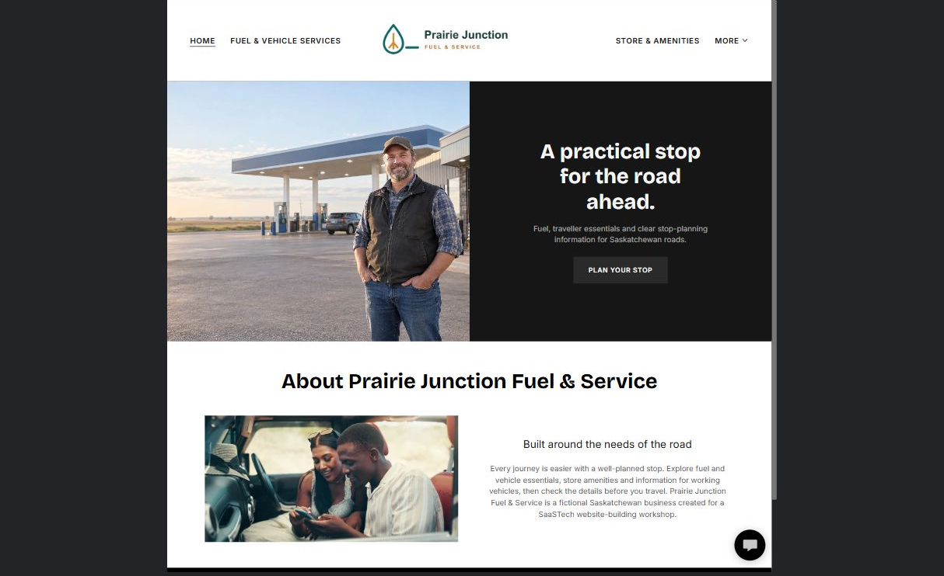

Actual Prairie Junction demo wording
A practical stop for the road ahead.
Fuel, traveller essentials and clear stop-planning information for Saskatchewan roads.
Built around the needs of the road
Every journey is easier with a well-planned stop. Explore fuel and vehicle essentials, store amenities and information for working vehicles, then check the details before you travel. Prairie Junction Fuel & Service is a fictional Saskatchewan business created for a SaaSTech website-building workshop.

Website advice
Use a wide photograph of your own station and leave room for the headline. Publish only verified services; do not imply 24-hour operation.

PAGE 1 · YOUR WORKSHOP DRAFT

Draft: Home
What is the most useful reason to choose your stop?

Headline and short introduction

Main content: the facts and benefits customers need

Button wording and destination

Unique photo, factual checks and approvals
Partner check: can someone unfamiliar with the business identify this page’s job and next step?

PAGE 2 · STUDY THE EXAMPLE

Fuel & Vehicle Services
Help customers check vehicle fit and service availability before making a detour.
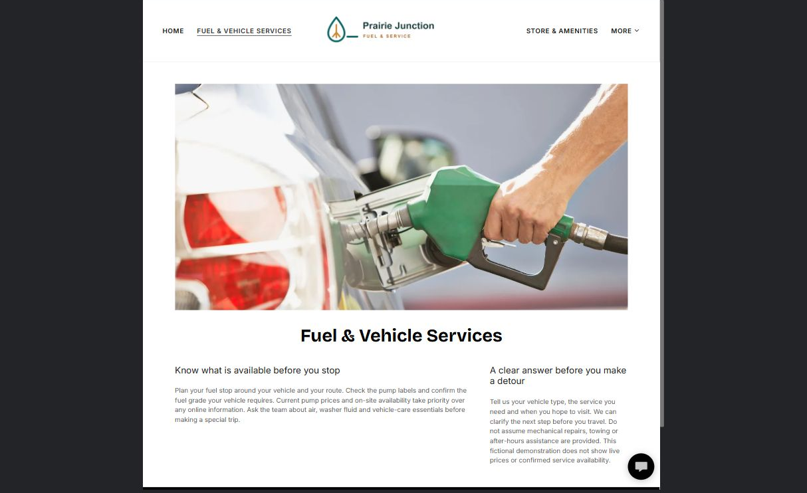

Actual Prairie Junction demo wording
Know what is available before you stop
Plan your fuel stop around your vehicle and your route. Check the pump labels and confirm the fuel grade your vehicle requires. Current pump prices and on-site availability take priority over any online information. Ask the team about air, washer fluid and vehicle-care essentials before making a special trip.
A clear answer before you make a detour
Tell us your vehicle type, the service you need and when you hope to visit. We can clarify the next step before you travel. Do not assume mechanical repairs, towing or after-hours assistance are provided. This fictional demonstration does not show live prices or confirmed service availability.

Website advice
Use an actual pump or service-area photo. Identify who updates availability. Do not invent fuel grades, repair services or prices.

PAGE 2 · YOUR WORKSHOP DRAFT

Draft: Fuel & Vehicle Services
Which vehicle needs can you confidently support?

Headline and short introduction

Main content: the facts and benefits customers need

Button wording and destination

Unique photo, factual checks and approvals
Partner check: can someone unfamiliar with the business identify this page’s job and next step?

PAGE 3 · STUDY THE EXAMPLE

Store & Amenities
Make it easy to judge whether this stop meets the needs of a traveller or family.
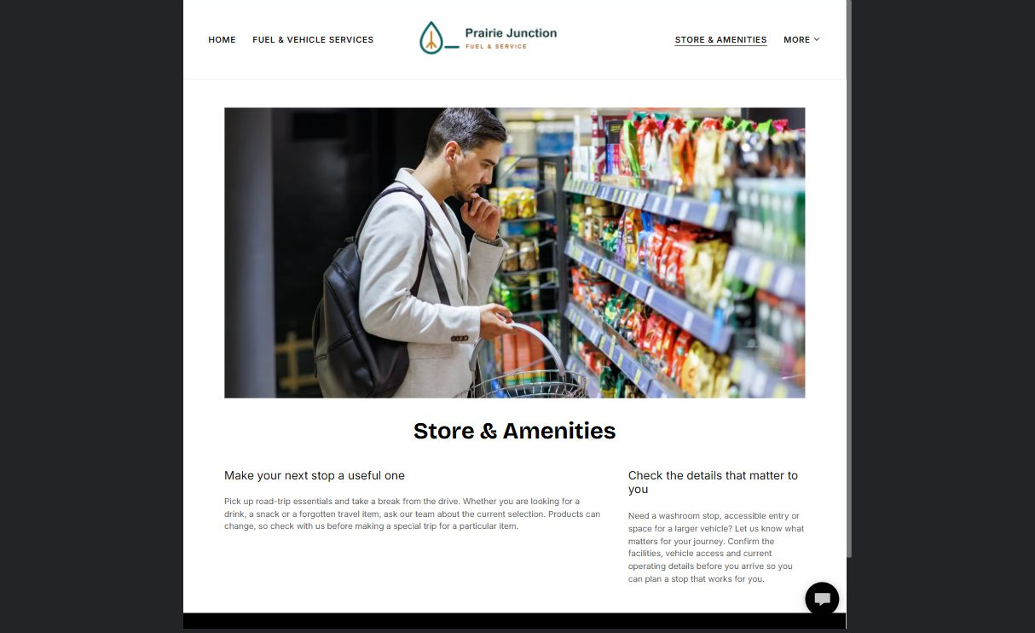

Actual Prairie Junction demo wording
Make your next stop a useful one
Pick up road-trip essentials and take a break from the drive. Whether you are looking for a drink, a snack or a forgotten travel item, ask our team about the current selection. Products can change, so check with us before making a special trip for a particular item.
Check the details that matter to you
Need a washroom stop, accessible entry or space for a larger vehicle? Let us know what matters for your journey. Confirm the facilities, vehicle access and current operating details before you arrive so you can plan a stop that works for you.

Website advice
Photograph a distinct store or amenity view. Verify accessibility details directly; do not describe a facility as accessible from a photo alone.

PAGE 3 · YOUR WORKSHOP DRAFT

Draft: Store & Amenities
Which amenities most affect a customer’s decision to stop?

Headline and short introduction

Main content: the facts and benefits customers need

Button wording and destination

Unique photo, factual checks and approvals
Partner check: can someone unfamiliar with the business identify this page’s job and next step?

PAGE 4 · STUDY THE EXAMPLE

Commercial & Fleet
Invite a useful business conversation without implying credit approval or a fleet-card partnership.
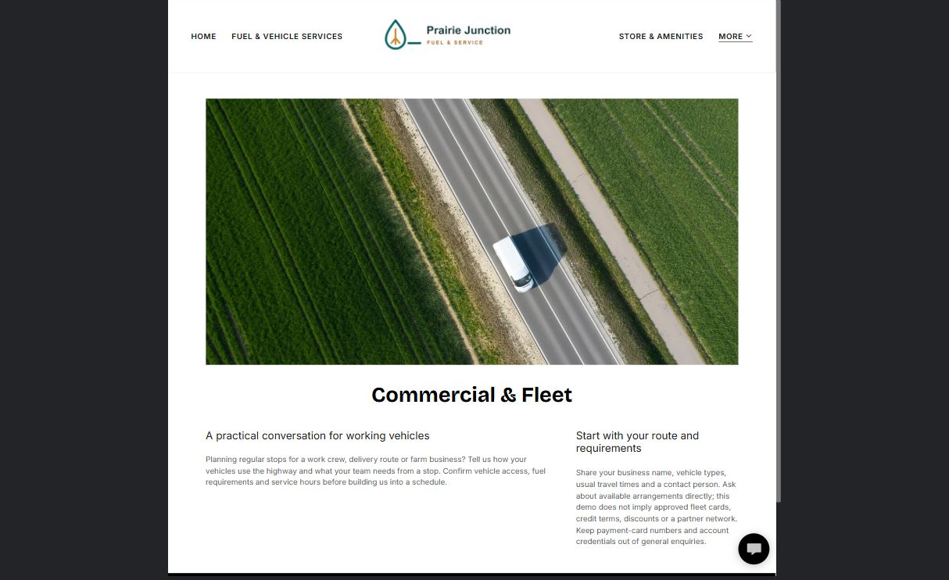

Actual Prairie Junction demo wording
A practical conversation for working vehicles
Planning regular stops for a work crew, delivery route or farm business? Tell us how your vehicles use the highway and what your team needs from a stop. Confirm vehicle access, fuel requirements and service hours before building us into a schedule.
Start with your route and requirements
Share your business name, vehicle types, usual travel times and a contact person. Ask about available arrangements directly; this demo does not imply approved fleet cards, credit terms, discounts or a partner network. Keep payment-card numbers and account credentials out of general enquiries.

Website advice
Show relevant working vehicles without suggesting they are customers. Confirm arrangements privately; collect only initial enquiry information online.

PAGE 4 · YOUR WORKSHOP DRAFT

Draft: Commercial & Fleet
What information helps you assess a commercial enquiry?

Headline and short introduction

Main content: the facts and benefits customers need

Button wording and destination

Unique photo, factual checks and approvals
Partner check: can someone unfamiliar with the business identify this page’s job and next step?

PAGE 5 · STUDY THE EXAMPLE

Community & Updates
Keep notices useful, dated and easy to remove when they expire.
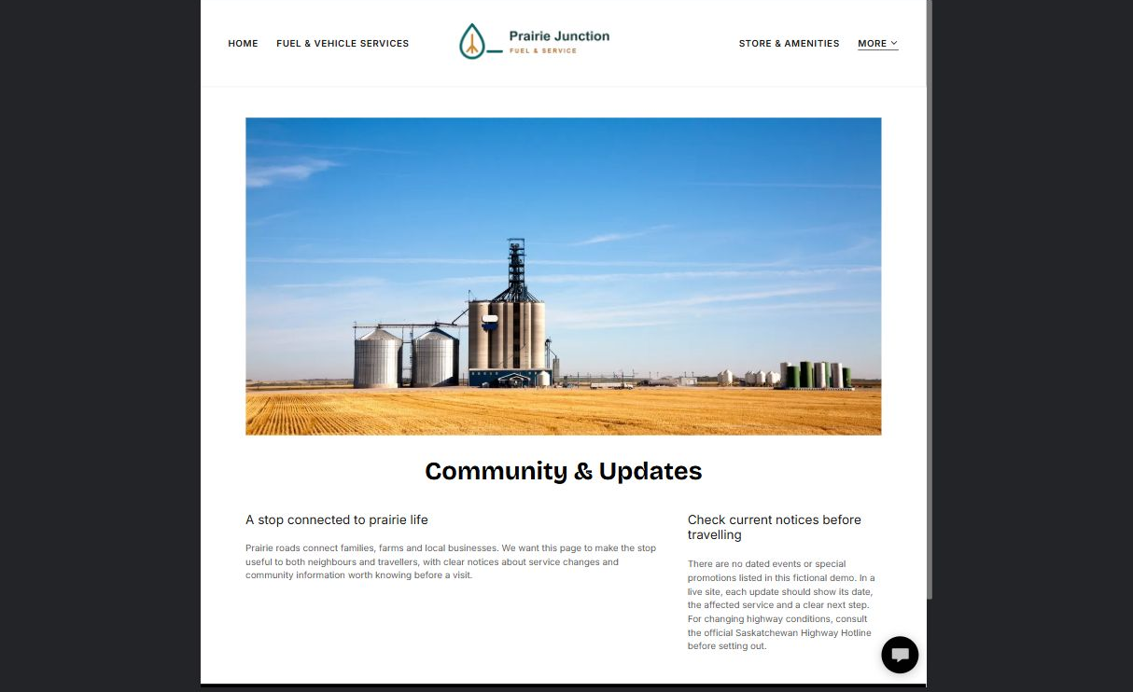

Actual Prairie Junction demo wording
A stop connected to prairie life
Prairie roads connect families, farms and local businesses. We want this page to make the stop useful to both neighbours and travellers, with clear notices about service changes and community information worth knowing before a visit.
Check current notices before travelling
There are no dated events or special promotions listed in this fictional demo. In a live site, each update should show its date, the affected service and a clear next step. For changing highway conditions, consult the official Saskatchewan Highway Hotline before setting out.

Website advice
Use a local landscape or permission-cleared community photo. Assign a notice owner and expiry date. Link to the appropriate official road-condition service.

PAGE 5 · YOUR WORKSHOP DRAFT

Draft: Community & Updates
Which changes should customers know before they travel?

Headline and short introduction

Main content: the facts and benefits customers need

Button wording and destination

Unique photo, factual checks and approvals
Partner check: can someone unfamiliar with the business identify this page’s job and next step?

PAGE 6 · STUDY THE EXAMPLE

Location & Contact
Bring the journey to a clear next step with verified directions, operating details and contact options.
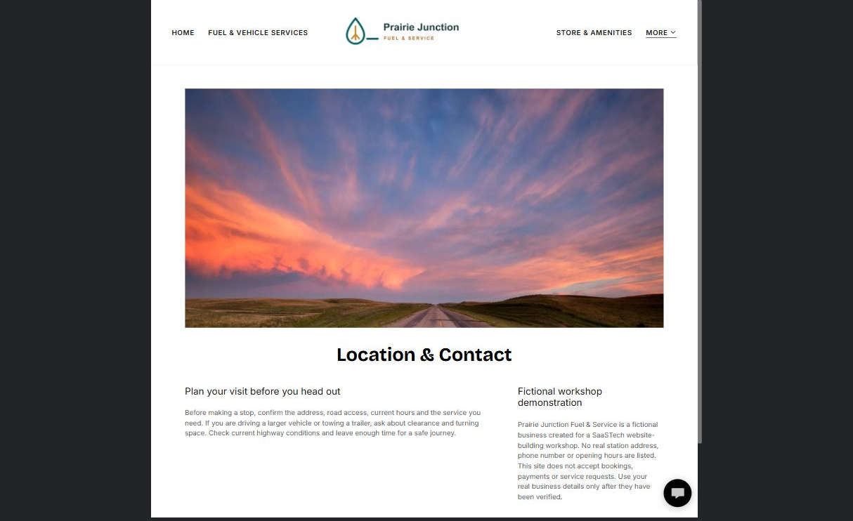

Actual Prairie Junction demo wording
Plan your visit before you head out
Before making a stop, confirm the address, road access, current hours and the service you need. If you are driving a larger vehicle or towing a trailer, ask about clearance and turning space. Check current highway conditions and leave enough time for a safe journey.
Fictional workshop demonstration
Prairie Junction Fuel & Service is a fictional business created for a SaaSTech website-building workshop. No real station address, phone number or opening hours are listed. This site does not accept bookings, payments or service requests. Use your real business details only after they have been verified.

Website advice
Test map pins, phone links and enquiry delivery on a real phone. Never use an invented address for a live business. Remove the fictional-demo notice only when your real site is ready.

PAGE 6 · YOUR WORKSHOP DRAFT

Draft: Location & Contact
What must a driver confirm before arriving?

Headline and short introduction

Main content: the facts and benefits customers need

Button wording and destination

Unique photo, factual checks and approvals
Partner check: can someone unfamiliar with the business identify this page’s job and next step?

READY TO BUILD AND LAUNCH

Check the complete journey
Use this checklist after building. A named backup is a recovery point, not a substitute for testing the published site.
□ Desktop and mobile: text, menus, buttons and photos are readable.
□ Every page has distinct, relevant imagery and correct light/dark logo contrast.
□ Address, map, hours, services and access details have an owner and review date.
□ Phone links and any configured form reach the right person; no sensitive information is requested.
□ Each notice has a date and expiry plan; no unsupported prices or availability promises remain.
□ Downloads open correctly; privacy and other required business policies are reviewed before publishing.
□ A clearly named final backup is saved before major future changes.

Changes to finish, owner and target date

Final approval and next review date
Compare Website Builder plans and follow the shop signup links

