

Forestry, Logging & Sawmills
Website workbook
A practical workshop for a 6-page website. Study the example, plan the content and draft your own version in Word or on paper.
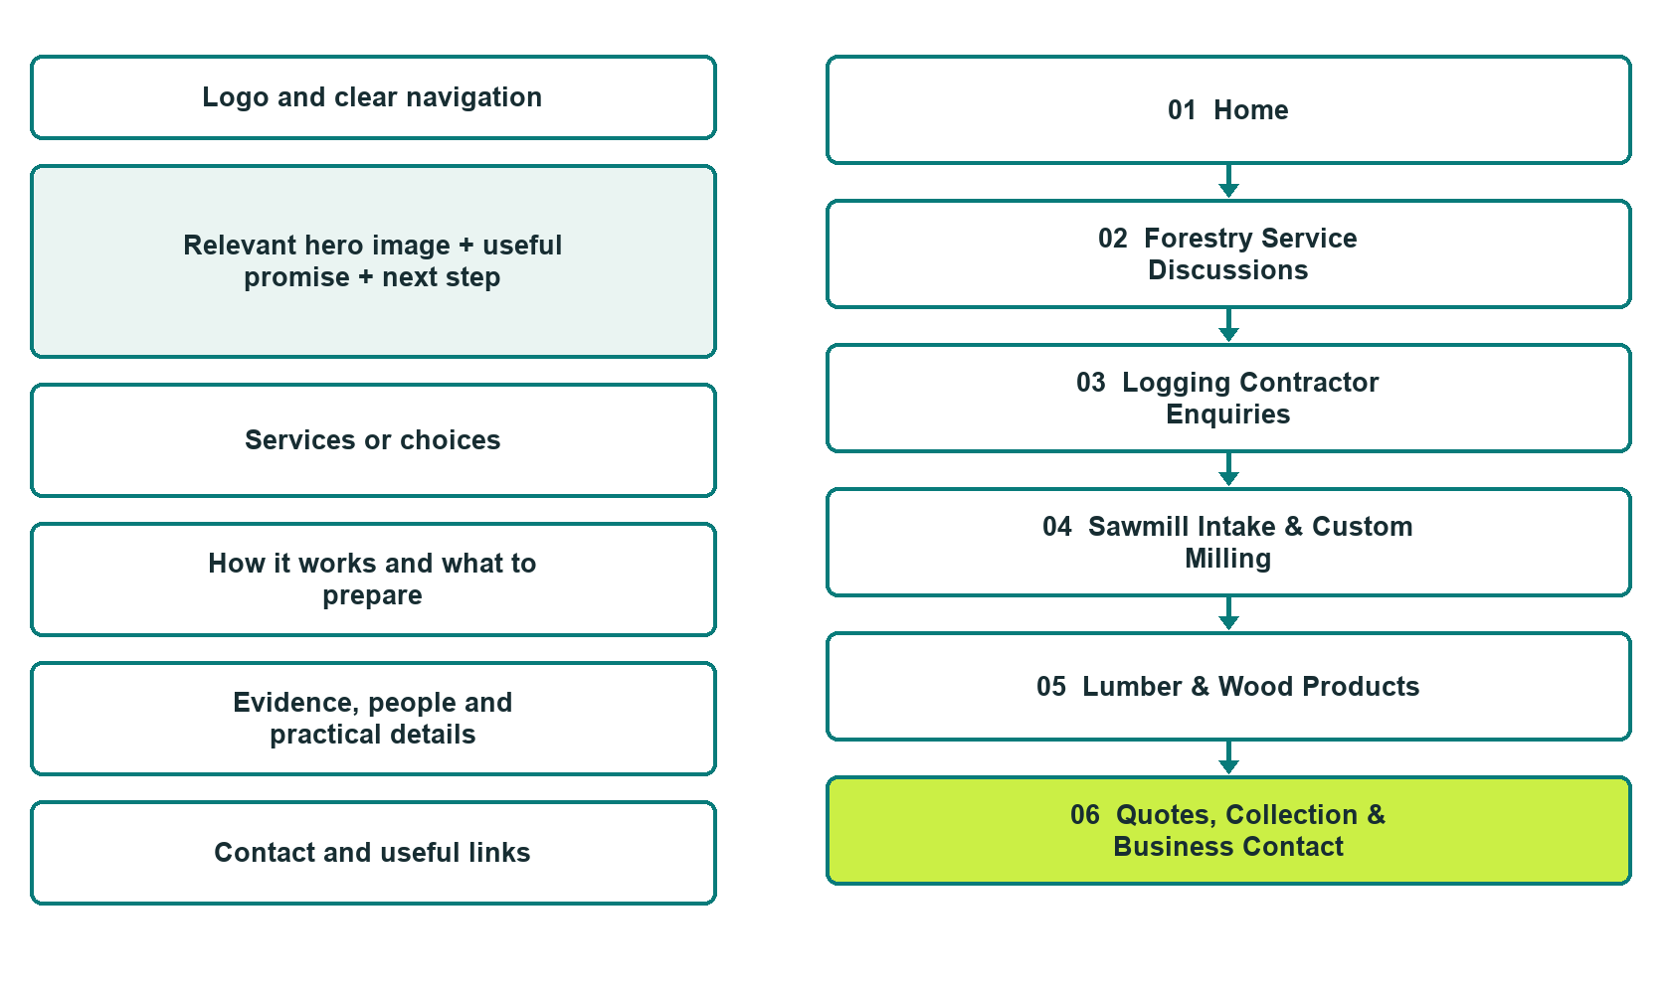

Plan → Draft → Build → Test
Captured demo edition. Study the unpublished six-page example. Paired desktop and mobile views, Editor Highlights, Themes and Paint settings appear in the industry gallery.
Explore Website Builder and compare plans

Before you build
Your business supplies the facts. Prairie Treeline Woodworks is a fictional teaching example, not a live service.
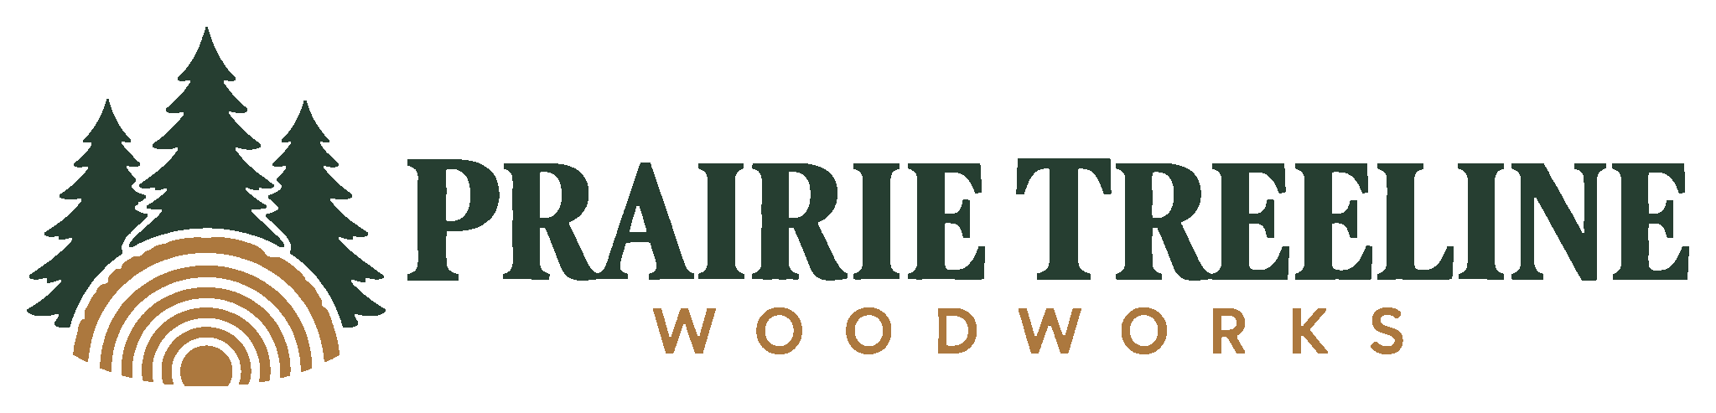
□ Choose a contractor or wood-product enquiry
□ Verified business identity, services and current contact information
□ A clear enquiry, review and confirmation process
□ Choose original photographs and confirm permission to use them.
□ Keep private customer records out of public website forms.

Your audience and the action you want them to take

Facts to verify and people who must approve them
Create your SaaSTech account

01 Home
Give this page one clear job in the customer journey.
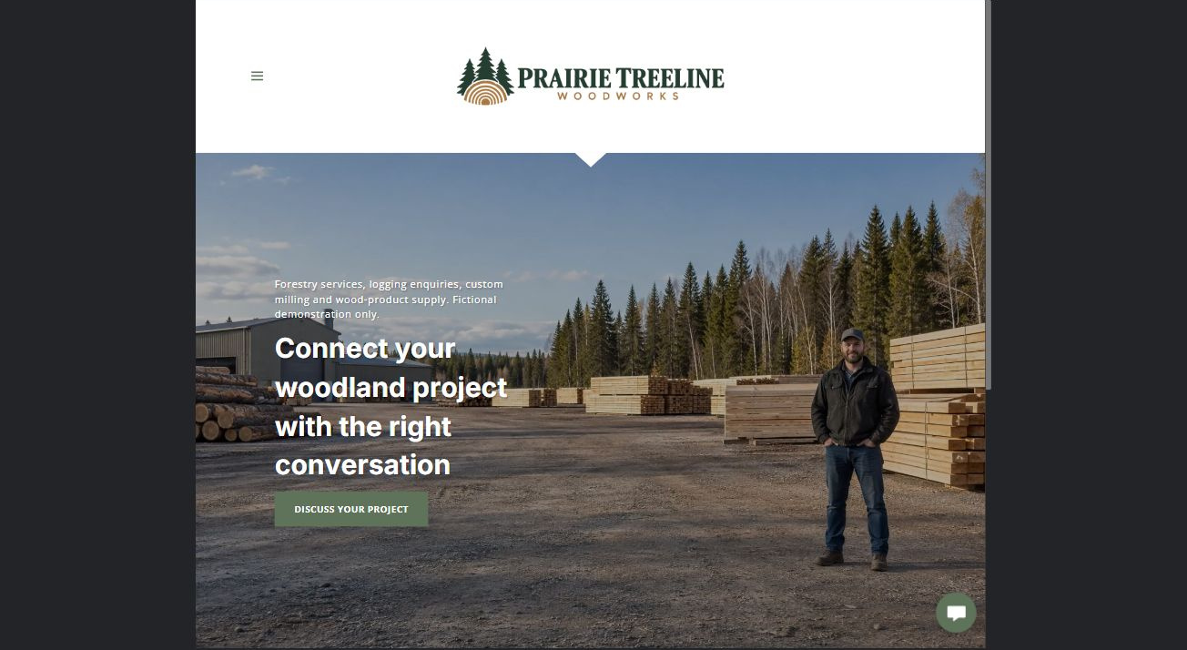
Actual desktop Website Builder preview. Its paired mobile view appears in the industry gallery.

Sample wording — adapt and verify
Connect your woodland project with the right conversation
A woodland-service discussion is different from a log intake or lumber enquiry.
Choose the appropriate route, describe the material or project you already know about, and let the team confirm its role and the information required.
Enquiry route: Project Enquiries. The Home button is Discuss your project.

Website advice
Separate forestry-service and logging enquiries from sawmill intake and wood-product supply; publish only confirmed capabilities and sourcing information.

Your draft: Home
Write in the voice of your own business. Use facts you can verify, not promises copied from the example.

Headline and short introduction

Main content and details visitors need

Button wording and destination

Photo choice, permission and facts still to confirm
Partner check: can someone unfamiliar with the business find a useful next step?

02 Forestry Service Discussions
Give this page one clear job in the customer journey.
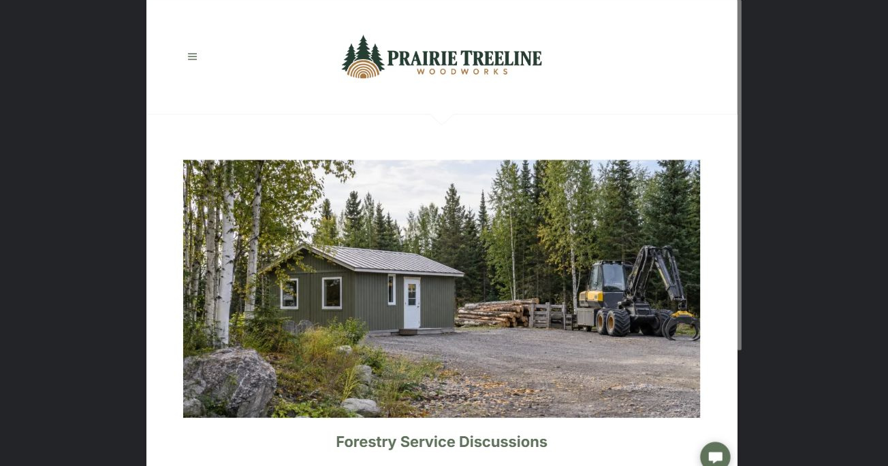
Actual desktop Website Builder preview. Its paired mobile view appears in the industry gallery.

Sample wording — adapt and verify
Start with the project and the intended outcome
Describe the general project area and the outcome you want to discuss with a qualified reviewer.
The coordinator can explain which services are offered and which questions need a different professional or authority.
Enquiry route: Project Enquiries. The Home button is Discuss your project.

Website advice
Explain accepted planning and woodland-service enquiry categories without giving management or environmental advice.

Your draft: Forestry Service Discussions
Write in the voice of your own business. Use facts you can verify, not promises copied from the example.

Headline and short introduction

Main content and details visitors need

Button wording and destination

Photo choice, permission and facts still to confirm
Partner check: can someone unfamiliar with the business find a useful next step?

03 Logging Contractor Enquiries
Give this page one clear job in the customer journey.
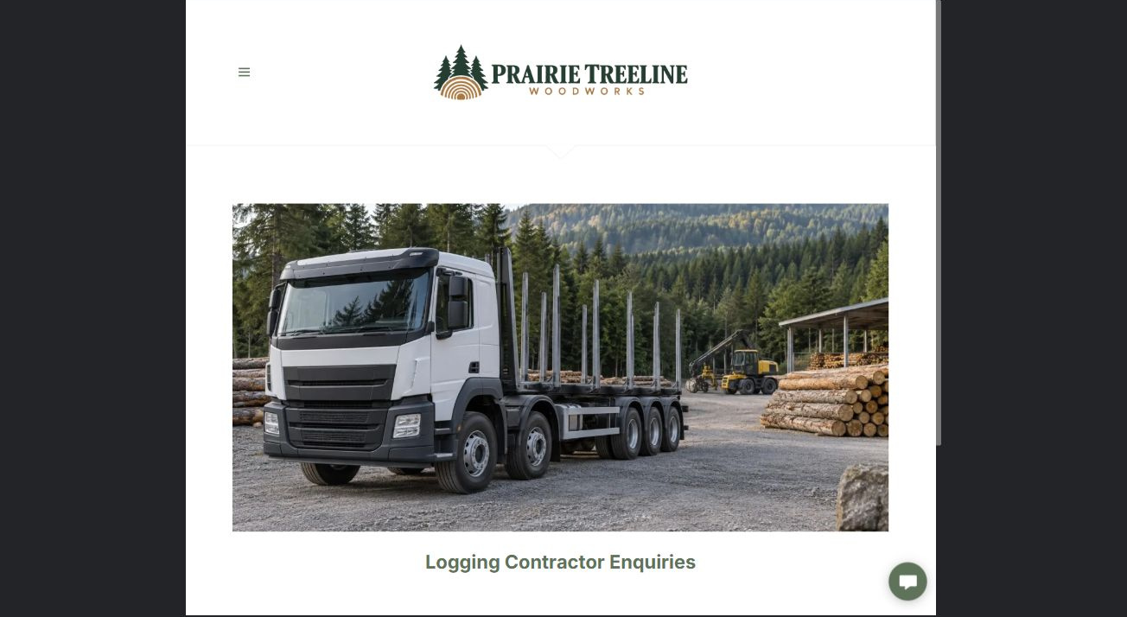
Actual desktop Website Builder preview. Its paired mobile view appears in the industry gallery.

Sample wording — adapt and verify
Confirm the scope before work is accepted
Share the broad work category, project stage and coordinating contact.
Scope, authority, documentation and scheduling must be reviewed through the operator’s process before the contractor accepts a project.
Enquiry route: Project Enquiries. The Home button is Discuss your project.

Website advice
Distinguish contractor capability discussions from forestry planning, legal authority and timber sales.

Your draft: Logging Contractor Enquiries
Write in the voice of your own business. Use facts you can verify, not promises copied from the example.

Headline and short introduction

Main content and details visitors need

Button wording and destination

Photo choice, permission and facts still to confirm
Partner check: can someone unfamiliar with the business find a useful next step?

04 Sawmill Intake & Custom Milling
Give this page one clear job in the customer journey.
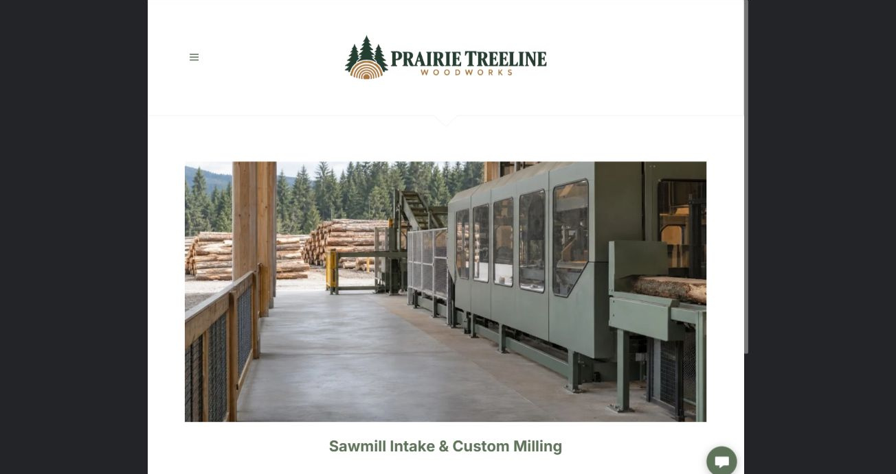
Actual desktop Website Builder preview. Its paired mobile view appears in the industry gallery.

Sample wording — adapt and verify
Discuss intake before bringing material
Ask whether the mill is accepting the type of material you want to discuss.
Staff will explain the details needed for an intake review and which dimensions, finish expectations and collection arrangements must be agreed before delivery.
Enquiry route: Project Enquiries. The Home button is Discuss your project.

Website advice
Explain material-acceptance enquiries and milling specifications without promising recovery, dimensions or acceptance.

Your draft: Sawmill Intake & Custom Milling
Write in the voice of your own business. Use facts you can verify, not promises copied from the example.

Headline and short introduction

Main content and details visitors need

Button wording and destination

Photo choice, permission and facts still to confirm
Partner check: can someone unfamiliar with the business find a useful next step?

05 Lumber & Wood Products
Give this page one clear job in the customer journey.
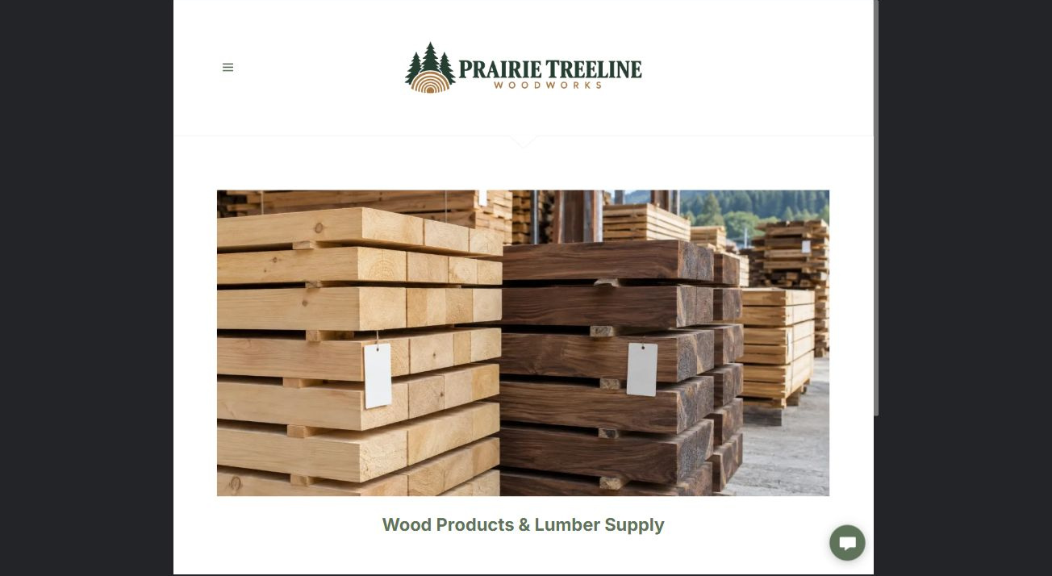
Actual desktop Website Builder preview. Its paired mobile view appears in the industry gallery.

Sample wording — adapt and verify
Describe the product you need
Use the exact dimensions and product description you need when requesting availability.
Ask for current product documentation and confirm suitability with the appropriate project professional rather than relying on a display photograph.
Enquiry route: Project Enquiries. The Home button is Discuss your project.

Website advice
Present verified species, dimensions and finish categories while keeping stock and intended-use questions separate.

Your draft: Lumber & Wood Products
Write in the voice of your own business. Use facts you can verify, not promises copied from the example.

Headline and short introduction

Main content and details visitors need

Button wording and destination

Photo choice, permission and facts still to confirm
Partner check: can someone unfamiliar with the business find a useful next step?

06 Quotes, Collection & Business Contact
Give this page one clear job in the customer journey.
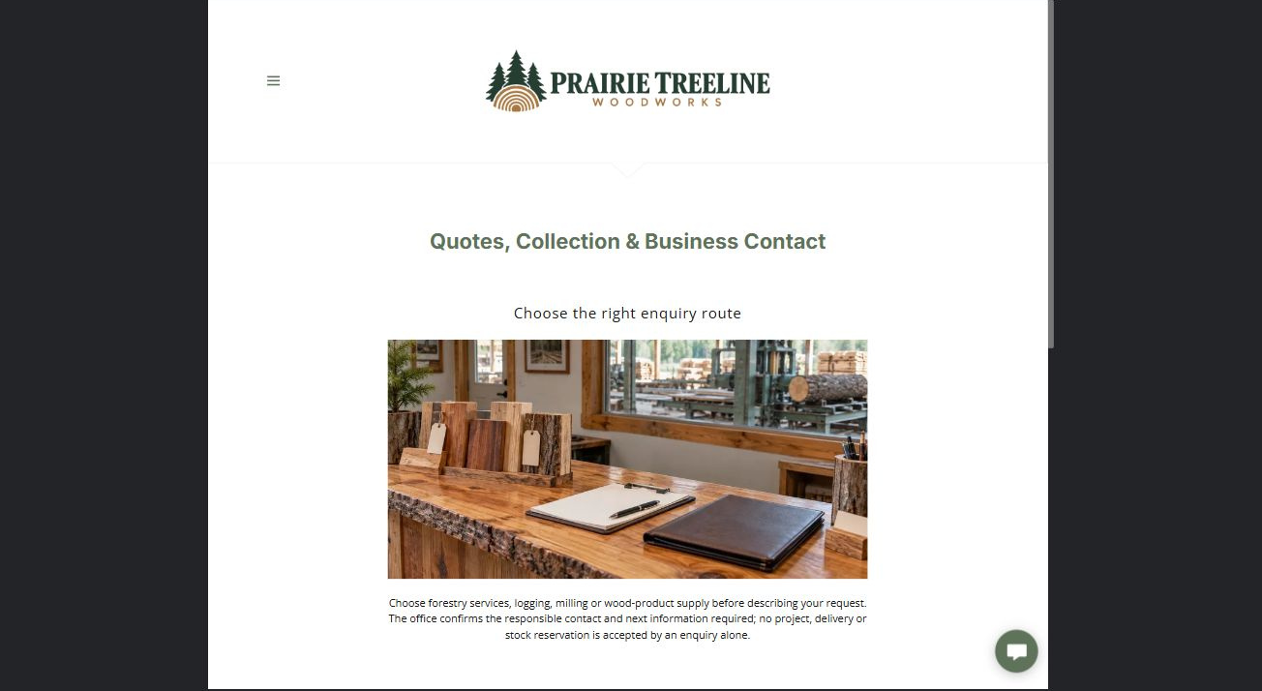
Actual desktop Website Builder preview. Its paired mobile view appears in the industry gallery.

Sample wording — adapt and verify
Choose the right enquiry route
Choose forestry services, logging, milling or wood-product supply before describing your request.
The office confirms the responsible contact and next information required; no project, delivery or stock reservation is accepted by the enquiry alone.
Enquiry route: Project Enquiries. The Home button is Discuss your project.

Website advice
Provide separate project, milling and product routes with clear acceptance and confirmation boundaries.

Your draft: Quotes, Collection & Business Contact
Write in the voice of your own business. Use facts you can verify, not promises copied from the example.

Headline and short introduction

Main content and details visitors need

Button wording and destination

Photo choice, permission and facts still to confirm
Partner check: can someone unfamiliar with the business find a useful next step?

Test before publishing
Review the captured desktop and phone journey. The fictional form has Name, required Email, required Enquiry category and Message. Recipient blank, attachments off; no submission or delivery test. Configure approved delivery and consent before a real launch.
□ Fictional demonstration only. No forestry prescription, harvesting instruction, land-rights advice or structural timber suitability assurance is provided. Verify authority, qualifications, accepted work, species descriptions and every environmental or certification claim.
□ Verify every service description, contact route and operating detail.
□ Replace fictional identity and example information before a live launch.
□ Test enquiries, links and downloads on desktop and mobile.
□ Keep confidential records in approved private systems.
□ Obtain operator approval for public wording and images.
□ Check every link, form destination, download and confirmation message.
□ Check logo contrast, hero framing, text sizes and image loading.
□ Save a named backup and assign a content-review date.

Changes to finish and person responsible

Approval and next review date
Website Builder plans and signup

