

Food Processors & Commercial Kitchens
Website workbook
A practical workshop for a 6-page website. Study the example, plan the content and draft your own version in Word or on paper.
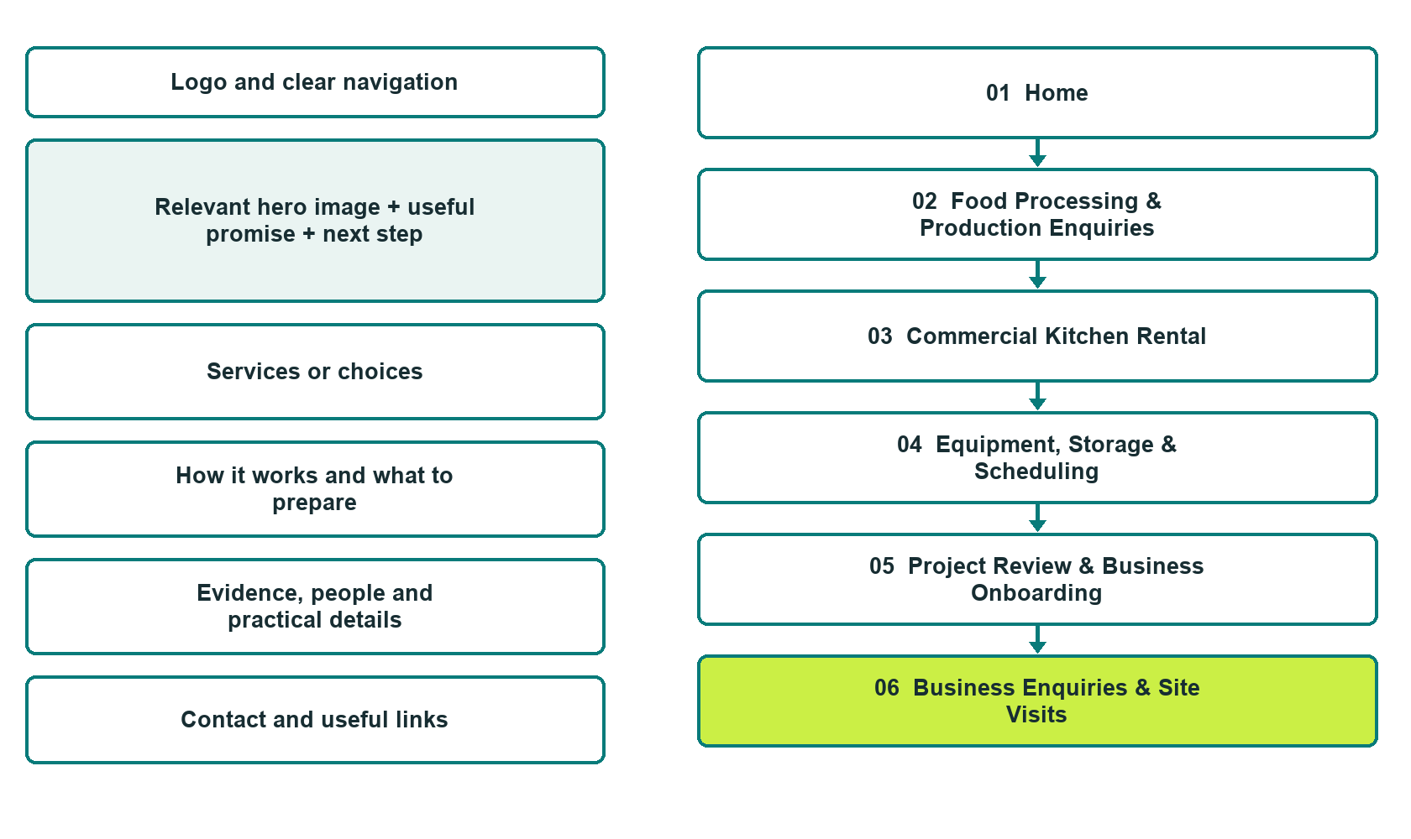

Plan → Draft → Build → Test
Captured demo edition. Study the unpublished six-page example. The industry gallery pairs each desktop preview with mobile and includes Editor Highlights, Themes and Paint settings.
Explore Website Builder and compare plans

Before you build
Your business supplies the facts. Prairie Batchworks is a fictional teaching example. Keep the demo unpublished, with no fabricated contact details, bookings or payments. Do not submit the demo form.

□ Discuss production services or kitchen use
□ Verified business identity, services and current contact information
□ A clear enquiry, review and confirmation process
□ Choose original photographs and confirm permission to use them.
□ Keep private customer records out of public website forms.

Your audience and the action you want them to take

Facts to verify and people who must approve them
Create your SaaSTech account

01 Home
Give this page one clear job in the customer journey.
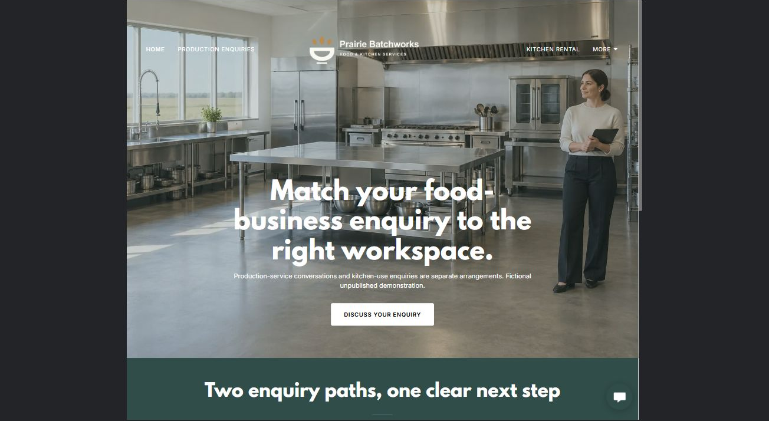
Actual desktop Website Builder preview. See the gallery for the paired mobile view.

Sample wording — adapt and verify
Match your food-business enquiry to the right workspace.
Choose a production-service conversation or a kitchen-rental enquiry; these are different arrangements with different responsibilities.
The coordinator checks product fit, workspace availability and onboarding requirements before discussing an agreement.
Home button: Discuss your enquiry. It opens Business Enquiries in this unpublished demo.

Website advice
Clearly separate contract food-processing enquiries from commercial-kitchen rental, including product-scope review, scheduling and approved onboarding.

Your draft: Home
Write in the voice of your own business. Use facts you can verify, not promises copied from the example.

Headline and short introduction

Main content and details visitors need

Button wording and destination

Photo choice, permission and facts still to confirm
Partner check: can someone unfamiliar with the business find a useful next step?

02 Food Processing & Production Enquiries
Give this page one clear job in the customer journey.
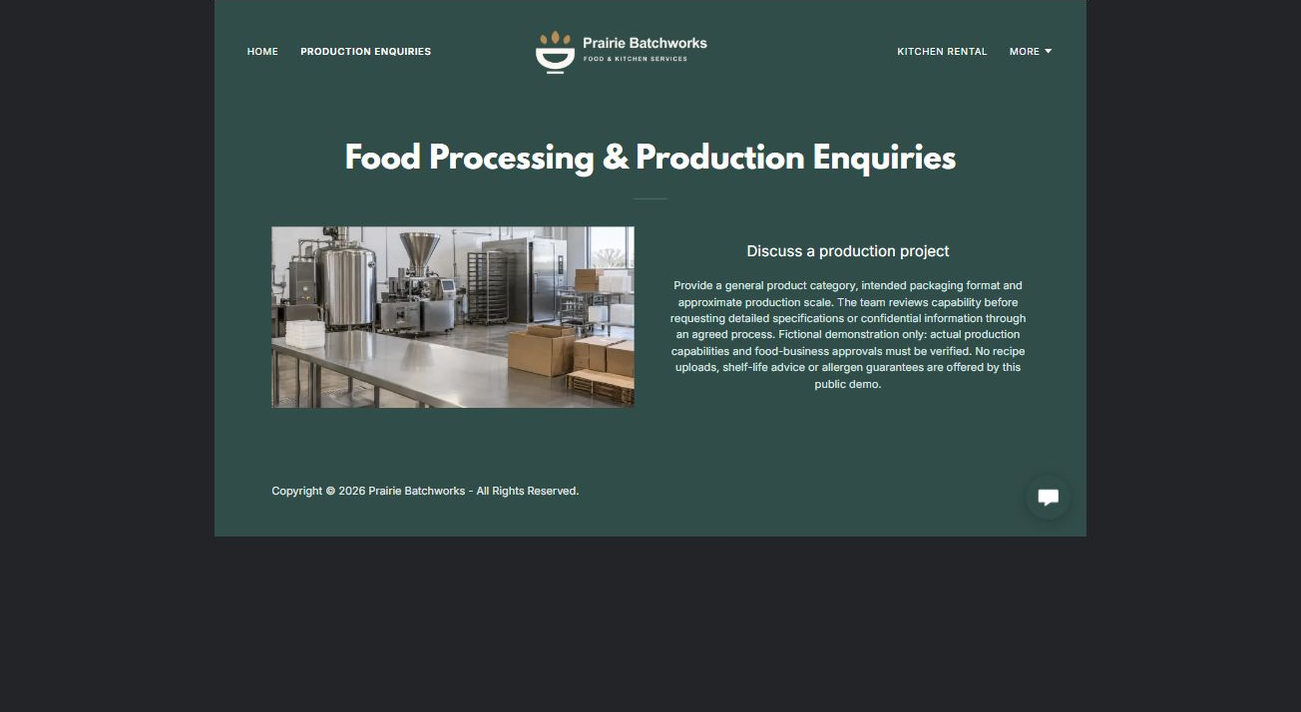
Actual desktop Website Builder preview. See the gallery for the paired mobile view.

Sample wording — adapt and verify
Food Processing & Production Enquiries
Provide a general product category, intended packaging format and approximate production scale.
The team reviews capability before requesting detailed specifications or confidential information through an agreed process.
Suggested button: Discuss production services or kitchen use

Website advice
Describe only verified processing categories and distinguish enquiries from accepted manufacturing orders.

Your draft: Food Processing & Production Enquiries
Write in the voice of your own business. Use facts you can verify, not promises copied from the example.

Headline and short introduction

Main content and details visitors need

Button wording and destination

Photo choice, permission and facts still to confirm
Partner check: can someone unfamiliar with the business find a useful next step?

03 Commercial Kitchen Rental
Give this page one clear job in the customer journey.
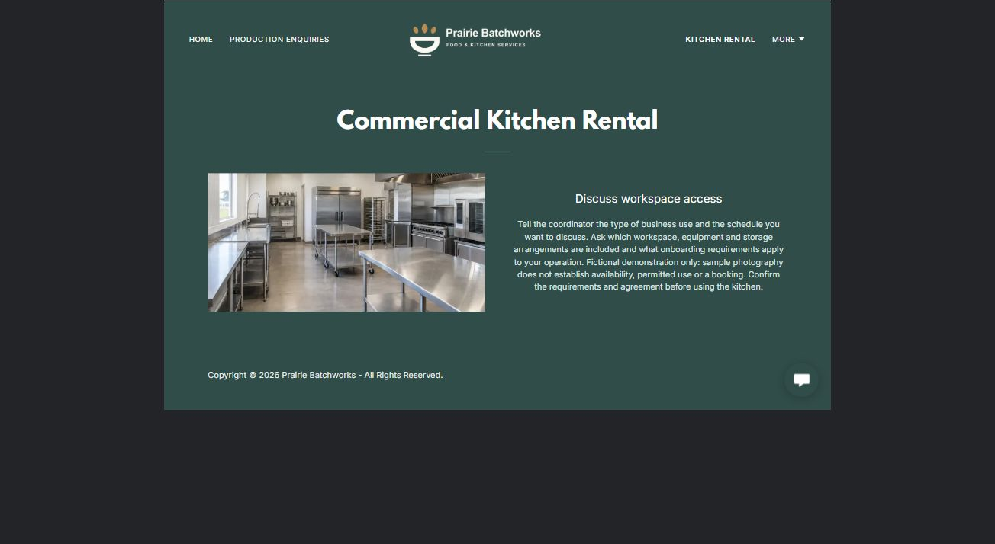
Actual desktop Website Builder preview. See the gallery for the paired mobile view.

Sample wording — adapt and verify
Commercial Kitchen Rental
Tell the coordinator the type of business use and the schedule you want to discuss.
Ask which workspace, equipment and storage arrangements are included and what onboarding requirements apply to your operation.
Suggested button: Discuss production services or kitchen use

Website advice
Explain rental formats, bookable spaces and responsibility questions without implying approval transfers to tenants.

Your draft: Commercial Kitchen Rental
Write in the voice of your own business. Use facts you can verify, not promises copied from the example.

Headline and short introduction

Main content and details visitors need

Button wording and destination

Photo choice, permission and facts still to confirm
Partner check: can someone unfamiliar with the business find a useful next step?

04 Equipment, Storage & Scheduling
Give this page one clear job in the customer journey.
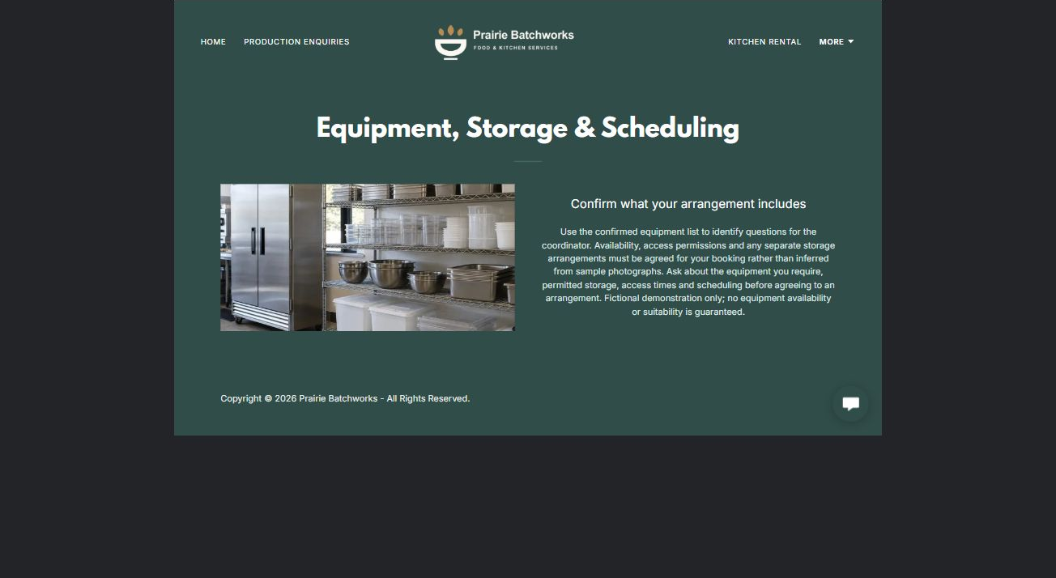
Actual desktop Website Builder preview. See the gallery for the paired mobile view.

Sample wording — adapt and verify
Equipment, Storage & Scheduling
Use the confirmed equipment list to identify questions for the coordinator.
Availability, access permissions and any separate storage arrangements must be agreed for your booking rather than inferred from sample photographs.
Suggested button: Discuss production services or kitchen use

Website advice
Present an operator-verified inventory and booking coordination, not technical operating instructions.

Your draft: Equipment, Storage & Scheduling
Write in the voice of your own business. Use facts you can verify, not promises copied from the example.

Headline and short introduction

Main content and details visitors need

Button wording and destination

Photo choice, permission and facts still to confirm
Partner check: can someone unfamiliar with the business find a useful next step?

05 Project Review & Business Onboarding
Give this page one clear job in the customer journey.
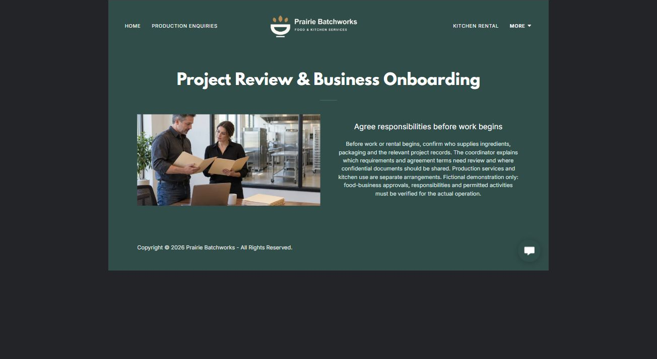
Actual desktop Website Builder preview. See the gallery for the paired mobile view.

Sample wording — adapt and verify
Project Review & Business Onboarding
Before work or rental begins, confirm who supplies ingredients, packaging and the relevant project records.
The coordinator explains which requirements and agreement terms need review and where confidential documents should be shared.
Suggested button: Discuss production services or kitchen use

Website advice
Separate capability checks, confidential specifications, reviewed operating requirements and written acceptance.

Your draft: Project Review & Business Onboarding
Write in the voice of your own business. Use facts you can verify, not promises copied from the example.

Headline and short introduction

Main content and details visitors need

Button wording and destination

Photo choice, permission and facts still to confirm
Partner check: can someone unfamiliar with the business find a useful next step?

06 Business Enquiries & Site Visits
Give this page one clear job in the customer journey.
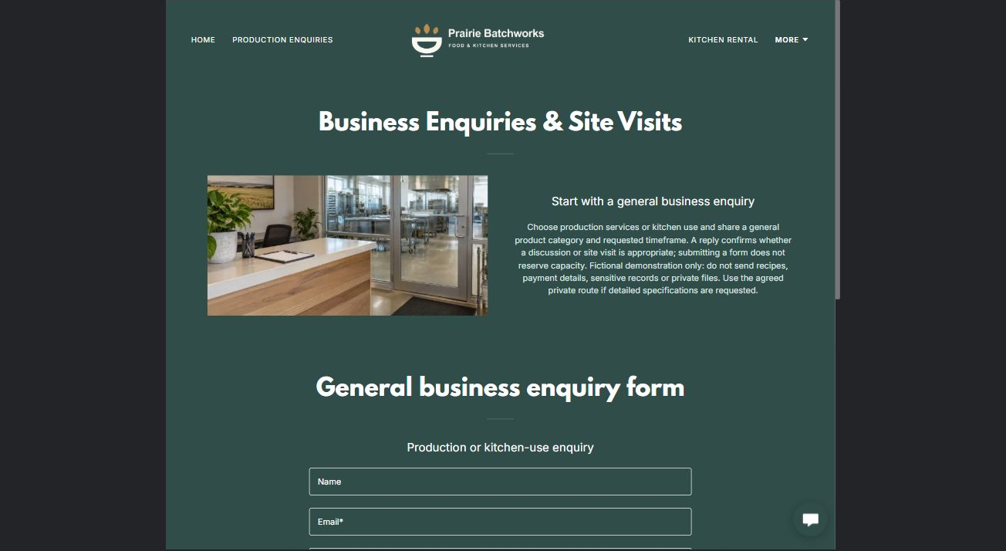
Actual desktop Website Builder preview. See the gallery for the paired mobile view.

Sample wording — adapt and verify
Business Enquiries & Site Visits
Choose production services or kitchen use and share a general product category and requested timeframe.
A reply confirms whether a discussion or site visit is appropriate; submitting the form does not reserve capacity.
Suggested button: Discuss production services or kitchen use

Website advice
The demo form has Name, required Email, production services or kitchen use, and a general category, timeframe and question. Phone and attachments are off; the recipient is blank. No submission or delivery test was performed. Do not send recipes, private specifications or payment details. An enquiry does not reserve capacity. Confirm the delivery route before a real launch.

Your draft: Business Enquiries & Site Visits
Write in the voice of your own business. Use facts you can verify, not promises copied from the example.

Headline and short introduction

Main content and details visitors need

Button wording and destination

Photo choice, permission and facts still to confirm
Partner check: can someone unfamiliar with the business find a useful next step?

Test before publishing
Review the captured journey on desktop and phone. The fictional demo remains unpublished. Verify the operator, capabilities, form recipient and confirmation process before a real launch.
□ Fictional demonstration only. Verify actual production capabilities, food-business approvals, equipment access and rental requirements. No food-safety procedures, shelf-life advice, allergen guarantees or compliance promises. Confidential recipes and business records require an approved private route.
□ Verify every service description, contact route and operating detail.
□ Replace fictional identity and example information before a live launch.
□ Visually check the demonstration form, links and downloads on desktop and mobile without submitting the form.
□ Keep confidential records in approved private systems.
□ Obtain operator approval for public wording and images.
□ Confirm the intended private form recipient before launch. Keep attachments off and review the confirmation message; an enquiry must not imply a booking or accepted order.
□ Check logo contrast, hero framing, text sizes and image loading.
□ Save a named backup and assign a content-review date.

Changes to finish and person responsible

Approval and next review date
Website Builder plans and signup

